
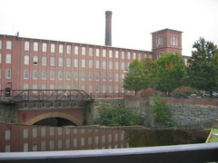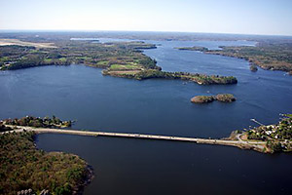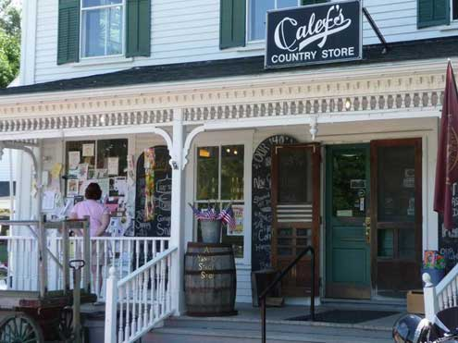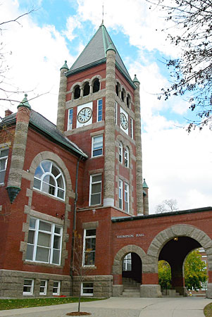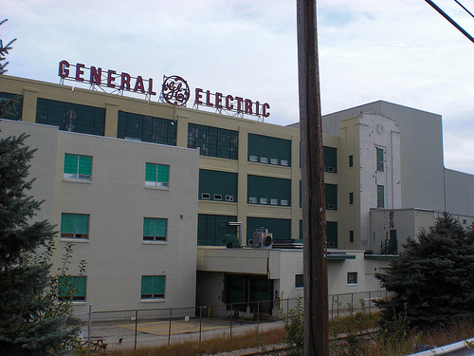

Strafford Regional 2011-2016
Comprehensive Economic Development Strategy

Volume 1

Acknowledgements

The 2011-2016 Comprehensive Economic Development Strategy (CEDS) for Strafford Region owes its funding to the willing and active leadership of Strafford Economic Development Corporation Executive Director Dennis McCann. Mr. McCann garnered both financial and participant support on behalf of the Strafford Region.

The 2011 Strafford Regional Comprehensive Economic Development Strategy Committee is constituted of thirty individuals representing a variety of interests including: municipal, business, state, regional, nonprofit, and education interests. The CEDS committee has met monthly and has had a direct and continuous role in formation of the document. In particular, the Strategy Committee has adopted a vision, goals and objectives; discussed regional data maps; conducted a Strengths Weakness Opportunities Threats (SWOT) analysis; designed a project solicitation process; and approved the final document. The CEDS Strategy Committee will now have the primary role of implementing the 2011-2016 CEDS and evaluating the results. A list of the Strategy Committee members with their affiliation is listed below.

Strafford Regional CEDS Strategy Committee Members

Name | Affiliation | City/Town/Region | Representing
Dan Barufaldi | Dover Business and Industrial Development Authority  Economic Development Director | Dover | Public
Alan Brigham | Economic Development Administration  Representative for Maine and New Hampshire | Federal | Public
Mike Burns | BCC Network Integration | Strafford | Private
Steve Cate | Waste Management | Rochester | Private
Glenn Coppelman | NH Community Development Finance Authority  Economic Development Director | State | Public
Warren Daniel | NH Small Business Development Center  Seacoast Regional Manager | Durham | Public
Christine Davis | NH Dept. of Resources and Economic Development  Business Resource Specialist | State | Public
Paul Eaton | IT | Strafford | Private
Tom Elliot | Idea Green House | Durham | Private
Jennifer Flannery | Community Partners  Development and Communications Coordinator | Region | Non-Profit
Rick Foster | Foster's Daily Democrat | Dover | Private
John Hall | Profile Bank, Executive Vice President | Rochester | Private
Robert Jaffin | Educator, Lecturer, Author | Rochester | Private
Jeremy LaRose | COAST Public Transit  Manager of Operations and Planning | Region | Public
Ute Luxem | Profile Bank  Assistant Vice President | Region | Private
Dennis McCann | Strafford Economic Development Corporation  Executive Director | Region | Non-Profit
Katie Muth | Durham Business Association  Executive Director | Durham | Non-Profit
Rad Nichols | COAST Public Transit  Executive Director | Region | Public
Marian Noronha | Turbocam International | International | Private
Denise Roy Palmer | Wentworth Economic Development Corporation, Inc.  Executive Director | Region | Non-Profit
Marcie Perry | Middleton Building Supply | Middleton | Private
Karen Pollard | City of Rochester  Economic Development Manager | Rochester | Public
Doreen Rainville | Winsor Brook Property Advisors | Region | Private
Todd Selig | Town of Durham  Town Administrator | Durham | Public
Deborah Shipman | Frisbie Memorial Hospital & Strafford Health Alliance  VP Ancillary Services | Region | Non-Profit
Mica Stark | University of New Hampshire  Government Relations and Strategic Initiative | Region | Public
Lin Tamulonis | Great Bay Community College  Associate Vice President | Region | Public
Charter Weeks | Charter Weeks Marketing | Barrington | Private
Peter Wensberg | Ami Companies | Strafford | Private
Craig Wheeler | City of Somersworth  Director of Development Services | Somersworth | Public

Without the active participation of the Strategy Committee members, this plan would not have been achieved. Strafford Regional Planning Commission is grateful to all of the stakeholders who attended meetings, who participated in focus interviews, and who provided comments and worked with staff during this twelve month development process. Together we have made a plan that we can implement.

On behalf of Strafford Regional Planning Commission we would like to thank Dr.Ross Gittell for his presentation on the “New Hampshire and Strafford Economic Outlook” annual meeting on Thursday, May 26th, 2011. Dr. Gittell announced Strafford Regional Comprehensive Economic Development Strategy draft and the public comment period along with valuable information about the New Hampshire and Strafford County economy. Professor Gittell, PhD. is the James R. Carter Professor of Management at the University of New Hampshire’s Whittemore School of Business and Economics. The presentation can be found on page 64 to 77 of the appendices.
Funding and Support

The Economic Development Administration (EDA) of the U.S. Department of Commerce, Grant No. 01-88-08863, financed the preparation of this document with matching funds provided by NH Business and Finance Authority, NH Department of Resource and Economic Development, NH Community Development Finance Authority, and NH Charitable Foundation. Additional funds were provided by the member communities of Strafford Regional Planning Commission.

Strafford Regional Planning Commission appreciates the support and counsel we received from the CEDS funding partners. A special thanks to Mr. Alan Brigham, EDA, Region 1, Economic Development Representative for Maine and New Hampshire, and Mr. Glenn Coppelman, Economic Development Director for NH Community Development Finance Authority for the advice and time they provided to staff, creating the possibility for a successful completion of the first Strafford Regional CEDS.







Strafford Regional Planning Commission Staff

Executive Director Cynthia Copeland has taken primary responsibility for preparing the 2011-2016 CEDS, in particular the goals and objectives, forming and bringing together the involvement of the CEDS Strategy Committee, and seeking input from state, regional, and local leaders. Dan Camara provided additional assistance with GIS mapping and research. Marilyn Barton assisted with coordination tasks, organization of the meetings and recorded meeting minutes. Michelle Auen assisted with research and data analysis, interviews, project solicitation, coordination tasks, and document preparation. Kyle Pimental provided support with communications through articles in SRPC newsletter, press releases and postings on the website, and formatting of the document. Linda Osburn was responsible for the grant management and report preparation. Essential editing support provided by Cynthia Copeland, Marilyn Barton, and Linda Osburn. Finally, thank you to the Strafford Regional Planning Commission members for their support throughout this condensed planning process.

The staff involved in this project includes:

Administration
Cynthia Copeland, AICP
Executive Director

Marilyn Barton, PHR
Executive Assistant

Linda Osburn
Bookkeeper

Planning
Marc Ambrosi
Regional Transportation Planner

Michelle Auen
Regional Planner

Dan Camara
Senior GIS Analyst/ Transportation

Kyle Pimental
Regional Planner

Support Services

Dennis McCann
Executive Director
Strafford Economic Development Corporation

Charlie French, Ph.D.
Extension Associate Professor
Community & Economic Development
UNH Cooperative Extension
Department of Natural Resourc

Resources

Cooperative Extension at the University of New Hampshire
Dr. Charlie French, Extension Associate Professor, Community & Economic Development, provided valuable insight and experience in regards to agenda development and meeting facilitation, environmental scan process, visioning, development of goals and objectives and benchmarks. Thank you for always being available when we needed guidance through this process.

Carsey Institute at the University of New Hampshire
University of New Hampshire Carsey Institute provides valuable information on Northern New England indicators sites for states and counties from a variety of federal and state agencies. These include the U.S. Bureau of Census, Bureau of Economic Analysis, Bureau of Labor and Statistics, and State Departments. This information was critical in creating this document. The Carsey Institute conducts national and regional policy research on vulnerable children, youth and families and on sustainable community development.

Indiana University’s Kelley School of Business
Indiana Business Research Center at Indiana University’s Kelley School of Business provides the web based service STATS America. This initiative is funded in part by the U.S. Commerce Department’s Economic Development Administration and Indiana University. The data is provided from hundreds of data sets from federal and state sources, along with some commercial and private source data.

Purdue University Center for Regional Development
Purdue University Center for Regional Development provides valuable information on Industry and Occupational Clusters. Staff at the Center generously provided assistance in generating an Industry Cluster and Occupational Cluster graphs for Strafford County.

Innovation in America Regions
Innovation in America Regions is a web based service maintained by the Indiana University Kelley School of Business through the STATS America site. The site provides tools to guide the strategic discussions about industry and occupation clusters leading to the development of regional strengths. This project was funded by the U.S. Commerce Departments Economic Development Administration with Purdue Center for Regional Development, the Indiana Business Research Center at Indiana University’s Kelley School of Business, and other research partners.

Table of Contents

Acknowledgements 3
Strafford Regional CEDS Strategy Committee Members 3
Strafford Regional Planning Commission Staff 6
Support Services 6
Resources 7

Forward 12

Executive Summary 16

Chapter 1: CEDS Planning Process 18
Introduction 18
Strafford CEDS Region 18
CEDS Legal Requirements 20
SRPC Responsibilities: 20
CEDS Regional Planning Process: 24
CEDS Public Comment 26
CEDS Approval Process 26
CEDS Strategy Committee Approved on July 7, 2011 26

Chapter 2: CEDS Context 27
Historic Development Patterns 27
Geographic Background 28

Chapter 3: Demographic 32
Population Trends and Projections 32
Age Cohorts 35
Race and Ethnicity 37
Educational Attainment 38
Wages and Income 40
Housing Affordability 41

Chapter 4: Regional Economy 59
Description of Regional and State Economy 59
Employment by Industry 60
Major Employers by Municipality 72
Self-Employment 75
Tax Policies and Bonding 76

Chapter 5: Areas of Economic Distress 79
Poverty Rates 80
Reduced School lunch program 81
Layoff Data 83
Foreclosure 84
Partners and Resources for Economic Development 85
Chapter 6: Infrastructure 88
Infrastructure 88
Transportation Planning 88
Surface Transportation (GIS Map) 89
Sewer and Water Systems 94
Utilities 96
Electric Systems 97
Telecommunications and Broadband Access 97
Solid Waste Disposal 98
Health Resources 98
Educational Systems and Training 99

Chapter 7: Environmental Profile 104
Natural Resources 104
Piscataqua River Basin 104
Estuarine and Coastal Resources 105
Tourism 105
Agricultural Land 106
Open Space and Conservation Land 106
Outdoor Activities and Recreation 108
Natural Hazard Mitigation 111
Environmental Issues 111
Water Quality 111
Air Quality 112
Invasive Species 112

Chapter 8: CEDS Regional Expectations 114
Vision Statement 114
Mission Statement 114
Regional Collaboration Principles 115
Strengths, Weaknesses, Opportunities, Threats (SWOT) Analysis 117
Goals and Objectives Benchmarks 120

Chapter 9: Plan of Action 133
Purpose of the CEDS Action Plan 133
Project Development Process 135
CEDS Projects 136
2011 Strafford Regional CEDS Project Matrix 165

Chapter 10: CEDS Implementation and Performance Measures 173
Performance Measures 173
CEDS Annual Evaluation 173

List of Maps

Map 1: Strafford CEDS Region 19
Map 2: Strafford Regional Planning Commission Area 22
Map 3: Maine, Massachusetts, New Hampshire, Vermont in Relationship to Strafford Regional CEDS 29
Map 4: New Hampshire Counties including York County, ME 31
Map 5: Strafford CEDS Region Percent Population Change 2000-2010 33
Map 6: Strafford CEDS Region Educational Attainment 38
Map 7: Strafford Regional Housing Needs Assessment 45
Map 8: Strafford CEDS Region Percent below Poverty Level 80
Map 9: Strafford Metropolitan Planning Organization 89
Map 10: COAST and Wildcat Transit Service Areas 92
Map 11: Water and Sewer 95
Map 12: Strafford CEDS SAU’s 101

List of Figures

Figure 1. Strafford County Population Growth from 1950-projected growth in 2030 34
Figure 2. Population Estimates by Age Groups for Strafford County, Carroll County, Rockingham County, New Hampshire, and the United States. 36
Figure 3. Private Sector Employment Area 42
Figure 4. Employment and Housing Units 42
Figure 5. Housing Units Authorized by Permit 43
Figure 6. Housing Production by Period by Structure Type 44
Figure 7. Industry Clusters Bubble Chart, Strafford County, NH (2009) 66
Figure 8: Occupation Clusters Bubble Chart, Strafford County, NH (2009) 69
Figure 9. Self Employment Rate U.S., New Hampshire, Carroll County, Rockingham County, and Strafford County, 1969-2009 75
Figure 10. Percent Unemployment Rate U.S., New Hampshire, Carroll County, Rockingham County, and Strafford County, 1969-2009 79
Figure 11. Percentage Foreclosure Deeds In New Hampshire by County by Year 84
Figure 12. Strengths, Weaknesses 118
Figure 13. Opportunities and Threats 119
Figure 14. Number of Physicians: Strafford County, NH, and U.S., 1996-2009 146

List of Tables

Table 1. Meeting for CEDS Strategy Committee 23
Table 2. CEDS Communities, Regional Planning Commission, and NECTA 30
Table 3. Strafford CEDS Region Population 1960-2010; Percent Change 2000-2010 34
Table 4. Changes in Population from 1950-2008 in Strafford Co., Carroll Co., Rockingham Co., State, and US. 35
Table 5: Race and Ethnicity US, NH Strafford County Towns Source US Census 37
Table 6. Strafford CEDS Region Educational Attainment 39
Table 7. Median Family Income 40
Table 8. Average Weekly Wage CEDS Towns 40
Table 9. Families Below Poverty U.S., NH, Carroll, Rockingham, Strafford County 40
Table 10. Comparison of Sub-Area Population and Housing 46
Table 11. Distribution of Employment, Property Value and Housing Share 47
Table 12: Maximum Housing Costs Based on SRPC Area Wages by Industry 51
Table 13. Historic Housing Production by Sub-Area 52
Table 14. Employment, Labor Force, Commuting Time 53
Table 15. Population Density 54
Table 16. Housing Supply (Total Units) and Units by Structure Type 55
Table 17. Households by Tenure and Age of Head Household 56
Table 18. Equalized Property Valuation 57
Table 19. Renter Households by Cost Burden 2000 & 2008 Assisted Housing Supply 58
Table 20. Average Annual Employment 60
Table 21. Largest Employment Growth by Sector 61
Table 22. Top 20 Employment Sectors 62
Table 23. Government Employment 63
Table 24: Average Annual Employment: Carroll, Rockingham, & Strafford Counties 63
Table 25: Average Annual Employment: New Hampshire 64
Table 26: Data for Industry Clusters Bubble Chart, Strafford County, NH (2009) 67
Table 27: Data for Occupation Clusters Bubble Chart, Strafford County, NH (2009) 70
Table 28. Major Employers in the Region by Municipality 72
Table 29 Tax Rates in the Strafford CEDS Region 2010 76
Table 30 Taxes in New Hampshire 77
Table 31. Poverty Rate by Age, U.S., NH, Carroll County, Strafford County, and Rockingham County 81
Table 32. Reduced School Lunch Program in Percentage 82
Table 33. Layoff Data for Strafford CEDS Region from July 2008-Present 83
Table 34. Utility Infrastructure 96
Table 35. Public Schools 102
Table 36. CEDS Region Non Public Schools 103
Table 37. CEDS Regional Career Technology Centers 103
Table 38. County Recreational Inventory 107
Table 39. County Public Water Access Sites 107
Table 40. Strafford CEDS Regional Cultural Resources 108
Table 41. Strafford CEDS Regional Outdoor Recreation Activities 110
Table 42. Number of Physicians for State and County 147
Table 43. Strafford 2011-2016 CEDS Action Plan 174

Forward

The Economic Development Administration

The mission of the Economic Development Administration, an agency of the U.S. Department of Commerce is:

To lead the federal economic development agenda by promoting innovation and competitiveness, preparing American regions for growth and success in the worldwide economy.

History

The Economic Development Administration (EDA) was established under the Public Works and Economic Development Act of 1965 (42 U.S.C. § 3121), as amended, to generate jobs, help retain existing jobs, and stimulate industrial and commercial growth in economically distressed areas of the United States. EDA assistance is available to rural and urban areas of the Nation experiencing high unemployment, low income, or other severe economic distress. In fulfilling its mission, EDA is guided by the basic principle that distressed communities must be empowered to develop and implement their own economic development and revitalization strategies. Based on these locally and regionally developed priorities, EDA works in partnership with state and local governments, regional economic development districts, public and private nonprofit organizations, and Indian tribes. EDA helps distressed communities address problems associated with long-term economic distress, as well as sudden and severe economic dislocations including recovering from the economic impacts of natural disasters, the closure of military installations and other Federal facilities, changing trade patterns, and the depletion of natural resources.

Investment Priorities

The EDA provides regions with both technical and financial assistance. Projects are reviewed within the parameters of a competitive grant process. All projects are evaluated to determine if they advance global competitiveness, create jobs, leverage public and private resources, can demonstrate readiness and ability to use funds quickly and effectively and link to specific and measurable outcomes.

To facilitate evaluation, EDA has established the following investment priorities:

- Collaborative Regional Innovation
Initiatives that support the development and growth of innovation clusters based on existing regional competitive strengths. Initiatives must engage stakeholders; facilitate collaboration among urban, suburban and rural (including Tribal) areas; provide stability for economic development through long-term intergovernmental and public/private collaboration; and, support the growth of existing and emerging industries.

- Public/Private Partnerships
Investments that use both public and private sector resources and leverage complementary investments by government/public entities and/or non-profits.

- National Strategic Priorities
Initiatives that encourage job growth and business expansion in clean energy; green technologies; sustainable manufacturing; information technology (e.g., broadband, smart grid) infrastructure; communities severely impacted by automotive industry restructuring; natural disaster mitigation and resiliency; access to capital for small and medium sized and ethnically diverse enterprises; and, innovations in science, health care and alternative fuel technologies.

- Global Competitiveness
Investments that support high-growth businesses and innovation-based entrepreneurs to expand and compete in global markets.

- Environmentally-Sustainable Development
Investments that encompass best practices in “environmentally sustainable development,” broadly defined, to include projects that enhance environmental quality and develop and implement green products, processes, and buildings as part of the green economy.

- Economically Distressed and Underserved Communities
Investments that strengthen diverse communities that have suffered disproportionate economic and job losses and/or are rebuilding to become more competitive in the global economy.

The Comprehensive Economic Development Strategy (CEDS)

The CEDS is a document containing a process of analysis, an economic road map, and an action plan with the purpose to generate economic investment and improve community infrastructure and services. Certification of this document by the Economic Development Administration (EDA) will allow the Strafford region and its communities to qualify for grant funding from various EDA grant programs. Projects identified in this document may be eligible for EDA funding.
The CEDS is designed to bring together the private, non-profit and public sectors to create a roadmap to strengthen regional economies. Regional planning commissions are responsible for developing and implementing a CEDS for their region. The regional planning commission for Strafford County is Strafford Regional Planning Commission. The first step in the CEDS process is appointing a “Strategy Committee” with representation from the public, non-profit and private sectors. The Strategy Committee is responsible for developing and revising the plan, and overseeing implementation of the plan. It must represent the main economic interests of the region.

There are two types of CEDS reports: the five-year plan (and its updates) and the annual reports.

The original five-year plan and its successive updates include the following:

- CEDS Planning Process: a description of the planning process
- CEDS Background Information: An analysis of the regional economy using available data and research
- CEDS Vision: An expression of the region’s aspirations
- CEDS Action Plan: An account of the regions goals, objectives, benchmarks, and project priorities over the next five years
- CEDS Implementation and Evaluation: An outline of the plan’s implementation and method for measuring progress on priority projects and meeting the CEDS overall goals

During the interim years, the annual reports track the progress toward meeting the economic development goals and completing priority projects in the CEDS. The annual report will document economic changes in the region and possible changes in priorities.

The Annual Reports include:

- Adjustments to the CEDS: changes in planning process, structure, or strategies
- Evaluation: Progress towards priority projects
- Goals evaluation: Overall progress in meeting regional goals
- Implementation Schedule: Timeline of activities for the upcoming years

CEDS Goals and Objectives, Regional Expectations

The goals, objectives, benchmarks and strategies were developed during the Strategy Committee meetings and with the additional help of these individuals: John Hall, Robert Jaffin, and Lin Tamulonis. Guidance was provided by Dr. Charlie French.

The goals, objectives and strategies relate to important subject areas of the CEDS that the Strategy Committee developed during the SWOT analysis and environmental scanning processes.

Action Plan

The CEDS Strategy Committee developed the Action Plan incorporating the vision, goals and objectives, benchmarks, and project sections. The Action Plan covers a period of five years and is broken down into:

- Short term (one to two years)
- Medium term (two- five years)
- Long term (5+ years)

The terms provide a timeframe for projects and a structural guideline for identifying priority projects: projects and services that address the region’s greatest needs and will best enhance the region’s competitiveness in the New England, United States and global economies.

Implementation
Strafford Regional Planning Commission and the Strategy Committee seek to evaluate the original 2011-2016 plan for the purpose of determining success in meeting both regional goals as well as EDA priorities. The implementation will be fairly broad in addressing each of these areas, while specific enough to quantify the results as noted by the Strategy Committee.

The 2011 planning process embraced a grass-roots process involving as many participants within the region as possible. The development of tools to measure the implementation process, such as participant surveys, visioning sessions, and Strategy Committee meetings, will be coupled with the development and updates of supporting statistical data. Strafford Regional Planning Commission will market the CEDS plan and process to business associations, nonprofits, municipalities, and community groups to reinforce the importance of the CEDS planning process and relevance of EDA to the future economic growth of the region.

Performance Measures
The final chapter of the CEDS contains the measures that have been defined to quantify or qualify the implementation of the CEDS. These performance measures are organized by subject area.

Executive Summary

Economic Development Needs

Severe job loss in Strafford County in the manufacturing sector (almost 2000 jobs between 2001-2005), and the ensuing emergence of retail trade as the largest employment sector, pushed economic development stakeholders to begin discussions concerning the preparation of a Strafford Comprehensive Economic Development Strategy (CEDS) as there was no CEDS for the Strafford region of New Hampshire. The region’s economic development stakeholders viewed these trends as a call for regional solutions that would benefit unemployed, dislocated, and low-income workers, and attract capital investment. These trends were further compounded by subsequent job losses incurred during the December 2007 – June 2009 recession.

Looking towards the future, Strafford region is uniquely positioned to benefit from its largest single employer, the University of New Hampshire, and its relative shelter being in the midrange for economic performance in the state of New Hampshire. The Strafford Regional 2011 -2016 CEDS focuses on its distinct education advantage that creates an economic advantage for business and professional services, for green ventures, and for advanced manufacturing. The location of the University of New Hampshire in the Strafford region draws additional economic growth and encourages business recruitment. With the region’s higher than average young adult population, businesses are attracted to the region, and as in the past, many successful businesses have been launched from basements and garages in the Strafford region. Additionally, the Strafford region functions as key gateway from the higher cost Boston metro and southern NH regions to the high amenity attractions of the Lakes and White Mountains in northern NH.

Support for Strafford CEDS

With active support from the New Hampshire Department of Resources and Economic Development, NH Business and Finance Authority, NH Community Development Finance Authority, NH Charitable Foundation, Strafford Economic Development Corporation (SEDCO) and Wentworth Economic Development Corporation (WEDCO) the Strafford Regional Planning Commission received planning assistance from the Economic Development Administration (EDA) to prepare the CEDS for the Strafford Region. The planning process began in the fall of 2010 with focus interviews, research, and data collection and analysis. In a condensed six month period, from January 2011 through July 2011, the thirty member Strafford CEDS Strategy Committee successfully completed the steps needed to develop a plan and project listing for the Strafford Region. Included in this CEDS are the thirteen municipalities located in Strafford County, and the municipalities of Brookfield and Wakefield located in Carroll County.

Vision, Goals for Strafford Regional CEDS

The vision developed by the Strafford CEDS Strategy Committee is:

Engage in collaborative networks to sustain and grow the region’s economic vitality and median income through business development, job creation, enhancement of the tax base, educational excellence, and cultural and civic diversity, all within a historic place rich in recreational opportunity and natural beauty.

The Strafford CEDS Strategy Committee used a Logic Model for the development of the CEDS goals, objectives, benchmarks, performance measures and outcomes. By focusing on the intended outcomes of the goals, a Logic Model elicits what actions and steps need to be taken for success. Goals for the Strafford CEDS are as follows:

Economic Development: Support the attraction, retention and expansion of business, as well as capital investments and employment in the region.

Regional Collaboration: Provide opportunities for regional collaboration and leadership in economic development among businesses, communities, institutions, governments and other parties.

Infrastructure: Expand access to the critical regional infrastructures of banking and finance, transportation, utilities, water and wastewater, waste management.

Resource and Environment: Capitalize on built environment and natural resources through measures that protect, preserve, manage and promote quality and an increasing diversity of resource usage.

Workforce and Entrepreneurial Development: Support development of education and training initiatives relevant to businesses in the region. Provide quality education and training for resident and employees of all ages and abilities.

Quality of Place: Improve the health and welfare of residents and workers in the areas of wealth generation, human health and wellbeing, educational attainment, recreation, social services and environment.

Project Development and Implementation

The Strategy Committee developed annual project solicitation and review processes. In May 2011 the Committee solicited for the Strafford Regional CEDS’ initial projects. Over thirty projects were received and, through a consensus decision, the Strategy Committee moved all projects into priority categories based on implementation times. The quality and diversity of the projects was impressive, ranging from downtown incubator development to proof of concept “idea greenhouse” center; from a multiregional trail development to freight rail improvements; from the creation of a center for agricultural and natural resources entrepreneurship to the development to livestock processing facility, and from the addition of regional revolving loan funds to the designation as an EDA economic development district. All the CEDS projects were grounded in the vision, collaborative principles, and goals of the Strafford Regional CEDS and the on-the-ground reality of current and historic economic development success and practices. The Strafford Regional CEDS for 2011-2016 was designed for step by step collaborative actions leading to sustained economic vitality, wealth generation, well-being of the residents, and ongoing preservation of the region’s quality of place and environment.

Chapter 1: CEDS Planning Process

Introduction

In April 2010, the Strafford Regional Planning Commission was invited by the Economic Development Administration (EDA) to compile and submit a Comprehensive Economic Development Strategy for Strafford County due to substantial job losses in the area. The mission of the EDA, an agency of the U.S. Department of Commerce, is to support the formulation and implementation of economic development programs that maintain or create full time permanent jobs and income for the unemployed in areas of economic distress.

Over the course of a year the CEDS process pulled together individuals representing the public, non-profit and private sectors to help shape, compile, draft, and complete a Comprehensive Economic Development Strategy for Strafford County, New Hampshire and the Towns of Wakefield and Brookfield in Carroll County.

A Comprehensive Economic Development Strategy (CEDS) for the Strafford Region would benefit the region in a number of ways. The coordination of regional economic development stakeholders in the private, non-profit and public sectors through a CEDS Strategy Committee would help to promote economic development projects and initiatives specific to Strafford’s unique region. A broad based regional perspective would be ensured through the diverse backgrounds of the Strategy Committee, representing municipalities, businesses, nonprofits, and organizations throughout the region and at the state level.

Strafford CEDS Region

Strafford Regional CEDS consists of fifteen incorporated communities in Carroll and Strafford Counties:

  - Barrington
  - Brookfield
  - Dover
  - Durham
  - Farmington
  - Lee
  - Madbury
  - Middletown
  - Milton
  - New Durham
  - Rochester
  - Rollinsford
  - Somersworth
  - Strafford
  - Wakefield

Note: The Towns of Newmarket, Nottingham, and Northwood are in Rockingham County, and thus are part of Rockingham Economic Development District. They are not included in the Strafford Regional CEDS although they are longtime members of the Strafford Regional Planning Commission.

Map 1: Strafford CEDS Region
[Source: NH GRANIT]
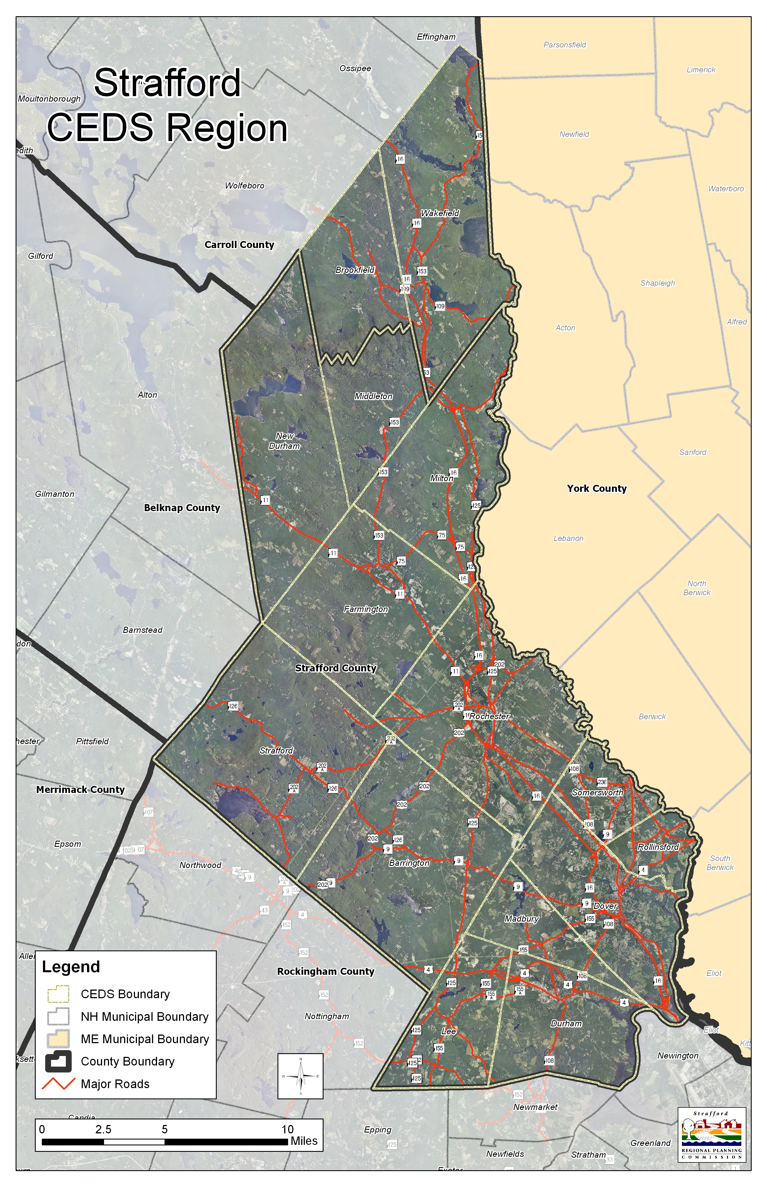

CEDS Legal Requirements

The Economic Development Administration identifies several key subject areas for a CEDS as follows: economic development background, analysis of economic development problems and opportunities, goals and objectives, public and private sector involvement, proposed projects, prioritized projects, economic clusters, a plan of action, performance measures, and strategy committee. Each of these components is found in the Strafford Regional CEDS within major headings and appendices. Implementation actions will be monitored annually, with adjustments made as outcomes are achieved, and as new data is obtained.

New Hampshire law RSA 36:47 I states:
A regional planning commission’s powers shall be advisory and shall generally pertain to the development of the region within its jurisdiction as a whole…It shall be the duty of the regional planning organization to prepare a comprehensive master plan for the development of the region within its jurisdiction, including the commission’s recommendations, among other thing, for the use of land within the region; for the general location, extent, type of use, and character of highways, major streets, intersections, parking lots, railroads, aircraft landing areas, waterways, and bridges, and other means of transportation, communication, and other purposes; for the development extent, and general location of parks, playgrounds, shore front developments, parkways, and other public property; and for the improvement, redevelopment, rehabilitation, or conservation of residential, business, industrial and other areas; including the development of programs for the modernization and coordination of buildings, housing, zoning, and subdivision regulations of municipalities and their enforcement on a coordinated and unified basis…

Strafford Regional Planning Commission (SRPC) prepared the CEDS in compliance with 13 CFR 303.6 for an EDA funded CEDS.

SRPC Responsibilities:

- Appoint a Strategy Committee
- Develop and submit to EDA a CEDS that compiles with 13 C.F.R. § 303.7
- Facilitate the planning process
- Provide public comment period for at least thirty (30) prior to submission to EDA
- Obtain approval of the CEDS from EDA
- Submit an updated CEDS performance report annually which includes: reporting implementation of the CEDS, and public/private sector participation
- Submit a new CEDS to EDA at least every five years unless determined that a CEDS is required earlier

The CEDS Lead Agency
Strafford Regional Planning Commission is the lead planning authority for the Strafford Regional CEDS region. SRPC has been active in regional planning for over 40 years as one of the nine regional planning commissions established by the New Hampshire legislature.

SRPC is composed of eighteen communities including all thirteen municipalities in Strafford County, three communities in Rockingham County, and two communities in Carroll County. Operating as a political subdivision of the State, SRPC serves an advisory role to local governments and organizations.

SRPC works to improve the region by coordinating local planning, promoting orderly growth and efficient land use and transportation systems, and addressing issues of regional concern. SRPC's professional planning staff assists in land use, transportation, environmental planning, economic development, hazard mitigation, facilitation, GIS, support services and project management.

SRPC Communities and Commissioners
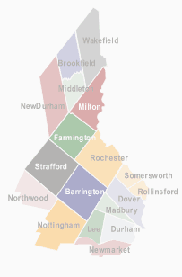

Barrington
Steven Conklin
Stephen Jeffery

Brookfield
Edward Comeau

Dover
Tom Clark

Durham
Wayne Burton
Brandon Anderson

Farmington
Vacant

Lee
Scott Kemp
Caren Rossi

Madbury

Middleton
Lou Vita
Carol Vita

Milton
Bruce Woodruff

New Durham
Dot Veisel

Newmarket
Rose-Ann Kwaks

Northwood
Scott Martin

Nottingham
Vacant

Rochester
Robert Jaffin
Sandra Keans
Kenn Ortmann

Rollinsford
Patrick Carroll
Edmund Jansen, Jr.

Somersworth
Roger Berube
Brian Tapscott
Dale Sprague

Strafford
Paul Eaton
Charles Moreno

Wakefield
John Ciardi

Janet Wall
Tom Crosby

Map 2: Strafford Regional Planning Commission Area
[Source: NH GRANIT]
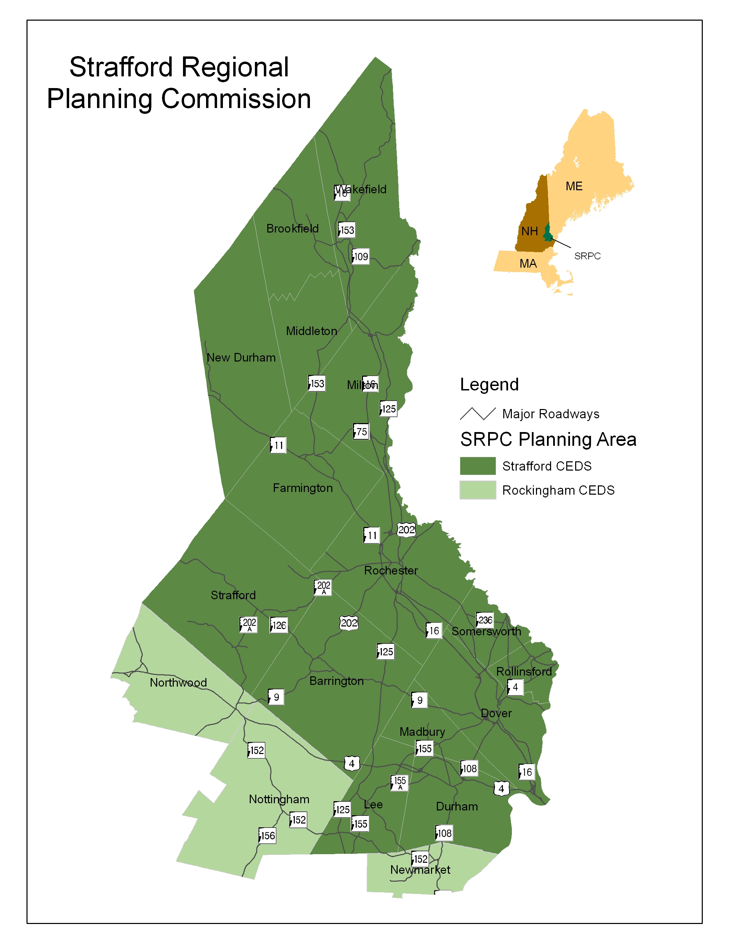

Since the mid 1980’s SRPC has been the federally mandated agency responsible for transportation planning throughout the region, functioning as the Strafford Metropolitan Planning Organization. SRPC works with NH Department of Transportation, Federal Highway Administration and Federal Transit Administration in this capacity. The Strafford Metropolitan Planning Organization is also the primary body representing the region with state and federal agencies and lawmakers on transportation planning and project development issues.

Additionally SRPC works with the Environmental Protection Agency, Federal Emergency Management Agency, National Oceanic and Atmospheric Administration, NH Office of Energy Planning, NH Department of Environmental Services, NH Department of Resources and Economic Development, NH Homeland Security & Emergency Management, and other corresponding state agencies to provide technical assistance to state, local, and nonprofit agencies. SRPC functions include: organizational development, research and analysis, budget preparation and monitoring, public involvement, outreach and education, advocacy, and securing funding for projects and programs.

SRPC understands the responsibilities as a facilitator for regional economic development while encouraging participation from all stakeholders.
CEDS Strategy Committee

The first step in creating a successful CEDS is to form a Strategy Committee that represents the main economic interests of Strafford County and southeastern Carroll County. SRPC and Strafford Economic Development Corporation compiled a list of various stakeholders in the area, comprised of public, non-profit and private sectors. The Strategy Committee represents the main economic interests of the region and helped direct the formation of the CEDS document. The Committee has adopted vision, goals, discussed regional data, conducted a SWOT analysis, and approved the final document. In the future the CEDS Committee will implement the Action Plan and evaluate the results of this document. This was a success in terms of the amount of private and public sector participation.

The Strategy Committee meetings began January 13th with the Kick-Off meeting to gather the participants together and orient them to the structure of the process. The Strategy Committee also prepared preliminary vision statements for the future economy of the Strafford Region.

The CEDS Strategy Committee met eight times during the CEDS process. Below is a summary of the meeting times and agendas.

Table 1. Meeting for CEDS Strategy Committee
January 13,2011  8:00 am-9: 30am  First Meeting | CEDS Presentation  Identify the need for SWOT analysis  Work on vision, five year objectives  Present background data
February 3, 2011  8:00 am-9: 30am | Cancelled Due to Weather
February 17, 2011  8:00 am-9: 30am  Second Meeting | Work on Vision Statement  Goals and objectives  Begin SWOT  SWOT analysis
March 10, 2011  8:00 am-9: 30am  Third Meeting | Results of SWOT analysis.  Finalize Vision Statement  Work Groups project listing
March 24, 2011  12:00 pm-1:30pm  Fourth Meeting | Focus Work groups  Goals and objectives  Work with Strategy Committee on draft evaluation measures and benchmarks.
April 14, 2011  8:00 am-9: 30am  Fifth Meeting | Finalize Vision and Mission  Principals  Review of Goals and Objectives
April 28, 2011  8:00 am-9: 30am  Sixth Meeting | Review DRAFT document  Project Profile listing and packet  Apply for EDA funding for Annual update  May 10, 2011
May24, 2011  8:00 am  Seventh Meeting | Priority Project  Matrix  CEDS document presented for 30-day public review and comment with project listing
May 26, 2011-Junes 27, 2011  8:00 am-9: 30am  Public Review for Draft Plan | DRAFT CEDS document presented for 30-day public review and comment
June 7, 2011  10:00 am  Public Hearing | Comments for the DRAFT Plan
July 7, 2011 | Approval of CEDS by Strategy Committee
July 31, 2011 | CEDS presented to US EDA for approval.  Grant closes with US EDA

SRPC held visioning sessions in early 2011 to embrace all stakeholders in the process. In addition, the Strategy Committee worked on an analysis of the region’s strengths, weaknesses, opportunities and threats (SWOT analysis) for economic development. The results were compiled from these meetings and used to create the vision, goals, and objectives for the 2011-2016 planning period. Using the vision and goals, the Strategy Committee and SRPC staff developed the 2011 Priority Projects List.

CEDS Regional Planning Process:

Strafford Regional Planning Commission has devoted financial and staff resources to the development of the original CEDS for Strafford Region. The plan is the initial document in the continuous planning process that will be built upon in future years to meet the needs of the region. The CEDS process was completed in three phases:

- Phase 1: Planning Foundation
- Phase 2: Strategy Development and Adoption
- Phase 3: Implementation and Evaluation

Phase 1: Planning Foundation: The goal of the first phase was to compile background information and data needed to inform the Strategy Committee of the planning and implementation process. The background information included socio-economic, geographic, and demographic data. During this phase SRPC staff prepared data and researched issues regarding this region and began to develop STATS Strafford County, in partnership with STATS America, which is managed by the Indiana Business Research Center at Indiana University Indianapolis. Data collection involved the U.S. Census Bureau, American Community Survey, County Profile data and other federal, state, and local sources.

SRPC worked with Strafford Economic Development Corporation to develop a list of participants for the Strategy Committee that would involve key economic stakeholders. Additionally, SRPC used the who are the leaders and who should be sitting at the table process to solicit further names from municipalities, businesses, non-profits. SRPC reached out to chambers of commerce and other business associations for names of business owners within the region.

SRPC conducted focus interviews with the municipalities and two economic development corporations to learn more about each community’s economy and longterm goals (contained in Volume 2 of this document).

Phase 2: Strategy Development and Adoption: SRPC held Strategy Committee meetings over the winter and spring for the both business and community leaders. The CEDS Strategy Committee shaped the vision of this document using a consensus decision-making process. The Strategy Committee conducted an Environmental Scan of the region, which shows strengths, weakness, opportunities, and threats. The Committee also developed goals and objectives which were incorporated into a Logic Model. The last step was to structure the project solicitation process, receive projects, and come to an agreement about the list of prioritized projects, programs, and activities.

The Strategy Committee held a 30 day public comment period and public hearing prior to approving the plan. At their last meeting on July 7, 2011, they reviewed the comments received from the public and the responses, and voted unanimously to approve the plan and send to Mr. Alan Brigham at the Field Office in Portland, Maine for review by EDA Region 1 staff.

Phase 3: Implementation and Evaluation CEDS process: Successful implementation of the CEDS will require leadership from a consortium of businesses, leaders, municipalities, nonprofits and state and regional agencies. SRPC staff needs the resources to inform and coordinate participants on a continual basis. The hard work from the previous Phase 1 and Phase 2 must advance. In order to maintain momentum, optimism, and regional collaboration created during the first year of the CEDS planning process, SRPC proposes the following work plan. This plan would be executed in partnership with the Strategy Committee but would require additional funding. The first step in the implementation process will be an application to the EDA for a planning grant to continue our efforts.

Data, Research, and Information

- Complete the development of SRPC CEDS web page
- Create a CEDS logo
- Create regional CEDS identity for Strafford Region
- Annual update amending the document

Public Outreach

- CEDS implementation kick off meeting with all partners and municipalities
- Presentation to stakeholders groups such as Chambers, businesses
- Workshops on obtaining EDA and other funding for priority projects
- Presentation of research- press conference, and newsletters
- Reach out to other groups and individuals for Strategy Committee membership
- Reach out to other regional planning commissions to create linkages and partnerships

Regional Priority Projects

- Submit a planning grant to the EDA to become an Economic Development District over next several years
- Update priority projects annually

CEDS Public Comment

The thirty day public review period started on May 26, 2011 with the release of the Draft CEDS at the SRPC Annual Meeting in Somersworth, NH. The public had the opportunity to comment on the planning process and on the priority projects. The draft report, along with meeting materials used throughout the planning process, was posted on the Commission’s website. The public review period was also included in Fosters Daily Democrat Newspaper announcing the comment period and project solicitation. A press release in the SRPC email Newsletter publicized the draft document. Drafts were made available at the Dover and Rochester Public Libraries and distributed widely within the region and community level.

CEDS Approval Process

The Strategy Committee endorsed the CEDS. The schedule of approval process is as follows:

CEDS Strategy Committee Approved on July 7, 2011

The agenda and minutes from the meetings are included in Volume 2 Appendix. The final step of the approval process is certification by U.S. Economic Development Administration, Region 1. The CEDS document was submitted on July 31, 2011.

Chapter 2: CEDS Context

Historic Development Patterns

Strafford County, named in honor of Thomas Wentworth, Earl of Strafford, was organized in 1773 as one of the five original counties in New Hampshire. The county was originally called Hilton's Point, Cocheco, Dover Point and Dover Neck, depending on the locality. Its river and ocean access made it an ideal location for sawmills and shipbuilding, two of the strong industries in the 1600s.

Following the close of the Indian Wars, shipbuilding was one of the major businesses in Dover. The Gonic Woolen Mill was formed in 1811 in Rochester and, in 1827, the Cocheco Manufacturing Company helped establish Dover as a leading producer of cotton goods. Shoe manufacturing was introduced in Dover in 1847. The Boston and Maine railroad came to Dover in 1841 and for a period in the mid-1800's ocean going schooners moved cargo between Dover and ports abroad. In the 1800's woolen mills, cotton mills, brickmaking and shoemaking became prominent industries in Strafford County.
Somersworth, situated on the Salmon Falls River, was home to many gristmills, sawmills, cotton and woolen making establishments in the 1800s.

In Farmington the location of three rivers (the Cocheco, Ela and Mad Rivers) encouraged the establishment of water-powered industries in Farmington, leading to the development of the downtown. In 1849, construction of a railroad through the vital mill area established Farmington as a commercial center.

Founded in 1866 as the New Hampshire College of Agriculture and the Mechanic Arts, the University of New Hampshire was one of the early land-grant institutions established to serve the sons and daughters of farming and laboring families. First situated in Hanover in connection with Dartmouth College, New Hampshire College moved to its campus in the Town of Durham in 1893 after Benjamin Thompson, a prosperous farmer, bequeathed land and money to further the development of the college. By 1923, the College, by state legislative decree, changed its name to the University of New Hampshire.

Rochester's combination opera house and city hall was built in 1908, one of only four such structures built in New England (another was in Dover). Only the Rochester building is still standing.

The New Hampshire Farm Museum in Milton offers a glimpse of an important aspect of the county’s history and economy, as does a drive along Dover Point Road by the Tuttle Farm, established in 1632, the country's oldest family farm. On Route 4 in Durham, another one of the country's oldest family farms, the Emery Farm was established in 1655.

Geographic Background

The Strafford region is located in the southeastern part of New Hampshire forming the eastern border of the state. The Salmon Falls River flows south into the Piscataqua River separating Strafford and Carroll Counties from Maine. The region is located equidistant of Metro Boston and Portland Maine (60 miles). The Lakes region and the White Mountains are directly north; and the seacoast is directly southeast. Massachusetts definitely influences the southern portion of the region, providing employment for thousands of residents of Strafford County.

Strafford is a region that is set apart by its beautiful natural resources, diverse communities from urban to rural, and a rich culture, and it is the only county in New Hampshire with Tri Cities (Dover, Rochester, and Somersworth).

The Strafford Regional CEDS is comprised of fifteen communities Most Strafford communities lay within the Piscataqua River Basin. Five coastal rivers pass through the region and converge in Great Bay, a nationally recognized Estuarine Research Reserve. The Piscataqua River drains the estuary into the Gulf of Maine through Portsmouth Harbor to the east. Rockingham County borders Strafford County to the south, the state of Maine to the northeast, Carroll County to the north, and Belknap and Merrimack Counties to the west.

For the purpose of developing the CEDS document, SRPC divided the data by County to include: Carroll, Strafford, and Rockingham County. The County data was compared to New Hampshire and the United States. The data was then broken down by municipal level (if the data was available) to get a more complete picture of the CEDS region.

Table 2 outlines the CEDS towns/cities, the county, regional planning commission and New England City and Town Areas (NECTAs).

NECTA is a geographic and statistical entity defined by the U.S. Office of Management and Budget and is associated with a core urban area with a population of at least 10,000 plus adjacent territory that has a high degree of social and economic integration with the core measured by commuting and employment. Metropolitan Statistical Areas have an urban core with a population of at least 50,000.

As shown in Table 2 there are eight communities in Rochester-Dover NH ME Metro NECTA. Several communities are listed as “unassigned” to a NECTA.

Map 3 shows the ten New Hampshire Counties and York County Maine. York County is shown on the map because of the close economic relationship with the Strafford Regional CEDS businesses.

Map 3: Maine, Massachusetts, New Hampshire, Vermont in Relationship to Strafford Regional CEDS
[Source: NH GRANIT, SRPC]
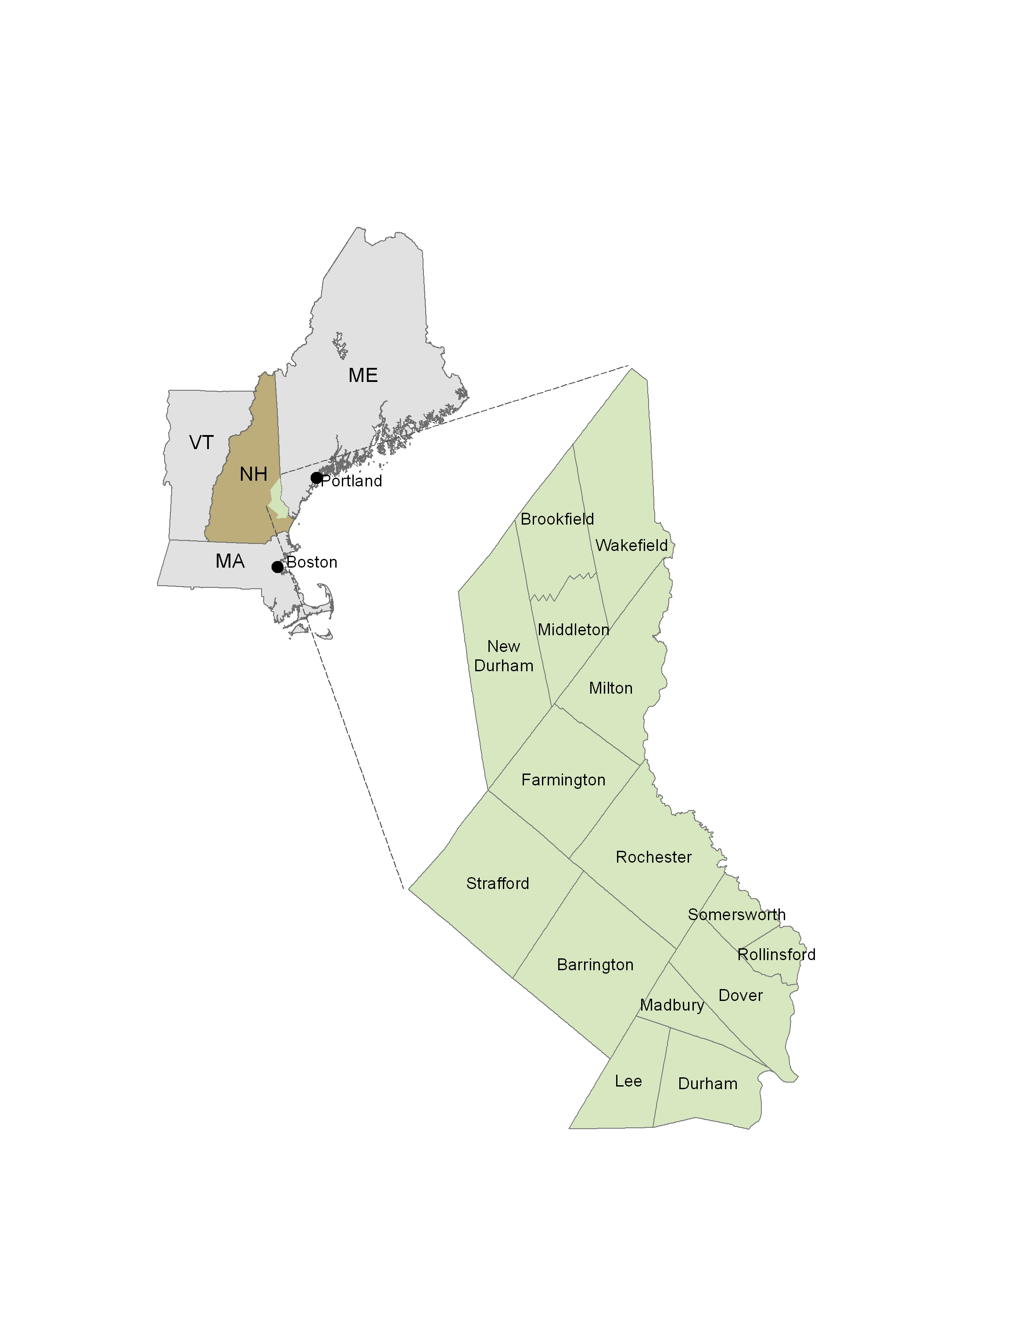

Table 2. CEDS Communities, Regional Planning Commission, and NECTA
[Source: U.S. Census]
CEDS Communities
Town/City | County | Regional Planning Commission | NECTA
Barrington | SC | SRPC | U
Brookfield | CC | SRPC | U
Dover | SC | SRPC | 16
Durham | SC | SRPC | 16
Farmington | SC | SRPC | U
Lee | SC | SRPC | 16
Madbury | SC | SRPC | 16
Middleton | SC | SRPC | U
Milton | SC | SRPC | 16
New Durham | SC | SRPC | U
Rochester | SC | SRPC | 16
Rollinsford | SC | SRPC | 16
Somersworth | SC | SRPC | 16
Strafford | SC | SRPC | U
Wakefield | CC | SRPC | U

Key:
SC = Strafford County
CC = Carroll County
SRPC = Strafford Regional Planning Commission
NECTA Regions:
U = Unassigned 16 = Rochester-Dover NH ME Metro NECTA

Map 4: New Hampshire Counties including York County, ME
[Source: NH GRANIT]

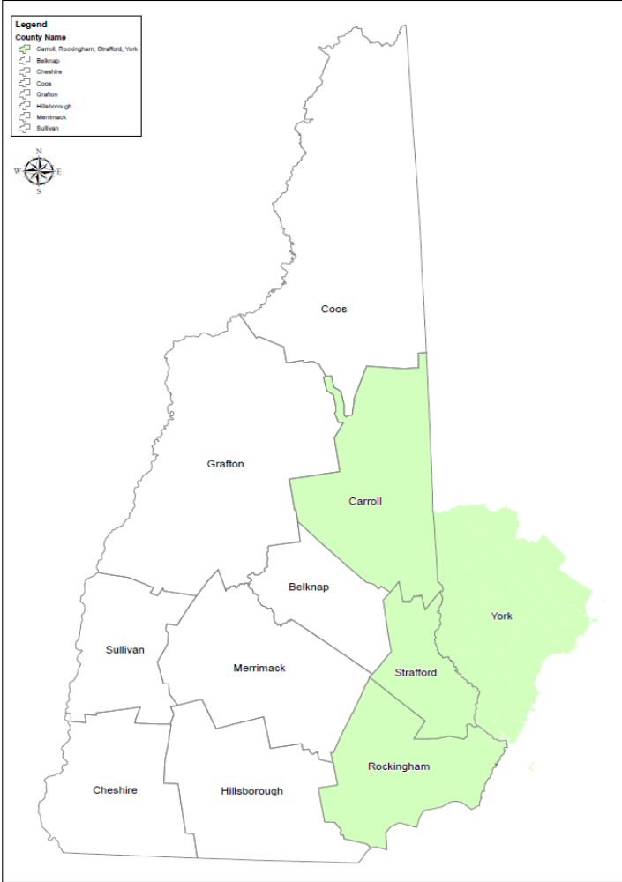

Chapter 3: Demographic

Population Trends and Projections

The United States is projected to grow to approximately 400 million people by 2040. The region’s proximity to large population centers, such as Boston, MA and Portland, ME, will impact the region’s population growth in the future. In the 2010 Census data Strafford County is the fastest growing county in the state of New Hampshire. This section will examine past, present, and projected future demographic trends through the examination of available data and reviewing key issues that will influence population, housing and employment trends in the future.

In New Hampshire, Strafford County is the smallest in land area, but is the third highest county in population density. As shown in Figure 1, Strafford County has experienced rapid population growth beginning in the 1950s through 2010 when the population actually doubled. It also shows projected growth into 2030. Population in current projections shows that the region will continue to experience significant growth, at a more moderate rate than in the past.

Map 5: Strafford CEDS Region Percent Population Change 2000-2010
[Source: NH GRANIT, U.S. Census Bureau]
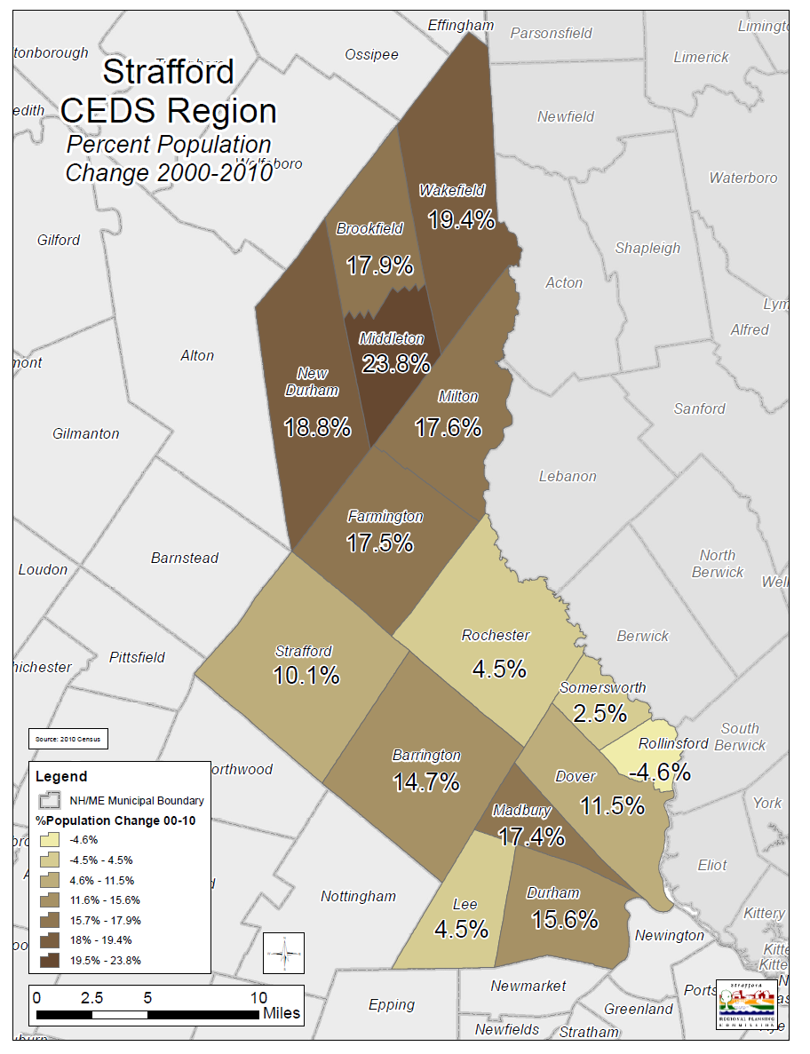

Table 3. Strafford CEDS Region Population 1960-2010; Percent Change 2000-2010
[Source: U.S. Census]
Strafford CEDS
U.S. Census 1960-2010
 | 1960 | 1970 | 1980 | 1990 | 2000 | 2010 | %Change 00-10
Barrington | 1,036 | 1,865 | 4,404 | 6,164 | 7,475 | 8,576 | 14.7%
Brookfield | 145 | 198 | 385 | 518 | 604 | 712 | 17.9%
Dover | 19,131 | 20,850 | 22,377 | 25,042 | 26,884 | 29,987 | 11.5%
Durham | 5,504 | 8,869 | 10,652 | 11,818 | 12,664 | 14,638 | 15.6%
Farmington | 3,287 | 3,588 | 4,630 | 5,739 | 5,774 | 6,786 | 17.5%
Lee | 931 | 1,481 | 2,111 | 3,729 | 4,145 | 4,330 | 4.5%
Madbury | 556 | 704 | 987 | 1,404 | 1,509 | 1,771 | 17.4%
Middleton | 349 | 430 | 734 | 1,183 | 1,440 | 1,783 | 23.8%
Milton | 1,418 | 1,859 | 2,438 | 3,691 | 3,910 | 4,598 | 17.6%
New Durham | 474 | 583 | 1,183 | 1,974 | 2,220 | 2,638 | 18.8%
Rochester | 15,927 | 17,938 | 21,560 | 26,630 | 28,461 | 29,752 | 4.5%
Rollinsford | 1,935 | 2,273 | 2,319 | 2,645 | 2,648 | 2,527 | -4.6%
Somersworth | 8,529 | 9,026 | 10,350 | 11,249 | 11,477 | 11,766 | 2.5%
Strafford | 722 | 965 | 1,663 | 2,965 | 3,626 | 3,991 | 10.1%
Wakefield | 1,223 | 1,420 | 2,237 | 3,057 | 4,252 | 5,078 | 19.4%
Total | 61,167 | 72,049 | 88,030 | 107,808 | 117,089 | 128,933 | 10.0%

Figure 1. Strafford County Population Growth from 1950-projected growth in 2030
[Source: US Census, NH OEP]
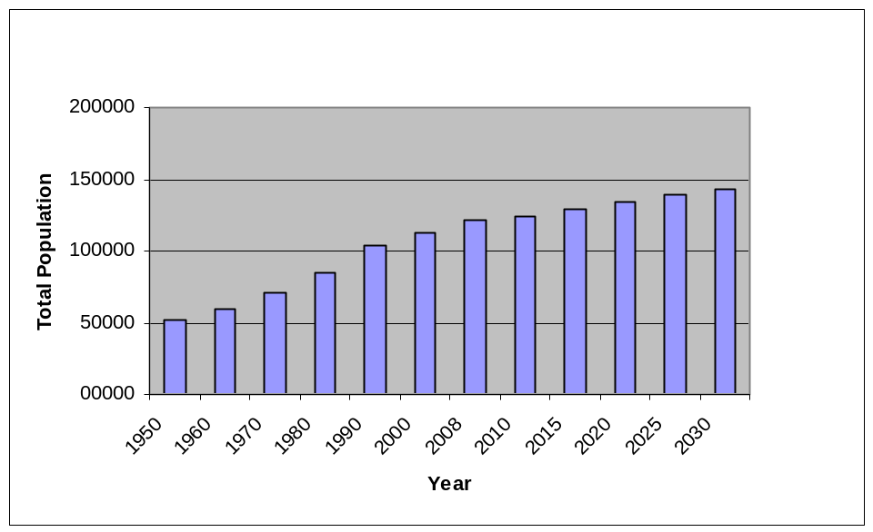

Strafford County gained 11,356 residents between 2000 and 2009. Since 1990 the County gained 19,356 residents. The County grew by 10.1 percent between 2000 and 2009 compared to 7.2 percent in the state as a whole.
Figures in Table 2 outline the changes in city and town population between 2000 and 2008, which are the most recent estimates of current population available. The State’s overall growth rate was 7.18 %. There are 14 municipalities with growth rates higher than the state. Most of these municipalities are classified as bedroom communities. Its largest municipality is Rochester with a population of 30,654 in 2008.

Table 3 shows that the State of NH has had a significantly larger percent change in population growth compared to the US from 1970 to 2000. The population growth slowed in Strafford County from 1990 to 2000 compared to the US. Changes in population 1990-2008 compare Strafford to US and NH projections

Table 4. Changes in Population from 1950-2008 in Strafford Co., Carroll Co., Rockingham Co., State, and US.
[Source: U.S. Census Data; NH Office of Energy and Planning]
Population Over Time | Strafford County NH | Carroll County | Rockingham County | NH | United States
1950 | 51567 | 5868 | 70059 | 533242 | 151,325,798
1960 | 59799 | 5829 | 99029 | 606921 | 179,323,175
1970 | 70431 | 8548 | 138951 | 737681 | 203302037
1980 | 85408 | 27931 | 190345 | 920610 | 226542250
1990 | 104233 | 35410 | 245845 | 1109252 | 248790925
2000 | 112233 | 43666 | 277359 | 1,235,786 | 281421906
2008 | 121914 | 47408 | 297350 | 1,324,575 | 307006550
1990 to 2000 % Change | 7.68 | 23.32 | 12.82 | 11.41 | 13.12
1980 to 2000 % Change | 31.41 | 56.34 | 45.71 | 34.24 | 24.22
1970 to 2000 %Change | 59.35 | 410.83 | 99.61 | 67.52 | 38.43

Age Cohorts

According to the US Census, and NH OEP Figure 2, the largest age group in the Strafford CEDS region is age 35 to 54, followed by the 20-34 year age and the 5-19 year age groups. Age patterns throughout the region were similar to New Hampshire and the US. Carroll County had a significantly higher year age group in the 65 year and over than the rest of the counties, state, and US. The median age for Strafford County was 36.1 years, which was lower than Rockingham with a median age of 41, and Carroll County with a median age of 44.3.

Figure 2. Population Estimates by Age Groups for Strafford County, Carroll County, Rockingham County, New Hampshire, and the United States.
[Source: US Census American Community Survey, and NH OEP]
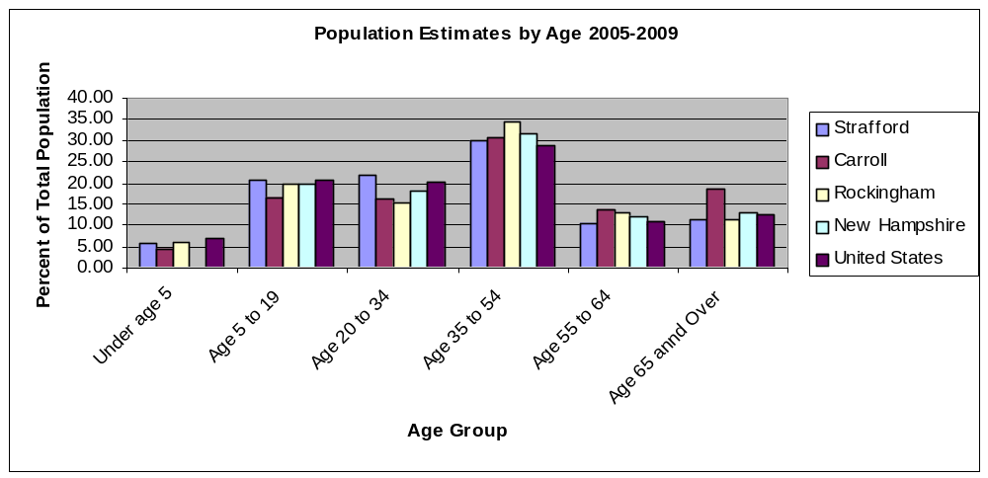

Race and Ethnicity

Table 5: Race and Ethnicity US, NH Strafford County Towns Source US Census
[Source: U.S. Census Bureau, 2005-2009 American Community Survey]
Race and Ethnicity
 | Total Population | White alone | Black or African American alone | American Indian and Alaska Native alone | Asian alone | Native Hawaiian and Other Pacific Islander alone | Some other race alone | Two or more races: | Two races including Some other race | Two races excluding Some other race, and three or more races
United States | 301,461,533 | 224,469,780 | 37,264,679 | 2,423,294 | 13,201,056 | 447,591 | 16,986,453 | 6,668,680 | 1,351,590 | 5,317,090
New Hampshire | 1,315,419 | 1,246,855 | 14,227 | 3,210 | 24,981 | 291 | 9,781 | 16,074 | 1,731 | 14,343
Carroll County | 47,591 | 46,586 | 174 | 211 | 233 | 0 | 46 | 341 | 17 | 324
Strafford County | 121,656 | 115,500 | 1,029 | 333 | 2,362 | 52 | 667 | 1,713 | 98 | 1,615
Rockingham | 296,680 | 284,230 | 2,067 | 292 | 4,981 | 33 | 1,640 | 3,437 | 459 | 2,978
Barrington | 8,389 | 8,217 | 60 | 14 | 54 | 0 | 0 | 44 | 0 | 44
Brookfield | 717 | 709 | 0 | 0 | 0 | 0 | 0 | 8 | 0 | 8
Dover | 28,595 | 26,533 | 483 | 33 | 998 | 34 | 136 | 378 | 33 | 345
Durham | 13,991 | 13,038 | 139 | 9 | 514 | 6 | 58 | 227 | 13 | 214
Farmington | 6,621 | 6,380 | 0 | 0 | 116 | 0 | 0 | 125 | 10 | 115
Lee | 4,446 | 4,348 | 0 | 0 | 88 | 0 | 0 | 10 | 0 | 10
Madbury | 1,857 | 1,574 | 0 | 5 | 214 | 0 | 5 | 59 | 0 | 59
Middleton | 1,630 | 1,597 | 7 | 4 | 0 | 0 | 0 | 22 | 1 | 21
Milton | 4,509 | 4,434 | 0 | 22 | 0 | 0 | 53 | 0 | 0 | 0
New Durham | 2,516 | 2,508 | 8 | 0 | 0 | 0 | 0 | 0 | 0 | 0
Rochester | 30,568 | 29,450 | 220 | 83 | 124 | 0 | 224 | 467 | 32 | 435
Rollinsford | 2,629 | 2,528 | 14 | 34 | 0 | 0 | 0 | 53 | 0 | 53
Somersworth | 11,876 | 10,920 | 98 | 129 | 254 | 12 | 184 | 279 | 9 | 270
Strafford | 4,029 | 3,973 | 0 | 0 | 0 | 0 | 7 | 49 | 0 | 49
Wakefield | 4,746 | 4,635 | 0 | 15 | 0 | 0 | 0 | 96 | 17 | 79
Note: This does not include Hispanic populations

Educational Attainment

Map 6: Strafford CEDS Region Educational Attainment
[Source: NH GRANIT, U.S. Census Bureau]
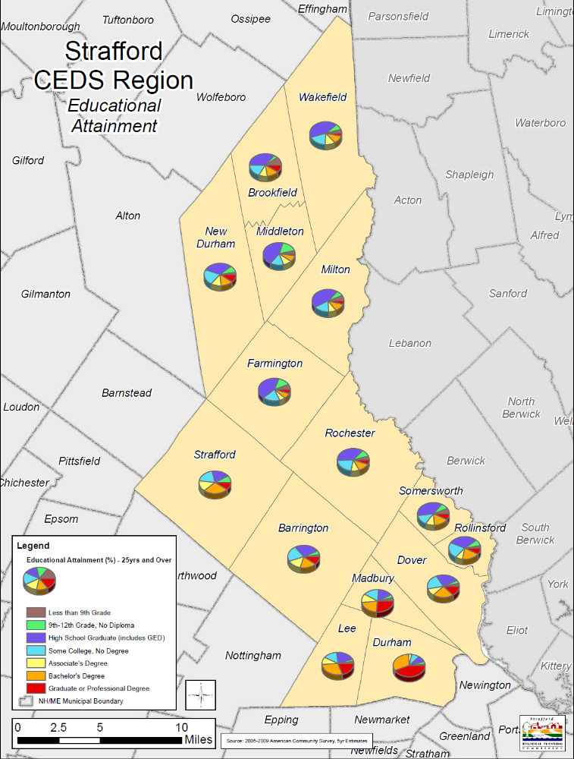

Table 6. Strafford CEDS Region Educational Attainment
[Source: 2005-2009 American Community Survey, 5-year Estimates]
Educational Attainment (%) - 25yrs and Over
Town | Less than 9th Grade | 9th-12th Grade, No Diploma | High School Graduate (includes GED) | Some College, No Degree | Associate's Degree | Bachelor's Degree | Graduate or Professional Degree
Barrington | 2.5 | 4.9 | 28.4 | 19.6 | 15.2 | 19.1 | 10.3
Brookfield | 10 | 4.4 | 35.7 | 16.2 | 10.8 | 13.7 | 9.1
Dover | 3.4 | 3.7 | 26.9 | 19 | 9.4 | 24.9 | 12.7
Durham | 1.5 | 2.9 | 8.2 | 9.2 | 3.9 | 30.1 | 44.2
Farmington | 6.1 | 13.2 | 41.9 | 20.5 | 6.7 | 7 | 4.5
Lee | 2.4 | 2.9 | 21.5 | 15.8 | 8.4 | 29.6 | 19.4
Madbury | 3.8 | 4 | 16.2 | 17.8 | 10.1 | 21.3 | 26.8
Middleton | 3.9 | 16.1 | 44.2 | 16.3 | 9.6 | 7.9 | 2
Milton | 6.3 | 7.1 | 44.7 | 17.6 | 9.5 | 10.8 | 4
New Durham | 2.5 | 9 | 33.1 | 19 | 12.7 | 14.3 | 9.5
Rochester | 4.4 | 9 | 37.3 | 21.6 | 10.2 | 12.1 | 5.4
Rollinsford | 2.9 | 7.7 | 33.2 | 19.5 | 8.6 | 20.7 | 7.4
Somersworth | 6.5 | 8 | 37.7 | 13.2 | 10.8 | 16.7 | 7.2
Strafford | 0 | 8.1 | 20.6 | 19.7 | 12.7 | 29.7 | 9.2
Wakefield | 4.5 | 7.3 | 43 | 19.4 | 12 | 10.7 | 3.1
Average | 4.0 | 7.2 | 31.5 | 17.6 | 10.0 | 17.9 | 11.7
Note: Population 25 years and over

Wages and Income

Table 7. Median Family Income
[Source: U.S. Census Bureau 2005-2009 5-year Estimates]
Strafford CEDS Region
Community | Med. Family Income
Barrington | $77,740
Brookfield | $69,625
Dover | $77,542
Durham | $114,757
Farmington | $62,992
Lee | $86,832
Madbury | $97,500
Middleton | $58,125
Milton | $59,750
New Durham | $80,938
Rochester | $60,097
Rollinsford | $70,338
Somersworth | $64,248
Strafford | $66,858
Wakefield | $62,109
Average | $73,963.40

Table 8. Average Weekly Wage CEDS Towns
[Source: NHELMIB]
Average Weekly Wage Strafford CEDS Region - 2009
Community | Avg. Weekly Wage
Barrington | $744.65
Brookfield | $976.15
Dover | $927.27
Durham | $1,009.57
Farmington | $705.85
Lee | $495.31
Madbury | $727.33
Middleton | $741.01
Milton | $649.56
New Durham | $537.64
Rochester | $686.00
Rollinsford | $650.06
Somersworth | $740.80
Strafford | $606.34
Wakefield | $558.78
Average | $717.09
State Wide | $864.05

Table 9. Families Below Poverty U.S., NH, Carroll, Rockingham, Strafford County
[Source: Stats America]
 | Median Household Income 2008 | Per Capita Personal Income 2008 | Below Poverty 2008
United States | $52,175 | $40,166 | 13%
NH | $63,235 | $43,423 | 7.80%
Carroll | $51,064 | $41,040 | 9.20%
Rockingham | $75,425 | $49,250 | 4.60%
Strafford | $60,230 | $35,477 | 10.70%

Housing Affordability

Regional Housing Needs Assessment for Strafford Regional Planning Commission

The Strafford Regional Planning Commission state designated area consists of all thirteen municipalities in Strafford County and two municipalities in Carroll County – all of which are included in the Strafford Region CEDS. Additionally there are three municipalities in the region, which are located in Rockingham County and are thereby included in the Rockingham CEDS. However, for the purposes of regional planning, all eighteen municipalities are included in transportation and housing planning documents developed by Strafford Regional Planning Commission.

New Hampshire regional planning commissions may use the framework of the State Comprehensive Development Plan as the basis for regional master plans, which must be updated at least every five years More specific to housing, under New Hampshire Revised Statutes Annotated (RSA) 36:47, II the regional planning commissions are required to compile a regional housing needs assessment that shall be updated every five years and provided to municipalities to assist in complying with RSA 674:2,III, regarding housing section of master plan.

Bruce Mayberry, BCM Planning LLC of New Gloucester, Maine completed the 2009 Strafford Regional Housing Needs Assessment update. This included all eighteen municipalities within the regional planning commission area.

Excerpts from the 2009 Strafford Regional Housing Needs Assessment in italics.

Purpose
The purpose of the regional housing needs assessment is to evaluate supply, demand, cost and affordability of housing within the Strafford Regional Planning Commission boundaries and to project the regional need for housing for all age and income levels. When preparing the housing section of a local master plan, a municipality should indicate how it plans to address the regional needs identified in this assessment.

Historical Perspective
Figure 3. Illustrates the history of private sector covered employment growth in the Strafford Regional Planning Commission area from 1995 to 2007. The relationship between employment within the area and total housing units is illustrated in Figure 4.

Given the transition away from a manufacturing economy and toward a service-providing job base, goods-producing employment showed no net job growth between 1995-2007 and has declined as a share of total employment. The area has relied on service-providing jobs as the source of net job growth. Many sectors of the service-providing job sectors generally have lower wages than traditional manufacturing employment. The number of new jobs in service-providing employment may not support the same level of housing expenditures once associated with a job growth profile that included higher-paying manufacturing employment.

Figure 3. Private Sector Employment Area
[Source: 2009 Strafford Regional Housing Needs Assessment]
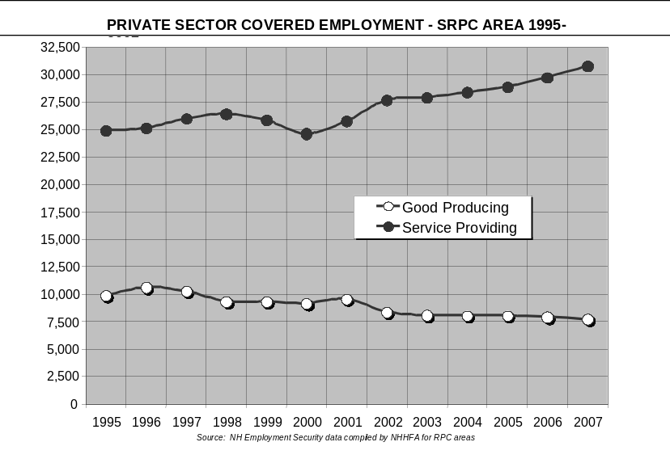

Figure 4. Employment and Housing Units
[Source: 2009 Strafford Regional Housing Needs Assessment]
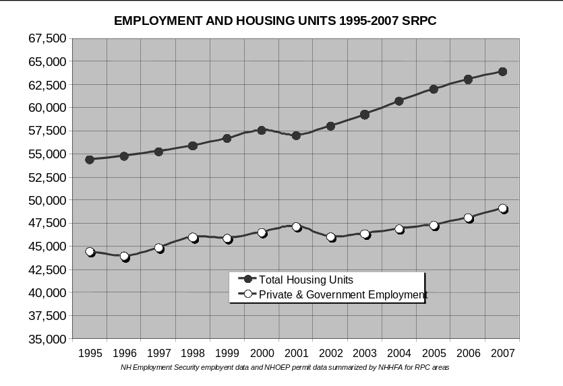

While there is a general relationship between area job growth and the number of housing units required to support employment, the resident labor force within the region works partly within and partly outside the region area. Thus, the Strafford Regional Planning housing demand is in part dependent on employment generated across a much broader regional economy. In 1990, approximately 42% of working residents of the region commuted to locations outside of the area, and by the year 2000, the ratio was 44%. Based on the American Community Survey (ACS) data for Strafford County, and its proportionate relationship to the SRPC, this ratio may have increased to about 48% as of 2007.

The general trend in Strafford Regional Planning Commission housing production since 1990 is illustrated in Figure 5.

Figure 5. Housing Units Authorized by Permit
[Source: 2009 Strafford Regional Housing Needs Assessment]
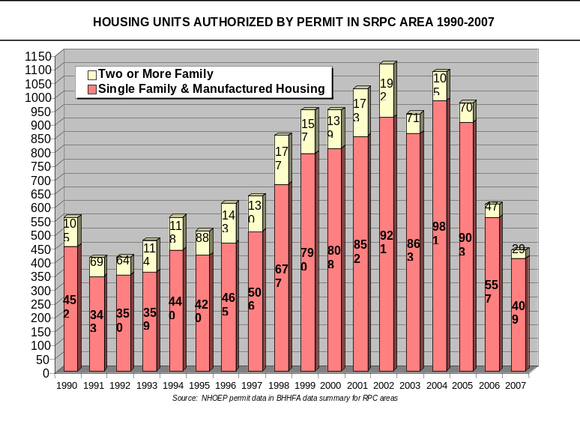

Figure 6. Illustrates the proportionate distribution of housing production within the SRCP region by single-family permits, units in 2 or more family structures, and manufactured housing as a percent of total units authorized by building permits.

Figure 6. Housing Production by Period by Structure Type
[Source: 2009 Strafford Regional Housing Needs Assessment]
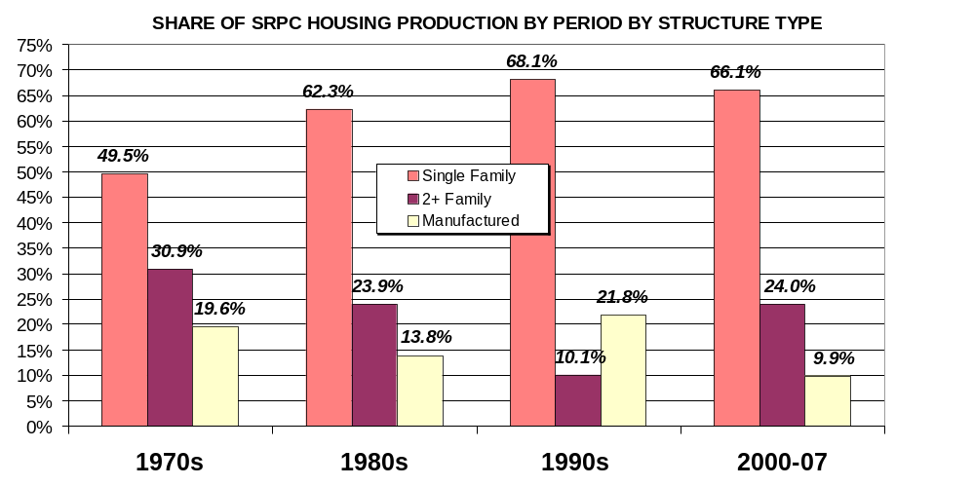

Analysis of Sub-Regional Housing Characteristics

For the purpose of analyzing housing production and housing cost at the sub-regional level, the municipalities of the SRPC were evaluated in three groupings: urban, suburban and rural. The urban group includes Dover, Rochester, Somersworth and Newmarket. These municipalities are the higher-density communities within the region and are the principal centers of private sector employment and commercial-industrial property valuation.

The suburban grouping of Barrington, Durham, Farmington, Lee, Northwood and Rollinsford include medium density communities located along the major transportation corridors, which appear to represent secondary locations of private sector employment and are which may support smaller centers of commercial development and job growth that are outside the urban centers.

The rural grouping of Brookfield, Madbury, Middleton, Milton, New Durham, Nottingham, Strafford, and Wakefield comprises the lowest density, predominantly single-family communities that contain only minor shares of the region’s jobs, commercial development, or multifamily housing.

Map 7: Strafford Regional Housing Needs Assessment
[Source: NH GRANIT, NHDES]
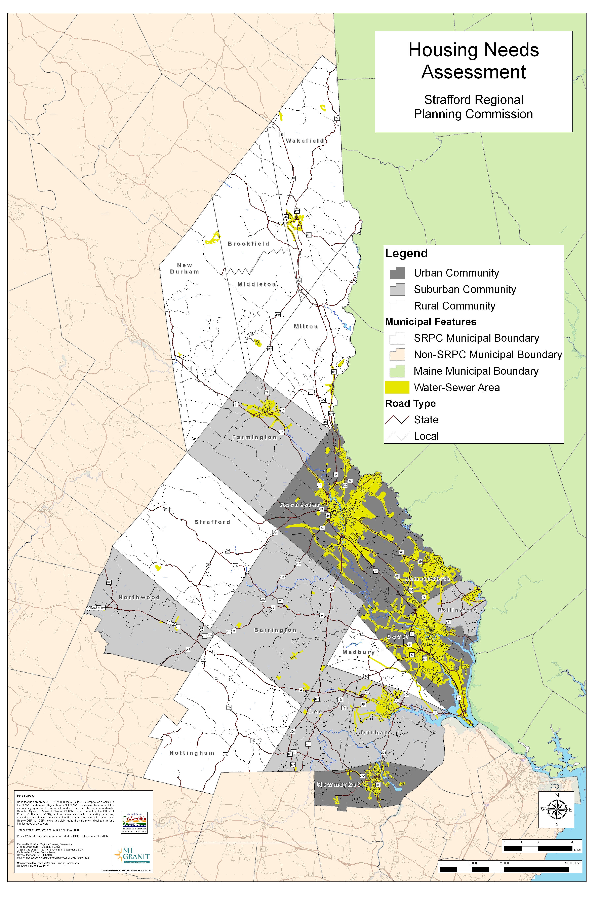
The purpose of this general grouping is to allow an analysis of the role of these sub-areas in accommodating the past housing growth of the region, and the relative affordability and gaps in the housing supply within the SRPC area.

Tables 10 and 11 contain comparisons of the summary characteristics of the three groupings of municipalities with respect to the number and share of the region’s employment, housing units, households, property valuation and other factors.

Table 10. Comparison of Sub-Area Population and Housing
[Source: 2009 Strafford Regional Housing Needs Assessment]
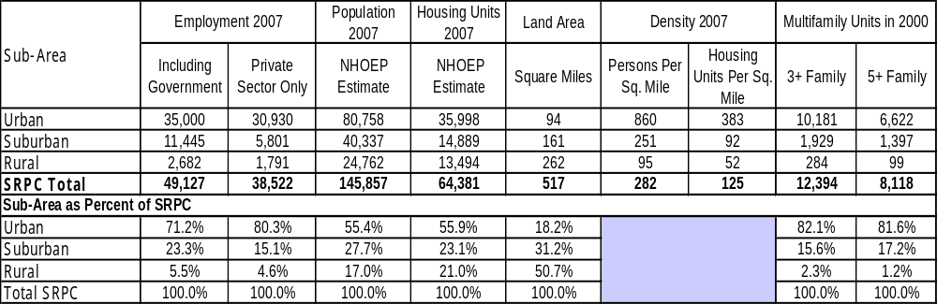

Table 11. Distribution of Employment, Property Value and Housing Share
[Source: 2009 Strafford Regional Housing Needs Assessment]
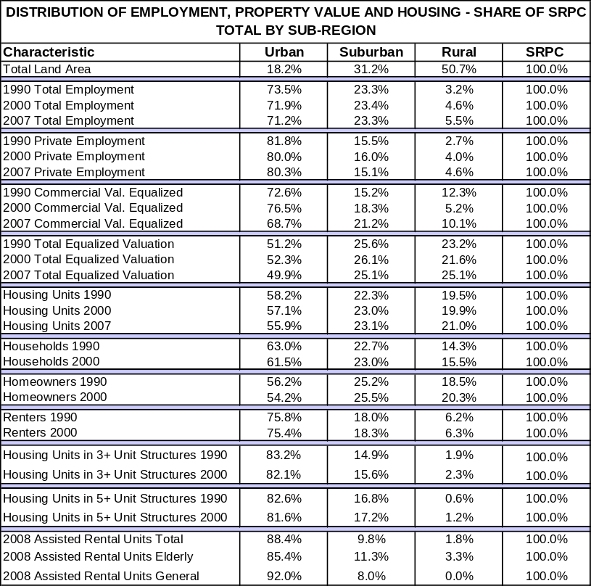

Executive Summary

Housing Production. Based on the use of several projection models to 2015, a range of potential housing development needs were developed. The average projection indicates that about 1,000 housing units per year should be created within the region, including about 250 rental units per year. Roughly half of the growth in rental units is needed for elderly households and half for unrestricted occupancy. To maintain an affordable housing supply, about half of the new ownership units should be priced at or below the cost affordable at 100% of Area Median Family Income (AMFI). In the rental inventory, about 75% of the units should be affordable to households at or below 80% of AMFI. Within this group, the lowest income households earning less than 40% of AMFI are likely to require rent subsidy which is difficult to secure for new development.

Home Price Distribution. The median home sales prices in the SRPC area in 2008 were: $267,000 for a new home; $230,000 for all home sales; $220,000 for existing homes; and $180,000 for condominiums. The median priced home is generally affordable to those earning at least 100% of the AMFI, but attaining this household income level generally requires more than one full time worker per household. Using area income schedules for 2009 published by the U. S. Department of Housing and Urban Development (HUD), it is estimated that about 45% of new units sold; 67% of existing home sales; and about 90% of condominiums sold at a price affordable under New Hampshire workforce housing definitions. The urban and rural portions of the SRPC region have the most affordable price distributions, while the suburban communities have the highest median prices and least affordable distribution.

Rental Cost Distribution. In 2009 the median rent in non-subsidized rental units in the SRPC area was $936 per month. Under the NH workforce housing definition for affordable rental units, the maximum affordable rent is $1,080 per month. At that cost level an income of $43,200 per year would be required. It is estimated that only about 37% of renters in the SRPC area could afford that gross rent. Except within in the four urban communities of Dover, Rochester, Somersworth and Newmarket, the unsubsidized rental supply offers virtually no units affordable at or below the “workforce” standard.

The HUD income standards that apply within the SRPC boundaries reflect statistical data that is representative of a larger geographic region in which incomes are higher than those specific to the SRPC area. This broader regional income benchmark generates “workforce” rent and home price thresholds for affordable housing that may be skewed above the levels typically supportable by actual incomes within the SRPC area.

Housing Cost Burden. When a high housing cost burden is defined by the expenditure of 30% or more of gross income on housing costs, the need gap in affordability within the SRPC area is estimated to total about 22,100 households (12,900 homeowners and 9,200 renters). This high cost burden as of 2007 is estimated to affect about 1/3 of all homeowners, nearly ½ of all renters, and 38% of all SRPC area households. (These estimates based on using 2007 American Community Survey cost/income distributions for Strafford County to the SRPC area). A somewhat smaller need gap would be defined if the 2000 Census cost burden data by income and tenure were applied to the regional estimate of total households.

Area Wages and Housing Cost. A comparison of wages paid in various industrial sectors for jobs located within the SRPC area indicates about half of the employment within the SRPC is in industries supporting annual worker earnings sufficient to afford the median cost apartment. When more than one worker per household is employed full time, that household should be capable of affording the median rent of a 2-bedroom apartment if the individuals are working in all but the lowest paying industrial sectors (comprising less than 10% of the employment of the region).

A household with one working person, employed within the SRPC region at the average wage paid in nearly all industries cannot afford the median price of any form of ownership. At least half of the jobs in the region are in industries that have wages high enough to support the purchase of a median priced condominium, provided that at least 1.5 persons in the households work. When two people per household are working at average wages, up to 60% of the employment in the SRPC area is in an industrial sectors with adequate wages to support the median priced home.

Within the SRPC area, the price of housing relative to income seems fairly well balanced with area wages, provided that the household has more than one full time worker contributing to income. Households with a single worker only will have difficulty affording either rent or ownership at the average wages generated in most industrial sectors in the SRPC region.

Future Production Roles: Urban, Suburban, and Rural. The urban communities of the SRPC contain over 90% of its assisted rental housing as well as a mix of affordable ownership opportunities. They are supported by local public housing authorities, and have the infrastructure to support higher-density development. These are likely to remain the centers for affordable rental housing production, while the suburban and rural towns are likely to absorb increased shares of single-family development.

The suburban communities have the highest median home prices within the SRPC area. They lack diversified rental opportunities, and median rents are far higher in the suburbs than in the urban centers. These towns should seek to diversify into more multifamily forms of housing and to increase their supply of rental units, particularly if they are supporting increased commercial development. Inclusionary housing ordinances may allow these towns to leverage some affordable single-family homes as well as an expansion of their rental inventory in smaller multifamily developments.

The median priced home in the rural communities is lower than that of the urban or suburban portions of the SRPC area. The rural outlying towns are absorbing increasing shares of new single family development, while the urban centers are supporting a lower percentage of the area’s single family homes than they have in the past. The rural communities are unlikely centers for the expansion of rental housing due to distance from major job centers and convenience services. However accessory units and two unit structures will allow for some modest expansion of rental opportunity. The rural towns may also contribute to the affordable housing inventory through manufactured housing. The rural communities may also be able to support inclusionary workforce ownership more easily than the suburbs due to their lower price profile in the marketplace.

Local Accommodation of Regional Needs. The concept of “fair share” was explored in two ways. First, fair share allocation options are reviewed as an assigned numerical share of various “housing need” definitions. Second, the fair share concept was reviewed as a principle centering on the removal of unnecessary regulatory barriers to workforce housing development at the local level. The latter is a preferred interpretation that is consistent with New Hampshire RSA 674:58 to 61 relative to workforce housing.

On a sub-regional basis, the suburban communities within the SRPC should be hosting more multifamily housing production. The cost data show rental housing costs to be very high in the suburbs and supply development very limited relative to employment growth and other measures. Rural communities will be better able to accommodate ownership workforce housing because prices in the rural towns tend to be lower than in the suburban towns that are closer to job centers.
Municipalities are advised to address their existing and future contributions to the region’s affordable housing supply, including workforce-housing opportunities, within the housing element of their local master plans. To comply with RSA 674:58 to 61 these opportunities must include multifamily structures (including opportunities to construct buildings with at least five units); overall, workforce housing of some type must be allowed within a majority of the residentially zoned land in the community. The statute does not mandate actual production of any particular quantity or share of the region’s workforce units.

Each municipality within the SRPC area should perform an internal review of their land development regulations, particularly those affecting residential density, units per structure, road maximum structures per lot, and road frontage per unit. The provisions should be evaluated to determine whether they exceed what is necessary to protect public health and safety, and the community should consider whether reduced or more flexible standards might be substituted generally or applied conditionally where affordable workforce housing is developed.

Nationally, it is estimated that the combined cost of raw land acquisition and lot development (exclusive of home construction) comprises only about 25% of the end-selling price of a new single family home. Since the early 1970s the average size of a new single family home in the United States has increased by about 1,000 square feet. Therefore local development regulations are not the only determinative factor of housing price. Cost to the consumer will also be influenced significantly by discretionary decisions by the developer regarding home size, amenities and the quality and extent of various features and options. Efforts by both the developer and municipalities are needed to enable a variety of workforce housing options throughout the SRPC region.

Table 12: Maximum Housing Costs Based on SRPC Area Wages by Industry
[Source: 2009 Strafford Regional Housing Needs Assessment]
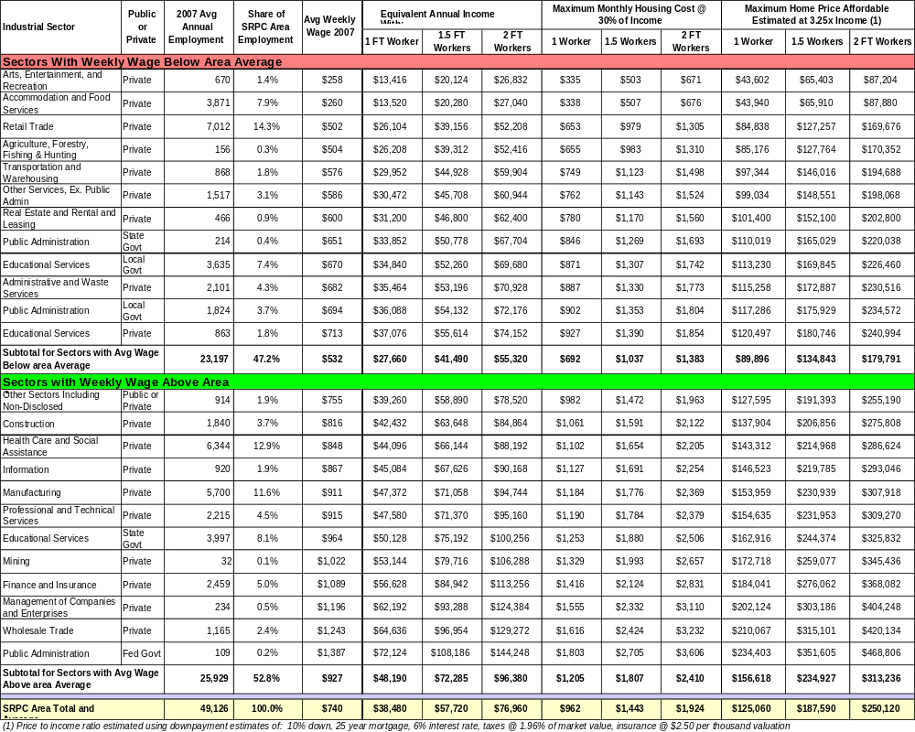

Table 13. Historic Housing Production by Sub-Area
[Source: 2009 Strafford Regional Housing Needs Assessment]
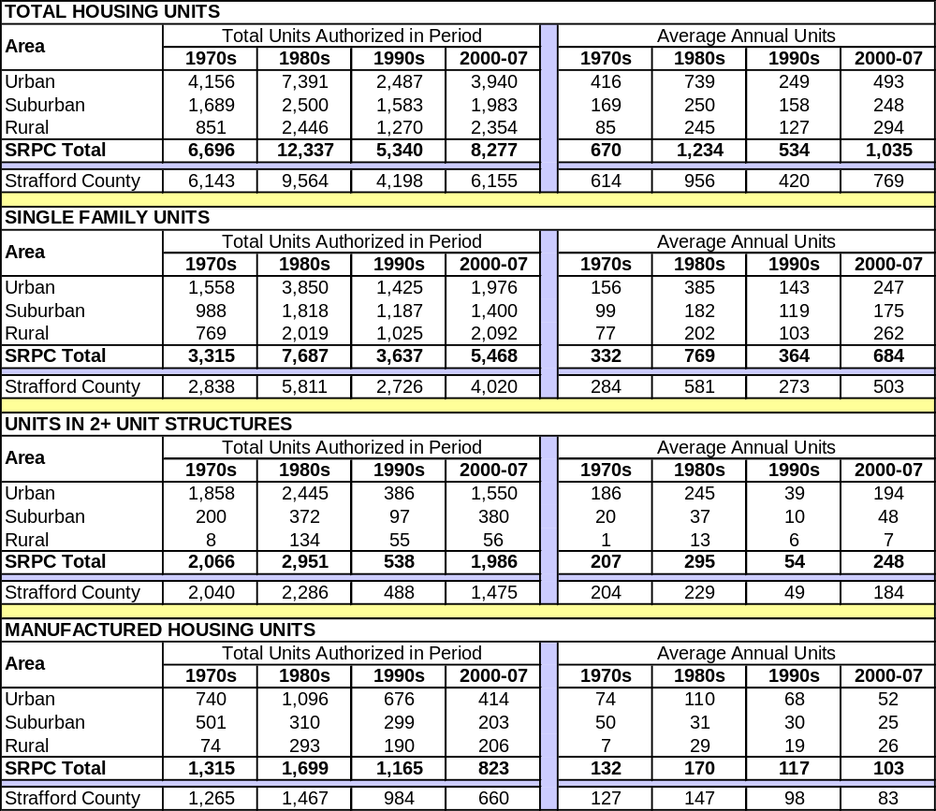

Table 14. Employment, Labor Force, Commuting Time
[Source: 2009 Strafford Regional Housing Needs Assessment]
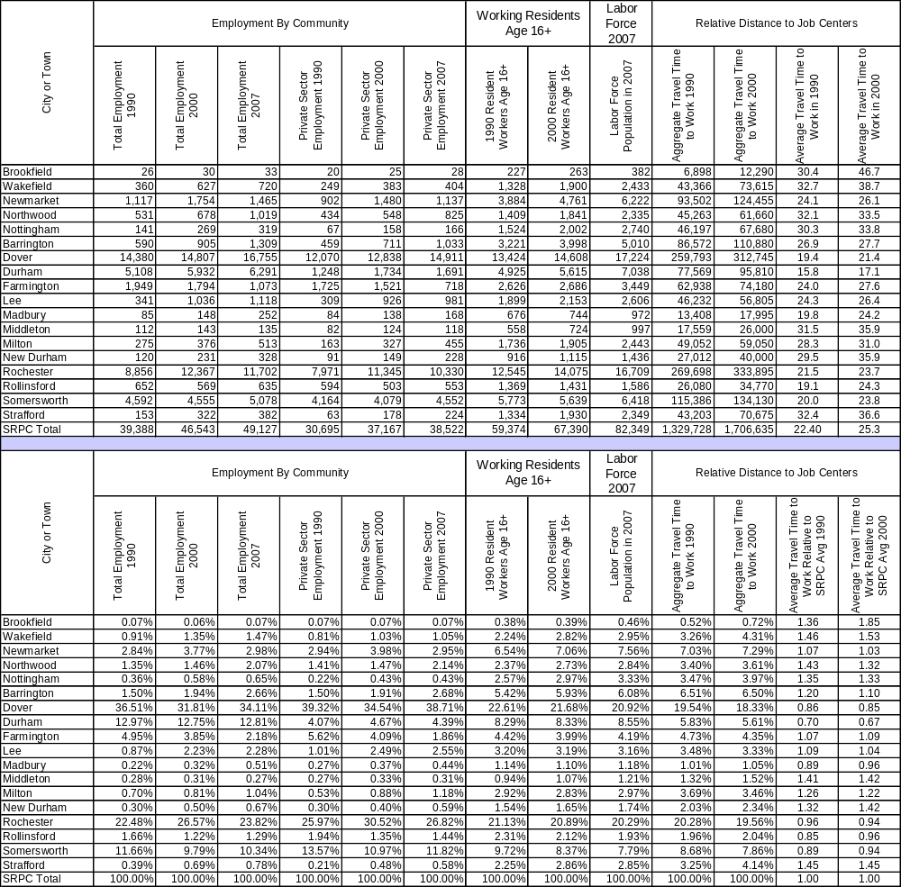

Table 15. Population Density
[Source: 2009 Strafford Regional Housing Needs Assessment]
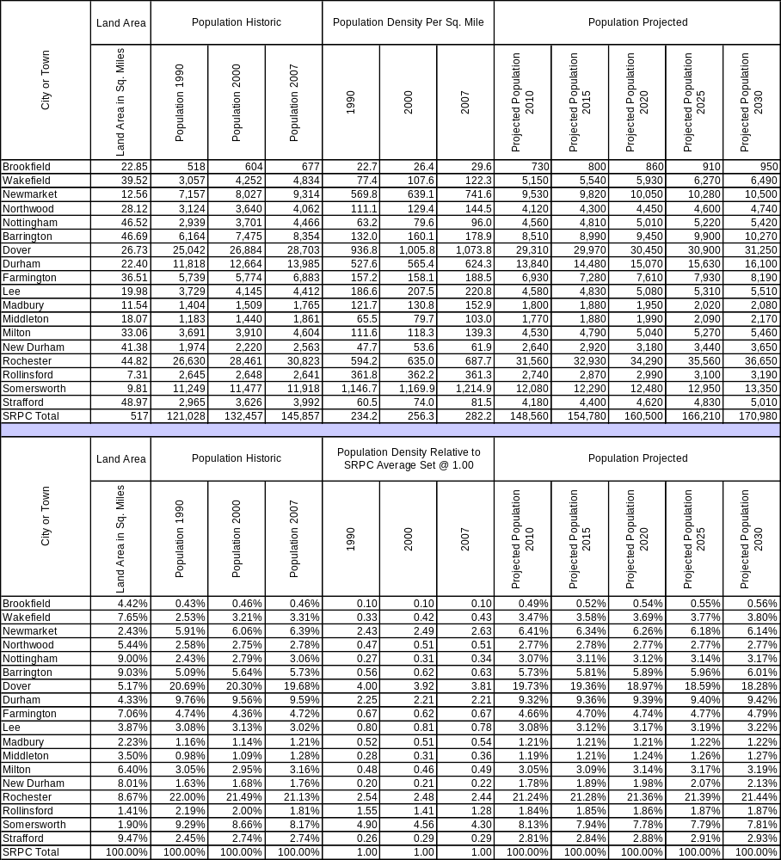

Table 16. Housing Supply (Total Units) and Units by Structure Type
[Source: 2009 Strafford Regional Housing Needs Assessment]
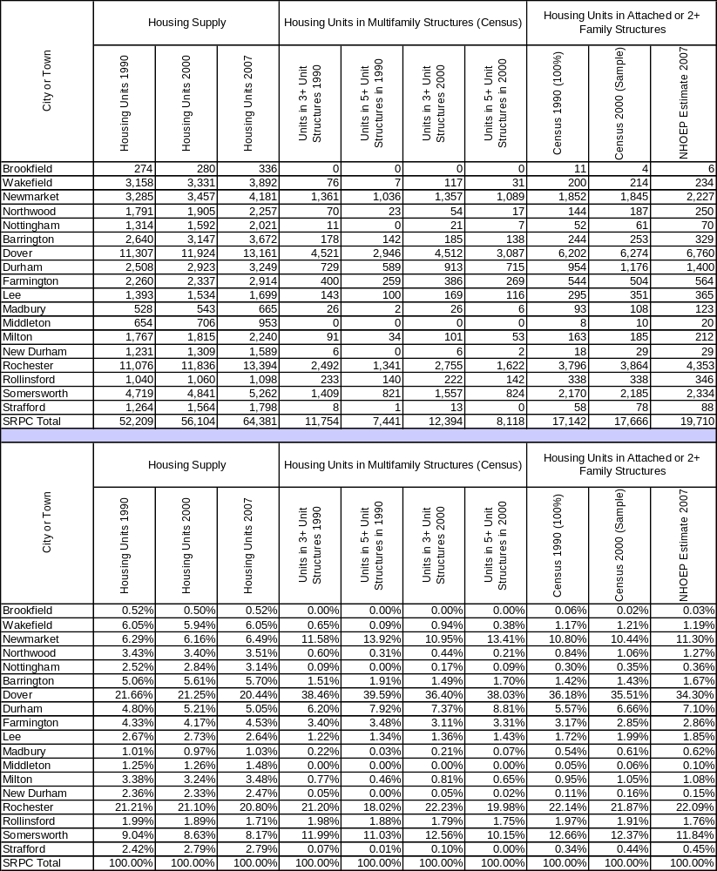

Table 17. Households by Tenure and Age of Head Household
[Source: 2009 Strafford Regional Housing Needs Assessment]
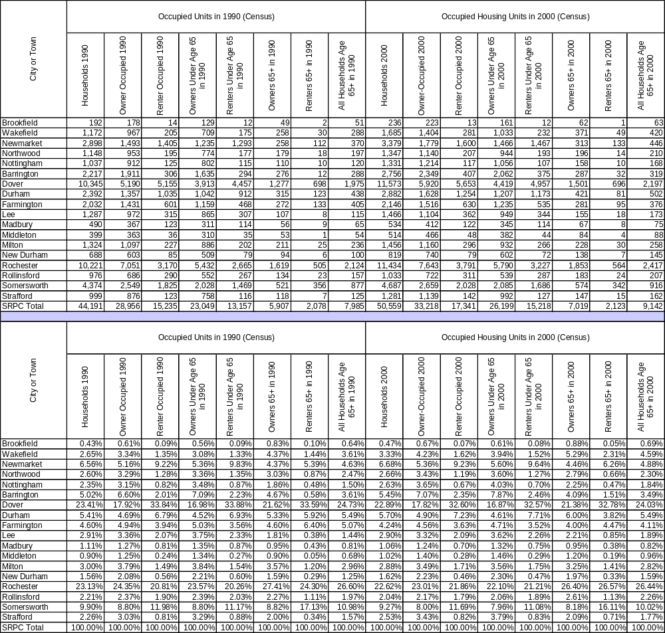

Table 18. Equalized Property Valuation
[Source: 2009 Strafford Regional Housing Needs Assessment]
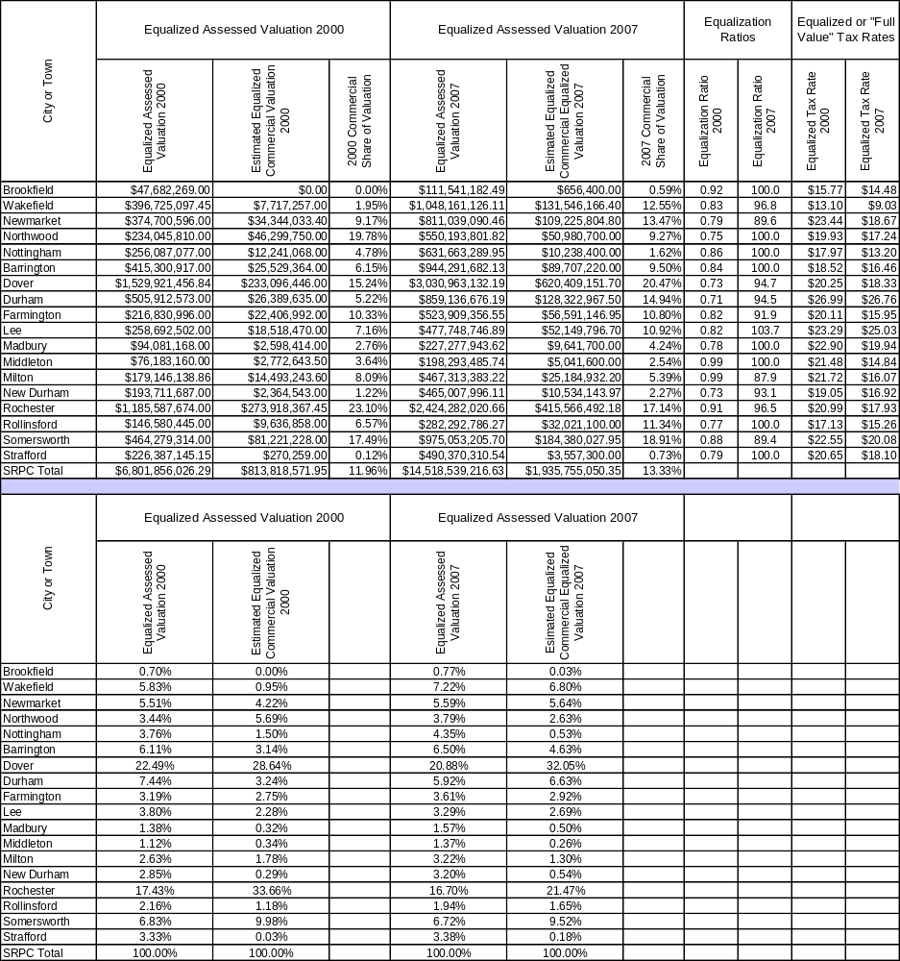

Table 19. Renter Households by Cost Burden 2000 & 2008 Assisted Housing Supply
[Source: 2009 Strafford Regional Housing Needs Assessment]
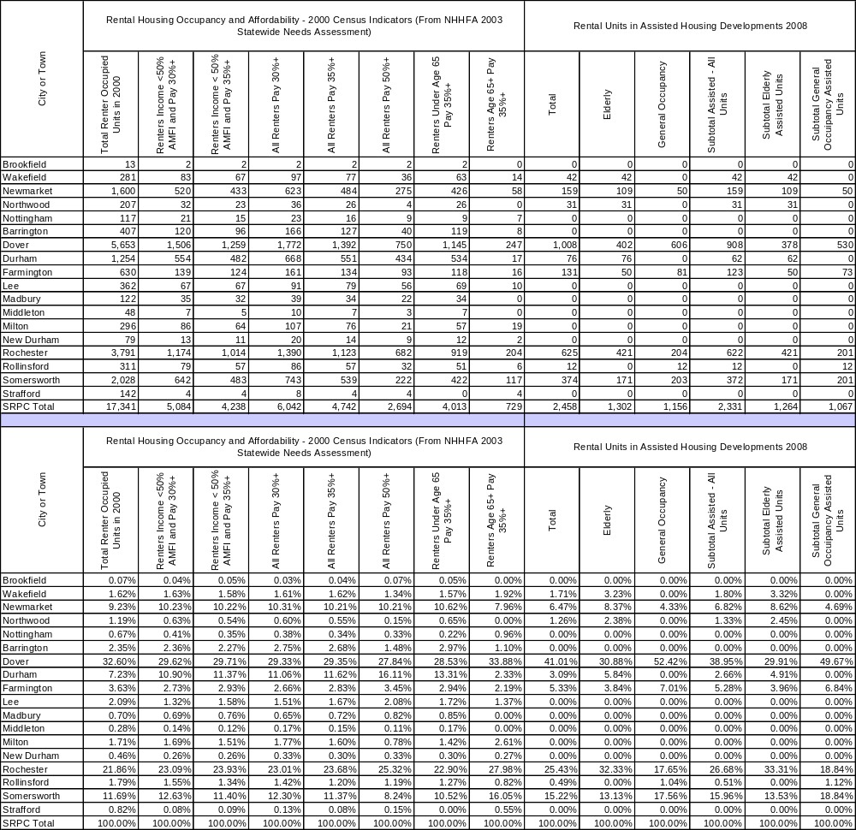

Chapter 4: Regional Economy

Description of Regional and State Economy

The health of Strafford County economy relies greatly on the condition of other counties abutting the area, and New Hampshire’s, and New England’s economies, which are linked to the national and global economies. Today the region’s economy is more than business or industries located in individual communities: most workers commute to other communities. The economy in the Strafford CEDS region is closely tied to: Rockingham County, northern Massachusetts (Essex, County), and southwestern Maine (York County). Many residents in Strafford region commute to Pease International Tradeport, Portsmouth Naval Shipyard, and as far as Metro and Downtown Boston. The region’s business and industries are diverse including: high tech manufacturing, financial services, educational services and institutions, medical or health care and service industry.

Strafford County, like New Hampshire, and all other states and the nation as whole has been affected by the current recession. The leading indicators include average weekly hours of production workers in manufacturing trended downward after December 2007. Claims for unemployment compensation rose from December 2008 to January 2009.

According to the Vital Signs 2010, which is produced by the New Hampshire Employment Security and labor Market Information Bureau, the state weathered the recession until September 2009 when unemployment rates hit 7.2 percent. New Hampshire’s employment losses from 2007 to 2008 were minor with a loss of only 300 non-farm private employment jobs. In January of 2009 there was a loss of 14,510 non-farm jobs for the State of New Hampshire. In December 2010 New Hampshire’s unemployment rate was 5.5% compared to the United States unemployment of 9.4% (NHELMB).

Strafford County has a diverse mix of public and private organizations that are involved in promoting economic and community development throughout this region. There are a wide variety of groups that provide or promote economic or community development services to select populations. Various types of public financial assistance are resources that exist for businesses, individuals, and entrepreneurs to help the private sector. Goods producing industries lost 8,200 jobs from 2005-2009. In 2009 there was a loss of 10,920 jobs within the first ten months. The often times low wages service industry showed an increase from 2005 to 2008 of 17,608 jobs. The construction industry fall began in 2007 to 2008 with a loss of 3600 jobs The Regional economy focuses on specific components required for the Strafford CEDS region that are necessary for a local CEDS planning process.

Employment by Industry
In Table 20. Average Annual Employment, the industries that had the largest percent change from 2005 to 2009 included Finance and Insurance (73.52%), Educational Services (26.07%), and Health Care and Social Assistance (13.5%). The Manufacturing industry lost the greatest number of employees (906) followed by Construction (586) lost between 2005-2009 as shown in Table 20.

In Table 21. Largest Employment Growth by Sector, Food and Drinking Places are the largest employment sector at 3,572, followed by Ambulatory Health Care Services at 2,446, and Hospitals with 2,187 employees. In Table 23, Government Employment Sectors, State Government had 452 fewer jobs from 2005-2009 while Local Government increased 350. Average annual employment in New Hampshire Total Private Industries decreased 18,515 employees as seen in Table 25. In the State Construction and Manufacturing lost a combined total of 18,823 which had the highest employees lost in the CEDS region.

Table 20. Average Annual Employment
[Source: NH Economic and Labor Information Bureau, SRPC]
Strafford Regional CEDS
NAICS | Industry | 2005 |  | 2009 |  | Change
NAICS | Industry | Employees | % of Total | Employees | % of Total | Employees | % Change
 | Total Private Industries | 36,869 |  | 37,079 |  | 565 | 0.57%
11 | Agriculture, Forestry, Fishing and Hunting | 186 | 0.50% | 144 | 0.39% | -42 | -22.58%
21 | Mining | 36 | 0.10% | 24 | 0.06% | -12 | -33.33%
23 | Construction | 2,018 | 5.47% | 1,432 | 3.86% | -586 | -29.04%
31-33 | Manufacturing | 5,828 | 15.81% | 4,922 | 13.27% | -906 | -15.55%
22 | Utilities | n |  | n
42 | Wholesale Trade | 1,407 | 3.82% | 1,025 | 2.76% | -382 | -27.15%
44-45 | Retail Trade | 6,845 | 18.57% | 6,873 | 18.54% | 28 | 0.41%
48-49 | Transportation and Warehousing | 860 | 2.33% | 802 | 2.16% | -58 | -6.74%
51 | Information | 1,100 | 2.98% | 1,017 | 2.74% | -83 | -7.55%
52 | Finance and Insurance | 2,039 | 5.53% | 3,538 | 9.54% | 1,499 | 73.52%
53 | Real Estate and Rental and Leasing | 496 | 1.35% | 428 | 1.15% | -68 | -13.71%
54 | Professional and Technical Services | 1,490 | 4.04% | 1,578 | 4.26% | 88 | 5.91%
55 | Management of Companies and Enterprises | 355 | 0.96% | n
56 | Administrative and Waste Services | 1,781 | 4.83% | 1,935 | 5.22% | 154 | 8.65%
61 | Educational Services | 675 | 1.83% | 851 | 2.30% | 176 | 26.07%
62 | Health Care and Social Assistance | 5,794 | 15.72% | 6,576 | 17.74% | 782 | 13.50%
71 | Arts, Entertainment, and Recreation | 666 | 1.81% | 571 | 1.54% | -95 | -14.26%
72 | Accommodation and Food Services | 3,797 | 10.30% | 3,853 | 10.39% | 56 | 1.47%
81 | Other Services Except Public Administration | 1,496 | 4.06% | 1,510 | 4.07% | 14 | 0.94%
Note: n = data not fully disclosed

Table 21. Largest Employment Growth by Sector
[Source: NH Economic and Labor Market Information Bureau, SRPC]
Strafford Regional CEDS
NAICS | Industry | Employment |  | Change from 2005 to 2009
NAICS | Industry | 2005 | 2009 | Employees | % Change
21 | Mining | 24 | 36 | 12 | 50.00%
23 | Construction | 1,432 | 2,018 | 586 | 40.92%
42 | Wholesale Trade | 1,025 | 1,407 | 382 | 37.27%
111 | Crop Production | 110 | 157 | 47 | 42.73%
212 | Mining (except Oil and Gas) | 24 | 36 | 12 | 50.00%
236 | Construction of Buildings | 274 | 536 | 262 | 95.62%
321 | Wood Product Manufacturing | 42 | 75 | 33 | 78.57%
326 | Plastics and Rubber Products Manufacturing | 590 | 787 | 197 | 33.39%
327 | Nonmetallic Mineral Product Manufacturing | 71 | 135 | 64 | 90.14%
332 | Fabricated Metal Product Manufacturing | 579 | 829 | 250 | 43.18%
333 | Machinery Manufacturing | 1,093 | 1,436 | 343 | 31.38%
336 | Transportation Equipment Manufacturing | 271 | 500 | 229 | 84.50%
423 | Merchant Wholesalers, Durable Goods | 402 | 711 | 309 | 76.87%
425 | Electronic Markets and Agents and Brokers | 210 | 309 | 99 | 47.14%
442 | Furniture and Home Furnishings Stores | 110 | 145 | 35 | 31.82%
484 | Truck Transportation | 145 | 210 | 65 | 44.83%
518 | Data Processing and Related Services | 12 | 57 | 45 | 375.00%
5414 | Specialized design services | 6 | 8 | 2 | 33.33%
5417 | Scientific research and development services | 15 | 31 | 16 | 106.67%
5616 | Investigation and security services | 28 | 56 | 28 | 100.00%

Table 22. Top 20 Employment Sectors
[Source: NH Economic and Labor Market Information Bureau, SRPC]
Strafford Regional CEDS
NAICS | Industry | Employees | Rank
238 | Specialty Trade Contractors | 1,021 | 10
326 | Plastics and Rubber Products Manufacturing | 590 | 18
332 | Fabricated Metal Product Manufacturing | 579 | 19
333 | Machinery Manufacturing | 1,093 | 8
334 | Computer and Electronic Product Manufacturing | 717 | 15
339 | Miscellaneous Manufacturing | 685 | 16
441 | Motor Vehicle and Parts Dealers | 829 | 13
444 | Building Material and Garden Supply Stores | 727 | 14
445 | Food and Beverage Stores | 2,018 | 4
452 | General Merchandise Stores | 1,096 | 7
541 | Professional and Technical Services | 1,578 | 6
561 | Administrative and Support Services | 1,740 | 5
611 | Educational Services | 851 | 12
621 | Ambulatory Health Care Services | 2,446 | 2
622 | Hospitals | 2,187 | 3
623 | Nursing and Residential Care Facilities | 1,045 | 9
624 | Social Assistance | 898 | 11
722 | Food Services and Drinking Places | 3,572 | 1
811 | Repair and Maintenance | 560 | 20
812 | Personal and Laundry Services | 591 | 17

Table 23. Government Employment
[Source: NH Economic and Labor Market Information Bureau, SRPC]
Strafford Regional CEDS
 | 2005 |  | 2009 |  | Change
 | Employees | % Total | Employees | % Total | Employees | % Change
Total, Private plus Government | 47,353 | 100.00% | 47,651 | 100.00% | 298 | 0.63%
Total Private | 36,956 | 78.04% | 37,352 | 78.39% | 396 | 1.07%
Total Government | 10,397 | 21.96% | 10,299 | 21.61% | -98 | -0.94%
Federal Government | 359 | 0.76% | 364 | 0.76% | 5 | 1.39%
State Government | 4,428 | 9.35% | 3,976 | 8.34% | -452 | -10.21%
Local Government | 5,610 | 11.85% | 5,960 | 12.51% | 350 | 6.24%

Table 24: Average Annual Employment: Carroll, Rockingham, & Strafford Counties
[Source: NH Economic and Labor Market Information Bureau, SRPC]
Carroll, Rockingham and Strafford Counties
NAICS | Industry | 2005 |  | 2009 |  | Change
NAICS | Industry | Employees | % of Total | Employees | % of Total | Employees | % Change
 | Total Private Industries | 175,855 |  | 167,766 |  | -8,089 | -4.60%
11 | Agriculture, Forestry, Fishing and Hunting* | 505 | 0.29% | 370 | 0.22% | -135 | -26.73%
21 | Mining* | 127 | 0.07% | 126 | 0.08% | -1 | -0.79%
23 | Construction | 10,377 | 5.90% | 7,769 | 4.63% | -2,608 | -25.13%
31-33 | Manufacturing | 20,796 | 11.83% | 19,502 | 11.62% | -1,294 | -6.22%
22 | Utilities* | 1,147 | 0.65% | 1,190 | 0.71% | 43 | 3.75%
42 | Wholesale Trade | 8,199 | 4.66% | 7,462 | 4.45% | -737 | -8.99%
44-45 | Retail Trade | 36,317 | 20.65% | 34,412 | 20.51% | -1,905 | -5.25%
48-49 | Transportation and Warehousing | 5,173 | 2.94% | 4,877 | 2.91% | -296 | -5.72%
51 | Information | 4,103 | 2.33% | 3,940 | 2.35% | -163 | -3.97%
52 | Finance and Insurance | 8,219 | 4.67% | 8,939 | 5.33% | 720 | 8.76%
53 | Real Estate and Rental and Leasing | 2,773 | 1.58% | 2,397 | 1.43% | -376 | -13.56%
54 | Professional and Technical Services | 8,876 | 5.05% | 8,904 | 5.31% | 28 | 0.32%
55 | Management of Companies and Enterprises* | 3,226 | 1.83% | 2,330 | 1.39% | -896 | -27.77%
56 | Administrative and Waste Services | 9,370 | 5.33% | 9,681 | 5.77% | 311 | 3.32%
61 | Educational Services* | 2,828 | 1.61% | 3,309 | 1.97% | 481 | 17.01%
62 | Health Care and Social Assistance | 23,788 | 13.53% | 23,053 | 13.74% | -735 | -3.09%
71 | Arts, Entertainment, and Recreation | 4,283 | 2.44% | 4,215 | 2.51% | -68 | -1.59%
72 | Accommodation and Food Services | 19,917 | 11.33% | 19,584 | 11.67% | -333 | -1.67%
81 | Other Services Except Public Administration | 5,831 | 3.32% | 5,706 | 3.40% | -125 | -2.14%
* All data for each county was not fully disclosed

Table 25: Average Annual Employment: New Hampshire
[Source: NH Economic and Labor Market Information Bureau, SRPC]
Average Annual Employment - New Hampshire
NAICS | Industry | 2005 |  | 2009 |  | Change from 2005 to 2009
NAICS | Industry | Employees | % of Total | Employees | % of Total | Employees | % Change
 | Total Private Industries | 536,173 | 100.00% | 517,658 | 100.00% | -18,515 | -3.45%
11 | Agriculture, Forestry, Fishing and Hunting | 1,964 | 0.37% | 1,758 | 0.34% | -206 | -10.49%
21 | Mining | 563 | 0.11% | 510 | 0.10% | -53 | -9.41%
23 | Construction | 29,443 | 5.49% | 22,630 | 4.37% | -6,813 | -23.14%
31-33 | Manufacturing | 80,064 | 14.93% | 68,054 | 13.15% | -12,010 | -15.00%
22 | Utilities | 2,760 | 0.51% | 2,532 | 0.49% | -228 | -8.26%
42 | Wholesale Trade | 27,458 | 5.12% | 26,476 | 5.11% | -982 | -3.58%
44-45 | Retail Trade | 97,553 | 18.19% | 92,908 | 17.95% | -4,645 | -4.76%
48-49 | Transportation and Warehousing | 12,787 | 2.38% | 11,921 | 2.30% | -866 | -6.77%
51 | Information | 12,700 | 2.37% | 12,440 | 2.40% | -260 | -2.05%
52 | Finance and Insurance | 29,097 | 5.43% | 26,990 | 5.21% | -2,107 | -7.24%
53 | Real Estate and Rental and Leasing | 8,265 | 1.54% | 7,073 | 1.37% | -1,192 | -14.42%
54 | Professional and Technical Services | 26,857 | 5.01% | 29,156 | 5.63% | 2,299 | 8.56%
55 | Management of Companies and Enterprises | 7,374 | 1.38% | 8,042 | 1.55% | 668 | 9.06%
56 | Administrative and Waste Services | 24,926 | 4.65% | 25,529 | 4.93% | 603 | 2.42%
61 | Educational Services | 17,074 | 3.18% | 17,382 | 3.36% | 308 | 1.80%
62 | Health Care and Social Assistance | 74,453 | 13.89% | 83,009 | 16.04% | 8,556 | 11.49%
71 | Arts, Entertainment, and Recreation | 10,851 | 2.02% | 10,897 | 2.11% | 46 | 0.42%
72 | Accommodation and Food Services | 52,443 | 9.78% | 50,965 | 9.85% | -1,478 | -2.82%
81 | Other Services Except Public Admin | 19,051 | 3.55% | 19,347 | 3.74% | 296 | 1.55%

Occupation Clusters are groups of occupations that share similar knowledge, skills, and other characteristics such as formal education levels, wage levels and availability of benefits. Occupation clusters are concentrated differentially by industry and geographic location according to regional specializations.

Industry Clusters
The industry cluster data helps to show networks of businesses that are creating wealth in their local or regional economy. Figure 7 focuses on 17 clusters across the United States in order to provide a framework that is easy to understand. Figure 7 shows Strafford County with location quotients over 1.2 (A location quotient over 1.0 means that a region has a higher concentration of employment in a particular industry that the national average. Using a location quotient of 1.2 or more provides a conservative estimation for this example.) The data shows that the region is strong in machinery manufacturing (3.08 LQ), biomedical/ biotechnical (life sciences 1.58 LQ), and fabricated metal production manufacturing (1.22 LQ). The emerging industries in Strafford County include: transportation and equipment manufacturing 57% change in LQ (2001-2009), and primary metal manufacturing 49% a change in LQ (2001-2009).

Figure 7. Industry Clusters Bubble Chart, Strafford County, NH (2009)
[Source: Purdue Center for Regional Development]
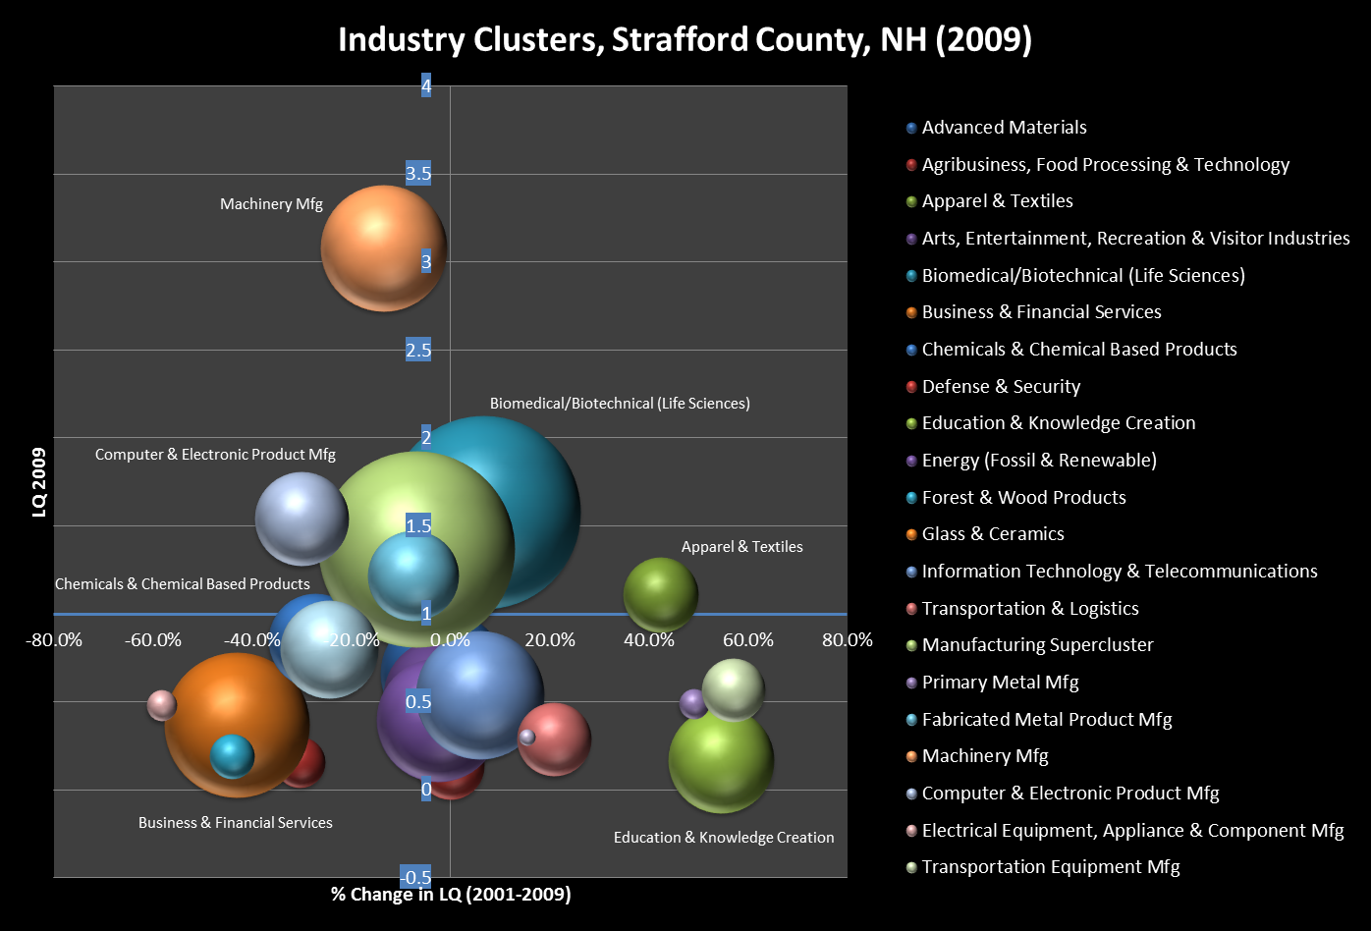
Mature

Emerging

Transitioning
Emerging

Note: The first figure is the percent change in Location Quotients, the second is the size of the LQS, and the third represents total cluster employment in 2009. An LQ of 1.2 or greater indicates a regional specialization

Table 26: Data for Industry Clusters Bubble Chart, Strafford County, NH (2009)
[Source: Purdue Center for Regional Development]
% Change in LQ(2001-2009) | LQ 2009 | Employment 2009 | Industry Clusters, Strafford County, NH
-1.49% | 0.66 | 1,064 | Advanced Materials
-30.43% | 0.16 | 173 | Agribusiness, Food Processing & Technology
42.31% | 1.11 | 378 | Apparel & Textiles
-1.85% | 0.53 | 925 | Arts, Entertainment, Recreation & Visitor Industries
6.76% | 1.58 | 2,550 | Biomedical/Biotechnical (Life Sciences)
-43.08% | 0.37 | 1,434 | Business & Financial Services
-27.35% | 0.85 | 600 | Chemicals & Chemical Based Products
0.00% | 0.14 | 306 | Defense & Security
54.55% | 0.17 | 760 | Education & Knowledge Creation
-2.44% | 0.4 | 1,036 | Energy (Fossil & Renewable)
-44.12% | 0.19 | 135 | Forest & Wood Products
-5.93% | 1.11 | 171 | Glass & Ceramics
5.88% | 0.54 | 1,113 | Information Technology & Telecommunications
20.83% | 0.29 | 369 | Transportation & Logistics
-6.80% | 1.37 | 2,632 | Manufacturing Super cluster
49% | 0.49 | 62 | Primary Metal Mfg.
-7.58% | 1.22 | 553 | Fabricated Metal Product Mfg.
-13.48% | 3.08 | 1,085 | Machinery Mfg.
-30.00% | 1.54 | 600 | Computer & Electronic Product Mfg.
-58.26% | 0.48 | 62 | Electrical Equipment, Appliance & Component Mfg.
57% | 0.57 | 271 | Transportation Equipment Mfg.
15.38% | 0.3 | 19 | Mining
-24.53% | 0.8 | 644 | Printing & Publishing

Occupation Cluster

Occupation Clusters analysis is a relatively new approach in regional development that focuses on the knowledge, skills, and abilities of the individuals who work in certain jobs. Figure 8: focuses on fifteen knowledge-based occupation clusters.
The table below identifies those occupations with the strongest percentage change and the largest increase in the number of jobs from 2001 to 2007. Mathematics, statistics, data, and, accounting had the second largest percent change 15.85 percent. Agribusiness and food technology had the largest percent change 15.91%, but that occupational segment is relatively small.
The figure below shows employment growth by cluster. Nine occupations clusters showed an increase in employment. Only postsecondary education and knowledge creation (1.72 LQ) and natural resources and environmental management (1.22 LQ) with allocation quotient higher that 1.2, indicate a concentration of such workers within the region compared to the United States overall.

Figure 8: Occupation Clusters Bubble Chart, Strafford County, NH (2009)
[Source: Purdue Center for Regional Development]
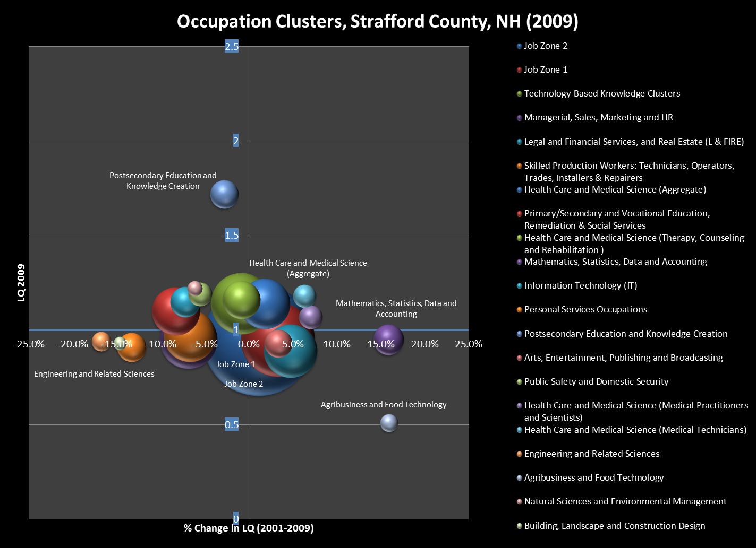

Table 27: Data for Occupation Clusters Bubble Chart, Strafford County, NH (2009)
[Source: Purdue Center for Regional Development]
% Change in LQ(2001-2009) | LQ 2009 | Employment 2009 | Occupation Clusters, Strafford County, NH
1.06% | 0.95 | 19,258 | Job Zone 2
3.26% | 0.95 | 8,330 | Job Zone 1
-0.87% | 1.14 | 5,780 | Technology-Based Knowledge Clusters
-6.86% | 0.95 | 5,087 | Managerial, Sales, Marketing and HR
4.71% | 0.89 | 4,424 | Legal and Financial Services, and Real Estate (L & FIRE)
-6.73% | 0.97 | 4,134 | Skilled Production Workers: Technicians, Operators, Trades, Installers & Repairers
1.79% | 1.14 | 3,864 | Health Care and Medical Science (Aggregate)
-8.33% | 1.1 | 3,531 | Primary/Secondary and Vocational Education, Remediation & Social Services
-0.85% | 1.16 | 2,220 | Health Care and Medical Science (Therapy, Counseling and Rehabilitation)
15.85% | 0.95 | 1,414 | Mathematics, Statistics, Data and Accounting
-7.26% | 1.15 | 1,398 | Information Technology (IT)
-13.33% | 0.91 | 1,258 | Personal Services Occupations
-2.82% | 1.72 | 1,230 | Postsecondary Education and Knowledge Creation
3.33% | 0.93 | 1,181 | Arts, Entertainment, Publishing and Broadcasting
-5.56% | 1.19 | 857 | Public Safety and Domestic Security
7.00% | 1.07 | 829 | Health Care and Medical Science (Medical Practitioners and Scientists)
6.31% | 1.18 | 815 | Health Care and Medical Science (Medical Technicians)
-16.81% | 0.94 | 571 | Engineering and Related Sciences
15.91% | 0.51 | 460 | Agribusiness and Food Technology
-6.15% | 1.22 | 338 | Natural Sciences and Environmental Management
-14.68% | 0.93 | 265 | Building, Landscape and Construction Design

Major Employers by Municipality
The largest employer in the Strafford CEDS region is the University of New Hampshire with over 4,000 employees. The next largest employer in the region is Liberty Mutual, an insurance provider.

Table 28. Major Employers in the Region by Municipality
[Source: NH Community Profile]
Barrington
Largest Business | Product/Service | Employees | Established
Turbocam USA | Manufacturer of components | 120 | 2004
Associated Buyers | Wholesale distributor of organic food | 45 | 1993
Computer Resources | Software for school administrators | 32 | 1989
Barrington Primary & Urgent Care | Outpatient medical services | 31 | 1991
Yankee Equipment Systems | Commercial laundry equipment | 30 | 1990
Christmas Dove | Retail store | 23 | 1973
Benjamin Walk, Inc. | Distributor of specialty footwear | 23 | 1981
Dover
Largest Business | Product/Service | Employees | Established
Liberty Mutual | Insurance | 3,500
City of Dover | Municipal Service | 1139
Wentworth-Douglass Hospital | Health care | 1048
Heidelberg Harris, Inc. | Web offset presses | 900
Fosters Daily Democrat | Newspaper | 220 | 1873
Cambridge Tool North | Die casting | 190
EAD Motors | Electric Motors | 172
DT Magnetic | High Frequency Transformer | 105
Moore Business Equipment | Business equipment and parts | 80
Durham
Largest Business | Product/Service | Employees | Established
University of New Hampshire | Education | 4,468
Goss International Printing Press | Printing Press | 555
Town of Durham | Municipal services | 78
Farmington
Largest Business | Product/Service | Employees | Established
UTEL Inc. & Subsidiaries | Telecommunications | 44 | 1903
Cameron's Sod Farm | Lawn & garden | 40 | 1935
Pike Industries | Asphalt, gravel, stone | 40 | 1975
Samco Inc. Rubber rolls 32 1979 | Rubber rolls | 32 | 1979
Bank of NH Banking | Banking | 20 | 1927
Energy Resource | Paper |  | 1999
Three Phase Line Electric | Specialized electrical contractor 1999
Spencer Johnston | Machinery
Holy Rosary Credit Union | Banking
Lee
Largest Business | Product/Service | Employees | Established
Market Basket Supermarket | Supermarket | 120 | 1993
S & J Transportation Trucking | Trucking Leasing Sales | 40 | 1992
McDonald's Fast | Fast Food restaurant | 35 | 1995
Wendy's Fast food | Fast Food restaurant | 35 | 2004
125 Family Restaurant | Restaurant | 20
Dunkin' Donuts | Donut shop | 20
Mobil Mart w/ Pizza Hut Express | Gas Station | 15
Sunoco Mart Gas station | Gas Station | 15
Madbury
Largest Business | Product/Service | Employees | Established
Taylor Egg Products | Egg Products | 21 | 1970
Kids 'n' More | Child Care Center Child care | 13 | 2003
University of NH | Farm Research | 9 | 1970
RAM Construction | General Contracting | 6
New England Metal Recycling | Auto recycling | 6
R & L Engines | Automotive shop | 4 | 1992
Green Acres Stables | Horse Stable | 3 | 1995
Garland's Garage | Automotive Service | 3 | 1988
Landcare Inc. | Landscaping Seasonal |  | 2000
Middleton
Largest Business | Product/Service | Employees | Established
Middleton Building Supply | Building Materials | 138 | 1993
Charles Diprizio & Sons | Lumber | 30 | 1988
Town of Middleton | Municipal Service | 18 | 1778
Milton
Largest Business | Product/Service | Employees | Established
Index Packaging | Foam Packaging | 120 | 1968
Milton School | Education | 77
Ray's Marina | Marina | 30 | 1970
Iron Mountain | Document Storage | 20
Seacoast Boat builders | Boat manufacturing | 14 | 1994
New Durham
Largest Business | Product/Service | Employees | Established
Powerspan | Computer boards | 50 | 1979
Johnson's Dairy Bar | Restaurant | 50 | 2005
Town of New Durham | Municipal service | 30
New Durham School Education 19 | Education | 19
New Hampshire Fish hatchery | Fish hatchery | 12
Sport’s Restaurant | Restaurant Inn | 6 | 1999
Rochester
Largest Business | Product/Service | Employees | Established
City of Rochester | Municipal services | 1,367 | 1981
Frisbee Memorial Hospital | Health care services | 655 | 1919
KW Thompson Tool | Firearms/investment castings | 375 | 1989
Hannaford | Supermarket | 464 | 1963
Wal-Mart Super center | Department store | 295 | 1970
Market Basket | Supermarket | 210 | 1996
Waste Management | Recycling and Solid Waste | 200 | 1983
Home Depot | Home improvement store | 176 | 2001
Laars Technologies | Boilers and water heaters | 170 | 1984
Eastern Propane & Oil | Retail propane & oil | 162 | 1989
Rollinsford
Largest Business | Product/Service | Employees | Established
Janco Inc. Plastic molding | Plastic molding fabrication | 67 | 1963
Janco Electronics | Circuit board assembly | 65 | 1963
MFB Holding, LLC | Fixtures in wood plastics | 13 | 1988
Somersworth
Largest Business | Product/Service | Employees | Established
Wal-Mart | Department Store | 400
General Electric Co | Manufacturing meter control division | 300
Somersworth School Department | Education | 291
Trelleborg Palmer-Chenard | Manufacturing, rubber products | 200
Market Basket | Supermarket | 180
Velcro | Hook and Loop products | 129
Busy Bee Janitorial Service | Janitorial Service | 120
The Works Athletic Club | Physical fitness/wellness | 120
General Linen | Laundry Facility | 116
City of Somersworth | Municipal Service | 114
Strafford
Largest Business | Product/Service | Employees | Established
David R. Whitcher | Building contractor | 25 | 1971
Amusement Media, Inc. | Media and Marketing | 15 | 1997
Strafford Machine & Welding Job | Machine shop | 5 | 1974
Isinglass Country | County Store | 3 | 1985
Wakefield
Largest Business | Product/Service | Employees | Established
Lovell Lake Food Center | Convenience store | 35
Poor Peoples Pub | Restaurant | 35
Longmeadow Hardware | Hardware | 18
Badman Family Practice | Healthcare | 7 | 1993

Self-Employment

The self-employment rate is the percent of all employed people who have their own businesses (proprietors) as opposed to working for someone else in the return for wages or salary. In 2008 the self-employment rate was 18.9 compared to 15.8 in 1999. Strafford County was lower than the rate of New Hampshire and U.S. for self-employment.

Figure 9. Self Employment Rate U.S., New Hampshire, Carroll County, Rockingham County, and Strafford County, 1969-2009
[Source: Carsey Institution UNH, 1969-2008: Bureau of Economic Analysis, Regional Economic Data, Local Area Personal Income, Table CA25, (http://www.bea.gov/regional/reis/)]
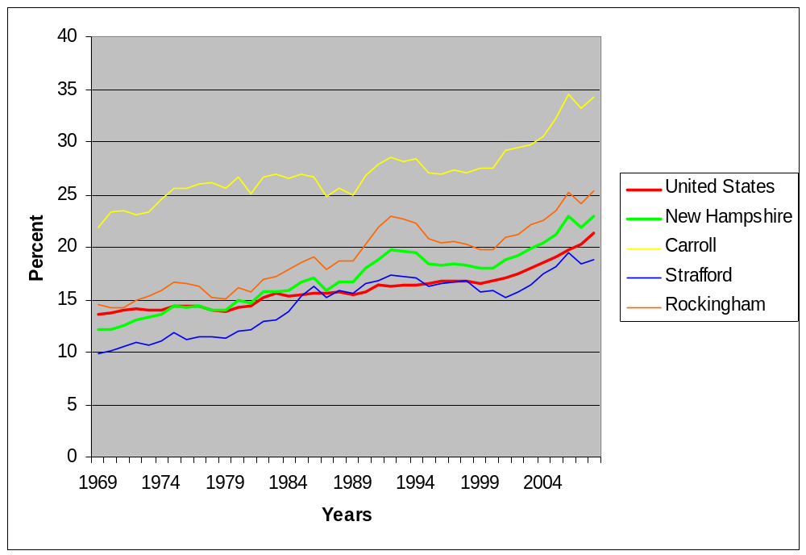

Tax Policies and Bonding

The chart compares the 2010 municipal valuation, municipal tax, local education tax, state education tax, county tax, and total tax. The 2010 Total Tax Rates range from $11.7 per $1,000 in Wakefield to $27.3 per $1,000 in Durham and Somersworth. The specific figures for each community are listed below in Table 29. The budgets and tax situation for each municipality varies.

Table 29. Tax Rates in the Strafford CEDS Region 2010
[Source: NH Department of Revenue Administration]
Tax Rate Strafford CEDS Region 2010
Municipality | Town Valuation | Town Tax | Local Education Tax | State Education Tax | County Tax | Total Tax
Barrington | 899,843,424 | 3.35 | 11.37 | 2.37 | 2.48 | 19.6
Brookfield | 102,602,100 | 3.86 | 6.84 | 2.44 | 1.06 | 14.2
Dover | 2,606,535,050 | 8.93 | 9.57 | 2.55 | 2.7 | 23.8
Durham | 892,139,835 | 7.12 | 15.43 | 2.19 | 2.54 | 27.3
Farmington | 467,620,120 | 6.57 | 8.72 | 2.39 | 2.56 | 20.2
Lee | 494,622,829 | 5.67 | 15.39 | 2.11 | 2.25 | 25.4
Madbury | 230,460,599 | 2.9 | 16.3 | 2.28 | 2.51 | 24
Middleton | 182,845,247 | 4.66 | 7.61 | 2.16 | 2.49 | 16.9
Milton | 387,944,220 | 6.64 | 10.65 | 2.52 | 2.76 | 22.6
New Durham | 416,006,500 | 6.95 | 9.32 | 2.37 | 2.55 | 21.2
Rochester | 2,005,896,840 | 7.74 | 10.71 | 2.64 | 2.8 | 23.9
Rollinsford | 259,558,703 | 2.36 | 13.15 | 2.31 | 2.71 | 20.5
Somersworth | 836,772,075 | 9.05 | 13.12 | 2.51 | 2.64 | 27.3
Strafford | 499,979,200 | 2.05 | 13.15 | 2.16 | 2.4 | 19.8
Wakefield | 878,879,160 | 2.77 | 5.33 | 2.5 | 1.09 | 11.7
Note: Tax rate per $1,000***2010 Municipal Budget

The current tax policies and bonding capacities at the state and municipal levels make New Hampshire an attractive place to locate for businesses and residents. The lack of a sales tax makes New Hampshire retail businesses competitive, particularly those located along the Massachusetts and Maine border. The dependence upon property tax has created differences among communities, and additional property tax to support increasing municipal budgets creates internal and external conflicts. The state does have a number of taxes and fees to support the state budget. The various state and local taxes are identified and summarized below.

Table 30. Taxes in New Hampshire
[Source: New Hampshire Department of Tax Revenue's http://www.nh.gov/revenue/]
Taxes in New Hampshire
Tax | What is it? | Who pays it?
Interest and Dividends | 5% tax on interest and dividend income | Resident individuals, fiduciaries, and trusts with non-transferable shares earning interest and dividend taxable income of more than $2,400 annually
Gambling Winnings | 10% tax on gambling winnings | If the tax is not withheld by the New Hampshire entity paying out your gambling winnings, then you are responsible for paying the tax.
Business Profits | 8.5% tax on business conducted within State | Any business organization, organized for gain or profit carrying on business activity within the state is subject to this tax. However, organizations with $50,000 or less of gross business income from all their activities are not required to file a return.
Business Enterprise | .75 tax on the enterprise value tax base | Enterprises with more than $150,000 of gross receipts from all their activities, or an enterprise value tax base more than $75,000, are required to file a return.
Communication Services Tax | 7% tax on all two -way communication services | The tax is paid by the consumer and collected by two-way communication providers.
Electricity Consumption | .00055 per kilowatt hour of electricity consumed | The tax is paid by the consumer, collected and submitted by distribution companies, except in the case of consumers who generate their own power. These self-generating companies or individuals must submit tax returns on their own behalf.
Meals and Rentals Tax | A 9% tax is assessed upon patrons of hotels and restaurants, on rooms and meals costing $.36 or more. A 9% tax is also assessed on motor vehicle rentals and campsites. | The tax is paid by the consumer and collected by operators of hotels, restaurants, food service, room rental, and motor vehicle rentals.
Tobacco Tax | Tax upon the retail consumer is hereby imposed at the rate of $1.78 for each package containing 20 cigarettes or at a rate proportional to such rate for packages containing more or less than 20 cigarettes, on all cigarettes sold at retail in this state. | The tax is paid by the consumer and collected by retailers and wholesalers.
Real Estate Transfer Tax | Tax is $.75 per $100 of the price or consideration of the transfer. | The tax is assessed on both the buyer and the seller, with a minimum charge of $20 each. The tax is paid at the Register of Deeds office in the county where the property is located.
Timber Tax | 10% of the stumpage value at the time of cutting | Individuals submits intent to Cut and Report of Cut forms
Gravel | Tax on removal of more than 1,000 cubic yards of earth | Individuals who removes more than 1,000 cubic yards whether sold or given away
State Education Property | Assessed based on total equalized valuation | Property owners pay local municipalities
Utility Property | Tax of $6.60 per $1,000 of value of utility property is | Utility Property owners
Local Property | Local Property taxes based upon assessed valuation | Property owners

Chapter 5: Areas of Economic Distress

Unemployment Rate

The unemployment rate in New Hampshire, compared to the United States over the last few years, has been lower. Strafford County’s unemployment rate has followed similar pattern to New Hampshire and Carroll County.

Figure 10. Percent Unemployment Rate U.S., New Hampshire, Carroll County, Rockingham County, and Strafford County, 1969-2009
[Source: US Census American Community Survey 2005-2009]
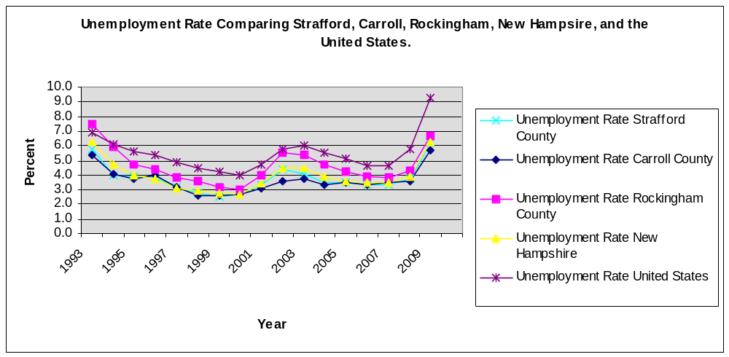
.

Poverty Rates
The poverty rate, meaning the percent of the population falling below federal poverty guidelines, ranged from 30.6% in Durham (attributed to the University) to 4.2% in Barrington. The northern CEDs region has a higher poverty rate (except New Durham and Wakefield) than the southern portion of the region. This is shown in Map 7. The poverty rate for Strafford County is more than double of Rockingham County as shown in Table 31. It is higher than the state of New Hampshire, but lower than the national poverty rate of 13.2%.

Map 8: Strafford CEDS Region Percent below Poverty Level
[Source: NH GRANIT, U.S. Census Bureau]

Table 31. Poverty Rate by Age, U.S., NH, Carroll County, Strafford County, and Rockingham County
[Source: U.S Census Bureau, 2006-2008 American Community Survey]
United States Poverty 2008
Age Group | Number | Percent
all ages in poverty | 39108422 | 13.2
Under 18 in Poverty | 13240870 | 18.2
Ages 5-17 Families in Poverty | 8549526 | 16.5
Under age 5 in Poverty | 4369698 | 21.2
New Hampshire Poverty 2008
Age Group | Number | Percent
all ages in poverty | 99,939 | 7.8
Under 18 in Poverty | 27280 | 9.4
Ages 5-17 Families in Poverty | 16714 | 7.8
Under age 5 in Poverty | 8954 | 12.1
Carroll County Poverty 2008
Age Group | Number | Percent
all ages in poverty | 4292 | 9.2
Under 18 in Poverty | 1234 | 14
Ages 5-17 Families in Poverty | 778 | 11.9
Under age 5 in Poverty | NA | NA
Strafford County Poverty 2008
Age Group | Number | Percent
all ages in poverty | 12311 | 10.7
Under 18 in Poverty | 3002 | 11.5
Ages 5-17 Families in Poverty | 1842 | 9.7
Under age 5 in Poverty | NA | NA
Rockingham County Poverty 2008
Age Group | Number | Percent
all ages in poverty | 14020 | 4.8
Under 18 in Poverty | 3609 | 5.3
Ages 5-17 Families in Poverty | 2379 | 4.7
Under age 5 in Poverty | NA | NA

Reduced School lunch program

The National School Lunch Program provides low cost or free lunches to students based on the student’s family size and income. Children from families with incomes at or below 130 percent of the poverty level are eligible for free meals. Those with incomes between 130 and 185 percent of the poverty level are eligible for reduced-price meals.

The percent of students eligible for free or reduced-price lunches is often used as a measure of children’s economic wellbeing. Higher percentages mean more children live in low-income families, and vice versa. The percent is calculated by dividing the number of eligible students (based on the criteria listed above) by the number of students enrolled. Not all schools participate in the federal lunch program.

Table 32. Reduced School Lunch Program in Percentage
[Source: UNH Carsey Institution]
Strafford CEDS Region
 | 1999 - 2000 | 2000 - 2001 | 2001 - 2002 | 2002 - 2003 | 2003 - 2004 | 2004 - 2005 | 2005 - 2006 | 2006 - 2007 | 2007 - 2008
BARRINGTON  SCH DIST | 15.3 | 13.5 | 12.1 | 12.3 | 14.1 | 12.3 | 13.4 | 13.8 | 12.8
DOVER SCH DIST | 22.7 | 21.1 | 18.5 | 18.6 | 20.1 | 18.6 | 18.8 | 18 | 16.4
FARMINGTON SCH DIST | 33. | 29.1 | 29 | 31.3 | 30.8 | 28.9 | 32.1 | 31.2 | 35.1
GOVERNOR WENTWORTH REG SCH DIS | 21.8 | 18.6 | 20.5 | 22.7 | 24.5 | 23.6 | 22.5 | 22.1 | 27
MIDDLETON SCHOOL DISTRICT | NA | NA | NA | NA | NA | NA | NA | NA | NA
MILTON SCH DIST | 29.9 | 30.2 | 31.9 | 28.9 | 33.4 | 33.8 | 37.1 | 34.7 | 34.3
OYSTER RIVER COOP SCH DIST | 5.1 | 5.4 | 3.9 | 4.2 | 5.6 | 5.5 | 4 | 3.8 | 4.8
ROCHESTER SCH DIST | 25.6 | 21.3 | 21.3 | 23.4 | 28.6 | 28.8 | 30.1 | 29.9 | 32.6
ROLLINSFORD SCH DIST | 13.1 | 9.7 | 10.8 | 5.8 | 9.2 | 7.7 | 15.7 | 18.6 | 15.7
SOMERSWORTH SCH DIST | 24.2 | 22.4 | 22.2 | 22.4 | 25.2 | 26.9 | 27.6 | 25.4 | 28.1
STRAFFORD SCH DIST | 10.3 | 8.1 | 7 | 10.2 | 8.3 | 8.8 | 8.2 | 11.1 | 7.6
WAKEFIELD SCH DIST | 33.5 | 29.3 | 32.5 | 25.4 | 22.3 | 24.1 | 28.7 | 28.4 | 30.9
Key: SCH = School; DIST = District

Note: NA and Blank cells = not available

Layoff Data

The New Hampshire Workforce Office compiles records on the number of layoffs experienced by business in the state and fulfills its role as the New Hampshire state contractor for the federal WARN system. The total number of business layoffs for the Strafford CEDS region was 27.

Table 33. Layoff Data for Strafford CEDS Region from July 2008-Present
[Source: NH Workforce Office]
County | City/Town of layoff | Company Name | Industry | Date of Layoff | # Total Employment | Total Employment Term
Strafford | Dover | City of Dover | service | 06/30/08 | NA | 15
Strafford | Strafford | Collins Business Holdings | service | 10/12/10 | 34 | 34 | Closed
Strafford | Rochester | Thompson Center Arms | manufacturing | 12/09/10 | 343 | 306 | Closed
Strafford | Somersworth | Trelleborg Sealing Solutions | manufacturing | 06/02/09 | 91 | 81 | Closed
Strafford | Durham | Goss | manufacturing | 10/27/09 | 690 | 50
Strafford | Rochester | Brand Partners | marketing/design | 04/14/10 | 52 | 52 | Closed
Strafford | Somersworth | Trelleborg Sealing Solutions | manufacturing | 04/21/10 | 91 | 91 | Closed
Strafford | Durham | NE Center | hospitality | 08/20/09 | 37 | 37 | Closed
Strafford | Rochester | Starbucks | service | 07/18/08 | 6 | 6 | Closed
Strafford | Milton | New Frontiers | recycling | 10/15/08 | 9 | 9 | Closed
Strafford | Dover | McIntosh College | education | 01/02/09 | 30 | 15
Strafford | Somersworth | Somersworth Company | manufacturing | 09/01/09 | 91 | 91 | Closed
Strafford | Rochester | Frisbie Memorial Hospital | medical | 03/31/09 | 1050 | 23
Strafford | Rochester | Albany Engineered Composites | manufacturing | 05/04/09 | 163 | 12
Strafford | Dover | Goss International | manufacturing | 05/08/09 | 635 | 170
Strafford | Dover | International Auto Dealers | auto sales | 05/13/09 | 238 | 15
Strafford | Rochester | Monarch School - | education | 05/15/09 | 65 | 20
Strafford | Milton | Eastern Boats | manufacturing | 08/01/08 | NA | 12
Strafford | Dover | Thompson Arms (2) | manufacturing | 09/25/08 | 360 | 84
Strafford | Dover | AT&T 2nd layoff | customer svc | 09/26/08 | 325 | 12
Strafford | Dover | Red Hook Brewery | restaurant | 11/18/08 | 68 | 1
Strafford | Dover | Vigilant Inc. | manufacturing | 12/03/08 | NA | 10
Strafford | Durham | Goss International | manufacturing | 01/06/09 | 750 | 65
Strafford | Dover | Strafford County | government | 01/06/09 | 500 | 20
Strafford | Dover | Electro craft (EAD) | manufacturing | 01/15/09 | 98 | 60
Strafford | Rochester | Thompson Arms (3) | manufacturing | 01/29/09 | 360 | 68
Strafford | Rochester | Albany Engineered Composites | manufacturing | 02/25/09 | 177 | 16
Strafford | Dover | AT&T 3rd layoff | customer svc | 02/27/09 | 310 | 310 | Closed

Foreclosure

According to New Hampshire Housing Foreclosure Updates there were 543 foreclosure deeds recorded in March 2011, an increase of 21% from foreclosure deeds recorded in March 2010, and an increase of 90% from the February 2011 monthly total, and a new record for foreclosure deeds in any one month. This is likely the result of the lifting of the moratoria on foreclosures by large lenders as the slowdown in the pace of foreclosure deeds observed between October 2010 and January of this year has come to an end. The larger question still remains, will the slow but steady improvement in New Hampshire's underlying economic conditions slow the rate of foreclosure.

Figure 11. Percentage Foreclosure Deeds In New Hampshire by County by Year
[Source: Real Data Corporation, Compiled by New Hampshire Housing]
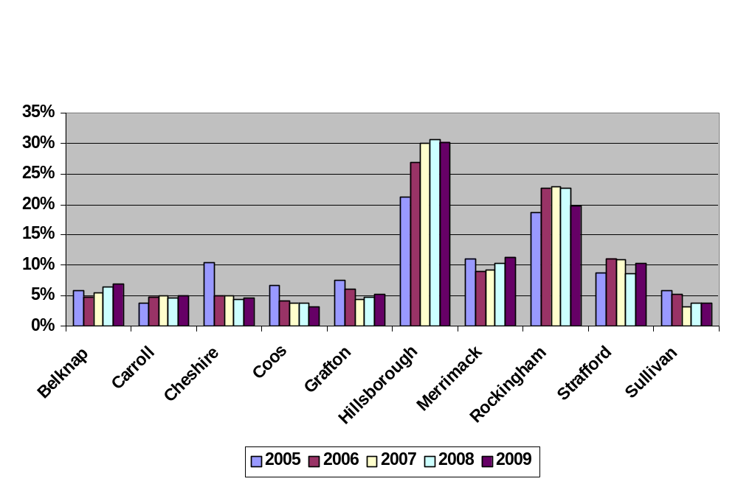

Partners and Resources for Economic Development
The ability of the economic stakeholders at the local, regional, state, federal, private, and non-profit levels to develop effective partnerships and relationships will determine how successful the CEDS is in meeting the goals. Outlined below is a list of partners and resources for economic development in the region.

Partners and Resources by Issue
Housing
NH Housing Authority
Economic Development (Commercial and Industrial)
Barrington Chamber of Commerce
Dover Chamber of Commerce
Greater Wakefield Chamber of Commerce
Municipal Economic Development Advisory Committees
New Hampshire Department of Resources and Economic Development
New Hampshire Employment Security
NH Better Business Bureau
NH Business and Finance Authority
NH Business and Industry Association
NH Small Business Development Center
NH Works
Rochester Chamber of Commerce
SCORE-Counselors to America’s Small Business
Somersworth Chamber of Commerce
Strafford Economic Development Corporation
The Cities of the Greater Seacoast Economic Development Alliance
US Department of Commerce, Economic Development Administration
US Housing and Urban Development
US Small Business Administration
US Small Business Development Center
Wakefield Chamber of Commerce
Wentworth Economic Development Corporation
Workforce Opportunity Council
Education and Training
Community College System of New Hampshire
Granite State College
Great Bay Community College
NH Department of Education
NH Training Program
NH Workforce Development Council
School Administrative Units (SAU)
Thompson School of Applied Science UNH
University of New Hampshire
University System of New Hampshire
Community Development
Community Partners
NH Community Development Finance Authority
NH Department of Transportation
NH Main Street Center
NH Office of Energy and Planning
Regional Planning Commissions
Strafford Regional Planning Commission
UNH Cooperative Extension
Transportation, Utilities, and Infrastructure
NH Department of Transportation
Pease Development Authority
Public Service of New Hampshire
US Department of Transportation
Travel and Tourism
NH Department of Tourism and Marketing
NH Department of Cultural Resources
NH DRED Division of Parks and Recreation
State Chamber of Commerce
Environment
Army Corps of Engineers
Jackson Laboratory
NH Department of Agriculture, Markets, and Food
NH Department of Environmental Services
NH Department of Resources Economic Development
NH Fish and Game
Society for the Preservation of NH Forests
Strafford Rivers Conservancy
US Department of Agriculture
US Environmental Protection Agency
Arts and Heritage
Historical Societies/ Heritage Commission
NH Association of Conservation Commission
NH Department of Cultural Research
NH Preservation Alliance
Rochester Opera House
UNH Theater
Social Services
Frisbee Memorial Hospital
NH Hospital Business Association
Strafford Community Action
Wentworth Douglas Hospital
Private Grant makers and Foundations
NH Charitable Foundation
NH Community Loan Fund
NH Endowment for Health
Government, Public Grant makers and Lenders
NH Business and Industry Association
NH Business Finance Authority
NH Community Development Finance Authority
NH Housing Finance Authority
NH Land and Community Heritage Investment Program
Strafford Economic Development Corporation
US Department of Commerce, EDA
US Department of Health and Human Services
US Department of Housing and Urban Development
US Environmental Protection Agency
USDA Rural Development
Wentworth Economic Development Corporation

Chapter 6: Infrastructure

Infrastructure

Infrastructure consists of the facilities and services such as roads, water, and sewer systems, broadband which support economic activity. Maintaining these services and facilities while planning for future need enables municipalities to direct future growth. The region has many locations suitable for expansion; however services and facilities vary by town and city. Many towns in the region are rural and have not developed infrastructure, such as wastewater treatment facilities.

Transportation Planning

The Strafford Regional Planning Commission is responsible for transportation planning in its designated jurisdiction. This activity is carried out through the federally mandated Metropolitan Planning Organization (MPO), a process which ensures coordination between state, regional, and local municipalities identifying and prioritizing transportation improvements. Strafford Metropolitan Planning Organization (SMPO), covers the Dover, Rochester, Somersworth urbanized region and the adjacent areas in the State of New Hampshire. SRPC maintains a regional travel demand model for the region.

Map 9: Strafford Metropolitan Planning Organization
[Source: NH GRANIT]
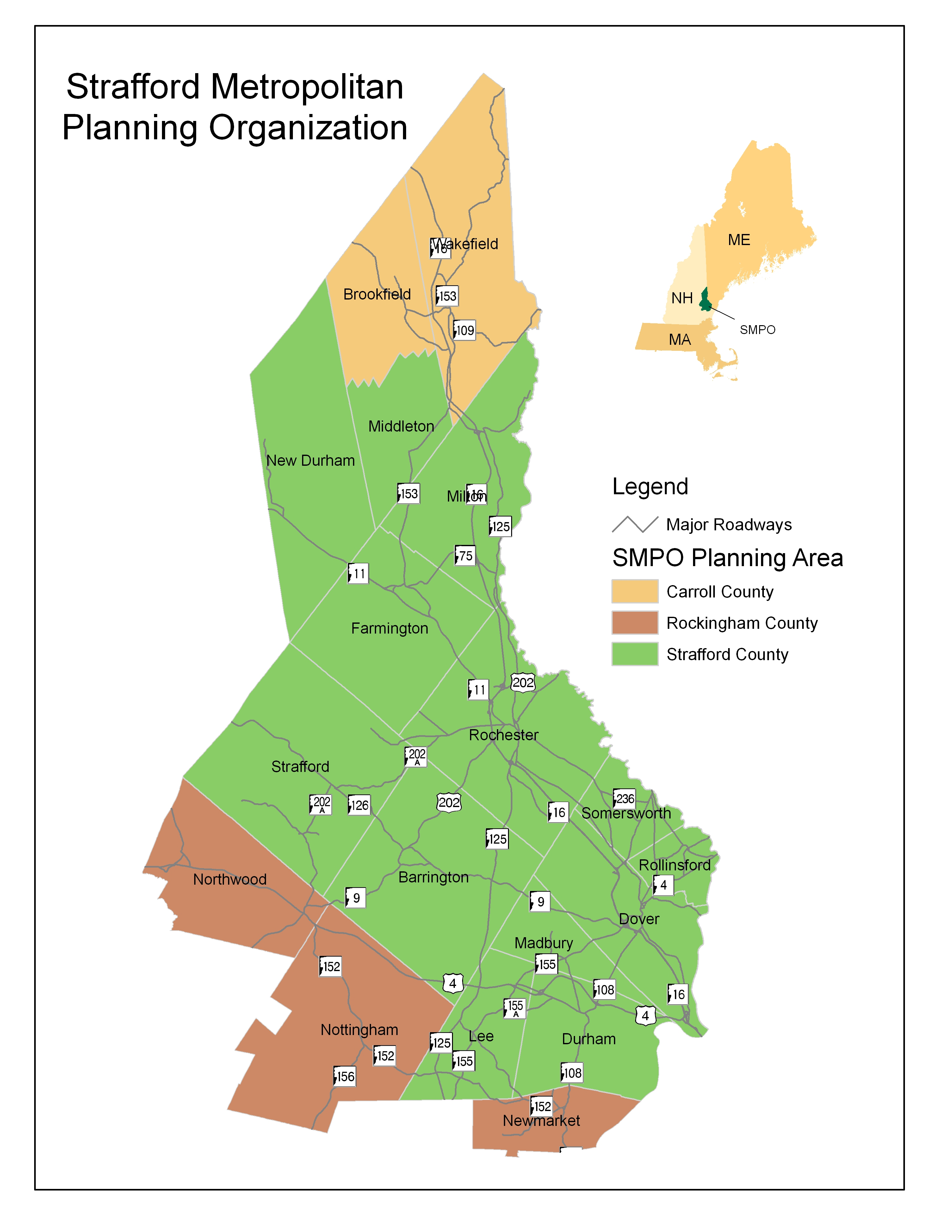

Surface Transportation (GIS Map)

The County is within a day's travel to the largest population centers, major markets, and transportation facilities in the Northeast. Boston and Portland are an hour away, while New York City, Montreal, Philadelphia and Washington D.C. are within five to eight hours. Strafford County is located between a variety of economically important sites such as Boston Metro, Gulf of Maine coastline, as well as the lakes, mountains and ski areas of northern New England.
Strafford County features a comprehensive highway and local road system that provides access to all parts of the state and direct expressway connections to Boston, Portland and New York. This network provides for efficient service by truck, rail, sea and air, particularly from the urban portion of the county. The Spaulding Turnpike is a divided highway that runs north and south. It connects to Interstate 95 leading south to Boston and north to Portland, Maine. U.S. 4 runs east and west through the county and is the major route to Concord, the state capital. It also connects to Interstate 93 and Portsmouth. NH 101, a newly improved four-lane intrastate highway, is only 20 minutes south of the urban core of the county. Route 125 is a secondary north-south road that connects to NH 101, the major east-west route to Manchester.

Transit
The Strafford County area features two public transit systems, connecting the rural and urbanized areas of the County to each other, to the University of New Hampshire and urban centers outside of the County. Intercity bus service is also available to Boston, Portland and Logan Airport.

The Cooperative Alliance for Seacoast Transportation (COAST) provides fixed route, deviated fixed route and ADA paratransit services in eleven communities, linking small urban Strafford County areas (Farmington, Rochester, Somersworth and Dover) with Rockingham County communities and Berwick Maine, in addition to intra-city services in Dover and Portsmouth. Under the new “Community Rides” regional initiative guided by the Alliance for Community Transportation (ACT), COAST now provides once-a-week demand response service, targeting the disabled and elderly, in five rural communities north of Rochester: New Durham, Middleton, Milton, Wakefield, and Brookfield.

In addition to traditional transit services in the County and surrounding area, there are a number of human service agencies that have developed demand response transportation programs, primarily for their own clients, by using Federally-funded vehicles. These agencies, along with COAST, the regional planning agencies and other entities formed ACT, which is now recognized as the Regional Coordinating Council for the region. ACT serves in an advisory and advocacy role to promote coordinated transportation services to improve more and efficient community transportation services.

Wildcat Transit, the UNH public transportation service, operates campus-based connector routes and public transit routes within Durham, Dover, Newington, Newmarket, and Portsmouth with hourly connections. Wildcat Transit is looking to expand services to connect their three campuses at UNH Manchester, UNH Durham, and UNH Concord with daily service. Additionally, a new commuter-based service between Rochester and UNH Durham is anticipated to begin in fall 2012.

Strafford County is also served by a private intercity bus provider, C&J. Founded in 1968, C&J is the second largest provider of intercity transportation in Northern New England serving six destinations with over 30 daily departures from the New Hampshire Seacoast, and Newburyport to Logan Airport and Boston South Station. C&J also offers daily services from UNH/Durham, Portsmouth to New York City.

When combined with Amtrak passenger rail service from Dover and Durham, Strafford County features one of the most accessible transportation environments in the State of New Hampshire

Map 10: COAST and Wildcat Transit Service Areas
[Source: NH GRANIT, SRPC]
Passenger Rail Service
The region is served by the Amtrak Down-Easter, providing passenger connections between Boston and Portland, Maine, operating five daily round trips. Service is available in two Strafford County locations: at new or renovated rail stations in Dover and Durham. The Amtrak Down-Easter has ten stops total which include: Portland, Old Orchard Beach, Saco, Wells, Dover, Durham-UNH, Exeter, Haverhill, Woburn, and Boston.

Rail Freight
Pan Am Railways, formerly known as Guilford Transportation, owns the rail line on which Amtrak’s Down-easter operates through New Hampshire and provides rail freight services connecting to Portland and Boston area intermodal rail terminals. This line was recently upgraded with continuously welded rail at passenger rail standards. The main line also connects in Rollinsford with the New Hampshire Northcoast Railway, which terminates in Ossipee, NH after passing through Somersworth, Rochester, Milton and Wakefield. This short freight railroad is accessible to numerous business and industrial parks in Strafford County.

Ports and Harbor
The Port of New Hampshire lies in Portsmouth Harbor along at the mouth of the Piscataqua River. The port is New Hampshire’s largest and most active commercial port. This port is easily accessed via the Spaulding Turnpike, Route 16, from most Strafford County communities.

Pursuant to the New Hampshire State Statute, RSA 12-G: 43, I (a), the Division of Ports and Harbors (DPH), of the Pease Development Authority, shall "plan for the maintenance and development of the ports, harbors, and navigable tidal rivers of the State of New Hampshire from the head of navigation to the seaward limits within the jurisdiction of the state, in order to foster and stimulate commerce and the shipment of freight through the state's ports and as an agency of the state, to assist shipping and commercial and industrial interests that may depend on the sea for transport of products.

Air
Strafford County is conveniently located nearly equidistant from three major commercial airports: Boston’s Logan International Airport, Boston/Manchester Airport, and Portland (Maine)’s International Jetport. All three airports offer passenger and cargo service. The Boston/Manchester Airport is the closest at approximately forty-five minutes travel, with its recently increased passenger and cargo services. Boston Logan International Airport, the largest New England airport, is located approximately one hour from the center of Strafford County. Portland’s Jetport, approximately one hour and fifteen minutes away, offers international and domestic flights along with cargo.

Closer to Strafford County, the Pease International Airport (PSM), while not currently providing scheduled passenger services, is equipped for air freight services and has the facilities to accommodate domestic and international flights. The Airport Terminal building has a full Federal Inspection Services Facility with on-site U.S. Customs and Border Protection staff and can handle any aircraft in the world regardless of size. PSM is equipped to handle any cargo requirement. Located within the Pease International Tradeport, PSM offers a Foreign Trade Zone with access to the east coast and international trade corridors via I-95, direct air cargo from Portsmouth International Airport or by sea via the Port of New Hampshire.

In Strafford County, Sky Haven airport in Rochester is a general aviation airport, which has benefited from recent infrastructure upgrades. It is managed by the Pease Development Authority and offers paved runways (max. 4,000 feet), fuel, flight instruction and repair, as well as hangers and tie downs for corporate and private general aviation aircraft.

Sewer and Water Systems

The more urbanized southeastern portion of the county has sufficient sewer and water capacity for current and forecasted needs with the majority of industrial and commercial land serviced. Particularly in the southeastern region, water infrastructure has the capacity to support continued economic growth. Several communities are considering plans to upgrade their wastewater treatment facilities. In addition, a number of communities are in the process of upgrading water distribution systems to meet the demands of the foreseeable future, while the majority of residents receive their water supply through private wells and rely on septic systems. In rural areas, municipal sewer primarily serves downtown areas. This is a limiting factor in the ability of rural communities to provide for future economic growth.

Map 11: Water and Sewer
[Source: NH GRANIT, NHDES]
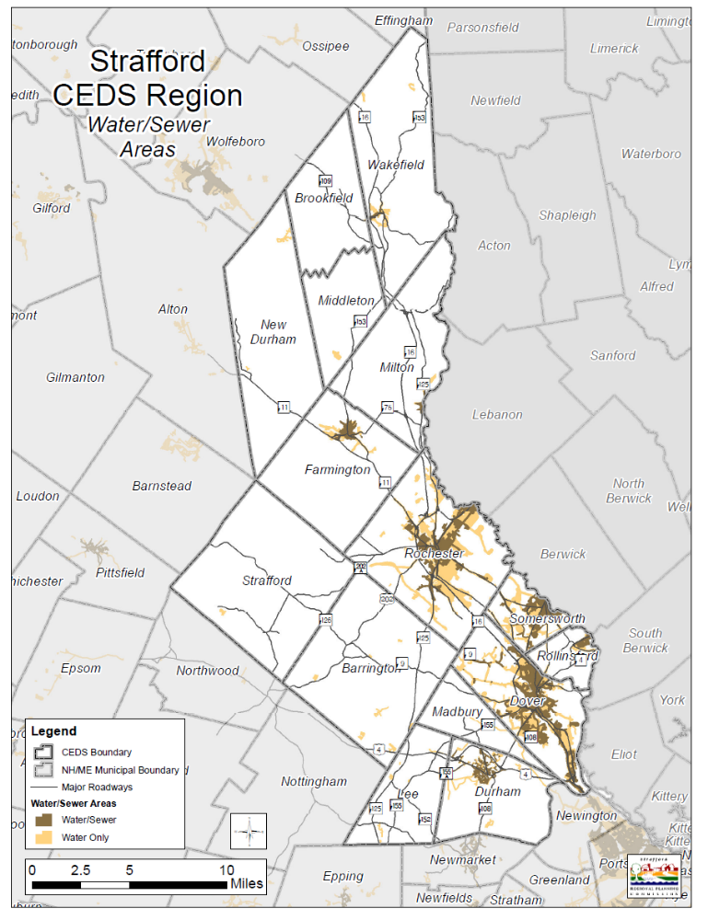

Utilities

Table 34. Utility Infrastructure
[Source: NH Community Profile, NH DES, Unitil Corp, Town Officials, and NH Public Utilities Community]
Utility Infrastructure-CEDS Region
Town Area | Water/Sewer |  | Solid Waste | Utilities |  |  |  |  | Telecomm
 | Central Sewer | Central Water | Percent’s Disposal | Electric service | Natural gas service | Telephone | Cable TV | Cable Company | Broadband Access
Barrington | N | N | Town | PSNH | None | Fairpoint | Y | Metrocast | Y
Brookfield | N | N | Town | PSNH, NHEC | None | Fairpoint | Y | Metrocast | Y
Dover | Y | Y | City | PSNH | NU | Fairpoint | Y | Comcast | Y
Durham | N | Y | Town | PSNH, NHEC | NU | Fairpoint | Y | Comcast | Y
Farmington |  |  | Town | PSNH, NHEC | NU | BayRing, Union | Y | Metrocast | Y
Lee | N | N | Town | PSNH, NHEC | None | Comcast, Fairpoint, AT&T | Y | Comcast | Y
Madbury | N | N | Private | PSNH | NU | Fairpoint | Y | Comcast | Y
Middleton | N | N | Town | PSNH | None | Fairpoint | Y | BayRing | Y
Milton | Y | N | Town | PSNH | None | Fairpoint | Y | Metrocast | Y
New Durham | N | N | Private | PSNH, NHEC | None | Fairpoint, Union | Y | Metrocast | Y
Rochester | Y | Y | Waste Management | PSNH | NU | Fairpoint | Y | Metrocast | Y
Rollinsford | Y | Y | Town | PSNH | None | Fairpoint | Y | Comcast | Y
Somersworth | Y | Y | Town | PSNH | NU | Fairpoint | Y | Comcast, Fairpoint, Verizon, Pactec, | Y
Strafford | N | N | Town | PSNH | None | Fairpoint, Union | Y | Metrocast | Limited
Wakefield | Y | Y | Town | PSNH, NHEC | None | Fairpoint, Union | Y | Time Warner | Y
Key: NHEC=NH Electric Coop PSNH=Public Service of NH NG=National Grid

Electric Systems

Electric rates in New Hampshire are currently some of the highest in the nation. This is largely a result of major industry changes in the 1970s. First, construction of the Seabrook nuclear power plant left utilities and consumers absorbing its construction costs. Second, in response to the OPEC oil crisis, the United States government encouraged alternative generating capacity and also required utilities to purchase electricity from small power producers. The State of New Hampshire mandated the purchasing of power from small power producers at rates that were reasonable in relation to current energy costs. Long-term contracts continue to obligate PSNH to purchase power from these small producers even though their rates are significantly higher than current market prices. When PSNH filed for bankruptcy in 1988, a plan was agreed upon which increased prices, leaving New Hampshire with some of the highest rates for electric power in the country.

Recent actions taken by the state government could help reduce electric costs by creating a competitive market with the goal of reducing electricity costs to current northeastern regional levels. In turn, this would allow established businesses to become more competitive while providing additional incentive for new businesses to move into the state.

Telecommunications and Broadband Access

New Hampshire Broadband Mapping Project is a coordinated, multi-agency initiative to inventory and map current and planned broadband coverage available to the states businesses, educators, and citizens. In January 2010, the New Hampshire Broadband Mapping & Planning Program (NHBMPP) started a multi-year, multi-agency effort to map areas in the state that are currently served by the state’s 70+ broadband providers. The Program, managed by the Complex Systems Research Center at the University of New Hampshire (UNH), is collaboration between UNH, the nine regional planning agencies in the state, and the NH Department of Resources and Economic Development/Division of Economic Development. The efforts of these organizations, other partners, and input from the public, will yield a mapped inventory of existing and planned broadband assets, as well as a view of locations in New Hampshire where there is either no or inadequate coverage.

The planning activities will include the creation of broadband stakeholder groups who will focus on collecting and analyzing relevant information, identifying barriers to broadband deployment, promoting collaboration with service providers, and facilitating information sharing between the public and private sectors regarding the use of and demand for broadband services. Results from the NHBMPP will be integrated into a national broadband availability map, and will provide a solid foundation for future broadband deployment efforts at the state and national level. This work is being funded through American Recovery Reinvestment Act (ARRA) and by the National Telecommunications and Information Administration (NTIA) as part of a nationwide telecommunications planning effort. SRPC has completed part of the inventory phase.
The importance of this planning process in economic development is determining where improvements are needed in broadband access, which will be identified and prioritized in the region.

Solid Waste Disposal

Many communities in Strafford County, as well as the greater Seacoast area, send their solid waste to the Turnkey Landfill in Rochester. To date, the site has three landfills, two of which were closed in the 1990s. The third site is projected to be open until the year 2020. Recent acceleration in population growth in the Seacoast area is putting additional pressure on the third site. While the disposal of solid waste is not an immediate concern, it is an issue the region will be forced to deal with in the longer term. Efforts are currently underway to consider future waste management alternatives that can accommodate the continued growth in the county.

Hazardous Waste Management

Although no comprehensive hazardous waste disposal program exists in Strafford County, several annual household hazardous waste collection programs are in place to address this need. These are sponsored by state and municipal funds, as well as waste management institutions. Broad educational campaigns attempt to ensure widespread participation in the collection of household hazardous waste and will continue.

Health Resources

The Dover Somersworth area is known for its wide range of specialized health care providers. The region has two medical centers: Frisbee Memorial Hospital in Rochester and Wentworth Douglas Hospital in Dover.

Hospitals

Frisbee Memorial Hospital offers a broad range of services to the region. In the expertise of medical staff 250 physicians and health care providers with combined experience in thirty-nine areas of specialty, offering excellence in trauma, surgery, cardiovascular care, radiology, respiratory care, and women's health. Board-certified oncologists and a hematologist from the prestigious Norris Cotton Cancer Center at Dartmouth-Hitchcock Medical Center provide oncology services.

Wentworth Douglas Hospital is the largest acute care hospital in the seacoast region of New Hampshire. The hospital specializes in trauma, and emergency services, surgery, cancer care, birthing, orthopedic services, cardiovascular services, sleep disorders, rehabilitation, pain management, and wound healing and offers a wellness and prevention programs. It is a not-for-profit organization and one of the largest employers in the state.
Huggins Hospital is located in Wolfeboro and serves our northern CEDS region. It is a non-profit, licensed, fifty-five bed community hospitals. The services include a twenty-seven bed Skilled Nursing and Rehabilitative Care Unit and other services.
There are a number of assisted living and long-term care facilities throughout the region including Riverside Rest Home. Riverside Rest Home is a 215 bed Medicare and Medicaid certified Nursing Facility owned by Strafford County. The home has served the citizens of Strafford County since 1867.

Educational Systems and Training

The education and training resources in the Strafford Regional CEDS are varied and extensive in each community. The Community College System of New Hampshire (CCSNH) is comprised of seven community colleges and four academic centers throughout the state that offer associates degrees, professional training, and transfer pathways to four-year degrees. The University System of New Hampshire (USNH) consists of the University of New Hampshire, Granite State College, Plymouth State University, and New Hampshire Public Television.

The Region is home to three institutions of higher education: University of New Hampshire, Granite State College, and Thompson School of Applied Science. Great Bay Community College is located at Pease Tradeport in Portsmouth New Hampshire. UNH offers continuing education, vocational, and professional development training to area residents. There are a number of career technology centers throughout the region for high school students. Under New Hampshire law, all school districts must form school administrative units (SAUs) to oversee the local educational system.

Secondary Education

University of New Hampshire was one of the early land grant institutions established to serve the sons and daughters of farming families. Today, the University of New Hampshire located in Durham, NH is not only a land grant institution but also a designated sea and space grant university serving over 14,000 students. It is among the top-tier research institutions nationally made up of dozen of academic departments, interdisciplinary institutes, and research centers and offers Associates, Bachelors, Masters, and Doctoral degrees. UNH also offers professional development and training through seminars and certification programs designed to provide new or advance career and professional skills.

UNH is one of eleven land grant institutions that offer an associate’s degree program. Thompson School of Applied Science (TSAS) is an academic unit of the College of Life Sciences and Agriculture and offers associate degree programs at the University of New Hampshire. The Thompson School offers seven degree programs, fourteen specialization, and three diploma programs.

Granite State College established in 1972 is a public college providing access to higher education online and at nine community-based academic centers. One of the four institutions of the University System of New Hampshire, it offers associate, and bachelor degrees as well as post baccalaureate teacher certification programs for adult learners of all ages.

The workforce development system in New Hampshire is managed by the Workforce Opportunity Council (WOC), which oversees the thirteen New Hampshire Works One Stop Centers throughout the state. The Strafford CEDS region has one of these centers located in Somersworth. This initiative can bring public systems providing services such as postsecondary technical training, employment, job search assistance, job training, retraining, adult literacy, and other labor market aid with closer links to the realities of changing job markets.

SAU Districts

There are approximately ninety SAU in New Hampshire serving its 234 communities. Within the Strafford CEDS region there are nine SAU’s serving the fifteen communities in the region. The SAU’s vary in size with single SAU’s serving Dover and Rochester. The schools that have a regional focus include: Governor Wentworth Regional (Brookfield), Oyster River Cooperative (Durham, Lee, and Madbury). In addition, charter schools such as Dover’s Cocheco Arts and Technology Academy that serves 9th to 12th grade students with specialized interest in arts and technology.

Map 12: Strafford CEDS SAU’s
[Source: NH GRANIT]
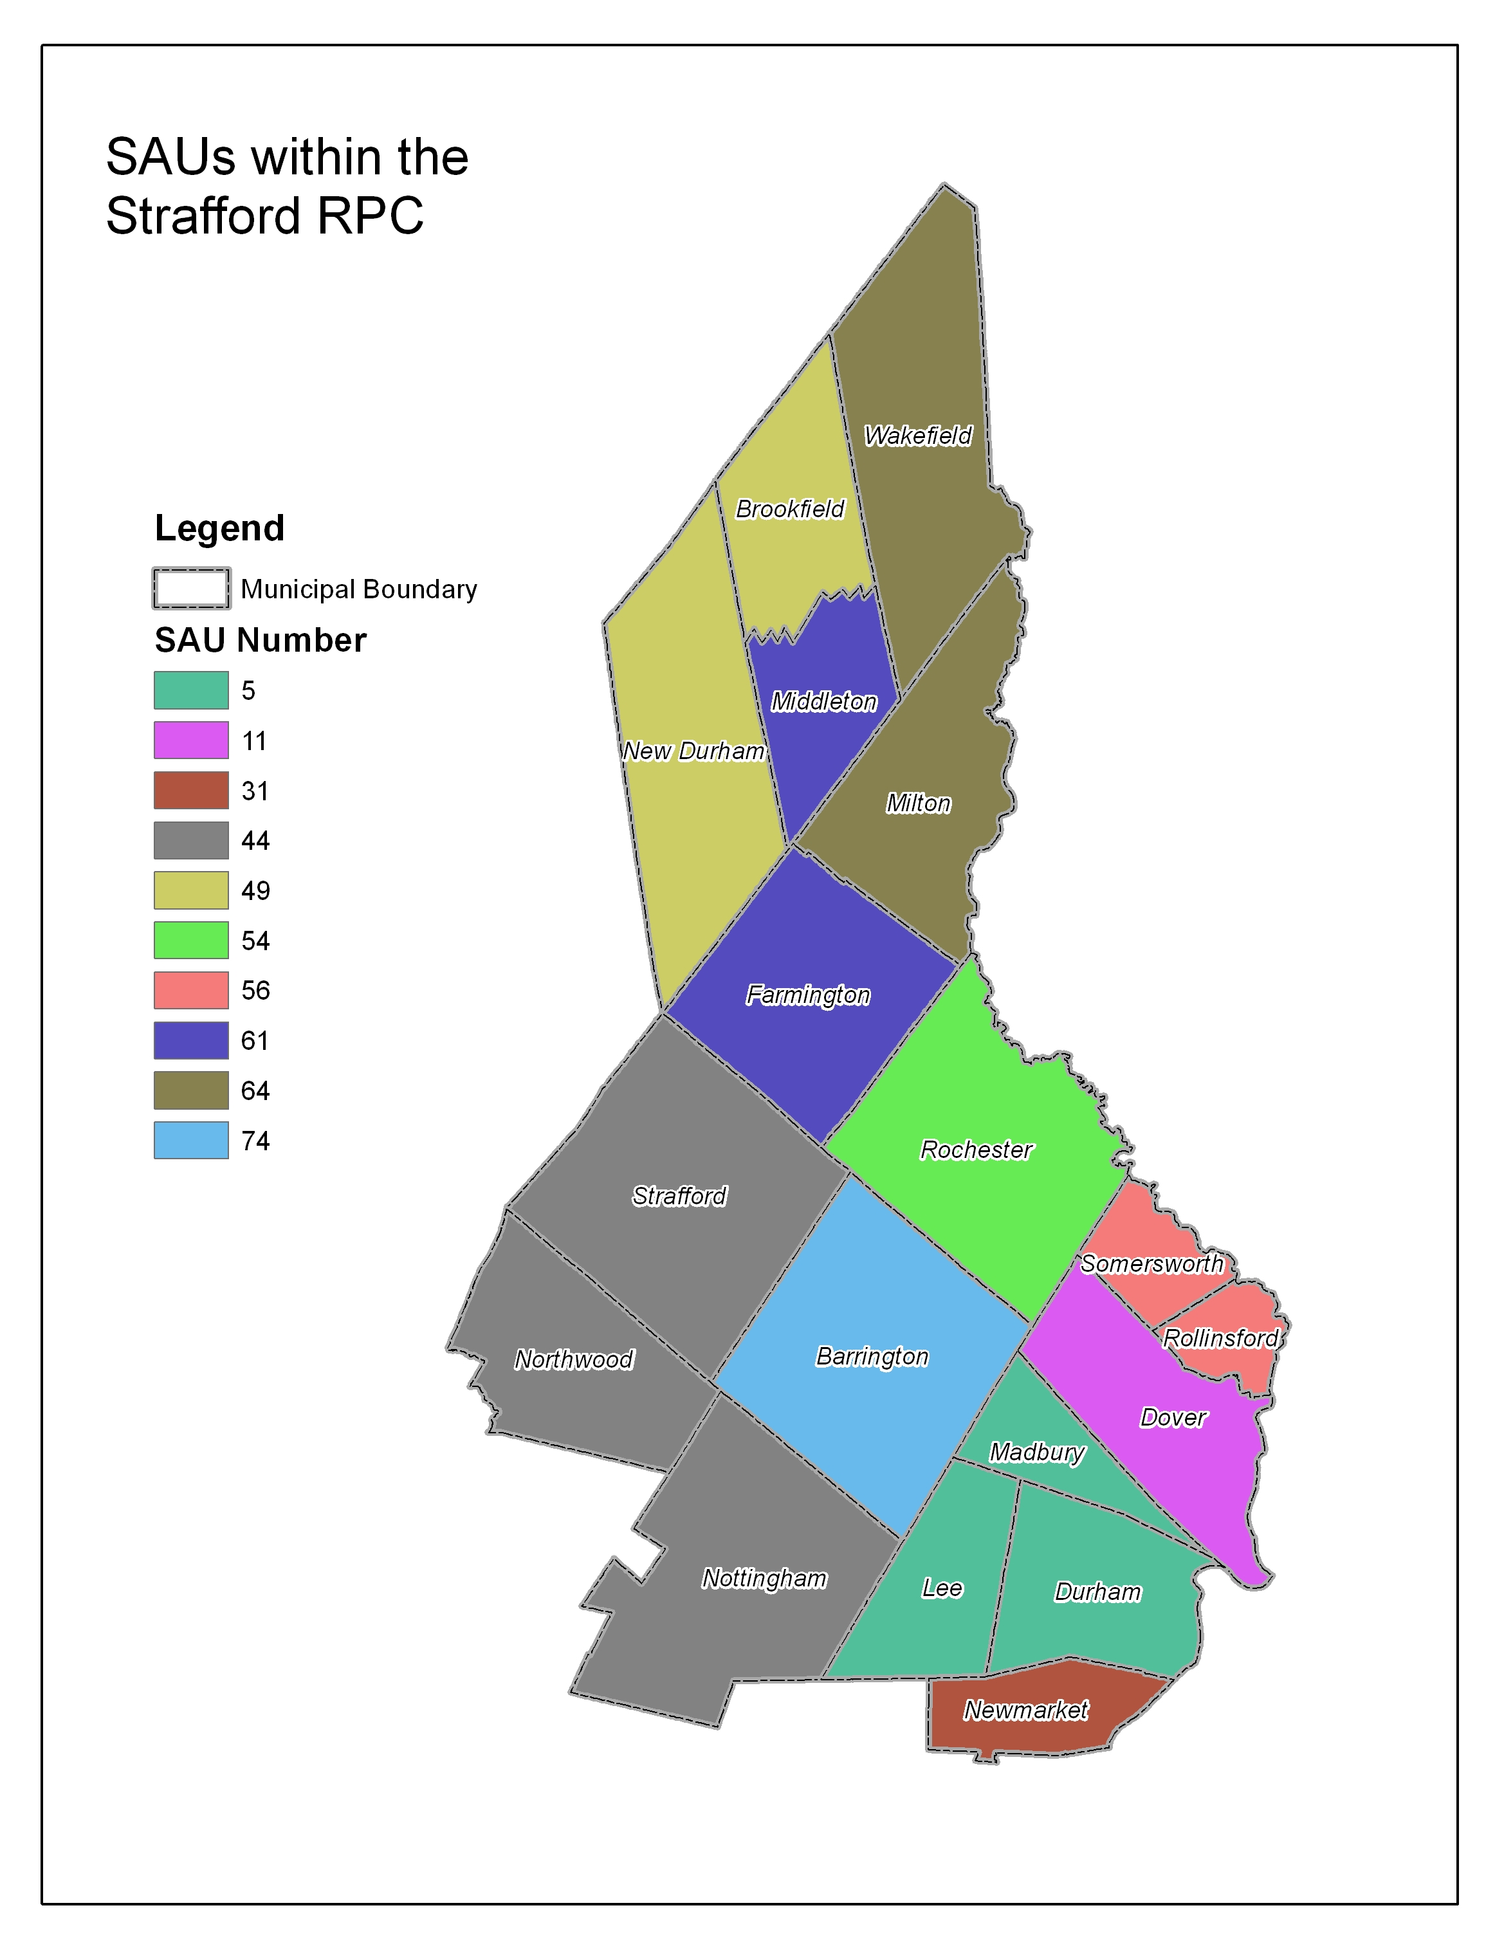

Table 35. Public Schools
[Source: NH Department of Education 2011]
CEDS Region Public Schools
Town | School | SAU | Grade Span
Barrington | Barrington Elementary School | 74 | K 1-4
Barrington | Barrington Middle School | 74 | 5-8
Dover | Dover Middle School | 11 | 5-8
Dover | Dover Senior High | 11 | 9-12
Dover | Garrison School | 11 | K 1-4
Dover | Horne Street School | 11 | K 1-4
Dover | Woodman Park School | 11 | K 1-4
Durham | Oyster River | 5 | 5-12
Farmington | Farmington High School | 61 | 9-12
Farmington | Henry Wilson Memorial School | 61 | 4-8
Farmington | Valley View Elementary School | 61 | K 1-3
Lee | Mast Way School | 5 | K 1-4
Madbury | Moharimet School | 5 | K 1-4
Milton | Milton Elementary School | 64 | K 1-5
Milton | Nute High School | 64 | 9-12
Milton | Nute Junior High School | 64 | 6-8
Rochester | Bud Carlson Academy | 54 | 9-12
Rochester | Chamberlain Street School | 54 | K 1-5
Rochester | East Rochester School | 54 | K 1-5
Rochester | Maple Street School | 54 | K1-3
Rochester | McClelland School | 54 | K 1-5
Rochester | Nancy Loud School | 54 | K 1-3
Rochester | Rochester Middle School | 54 | 6-8
Rochester | School Street School | 54 | K 1-4
Rochester | Spaulding High School | 54 | 9-12
Rochester | William Allen School | 54 | K 1-5
Rollinsford | Rollinsford Grade School | 56 | K 1-6
Somersworth | Hilltop School | 56 | 1-4
Somersworth | Maple Wood Elementary School | 56 | K 1-4
Somersworth | Somersworth High School | 56 | 9-12
Somersworth | Somersworth Middle School | 56 | 5-8
Strafford | Strafford School | 44 | K 1-8
Wakefield | Paul Elementary School | 64 | K 1-8
Wakefield | Coe-Brown Academy | 201 | 9-12

Table 36. CEDS Region Non Public Schools
[Source: NH Department of Education 2011]
CEDS Region Non Public Schools
Town | Name | Grade Span
Dover | Cross Road Kindergarten and School | K-3
Dover | My School | K-1
Dover | Portsmouth Christian Academy | K-12
Dover | St. Mary Academy | K-8
Dover | St. Thomas Aquinas High School | 9-12
Milton | Shortridge Academy | 9-12
Rochester | Lighthouse Christian Academy | K-12
Rochester | St. Elizabeth Seton School | K-8
Somersworth | Somersworth Tri City Christian Academy | K-12

Career Technology Centers are located throughout the region that offers “hands on” educational opportunities. The northern CEDS region is served by the Wolfeboro Vocational Technical Center. It is not in our CEDS region.

Table 37. CEDS Regional Career Technology Centers
[Source: NH Community Profile]
Regional Career Technology Centers
Town | Name
Dover | Career Technical Center
Rochester | Creteau Regional Technology Center
Somersworth | Career Technical Center
Wolfeboro | Region 9 Vocational Technical Center

In 1999 the Community College System of New Hampshire (CCSNH) introduced the Running Start program, a partnership between the Community Colleges of New Hampshire and high schools to give students an opportunity to take college courses for college credit while also completing the requirements for high school graduation. This is offered at many schools in the region.

Chapter 7: Environmental Profile

Natural Resources

Water is Strafford County’s most important resource. The county’s diverse natural resources include the Cocheco, Salmon Falls, Isinglass, Oyster and Bellamy rivers, extensive forests, and a significant amount of agricultural land. The economic value, recreational opportunities and natural beauty of these resources are a great asset to the county. The emergence of watershed-based planning efforts reflects countywide recognition of the importance of its freshwater resources and the need to manage them for future sustainable use. Combined with the employment opportunities, services and cultural amenities offered by the urban portions of the county, Strafford County’s natural resources provide an attractive living environment in local communities and add substantially to the quality of life.

Resource-based industries within the county provide an employment base for many people, particularly in rural communities, in individual agricultural businesses, forestry, mining, and the processing of raw natural resources. Reservoirs, aquifers and rivers provide fresh water to several Seacoast area communities outside of Strafford County, and their continued protection is a priority. Tourism and recreation associated with natural resources is increasingly important to local communities. Recognition and support of this sector of the regional economy is growing.

One of the fundamental factors influencing the region’s economy is the natural resources and environmental capital. The region’s primary developed areas are located along the major rivers. In the rural areas the natural environment can act as a constraint to overall growth and commerce while providing the region with water and rural character. The region has four designated rivers: Cocheco, Isinglass, Oyster and Lamprey, which are managed and protected for their outstanding natural and scenic resources.

Piscataqua River Basin

The Piscataqua River Basin, and in particular its watershed, is vital to the communities within Strafford County and beyond, providing water resources to numerous municipalities within the Seacoast region as well as containing critical plant and wildlife habitat. Shoreline development threatens the environmental condition of these riverine systems, removing plant cover, which leads to increased runoff and erosion and fragmenting habitat in the process. Population growth within the region adds to non-point sources of pollution and increases demand for freshwater drawn from the system.

Several institutions are in place to help manage estuary resources, including both public agencies, research institutions and a multitude of nonprofits focused on coastal resource protection, outreach and education. The New Hampshire Coastal Program, which helps coordinate public regulation and investments in the coastal area and provides planning and project development funding, has been in place since the early 1980s. In the early 1990s, the Great Bay Estuarine Research Reserve was established to increase resources available for scientific research and public education in the estuary. Most recently, the Environmental Protection Agency provided funding to help create the New Hampshire Estuaries Project, now the Piscataqua Region Estuaries Partnership, which has been implementing its Management Plan over the last decade plus. The Plan identifies and prioritizes a wide array of initiatives that should be taken to help preserve and protect the health of the estuaries in both New Hampshire and Maine.

Estuarine and Coastal Resources
The Great Bay is both a saltwater and freshwater estuary located in Strafford and Rockingham counties in southeast New Hampshire and in southwest Maine. It is one of 28 estuaries of national significance designated by U.S. Environmental Protection Agency, and, reaching fifteen miles inland, is one of the most recessed estuaries in the United States. It adds 144 miles of tidal shoreline to New Hampshire’s seventeen miles along the Atlantic Ocean.
The Great Bay estuary occupies over 6,000 acres, not including its tidal river tributaries. The outlet is at Hilton Point in Dover, New Hampshire, where waters from Great Bay flow into the Piscataqua River, then proceed southeast to the Atlantic Ocean near Portsmouth.
Tributaries to Great Bay include the Bellamy, Oyster, Lamprey, Squamscott, and Winnicut Rivers. The Piscataqua River is formed when the Cocheco and Salmon Falls Rivers join together at Three Rivers along the Dover Rollinsford municipal lines. Altogether these coastal river watersheds include 10% of New Hampshire’s land area, and one third of the state’s populations and businesses.
Great Bay estuary is home to the Great Bay National Estuarine Research Reserve and the Great Bay National Wildlife Refuge, and additional lands protected for their water and habitat values by national, state, regional and local land trusts and individuals.

Tourism

Strafford County has numerous cultural and recreational amenities. The many lakes, parks, historic downtowns and sites, cultural centers, festivals and events draw tourism to the county. One of the primary challenges facing Strafford County, given the rapid economic expansion the Seacoast region is experiencing, is how to maintain the quality of its recreational amenities and open space, and how to best use these assets as part of a comprehensive economic development strategy.

Strafford County is home to several historically significant agricultural and industrial sites. Brick mill buildings from the region’s peak industrial days can be found alongside major rivers, connecting modern town centers with the past. Important agricultural lands such as The New Hampshire Farm Museum in Milton have been preserved and offer the public the opportunity to visit an operating historic farm.

The University of New Hampshire in Durham hosts a wide variety of events including theater productions, concerts, sporting events, lectures, and exhibits. In addition, UNH holds several farms and forested lands of historical importance and recreational value. Other theaters are spread throughout the county and several communities’ host festivals coinciding with seasonal events.

Recreationally, Strafford County’s access to lakes, rivers and the Gulf of Maine coastline is attractive to recreational fishers and boaters.

Agricultural Land

Agricultural lands, both active and inactive, make up a portion of the CEDS region’s economic activity covering the production and sales of cash crops. These include horticultural crops, fruits and vegetables, dairy farming, equestrian, and forest products. It is a small portion of the economic activity, but the local foods movement could be a potential niche market.

Open Space and Conservation Land

Open space conservation is an important issue in southeast New Hampshire because of continued development. Natural beauty and scenic character are a part of the CEDS regional economy. The growth in Strafford County has resulted in loss of agricultural lands, scenic landscapes, wetlands, historic buildings and other features. With increased population growth a new set of problems occurs such as traffic congestion, air quality, water quality and other negative results. This is why it is increasingly important to protect areas of significant scenic, water and habitat importance.

Land conservation activities are carried out at the local level, private and public sectors.
Many communities in the CEDS region have active land conservation efforts and plans to acquire land and provide stewardship of these lands. Several properties protected in the 2000’s are now in active agricultural use.

Table 38. County Recreational Inventory
[Source: 2007 Recreation Inventory, NHOEP]
Area | Camp-ground | Field Sport Areas | Golf Courses | Historic Areas | Natural/Passive Recreation Areas | Parks/Picnic Areas | Water Sports/Fishing Areas | Winter Sports/Skiing Areas
Belknap | 34 | 31 | 10 | 2 | 57 | 32 | 80 | 3
Carroll | 59 | 28 | 9 | 9 | 111 | 24 | 68 | 14
Cheshire | 26 | 56 | 7 | 3 | 146 | 43 | 47 | 1
Coos | 28 | 24 | 9 | 2 | 122 | 35 | 47 | 6
Grafton | 53 | 85 | 14 | 9 | 145 | 31 | 66 | 17
Hillsborough | 28 | 149 | 20 | 14 | 247 | 100 | 54 | 7
Merrimack | 23 | 76 | 10 | 21 | 173 | 59 | 66 | 7
Rockingham | 42 | 159 | 23 | 26 | 263 | 178 | 68 | 6
Strafford | 22 | 46 | 7 | 5 | 104 | 46 | 25 | 3
Sullivan | 10 | 23 | 6 | 6 | 53 | 35 | 32 | 2
STATEWIDE | 325 | 677 | 115 | 97 | 1420 | 583 | 553 | 66

Table 39. County Public Water Access Sites
[Source: NH Public Access Sites, NHFG 2007]
NH Fish and Game Public Water Access Sites
 | Sites Listed | Trailer Parking | Canoe/Car-top Parking | Shore-Bank, Roadside or other parking
Belknap | 11 | 7 | 4 | 0
Carroll | 10 | 4 | 5 | 1
Cheshire | 24 | 15 | 9 | 0
Coos | 22 | 12 | 9 | 1
Grafton | 29 | 20 | 9 | 0
Hillsborough | 19 | 15 | 3 | 1
Merrimack | 44 | 28 | 9 | 7
Rockingham | 19 | 12 | 5 | 2
Strafford | 14 | 8 | 5 | 3
Sullivan | 14 | 10 | 3 | 1
STATEWIDE | 206 | 131 | 61 | 16

Table 40. Strafford CEDS Regional Cultural Resources
[Source: NH Business Guide, http://www.nh.com/nh/home/, NH OEP, Town Websites]
Regional Cultural Resources
Resource | Town
Artstream Studios | Rochester
Children’s Museum | Dover
Demeritt Hill Farm | Lee
Emery Farm | Durham
Flag Hill Winery & Distillery | Lee
Farmington Recreation Rail Trail | Farmington
Garrison Players Theater | Rollinsford
Hilltop Fun Center | Somersworth
Johnson Theatre; Paul Creative Art Center at UNH | Durham
Millpond Center for the Arts | Durham
Museum of Art at the UNH | Durham
Museum of Childhood | Wakefield
New Hampshire Farm Museum | Milton
Rochester Fairgrounds | Rochester
Rochester Opera House | Rochester
Rotary Arts Pavilion | Dover
Somersworth Historical Museum | Somersworth
Tuttle’s Farm | Dover
UNH Marine Docent Program Discovery Cruises | Durham
Whitmore Center | Durham
Woodman Institution | Dover

Outdoor Activities and Recreation

Most people would not see their morning run or evening walk as outdoor recreation but these are two of the most popular activities that New Hampshire residents and visitors participate in on a regular basis. Sightseeing and visiting beaches are two other popular activities. Demand for outdoor activities is increasing due to population growth, personal health goals, and increased popularity.
The New Hampshire Statewide Comprehensive Outdoor Recreation Plan was last updated in 2007 by the New Hampshire Office of Energy & Planning. Surveys in the 2007 plan showed that local recreational demand exceeds supply for many activities ranging from campsites, trails, athletic fields, bike lanes, dog parks, and motorized recreation. Six statewide focus areas were developed as follows:
Stewardship of the natural resource base for outdoor recreation activities ties directly to tourism and the economy. Development of land and population growth can directly impact these resources. Southeast New Hampshire will be absorbing most of the population growth over the next twenty five years making stewardship of the natural resource base critical in the Strafford region.
With the number of tourist destinations along the coast, at the lakes and mountains of New Hampshire, it is important to provide different, sometimes competing, recreational opportunities in local, close to home venues. This is an opportunity for the Strafford region to build a niche market in close to home activities.
Funding is needed to support local and regional recreational opportunities, including facility rehabilitation, development and land acquisition for organized and unorganized activities. The Strafford region has a strong network of volunteers, land trusts, nonprofits, businesses, governments and schools working to provide excellent services and facilities.
Education is needed for recreational users, municipalities and landowners to understand responsible behavior, laws and liability. With increasing demand for activities, it is important that every party understand their role and responsibilities to manage conflicts and concerns. Again, the Strafford region is dependent upon the existing network of providers, users, and benefactors who teach hunting and gun safety, “pack it in and out” behaviors, as well skills and knowledge needed to have positive experiences outdoors.
Current land use patterns of low density development and single occupant vehicular use can have a negative effect on recreational opportunities. A better way is to work on preserving the existing natural resource base, creating networks of trails, paths and greenways. In the Strafford region there are a growing number of residents interested in working in these areas.
Outdoor recreation activities promote increased wellness and health. Many schools, health centers, and employers in the Strafford region are linking programs and funds to better promote and provide for opportunities in neighborhoods, communities and access to information.

Table 41. Strafford CEDS Regional Outdoor Recreation Activities
[Source: NH Business Guide, http://www.nh.com/nh/home/, NH OEP, Town Websites]
Regional Outdoor Recreation Activities
Resource | Town
Adams Point | Durham
Barbados Pond | Madbury
Bellamy River Wildlife Area | Dover
Blue Job fire tower | Farmington
Cocheco River Conservation Area | Dover
College Woods | Durham
Cooper Cedar Woods Forest | New Durham
Doe Farm | Durham
East Foss Farm | Durham
Ellis Hatch Jr. Wildlife Management Area | Brookfield
Garrison Hill Tower | Dover
Hilton State Park | Dover
Jackson Landing | Durham
Jennings Forest | New Durham
Jones Forest | Madbury
Kingman Farm | Madbury
Lang maid Road | Durham
Little River Park | Madbury
Mill Pond | Durham
Old Reservoir | Durham
Old Town Landing | Durham
Strafford County Farm | Dover
The Commons Park | Rochester
Thompson Farm | Durham
UNH Outdoor Recreation Center | Barrington
Wagon Hill Farm | Durham
West Foss Farm | Durham
Willard Pond | Dover
Wolfeboro Branch Recreational Trail | Wakefield
Woodridge Recreation Area | Durham

Natural Hazard Mitigation

Strafford Regional Planning Commission is responsible for assisting communities with the development of municipal hazard mitigation plans. The New Hampshire Homeland Security and Emergency Management state bureau (NHHSEM) contracts with the nine regional planning commissions to develop and update municipal Hazard Mitigation Plans every five years. This enables municipalities to be eligible to receive hazard and disaster related mitigation funds. Natural Hazard Mitigation Plans are a required document in accordance with the Disaster Mitigation Act of 200 (DMA 2000. This requires municipalities to have a Federal Emergency Management Agency (FEMA) approved plan in order to receive Pre-Disaster PMD project grants. Also local governments must have a FEMA approved Plan in order to receive Hazard Mitigation Grant Program (HMGP) project funding for disasters declared or after November 1, 2004.

These plans are compiled to aid municipalities in reducing and mitigating future losses from natural and man-made hazardous events. These plans identify past hazard events, community assets and risks, potential damages, and strategies to mitigate losses from hazardous events. The planning process includes reviewing other municipal plans, ordinances, regulations and best practices, technical manuals, federal and state laws and regulation as well as researched data. By combining these elements, the participants from the hazard mitigation teams are able to produce an integrated multi-hazard plan that can be incorporated into other municipal activities such as comprehensive land use planning, capital improvements planning, site plan regulations, emergency response, and buildings codes to guide and control development, when appropriate.

Environmental Issues

Great Bay Water Quality

As reported in 2009 by the Piscataqua Region Estuaries Partnership (PREP) in its State of the Estuaries Report, the environmental quality of the estuary is declining over the past five years as the total nitrogen load to the Great Bay increased 42%. This is largely due to stormwater runoff and nonpoint source pollution. Water clarity has declined and eelgrass habitat has been displaced. Indicators such as nitrogen concentrations, eelgrass, oysters, and impervious surfaces continue to have a negative trend, which demonstrates deteriorating conditions.

Water Quality

Water is among Strafford County’s most important natural resources, and protection of water resources continues to be a priority. Most groundwater in the county is of good quality, and no immediate threats to groundwater are on the horizon. Meanwhile, several rivers historically polluted with heavy metals and toxic chemicals from past industrial use are cleaner than they’ve been in decades thanks to continuous efforts by communities to protect river resources. Drinking water for Strafford County communities is obtained both through ground and surface water, and surface waters within the county service communities in other regions as well. Protection efforts are largely dependent upon appropriate land use regulation and conservation of lands. Communities have adopted watershed-based planning efforts to protect open space and minimize point & nonpoint sources of water pollution. Significant aquifers in the county are protected in several communities by overlay zoning protection and wellhead protection areas.

Air Quality

The Clean Air Act Amendment of 1990 (CAAA) requires that all areas of the country meet federal standards for air quality. Under the CAAA, areas with levels that exceed federal standards more than three times over a three-year period are designated as non-attainment areas. The CAAA requirements led to the designation of the entirety of Strafford and Rockingham counties as non-attainment regarding ground level ozone. As a result, the State has implemented measures to reduce emissions of ozone and its precursor pollutants, nitrous oxide and volatile organic compounds (VOCs). Transportation planning in the region undergoes a rigorous process to determine the state of progress toward air quality goals and objectives.

Businesses, which are new or existing “major sources” of nitrous oxide or VOCs, may incur costs associated with the purchase and operation of state-of-the-art pollution control equipment. Due to the costs associated with these requirements, new or existing “major sources” may seek relocation to cut operating costs.

Invasive Species

Per the definition written in Executive Order 13112 establishing a National Invasive Species Council, an invasive species is a plant that is non-native to the ecosystem under consideration and whose introduction causes or is likely to cause economic, environmental, or human health harm. These non-native species aggressively compete with and displace the local flora and fauna communities.

These non-native species often come from areas that have similar climates. Some species were introduced accidentally in packing material, as crop contaminants, in shipping containers or from the cargo holds of ships. But many invasive plants have been brought here deliberately. Only a small portion of non-native species is invasive. Exotic or non-native species are considered to be invasive only when they cause harm.

If a non-native plant is used over a long period of time, it stands a better chance of naturalizing. Extensive use in landscaping also increases the likelihood that a plant will naturalize, which is the first step to becoming an invasive problem. Many invasive species start on disturbed soils and habitat disturbances such as construction, grading, plowing and mowing which can increase the vulnerability of any habitat to invasive species. Areas such as rights-of-way, fencerows, old fields, ditches and roadsides all have a high rate of disturbance.

Many invasive plants were initially introduced for landscaping. Some non-native plants were used here for many years before they became an invasive problem. This phenomenon has been termed “The Lag Phase”. This refers to the period of time after a plant has been introduced, escapes, and naturalizes but before the population reaches the point at which it begins to increase rapidly. It may take decades before a plant becomes an invasive problem. This is one reason it is important to track populations of non-native plants that have escaped and naturalized, even though they may not actually be invasive at this time. Tracking non-native plant populations is especially important for species that have been shown to be an invasive problem in other regions, states or countries.

Established in 2005 in Georgia, the Early Detection Distribution Mapping System (EDDMS) collects real-time tracking reports that are verified by state verifiers. Within the state of New Hampshire there are 326 exotic species and 15, 853 reports recorded on EDD Maps. By category forbs/herbs leads with 188 species, followed by grass or glasslike at 41 species; shrub or subshrub at 37 species; hardwood trees at 28 species; vines at 21 species, aquatic at 5 species; and conifer trees at 2 species.

In descending order of abundance these invasive species are found in all ten New Hampshire counties: Japanese knotweed, autumn olive, purple loosestrife, oriental bittersweet, glossy buckthorn, Norway maple, winged burning bush, Japanese barberry, Japanese honeysuckle, and European barberry. Strafford County leads the state with the most invasive species reported at 280 species. Invasive species may have both economic and environmental consequences for the native forest, wetlands, riverine and coastal resources that add to the quality of life existing in Strafford County.

Non-Point Source Pollution

In New Hampshire stormwater contributes to over 80% of surface water quality impairments, according to data compiled by NH Department of Environmental Services. Impervious surfaces generate significant volumes of stormwater run-off. Impervious surfaces, such as roads, rooftops, parking lots, lawns in the shoreland zone, increase the pollutant and sediment loads, and volume and velocity of water flowing into streams, rivers, and estuaries. Increasing amounts of impervious surfaces from development also contributes to increasing frequency and magnitude of flooding. Other sources of nonpoint sources pollution come from agricultural and forestry activities, septic systems, and groundwater.

Chapter 8: CEDS Regional Expectations

Vision Statement

Engage in collaborative networks to sustain and grow the region's economic vitality and median income through business development, job creation, enhancement of the tax base, educational excellence, and cultural and civic diversity, all within a historic place rich in recreational opportunity and natural beauty.

Mission Statement

The mission of the Strafford Regional Comprehensive Economic Development Strategy collaborators is to create a community of private, nonprofit and public entities that cherishes the diversity of the region and works to maximize its potential through shared actions.

The Strafford region supplies a multitude of work, living and learning environments that present choices for residents, businesses and visitors. The Strafford Comprehensive Economic Development Strategy collaborators strive to enhance the best the region has to offer through a linked effort of continuous improvements.

Through these efforts, the Strafford Comprehensive Economic Development Strategy collaborators will:

Build a business climate that encourages sustainable expansion of current employers and attracts diverse enterprises and entrepreneurs providing prosperity throughout the region.

Create innovative educational opportunities that are effective in meeting needs of current residents, attract talent to the region, and provides the workforce necessary to support business growth and development.

Maintain a quality of place ethic that values Strafford region’s natural resources, strengthens the agricultural and mill heritage, supports civic leadership and community volunteerism, and further develops cultural and recreational resources.

Develop a sustainable transportation infrastructure that not only moves people through but also to our communities to live, work and play.

Sustain high quality health, education, public safety, and social services as well as diverse housing options.

The Strafford Comprehensive Economic Development Strategy collaborators will use the following principles of regional collaboration in their work:

Regional Collaboration Principles

Focus on a compelling purpose – have a catalyst
Working together achieves shared and individual goals.

Organize around collaborative leadership.
Develop relationships that respect a diversity of ideas and views by listening carefully, building trust, understanding and agreement.

Assemble the necessary resources – have the capacity to initiate and sustain a process
Identify and put together the people, skills, information and funds needed to confidently begin and maintain the processes needed for success.

Jointly develop a shared vision and strategy of action.
Build a shared vision and action plan to achieve goals - making changes as needed and always celebrating success.

Move from vision to implementation.
Demonstrate that the potential gain is greater than the risk to the larger audiences in the region; motivate the political will needed to reach goals.

Learn and adapt for sustainable accomplishments.
Learn from achievements by adapting successes and failures to new opportunities, information and challenges.

The Strafford Comprehensive Economic Development Strategy collaborators and Strafford Regional Planning Commission staff will use the following principles of sustainable assessment to measure goals, objectives; create benchmarks, and measure progress:

Bellagio Principles for Sustainable Assessment

Guiding Vision and Goals
Develop a clear vision of sustainable development and goals to define that vision.

Holistic Perspective
Consider the well-being of social, ecological, and economic subsystems in monetary and non-monetary terms.

Essential Elements
Consider equity and disparity issues, ecological conditions, economic development, and other non-market activities contributing to human and social well-being.

Adequate Scope
Adopt a time horizon long enough to capture both human and ecological time scales; build on historic and current conditions to anticipate future conditions.

Practical Focus
Generate explicit set of categories or organizing framework to link vision and goals to indicators and assessment criteria.

Openness
Make methods and data accessible to all; make explicit all judgments and assumptions in data and interpretations.

Effective Communication
Design to address needs of users; draw from indicators and other tools to engage decision makers.

Broad Participation
Provide for inclusive representation and participation.

Ongoing Assessment
Ensure capacity for repeated measurement; adjust goals and framework as new insights gained.

Institutional Capacity
Clearly assign responsibilities; support development of local assessment capacity.

Strengths, Weaknesses, Opportunities, Threats (SWOT) Analysis

The Strategy Committee worked extensively on the Strengths Weaknesses Opportunities Threats (SWOT) Analysis over a number of meetings. The result is an up-to-date assessment of the Strafford Regional CEDS economy and environment with contributions from over twenty five economic development professionals, business owners, and nonprofits.

There was far from unanimous agreement on the committee during the SWOT analysis, but the committee was able to come to consensus.

SRPC staff created a matrix of the direct input received from committee members, which was presented at meetings. The Strategy Committee then reviewed several draft matrices at meetings and came to consensus on a final SWOT matrix. Figures 10 and 11 show the strengths, weaknesses, opportunities, and threats this region is facing in infrastructure, natural resources, workforce development, sector development, and business climate.

Figure 12. Strengths, Weaknesses
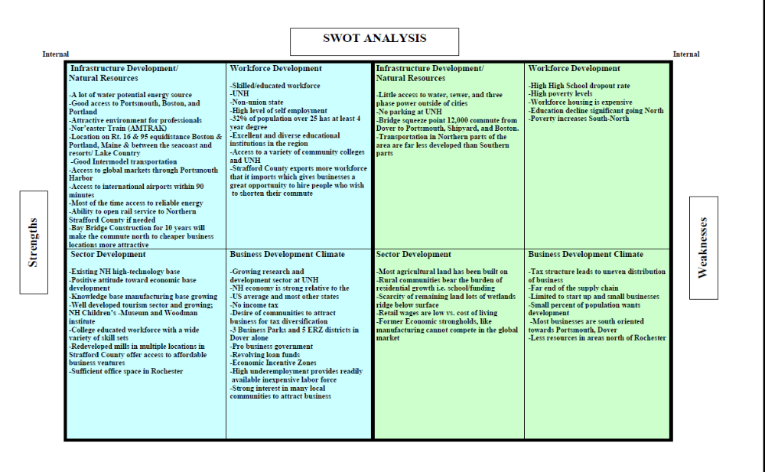

Figure 13. Opportunities and Threats
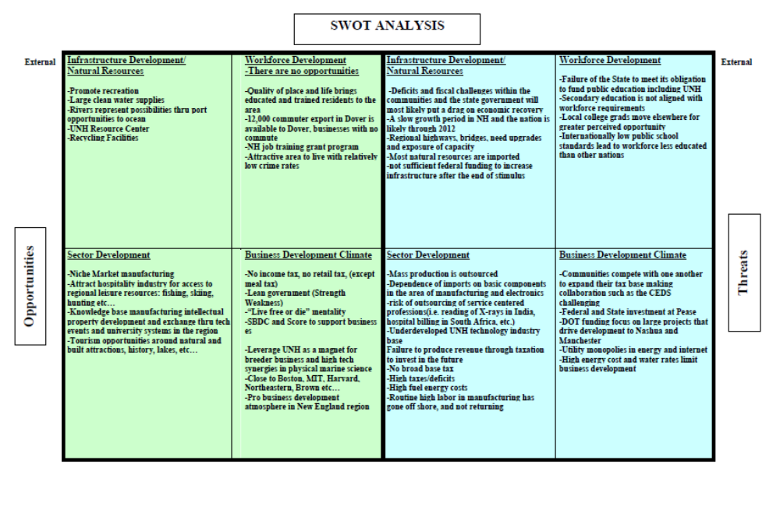

Goals and Objectives Benchmarks

Upon recommendation of University of New Hampshire Cooperative Extension staff, the Strategy Committee used a logic model as discussed in the following section. The benchmarks for the goals and objectives developed by the Strategy Committee are contained within the logic model for the CEDS. They are labeled as “Benchmarks”. Additionally, the logic model contains data and system gaps that are particularly relevant for the creation, updating and monitoring of benchmarks. The Strategy Committee was very supportive of using the logic model for the CEDS and implementation actions.

Strategy Committee Input Sessions

SRPC held Strategy Committee regional meetings from January through July 2011 with the purpose of defining the regional vision, setting goals and objectives, and developing implementation actions and benchmarks. The goals, objectives, actions and benchmarks were developed based on the consensus decisions of the Strategy Committee with input from stakeholders and individuals. A copy of each meeting minutes can be found in Volume 2, the Appendix.

Logic models help individuals and groups to plan, implement, evaluate, and communicate their work more effectively. Increasingly, funders and organizations require logic models in grant and funding requests. The premise of the logic model is to have groups and organizations start by clearly defining what outcomes, or end results, they hope to achieve. Outcomes may be defined as short-term (learning), medium-term (action), or long-term (condition). Starting with the long-term outcome, the idea is to work backwards and define what action needs to take place by a specified audience to facilitate the outcome(s), what learning needs to take place to ensure action takes place, what activities, projects and initiatives need to take place with specific audience to ensure learning, and what resources need to be in place to ensure that these activities can be implemented.
Note that SRPC staff, with support from the Strategy Committee, slightly revised the logic model format to better define specific indicators and benchmarks for the CEDS themes the strategy committee had identified.

Overall, the Strategy Committee was quite supportive of the format and content created by using the logic model, of the consensus based decision-making process, and of meeting minutes, meeting packets and general process to inform them, and invite further participation of stakeholders and the general public.

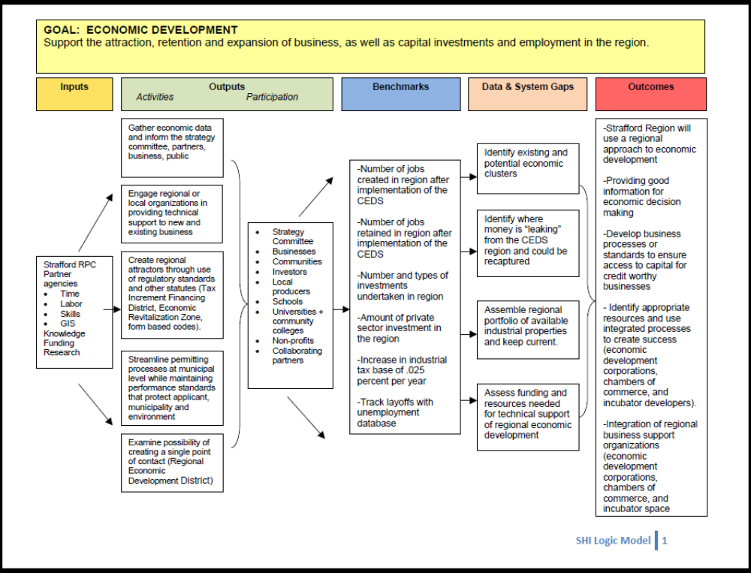
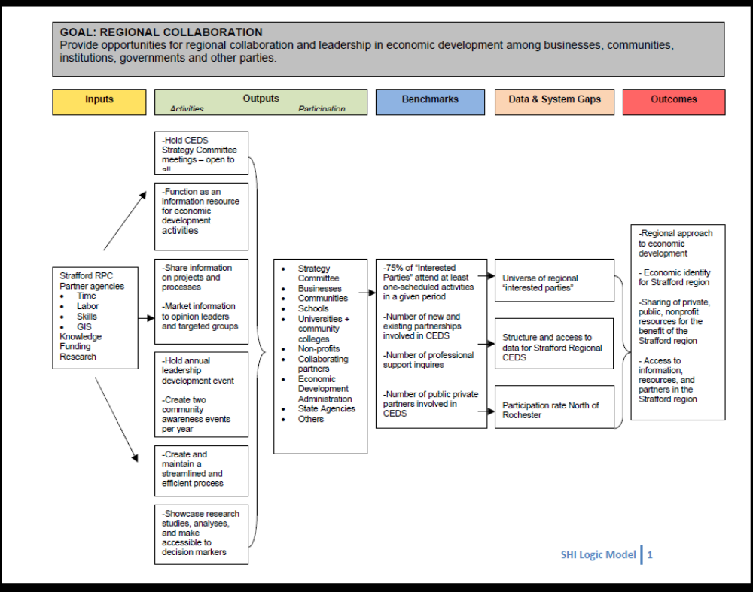
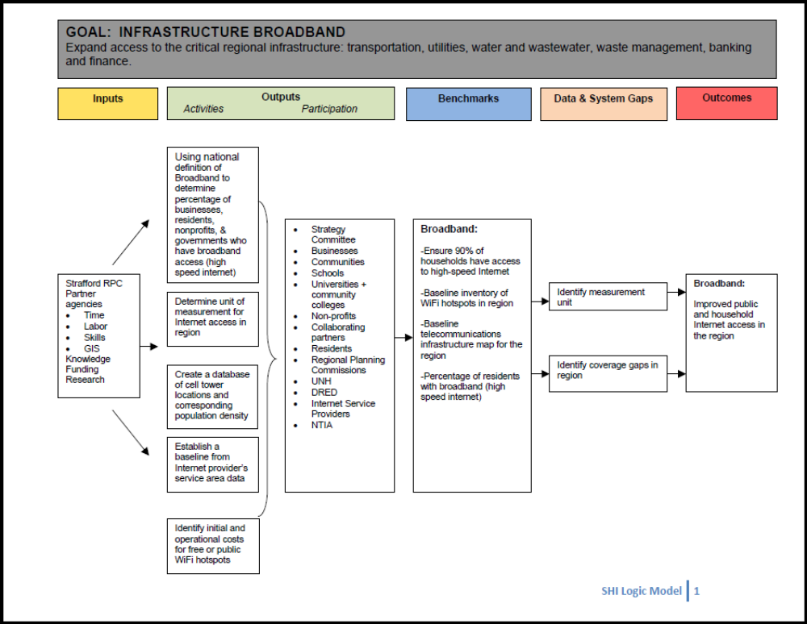
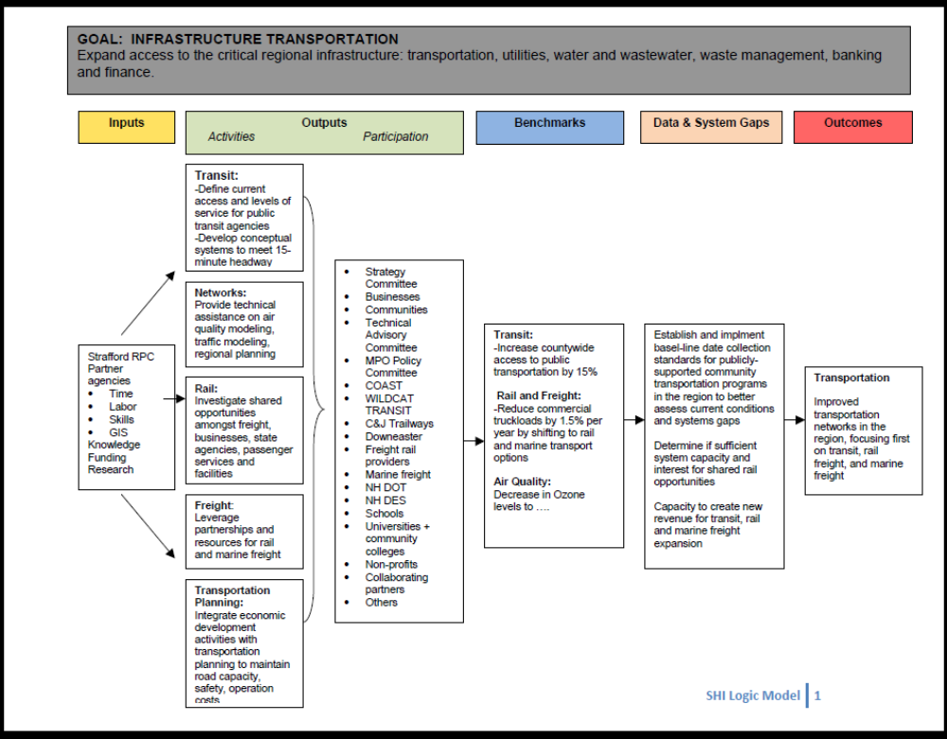
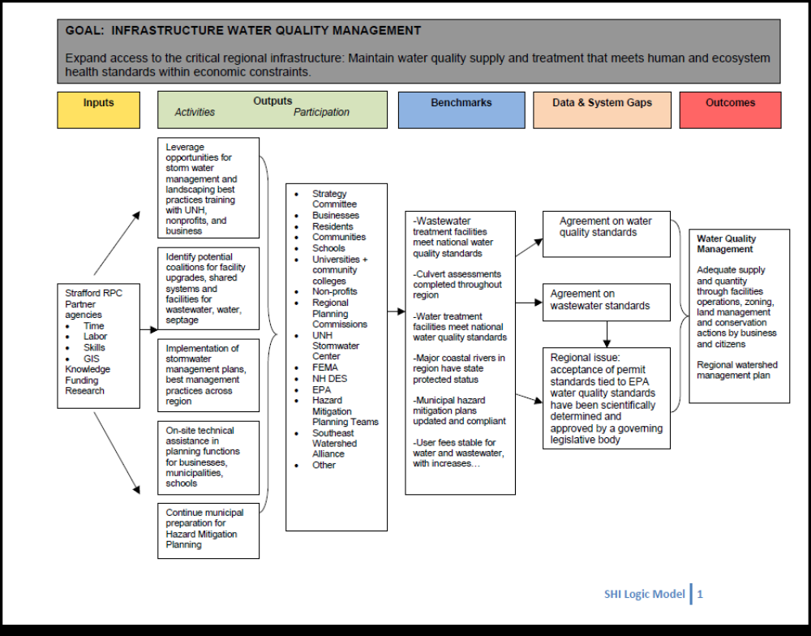
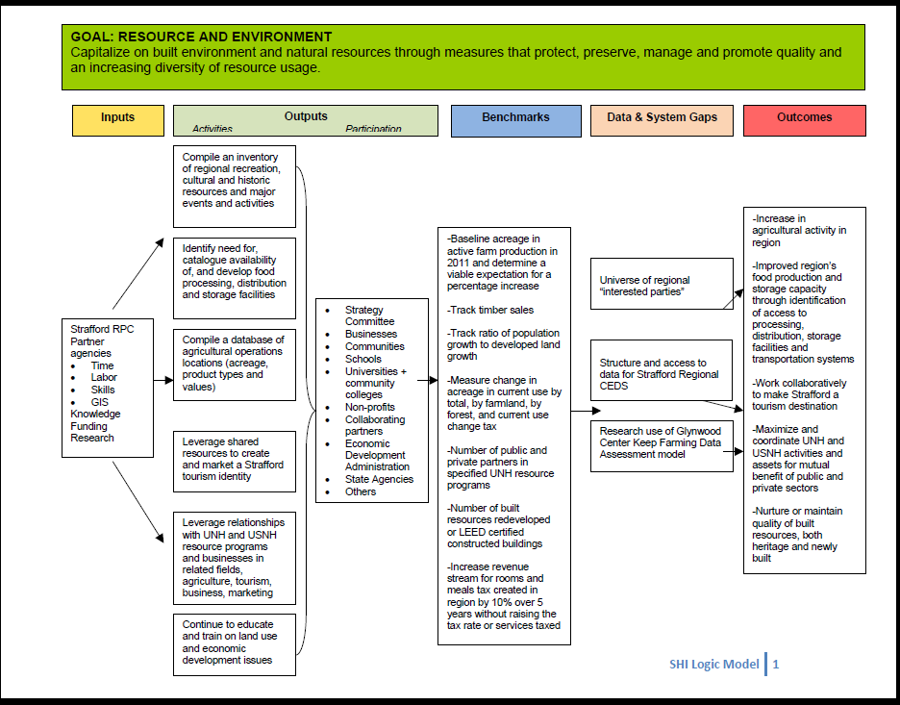
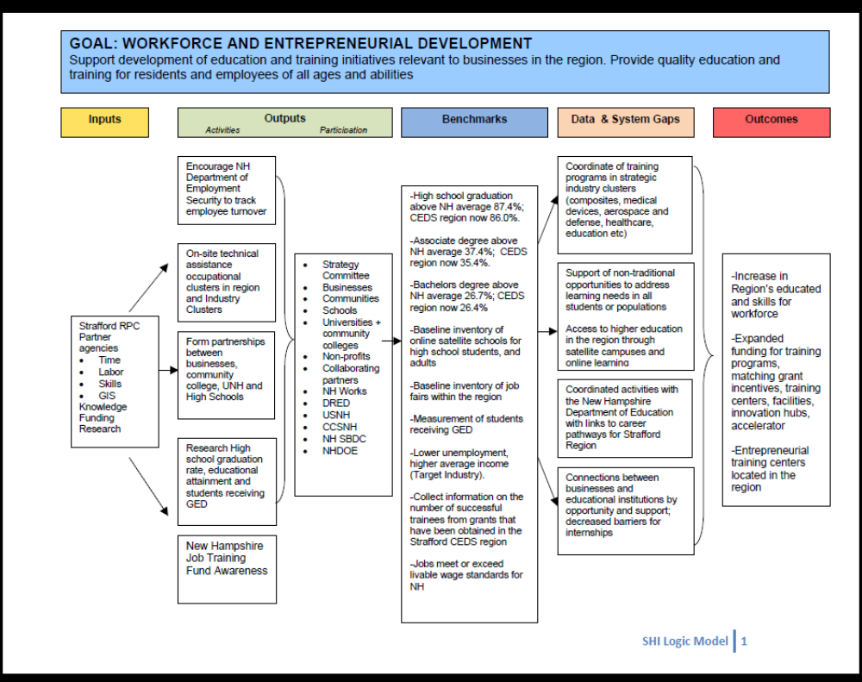
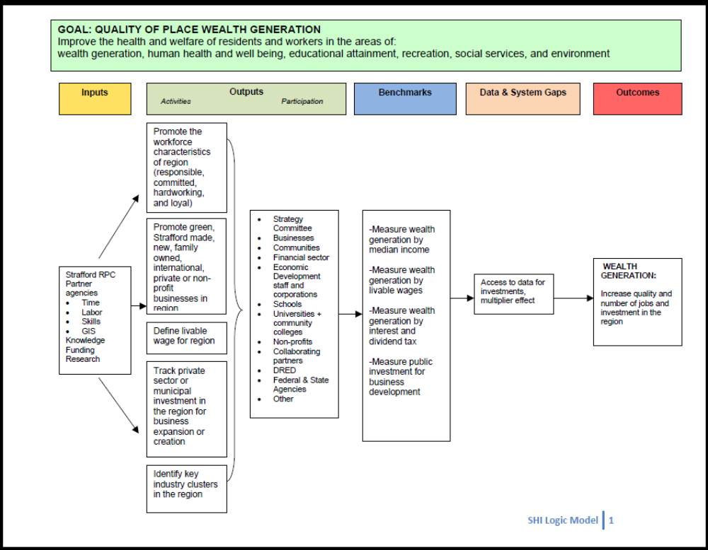
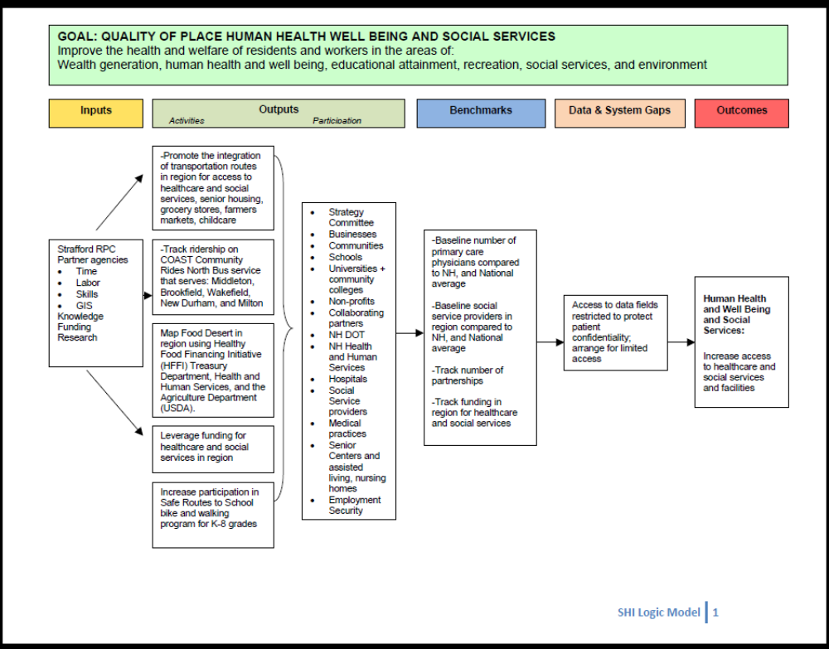
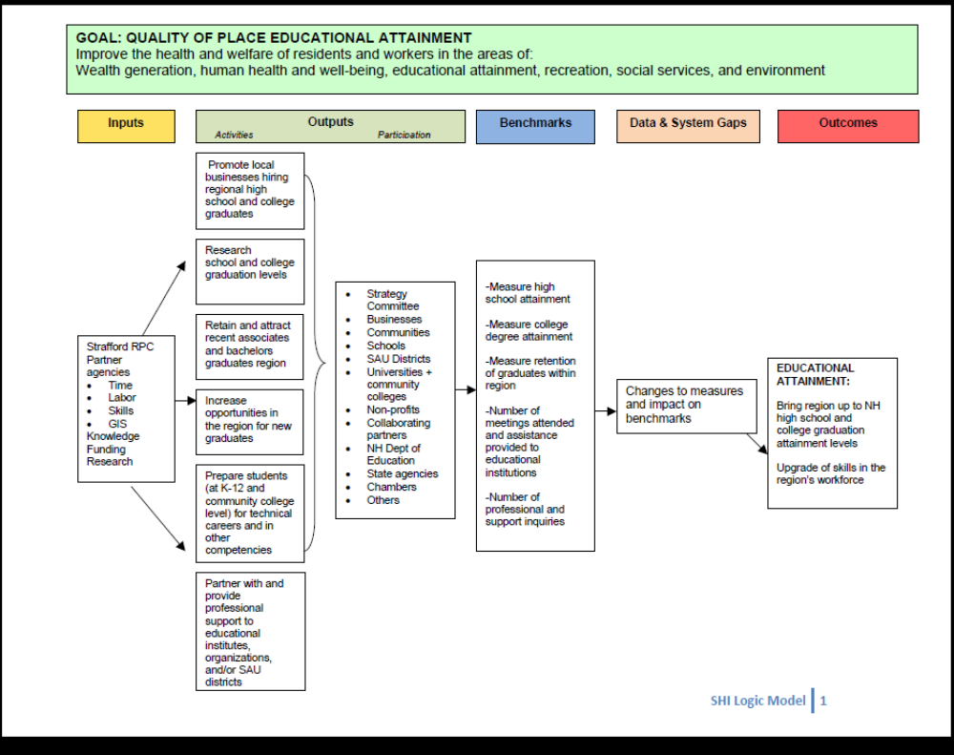
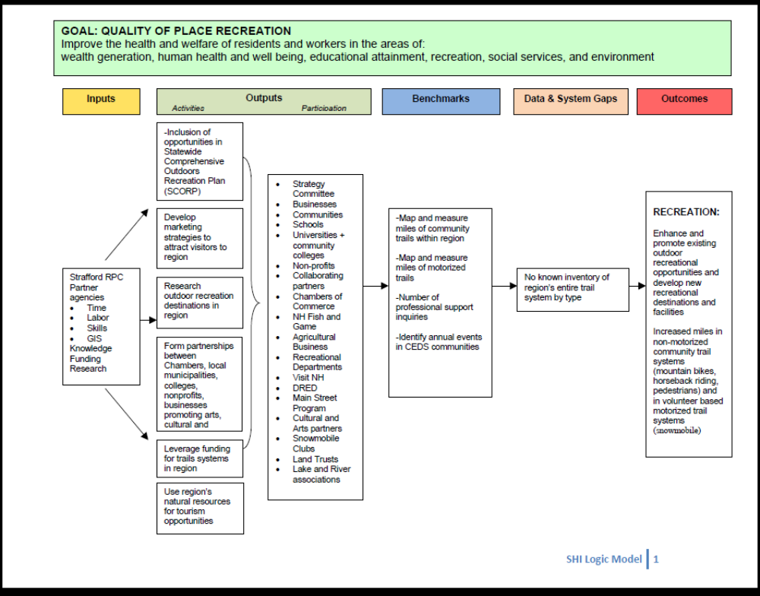
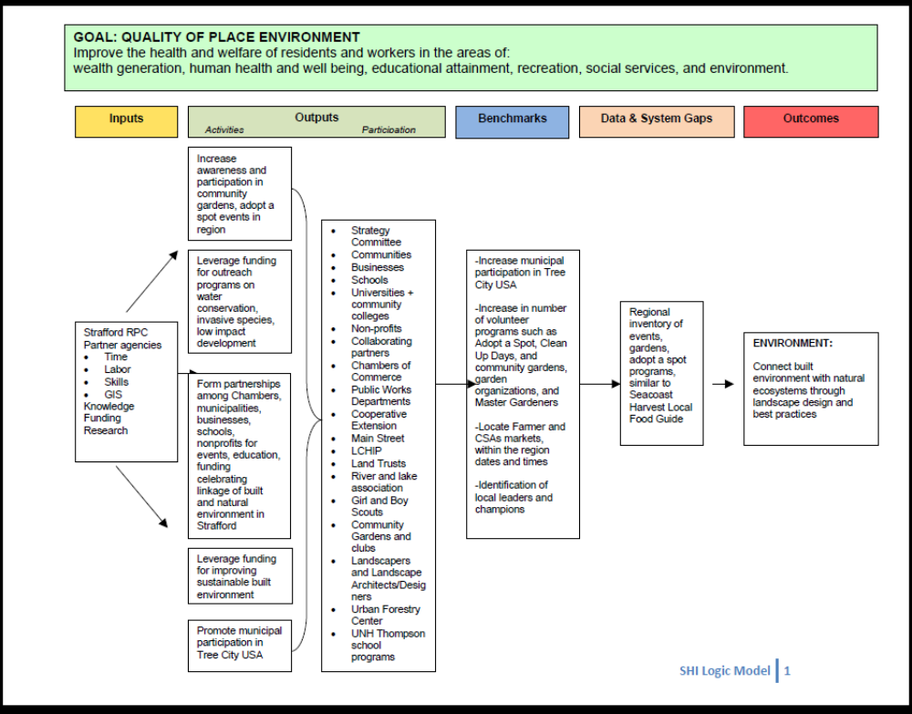

Chapter 9: Plan of Action

Purpose of the CEDS Action Plan

The purpose of the CEDS Action Plan is to lay out a road map for all entities involved in economic development in the CEDS region so they can coordinate and share resources to achieve the greatest impact. As described in earlier sections the development of this CEDS plan has been organized around six focus areas that emerged from the strategic planning process by the Strategy Committee.

Structure of the CEDS Action Plan
This section provides an overview of the activities that SRPC staff, the Strategy Committee, and other individuals and entities will undertake in 2011-2012, including specific activities and action plans that will involve work on projects in economic development, planning, coordination, and training that will promote the region.

The Strafford Regional CEDS Strategy Committee, facilitated by SRPC staff, will implement its economic development program by fully using its individual and combined resources, but will also seek partnerships with other public and private groups at local, state and federal levels.

The primary resources include:

Strategy Committee

The Strategy Committee is the advisory and guidance representative for the Strafford Regional CEDS economic development program. It represents private sector, public officials, community leaders, representatives of workforce development, and representatives of higher education and labor groups. They oversee and approve the CEDS document and its project profile list. They unify the region and provide a medium through collaboration and program development. The Strategy Committee will forge strategic alliances and communicate the region’s needs and opportunities in the future.

SRPC Staff

The staff of Strafford Regional Planning Commission roles for the action plan will include:
- After obtaining approval of the CEDS, submitting to the EDA an updated performance report annually. The performance report, in addition to reporting progress on the CEDS implementation will discuss community and private sector involvement in the CEDS effort.
- Arrange and facilitate meetings.
- Develop, coordinate, monitor data requirements for benchmarks.
- Provide information, outreach and education activities regarding CEDS and its action plan
- Work with Strategy Committee members and stakeholders on specific projects and funding opportunities.

CEDS Action Plan

The plan of action, as described in this document will implement the goals and objectives through the use of EDA guidelines and priorities:

- Promote economic development and opportunity;
- Foster effective transportation access;
- Enhance and protect the environment;
- Maximize effective development and use of workforce consistent with any applicable state and local workforce investment strategy;
- Promote the use of technology in economic development including access to high speed telecommunications;
- Balance resources through sound management of physical development; and
- Obtain and use adequate funds and other resources

The CEDS must also contain a section that discusses the methodology for cooperating and integrating the CEDS with New Hampshire’s economic development priorities.

Implementing the CEDS Goals

The development of the CEDS goals and objectives was largely accomplished through input provided at the Strategy Committee meetings. The Strategy Committee, using the knowledge base and experience of local economic development leaders, and SRPC and UNH Cooperative Extension staff, provided the direction for the goals and objectives. There were six goals that addressed areas of concern. SRPC has primary position on tracking goal implementation. The effort and responsibility for implementation of the action plan is that of the Strategy Committee, private sector, nonprofits, educational institutions, municipalities, agencies, SRPC and other identified stakeholders in the region.

The resources available to implement the Action Plan are limited and depend upon an EDA annual planning grant with local match from state and nonprofit agencies. SRPC has been successful in receiving funding for the CEDS Planning Process in its first year, and has restructured work tasks in several of its contracts to ensure that progress can be made on goals and actions during the first year of CEDS implementation. In particular work will progress on transit, broadband, and agriculture goals. It is the hope of SRPC and the Strategy Committee that other agencies and businesses will make a like contribution to the implementation of the CEDS action plan.
In the future SRPC is working, as measured by implementation activity success, to become an Economic Development District. The Strafford Regional CEDS anticipates securing funding through the EDA Public Works Grants, HUD Community Development Block Grant, and USDA Rural Development, and US DOT funds to implement many of the initiatives outlined in the 2011-2016 CEDS documents.

Project Development Process

The project development process began with the distribution of a project solicitation letter and form (in Volume 2, Appendix) to municipalities, nonprofits, education institutions, organizations, Strategy Committee, and businesses. The purpose of the project solicitation letter and project form was to better publicize the CEDS and to generate submittals for projects that may be eligible for both EDA and non EDA funding, as well as benefitting the region’s economic development. SRPC put together a package consisting of goals and objectives, an explanation of the CEDS process and projects, project submission form, and examples of past EDA investments in New Hampshire. The request for new projects was also sent via email to all municipalities in the region and follow up telephone calls as needed.

Submittals included projects ranging from the redevelopment of historic downtowns to feasibility studies for advanced technology concepts. SRPC staff provided assistance on an as-needed basis in preparation of individual project submittals.

After collecting the projects, SRPC staff reviewed each to ensure compliance with CEDS goals and objectives. The projects were grouped based on timeframe for project implementation: short-term (0-36 months), mid-term (3-5 years), and longterm (5 plus years). SRPC staff then inputted this into a project matrix that was presented to the Strategy Committee at a meeting.

The Strategy Committee reviewed the projects that were submitted. There was consensus among the Committee that all projects, in this first solicitation, should be included in the CEDS document. It was agreed that each project would help the region in the long term. There was also consensus in that projects would be listed by start date in the project matrix. The project solicitation process helped to bring in a diverse array of business ideas, concepts and infrastructure - many of which are important for the long-term economic vitality of the region. All submitted projects were evaluated by the Strategy Committee, and by consensus decision are included in the CEDS project list.

CEDS Projects

Short Term Projects (0-36 months to Completion)

Center for Agricultural and Natural Resource Base Entrepreneurship 2011-001

Project Description

Over 40% of new jobs are created by existing small businesses. Yet, economic development programs often focus on recruitment mid- to large-sized industries and commercial enterprises. The outcome of this general policy is twofold. First, recruiting industries to one region can result in the loss of industries in another region; a zero-sum game in the sense that jobs are not necessarily created, but rather, moved. Second, the focus on large enterprises means that there are few resources left over to support entrepreneurship at the local level.

Therefore, this proposal seeks to build off existing UNH resources and programs – including the Green Launching Pad, the Small Business Development Center, the Stonyfield/UNH Entrepreneur Boot Camp, and the Manufacturing Extension Center, and Cooperative Extension’s Agriculture and Natural Resources Business Institute (ANRBI) – to foster the development and/or expansion of local agricultural and natural resource-based enterprises and to help existing ones to expand. This support would be coordinated through a new Center for Agricultural and Natural Resource-based Entrepreneurship (CANRE). The audience for the Center’s services will include – but not be limited to –fishers, farmers, artisans, specialty food producers, and craftsmen.

The Center will not only coordinate technical and training resources, but it will also launch a series of new programs aimed at providing agriculture and natural resource businesses to assess marketability of products, identify opportunities to collaborate to generate economies of scale, and access technical assistance with product development, marketing, and regulations (see attached). As well, University graduate interns from the Whitmore School of Business and the Masters in Development Policy and Practice Program will be made available to businesses and communities to provide up to four months of assistance, with support from faculty advisors.

The Center will work with, and support, collaborators including the Strafford County Economic Development Corporation, the Dover Business and Industrial Development Authority, and Rochester Economic Development, Somersworth Economic Development, and the Milton Economic Development Committee. The Center will work to supplement their services, but not to duplicate them.

Center staff will include a part-time Program Coordinator, a full time Outreach Specialist, two partial FTEs whose existing staff time will be reallocated to the Center, 1-2 graduate Fellows, and collaborating staff from various UNH programs and departments. UNH Cooperative Extension will designate a program coordinator to manage the Center. Management functions include developing yearly work plans, supervising staff and graduate Fellows, fielding requests for assistance, identifying financial support for Center activities, coordinating with partner organizations and providing technical support to staff.
Purpose:

Training will also be provided to communities with Strafford County to build their capacity to foster entrepreneurship activity within the community and to implement a regional approach to economic development. Training and support will be provided in areas to include business management, market identification, marketing/branding, health and safety regulations, technology, value-added processing, etc. These supports will help to address gaps in the small business support infrastructure, specifically training, networking, business coaching, business retention and expansion analysis, community assistance, and green business research and development.

Description of Goals met:

- Economic and Workforce Development: Through training and technical support to existing and potential agriculture and natural resource based businesses, this center will help to sustain existing jobs, as well as create new local jobs.
- Quality of Life: As well, the Center will help entrepreneurs to add value to existing agricultural and natural resources, thereby enabling them to preserve farms, forests, and other amenity resources key to the quality of place in Strafford County.
- Partnerships: The Center will draw upon UNH resources, but will leverage the capacities of local organizations and entities, such as Strafford County Economic Development Corporation, the Dover Business and Industrial Development Authority, Rochester Economic Development, as well as other capacity-building entities.
- Resources and the Environment: Lastly, the center will provide technical support to fishers, farmers and foresters to help them effectively and efficiently utilize the resource base in a manner that does not jeopardize the health of resources in the future

Idea Greenhouse: Business Incubator/Proof of Concept Center 2011-002

Project Description

The Idea Greenhouse is seeking CEDS Project approval and eventual EDA funding to enhance and broaden our Proof of Concept center activities in downtown Durham, NH. The Idea Greenhouse provides three key elements to aid entrepreneurs in launching successful start-ups. These widely identified elements for new business success include Financial Support, Business Counseling and Mentorship, and Networking combined with Training Opportunities. These services will be bolstered through EDA funding.

EDA is identified as a potential partner due to the close alignment of the Idea Greenhouse to EDA priorities. Idea Greenhouse is aligned with all six of the EDA Investment Priorities: Collaborative Regional Innovation, Public/Private Partnerships, National Strategic Priorities, Global Competitiveness, Environmentally-Sustainable Development and Economically Distressed and Underserved Communities. The Idea Greenhouse Proof of Concept Center activities align with two EDA Programs: Public Works and Economic Development and Economic Adjustment Assistance.

The Great Bay/Oyster River region has a clear need for this resource. A vibrant Proof of Concept center will create jobs for local residents, accelerate diverse non-student centered growth and retail business in the downtown corridor, and has the potential to grow businesses that will rent existing or renovated downtown office space. Additionally, many students who attend UNH, located 100 yards from the Idea Greenhouse and a co-tenant of our facility, are from rural impoverished parts of the state and may be the first generation of their family to attend college. The Proof of Concept Center is purposefully inclusive of these students via internships and educational, employment, and entrepreneurship opportunities.

Description of Goals met:

- Economic Development: By design and structure the Proof of Concept Center is designed to attract, retain and expand capital investments and employment opportunities.
- Quality of Place: The Proof of Concept Center builds on the goal of wealth generation and education.
- Regional Collaborative: The design elements of the Proof of Concept Center facilitate the collaborative economic development opportunities for stakeholders listed under this goal.
- Workforce Development: A main pillar of The Proof of Concept Center is workforce development through training initiatives relevant to businesses in the region.

Somersworth Downtown Tax Increment Financing (TIF) District Study 2011-003

Project Description

The project will consist of a study to identify the scope of the district by performing research on properties within the downtown area to determine the eligibility of the proposed area for designation as a Tax Increment Financing District. The study will identify public infrastructure improvements that will be supported through the TIF and outline the process for implementation. The City’s aging downtown infrastructure is in need of upgrades and repairs. As demands for additional infrastructure and physical improvements are required as part of a downtown revitalization effort, the City needs to secure additional tools to enhance and foster private development. This is an economic development initiative that will ultimately foster needed development and redevelopment in the City’s urban core.

Description of Goals met:

- Economic Development: This project will provide incentive for economic development in the urban core.
- Infrastructure: The project will ultimately result in the upgrade of the City’s aging downtown infrastructure through funding from the TIF.
- Quality of Place: The project will create an attractive downtown area with amenities for all users.

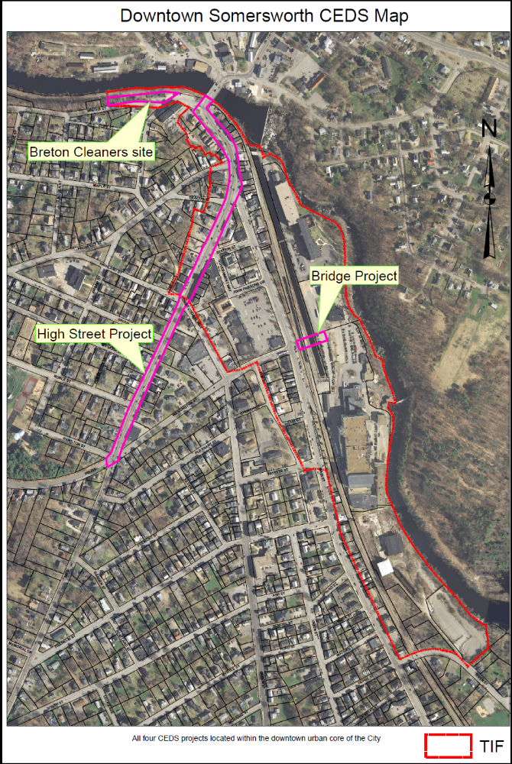
Washington Street Bridge Feasibility Study Somersworth 2011-004

Project Description

The Mill yard area of Somersworth, which parallels approximately 3000 feet of the Salmon Falls River, is an important component of the City’s industrial heritage. The City has designated this area as an Economic Development Zone, whereby there are incentives to locate a business here. Currently there are two main structures in the Mill yard area: a large former industrial mill building that has been converted to mixed residential and small business use and a smaller brick industrial mill building that is not vacant. The other dominant feature of the Mill yard area is the General Electric Meter manufacturing plant, which has been a fixture in the community for over 80 years and has long been the City’s largest employer.

The Mill yard area has two points of access: the main entrance in front of General Electric and the very narrow Canal Street entrance located at the northern end of the Mill yard. Both entrances have severe access constraints. The Canal Street Entrance is narrow and very difficult for large trucks to maneuver. Additionally, this entrance is hidden providing no visibility to the Mill yard area by the casual passerby. The Canal Street point of access requires vehicles to navigate over an unprotected, unsignalized at grade railroad crossing. The access to General Electric’s main manufacturing facility is from Main Street and is at an oblique angle to Main Street. It is difficult for delivery trucks to gain access from Main Street and results in short traffic delays from Main Street. Main Street is a significant, but depressed retail business corridor on the opposite side of the street from General Electric.

Proposal:

To perform an engineering feasibility study for the construction of a new centralized point of access to the Mill yard area by extending Washington Street over the railroad and into the Mill yard area and General Electric Property. The railroad and adjacent canal would be bridged eliminating the at-grade crossings at Canal Street and General Electric. Access to the Mill yard would be much more visible and accessible providing the opportunity for greater utilization of the mill buildings by a greater variety of businesses and thus increasing jobs both in the Mill yard as well as in the vacant storefronts on Main Street that are opposite the Mill yard area. This access point would eliminate the current access constraints posed by the hidden, narrow, and poorly aligned access points to the Mill yard area that now provides a disincentive for full utilization. The engineering study will look at alignment, elevations, orientation, and cost of this new point of access including the construction of the bridge over the existing railroad and canal.

Description of Goals met:

- Economic Development – Will provide greater access to an under-utilized industrial/commercial mixed use area of the City of Somersworth. With the improved access, a wider variety of business interests would be attracted to this area both in terms of better utilization of an existing under-utilized mill building in the Mill yard area, the open land that could be built upon in a riverside setting that could be made to be very attractive and a focal point of the community. Making this a focal point would bring additional people to the Mill yard area generating economic activity. The added activity in the Mill yard could provide more economic activity in the area making it attractive for retail businesses and shops to return to Main Street. The lack of a good and visible access to the Mill yard area is one of the elements that are constraining the ability of this area of Somersworth from reaching its full potential in this area.
- Infrastructure - Building a bridge over the railroad and canal will add to the infrastructure of the community, but will provide an alternate means of access both in terms of traffic and water supply as we would have the ability to hang a water service off the bridge and get more water to the Mill yard area for supply and firefighting capability without having to disturb the railroad right of way. Being able to bridge this property and enhancing the access to this underused area, provides an opportunity for access to rehabilitate an area that would be attractive to a wide variety of commercial interests such as banking, finance, and trade.
- Quality of Place – The Mill yard area parallels a rapidly flowing section of the Salmon Falls River. Providing greater access to the adjacent land and buildings creates an opportunity to build an area that could be destined be a focal point for the Community.

Downtown Dover Public Parking Garage 2011-005

Project Description

A public/private partnership for the construction of a 525 space public parking garage in the core of downtown Dover, NH that will provide parking for the businesses, employees and customers of all downtown merchants as well as the stressed and half empty economic anchor mills of Dover, now severely limited by the lack of sufficient parking. The area is part of the downtown Economic Revitalization Zone District. EDA funding assistance for the planning, design and construction of this facility would bring both near term and long-term jobs to the Dover downtown.

Description of Goals met:

- Economic Development
- Workforce Development
- Infrastructure
Feasibility Study for the Extension of Water and Sewer Service in Milton 2011-006

Project Description

The Town of Milton is interested in exploring the feasibility of extending the Town’s water and sewer service area. At present, the Town has sufficient capacity for both water and sewer and the intent would be to encourage additional non-residential development. The study would investigate the design, environmental, engineering and financial components related to the extension of water and sewer service. This is an important element of the Town’s economic development effort.

Description of Goals met:

- Economic Development the expansion of the Town’s water and sewer service will be targeted to those areas that have the potential for non-residential development. The overall goal is to encourage private investment in a manufacturing facility that will lead to new job creation, investment in new developments that will create new employment opportunities
- Infrastructure expand the area served by Town water and sewer
- Resource and Environment --- overall improvement to the environment through the use of public water and sewer.

High Street Reconstruction Somersworth 2011-007

Project Description

This project involves the reconstruction of approximately 2,750 feet of High Street in the downtown area of Somersworth, NH. It will involve the reconstruction of water main that is over 100 years old, evaluation and upgrade of drainage system and sewer collection system, if necessary. The roadway of this vital business corridor will also be reconstructed, while accommodating the needs of traffic and the business community.

High Street is one of the busiest roads in the City. The condition of the street and its infrastructure is old. The city has received a $400,000 Transportation Enhancement grant from the Dept. of Transportation for sidewalk and streetscape upgrades along this corridor. High Street is NH Route 9, which is a regional arterial that connects York County Maine and Strafford and Rockingham Counties in New Hampshire.

This section of High Street is the heart of the downtown business district, so during construction there will need to be accommodations for traffic circulation and to facilitate the need for continued commerce during construction activity. Improving the infrastructure and the streetscape in the downtown area will enhance the shopping experience and create more economic activity and vibrancy in what is now a sluggish downtown area.

In addition to the TE grant, the city will use State Revolving Loan Funds for water improvements and sewer and drainage improvements. The drainage improvements stand to improve the water quality of the adjacent Salmon Falls River. The City will contribute 25 percent or approximately $550,000 of the remaining cost of this effort. This grant will cover those elements that these other funding sources will not.

Description of Goals met:

- Quality of Place: downtown Somersworth is located adjacent to the Salmon Falls River, however because of storefronts and nearby old mill buildings isolates the River from the downtown area. With careful planning, the beauty of the river could be made a focal point of the downtown and made to be an attraction bringing more people to the area to occupy their time and spend money. This would create more of a sense of place for the residents, business owners, and those to choose to spend time here.
- Infrastructure: Project rehabilitates infrastructure that is old and decaying. High Street in Somersworth serves as a gateway community to southeastern New Hampshire from Maine. Its appearance needs to be rejuvenated, otherwise it will be a less attractive place to do business and its economic vitality will continue to diminish as users will be inclined to go to more appealing places. The current pavement condition is bumpy, the adjacent sidewalks are cracked, broken, and do not meet current ADA requirements. The water infrastructure, while generally serviceable is over 100 years old, so it is also in need of rejuvenation. Investing in the infrastructure will make it a more attractive center of commerce and restore what was once a vibrant downtown area.
- Resources and Environment: Enhancements to the drainage system which is located close to the Salmon Falls River will aid in meeting the resource and environment goals as it relates to improving the water quality in the river.

Breton Cleaners Site Cleanup and Reuse Study 2011-008

Project Description

The Breton Cleaners property is located at 1 Winter Street in Somersworth. The site comprises .55-acre parcel and a 3,444 square foot building. Over the years it has been used in a variety of retail and service providers. The site was used from 1982 -1995 as a dry cleaning operation. The site has been the subject of a “Hazardous Building Material Survey and Subsurface Investigation” (submitted to NHDES site # 200411112). As a documented and recognized hazardous waste site by NHDES, preliminary cost estimates for cleanup of the site range from $80,000- $193,000.

Presently the property is vacant and privately owned. There are back taxes owned on the property in excess of $28,000 and outstanding water and sewer bills.

This property in located in the downtown area and on a major gateway corridor into the community. In its current physical condition it contributes to an overall blighted appearance upon entering the community.

Description of Goals met:

- Economic Development: productive reuse of this property and removal of the hazardous waste elements will contribute to overall economic vitality in the urban core.
- Quality of Place: the physical cleanup of a deteriorated and boarded up structure will enhance the value and vitality of the adjacent properties while removing a blighted structure on our major entrance corridor into the community.
- Resource and Environment: the remediation and removal of the hazardous waste material will ensure protection to the adjacent Salmon Falls River.

Economic Development District Strafford Regional Planning Commission 2011-009

Project Description

Strafford Regional Planning Commission will be implementing the Comprehensive Economic Development Strategy to achieve the goals and objectives that the Strafford Regional Strategy Committee developed through the strategic planning process. In addition SRPC has developed collaborative relationships with federal, state, and local entities, non-profits, and private sector participant to advance the region’s economic development. SRPC within the next five years will be applying for funding through the Economic Development Administration for Economic Development Districts (EDD) designation. Currently there are only two in the State of New Hampshire: North Country Council and Rockingham Economic Development District. There are currently approximately 380 EDA-designated Economic Development Districts throughout the nation. With this designation the region will have the potential to access increased amounts of federal development funds. This designation and funds will ensure that SRPC will be able to implement the CEDS to address the unique needs of our region. In order to be eligible for this funding, SRPC will be required to complete and annually update the CEDS for the region among other responsibilities.

Description of Goals met:

- Regional Collaboration: Economic Development District will draw upon new and existing partnerships and will leverage the capacities of local organizations and entities, such as business (small business, national, and international) Strafford Economic Development Corporation, Wentworth Economic Development Corporation, University of New Hampshire, Great Bay Community College, Small Business Development Center, and other capacity-building entities. This will allow Strafford County, including Wakefield and Brookfield; to take a regional approach to economic development use shared knowledge and resources as well as leveraging and securing funding.
- Economic Development: Support the attraction, retention and expansion of capital investments and employment opportunities in the region. This will also allow us to help the Northern Strafford Regional CEDS area to explore economic development opportunities, which has been overlooked due to lack of funds.

Regional Revolving Loan Fund Strafford Economic Development Corporation 2011-010

Project Description

For 14 years, Strafford Economic Development Corporation has been providing loans and “patient capital” to businesses who struggled to find financing for projects. One project now nearing completion required over two years before a primary lender could be located. This project created 28 new jobs, helped save 50 others and will be recycling 4,000,000 gallons of oil per year. The injection of capital into the regional revolving loan fund would allow SEDC to step into gaps in the commercial finance market on a timely basis and get these types of projects off the ground, thus spurring economic recovery. All principal payments would be deposited into the loan fund and used to make further loans of the same type.

The region seems to have a gap in its commercial lending capacity. There are many smaller local and regional banks that do not have the capacity to lend and properly reserve against larger commercial loans. Two large multi-national banks operate in the region, but are extremely careful due to recent business experiences outside this region.

EDA funds would be used with other SEDC revolving loan funds when available, as well as NH Business Finance Authority funds, Community Development Block Grant funds, NH Community Loan Fund assistance, business assistance funds from the City of Dover and the City of Rochester, and funds from the Great Falls Development Corporation. These funds would be used to leverage lending and investment from the private and commercial capital markets. This would be structured and take place on a case-by-case basis.

Description of Goals met:

- Economic Development: the project would directly address the goal of economic development by providing financial assistance to businesses in need of growth capital. Technical assistance would be an important component of this project.

Dover Downtown Infill Development of City Owned Parking Lots 2011-011

Project Description

Development, through public/private partnerships of four City owned parking lots, also in a Dover downtown Economic Revitalization Zone District to provide infill commercial and residential mixed use development in the City core, while preserving some parking spaces approximately equaling the former lot parking spaces and transforming the infill spaces to higher value tax ratable while preventing infrastructure sprawl and the associated costs.

Description of Goals met:
- Resource and Environment ( sprawl prevention) this project would meet all goals associated in the CEDS.

Frisbie Medical Office Building 2011-012

Project Description

Frisbie Memorial Hospital is constructing medical office buildings to serve the needs of the region. The Medical Office building to house primary care physicians including pediatrics as there is a significant shortage of primary care physicians in the area. Current statistics show that the ratio of primary care providers is 953:1 compared to the statewide average of 738:1. For every provider hired an additional 2.5 full time support will also be needed creating more employment opportunities for the region.

In Strafford County there were 1.9 physicians per 1,000 populations in 2007, compared to 2.5 per 1,000 in New Hampshire and 2.4 per 1,000 in the U.S.

Figure 14. Number of Physicians: Strafford County, NH, and U.S., 1996-2009
[Source: Carsey Institute University of New Hampshire, 1996-2009: American Medical Association, Physician Characteristics and Distribution in the US]
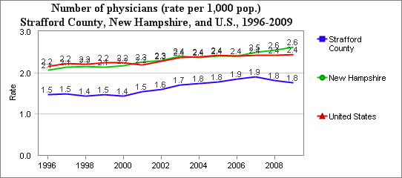
Note: Note that data from 2003 and later count all physicians in patient care. Data prior to 2003 count only physicians in patient care who are not employed by the federal government. The rate is presented on a "per 1,000" basis. NA = Not Reported or Not Available.

Table 42. Number of Physicians for State and County
[Source: Carsey Institute University of New Hampshire, 1996-2009: American Medical Association, Physician Characteristics and Distribution in the US]
Number of physicians for State and County
Region Name | Physicians | Rate per 1,000 population | Total Population
 | 2009 | 2009 | 2009
New Hampshire | 3469 | 2.619 | 1324575
Belknap | 119 | 1.9394 | 61358
Carroll | 80 | 1.6715 | 47860
Cheshire | 128 | 1.6614 | 77045
Coos | 69 | 2.1914 | 31487
Grafton | 928 | 10.7543 | 86291
Hillsborough | 868 | 2.1384 | 405906
Merrimack | 421 | 2.8242 | 149071
Rockingham | 547 | 1.8277 | 299276
Strafford | 218 | 1.7639 | 123589
Sullivan | 91 | 2.1315 | 42692

Description of Goals met:

- Economic Development: create necessary space for primary care physicians will create employment opportunities.
- Quality of Place: improve health and welfare of residents and workers by increasing access to primary care services in region.

Downtown Durham Structured Parking Facility 2011-013

Project Description

The Durham downtown area currently has 287 parking spaces to service a variety of businesses and commercial residential uses. The downtown has commercial building floor area of 112,270 sq. ft. with 35,150 of the commercial space being restaurant or restaurant-related. The lack of adequate parking facilities precludes substantial growth within the downtown core necessitating the need for a structured parking facility of between 250-300 spaces costing between $7,5000,000 and $9,000,000 plus land acquisition in the range of $1,000,000.

Description of Goals met:

- Economic Development: Job creation and retention. Expansion of the tax base.
- Workforce Development: Job creation
- Infrastructure: Using existing infrastructure and expanding it
- Resources and Environment: High concentration of business activity without significant land use. Improvement of life quality in Durham and its neighboring towns
- Quality of Place: Enhancement of Durham, intended to allow Durham’s downtown core to become more vibrant and relevant to the local population by enabling further investment and growth. Ability to foster smart growth and investment within Durham’s downtown core

Community Partners Workforce Development 2011-014

Project Description

Community Partners annually provides an array of services to over 3,500 Strafford County residents with behavioral health issues and developmental disabilities. The Advanced Employment Services department works with clients to assist in finding them meaningful work. In the last calendar year they secured thirty jobs for clients and worked with a total of sixty plus employers in the region. Currently, Advanced Employment Services is seeking jobs for nearly 200 unemployed clients.

Community Partners is seeking CEDS Project approval to build our capacity through Economic Development Administration support to aide more clients in their search for work. We would partner with large and small area employers to provide job training or internship programs for clients and training for employers to increase their likelihood of hiring clients.

Description of Goals met:

- Economic Development: We will target both large and small employers to improve economic development through providing employment opportunities to people with developmental disabilities or behavioral health issues.
- Quality of Place: Through finding meaningful employment for people with developmental disabilities or behavioral health issues we are improving the Quality of Place in the areas of wealth generation, healthcare and social services.
- Workforce Development: In our project clients would participate in job training opportunities including paid or unpaid internships and building the skills necessary to get and succeed on the job. Workforce development skills provided by Community Partners include assistance with filling out applications, writing resumes, interview skills, job searching, placement, coaching and follow along skills, as needed.

Regional Revolving Loan Fund Wentworth Economic Development Corporation
2011-015

Project Description:

The primary purpose of Wentworth Economic Development Corporation's Revolving Loan Fund (RLF) is to retain and/or create quality year round employment opportunities for area residents. The RLF can provide financial assistance to eligible businesses in and around Carroll and Strafford County. The Revolving Loan Fund is designed to assist existing and new small businesses with limited financing, so that actual or threatened job loss can be avoided, or that new employment opportunities can be created. Retention and/or expansion of the regional employment base, leveraging of additional financial resources and demonstration of the borrower's financial ability to repay the loan during its term are the primary criteria for the RLF. Establishment of a creative public-private partnership whereby the RLF can play a small but significant role in an overall financial package, and thereby leverage other public and private resources is a fundamental policy of the RLF. A shortage of investment capital at a reasonable cost has previously precluded small to medium size companies from being successful in the start-up or expansion phases. Loans from $5,000 to $50,000 are typical but larger amounts will be considered. Primary outcomes for a successful loan application are debt service coverage from actual or projected cash flow and collateral coverage available.

The primary focus of the RLF will be to:
a.) Complement the area's existing financial resources;
b.) Help stabilize and diversify the region's economy;
c.) Establish a public-private partnership for economic development;
d.) Encourage the expansion of existing businesses;
e.) Promote regional economic cooperation among communities in and around Carroll and Strafford County.

Description of Goals met:
- Economic Development: Support the attraction, retention and expansion of capital investments and employment opportunities in the region.
- Infrastructure: Expand access to the critical regional infrastructure to include transportation, utilities, banking and finance.
- Quality of Place: Improve the health and welfare of residents and workers in the areas of: wealth generation, healthcare, education, recreation and environment.
- Regional Collaboration: Provide opportunities for regional collaboration and leadership in economic development among businesses, communities, institutions, governments and other parties.

Study Phase 11 Granite State Business Park Rochester 2011-016

Project Description:

The Granite State Business Park has been designated a New Hampshire Economic Development Revitalization Zone location as an underutilized industrial park. The City of Rochester Economic Development Department has developed a detailed development plan to attract new industry and to capitalize on expansion opportunities with existing businesses. Study to determine the demand and suitability for an Inter-Modal Transportation hub at the Granite State Business Park.

In initial discussions with park tenants, there are multiple potential expansions we will be assisting.

Albany Engineered Composites – announced October 2010 relocation of corporate headquarters to the park and construction of a new 200,000+ square foot facility expansion with 500+ new full time jobs. SpecTex – 30,000 square foot new manufacturing facility, land purchased 2 years ago Amarosa – interest in a 30,000 square foot single tenant, his 3rd building in the park Smith & Wesson (Thompson Center Arms Foundry) – Rochester’s largest manufacturing employer announced in November 2010 that they will relocate their operations to Springfield and shut down the Rochester plant putting 245 people out of work, and relocating a small number to Mass. The foundry has potential to spin off from the parent; negotiations are underway to try to save that component and the 30 employees by building a new facility in the GSBP.

Inclusion of 400 acres of inaccessible land for development by providing access over the active NH North coast Rail line, development of a spur for either public or private use.
Development of a multi-modal transportation hub: Using as a foundation the COAST Bus Services, Skyhaven Airport, NH Northcoast Rail, NH Route 108 and the Spaulding Turnpike.

History

The Illustrative Master Plan and marketing package for the Granite State Business Park was created in 1990 by Matarazzo Design Inc. and S.G. Phillips Companies as a multi-use site with superior transportation access, including the potential for a more direct connection via Exit 10 from the Spaulding Turnpike. The intent was to fill what was perceived as a strong demand in the marketplace for light and heavy industrial space in the Seacoast region. This was prior to Pease Air Force Base closing and the subsequent conversion into a very successful business park, the Pease International Tradeport in Portsmouth.

Early tenants included Prime Tanning, Albany International Techniweave and Salmon Falls Precision. Albany and Salmon Falls were both internal expansions of Rochester businesses. The Rochester Industrial Development Authority was a partner in the Salmon Falls Precision project by an application to the New Hampshire Business Finance Authority for financing and a successful built-to-suit/lease-to-own agreement. The demand for development space changed significantly during the years between 1990 and 2000. The Ten Rod Road Business Park enabled Cabletron to expand and become the largest employer in the state. The Pease Tradeport and other area business parks were developed to capture the market, and the Granite State Business Park languished with the owner moving on to other, more lucrative and active development projects. The lack of direct highway access was often cited as an eliminator for prospects that did not choose this location.

More recently, commodity production has moved overseas and New Hampshire has found strength in niche and specialty markets. Salmon Falls Precision closed and 88 Airport Drive is now a multi-tenant building housing Phase 2 Medical, recognized as one of New Hampshire’s Fastest Growing Businesses. Albany International currently has two buildings a 160,000 square foot with 225 employees and is leasing 216 Airport Drive to ramp up their growth phase and house their corporate offices while a new building is under construction. Interest in the park has been steady as Rochester has matured as a regional hub for business and residential development, although the transportation challenge remains. We anticipate the need to expand the park into the Phase 2 Zone based on Albany’s announced expansion. Acquisition and access to Phase 2 will be costly. The active rail line is an asset to the park, but prospects prefer a bridge over the rail rather than a crossing at grade to reduce their liability and the number of potential conflicts with employees, deliveries and shipments.

Description of Goals met:
- Quality of Place, Business Retention and Attraction: An inter-modal transportation center would support business retention and attraction, successful deployment of resources and maintaining the quality of place so attractive to residents and businesses in the region. The center would have the ability to serve the region including the communities of Rochester, Dover, Somersworth, Rollinsford, Sanford ME, Springvale ME, Berwick ME, and South Berwick, ME. The infrastructure involved would be passenger and freight rail, freight transit, regional bus transit, personal vehicle transit, bicycle & pedestrian travel and air freight and air passenger transit.

Feasibility Study for Anaerobic Digester-based Town Energy Park 2011-017

Project Description

This feasibility study is the first step toward building a local anaerobic digester-based town energy park in North Lee that would bring in biomass from the region to produce power and heat for the energy park and the immediate neighborhood. These systems are in use now in other parts of the country, and there are New Hampshire-based companies with the expertise to build them.

New Hampshire imports 90% of its fuel, and the EPA is requiring improved water quality standards for waste treatment plants in Great Bay. This waste-to-energy project would produce local power and heat, relieve nutrient loading of Great Bay, and build local manufacturing capacity. Co-located businesses on the Lee Energy park site would have abundant heat and power. The 40-acre site has good access to the transportation corridor of Route 125.

Description of Goals met:
- Economic Development: This waste-to-energy anaerobic digester project will support the attraction, retention, and expansion of capital investments and employment opportunities in the region.
- Infrastructure: This project will expand access to the critical regional infrastructure needs that include heat and power.
- Quality of Place; This project will improve the health and welfare of residents and workers in the areas of healthcare, education in sustainable living standards, improving the environment by improving water quality through safe processing of waste materials into usable energy and power, and reducing the nutrient loading that is now taking place from the seacoast region into Great Bay.
- Regional Collaboration: This project will provide opportunities for regional collaboration and leadership in economic development among businesses, communities, institutions, governments, the University of New Hampshire, and other parties.
- Resources and Environment: This project will capitalize on natural and environmental resources by protecting ecosystems and increasing the diversity of resource usage. The Wise use of our presently wasted nutrients is critical for long-term sustainability of our healthy living here on the seacoast of New Hampshire.

Feasibility Study of Development Noble Farm 2011-018

Project Description

The Town of Lee acquired the Noble Farm property through a tax deed in May of 2010. A committee was then formed by the Planning Board to investigate the options available and desired by the community of Lee. The property had 38 previously approved house lots, with some infrastructure for the development in place. The committee held several community meetings throughout the summer and fall of 2010 to solicit ideas. It made two recommendations to the town at a Public Hearing on October 25, 2010. These include: 1) Mixed use: light, clean industry and natural, 2) Mixed use: affordable residential and natural.
The proposed project is to hire a consultant or property developer to propose the several different land use options, taking into consideration the following:

- Buffer zone (property drains into nearby Lamprey River tributary)
- Drainage needs
- Designs for land suitable for development
- Re-zoning or “spot” zoning possibilities
- Work with Planning Board to keep proposed development complementary with the neighborhood

Description of Goals met:

- Economic Development: The project would involve planning for the development of a 70-acre property into a small business park, which would support the attraction, retention, and expansion of capital investment and employment opportunities in the region.
- Quality of Place: The property includes a very lovely small pond and could easily accommodate attractive walking trails for the use of the immediate neighborhood and wider community. These would be compatible with development of the light industry or office use of the property. The neighbors and community support the development of walking trails and passive recreation opportunities on the property, which would enhance health and welfare of the community residents and workers.
- Regional Collaboration: The project would involve communications and collaboration with regional organizations, businesses, institutions, transportation infrastructure, local and state government, and the nearby state university in order to seek the optimal uses of the property that would complement the needs of the region.
- Resource and Environment: The project would capitalize on the natural and environmental resources of the property, particularly around the pond at the southern end, by protecting the ecosystems and using the resources available.

Engineering and Feasibility Study for Town Center Combined District Heating, Co-Generation, and Next-Generation Biomass Pelletizing Facility 2011-019

Project Description

The Town of Lee has been investigating how to lower its energy bills while also using more sources of renewable energy. The town has worked with the Municipal Energy Assistance Program and Clean Air/Cool Planet to do energy audits for its municipal buildings. It received a grant from the NH Office of Energy and Planning to write a comprehensive Lee Energy Plan, which is underway during 2011. One aspect of this plan is proposing a District Heating/Cogeneration/Pelletizing Facility at our Transfer Station in order to heat and power our central municipal and community buildings. These include the Town Hall and Annex, Library, church, and elementary school. This engineering and feasibility study proposal is the next stage toward actually building the facility.

Pellet boilers are an efficient way to heat rural homes, businesses, and municipal buildings. However, no New Hampshire facilities are capable of handling non-woody biomass, such as switch grass, willow, corn Stover, or agricultural wastes. Next-generation biomass crops produce many times more biomass per acre than doe’s forest-derived biomass. Sweden has been heating and powering many of its rural communities in this way for years.

Description of Goals met:

- Economic Development: This project will support the attraction, retention, and expansion of capital investments and employment opportunities in the region by demonstrating a model for providing local heat and power economically.
- Workforce Development: This project will provide quality education for residents and employees of all ages and abilities in demonstrating use of local resources to provide locally produced heat and power. As a model, the project would support development of training initiatives relevant to all businesses in the region.
- Infrastructure: This project will expand access to the critical regional infrastructure of locally produced power and heat generation.
- Quality of Place: This project should improve the health and welfare of residents and workers in the areas of health, education, and environment. Local energy generation empowers a community to be more sustainable.
- Regional Collaboration: This project will provide opportunities for regional collaboration and leadership in economic development among communities, businesses, institutions, governments, the University of New Hampshire, and other parties. The region will benefit to have models of environmentally safely produced local power and heat.
- Resources and Environment: This project will capitalize on natural and environmental resources by protecting ecosystems and increasing the diversity of resource usage. It will also use our underutilized farmland fields and woods to help sustainably produce both woody and non-woody biofuels.

Feasibility and Design Study of Livestock Processing Facility 2011-020

Project Description

The project is feasibility and design study for a USDA/NH state certified livestock slaughtering and processing facility to serve the local and regional agricultural community in order to provide safe, locally raised meat for the seacoast region of New Hampshire. It would be designed for humane treatment of the animals, and would use ecologically safe processing and waste disposal methods. It would work on the same site with another Lee CEDS proposal, the “Anaerobic Digester-based Energy Park, which involves producing local heat and power from locally produced biomass. The need for a regional livestock slaughtering and processing facility has been identified as critical for increasing the livestock processing capacity in order to meet the increasing demand for locally produced meat.

Description of Goals met:

- Economic Development: The livestock processing facility will support the attraction, retention, and expansion of capital investment and employment opportunities for the region. It will provide an important link now missing in the local agricultural infrastructure.
- Infrastructure: The livestock processing facility will significantly expand the critical regional agricultural infrastructure, which will make more meat production possible locally.
- Quality of Place: The livestock processing facility will improve the health and welfare of residents and workers in the area. Waste products from the facility can be used in the nearby anaerobic digester to produce clean heat and power that will be available locally.
- Regional Collaboration: The livestock processing facility will provide opportunities for regional agricultural collaboration and leadership in economic development among farm businesses, communities, institutions, governments, and other parties. Local food security in New England communities is of paramount importance.
- Resources and Environment: The livestock processing facility will capitalize on natural and environmental resources by protecting the ecosystems and increasing the diversity of resource usage. Farmers in this region need to have access to a livestock processing facility within 40 miles of their farms to make the raising of meat animals become more economical. This facility could be a model of ecologically sound and safe design, which could be replicated in other parts of New England in order to increase our ability to raise our own food, and reduce our food imports.

The Cotton Valley Trail Feasibility Study 2011-021

Project Description

The Cotton Valley Trail is a recreational multi-use trail which will eventually extend 12 miles, linking the town of Wolfeboro, Brookfield and Wakefield via a former railroad right-of-way. 11.5 miles is in a state right of way that has the tracks of the old railroad line still in place. Along the way, the rail meanders across to lakes, over trestles, and climbs through Cotton Valley, a distance of 6.2 miles. This section is completed for three season use to walk, run, bike, fish and view wildlife. The Cotton Valley Rail Trail club utilizes the entire length of the trail and in winter snowmobiles, snow showing and x-country skiers to as well. This portion of the trail is handicapped accessible. This section is heavily utilized by residents and tourists alike. This has an economic benefit to the community because it provides a healthy alternative to access the downtown area for shopping, dining, museums, beeches, etc.

The section still not completed for summer use, but when built, it will go through scenic wetlands, back woods and fields through Brookfield ending at Turntable Park in
Wakefield. This railroad turntable is one of only two remaining in New Hampshire. The distance from Cotton Valley to Route 16 is estimate at being 5 ½ miles and then ½ mile to Turntable Park. Once completed, it will provide additional economic benefit to the Wakefield (Sanbornville) downtown area by connecting these two active tourism base communities.

Feasibility Funds are being requested to determine the best option for crossing
Route 16 aka Spaulding Turnpike. Improvements for the trail will include volunteers and professionals as needed, in-kind contributions of time and/or material, as well as traditional fundraising and accessing grants to complete the trail. The Trails Rails Action
Community has been extremely successful with doing so with the completed section of the trail. The Trails Rails Action Committee (TRAC) is a local volunteer group that oversees the interest of the three communities and maintains and improves the trail on a regular basis.

Description of Goals met:

- Economic Development: Support the attraction, retention and expansion of capital investments and employment opportunities in the region.
- Infrastructure: Expand access to the critical regional infrastructure to include transportation, utilities, banking and finance.
- Quality of Place: Improve the health and welfare of residents and workers in the areas of: wealth generation, healthcare, education, recreation and environment.
- Regional Collaboration: Provide opportunities for regional collaboration and leadership in economic development among businesses, communities, institutions, governments and other parties.
- Resources & Environment: Capitalize on natural and environmental resources by protecting ecosystems and increasing the diversity of resource usage.
- Economic Development: Support the attraction, retention and expansion of capital investments and employment opportunities in the region.

Mid-Term Priority Projects (3-5 years to Completion)

Milton Rail Siding 2011-022

Project Description

At present, Index Packaging in Milton, NH employs approximately 160 persons and ships about four (4) trucks a week to Boston for rail shipment to the Chicago area. Index has expressed an interest in using a local rail siding for shipment of its products directly by rail to the mid-west. The ability to ship product by rail from its Milton, NH facility will likely enable the company to expand its employment base. If there is interest in this project among potential funding agencies, the Town will contact other companies in the Milton and surrounding area to determine the potential level of demand for a public rail siding.

Description of Goals met:
- Economic Development: an increase in the number of jobs at companies who use rail.
- Resource and Environment: use a more energy efficient method of transportation of products to the client.
- Infrastructure: provide an infrastructure incentive for companies to use rail who may consider a location in Milton.

Public Infrastructure for Technology Park in Downtown Durham NH 2011-023

Project Description

Downtown Durham, defined broadly as the developed Central Business District and Professional Office District, is deteriorating for lack of reinvestment. Currently the most prevalent real estate business model is student housing, including poorly maintained, depreciated, and aged housing structures, and the low value student-oriented retail that follows student housing. Desirable mixed used redevelopment, including professional office space, is economically challenging, yet is the essential catalyst to create to a more diverse, resilient, and year-round retail environment catering to office workers, local families, and the larger non-student regional population.

Downtown Durham is ripe for redevelopment as a technology, web, and creative entrepreneurial center. Technology-driven office space development will spur follow-on development of appropriate retail, dining, hospitality, professional service, and adult housing in the larger commercial core.

The Town of Durham seeks to partner with the University of New Hampshire and other private development entities to remake the central business district as a distributed technology park geared toward both existing and new startup companies seeking to capitalize on either university resources & talent or the high quality of life in Durham, or both.

By “distributed,” Durham intends to take the well-worn concept of a concentrated business or Technology Park placed in the outskirts of town on an undeveloped “green field” and locate it instead in among an existing downtown district, sparking extensive redevelopment of the very type of office space so often found in a “tech park.” Rather than a set of single-purpose buildings far away from other important services and housing, these buildings could be mixed use with retail below and/or housing above

To leverage private investment, the town of Durham needs significant public investment in infrastructure to facilitate this transformation. This includes street construction, water and sewer upgrades, land acquisition, and planning support.

Description of Goals met:

- Job creation and detention
- Using existing infrastructure and expanding it
- High concentration of business activity without significant land use
- Improvement of life quality in Durham and its neighboring towns

Ten Rod Road Rochester 2011-024

Project Description:

Ten Rod Road Business Park needs a million gallon water tower to meet current fire flow standards and to fill existing space to capacity. Business development and utilization of vacant space in the industrial park are significantly hampered by the low flows in the existing fire suppression systems and inability to expand the system to meet current or future demand.

Description of Goals met:
The Ten Rod Road Business Park has the highest vacancy rate in the city at 40% vacancy. Water capacity for business use and fire suppression is essential, yet the current municipal system is marginally adequate to support existing businesses. Expansion of the park and 100% utilization of existing available space are hampered by the water system and its shortcomings. The water tower would resolve the water pressure concerns and improve the municipal system by looping the water lines and connecting two areas of development, making the best use of water and land resources, and allowing for the complete utilization of existing space at Ten Rod Road Business Park.

Granite Ridge Development District Utilities 2011-025

Project Description:

Granite Ridge Development District, utilities expanded include pump station, Route 11 improvements & widening, frontage road ROW, & construction. Studies and preliminary engineering have already been completed for the infrastructure plan covering more than 700 acres that will allow more than 2 million square feet of new business development, including hospitality, retail, office and medical development. The project includes a Rails-to-Trails project, connections to public transportation and relies on inter-agency collaboration between private development interests, the City of Rochester, NH DOT, DES, Army Corps of Engineers, Fish & Wildlife and more. The City has created a new development district including zoning after completion of the TIF Study Report and analysis by CLD Engineers. The TIF District has not yet been implemented, but it is the City’s intention to financially support the construction of infrastructure with TIF revenues.

Description of Goals met:
The region is underserved for hospitality, retail and commercial businesses as demonstrated in a retail analysis completed in 2007. The creation of this district supports improvement in the quality of place and accessibility to goods and services by residents and visitors to the region. The Granite Ridge Development District provides greatest opportunity for new development and successful expansion of municipal and state infrastructure in collaboration. The project includes opportunities for wetlands and uplands protection along the Cocheco River, which bounds the District on the east and includes the Rails-to-Trails portion of the project. Recreation of natural habitat for wildlife is also possible on property the city purchased for water system expansion in 2008. This project fits into the city’s Master Plans for Economic Development, Natural Resources, Transportation, Land Utilization and Recreation.

55 North Maine Street Incubator 2011-026

Project Description:

The City of Rochester, with funding provided by a Rural Business Enterprise Grant from the USDA Rural Development, was able to conduct a study on a potential business incubator space. The Hoffman building which is called the “55 North Main Street Incubator” is located in downtown Rochester and has been vacant since 1986. The building has 6,000 square feet of space on the ground floor and similar square footage in the basement. The Incubator Study, in one set of estimates, put the cost of repairs and replacements at $1,131,000, including $200,000 for an HVAC system, $100,000 for a sprinkler system and $100,000 for restrooms and a domestic water supply.

A second estimate, obtained from a local entity, came in at $669,000 — $50,000 for the HVAC, $10,000 for a fire alarm system instead of a sprinkler system, and $15,000 for the plumbing, if the work is done with the help of the Creteau Technology Center's training program. Whereas the first estimate had interior finish costs at $300,000, and the second local estimate had $120,000 for interior finish costs.
There are strong educational partners for the project including Richard W. Creteau Technology Center, Granite State College, Great Bay Community College, SCORE, and the Small Business Development Center. These partners would be part of the preliminary as well as continuing education component related to the project.

Description of Goals met:

The 55 North Main Street Incubator will support new business development, with an expectation of 30 new businesses and 60+ new employees over the 10 year project period. It will improve the quality of place in the distressed Downtown Business District by providing a destination for consumers and a critical mass of activity on Main Street. The project will provide support for entrepreneurial activity including shared spaces and cooperative marketing, business training, a teleconference center and conference room for the use of the project partners and participants, and an ongoing way to identify and encourage new entrepreneurs. The project will improve downtown infrastructure and utilize and an existing building that has been a vacant space for more than 20+ years.

The Cotton Valley Trail’s Route 16 Crossing 2011-027

Project Description (including a Brief Assessment of Community Need):

The Cotton Valley Trail is a recreational multi-use trail which will eventually extend 12 miles, linking the town of Wolfeboro, Brookfield and Wakefield via a former railroad right-of-way. 11.5 miles is in a state right of way that has the tracks of the old railroad line still in place. Along the way, the rail meanders across to lakes, over trestles, and climbs through Cotton Valley, a distance of 6.2 miles. This section is completed for three season use to walk, run, bike, fish and view wildlife. The Cotton Valley Rail Trail club utilizes the entire length of the trail and in winter snowmobiles, snow showing and x-country skiers to as well. This portion of the trail is handicapped accessible. This section is heavily utilized by residents and tourists alike. This has an economic benefit to the community because it provides a healthy alternative to access the downtown area for shopping, dining, museums, beeches, etc.

The section still not completed for summer use, but when built, it will go through scenic wetlands, back woods and fields through Brookfield ending at Turntable Park in
Wakefield. This railroad turntable is one of only two remaining in New Hampshire. The distance from Cotton Valley to Route 16 is estimate at being 5 ½ miles and then ½ mile to Turntable Park. Once completed, it will provide additional economic benefit to the Wakefield (Sanbornville) downtown area by connecting these two active tourism base communities.

These Infrastructure Funds are being requested towards the cost involved with the construction of the “crossing” on Route 16. It is anticipated that a Feasibility Study will provide options, recommendation for design and cost estimates. Improvements for the trail will include volunteers and professionals as needed, inkind contributions of time and/or material, as well as traditional fundraising and accessing grants to complete the trail. The Trails Rails Action Community has been extremely successful with doing so with the completed section of the trail. The Trails Rails Action Committee (TRAC) is a local volunteer group that oversees the interest of the three communities and maintains and improves the trail on a regular basis.

Description of Goals met:

- Economic Development: Support the attraction, retention and expansion of capital investments and employment opportunities in the region.
- Infrastructure: Expand access to the critical regional infrastructure to include transportation, utilities, banking and finance.
- Quality of Place: Improve the health and welfare of residents and workers in the areas of: wealth generation, healthcare, education, recreation and environment.
- Regional Collaboration: Provide opportunities for regional collaboration and leadership in economic development among businesses, communities, institutions, governments and other parties.
- Resources & Environment: Capitalize on natural and environmental resources by protecting ecosystems and increasing the diversity of resource usage.
- Economic Development: Support the attraction, retention and expansion of capital investments and employment opportunities in the region.

Long Term Priority Projects (5+ Years to Completion)

Granite State Business Park Expansion Siding Spur 2011-028

Project Description:

Granite State Business Park is a 200+ acre, high quality multiuse industrial and commercial complex. Located on the south side of Rochester next to Sky Haven Airport, it houses Albany Engineered Composites, a manufacturer of specialty fibers used in aerospace, and Rand Whitney, a manufacturer of corrugated containers. The Park has access to the Northeast rail line on the east and has airport access on the west. Expansion of Granite State Business Park, including land acquisition, utility expansion, RR crossing, potential for siding on active line

Planning Funding for Enterprise Park, Phase II Dover 2011-029

Project Description:

Planning funding for Enterprise Park, Phase II. This Dover Business and Industrial Development Authority business park is approaching full occupancy with only a few small parcels still available for building. The planning function for the next business park needs to begin shortly to provide continuity of the economic development momentum currently underway to bring businesses and jobs to the community. Two properties under consideration for Phase II are in Economic Revitalization Zone Districts. Since Dover’s ratio of residential to commercial/industrial property is 75% to 25%, the need to have commercial development property available to stabilize the property tax rate and continue Dover as a viable community on a tax basis is vital.

Description of Goals met:

- Economic Development:
- Workforce Development:

Technology Park Durham Depot lot/train station 2011-030

Project Description:

Durham is home to the State of New Hampshire’s UNH. UNH is one of the top research universities in the country, and many professors and students are looking to start a business with research done at UNH, or products being developed. While many of the “desk” companies are best placed in a downtown environment, companies in the area of early production are not. The Depot lot is uniquely located in the middle of campus, right next to the Amtrak line going from Boston to Brunswick. This location is ideal for an environmentally friendly high tech research and production facility because of:

- The immediate access to the research and development resources at UNH
- Its location right on the train station (delivery of parts, access to commuting students and staff)
- Access to Route 4 and Route 108
- Access to educated workforce, including interns

The property is located on Town land which will strengthen the Towns tax base while giving UNH the opportunity to generate income out of intellectual property rights. It invites itself for cooperation with UNH because the University is considering the development of its adjacent parking lot which could lead to a joint venture. A multi-story building will have a lower impact on natural resources than the usual single story business park.

Description of Goals met:

- Economic Development: job creation and detention
- Infrastructure: using existing infrastructure and expanding it
- Resources and Environment: high concentration of business activity without significant land use
- Quality of Place: Improvement of life quality in Durham and its neighboring towns

The Cotton Valley Trail’s Route 16 Crossing 2011-031

Project Description:

The Cotton Valley Trail is a recreational multi-use trail, which will eventually extend 12 miles, linking the town of Wolfeboro, Brookfield and Wakefield via a former railroad right-of-way. 11.5 miles is in a state right of way that has the tracks of the old railroad line still in place. Along the way, the rail meanders across to lakes, over trestles, and climbs through Cotton Valley, a distance of 6.2 miles. This section is completed for three season use to walk, run, bike, fish and view wildlife. The Cotton Valley Rail TrailClub utilizes the entire length of the trail and in winter snowmobiles, snow showing and x-country skiers to as well. This portion of the trail is handicapped accessible. This section is heavily utilized by residents and tourists alike. This has an economic benefit to the community because it provides a healthy alternative to access the downtown area for shopping, dining, museums, beeches, etc.

The section still not completed for summer use, but when built, it will go through scenic wetlands, back woods and fields through Brookfield ending at Turntable Park in Wakefield. This railroad turntable is one of only two remaining in New Hampshire. The distance from Cotton Valley to Route 16 is estimate at being 5 ½ miles and then ½ mile to Turntable Park. Once completed, it will provide additional economic benefit to the Wakefield (Sanbornville) downtown area by connecting these two active tourism base communities.
These Infrastructure Funds are being requested towards the cost involved with the construction of the “crossing” on Route 16. It is anticipated that a Feasibility Study will provide options, recommendation for design and cost estimates.

Improvements for the trail will include volunteers and professionals as needed, in-kind contributions of time and/or material, as well as traditional fundraising and accessing grants to complete the trail. The Trails Rails Action Community has been extremely successful with doing so with the completed section of the trail. The Trails Rails Action Committee (TRAC) is a local volunteer group that oversees the interest of the three communities and maintains and improves the trail on a regular basis.

Description of Goals met:

- Economic Development: Support the attraction, retention and expansion of capital investments and employment opportunities in the region.
- Infrastructure: Expand access to the critical regional infrastructure to include transportation, utilities, banking and finance.
- Quality of Place: Improve the health and welfare of residents and workers in the areas of: wealth generation, healthcare, education, recreation and environment.
- Regional Collaboration: Provide opportunities for regional collaboration and leadership in economic development among businesses, communities, institutions, governments and other parties.
- Resources & Environment: Capitalize on natural and environmental resources by protecting ecosystems and increasing the diversity of resource usage.
- Economic Development: Support the attraction, retention and expansion of capital investments and employment opportunities in the region.

Library Community Center Lee 2011-032

Project Description:

In 2004, a committee of citizens and trustees was appointed by the Library Trustees to assess the library’s physical plant and its needs for expansion. Committee activities have included meetings, inspections of the building, publicity and the planning and implementation of a community-wide survey.

The Lee Public Library is housed in a nineteenth-century schoolhouse, which was moved to the present site in 1962. Ten years later, a small addition was constructed to the rear. A subsequent small space with a new main entrance was added to the left of the 1972 addition in 1984, while a final rear addition, with a basement meeting space, was constructed in 1996.

Each small addition to the library in the past forty-three years has barely kept even with the growth in Lee’s population over the same period.

Back in 1960, the American Library Association published an across-the-board standard for public libraries of 0.7 square foot per capita. In Lee, this minimal outdates standard was not even met back in 1996.

Description of Goals met:

- Economic Development:
- Infrastructure: To build a library 11, 894 square feet to 12, 370 square feet to meet the need based on square foot per capita. To build a library that is ADA compliant, meets current codes regarding construction, insulation, wiring, heating and air conditioning, air ductwork and fireproofing.

2011 Strafford Regional CEDS Project Matrix

The Strafford Hazard Mitigation Planning Committee has developed the summary project matrix presented on the following pages. This matrix is a summary of the preceding information.

Short Term Projects (0-36 months to Completion)
Identifier | Project Name | Project  Description | Project  Proponent | Estimated  Cost | Possible Funding Source | Start  Date | Goals  Addressed
2011-001 | Center for Agricultural and Natural Resource-based Entrepreneurship (CANRE) | Build off existing UNH resources and programs to foster development of new, local, and natural-based enterprises and help existing ones expand | Charlie French | 356,000 | UNH Alumni donor | January-11 | Economic development, workforce development, quality of place, regional collaboration, resource and environment
2011-002 | Idea Greenhouse: Business Incubator/ Proof of Concept Center | Enhance and broaden Proof of Concept. Center activities in downtown Durham, NH | Idea Greenhouse | 200,000 | Unknown | October-11 | Economic development, workforce development, quality of place, regional collaboration
2011-003 | Downtown Tax Increment Financing (TIF) district study | Study to identify scope of district to determine eligibility for designation as a TIF | City of Somersworth | 25,000 | EDA/City of Somersworth | March-12 | Economic development, infrastructure, quality of place
2011-004 | Washington Street Bridge Feasibility Study | Engineering feasibility study involving construction of a new centralized point of access to Mill yard area and General Electric property | City of Somersworth | 30,000 | EDA | Jun-12 | Economic development, infrastructure quality of place
2011-005 | Downtown Dover Public Parking Garage | Construction of a 525 space public parking garage in core of downtown Dover | City of Dover | 11,000,000 | EDA | June-12 | Economic development, workforce development, infrastructure
2011-006 | Feasibility Study for the Extension of Water and Sewer Service in Milton, NH | Extending the Town's water and sewer service by way of feasibility study. The study would investigate the design, environmental, engineering and financial components related to extension of water and sewer service. | Town of Milton | 50,000 | EDA | June-12 | Economic development, Infrastructure, resource and environment
2011-007 | High Street Reconstruction | Reconstruction of approximately 2,750 feet of High Street in downtown area; reconstruction of water | City of Somersworth | 4,800,000 | EDA/City of Somersworth; Clean Water SRF;  Drinking Water SRF | March-13 | Resource and environment
2011-008 | Breton Cleaners Site Cleanup and Reuse Study | Develop a reuse plan and cost estimate | City of Somersworth | 25,000 | NHDES Brownfield Clean up funds | June-13 | Economic development, quality of place
2011-009 | Economic Development District | Apply for funding through the Economic District for Economic Development District designation | Strafford Regional Planning Commission | 75,000 | EDA | July-13 | Regional collaboration
2011-010 | Regional Revolving Loan Fund | Providing financial assistance to businesses in need of growth capital | Strafford Economic Development Corp. | 4,000,000 | unknown | unknown | Job retention, job creation, business entrepreneurial, economic development
2011-011 | Dover Downtown Infill Development of City Owned Parking Lots | Development of four city owned parking lots; mixed use development | City of Dover | 20,000,000 | EDA/private | unknown | Economic development, workforce development, infrastructure, quality of place, resource and environment
2011-012 | Medical Office Building | Medical office building to house primary care physicians, including pediatrics | Frisbee Memorial Hospital | unknown | unknown | unknown | Economic development, quality of place
2011-013 | Downtown Durham Structured Parking Facility | Structured parking facility between 250-300 spaces plus land acquisition | Town of Durham | 7,500,000 to 10,000,000 | unknown | unknown | Economic development, workforce development infrastructure, quality of place, resource & environment.
2011-014 | Community Partners Workforce. Development for people with developmental disabilities & behavioral health issues | Build capacity to aide more clients in their search for work by partnering with large and small employers to provide job training or internship programs for clients | Community Partners | 200,000 | unknown | unknown | Economic development, workforce development, quality of place
2011-015 | WEDCO | Revolving loan fund | WEDCO | 500,000 | Equity/ USDA Relending Program | September-12 | economic development, infrastructure, quality of place, regional collaboration
2011-016 | Study Phase II: Granite State Business Park-Placeholder | Study to determine the demand and suitability for an Inter-Modal Transportation hub at the Granite State Business Park. | City of Rochester | $100,000 | EDA | January-12 | Economic development, infrastructure, quality of place, resource and environment, regional collaboration
2011-017 | Feasibility Study for Anaerobic Digester-based Town Energy Park | Feasibility study | Town of Lee | 120,000 | unknown | January-12 | Economic development, workforce development, infrastructure, quality of place, resource and environment, regional collaboration
2011-018 | Noble Farm Property | Hire a consultant or property developer to draft land use options and feasibility | Town of Lee | 75,000 | Unknown | Jan-12 | Economic development; quality of place workplace development, resource and environment, regional collaboration
2011-019 | Engineering and Feasibility Study for Town Center Combined District Heating, Co-Generation and Next-Generation Biomass Pelletizing Facility | Engineering and feasibility study | Town of Lee | 150,000 | Unknown | January-12 | Economic development, workforce development infrastructure, quality of place, regional collaboration and resources and environment
2011-020 | Feasibility and Design Study of Livestock Processing Facility | Feasibility and design study | Town of Lee | 100,000 | Unknown | January-12 | Economic development, agricultural quality of place, regional collaboration, resource and environment
2011-021 | The Cotton Valley Trail Feasibility Study 2011-022 | Feasibility and Design Study | Region | 400,000 | EDA | February-11 | Economic development, agricultural quality of place, regional collaboration, resource and environment

Intermediate Term Projects (2-4 Years to Completion)
Identifier | Project  Name | Project  Description | Project Proponent | Estimated  Cost | Possible Funding Source | Start  Date | Goals Addressed
2011-022 | Milton Rail Siding | Index Packaging (160 employees) ships 4 trucks a week to Boston for rail shipment to Chicago. The ability to ship by rail will enable company to expand its employment base. If there is interest, the town would contact other companies in surrounding area to determine level of demand for public. | Town of Milton | 500,000 | EDA, NHDOT, Northcoast | Jul-13 | Economic development, infrastructure
2011-023 | Tom Elliot-Idea Greenhouse-Placeholder | Funding for infrastructure and land acquisition for a new tech park located in several buildings in downtown Durham in partnership with UNH | Idea Greenhouse/Town of Durham | 25 | unknown | unknown | unknown
2011-024 | Ten Rod Road-Placeholder | Million gallon water tower to meet current fire flow standards and to fill existing space to capacity | City of Rochester | 3 million | EDA, Private | 2013 | Infrastructure, resource & environment
2011-025 | Granite Ridge Development District Utilities-Placeholder | Expand pump station, Rt. 11 improvements & widening, Frontage Rd ROW & construction | City of Rochester | 25 Million | EDA | unknown | Economic development, Infrastructure, Quality of Place, Resources and Environment
2011-026 | 55 North Main St. Incubator-Placeholder | Repairs and replacements for HVAC system repairs and replacements for sprinkler system, repairs and replacements for restrooms and domestic water supply | City of Rochester | 1.5 Million | unknown | unknown | Economic development, workforce development, infrastructure, quality of place, resource and environment
2011-027 | The Cotton Valley Trail’s Route 16 Crossing | These Infrastructure funds are being requesting towards the completion of Section #1 Clark Road, Brookfield to Cotton Valley Station. This will assist in the construction to Route 16, a distance of 5.5 miles as it progresses towards Turntable Park in Wakefield. Improvements will include volunteers and professionals, as needed, in-kind contributions of time and/or material, as well as traditional fundraising and accessing grants to complete that. |  | 300,000 | EDA, Other | 2013-2014 | unknown

Long Term Projects (5+ Years to Completion)
Identifier | Project  Name | Project  Description | Project  Proponent | Estimated  Cost | Possible Funding Source | Start  Date | Goals  Addressed
2011-028 | Granite State Business Park Expansion Siding Spur-Study | Development of a multi-modal transportation hub | City of Rochester | 50,000 | EDA, |  | Economic development, infrastructure resource and environment
2011-029 | Planning funding for Enterprise Park, Phase II | Planning funding | City of Dover | 250,00 | EDA/Private | Jun-14 | Econ
2011-030 | Technology Park Durham lot/train station | Students are looking to start business with research done at UNH | Town of Durham | 6,000,000 to 10,000,000 | Unknown | unknown | Economic development, workforce development, infrastructure, quality of place, resource and environment
2011-031 | The Cotton Valley Trail’s Route 16 Crossing | Connecting the Lakes Region Trail System to the Northern CEDS region to the south. | Towns of Brookfield/Wakefield and WEDCO | 300,000 | EDA | unknown | Economic development, infrastructure, quality of place, regional collaboration and resource and environment
2011-032 | Library Community Center – Placeholder | Expand Library | Town of Lee | Unknown | Unknown | Unknown | Infrastructure

Chapter 10: CEDS Implementation and Performance Measures

Performance Measures

SRPC staff determined the process to measure the implementation of this first regional Comprehensive Economic Development Strategy using the EDA criteria as follows:

- Number of jobs created after the implementation of the CEDS
- Number and types of investments undertaken in the region
- Number of jobs retained in the region
- Amount of private sector investment in the region after the implementation of the CEDS
- Changes in the economic environment of the region

SRPC also developed additional quantitative and qualitative measures, which allows the Strategy Committee to evaluate progress toward achieving specific, identified CEDS goals. These can be found in the logic model heading for benchmarks. For instance, under the goal for Quality of Place – Educational Attainment, the outcome is to bring region up to NH high school attainment levels, with the performance measure as high school attainment in the region. This approach strengthens the network of measures, actions, and evaluation techniques and thus leads to greater success and knowledge of the region.

CEDS Annual Evaluation

Much of the baseline demographic data necessary to start the evaluation comparison has been completed for this document. SRPC will update Census derived products as they become available over the next five years, as well as NH derived demographic and employment products and those data sets generated by the region and local entities. Data updates will be posted to the SRPC website CEDS page in a clearly delineated format or indicated by linkages. SRPC has ongoing staff capacity in its office to perform these valuable data functions. The Strategy Committee is committed to reviewing this data as it becomes available at meetings.

The strategies outlined in the Strafford CEDS Action Plan in Table 41 are ongoing as a strategic planning process. They will be used as the basis of the Annual Report to EDA. Of necessity they will change over time. The table clearly indicates the type of action (planning, research, outreach, and technical assistance), responsible parties, timeframe, and guidelines.

The CEDS process in the Strafford region has been an opportunity to have a broad, in-depth conversation about economic development. The connections and relationship building developed through CEDS process will be sustained through the auspices of an EDA approved CEDS document and its implementation through the action plan.

Table 43. Strafford 2011-2016 CEDS Action Plan
Action |  | Year One Implementation |  | Complete |  | In Progress |  | Not Started |  | Recommendations |  | Guidelines
Economic Development Planning |  | Apply for EDA Annual Planning Grant. |  |  |  |  |  |  |  | Pending approval from EDA ; Resubmit if not awarded |  | EDA Priorities and Guidance
 |  | Design annual review planning process. |  |  |  |  |  |  |  |  |  | EDA Priorities and Guidance
 |  | Obtain EDD status |  |  |  |  |  |  |  | Multi- year process, place priority in Year 2 |  | EDA Priorities and Guidance
 |  | Design and carry out Strafford CEDS evaluation tasks. |  |  |  |  |  |  |  | Use lessons learned from 2011-2016 Five Year document |  | EDA Priorities and Guidance
Research |  | Complete CEDS Annual Report |  |  |  |  |  |  |  | Evaluate and process with Strategy Committee |  | EDA Performance Measures Guidance & Strafford CEDS Performance Measures
 |  | Update 2011-2016 Five year plan with 2010 Census Data |  |  |  |  |  |  |  | Update when 2010 Census data released
 |  | Update Project Profiles annually |  |  |  |  |  |  |  | Work with sponsor's) to keep projects current
 |  | Continue Cluster Analysis Research |  |  |  |  |  |  |  | Ongoing
 |  | Establish and measure benchmarks |  |  |  |  |  |  |  | Ongoing
Outreach |  | CEDS Implementation Kick off meeting |  |  |  |  |  |  |  | Continue the momentum of the Strategy Committee; invite new members |  | Strafford CEDS Vision, Mission, Principles, Goals and Objectives
 |  | Continue regional collaboration involvement in CEDS |  |  |  |  |  |  |  | Engage communities, businesses, nonprofits
 |  | Present information at local economic development committees |  |  |  |  |  |  |  | Engage communities, businesses, nonprofits
 |  | Present information to Chambers, Rotary, business associations, and other champions in Economic Development |  |  |  |  |  |  |  | Establish a more formal partnership
 |  | CEDS Progress reports |  |  |  |  |  |  |  | Expand audience
Action | Year 1Implementation |  | Complete |  | In Progress |  | Not Started |  | Recommendations |  | Guidelines
Technical Assistance | Carryout annual project solicitation process |  |  |  |  |  |  |  |  |  | Strafford CEDS Vision, Mission, Principles
Technical Assistance | Apply for EDA funding for projects of highest priority included within CEDS |  |  |  |  |  |  |  | Assistance in apply for EDA funding
Technical Assistance | Assist with grants and loans from other funding sources |  |  |  |  |  |  |  | Assistance in apply for EDA funding
Technical Assistance | Assist in project or services development |  |  |  |  |  |  |  | Expand audience |  | Strafford CEDS Vision, Mission, Principles
Technical Assistance | Update Strafford.org website with CEDS information on separate pages |  |  |  |  |  |  |  | Make information readily available
Technical Assistance | Direct Technical Assistance provided to municipalities, nonprofits, and businesses |  |  |  |  |  |  |  | Provide towns with Technical Assistance in regards to Economic Development

http://www.strafford.org/uploads/SRPCHousingAssessment2009Dec29.pdf
Newmarket is located in Rockingham County and is not part of the Strafford CEDS, but is part of Strafford Regional Planning Commission.
Northwood is located in Rockingham County and is not part of the Strafford CEDS, but is part of Strafford Regional Planning Commission.
Nottingham is located in Rockingham County and is not part of the Strafford CEDS, but is part of Strafford Regional Planning Commission.
Adapted from the Lincoln Institute of Land Policy and University of Montana at Missoula, Public Policy Research Institute Regional Collaboration website. http://www.lincolninst.edu/subcenters/regional-collaboration/
Adapted from Hardi and Zdan 1997, 2-4. American Planning Association. http://www.planning.org/eda/toolkit/2008/

