Indicator: Conservation Lands (focus areas)

Question

How much of the Conservation Focus Areas in the Piscataqua Region are permanently conserved or considered conserved public lands?

Short Answer

In 2017, 34.4% of Conservation Focus Areas (CFAs) in New Hampshire and 14.2% of CFAs in Maine were conserved. This represents a combined impact of 40.9% of progress towards the PREP goal of conserving 75% of all total acres in the CFAs. Given the challenges associated with conserving these important lands, the goal of conserving 75% (or 124,659 acres) of these core focus areas in both ME and NH by 2025 will take significant additional effort to achieve.

PREP Goal

Conserve 75% (124,659 acres) of lands identified as conservation focus areas by 2025 (from the PREP Comprehensive Conservation and Management Plan, PREP 2010).

Why This Matters

The Piscataqua Region is home to exceptional, unfragmented natural areas and corridors supporting important wildlife populations, water filtration capacity and storm buffering. Due to the infrastructure and growth pressures in our region, there is limited time to protect these areas in order to ensure they will continue to provide benefits for future generations.

Results Summary (from State of Our Estuaries Report)

The Land Conservation Plan for New Hampshire’s Coastal Watersheds (Zankel et al. 2006) and The Land Conservation Plan for Maine’s Piscataqua Region Watersheds (Walker et al. 2010) are two science-based regional conservation master plans developed by a range of municipal, regional, and technical partners to guide conservation efforts throughout the region. The plans identify 90 CFAs that have high conservation values associated with them (such as rare habitat for threatened or endangered species). Of the 166,212 acres that fall within these designated CFAs, a total of 51,062 acres, have been permanently protected (40.9% of progress towards the PREP goal of 124,659 acres). That represents an increase of 3.7% since 2011 or 5,197 new conserved acres, with the majority of these increases being in NH. There are a few notable areas where gains have been significant (over 50% increases since 2011), including the Winnicut River, Isinglass River, Kennard Hill and Birch Hill Lowlands. There are 16 CFAs where 50% or more of the acres have been protected (see Figure CF-1). CFAs where 70% or more have been protected include the Upper and Middle Winnicut, Creek Pond Marsh, Lower Lubberland Creek, Exeter River, Fabyan Point and Laroche and Woodman Brooks. Continued, focused efforts are needed to meet the goal in protecting 75% of these CFAs by 2025.

Methods and Data Sources
The general conservation lands database was further queried to identify the intersection of the conservation lands data and conservation focus areas data within the Piscataqua Region watershed (HUC8 01060003). Only core areas for conservation focus areas were used for this analysis (Table CF-1, CF-2.)

Conservation lands were grouped into “permanent,” “unofficial,” and “unknown” categories using the protection level fields from GRANIT (Table CF-3). Permanent conservation lands are protected from development through legally enforceable mechanisms, such as conservation easements, deed restrictions our ownership by an organization or agency whose mission emphasizes land protection. Unofficial conservation lands are not permanently protected; rather, they are owned by a public agency or private organization with the stated intent of protecting the land. The “unknown” designation is self-explanatory.

Data Sources
The most recent dataset of conservation lands from the Maine Office of GIS for the Maine towns and NH GRANIT for the New Hampshire towns were the primary data source for this indicator. Conservation focus area boundaries were obtained from Zankel (2006) and Walker et al. (2010).

References Cited

PREP 2010. Piscataqua Region Comprehensive Conservation and Management Plan, Piscataqua Region Estuaries Partnership: D.B.Truslow Associates, Mettee Planning Consultants, 2010, Durham, NH. http://scholars.unh.edu/prep/22/. Accessed 14 September 2017.

Walker S, Smith T, Schumacher P, Czapiga J, Sowers D, Oman-Saltmarsh J, Dest P. 2010. The Land Conservation Plan for Maine’s Piscataqua Region Watersheds. Maine Beginning with Habitat, Wells National Estuarine Research Reserve, Southern Maine Regional Planning Commission, and Piscataqua Region Estuaries Partnership. Published by the Piscataqua Region Estuaries Partnership, Durham, NH. http://scholars.unh.edu/prep/32/

Zankel M, Copeland C, Ingraham P, Robinson J, Sinnott C, Sundquist D, Walker T, Alford J. 2006. The Land Conservation Plan for New Hampshire's Coastal Watershed. PREP Publications. 174.
http://scholars.unh.edu/prep/174

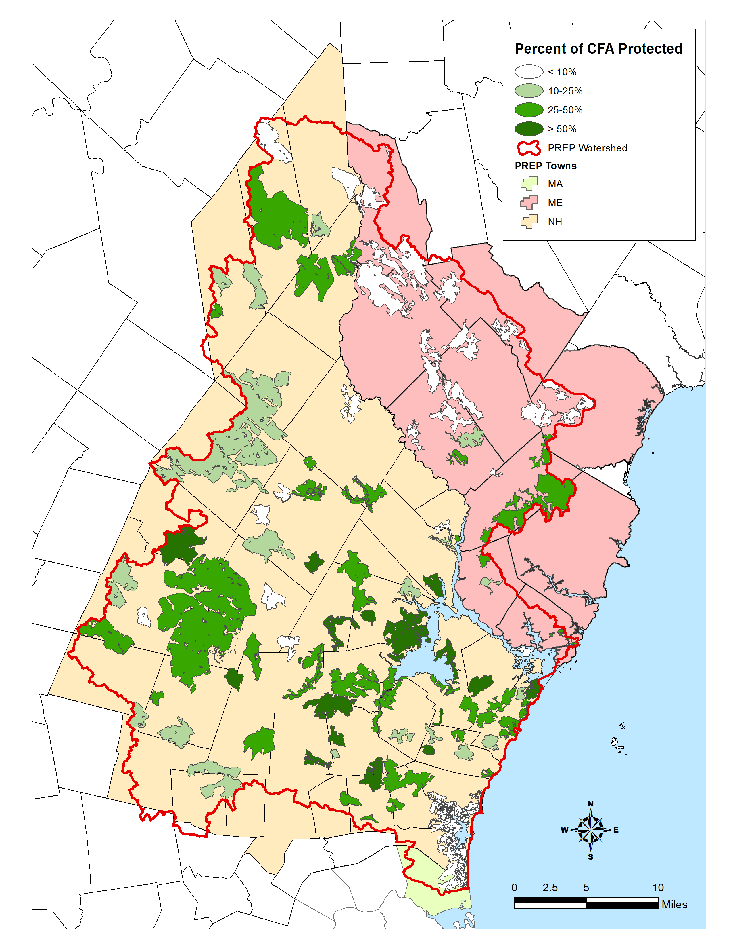
Figure CF-1. Percent of each Conservation Focus Area in the Piscataqua Region conserved.
Data Source: NH GRANIT

Table CF-1: Conservation lands in individual conservation focus areas in New Hampshire in 2017.
Core Focus Area Name | Conservation Lands | Area of Core | Percent of Core | Conservation Lands | Percent of Core | Acreage | Percentage
 | 2017 (acres) | CFA (acres) | CFA Area (2017) | 2011 (acres) | CFA area (2011) | Change | Change
Awcomin Marsh | 346.4 | 885.0 | 39.1% | 334.1 | 37.7% | 12.3 | 1.4%
Bailey Brook | 138.5 | 564.2 | 24.6% | 115.7 | 20.5% | 22.8 | 4.1%
Bayside Point | 120.7 | 333.1 | 36.2% | 120.7 | 36.2% | 0.0 | 0.0%
Bellamy River | 529.4 | 796.0 | 66.5% | 529.4 | 66.5% | 0.0 | 0.0%
Birch Hill Road Lowlands | 30.2 | 57.7 | 52.2% | 0.0 | 0.0% | 30.2 | 52.2%
Bloody and Dudley Brooks | 357.2 | 552.8 | 64.6% | 361.2 | 65.3% | -3.9 | -0.7%
Blue Hills | 3,708.2 | 16,879.0 | 22.0% | 2,894.7 | 17.2% | 813.5 | 4.8%
Bumfagging Hill | 465.0 | 2,361.1 | 19.7% | 478.9 | 20.3% | -13.8 | -0.6%
Candia Road | 0.0 | 549.2 | 0.0% | 0.0 | 0.0% | 0.0 | 0.0%
Cocheco Headwaters | 173.5 | 1,691.1 | 10.3% | 173.5 | 10.3% | 0.0 | 0.0%
Coldrain Pond | 129.5 | 906.3 | 14.3% | 129.5 | 14.3% | 0.0 | 0.0%
Cooper Cedar Woods | 169.2 | 379.5 | 44.6% | 130.9 | 34.5% | 38.3 | 10.1%
Creek Pond Marsh | 632.6 | 671.2 | 94.2% | 632.6 | 94.2% | 0.0 | 0.0%
Crommet/Lubberland Creeks | 2,312.0 | 3,798.7 | 60.9% | 2,201.5 | 58.0% | 110.5 | 2.9%
Davis and Oak Hill | 38.8 | 1,337.3 | 2.9% | 38.8 | 2.9% | 0.0 | 0.0%
Dogtown Swamp | 40.5 | 164.1 | 24.7% | 35.8 | 21.8% | 4.7 | 2.9%
Dumplingtown Hill | 118.7 | 364.9 | 32.5% | 118.7 | 32.5% | 0.0 | 0.0%
Exeter River | 480.8 | 620.3 | 77.5% | 436.5 | 70.4% | 44.3 | 7.1%
Fabyan Point | 799.1 | 1,071.6 | 74.6% | 797.8 | 74.4% | 1.3 | 0.2%
Fordway Brook Headwaters | 125.5 | 941.4 | 13.3% | 118.3 | 12.6% | 7.2 | 0.7%
Fresh Creek | 0.0 | 325.9 | 0.0% | 0.0 | 0.0% | 0.0 | 0.0%
Garvin Brook | 37.0 | 82.8 | 44.7% | 37.0 | 44.7% | 0.0 | 0.0%
Great Bog | 661.4 | 989.2 | 66.9% | 645.4 | 65.2% | 16.0 | 1.7%
Great Meadows | 816.6 | 1,400.2 | 58.3% | 816.7 | 58.3% | -0.1 | 0.0%
Hampton Marsh | 645.6 | 7,437.6 | 8.7% | 669.5 | 9.0% | -24.0 | -0.3%
Hart Brook / Mt. Tenneriffe | 1,121.8 | 3,503.0 | 32.0% | 764.7 | 21.8% | 357.1 | 10.2%
Johnson and Bunker Creeks | 178.0 | 747.6 | 23.8% | 178.0 | 23.8% | 0.0 | 0.0%
Kennard Hill | 575.2 | 1,294.6 | 44.4% | 0.0 | 0.0% | 575.2 | 44.4%
Lamprey River | 627.8 | 1,722.2 | 36.5% | 536.6 | 31.2% | 91.2 | 5.3%
Langley and Cyrus Ponds | 0.0 | 1,027.8 | 0.0% | 0.0 | 0.0% | 0.0 | 0.0%
LaRoche and Woodman Brooks | 350.5 | 444.1 | 78.9% | 350.6 | 78.9% | 0.0 | 0.0%
Lower Berry's Brook | 58.4 | 270.2 | 21.6% | 58.4 | 21.6% | 0.0 | 0.0%
Lower Cocheco River | 107.2 | 485.5 | 22.1% | 107.2 | 22.1% | 0.0 | 0.0%
Lower Fordway Brook | 214.0 | 1,679.1 | 12.7% | 201.5 | 12.0% | 12.5 | 0.7%
Lower Isinglass River | 518.2 | 1,260.9 | 41.1% | 224.3 | 17.8% | 293.8 | 23.3%
Lower Lamprey River | 616.6 | 1,228.1 | 50.2% | 535.7 | 43.6% | 80.8 | 6.6%
Lower Little River | 76.8 | 195.9 | 39.2% | 76.8 | 39.2% | 0.0 | 0.0%
Lower Lubberland Creek | 170.7 | 239.1 | 71.4% | 189.1 | 79.1% | -18.4 | -7.7%
Lower Piscassic River | 1,280.1 | 3,027.2 | 42.3% | 1,208.3 | 39.9% | 71.9 | 2.4%
Lower Winnicut River | 61.4 | 229.0 | 26.8% | 61.4 | 26.8% | 0.0 | 0.0%
Middle Isinglass River | 0.0 | 504.4 | 0.0% | 0.0 | 0.0% | 0.0 | 0.0%
Middle Little River | 102.0 | 595.2 | 17.1% | 95.5 | 16.0% | 6.6 | 1.1%
Middle Piscassic River | 1,218.4 | 2,281.3 | 53.4% | 1,215.6 | 53.3% | 2.8 | 0.1%
Middle Winnicut River | 118.6 | 163.9 | 72.4% | 36.8 | 22.4% | 81.9 | 50.0%
Moose Mountains | 3,960.5 | 8,788.7 | 45.1% | 3,638.4 | 41.4% | 322.1 | 3.7%
Muddy Pond | 61.4 | 156.3 | 39.3% | 61.4 | 39.3% | 0.0 | 0.0%
North River / Rollins Brook | 61.8 | 813.9 | 7.6% | 33.7 | 4.1% | 28.1 | 3.5%
Northeast Pond | 733.9 | 1,803.3 | 40.7% | 703.0 | 50.8% | 30.9 | -10.1%
Oyster River | 1,006.6 | 2,691.1 | 37.4% | 749.9 | 27.9% | 256.6 | 9.5%
Packer Bog | 394.1 | 815.1 | 48.4% | 394.1 | 48.4% | 0.0 | 0.0%
Parkman Brook | 74.5 | 547.2 | 13.6% | 74.5 | 13.6% | 0.0 | 0.0%
Pawtuckaway Mountains | 10,914.1 | 23,142.6 | 47.2% | 10,293.5 | 44.5% | 620.5 | 2.7%
Pawtuckaway River | 424.9 | 749.0 | 56.7% | 424.9 | 56.7% | 0.0 | 0.0%
Pike Brook | 57.4 | 2,338.7 | 2.5% | 57.4 | 2.5% | 0.0 | 0.0%
Preston Pond | 110.2 | 342.5 | 32.2% | 110.2 | 32.2% | 0.0 | 0.0%
Rochester Heath Bog | 49.2 | 1,024.0 | 4.8% | 49.2 | 4.8% | 0.0 | 0.0%
Rochester Neck | 446.6 | 1,605.2 | 27.8% | 354.5 | 22.1% | 92.0 | 5.7%
Saddleback Mountain | 1,841.3 | 3,342.9 | 55.1% | 1,658.3 | 49.6% | 183.0 | 5.5%
Seavey Creek / Fairhill Swamp | 439.0 | 633.2 | 69.3% | 439.8 | 69.4% | -0.7 | -0.1%
Spruce Swamp | 759.1 | 1,854.5 | 40.9% | 452.8 | 24.4% | 306.3 | 16.5%
Squamscott River | 648.4 | 2,023.6 | 32.0% | 638.1 | 31.5% | 10.3 | 0.5%
Stonehouse Brook | 0.0 | 726.5 | 0.0% | 0.0 | 0.0% | 0.0 | 0.0%
Taylor River and The Cove | 767.5 | 2,421.9 | 31.7% | 693.0 | 28.6% | 74.4 | 3.1%
Thurston Pond / Hartford Brook | 347.4 | 2,474.7 | 14.0% | 382.9 | 15.5% | -35.5 | -1.5%
Union Meadows | 165.8 | 985.9 | 16.8% | 43.9 | 4.5% | 121.9 | 12.3%
Upper Berry's Brook | 389.5 | 1,460.6 | 26.7% | 326.9 | 22.4% | 62.6 | 4.3%
Upper Exeter River | 539.0 | 3,011.2 | 17.9% | 395.3 | 13.1% | 143.7 | 4.8%
Upper Great Brook | 223.7 | 543.5 | 41.2% | 185.9 | 34.2% | 37.8 | 7.0%
Upper Isinglass River | 203.5 | 853.8 | 23.8% | 203.6 | 23.8% | 0.0 | 0.0%
Upper Little River | 86.7 | 326.6 | 26.5% | 86.7 | 26.5% | 0.0 | 0.0%
Upper North Branch River | 1,227.3 | 2,879.9 | 42.6% | 1,025.7 | 35.6% | 201.6 | 7.0%
Upper Taylor River | 122.5 | 439.0 | 27.9% | 107.8 | 24.6% | 14.6 | 3.3%
Upper Winnicut River | 221.2 | 289.6 | 76.4% | 49.3 | 17.0% | 171.9 | 59.4%
Wallis Marsh | 137.0 | 310.9 | 44.1% | 137.6 | 44.3% | -0.6 | -0.2%
Winnicut River / Cornelius Brook | 50.4 | 329.4 | 15.3% | 50.4 | 15.3% | 0.0 | 0.0%
TOTAL: | 46,737.0 | 135,784.6 | 34.4% | 41,480.5 | 30.6% | 5,256.5 | 3.8%

All reported acreages reflect ONLY those areas within the Piscataqua Region watershed.
2011 CFAs also included "Northeast Pond," however 2017 analysis does not include this CFA.

Table CF-2: Conservation lands in individual conservation focus areas in Maine in 2017.

Core Focus Area Name | Conservation Lands | Area of Core | Percent of Core | Conservation Lands | Percent of Core | Acreage | Percentage
 | 2017 (acres) | CFA (acres) | CFA Area (2017) | 2011 (acres) | CFA area (2011) | Change | Change
Bauneg Beg Mountain | 0.0 | 1571.7 | 0.0 | 0.0 | 0.0 | 0.0 | 0.0
Beaver Dam Heath | 155.6 | 1051.4 | 0.1 | 120.9 | 0.1 | 34.7 | 0.0
Brave Boat Harbor/Gerrish Island | 91.3 | 339.8 | 0.3 | 82.4 | 0.2 | 8.9 | 0.0
Cranberry Meadow | 181.4 | 426.6 | 0.4 | 126.7 | 0.3 | 54.7 | 0.1
Gerrish Mountain | 0.0 | 1282.9 | 0.0 | 32.8 | 0.0 | -32.8 | 0.0
Knights Pond | 0.0 | 113.5 | 0.0 | 0.0 | 0.0 | 0.0 | 0.0
Little River East | 0.0 | 4372.2 | 0.0 | 0.0 | 0.0 | 0.0 | 0.0
Little River West | 32.7 | 476.8 | 0.1 | 32.7 | 0.1 | 0.0 | 0.0
Merriland River Wetlands | 294.3 | 3231.1 | 0.1 | 341.4 | 0.1 | -47.1 | 0.0
Mt Agamenticus and | 3009.7 | 6845.7 | 0.4 | 3098.3 | 0.5 | -88.6 | 0.0
York River Headwaters
Sanford Ponds | 62.7 | 907.4 | 0.1 | 62.5 | 0.6 | 0.1 | -0.6
Shapleigh Pond | 0.0 | 77.2 | 0.0 | 0.0 | 0.0 | 0.0 | 0.0
South Acton Swamps | 436.0 | 8179.9 | 0.1 | 424.8 | 0.1 | 11.2 | 0.0
Sturgeon Creek | 49.3 | 295.9 | 0.2 | 49.3 | 0.2 | 0.0 | 0.0
West Sanford Swamps | 12.5 | 1256.2 | 0.0 | 12.6 | 0.0 | 0.0 | 0.0
TOTAL: | 4325.4 | 30428.3 | 0.1 | 4384.2 | 0.1 | -58.8 | 0.0

All reported acreages reflect ONLY those areas within the Piscataqua Region watershed.
2011 CFAs also included "Northeast Pond," however 2017 analysis does not include this CFA.

Table CF-3: Conservation lands in the Piscataqua Region Watershed 2017
Protection Type | New Hampshire | Maine | Total | % of Total
Permanent | 83,100.3 | 23,156.6 | 106,256.9 | 81.5%
Unofficial | 16,088.9 | 1,675.1 | 17,764.0 | 13.6%
Unknown | 6,257.2 | 24.2 | 6,281.4 | 4.8%
Total | 105,446.4 | 24,855.9 | 130,302.3 | 100.0%
% of Total | 80.9% | 19.1% | 100.0%

