Research and Technology
Backup Cameras

Every day our Maintenance personnel face the challenge of backing up their vehicles safely. Rearward visibility in many of trucks, loaders, and graders operated by Maintenance is non-existent or severely limited. In an effort to reduce or eliminate the number of backing accidents, personnel from the Maintenance Bureau and Mechanical Services approached the Materials and Research Bureau for help in obtaining and evaluating backing cameras on some NHDOT vehicles. The Research Section set up a project whereby seven cameras and an infrared radar system were purchased and installed on one vehicle in each Maintenance District and on one vehicle in the Turnpikes system. Each of these vehicles was identified as being a vehicle that did a lot of backing on its assigned plow route.

The cameras have now been in use for one year and drivers’ opinions have been solicited. An important part of the research process is an objective evaluation, and in this case, some lessons were learned. The general consensus is that the cameras would work better on the trucks if they were mounted properly, and that shutters are definitely necessary to keep snow from covering the lens. On several of the trucks, the mounting position caused the camera to be obscured by the spreader box during winter operations. The cameras worked well during the winter on the loader and on one of the trucks that was equipped with a municipal body (no spreader box needed) and a shuttered camera. The loader operator thought that the camera was a great asset for operating the loader safely. The heat from the radiator kept the camera snow-free and the operator was impressed with the visibility. His shed and another requested cameras for their graders because of the very poor rearward visibility. The majority of drivers thought that the cameras were beneficial for safety but also cautioned that looking in the mirrors is still necessary, and nothing is a substitute for getting out and looking if unsure. The cameras worked well in non-winter conditions and several drivers said the cameras were especially helpful during trailer operations.

To address the problems with mounting, personnel visited the Town of Bow to view their camera systems. Bow has developed an innovative quick-mount system that allows them to quickly move their cameras onto the spreader box thereby preventing the camera from getting obscured. Bow also has shutters for all of their cameras to prevent them from getting snow covered. By instituting the lessons learned, the backup camera could become a successful safety system for the NHDOT.

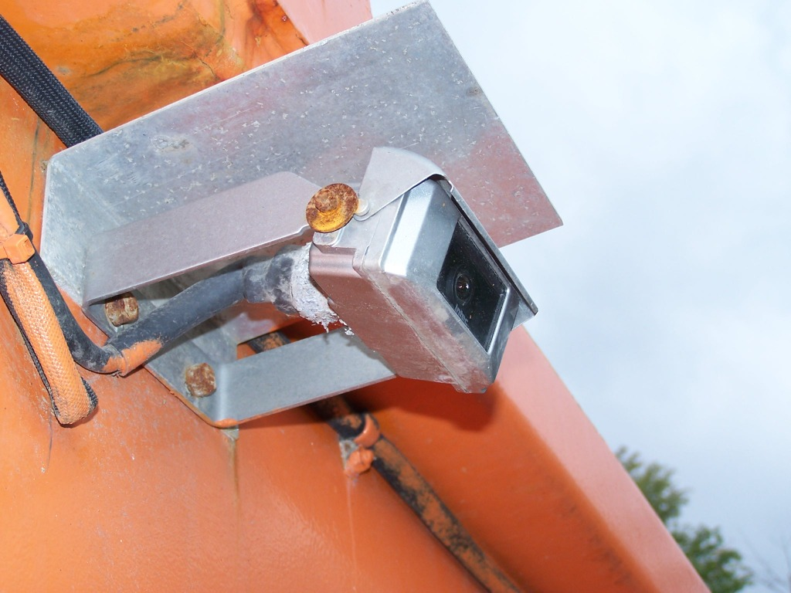
Camera with shutter on municipal body
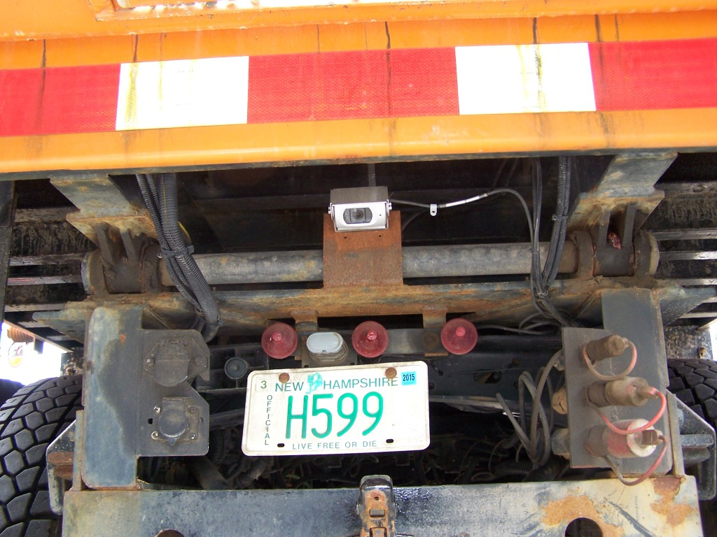
Camera in position where obscured by spreader on regular body
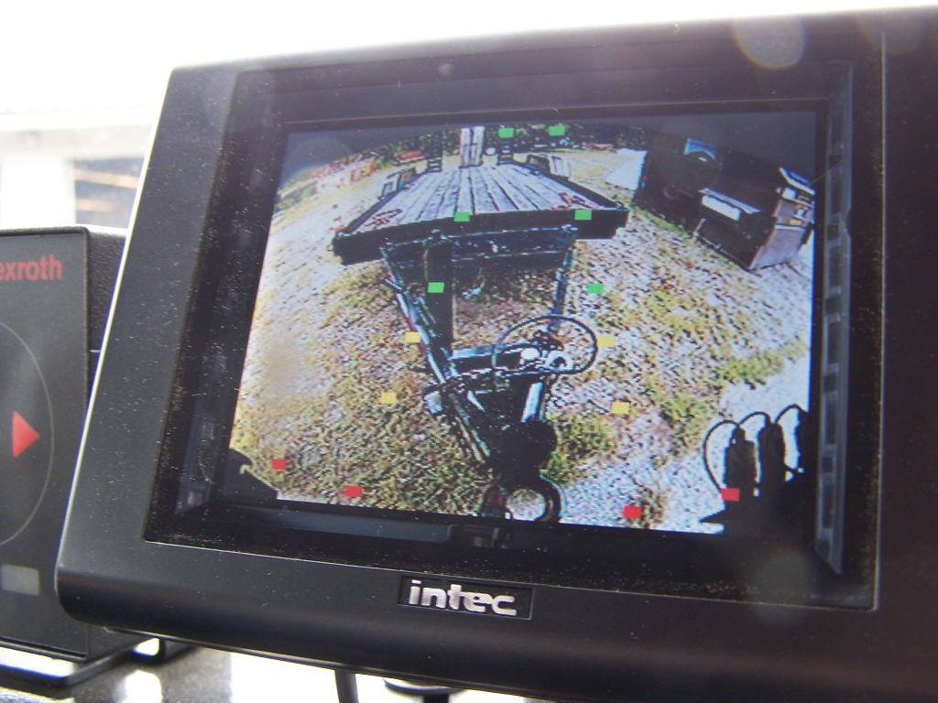
Camera being used during trailer operations
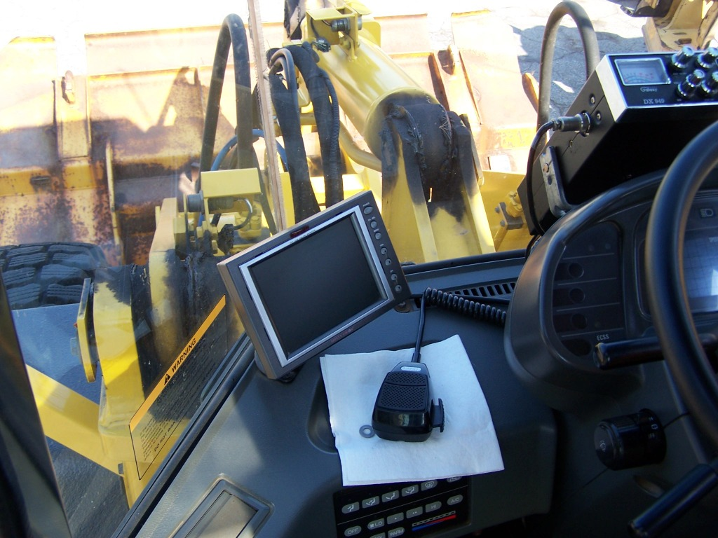
Camera in loader cab

