Transportation
Land Development
Environmental
S e r v i c e s

Memorandum |  |  | To: | Stuart Thompson,  New Hampshire DOT | Date: | August 20, 2012
 |  |  |  |  | Project No.: | 37769.34
 |  |  |  |  | Project Name: | MIRE MIS
 |  | From: |  | Becky Fiedler, VHB | Re: | Intersection Inventory

Errors in the Intersection Inventory
The purpose of this memorandum is to describe the most frequent errors found in the intersection node and intersection leg layers during the data collection effort. The data entry clerks made note of any perceived errors in the VHB comments field. The most common errors in the layers are described below. Accompanying this memo is a spreadsheet that contains each of the tables referenced in the following sections (Intersection inventory errors.xlsx). Each table includes the agency ID, leg ID, major and minor road SRI, major and minor road name, and town for each the intersections with errors.
Legs not split
Table 1 lists the intersections that have two legs that are not split at the node (e.g., the eastbound and westbound legs are combined as one leg instead of two individual legs). These combined legs will need to be split, and the data for each individual leg will need to be collected.
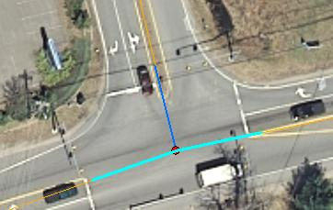
Example of legs that are not split at the intersection node.

Add legs
Table 2 lists the intersections that need additional legs generated. This is based on the Asset Roads layer and aerial imagery. The node data represent the correct number of legs at the intersection.
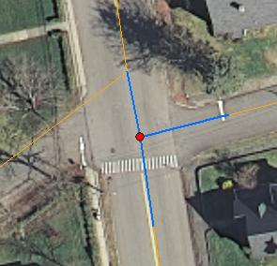
Example of intersection that needs an additional leg generated.

Delete nodes
Table 3 lists the intersections that should be deleted from the system. Intersections are recommended for deletion if they fit one of the following criteria:
- The 3rd leg of a 3-leg intersection is a Class VI road.
- The 3rd and 4th legs of a 4-leg intersection are Class VI roads.
- There is no intersection at this location (based on Asset Roads layer and aerial imagery).
- The Asset Roads layer has connecting linework, but there is no intersection at this location.
- Node was falsely generated where two roads are grade-separated.
- The minor road does not connect to the major road (e.g., road closed, dead end).
- The 3rd leg of the 3-leg intersection is actually a pedestrian path.
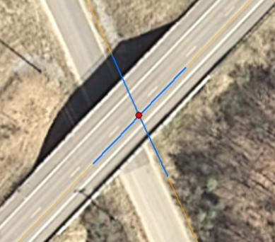
Example of a node that should be deleted (roadways are grade-separated).
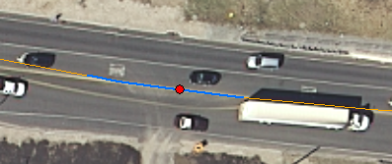
Example of node that should be deleted (intersection does not exist).

Add nodes and legs
Table 4 lists intersections that are not present in the node layer, and therefore need both nodes and legs generated. Based on the SRI, these are State-State and State-location intersections.
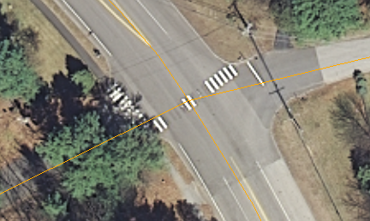
Example of State-local intersection that needs node and legs generated.

Two nodes, but should be one node
Table 5 indicates pairs of nodes that should be combined into one node. For most of these, an additional node was generated based on the linework in the Asset Roads layer; however, the aerial imagery indicates the node pairs should represent one intersection.
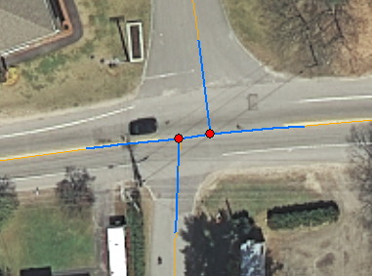
Example of two nodes that should be represented by one node.

Extra legs
Table 6 lists the intersections that have too many legs. Aerial imagery indicates there were too many legs generated from the Asset Roads layer. Each intersection has one, or more, legs that should be deleted from the system.
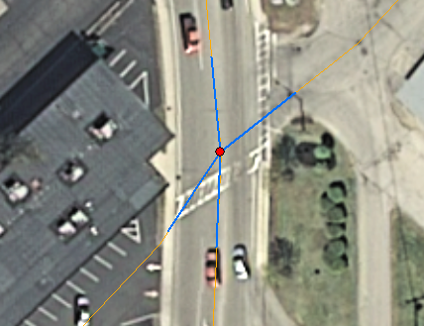
Example of intersection with too many legs.

Incorrect intersection location and/or approach orientation
Table 7 list intersections that are incorrectly located or have one or more approaches in the wrong orientation. Based on the linework in the Asset Roads layer, the nodes were generated slightly off from where they are actually located.
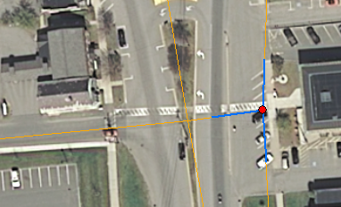
Example of incorrect intersection location.

