New Hampshire
Floodplain Management
Handbook
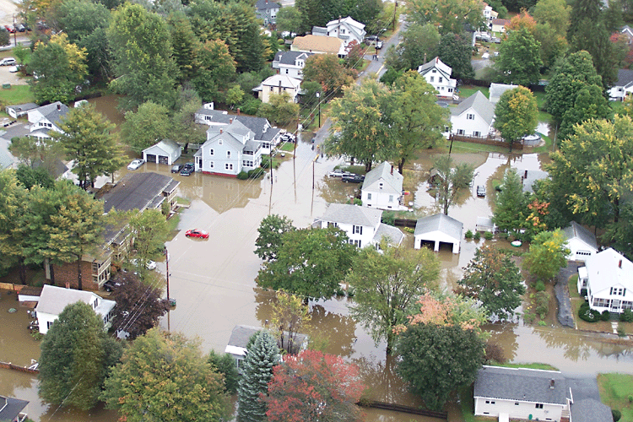

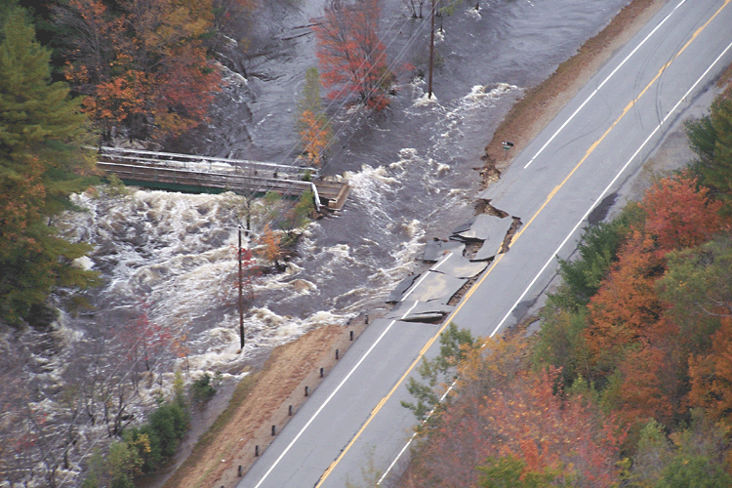
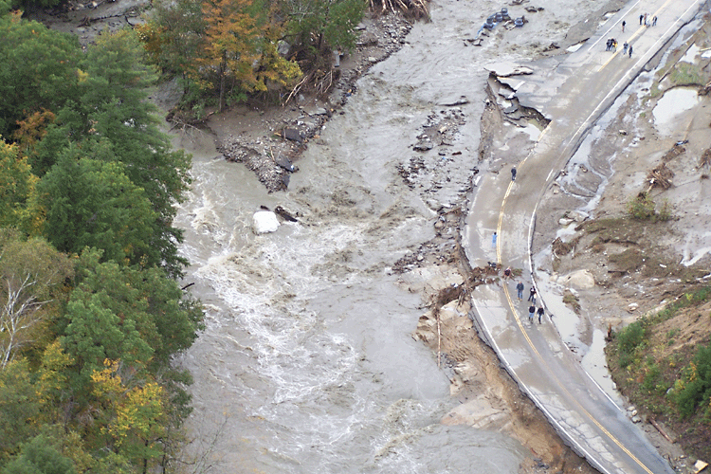

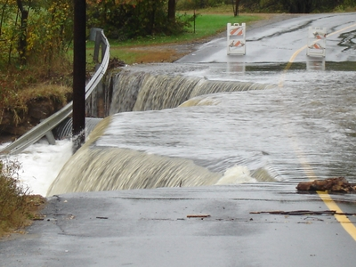



September 2006

Cover Page:

Over a 10-day period in October 2005, remnants of Tropical Storm Tammy and Subtropical Depression Twenty-Two merged with incoming continental cold fronts to produce torrential rains over interior New England, as well as over parts of New Jersey and New York. During this 10-day period, 7 through 16 October 2005, approximately 6 to 15 inches of rainfall occurred within New England River basins. New Hampshire was particularly hard hit as roads and bridges were wiped out, whole buildings were destroyed and several deaths occurred. Photographs on the cover show some of the destruction that resulted. The top center picture shows flooding in Keene; the center right photographs shows the collapse of Route 123; the bottom center picture was taken in Hinsdale; and the middle left photograph shows the destructive force of the Ashelot River along Route 10 in Marlow.
TABLE OF CONTENTS
1.0 Introduction 1-1
Flooding, Floodplains, and Floodplain Management 1-1
Flooding 1-1
Floodplains 1-2
Floodplain Management 1-3
History of Flooding in New Hampshire 1-3
2.0 The National Flood Insurance Program 2-1
Background and Overview of NFIP 2-1
National Flood Insurance Act of 1968 2-1
Flood Disaster Protection Act of 1973 2-2
Executive Order 11988 2-2
National Flood Insurance Reform Act of 1994 2-2
Roles and Responsibilities 2-3
Local Government 2-3
State 2-3
Federal 2-4
Community Participation 2-4
Benefits of Joining 2-4
Consequences of Not Joining 2-5
NFIP Phases 2-5
Suspension, Probation, and Re-entry 2-8
3.0 Floodplain 101 3-1
General Concepts 3-1
Base Flood (1% Chance Flood) 3-1
Special Flood Hazard Areas (SFHA) 3-1
Hydrology and Hydraulics 3-2
Flood Damage 3-3
Hydrodynamic Forces 3-3
Debris Impact 3-3
Hydrostatic Forces 3-4
Soaking 3-5
Sediment and Contaminants 3-5
4.0 NFIP Floodplain Management Requirements 4-1
Origin of Regulations – 44 CFR 4-1
Model Floodplain Ordinances 4-2
State Building Code 4-2
Subdivision and Site Plan Review Requirements 4-2
Subdivision Review 4-2
Site Plan Review 4-3
Higher Standards 4-3
Overview 4-3
Adoption of More Restrictive Ordinance Measures 4-4
No-Build Floodplain District Provisions 4-5
Community Rating System (CRS) 4-6
No Adverse Impact (NAI) 4-7
5.0 Administration 5-1
Local Floodplain Administrator Duties 5-1
Permit Process 5-2
Procedures for Review of Development in the Floodplain and Floodway 5-2
Inspections 5-5
Enforcement 5-6
Appeals, Special Uses, Variances 5-6
Appeals 5-7
Special Uses 5-7
Variances 5-7
Records 5-8
Biennial Report 5-9
Community Assistance Contacts and Visits 5-9
6.0 Construction Requirements 6-1
Anchoring 6-1
Construction Materials and Methods 6-2
Utilities 6-2
Structural Requirements 6-2
Lowest Floor 6-2
Residential Structures 6-3
Non-Residential Structures 6-3
Additional Requirements 6-3
Manufactured Housing (Mobile Homes) 6-5
Recreational Vehicles 6-6
Accessory Structures 6-6
Substantial Improvement and Damage 6-7
Encroachments 6-7
Watercourse Alterations 6-8
7.0 Coastal Regulations 7-1
Structures 7-1
Beach Stabilization 7-3
Building Code and Zoning Requirements 7-3
8.0 NFIP Flood Maps and Studies 8-1
History of Maps 8-1
Map Users 8-1
Flood Insurance Studies 8-2
Flood Zones 8-3
Type of Maps 8-4
Flood Hazard Boundary Map (FHBM) 8-4
Flood Boundary Floodway Map (FBFM) 8-4
Flood Insurance Rate Map (FIRM) 8-5
Approximate Flood Insurance Rate Maps 8-5
Digital Flood Insurance Rate Map (DFIRM) 8-6
Determining Base Flood Elevations 8-7
A and V Zones with BFEs 8-7
A and V Zones without BFEs 8-7
Floodways 8-8
Municipalities with Floodway Identified 8-9
Municipalities without Floodway Identified 8-10
Types of Map Changes 8-10
Restudy 8-10
Limited Map Maintenance Project 8-10
Map Revision 8-10
Map Amendment 8-10
Letter of Map Changes 8-11
Letter of Map Revision (LOMR) 8-11
Letter of Map Amendment (LOMA) 8-12
Appeals 8-12
9.0 Flood Insurance 9-1
Definition of a Flood 9-1
Policies 9-1
Coverage 9-1
30-Day Waiting Period 9-3
Increased Cost of Compliance 9-4
Grandfathering 9-5
Flood Insurance Rates 9-5
Mandatory Purchase Requirements 9-5
Relationship to Regulations 9-5
Community Rating System 9-6
10.0 Disaster Operations and Mitigation 10-1
Disaster Operations 10-1
Hazard Mitigation 10-2
Mitigation Assistance Programs and Grants 10-3
Hazard Mitigation Grant Program 10-3
Pre-Disaster Mitigation Grant Program 10-4
Flood Mitigation Assistance Program 10-4
Flood Mitigation and the Planning Process 10-4
Hazard Mitigation Plan 10-5
Hazard Identification 10-5
Implementation 10-6

Appendix A Acronyms

Appendix B Glossary

Appendix C Contacts

Appendix D Information Web Site Links

Appendix E References

Appendix F Find and Print Maps

Appendix G Sample Floodplain Development Permit and Checklist

Appendix H Procedures for Compliance with Floodway Regulations

Appendix I Biennial Report Information and Sample Reports

Introduction

Floods are New Hampshire’s most significant hazard – whether natural or manmade. New Hampshire communities have been dealing with floods and the effects of flooding since the first settlers arrived. Flooding in New Hampshire often occurs as a result of heavy spring rains, rapid snowmelt, runoff, ice jams, and coastal storms. Damage from flooding can be localized, but the cost of repairs is always high. A floodplain management program is an important part of community land use planning.
The National Flood Insurance Program (NFIP) is a partnership between a community and the Federal government. In communities that participate in the NFIP, property owners and renters can purchase insurance to protect them against losses from flooding. Communities participate by agreeing to adopt and enforce floodplain regulations designed to reduce future flood risks.
Currently, there are 196 communities (83 percent) in New Hampshire that participate in the Program. As of August 2006, there are 6,890 flood insurance polices in place with almost
50 percent in Rockingham County. The amount of insurance in force is approximately $1 billion.
The purpose of this Handbook is to provide guidance to New Hampshire local officials in implementing the NFIP regulations through the eyes of New Hampshire state law and to help local officials meet Federal regulations. This edition updates and replaces earlier additions.

Flooding, Floodplains, and Floodplain Management

Flooding
Flooding is a natural and beneficial function of stream and lacustrine, or lake, systems. Floods occur when rivers, streams or lakes overflow their banks and spill onto the adjoining land area, which is called a floodplain. Loss of life and property can result when people build structures and develop in flood hazard areas.

In New Hampshire, there are many types of flooding that occur, including riverine, flash flooding, coastal flooding, and shallow flooding. Riverine flooding is flooding produced by a river or stream. On larger rivers and streams it is generally characterized by slower rising water, which allows for increased warning time but has the potential to last for longer periods of time. An example of riverine flooding is that which occurred in October 2005 in the southwestern portion of New Hampshire when approximately 6 to 15 inches of rainfall fell over 10 days, causing flooding in the Connecticut, Cold, and Ashelot Rivers and Otter Brook.

Flash flooding can occur when a severe storm produces large amounts of rainfall in a short time. Flash flooding is generally characterized by high velocity water that rises and recedes quickly, allowing little or no warning time to evacuate and for this reason, is hazardous and very destructive. Flash flooding tends to occur along the State’s waterways at higher elevations. In urban areas, flash flooding can occur where impervious surfaces, gutters and storm sewers speed runoff. The U.S. Geological Survey (USGS) has concluded that urbanization generally increases the size and frequency of floods and may increase a community’s flood risk.

Coastal flooding occurs in the low-lying areas on the New Hampshire coast. Coastal flooding in New Hampshire primarily occurs due to major rain storms and nor’easters (severe storms on the Atlantic coast with winds out of the Northeast) with the added combination of full moon tides causing storm surge and wave effects. On open coasts, the magnitude of a flood varies with the tides. An increase in the level of the ocean during high tide will flood larger areas than a storm that strikes during low tide. Waves can be highly destructive as they move inland, battering structures in their path. In some areas, human activities, particularly disruption of natural protective coastal features (e.g. dunes or wetlands) may also aggravate the coastal flooding hazard.

Shallow flooding occurs in flat areas with inadequate channels that prevent water from draining easily. There are four types of shallow flooding: sheet flow, ponding, and urban drainage. Sheet flow flooding occurs in areas where channels are not defined so that the floodwaters spread over a large area at a somewhat uniform depth. Sheet flow flooding moves downhill and covers a large area under a relatively uniform depth.

Ponding occurs in flat areas where runoff collects in depressions and cannot adequately drain. Ponding can occur where glaciers carved out depressions in the landscape, and where man-made features, such as roads, have blocked drainage outlets. Ponding floodwaters do not move or flow away. Floodwaters will remain in the temporary ponds until they infiltrate into the soil, evaporate or are pumped out.

An urban drainage system comprises the ditches, storm sewers, retention ponds and other facilities constructed to store runoff or carry it to a receiving stream, lake or the ocean. Other man-made features in such a system include yards and swales that collect runoff and direct it to the sewers and ditches. When most of these systems were built, they were typically designed to handle the amount of water expected during a 10-year storm. Larger storms overload them, and the resulting backed-up sewers and overloaded ditches produce shallow flooding.

Ice jams occur when ice cover on rivers and lakes breaks up and creates temporary dams or obstructions to flow (i.e. under bridges). When ice jams combine with snowmelt or stormwater, flooding may occur.

Floodplains
Historically, people have been attracted to bodies of water as places for living, industry, commerce and recreation. During the early settlement of the United States, locations near water provided necessary access to transportation, a water supply and water power. In addition, these areas had fertile soils, making them prime agricultural lands. This pattern of development continued as communities grew. In recent decades, development along waterways and shorelines has been spurred by the aesthetic and recreational value of these sites.

Unfortunately, many of these developed areas along waterways are floodplains. In their natural condition, floodplains provide floodwater storage and conveyance, reduce flood velocities and flood peaks, and curb sedimentation. Human development can have an adverse impact on floods and floodplains. The most obvious impact of development on riverine flooding comes with moving or altering channels or constructing bridges and culverts with small openings. Construction and regrading of the floodplain can obstruct or divert water to other areas. Filling obstructs flood flows, backing up floodwaters onto upstream and adjacent properties. It also reduces the floodplain’s ability to store excess water, sending more water downstream and causing floods to rise to higher levels. This also increases the floodwater velocity.

Coastal development similarly affects the dynamics of coastal flooding. Removing the sand from beaches and dunes also removes the natural barrier built up by flood forces over the years and exposes inland areas to an increased risk of flooding. Coastal erosion is affected by construction of navigation channels, breakwaters, and jetties, and the mining of sand. Often construction of barriers, seawalls, or even sandbag walls to protect buildings from flooding or erosion has an adverse affect on properties at the end of the walls where erosion is accelerated.

Floodplain Management
Floodplain management is the corrective and preventative measures taken to reduce flood damage. Flood losses can be curbed by controlling floodwater with structures, such as dams, levees and floodwalls. Non-structural measures take a variety of forms and generally include requirements for zoning, subdivision or building, and special-purpose floodplain ordinances. Initially, the government’s emphasis was on structural flood control measures, but the amount of flood damages continued to increase. One of the main reasons structural flood control projects failed to reduce flood losses was that people continued to build in floodplains. In response to repeated flood damages, Federal, state and local agencies began to develop policies and programs with a “non-structural” emphasis, that did not prescribe projects to control or redirect the path of floods. Since the 1960s, floodplain management has evolved from a heavy reliance on flood control or structural measures, to one using a combination of many tools. The creation of the NFIP in 1968 was a landmark step in this evolution.

History of Flooding in New Hampshire
New Hampshire has more than 16,000 miles of rivers and streams covering 9,282 square miles. Initially, communities developed along the waterways which provided transportation and mills with water power. Then with industrialization, people continued the pattern of settling in the floodplain by moving to the cities and larger villages along the waterways. As a result of this development pattern, many of the State’s floodplains were settled. Such encroachment leads to flooding problems since the floodplains are extensions of the waterways they are adjacent to and the development pressure decreases their capacity to carry or store excessive runoff. General flooding is also caused by major hurricanes that follow the coast as well as those that track inland. As the following table shows significant flooding occurs periodically along the waterways with resultant loss of lives and property.

Recently, New Hampshire has had significant flood events. During the 10-day period from October 7th through the 16th, 2005, approximately 6 to 15 inches of rainfall fell when remnants of Tropical Storm Tammy and Subtropical Depression Twenty-Two merged with incoming continental cold fronts to produce torrential rains over interior New England. This caused flooding in the Connecticut River and its tributaries, Ashelot River, Cold River and Otter Brook. New Hampshire was particularly hard hit with roads and bridges wiped out, several reported deaths, and whole buildings destroyed. This was considered a major flood event especially for the Town of Alstead, who was hit the hardest, and other southwestern communities in New Hampshire.

A heavy rainfall of 8-12 inches fell on May 13-15, 2006 in the Merrimack and Piscataquoq River basins causing flooding in the Concord and Manchester areas that had not been experienced since September 1938. The USGS estimated that the storm was equal or slightly greater than a 100-year flood event. Floods of record were observed in the Warner, Piscataquog, Soucook, Lamprey, and Exeter Rivers. These recent events as well as historic ones are listed in the table on the following page.

State of New Hampshire
Natural Hazard Mitigation Plan 2004

New Hampshire’s Flood History
Date | Area Effected  (River Basins or Region) | Recurrence  interval (yr) | Remarks
December 1740 | Merrimack | Unknown | First recorded flood in New Hampshire
October 23, 1785 | Cocheco, Baker, Pemigewasset, Contoocook and Merrimack | Unknown | Greatest discharge at Merrimack and at Lowell, Mass. Through 1902
March 24-30, 1826 | Pemigewasset, Merrimack, Contoocook, Blackwater and Ashuelot | Unknown
April 2 1-24, 1852 | Pernigewasset, Winnespaukee, Contoocook, Blackwater, and Ashuelot | Unknown | Merrimack River at Concord; highest stream stage for 70 years. Merrimack River at Nashua,; 2 feet lower than 1785
April 19-22, 1862 | Contoocook, Merrimack, Piscataquog, and Connecticut | Unknown | Highest stream stages to date on the Connecticut River; due solely to snowmelt
October 3-5, 1869 | Androscoggin, Pemigewasset, Baker, Contoocook, Merrimack, Piscataquog Soughegan, Ammonoosuc, Mascoma, and Connecticut | Unknown | Tropical storm lasting 36 hours. Rainfall, 6-12 inches
November 3-4, 1927 | Pemigewasset, Baker, Merrimack, Ammonoosuc and Connecticut | 25 to>5O | Upper Pemigewasset River and Baker River; exceeded the 1936 Flood. Down stream at Plymouth; less severe than 1936 flood
March 11-21, 1936 | Statewide | 25 to> 50 | Double flood; first due to rains and snowmelt; second, due to large rainfall
September 21,1938 | Statewide | Unknown | Hurricane. Stream stages similar to those of March 1936 and exceeded 1936 stages in Upper Contoocook River
June 1942 | Merrimack River Basin | Unknown | This was the fourth flood in the lower Merrimack River basin at Manchester, NH
June 15-16,1943 | Upper Connecticut, Diamond and Androscoggin | 25 to >50 | Intense rain exceeding 4 inches; highest stream stages of record in parts of the affected area
June 1944 | Merrimack River | Unknown | This was one of the five highest known floods at Manchester on the Merrimack
November 1950 | Contoocook River and Nubanusit Brook | Unknown | Localized storm resulted in flooding of this area
March 27, 1953 | Lower Androscoggin, Saco, Ossipee, Upper Amrnonoosuc Israel, and Ammonoosuc | 25 to>50 | Peak of record for the Saco and Ossipee Rivers.
August 1955 | Connecticut River Basin | Unknown | Heavy rains caused extensive damage throughout the basin area
October 25, 1959 | White Mountain Area; Saco, Upper Pemigewasset and Ammonoosuc Rivers | 25 to>50 | Largest of record on Ammonoosuc at Bethlehem Junctions; third largest of record on the Pemigewasset and Saco Rivers
December 1959 | Piscataquog - Portsmouth | Unknown | A Northeaster brought tides exceeding maxim tidal flood levels in Portsmouth. Damage was heavy along the coast
April 1960 | Merrimack and Piscataquog | Unknown | Flooding resulted from rapid melting of deep snow covering and the moderate to heavy rainfall. This was the third highest flood of record on the rivers
April 1969 | Merrimack River Basin | Unknown | A record depth of snow cover in the Merrimack River Basin and elsewhere resulted in excessive snowmelt and runoff when combined with sporadic rainfall
February 1972 | Coastal Area | Unknown | The Coastal Area was declared a National Disaster Area as a result of the devastating effects of a severe coastal storm, damage was extensive
June 1972 | Pemigewasset River  - | Unknown | Five days of heavy rain caused some of the worst flooding since 1927 along streams in the upper part of the State, damage was extensive along the Pemigewasset River and smaller streams in northern areas
June 30, 1973 | Ammonoosuc River | 25 to >50 | Northwestern White Mountains
April 1976 | Connecticut River | Unknown | Rain and snowmelt brought the river to 1972 levels, flooding roads and croplands.
March 14,1977 | South-central and Coastal New Hampshire | 25 to 50 | Peak of record for Soucook River
Februaiy 1978  (“The Blizzard of ‘78) | Coastal New Hampshire | Unknown | A Nor’easter brought strong winds and precipitation to the entire state. Hardest hit area was the coastline, with wave action and floodwaters destroying homes. Roads all along the coast were breached by waves flooding over to meet the rising tidal waters in the marshes
July 1986-August 10,1986 | Statewide | Unknown | Severe summer storms with heavy rains, tornadoes; flash flood and severe winds  FEMA DR-71l-NH
March31 to April 2, 1987 | Androscoggin, Saco, Ossipee, Pi5c2:taquOg, Pemigewasset, Merrimack & Contoocook River | 25 to >50 | Caused by snowmelt and Sense rain Precursor to a significant, following event
April 6-7, 1987 | Lamprey River and Beaver Brook | 25 to>50 | Large rainfall quantities following the March 31- April 2 storm. FEMA DR-789-NH
August 7-11, 1990 | Statewide | Unknown | A series of storm events from August 7-11, 1990 with moderate to heavy rains during this period produced widespread flooding. FEMA DR-876-NH
August 19, 1991 | Statewide | Unknown | Hurricane Bob struck New Hampshire causing extensive damage in Rockingham and Stafford counties, but the effects were felt statewide.  FEMA DR-917-NH
October 1996 | Northern and Western Regions | Unknown | Counties Declared Carroll, Cheshire, Coos, Grafton, Merrimack, and Sullivan. FEMA DR-1077-NH
October – November 1995 | Northern and Western Regions | Unknown | Counties Declared:Grafton, Hillsborough, Merrimack, Rockingham, Strafford & Sullivan.  FEMA DR-1144-NH
June — July 1998 | Central and Southern Regions | Unknown | Series of rainfall events. Counties Declared: Belknap, Grafton, Carroll, Merrimack, Rockingham and Sullivan. (1fatality) (Several weeks earlier, significant flooding, due to rain and rapid snowpack melting, occurred in Coos County, undeclared in this event. Heavy damage to secondary roads occurred) FEMA DR-1231-NH
September 18- 19, 1999 | Central and Southwest Regions | Unknown | FEMA DR-1305-NH: Heavy rains associated with Tropical Storm/Hurricane Floyd. Counties Designated: Belknap, Cheshire and Grafton.
July21 - August 18, 2003 | Southwestern Region | Unknown | FEMA-1489-DR: Severe Storms and Flooding occurred in Cheshire and Sullivan counties. Public Assistance provided for repair of disaster damaged facilities.
October 7 -16, 2005 | Southwestern Region | 100 | FEMA-1610-DR: Heavy rains associated with Tropical Storm Tammy and Subtropical Depression 22 resulted in 6-15 inches of rain.
May 13-15, 2006 | Merrimack and Piscataquog River Basins | 100 | FEMA-1643-DR: Heavy Rainfall 8-16 inches

The National Flood Insurance Program

Background and Overview of NFIP
The NFIP is a Federal program enabling property owners in participating communities to purchase insurance protection against losses from flooding. This insurance is designed to provide an insurance alternative to disaster assistance to meet the escalating costs of repairing damage to buildings and their contents caused by floods.

Participation in the NFIP is based on an agreement between local communities and the Federal government that states if a community will adopt and enforce a floodplain management ordinance to reduce future flood risks to new construction in Special Flood Hazard Areas (SFHA), the Federal government will make flood insurance available within the community as a financial protection against flood losses. The combination of development regulations and insurance means that there is help for everyone already living in a floodplain. In addition, new construction is regulated to ensure that it is not subject to flood damage and does not impede or deflect flood flows. Insurance provides relief for even small floods, unlike disaster relief. The intent of the NFIP is not to prohibit, but to guide development in floodplain areas in a manner consistent with both nature's need to convey flood waters and a community's land use needs.

The NFIP was established in 1968 and was amended by enactment of the Flood Disaster Protection Act of 1973, and the 1994 Reform Act. Initially administered by the Department of Housing and Urban Development, the program was transferred to the Federal Emergency Management Agency (FEMA) in 1979. The program emphasizes the importance of managing the Nation’s floodplains in order to reduce flood hazards and the spiraling cost of flood damage. It is designed to minimize the disruption of lives and business and to provide reasonable compensation for loss and damages to property.

National Flood Insurance Act of 1968
When the NFIP was created, the U.S. Congress recognized that insurance for “existing buildings” constructed before a community joined the Program would be prohibitively expensive if the premiums were not subsidized by the Federal government. Congress also recognized that most of these flood-prone buildings were built by individuals who did not have sufficient knowledge of the flood hazard to make informed decisions.

Therefore, the purposes of the 1968 Act were to:

- Establish an insurance program as an alternative to disaster relief;
- Reduce future flood damages through State and community floodplain management regulations;
- Reduce Federal expenditures for disaster assistance and flood control;
- Distribute responsibility for floodplain management to all levels of government and the private sector;
- Set a national standard for regulating new development in floodplains; and
- Develop a comprehensive floodplain mapping program.

Flood Disaster Protection Act of 1973
Early in the Program’s history, the Federal government found that providing subsidized flood insurance for existing buildings was not a sufficient incentive for communities to voluntarily join the NFIP nor for individuals to purchase flood insurance. Tropical Storm Agnes in 1972, which caused extensive riverine flooding along the East Coast, proved that few property owners in identified floodplains were insured. This storm cost the Nation more in disaster assistance than any previous disaster. For the Nation as a whole, only a few thousand communities participated in the NFIP and only 95,000 policies were in force.

As a result, Congress passed the Flood Disaster Protection Act of 1973 which tightened the Program by providing sanctions, primarily affecting lending institutions. The 1973 Act prohibits Federal agencies from providing financial assistance for acquisition or construction of buildings and certain disaster assistance in the floodplains in any community that did not participate in the NFIP by July 1, 1975, or within 1 year of being identified as flood-prone.

Additionally, the 1973 Act required that Federal agencies and Federally insured or regulated lenders had to require flood insurance on all grants and loans for acquisition or construction of buildings in designated SFHAs in communities that participate in the NFIP. This requirement is referred to as the Mandatory Flood Insurance Purchase Requirement.

The Mandatory Flood Insurance Purchase Requirement, in particular, resulted in a dramatic increase in the number of communities that joined the NFIP and a dramatic increase in the number of flood insurance policies in force.

Executive Order 11988
In 1977, President Carter issued Executive Order 11988, Floodplain Management. The order requires Federal agencies to avoid long and short-term adverse impacts associated with the occupancy and modification of floodplains and to avoid direct and indirect support of floodplain development wherever there is a practicable alternative. The Order applies to all agencies that: (1) acquire, manage, or dispose of Federal lands and facilities; (2) undertake finance or assist construction and improvements; and (3) conduct activities and programs affecting land use, including planning, regulating and licensing.

National Flood Insurance Reform Act of 1994
In 1994, Congress amended the 1968 Act and the 1973 Act with the National Flood Insurance Reform Act. The 1994 Act included measures, among others, to:

- Increase compliance by mortgage lenders with the mandatory purchase requirement and improve coverage;
- Increase the maximum amount of flood insurance coverage that can be purchased;
- Provide flood insurance coverage for the cost of complying with floodplain management regulations by individual property owners (Increased Cost of Compliance coverage);
- Establish a Flood Mitigation Assistance (FMA) grant program to assist States and communities to develop mitigation plans and implement measures to reduce future flood damages to structures;
- Authorize the NFIP’s Community Rating System (CRS); and
- Require FEMA to assess its flood hazard map inventory at least once every 5 years.

Roles and Responsibilities
The NFIP is founded on a mutual agreement between the Federal government and each participating community. Local, state and Federal governments and private insurance companies must share roles and responsibilities to meet the goals and objectives of the NFIP.

Local Government
The local government means the community. This can include just about any political subdivision other than the state. Towns, cities, counties, Indian tribes, and special districts are included. The community enacts and implements the floodplain regulations required for participation in the NFIP. The community’s measures must meet regulations set by its state, as well as NFIP criteria. In return, the Federal government underwrites flood insurance for the community.

A participating community commits itself to:

- Adopt and enforce a floodplain management ordinance;
- Issue or deny floodplain development/building permits;
- Inspect all development to assure compliance with the local ordinance;
- Maintain records of floodplain development;
- Assist in the preparation and revision of floodplain maps;
- Help residents obtain information on flood hazards, floodplain map data, flood insurance and proper construction measures.

State
New Hampshire has given authority to municipalities to implement floodplain management policies. State law allows communities to adopt floodplain management regulations as part of the zoning ordinance or the State building code. New Hampshire RSA 674:16 and 674:18 authorize municipalities to adopt or amend a zoning ordinance and RSA 155-A:2 enables local communities to adopt the State Building Code and any related regulations. Prior to adopting floodplain management regulations, communities should have a local master plan which has identified floodplain management as an objective.

The Office of Energy and Planning (OEP) is the State Coordinating Agency for the NFIP in New Hampshire and receives a grant from FEMA for its work. OEP provides technical assistance to communities and the public on floodplain management and helps to promote sound land use planning techniques that will reduce flood losses.
OEP does the following:
- Provides technical assistance to communities;
- Acts as liaison between FEMA and local officials;
- Offers technical workshops and training;
- Provides model ordinances and reviews local ordinances for compliance with the NFIP standards;
- Makes community assistance visits and contacts;
- Provides assistance to communities interested in lowering their flood insurance premiums with the Community Rating System (CRS) (http://www.fema.gov/business/nfip/crs.shtm) (See Section 9 for more information.);
- Provides assistance to communities to reduce repetitive losses from flooding through the Flood Mitigation Assistance (FMA) Program (http://nh.gov/oep/programs/floodplainmanagement/fma.htm) (see Section 10 for more information.)
- Provides assistance for correcting or updating floodplain maps and/or studies through the Limited Map Maintenance Program (LMMP).
OEP also participates in interagency reviews of state funded projects. The purpose of these reviews is to assure compliance with floodplain management regulations and to meet the objectives of Executive Order 96-4 issued by Governor Merrill directing state agencies to comply with the floodplain management requirements of local communities participating in the NFIP whenever state-owned properties are involved in activities that impact the floodplain.

Federal
The Federal agency responsible for administering the NFIP is the FEMA, which is within the U.S. Department of Homeland Security.

FEMA’s responsibilities are to:

- Provide affordable flood insurance coverage;
- Provide flood hazard identification and mapping;
- Ensure NFIP enforcement and compliance;
- Provide resources for hazard mitigation planning and reduction projects;
- Provide assistance to NFIP Communities for Federally Declared Disasters;
- Assist the state NFIP coordinating agencies;
- Assess community compliance with the minimum NFIP criteria;
- Advise local officials responsible for administering the ordinance;
- Answer questions from design professionals and the public;
- Approve community floodplain management regulations; and
- Provide information and training on the flood insurance purchase requirements.

Services are available from FEMA’s Regional Office in Boston (http://www.fema.gov/about/regions/regioni/index.shtm).

Community Participation
To participate in the NFIP, a community must adopt and enforce floodplain management regulations that meet or exceed the minimum requirements of the Program. These requirements are intended to prevent loss of life and property and reduce taxpayer costs for disaster relief, as well as minimize economic and social hardships that result from flooding.

Benefits of Joining
The biggest benefit of a community’s participation in the NFIP is that it allows all its citizens the opportunity to purchase flood insurance to protect themselves from flood losses. Federal flood insurance is designed to provide an alternative to disaster assistance and disaster loans. Disaster assistance is a poor choice – it never comes close to covering all the costs of repairing homes and businesses. It is especially important to remember that disaster assistance is available only after the floods that are declared major disasters by the President of the United States. Federal flood insurance also is a better alternative than disaster loans that are made available only when a disaster declaration is made by the President or by the Small Business Administration. Loans require repayment, typically over a 10-year period. Insurance will pay whenever damage from a qualifying flood event occurs.

Additional benefits are:

- Many communities are furnished a comprehensive and detailed study of the hydrologic and hydraulic aspects of the flooding problems by FEMA, at no expense to the community;
- These studies provide data that is useful in floodplain and water resources management and other aspects of community planning; and
- Moreover, by employing the wise floodplain management practices required under the program, the community can help protect its residents from the financial devastation and human loss which is caused by flood disasters, and reduce the burdens on taxpayers for disaster relief and recovery efforts.

Consequences of Not Joining
The following sanctions apply if a community does not qualify for participation in the NFIP within one year of being identified as flood-prone by FEMA. Non-participating communities that have not been identified as flood-prone by FEMA are not subject to these sanctions.

- Property owners will not be able to purchase NFIP flood insurance policies and existing policies will not be renewed.
- Federal grants or loans for development will not be available in identified flood hazard areas under programs administered by Federal agencies
- Federal disaster assistance for flood damage will not be provided to repair an insurable building located in identified flood hazard areas.
- Federal mortgage insurance or loan guarantees will not be provided in identified flood hazard areas.
- Federally insured or regulated lending institutions are allowed to make conventional loans for insurable buildings in flood hazard areas of non-participating communities. However, the lender must notify applicants that the property is in a flood hazard area and that the property is not eligible for Federal disaster assistance. Some lenders may voluntarily choose not to make loans.

NFIP Phases
The NFIP is divided into three phases; the Application Phase, the Emergency Program Phase and the Regular Program Phase. Most New Hampshire communities are in the Regular Program Phase. (See the table and figure that follow this section to see a list of participating communities and their status.)

Application Phase

Community involvement in the NFIP starts with the preparation of an application package for participation in the NFIP. The documents to be submitted for application are described below and can be obtained from OEP. Applications are generally processed in four to six weeks following receipt of all requirements and information by the FEMA Region 1 Office in Boston.

A community must do and submit the following:

- Complete and submit the “Application for Participation in the National Flood Insurance Program” (FEMA Form 81-64).

- Adopt a Resolution of Intent (adopted by the Board of Selectmen). This should be done as soon as possible. A sample resolution is available for use by the Town and is included in the application package. Submit a copy of the adopted resolution that is dated and certified by the Town Clerk or Board of Selectmen attesting to its adoption.

- Amend the Town’s Subdivision and Site Plan Review Regulations to add required language. The Town’s Planning Board can do this at any time after holding a public hearing. Submit a copy of the amended subdivision and site plan review regulations that is dated and certified by the Town Clerk attesting to its adoption.

- Adopt a model Floodplain Management Ordinance as an amendment to the town’s Zoning Ordinance or as stand-alone ordinance especially if there is no zoning in the Town. Adoption of the floodplain ordinance has to be done at either a regular or special Town Meeting. Submit a copy of the adopted ordinance that is dated and certified by the Town Clerk or Board of Selectmen attesting to its adoption.

If the Town decides to make any changes or additions to the ordinance, it is strongly advised that a copy of this ordinance be sent to OEP for review before any actions on it are taken to ensure it meets FEMA minimum requirements.

- It is highly recommended that a community amend their Building Permit application to include the question: “Is this property in a Special Flood Hazard Area?” The answer to this question will serve as a flag as to whether the requirements in the floodplain ordinance will need to be followed. Submit a copy of the amended Building Permit application.

In addition to submitting this information with its application, the community makes a commitment to:

- Designate an official, such as the building inspector, as local administrator, with the responsibility and authority to implement the floodplain regulations in the community;
- Establish a building permit system, if one is already not established, which enables monitoring of development activity in SFHAs and provides for review of individual projects.
- Make available for public inspection the FEMA floodplain maps at some location within the community, such as the Clerk’s office or local administrator’s office, and provide FEMA with the address;
- Recognize and evaluate flood hazards in all official actions in SFHAs and to take such actions as are necessary to carry out the objectives of the NFIP;
- Assist FEMA in the delineation of the limits of the SFHA;
- Provide to FEMA, upon request, information concerning present uses and occupancy of the SFHA;
  - Maintain for public inspection and furnish upon request, any certificates of floodproofing and information on the elevation of the lowest floor, including basement, of all new and substantially improved structures; cooperate with neighboring communities in the management of adjoining floodplain areas in order to prevent aggravation of existing hazards;
- Notify FEMA in writing whenever the boundaries of the community have been modified by annexation or the community has otherwise assumed or no longer has land use control authority for a particular area; and;
- Have the local administrator and the Chief Executive Officer complete the biennial report form provided by FEMA, concerning the community’s participation in the NFIP.

After FEMA approves the application, the community is notified by FEMA as to when the community will enter either the Emergency Program or Regular Program.

Emergency Program

When a community enters the Emergency Program, a limited amount of flood insurance coverage is available. Such insurance may be purchased throughout the community for any structure and its contents, existing or under construction when the community enters the program. Insurance will be required by Federally backed lenders for all structures that may be located within the flood hazard area as shown on the current flood maps.

While a community is in the Emergency Program, FEMA will decide whether a detailed Flood Insurance Study (FIS) of the flood hazard areas should be undertaken, particularly for developed or developing communities. The information collected from the study is used in the production of Flood Insurance Rate Maps (FIRMs). Once the FIRM becomes effective, FEMA will notify the community of its entrance into the Regular Program.

In less developed communities, FEMA may decide to convert the Flood Hazard Boundary Map (FHBM) to a FIRM with only some minor changes and the community will be brought into the Regular Program by a process called a Minimal Flood-prone Conversion. Under this process no detailed study is performed and no flood elevations are published.

Regular Program

A community enters the Regular Program when the FIRM takes effect and when all floodplain management regulations have been established. The first level of insurance that became available when the community entered the Emergency Program may then be supplemented by insurance based on actuarial rates to provide maximum coverage allowed under the program.

Once a community enters the Regular Program, the local administrator and land use boards have the responsibility for administering and enforcing the regulations. This includes filing a biennial report with FEMA. FEMA reviews this report to determine whether the community is adequately enforcing local requirements and can monitor the status and progress of the community’s efforts. In addition, local officials will be involved with any Revisions to the Effective FIRM (See the Revision section in Section 8).

All citizens, both in and out of the SFHA are eligible to purchase flood insurance as long as the community is in the Regular Program. If the policy is not renewed and a flood occurs, the property owner may not be eligible for Federal grants or loans for disaster relief.

Suspension, Probation, and Re-entry
Communities that do not enforce the floodplain management ordinances can be placed on probation or suspended from the program. During probation, an additional $50 charge is added to the premium for each policy sold or renewed in the community and FEMA notifies all policy holders that poor compliance is the reason for the extra charge.

If the community is suspended, the sale and renewal of flood insurance ceases, as does Federal aid for construction or reconstruction in the SFHAs. This will severely restrict the availability of mortgages and other loans, Federal grants, and disaster assistance.

If a community has been suspended and wishes to re-enter in the NFIP it must submit the following materials to FEMA:

- A copy of the completed application form;
- A copy of a resolution adopted by the community’s governing board reaffirming the community’s intent to comply with the NFIP criteria;
- A statement which includes:

  - the amount of and type of construction (development) that has taken place in the Federally designated SFHA within the community since suspension;
  - whether that construction (development) is compliant with the minimum requirements of the NFIP. (FEMA reserves the right to perform on-site review to determine if structures cited are in fact compliant.); and

    - A copy of the portion of the community’s zoning ordinance, subdivision regulation, and site plan review regulation or building code which covers the requirements of the NFIP. These ordinance sections will be reviewed by FEMA to determine whether they are in accordance with the most current NFIP regulations. If they are not, the community will be asked to take the appropriate legislative steps to make the required modifications.

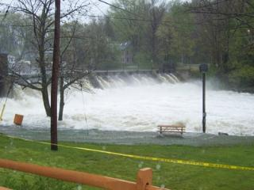

Milton Dam on May 14, 2006
NH Community Participation in NFIP

NH Community Status Report

Floodplain 101

General Concepts

Base Flood (1% Chance Flood)
The definition of base flood is a flood that has a 1 percent or 1 out of 100 chance of occurring in any given year. Over a long period of time, base floods will occur on the average once every 100 years. For this reason, the base flood used to be commonly referred to as the “100-year flood”. An item related to the base flood is the Base Flood Elevation (BFE). The BFE is defined as the elevation to which a body of water could be expected to rise during a base flood.

Special Flood Hazard Areas (SFHA)
The area that would be inundated by the base flood is called a “Special Flood Hazard Area” (SFHA). The SFHA is the land in the floodplain subject to a one percent or greater chance of flooding in any given year (also known as the 100 year floodplain) and is designated as Zone AE or VE on the post-1986 flood maps and as Zone A and V on the pre-1986 flood maps. In order to minimize the potential for flooding, the NFIP program regulates development and reconstruction in the SFHA.

The SFHA is composed of the floodway and the flood fringe. The floodway is the stream channel and that portion of the adjacent floodplain that must remain open to permit passage of the base flood. Floodwaters generally are deepest and swiftest in the floodway, and anything in this area is in the greatest danger during a flood. The remainder of the floodplain is called the flood fringe, where water may be shallower and slower. The following figure illustrates the relationship between the floodway and flood fringe.

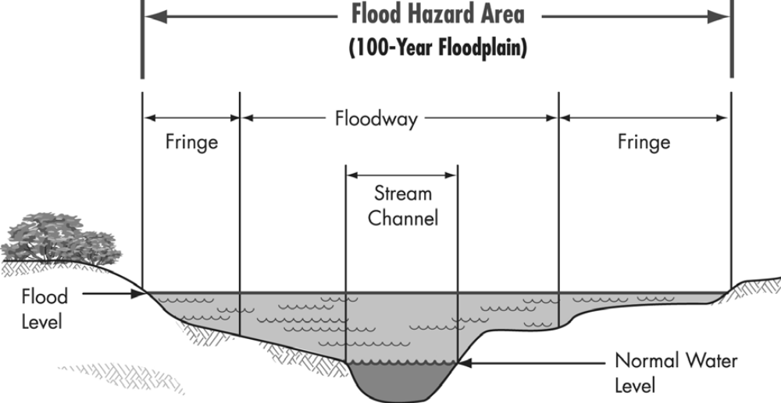

Cross-section showing the Floodway and Flood Fringe

NFIP minimum standards provide that other areas outside the boundaries of the floodway can be developed without further analysis. Consequently, most communities permit development in the flood fringe if the development is elevated or otherwise protected to the base flood level (or any higher state or local standards). Development in the floodway is allowed if it can be demonstrated that no rise in the BFE will occur.

The area between the 100 and 500 year flood boundaries is the “Moderate Flood Hazard Area”, known as the B zone or Shaded X zone on the post-1986 maps. The remaining area above the 500-year flood level is termed the “Minimal Flood Hazard Area” and is known as the C on the pre-1986 maps or X zone on the post-1986 maps. However, this is not to say that areas outside of the SFHA are not subject to flooding. As the following figure shows, the water level for the 500-year flood is higher than that for a 100-year storm so consequently more land is inundated.

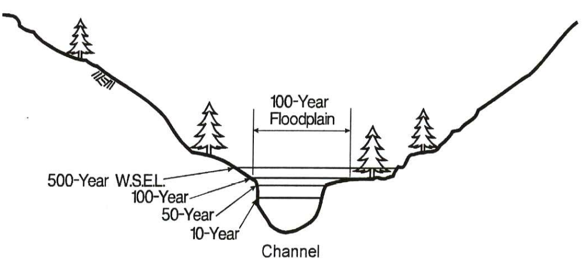

Cross Section with Flood Elevations for Different Flood Events

Hydrology and Hydraulics
For regulating floodplain development, a map developed through hydrologic and hydraulic analysis (H&H) is used. The science of hydrology is used to determine the amount of water that a river or stream must convey for a given storm. This involves calculating the amount of runoff that can be expected to drain from the surrounding watershed. The principles of hydraulics are applied to help determine how the river or stream channel will handle the flow and to what extent the excess water will spread over the floodplain when the flood is at its peak. Specialized computer programs are used to perform most hydrologic and hydraulic computations. The advantage of using H&H analyses is that specific frequencies of flooding can be selected for delineating a floodplain. It is often difficult to associate the drawing of a floodplain based on soils, physiography, or vegetation, with a particular frequency of flooding. If applied properly, an H&H analysis provides a sound technical and legal basis for adopting and administering floodplain management regulations.

Flood Damage

Hydrodynamic Forces
Moving water creates a hydrodynamic force which can damage a building’s walls in three ways (see figure below):

- Frontal impact, as water strikes the structure.
- Drag effect, as water runs along the sides of a structure.
- Eddies or negative pressures, created as water passes the downstream side.

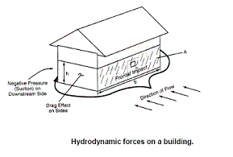

The speed of moving water is called velocity, which is measured in feet per second. The faster water moves, the more pressure it puts on a structure and the more it will erode stream banks and scour the earth around a building’s foundation. Floodwaters moving faster than 5 feet per second comprise a high-velocity flood, requiring special design considerations for buildings, roads, bridges and other manmade structures in its path.

While velocity is one factor in determining the potential harm of a flood, the total impact of moving water is related to the depth of the flooding. Studies have shown that deep water and low velocities can cause as much damage as shallow water and high velocities. People are more susceptible to damage than buildings. Studies have shown that it doesn’t take much depth or velocity to knock a person over. Thus, no areas with moving floodwater can be considered safe for walking. A car will float in only two feet of moving water, which is one reason floods kill more people trapped in vehicles than anywhere else. Often victims put themselves in perilous situations by ignoring warnings about travel or mistakenly thinking that a washed-out bridge is still open.

Debris Impact
Debris also increases the hazard posed by moving water. Floodwaters can and will pick up anything that will float—logs, lumber, ice, even propane tanks and vehicles. Moving water will also drag or roll objects that don’t float. All of this debris acts as battering rams that can knock holes in walls.

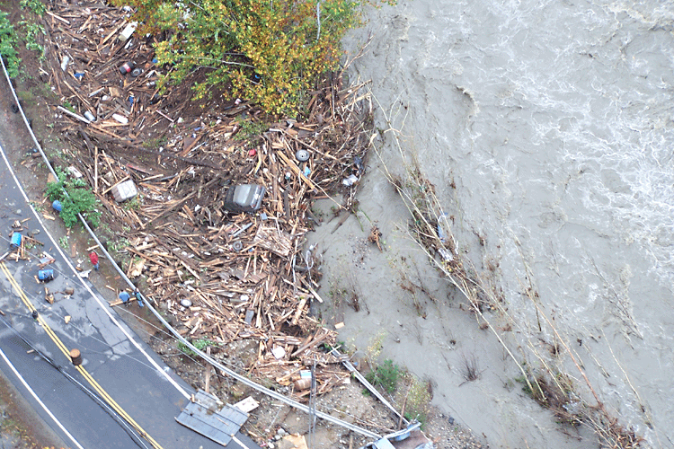

Debris carried by floodwaters along Route 123 in October 2005

Hydrostatic Forces
The weight of standing water puts hydrostatic pressure on a structure. The deeper the water, the more it weighs and a greater hydrostatic pressure is exerted. Because water is fluid, it exerts the same amount of pressure sideways (lateral pressure) as it does downward. As water gets deeper, it exerts more lateral pressure than shallow water. Most walls are not built to withstand lateral pressure. Studies and tests have shown that the lateral force presented by three feet of standing water can be enough to collapse the walls of a typical frame house. Basement walls and floors are particularly susceptible to damage by hydrostatic pressure. Not only is the water deeper, a basement is subjected to the combined weight of water and saturated earth. Water in the ground underneath a flooded building will seek its own level – resulting in uplift forces that can break a concrete basement floor. Hydrostatic pressure can also cause damage due to floatation or buoyancy. Improperly anchored buildings can float off their foundations and empty inground storage tanks can pop out of the ground even forcing their way through several inches on concrete.

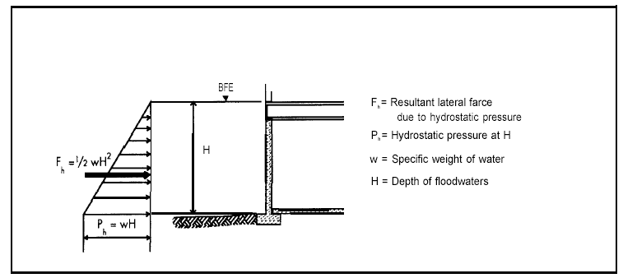

Lateral Hydrostatic Force and Pressure

Soaking
When soaked, many materials change their composition or shape. Wet wood will swell, and if it is dried too fast it will crack, split or warp. Plywood can come apart. Gypsum wallboard will fall apart if it is bumped before it dries out. The longer these materials are wet, the more moisture they will absorb. Soaking can cause extensive damage to household goods. Wooden furniture may get so badly warped that it can't be used. Other furnishings, such as upholstery, carpeting, mattresses and books, usually are not worth drying out and restoring. Electrical appliances and gasoline engines won't work safely until they are professionally dried and cleaned.

Sediment and Contaminants
Many materials, including wood and fiberglass or cellulose insulation, absorb floodwater and its sediment. Even if allowed to dry out, the materials will still hold the sediment, salt and contaminants brought by the flood. Simply letting a flooded house dry out will not render it clean—and it certainly will not be as healthy a place as it was before the flood. Few floods, especially those that strike inland, have clear floodwater, and so they leave a mess made of natural and man-made debris. Stormwater, snowmelt and river water pick up whatever was on the ground, such as soil, road oil, and farm and lawn chemicals. If a wastewater treatment plant upstream was inundated, the floodwaters will likely include untreated sewage. Flooding can leave large amounts of sand, sediment and debris that require major cleanup efforts. After the water recedes or evaporates, these sediments are left on and in a building, and its contents.

NFIP Floodplain Management Requirements

Origin of Regulations – 44 CFR
In order to be eligible for Federal flood insurance, communities must adopt and enforce floodplain management standards that meet or exceed those outlined in the NFIP Regulations. These standards are intended to prevent loss of life and property, as well as economic and social hardships that result from flooding. Since floodplain management is related to land use, New Hampshire law requires the regulations to be adopted using the zoning ordinance procedures in RSA 675:2-5. In addition, the community must have requirements for subdivisions, which are located on land designated as SFHA by the NFIP. (See 8.0 NFIP Flood Maps for discussion on SFHAs.)

The NFIP requirements can be found in Chapter 44 of the Code of Federal Regulations (44 CFR). Most of the requirements related to the model ordinances are in Parts 59 and 60.

44 CFR 59.2(b) To qualify for the sale of Federally-subsidized flood insurance a community must adopt and submit to the Administrator as part of its application, flood plain management regulations, satisfying at a minimum the criteria set forth at Part 60 of this subchapter, designed to reduce or avoid future flood, mudslide (i.e., mudflow) or flood-related erosion damages. These regulations must include effective enforcement provisions.

When a community joins the NFIP, it agrees to abide by these regulations. When a community’s FIRM is published, it has to submit its ordinance to FEMA to ensure that it meets these requirements.

NFIP regulations identify minimum requirements that communities must fulfill to join and stay in the program. The requirements that apply to a particular community depend on its flood hazard and the level of detail of the data FEMA provides to the community. The specific requirements are in Section 60.3, and apply to communities as follows:

- 60.3(a) FEMA has not provided any maps or data.
- 60.3(b) FEMA has provided a map with approximate A Zones.
- 60.3(c) FEMA has provided a FIRM with BFEs.
- 60.3(d) FEMA has provided a FIRM with BFEs and a map that shows a floodway.
- 60.3(e) FEMA has provided a FIRM that shows coastal high hazard areas (V Zones).

Two important notes:
The NFIP requirements are minimums. As noted in 44 CFR 60.1(d), “Any floodplain management regulations adopted by a State or a community which are more restrictive than the criteria set forth in this part are encouraged and shall take precedence.”

These requirements are cumulative. A 60.3(c) community must comply with all appropriate requirements of sections 60.3(a) and (b). For example, 60.3(a) includes basic requirements for subdivisions and utilities that are not repeated in the later sections. All communities in the NFIP must comply with these subdivision and utility requirements. For example, a 60.3(c) community must use the BFEs provided on the FIRM. If that community has an approximate A Zone without a BFE, it must comply with the requirements of 60.3(b) for that area.

Model Floodplain Ordinances
Currently, there are 196 communities in New Hampshire that participate in the NFIP. These communities have agreed to adopt and enforce an ordinance regulating floodplain development. It is the ordinance, therefore, which forms the basis for a community’s floodplain regulatory program.

Model Ordinances have been developed by OEP for use by New Hampshire municipalities and meet all the minimum requirements of the NFIP regulations. There are five different model ordinances, depending on the type of maps a community has been given by FEMA and whether or not the community is a coastal community. Communities whose maps do not show BFEs, and who do not have detailed studies, have less detailed ordinances than communities whose maps contain more information.

State Building Code
New Hampshire has a state wide building code, which is contained in RSA 155-A. The Flood Resistant Construction section of the building code is consistent with the minimum requirements of the NFIP. The code gives powers to a community’s building official (i.e. local floodplain administrator) to regulate development in SFHA to minimize flood damage. The building code outlines the permitting requirements of floodplain development and minimum construction requirements in the floodplain such as the subdivision of land, installation of utilities, placement of manufactured homes, new construction and repair, reconstruction, rehabilitation, or additions to new construction and substantial improvement of existing buildings and structures.

Subdivision and Site Plan Review Requirements

Subdivision Review
To participate in the NFIP, the community’s subdivision regulations must include NFIP regulations. The NFIP regulations require that all subdivision proposals and other proposed new developments greater than 50 lots or 5 acres, whichever is the lesser, include BFE data. Sufficient evidence (construction drawings, grading and land treatment plans) shall be submitted by the applicant so as to allow determination that: all such proposals are consistent with the need to minimize flood damage; all public utilities and facilities, such as sewer, gas, electrical, and water systems are located, and constructed to minimize or eliminate flood damage; and adequate drainage is provided so as to reduce exposure to flood hazards. Grading and construction should not cause increased flooding elsewhere in the community.

The Planning Board should evaluate a subdivision or development proposal, within the floodplain, in terms of all local, state and Federal requirements, specifically:

- Approval of a subdivision or development must be granted on the condition that a building permit is issued and that the applicant has obtained proper approvals from Federal (i.e. U.S. Army Corps of Engineers) and State Agencies (i.e. Department of Environmental Services, Wetlands Bureau);
- The subdivision proposal should be designed to minimize flood damage within the floodplain;
- The public utilities and facilities should be designed and constructed so as to minimize flood damage;
- The subdivision plan should indicate proper grading and drainage to accommodate runoff needs;
- The BFE data should be shown on plans for subdivision proposals greater than 50 lots or 5 acre lots;
- Neighboring communities should be notified of proposed watercourse alterations if flooding might inundate lands in adjoining jurisdictions;
- The Wetlands Bureau and the FEMA should be notified of all proposed watercourse alterations;
- The applicant should provide data to assure that any altered water course has been designed to carry its original flood carrying capacity; and
- In manufactured housing developments, require that stands (sites) are elevated to or above the BFE and that adequate access and drainage provisions are provided to reduce flood hazard exposure.

Site Plan Review
A community’s site plan review regulations must also include the same NFIP regulations as for subdivision proposals. The Planning Board must make the following determinations regarding site plan applications within the floodplain:

- The building elevation in relationship to the BFE or best available flood information, if BFE is not available;
- That the proposal minimizes flood damage;
- That public utilities and facilities are designed and constructed so as to minimize flood damage (sewage disposal, water supply, roads, etc.);
- That the site is properly graded and drained;
- That the BFE data is submitted with the proposal if it is greater than 50 lots or 5 acres;
- That a manufactured housing development in the 100-year floodplain is designed so that
its stands (sites) are elevated to or above the BFE; and
- That the development is properly graded and drained.

Higher Standards

Overview
This section discusses the importance of communities enforcing more restrictive State and Federal measures in addition to the minimum NFIP requirements to prevent the loss of life and property damage. In places where the flood hazards are severe, some communities may restrict building in parts or all of these areas. If special building restrictions are enforced in these areas, close attention to location restriction language is important to prevent any confusion or complications when and if development takes place. Because some communities may enforce more restrictive floodplain management programs under these situations, they may be eligible for CRS credit, which would grant policyholders a discount in flood insurance premium. However, communities must be compliant with NFIP requirements and be enrolled in the Regular Phase to be eligible. In addition, No Adverse Impact (NAI) , is a tool for communities to provide a higher level of protection and prevent increased flooding. NAI is used to address the shortfalls of typical floodplain management by providing a framework for communities to develop floodplain management programs that address their true needs. Below, each section is discussed in further detail.

Adoption of More Restrictive Ordinance Measures
FEMA has established minimum floodplain management requirements for communities participating in the NFIP. In addition to the minimum NFIP requirements, communities must also enforce more restrictive State requirements, but should also consider enacting regulations that exceed the minimum State and Federal criteria to further prevent loss of life and property damage, and maintain the beneficial uses of floodplains. Additional regulatory measures can be found in 44 CFR §60.22. A few examples of these measures are discussed below.
Examples of More Restrictive Ordinances

- Encroachment Standards
- Setbacks
- Freeboard
- Foundation Standards

1. Encroachment Standards
Some communities are not comfortable with allowing development in the flood fringe that is defined by floodway analyses that assume encroachment may occur until the water-surface elevation increases by up to one foot. A one-foot increase in flood heights will increase the potential for flood damage to flood-prone buildings and affect properties that were otherwise not threatened by the BFE. This is especially true in flat areas where a one-foot increase can extend the floodplain boundary inland a considerable distance.

These communities require floodway mapping and encroachment studies to allow a smaller surcharge, usually 0.5 or 0.1 foot. This results in a wider floodway, but less potential for increased flood losses due to future development.

2. Setbacks
Setbacks may be used to keep development out of harm’s way by establishing minimum distances that structures must be positioned or “set back” from river channels and coastal shorelines.

Setbacks can be defined by vertical height, horizontal distance, or a combination. While floodplain boundaries are defined by vertical measures, horizontal setbacks also provide protection from flood damage especially in coastal areas where wave effects decrease further inland. For coastal shorelines, setback distances act as buffer zones against beach erosion. In riverine situations, setbacks prevent disruption to the channel banks and protect riparian habitat. Such setbacks are frequently created to serve as isolation distances to protect water quality and stream and wetland resources.

Setbacks from watercourses have been used to minimize the effect of non-point sources of pollution caused by land development activities, timber harvesting, and agricultural activities. Solid waste landfills and on-site sewage disposal systems often are restricted within certain distances of a body of water.

3. Freeboard
Freeboard is an additional height requirement above the base flood elevation that provides a margin of safety against uncertainties in floodplain modeling, waves smaller than three feet, future upstream development, and flood level increases due to flood fringe development. This reduces the risk of flooding and makes the structure eligible for a lower flood insurance premium rate.

While not required by NFIP standards, communities are encouraged to adopt at least a one-foot freeboard to account for the one-foot rise built into the concept of designating a regulatory floodway and the encroachment requirements where floodways are not identified. One of the obstacles that communities may face in adopting freeboard is cost. However, when constructing a new elevated building, the additional cost of adding one or two feet is usually negligible. Elevating buildings above the base flood elevation also reduces flood insurance costs for current and future owners.

4. Foundation Standards
Without a stable foundation, an elevated building can suffer damage from a flood due to lateral movement, uplift, debris impact, erosion, scour, or settling. The NFIP regulations provide performance standards for anchoring new buildings and foundations, and fill placement standards for floodproofed buildings in V Zones.

However, the NFIP performance standards do not specify how building foundations are to be constructed. Especially in areas where an engineer’s certificate is not required by NFIP regulations, more specific foundation construction standards would help protect buildings from flood damage. One option is to require that a registered professional engineer or architect certify the adequacy of elevated building foundations and the proper placement, compaction, and protection of fill when it is used in building elevations.

No-Build Floodplain District Provisions
Where the hazard is so severe that a community decides to prohibit or limit certain types of development, a location restriction provision may be appropriate. Some communities prohibit some or all development in parts or all of the floodplain. A common approach is to prohibit particular types of structures in the floodway or in areas exceeding certain flood depths or velocities.

Because this is the most restrictive higher regulatory provision, location restriction language has to be carefully drafted to avoid obstacles. Sometimes, a community can tie transfers of development rights or other benefits to a development that avoids the flood hazard area. These types of situations benefit everyone and reduce the potential for challenging the ordinance.

1. Highly Hazardous Areas
Prohibiting development makes sense in high hazard areas where people are exposed to a life-threatening situation even though buildings could be protected from flood damage. For example, it would be appropriate to prohibit development along a narrow floodplain in a stream valley that is susceptible to flash flooding.

2. Critical Facilities
For some activities and facilities, even a slight change of flooding poses too great a threat. These activities and facilities should be given special consideration when formulating regulatory alternatives and floodplain management plans.

There are four kinds of critical facilities:

- Structures or facilities that produce, use, or store highly volatile, flammable, explosive, toxic, and/or water-reactive materials;
- Hospitals, nursing homes, and housing likely to have occupants who may not be sufficiently mobile to avoid injury or death during a flood;
- Police stations, fire stations, vehicle and equipment storage facilities, and emergency operations centers that are needed for flood response activities before, during, and after a flood; and
- Public and private utility facilities which are vital to maintaining or restoring normal services to flooded areas before, during, and after a flood.

Ideally, a critical facility should not be located in a floodplain. Communities often prohibit the development of critical or hazardous facilities in or near the floodway, V Zones, or the entire floodplain. While a building may be considered protected from the BFE, a higher flood or an error by the builder or operator could result in a greater risk than the community is willing to accept. If locating a critical facility in a flood hazard is unavoidable, then application of higher levels of protection is a common approach such as higher freeboard or level of floodproofing.

3. Low-Density Zoning
As part of their land use planning and zoning ordinances, many communities consider which uses and densities are appropriate for flood hazard areas. Some elect to zone the floodplain for agricultural open space or other low-density uses to minimize the number of structures that can be built.

4. Natural Areas
The natural and beneficial functions of floodplains coupled with nature have led communities to promote and guide the less intensive use and development of floodplains. More communities are requiring that important natural attributes such as wetlands, drainage ways, and floodplain areas be set aside as open space as a condition to approving subdivision proposals and large lot commercial developments.

5. Wetland Protection
The Federal regulation that local permit officials see most often is the program established by Section 404 of the Clean Water Act. Jointly administered by the U.S. Army Corps of Engineers and the U.S. Environmental Protection Agency, the Section 404 program regulates the discharge of fill or dredged material into U.S. waters including adjacent wetlands.

Section 303(b)(1) of the Clean Water Act provides extensive environmental criteria for judging permit applications while emphasizing the need to prevent avoidable losses of aquatic resources as well as the need to minimize adverse environmental impacts.

The desire to reduce the cumulative impacts of wetland losses has led many jurisdictions to adopt a “no net loss of wetlands” policy. No net loss is addressed either in terms of acreage or the functional value of the wetlands. Despite these programs and other such efforts, as recent as 1989 it was estimated that the country was losing 300,000–450,000 acres of wetlands annually.

Community Rating System (CRS)
Many of the more restrictive requirements mentioned above are eligible for credit under CRS, a voluntary program which provides insurance premium discounts to policyholders in NFIP-participating communities with more restrictive floodplain management programs. The table below lists the higher standard and the corresponding CRS activity number and name. Please see Section 9 for more information about CRS.

Higher Standard | CRS Activity Number and Activity Name
More Restrictive Ordinance Measures | Activity 400–Mapping and Regulations
Encroachment Standards | Activity 410–Additional Flood Data
Setbacks | Activity 430–Higher Regulatory Standards
Freeboard | Activity 430–Higher Regulatory Standards
Foundation Standards | Activity 430–Higher Regulatory Standards
No-build Floodplain District Provisions | Activity 420–Open Space Preservation
Highly Hazardous Areas | Activity 430–Higher Regulatory Standards
Critical Facilities | Activity 430–Higher Regulatory Standards
Low-Density Zoning | Activity 430LD–Land Development Criteria
Natural Areas | Activity 420–Open Space Preservation

No Adverse Impact (NAI)
CRS and NAI are closely related. Most of the activities associated with the NAI principles are recognized by one of the CRS activities. NAI floodplain management is a managing principle developed by the Association of State Floodplain Managers (ASFPM) to address the shortcomings of the typical local floodplain management program. Rather than depending on the minimum requirements of State or Federal programs, NAI provides tools for communities to provide a higher level of protection for their citizens and to prevent increased flooding now and in the future.

For local governments, NAI floodplain management represents a more effective way to tackle their flood problems. The concept offers communities a framework to design programs and standards that meet their true needs, not just the requirements of a State or Federal agency. The NAI floodplain initiative empowers communities (and their citizens) to work with stakeholders as well as build a program that is effective in reducing and preventing flood problems. NAI floodplain management is about communities being proactive–understanding potential impacts and implementing prevention and mitigation activities before the impacts occur.

Please consult the ASFPM publication, No Adverse Impact, A Toolkit For Common Sense Floodplain Management, for more information about NAI. This publication can be downloaded or purchased on ASFPM’s web site, www.floods.org. The Toolkit also lists other CRS references and guides, and shows which tools are credited by CRS.

Administration

Local Floodplain Administrator Duties
The person designated as responsible for administering a community’s floodplain regulations is called “the administrator.” The administrator has many duties to perform in order for a community to comply with the NFIP regulations. These duties include the following:

- Knowledge of regulations. An understanding of the general and technical provisions of various federal, state, and local regulations is important in order to explain them and assist potential applicants.
- Assistance with permit application process. Inform the public of which permits are needed, how to obtain them, and provide assistance to the applicant.
- Processing permit applications. Review permit applications for compliance with applicable local regulations. This process involves: collecting permit fees, assessing accuracy and completeness, evaluating design plans and technical data, identifying deficiencies and devising ways to correct them, issuing or denying permits, and informing applicants about the appeals or variances processes.
- Program Coordination. This includes advising the applicant on the need for additional local, state, or federal permits for the proposed development; notifying adjacent communities and OEP of any alteration or relocation of a watercourse; and informing adjacent communities of plans for a substantial commercial development or large subdivision that could affect their flood hazard areas.
- Inspection of Projects. Periodic and timely on-site inspections must be performed in order to confirm that development follows the approved plans and to verify lowest floor elevations.
- Correcting violations. All complaints must be evaluated and investigated. If necessary, the administrator may use legal recourse to correct the violations.
- Enforcement actions. When noncompliant activities are discovered, the appropriate actions must be made to resolve the situation. Actions may involve issuing stop-work orders or other violation notices, coordinating enforcement procedures with the community’s attorney, or appearing in court.
- Record keeping. Elevation/floodproofing data, variance requests, and other administrative forms should be on file indefinitely for all development located in SFHAs. Project files should be developed and maintained for each development permit application.
- Maintaining and updating flood data and maps. An adequate supply of maps depicting the regulatory floodplain should be maintained and available for the community’s use. All map corrections and notices of map revisions should be recorded and denoted on administrative maps, with the details kept in an indexed file. FEMA and OEP must be notified as soon as possible of an annexation or when the community has assumed or relinquished authority to adopt or enforce floodplain management regulations for a particular area. FEMA and OEP must be notified within six (6) months of physical changes that can affect flooding conditions.
- Ordinance update. The ordinance must be revised within six (6) months after changes in federal or state laws and/or regulations. If new flood data has been provided by FEMA, the ordinance must be revised within six (6) months to adopt the data and regulatory requirements appropriate for that level of data. Copies of the revised ordinance must be submitted to FEMA and to OEP after the adoption.

Permit Process
As a condition for participation in the NFIP, each community must have an administrative system, which requires a building permit for a development, which is located within the SFHA. The floodplain permit may either be included as part of the municipality’s general building permit system or may be separate. A sample permit form is included in Appendix G. In either case, the local administrator is responsible for administering and enforcing the local building permit system and building regulations.

A building permit can be for a single family residential structure, a series of residential structures, or a non-residential structure (commercial properties). It can also involve the modification or renovation of any of these.

A community is required to have all information associated with the building permit application on file. See the Records section below for more information about the specific documents required to be on file.

In the case of new construction or a substantial improvement to an existing structure, a building permit application typically passes through a series of review steps prior to the issuance of the permit. The review procedure is initiated by the applicant’s submission of a completed application and the above-required documents to the local administrator. The local administrator evaluates the permit application, to ensure compliance with the local zoning ordinance and to determine whether the proposed building site is reasonably safe from flooding.

If an application is in compliance, the local administrator will issue a building permit. If the application is denied, the applicant may appeal the administrative decision to the Zoning Board of Adjustment (ZBA), or may seek a variance from the zoning ordinance requirement. The ZBA, after a public hearing, will either approve or disapprove the request for an administrative decision or a variance. If granted, the local administrator may then issue a building permit. If denied, the applicant may file for a new hearing. If the ZBA denies the motion for a rehearing, or if after the rehearing the ZBA reaffirms its earlier decision, the applicant is then free to appeal the decision directly to the Superior Court.

If an applicant proceeds with construction in violation of the terms of the building permit issued by the building inspector, the landowner runs the risk of having the building permit revoked, and having the municipality obtain injunctive relief against further construction. See the Enforcement section below for more information.

Procedures for Review of Development in the Floodplain and Floodway
When a building permit application is received, local officials must review the flood maps to determine if the proposed structure is located in a SFHA. To assist in this decision, the applicant should be required to submit an accurate site plan showing flooding relationships, including elevations. To determine if a structure is located in a flood hazard area, the applicant should hire a licensed land surveyor or certified engineer to measure the distance from a physical feature on the FIRM, or Flood Boundary and Floodway Map (FBFM) (e.g., a road or railroad) to the structure’s location.

Once a development has been determined to be within a SFHA, a determination then needs to be made as to whether the development is within the floodway fringe or the floodway. The location in the floodplain of the proposed development has a significant effect on the development requirements. Within the flood fringe, new development or substantial improvements to existing structures are allowed, provided that all residential developments be elevated to or above the base flood level and non-residential development be elevated or floodproofed to or above the base flood level. Development within the regulatory floodway is only allowed if there is no resulting increase in flood elevations.
The following is a summary of the procedures that should be followed. This summary came from the Procedures for Compliance with Floodway Regulations, which can be found in Appendix H.

- The initial step of the developer is to determine the location of the proposed development with respect to the floodway fringe and floodway delineation for the area. The procedures for properly determining the limits of the floodplain and its relationship to the proposed development location are the following:
  - The 100-year elevation or BFE for the corresponding proposed development stream mile should be determined from the flood profiles or floodway data tables provided with the FIS report.
  - A field survey of the proposed development site should be conducted to determine whether the site actually lies outside (above) the floodplain or within the floodway fringe and floodway area.
  - If the flood maps show the structure or property to be within the floodway fringe but the field surveys show otherwise the owner may request a Letter of Map Amendment (LOMA) from FEMA to become exempt from flood insurance purchase requirements. The developer, through the community, may also request that FEMA formally revise flood maps through a Letter of Map Revision (LOMR) if it is shown that the original study is in error. (For more information on LOMA and LOMR see section 8.)
- If the proposed development is determined to be located within the flood fringe, the development must comply with regulations contained in the community's floodplain ordinance.
- If the proposed development is determined to be located within the floodway, the following procedures need to be followed.
  - The developer must perform technical studies to demonstrate the impact of the proposed development on the base water surface profile.
  - If the development results in “no rise” in the base water surface profile, it may be approved.
  - If the proposed development encroaches in the floodway causing an increase in the base water surface profile more than the surcharge limit (normally one foot), the project must mitigate for the rise in base water surface profile by:

- Increasing the flow conveyance upstream and/or downstream;
- Modifying the flow alignment in the vicinity of the development;
- Reducing the conveyance roughness;
- Increasing the flow gradient in the vicinity of the structure; and/or
- Modifying the design of the piers, abutments, and other floodway components

  - If the proposed development results in a rise of the base water surface profile within surcharge limits, the developer must provide the community with computations updated to reflect existing encroachment conditions. Based on this analysis, the community may request a revision to the floodway boundaries or require the developer to implement mitigation measures so that no rise occurs.

  - If the developer demonstrates that an unavoidable increase in the water surface profile above the surcharge limit results from the proposed project, then the following are required:
- A request for conditional approval of the map change.
- An evaluation of alternatives which would not result in a flood elevation increase above the allowable surcharge limit and why these alternatives are not feasible.
- Documentation of individual legal notice to all impacted property owners explaining the impact of the proposed action on their property.
- Concurrence of the administration officer of any other communities affected by the proposal.
- Certification that no structures are located in areas which would be impacted by the increased BFE.
- Request for revision of the BFE and the floodway.

Examples of proposed developments in the floodway such as small additions to proposed structures, relocation of channel alignment to allow development, replacement of the cross-sectional area of conveyance taken by the development with an equal area below the BFE (i.e. excavation), and development elevated on piers or columns, and associated engineering considerations and analyses are discussed in more detail in Appendix H.

In order for a community to determine whether or not the request for the proposed floodway development should be approved, the developer should provide the following for a floodway impact analysis:

- Cross-sections of the channel and overbank areas.
- Water surface elevations from the base profile downstream of the proposed development to nearest cross-section.
- Photographs of the stream channel and overbank areas and control structures.
- Plan view of proposed development.
- Bridge Data.
- Culvert Data.
- Dam Data.
- Hydraulic floodway impact analysis of the base water surface profile which should extend far enough upstream and downstream to evaluate the impact of the proposed development.

In order to revise the floodway, the community must submit the following technical data to FEMA as part of the LOMR (for more information about LOMRs see Section 8):

- Plan view and cross-sections of the proposed development.
- Photographs of the site, upstream and downstream conditions, and of unique features that may influence the water surface profile.
- Copy of FEMA flood map showing current regulatory floodway, proposed development, and revised floodway limits.
- Copies of the printout of the original hydraulic computer models used to determine the present effective floodway.
- Copy of the printout of the hydraulic model representing the floodway run for the proposed floodway.
- Copy of the revised Floodway Data Table representing data for the proposed floodway configuration.
- Certification from a professional engineer that the physical parameters used in the proposed floodway delineation represent actual conditions.
- If the proposed development is a channel modification, dam, or any other structural measure, design calculations and proof of adequate maintenance and operations provisions.
- Documentation of approval of the proposed floodway revision from OEP.

FEMA will review the community request for floodway map revisions and make a determination on whether the revised floodway meets FEMA minimum criteria.

Inspections
Review and approval of development plans are only part of the process of floodplain management. The local administrator should not consider the job finished with the issuance of a permit. It is important to make sure that construction is carried out as proposed and that any changes do not violate the community’s floodplain regulations and standards.

The most effective method of ensuring compliance is to inspect the construction multiple times while it is ongoing. This is particularly important in the early phases of work on a structure because at this time, errors in the elevation of the lowest floor or the floodproofing level can be determined and corrections more easily made. If problems are not rectified and would result in a serious violation of an NFIP standard, or if continuation of work would make the problem physically impossible to correct later, the local administrator should shut the jobsite down until the situation is addressed. The following is a recommended series of inspections.

- First Inspection – The initial inspection should occur after the site has been staked out but the ground has not been disturbed. The location of the floodplain and floodway boundaries; setbacks, and flood encroachments should be checked.
- Second Inspection – This inspection should be scheduled to confirm the elevation of the lowest floor. The floor elevation can be certified by a surveyor/engineer or the floodplain administrator. The type of foundation will dictate when during construction, this inspection should be scheduled. If the building is on a slab foundation, the inspection should occur when the forms are placed by checking the elevation of the top of the forms. If the inspection is on an elevated foundation, the inspection should occur after the foundation is completed. If the building is to be floodproofed and the floodproofing method is easy to check, then the inspection should occur after the installation of the floodproofing is complete. In addition to checking the lowest floor elevation, the inspection should verify that the building’s location matches the permit application; that the fill meets the necessary compaction, slope and protection standards; the number and size of openings; and whether the project encroaches into the floodway.
- Third Inspection – The inspection should be conducted when the project is near completion. The inspection should check that enclosures below the lowest floor have adequate openings, that furnace or air-conditioning units are not located below the lowest floor; and that there aren’t any floodway encroachments. In V Zones, the breakaway walls should be inspected and in manufactured homes, the anchoring system should be checked. After the project passes final inspection, many communities issue a document called a certificate of occupancy.
- Later Inspections – Periodic inspections should be scheduled to ensure that the property remains in compliance. This is particularly important when a structure contains an enclosure below the lowest floor as these areas can be easily modified and made into habitable spaces in violation of the regulations.

As the project progresses, utilities should be carefully checked to determine that they are above the 100-year flood level or properly floodproofed. Final grading should be inspected to ensure that it allows for drainage away from structures. The permit holder should be required to provide a completed Elevation Certificate or other acceptable documentation of the as-built elevation of the critical regulated component (e.g. lowest floor, lowest horizontal member of lowest floor, floodproofing level)

A written record of all inspections should be kept in the project permit file.

Enforcement
Adequate, uniform and fair enforcement means two things:

- All development in a floodplain must have a permit.
- All development with a permit must be built according to the approved plans.

Therefore, in addition to checking on the status of permitted development activities, local administrative officials must also monitor the community for signs of unpermitted development in floodplain areas. Unpermitted construction in a SFHA and development proceeding in violation of a permit should be halted until it is brought into compliance. RSA 676 details New Hampshire’s administrative and enforcement procedures. A community should consult with their legal counsel when unpermitted construction occurs.

If voluntary and legal means ensure compliance have been exhausted, then the community can submit information to FEMA to deny flood insurance to specific buildings under Section 1316 of the NFIP.

Section 1316 of the National Flood Insurance Act of 1968 authorizes and establishes a process for the denial of flood insurance to structures in violation of state or local floodplain regulations. The process involves the declaration of the property in violation by a public body authorized to do so such as city council, town or village board, and the notification of FEMA of such declaration. If the property is brought into compliance, the restriction can be removed by FEMA. This could have a serious adverse impact on the property owner because most banks will not likely issue a mortgage secured by such properties.

Appeals, Special Uses, Variances
Generally, procedures for appeals, special uses and variances are specified by state law. They require judgment calls involving several people, as ordinances typically do not allow only one person to decide these issues.

Appeals
Ambiguous language or differing interpretations can lead the applicant and permit office to disagree. A community’s ordinance should have a process for referring these disagreements to a board of appeals or adjustment which will interpret the ordinance and settle the dispute.

Special Uses
Some regulations require that certain situations be given a special review to determine if they should be allowed and, if so, whether conditions should be attached to the permit. While the NFIP sets construction standards for all buildings, a community may have decided that residences should not be allowed in a floodway and that floodproofed nonresidential buildings should be allowed only if certain conditions are met. Some official body needs to determine if a special use permit or if a conditional permit should be issued.

Variances
A variance is a grant of relief by a community from the terms of a land use, zoning or building code regulation. It may be granted only for a specific project on a specific site. While a strict requirement of the ordinance may be relaxed, a variance must still be consistent with the purposes of the ordinance. Because a variance can create an increased risk to life and property, variances from flood elevation or other requirements in the flood ordinance should be rare. Variances may not be issued within any designated floodway if any increase in the base flood level would result.

Cases in which variances to the requirements may be issued include:

- Small Lot/Infill - New construction or substantial improvements of structures to be erected on lots of ½ acre or less in size which are surrounded by and contiguous to lots with existing structures constructed below the BFE;
- Historic Restoration – The rehabilitation or repair of historic structures, provided the proposed repair or rehabilitation will not preclude the continued designation of the structure as historic, and the variance is the minimum necessary to preserve the historic character and design of the structure;
- Water Dependent Uses – New construction or substantial improvements and other development necessary for the conduct of a use that cannot perform its intended purpose unless it is carried out in close proximity to water, including only docking facilities, port facilities necessary for the loading and unloading of cargo and passengers, and ship building and repair facilities.

Requests for variances must follow the procedures and meet the standards established in State law, and by the applicable regulations (e.g., local zoning or land development review ordinance). In addition, the NFIP requires that variances granted to the Program's requirements by local (and/or State) appeals boards conform to the following substantive standards:

- Cause - A showing that the applicant has good and sufficient cause for requesting the variance;
- Hardship - A finding that, absent the variance, the applicant will suffer exceptional hardship;
- Benign Effect - A demonstration that granting of the variance will not cause increased flood heights, additional threats to public safety, extraordinary public expense, create nuisances, cause fraud or victimization of the public, or conflict with existing local laws or ordinances; and
- Minimum Necessary Relief – A finding that the variance granted is the minimum necessary, considering the flood hazard, to afford relief.

Records
Maintaining complete and accurate records of floodplain development is a requirement to participate in the NFIP. Local officials and boards which review permit requests must record and retain critical data such as the number of permits and variances granted in flood hazard areas, the BFE and the elevation of critical structural components or floodproofing level for new development permitted in flood hazard areas.

To document compliance of individual floodplain development, the community should keep the following, as appropriate, for each project:

- The permit application form and all attachments, including the site plan showing the location of existing structures, bodies of water such as streams or lakes, adjacent roads and lot dimension.
- All correspondence pertinent to the project.
- A statement indicating that the development is in or out of the SFHA. If the development is in the SFHA, the 100-year flood elevations must be provided by a registered engineer or a licensed land surveyor for a subdivision greater than 50 lots or 5 acres. If no prior flood elevation history is available FEMA suggests that the lowest floor be elevated at least 2 to 3 feet above the adjacent ground level.
- Flood and floodway data prepared by the developer.
- Engineering analyses of floodway encroachments and watercourse alterations.
- Special engineering designs for enclosures below the BFE.
- In coastal high hazard areas, engineering certifications of designs and construction methods of new and substantially improved buildings.
- In coastal high hazard areas, certification of specially designed breakaway walls.
- Any variances or appeals proceedings.
- Records of inspections of the project while under construction.
- Documentation of the “as-built” lowest floor elevation of all new and substantially improved buildings.
- Certification of the elevation to which any nonresidential building has been floodproofed.
- Certificates of compliance or occupancy.

The following certificates, if applicable, should also be on file.

- Elevation Certificate (FEMA Form 81) – Since the elevation record is used to determine the flood insurance premium on the building and to check whether the building is properly constructed, it is important that the elevation of the lowest floor be properly taken and recorded for each new building in the floodplain. This data can be recorded using the certificate found on FEMA’s website at www.fema.gov/business/nfip/elvinst.shtm.

- Floodproofing Certificate (FEMA Form 81-65) – The floodproofing of non-residential buildings may be permitted as an alternative to elevating a structure to or above the BFE; however, a floodproofing design certification is required. This form must be used for that certification. This form can be found on FEMA’s website at www.fema.gov/plan/prevent/fhm/dl_fpc.shtm.

- V-Zone certification – Buildings in coastal high hazard areas or V Zones are subject to a greater hazard than buildings built in other types of floodplains. Not only do they have to be elevated above the base flood level, they must be protected from the impact of waves, hurricane-force winds and erosion. The NFIP regulations require coastal communities to ensure that buildings built in the V Zone are anchored to resist these wind and water loads acting simultaneously. This certificate can be found at http://www.fema.gov/pdf/rebuild/mat/fema499/hgcc_fact05.pdf.

- No-rise certification - Certification by an engineer that a project will not cause a set increase in flood heights. There is no formal FEMA form for this certification.

In addition, records of the following statistics should be kept for the community as a whole:

- Total number of permits requested within SFHAs;
- Total number of permits approved within SFHAs;
- Number of permits granted for new construction or substantial improvement of structures within SFHAs; and
- Number of variances granted to NFIP standards.

The records kept by the community will be used by it to prepare the community’s biennial report to FEMA, as described below.

Biennial Report
Local officials submit a report every 2 years to FEMA describing the progress made in the implementation of floodplain management measures. In New Hampshire, generally the Chairman of the Board of Selectman or the Chief Executive Officer completes and submits the biennial report.

The biennial report form is sent from FEMA to the Chief Executive Officer or to the individual who signed the last report. The report is due back to FEMA within 30 days. Information is requested regarding boundary and topographical changes, numbers of permits and variances in the SFHAs and changes in the number of structures and population in the last 2 years.

The first four pages of the report are returned to FEMA and the yellow copy is retained in the community files. This is a major source of information that FEMA receives regarding a community’s compliance with FEMA regulations. Therefore, local officials should be particularly careful to fill out the forms accurately. If the report indicates that there is a problem in the community, a FEMA representative will respond. More information and examples of the biennial report forms sent to various communities are in Appendix I.

Community Assistance Contacts and Visits
FEMA or its representatives will periodically conduct a Community Assistance Contact (CAC) with communities as a means of establishing or re-establishing contact with an NFIP participating community. The intent of the contact is to review with local officials the local floodplain management program as it relates to the NFIP. A CAC is generally a phone call but it can be a brief visit to determine if any problem issues exist and to offer assistance. It may result in a follow-up CAV.

A Community Assistance Visit (CAV) is FEMA’s method of assisting a community under the NFIP. The CAV is conducted by a staff person from FEMA, OEP, or a Regional Planning Commission. The process begins with a tour of the community to observe recent developments and improvements in the SFHA. Following the tour, a meeting is held with the local officials to identify most of the community’s assistance needs and define any compliance problems that need to be resolved to ensure that the community is meeting the objectives of the NFIP. During this meeting, floodplain management regulations are reviewed, accuracy of the flood maps are examined, recent flooding history is discussed, and the floodplain development review process is reviewed. In addition to this meeting, there is an examination of the zoning ordinance, building code regulations, variances and building permits for construction in the SFHA.

After the visit, a follow-up letter will be sent to the community that outlines any specific deficiencies and violations found in the program administration. The letter also will outline corrective actions and changes in procedures that are required and confirm any assistance to be provided to the community in correcting the deficiencies. The community will likely be required to take action on non-compliant development to mitigate the flood hazard or to bring the development into compliance with regulations.

FEMA, in conjunction with the OEP, usually decides in the fall of each year which communities will be visited. At that time, a letter is sent to the community’s chief elected official, informing him/her that a CAV will occur sometime during the coming year. A few weeks prior to the visit, a representative of FEMA will contact the local administrator and set up a date and time for the visit. The local administrator should have the information mentioned above readily available for the visit and should be available for the floodplain tour.

It is FEMA’s goal to conduct either a CAC or CAV in each community a minimum of every 5 years. Those communities with enforcement problems or other concerns may have site visits more often. In the event additional assistance is requested, a CAV may be scheduled.

Construction Requirements

The NFIP’s construction standards apply to all newly-constructed structures and to substantially-improved and substantially-damaged existing structures within a community’s designated SFHAs. Construction by Federal, state and municipal agencies, including school districts, may be exempt from the requirements of related local zoning and building regulations. However, this is not the case where the proposal involves construction in the SFHA designated on the FIRM or Flood Boundary Floodway Map (FBFM). The NFIP does not exempt Federal, state and other agencies from complying with the NFIP requirements. All public agencies involved in construction or renovation of a public facility located in a SFHA must give notice to the local administrator before initiating the project. The FIRM and/ or FBFM must be used to determine if the structure is located in the SFHA.

If a proposed building site is located in a SFHA, all new construction or substantial improvements must:

- Be designed (or modified) and adequately anchored to prevent floatation, collapse, or lateral movement of the structure resulting from hydrodynamic and hydrostatic loads, including the effects of buoyancy;
- Be constructed with materials resistant to flood damage;
- Be constructed by methods and practices that minimize flood damage; and
- Be constructed with electrical, heating, ventilation, plumbing, and air conditioning equipment, and other service facilities that are designed and/or located so as to prevent water from entering or accumulating within the components during conditions of flooding.

In addition, where new or replacement water and sewer systems (including on-site systems) are proposed in a SFHA the applicant shall provide the local administrator with assurance that these systems will be designed to minimize or eliminate infiltration of flood waters into the systems and discharges from the systems into flood waters, and on-site waste disposal systems will be located to avoid impairment to them or contamination from them during periods of flooding.

The NFIP construction requirements distinguish between structures located in riverine flood-prone areas, designated as “A-Zones” and coastal high hazard areas, designated at “V-Zones” on the FIRM maps. Additional information about construction in coastal areas is in the following chapter.

Anchoring
All structures must be anchored sufficiently to their foundations to prevent floatation, collapse or lateral movement from floodwaters. In addition, manufactured homes must have additional anchoring such as over-the-top or frame ties for resisting wind forces. FEMA’s publication Manufactured Home Installation in Flood Hazards Areas (http://www.fema.gov/hazard/flood/pubs/lib85.shtm) is a useful reference for anchoring manufactured homes. Flood insurance coverage is void if manufactured house is not anchored.

In addition to buildings and manufactured homes, these anchoring standards are applicable to other structures such as storage sheds, detached garages, accessory buildings and liquid storage tanks (both above and below ground).

Construction Materials and Methods
All new structures and substantial improvements must be constructed with materials and methods that resist flood damage. Structures in floodplains can be subjected to hydrostatic (standing water) and hydrodynamic (flowing water) pressures during floods. During a flood, these pressures can be sufficient to displace foundation walls and collapse structures. Even foundation walls that are mostly underground can be collapsed by pressures from saturated soils and floodwater. Building materials such as drywall are easily damaged by water. Other materials can warp or decay beyond usefulness when saturated with water. Care should be taken to use water resistant materials where they might be exposed to flood waters.

In areas where BFEs are unavailable, the building should be elevated or floodproofed to a reasonable level based on any recent or past flood experiences in the area. It is suggested that the lowest floor or floodproofing levels be set one foot above the experienced flood events.

If there have been no experienced flood information available then it is suggested that the lowest floor be elevated at least two to three feet above the ground level. Basements or cellars, which would be below, ground level and therefore below flood level should not be allowed in Zone A.

Utilities
Utility equipment such as electrical, plumbing, heating, air conditioning, ventilation and other service equipment that can be damaged by floodwaters must be designed and/or located so as to prevent water from entering and accumulating within the components during conditions of flooding.

New and replacement water supply and sanitary sewage systems are to be designed to minimize or eliminate the infiltration of floodwaters into the systems. In most instances, this is accomplished by requirements for system design. Manholes should be raised above the 100-year flood level or equipped with seals to prevent leakage.

On-site waste disposal systems should be located to avoid impairment to them or contamination from them during flooding. The first objective should be to locate the system outside the flood hazard area if that is feasible. Otherwise, a mound system can sometimes be used. Where new or replacement water and sewer systems (include on-site systems) are proposed in a SFHA, the applicant must provide the building inspector with assurance that these systems will be designed to minimize or eliminate infiltration of flood waters, and on-site waste disposal systems will be located to avoid impairment to them or contamination from them during periods of flooding. Systems constructed in accordance with the requirements of the New Hampshire Department of Environmental Services meet the minimum requirements of the NFIP.

Structural Requirements

Lowest Floor
The lowest floor of a structure is defined as the lowest floor of the lowest enclosed area (including basement). All floor levels of a new or substantially improved structure, except those used exclusively for parking of vehicles (i.e. garage), limited storage, or building access (i.e. stairs, elevator shafts, etc.) must be elevated to or above the BFE. The specific requirements apply to residential and non-residential structures are discussed below.

Residential Structures
All new construction and substantial improvements of residential structures within Zones AI-30, AE and AH must have the lowest floor, including the basement, elevated to or above the BFE. (In riverine floodplains, it is advisable to elevate to at least one foot above the BFE.) For example, any floor equipped for such uses as kitchen, dining, living, family room, bedroom, bathroom, office, professional studio or commercial occupancy, may not be permitted below the BFE. A basement, meaning that portion of a residential building having its floor below ground level on all sides, is never permitted below the BFE. In river, lake, and stream floodplains, earth fill is the preferred method of elevating; assuming a state wetlands permit has been issued. Fill should be placed in layers and compacted to prevent settling. Other options include elevating the structure on columns, piers, or shear walls. These methods are often the most economical in areas where floodwaters reach depths of several feet. In coastal high hazard areas (Zones V, V1-30, and VE), elevating on pilings, columns or shear walls are the only options. The use of fill for structural support of buildings and floodproofing are not allowed in these areas.

Non-Residential Structures
Non-residential structures include commercial and industrial buildings, stores, banks, factories and other similar structures. The lowest floor, including basement, shall be either elevated to or above the BFE or be designed so that below the base flood level the structure is floodproofed with walls substantially impermeable to the passage of water and with structural components having the capability of resisting hydrostatic and hydrodynamic effects. Floodproofing is a method of protecting the structure by excluding the entry of floodwaters. Utilities and sanitary facilities also must be protected from flood damage. A floodproofed building must be designed by a registered professional engineer or architect who must certify the design and methods of construction. (See Appendix D for website to download FEMA Floodproofing Certificate form)

In Coastal High Hazard Areas all new construction and substantial improvements must be elevated on pilings and columns so that (i) the bottom of the lowest horizontal structural member of the lowest floor (excluding the pilings or columns) is elevated to or above the base flood level; and (ii) the pile or column foundation and structure attached thereto is anchored to resist flotation, collapse and lateral movement due to the effects of wind and water loads acting simultaneously on all building components.

Additional Requirements
The allowance of certain reasonable uses below the BFE, such as parking of vehicles, is permitted in an enclosed area other than a basement because the amount of damage caused by flooding to these areas can easily be kept to a minimum by following design and construction requirements contained in the floodplain regulations. The conditions outlined below must be met whenever such enclosed space (i.e. used for parking of vehicles, storage or building access) is located below the BFE.

- Machinery or equipment which serves a building such as furnaces, air conditioners, heat pumps, hot water heaters, washers, dryers, elevator lift equipment, electrical junction and circuit breakers boxes and food freezers are not permitted below the BFE unless an architect has designed an enclosure which prevents water from entering or accumulating within the components during conditions of flooding;
- All interior walls, floor and ceiling materials located below the BFE must be unfinished and resistant to flood damage. This condition is meant to exclude use of materials and finishing which are normally associated with living areas constructed above the BFE. However, materials and finishing which are necessary to meet applicable fire codes are permitted;
- The walls of any enclosed area below the BFE must be constructed in a manner to prevent flotation, collapse or lateral movement of the structure. This condition is intended to address structural integrity considerations, since these walled areas are subject to external loading from a wide range of flood inundation levels; and
D. The area is designed to automatically equalize hydrostatic flood forces on exterior walls by allowing for the entry and exit of floodwaters. Minimum of two openings having a total area of not less than one square inch for every square foot of enclosed area is required.

The type of storage permitted in these enclosures is only that which is incidental and accessory to the use of the structure. For instance, if the structure is a residence, the storage in the enclosure should be limited to items such as lawn and garden equipment, snow tires or other low damage items. Also, note that machinery and equipment can often be raised above the BFE on pedestals or platforms within these enclosed areas.

It must be emphasized that the placement of unprotected machinery and equipment below the BFE in new construction (i.e. structures built after the effective date of the community’s first FIRM) is a violation of NFIP minimum floodplain management standards. These types of violations are identifiable during the insurance loss assessment process and can affect both the insurability of the structure and the community’s participation status in the NFIP.

The above standards apply to all structures built in the floodplain. The requirements are intended to be “performance” oriented, as opposed to being “prescriptive”. Performance oriented standards tend to allow greater flexibility in choice of design and materials, and in many instances, allow lower construction costs.

The walls of an enclosed area below the BFE, such as a garage, must be designed and constructed to prevent buildup of flood loads, which could result in foundation failure or damage. For most residential construction, this becomes a necessary design consideration where expected flood depths above grade exceed one foot. The enclosure should be designed to minimize the buildup of flood loads by allowing water to automatically enter into, flow through (in higher velocity situations), and drain from the enclosed area. The manner in which this is accomplished can vary depending on the flood conditions possible at the building site. For example, under low velocity conditions (less than 5 feet per second) this may be accomplished simply by a series of small vents, louvers or valves which permit the level of floodwaters inside the enclosed area to match rising and falling flood levels on the outside of the building.

For fully enclosed areas, the balance of internal and external water pressure is controlled by size and placement of the openings. The size, number and placement of these openings may be determined by a design professional. At no time should the design allow the differential hydrostatic pressure to exceed one foot and the design must be certified by a registered professional engineer or architect. The following criteria may be used in the construction:

- A minimum of two openings having a total net area of not less than one square inch for every square foot of floor area;
- The bottom of all openings located no higher than one foot above ground; and
- Openings equipped with screens, louvers, valves, or other coverings or devices, provided that they permit the automatic entry and exit of floodwaters.

If depths of flooding are possible within two feet of the ceiling of the enclosed area, air vents extending above the first floor level should be provided to prevent trapping if air by rising floodwaters.

It should be noted that the allowance of enclosed areas below the lowest floor is meant to permit the enclosing of areas below structures in locations where floodwaters are quite deep. These structures are usually built on piers or pilings. The regulations allow the enclosure of the areas between the ground level and the first floor when adequate openings for equalizing floodwater pressures are provided. These enclosed areas cannot be below ground level on all sides because they are then basements and basements below the BFE are not permitted.

Manufactured Housing (Mobile Homes)
New Hampshire RSA 674:31 defines ‘Manufactured Housing’ as “any structure, transportable in one or more sections, which, in the traveling mode, is 8 body feet or more in width and 40 body feet or more in length, or when erected on site, is 320 square feet or more, and which is built on a permanent chassis and designed to be used as a dwelling with or without a permanent foundation when connected to required utilities, which include plumbing, heating and electrical heating systems contained therein. Manufactured housing as defined in this section shall not include presite built housing as defined in RSA 674:31 – a.

For the purposes of FEMA regulations in this section, it also includes park trailers, travel trailers and similar transportable structures placed on a site for 180 consecutive days or longer and intended to be improved property (see definition in Glossary). In the past, the placement of manufactured home in floodways or coastal high hazard areas (V zones) was prohibited. Since 1986, placement of manufactured homes in the SFHA is allowed according to certain standards.

Manufactured homes sited in a SFHA must generally meet the same requirements as the more traditional residential structure. They must be installed using methods and practices, which minimize flood damage and must be elevated.

In New Hampshire, all manufactured homes being installed or substantially improved in a non-velocity SFHA area (FIRM Zones A, A1-30, AE, AH, and AO) must be elevated on a permanent foundation such that the lowest floor of the manufactured home is elevated to or above the BFE and be securely anchored to an adequately anchored foundation system to resist floatation, collapse and lateral movement.

Alternatives to reinforced piers are acceptable, such as posts, piles, poured concrete or reinforced block foundation walls or compacted fill, providing they are as capable of resisting flood forces as the piers. Commonly, dry stacked concrete blocks are used – this type of foundation is not acceptable. The word “reinforced” is intended to emphasize the general requirement that the manufactured home be placed on a permanent foundation and be securely anchored to an adequately anchored foundation system to prevent flotation, collapse or lateral movement due to flood forces. At a minimum, a “reinforced pier” would have a footing adequate to support the weight of the manufactured home under saturated soil conditions such as occur during a flood. In addition, if stacked concrete blocks are used, vertical steel reinforcing rods should be placed in the hollows of the blocks and those hollows filled with concrete or high strength mortar. In areas subject to high velocity floodwaters and debris impact, cast- in-place reinforced concrete piers may be appropriate. The community will have to determine what reinforcement is appropriate given the flooding and debris conditions at the site. (See the Manufactured Home Installation in Flood Hazard Areas at www.fema.gov/hazard/flood/pubs/lib85.shtm for more details).

Recreational Vehicles
A “Recreational vehicle” is defined to have the following characteristics:

- Built on a single chassis;
- 400 square feet or less when measured at the largest horizontal projection;
- Designed to be self-propelled or permanently towable by a light duty truck; and
- Designed primarily not for use as a permanent dwelling but as temporary living quarters for recreational, camping, travel or seasonal use.

As noted earlier, recreational vehicles are subjected to the same conditions as manufactured homes under certain circumstances. No floodplain management regulations would apply to a recreational vehicle if:

- That vehicle was on site for fewer than 180 consecutive days; or
- Was fully licensed and “ready for highway use”.

“Ready for Highway Use” means that the recreational vehicle is on its wheels or jacking system, is attached to the site only by quick disconnect type utilities and security devices, and has no permanently attached additions.

If the vehicle does not meet either of these criteria, it is subject to the permitting and elevation and anchoring requirements noted above in the manufactured homes section.

Accessory Structures
Accessory Structures, such as detached garages, sheds, garden buildings, pool enclosures, and barns, are technically included under the definition of "structure" and, therefore, are subject to all applicable requirements. The NFIP recognizes, however, that the investment needed for such structures to comply with all of the NFIP’s new construction standards would render many of them economically unfeasible. Consequently, accessory structures which represent minimal investments, and which do not represent a hazard to life or other property, may be waived from complying with the NFIP's "lowest floor elevation" or "dry floodproofing" requirement for new construction. The definition of minimal investment must be determined by the community, and should be clearly established in local regulations. FEMA guidance recommends a dollar value of $500 or less for the definition of minimal investment, but recognizes that regional and local variations in construction costs may necessitate adjustments to this recommended figure.

All other NFIP requirements do apply, however, including standards requiring structures to be securely anchored to resist flotation, collapse or lateral movement, and be constructed by methods and practices that minimize flood damages, and with flood-resistant materials, utility systems, and equipment.

Substantial Improvement and Damage
A “substantial improvement” means any repair, reconstruction or improvement of a structure, where the cost of which equals or exceeds 50 percent of the market value of the structure before the start of construction of the improvement or repair. For the purposes of this definition, “substantial improvement” is considered to occur when the first alteration of any wall, ceiling, floor or other structural part of the building commences. This term includes structures, which have incurred “substantial damage”, regardless of the actual repair work performed. Substantial improvement does not include either any improvement of a structure to correct existing violations of state or local health, sanitary, or safety code specification which have been identified by the local code enforcement official and which are the minimum necessary to assure safe living conditions; or any alteration of an “historic structure”, provided that the alteration will not preclude the structure’s continued designation as an “historic structure”.

FEMA allows the following methods to be used in estimating the market value: appraisals; actual cash values; tax investment values; NFIP flood claims data; and the officials’ judgment. Replacement cost cannot be used for determining market values. Regardless of how the market value is derived, when a building is damaged to 50% of its market value, the lowest floor must be elevated to or above the BFE in the repair and restoration process.

Review must be carried out on all substantial improvements to structures in the floodplain (whether or not there has been damage due to natural disasters).

If there is a lateral addition (50%) to an existing residential unit and there are no modifications to the walls or interior of the existing structure other than the construction of a doorway, the only requirement is that the lowest enclosed floor of the addition be constructed above BFE.

When a structure is substantially damaged due to natural, catastrophic events, the lowest fully enclosed floor of the structure must be raised to or above the BFE. Substantial damage occurs when a structure sustains damage of any origin whereby the cost of restoring the structure to its before damage condition would equal or exceed 50 percent of the market value of the structure before the damage occurred. This process enables the NFIP to eliminate grandfathered structures by requiring that they are brought into compliance once they are substantially damaged.

If there are significant modifications to the walls or interior of the existing structure, the lowest enclosed floor of the entire structure must be reconstructed above BFE, if the cost of the improvement is more than 50% of the market value of the existing structure. The “substantial improvement” provisions apply to all structures including pre-FIRM structures. Pre-FIRM structures are those that were constructed, or for which the “start of construction” occurred, before the effective date of the community’s first FIRM. The effective date is found on the FIRM. Any renovation, reconstruction or additions to structures built after the first FIRM must meet all of the community’s floodplain regulations. Also, it should be remembered that any development, including any improvements whether they be substantial or not, must be permitted before beginning construction.

Encroachments
For the purpose of the NFIP, an encroachment is defined as any physical object placed in a floodplain that hinders the passage of water or otherwise affects flood flows. Encroachments into the SFHA are allowed with certain restrictions. The aims of these restrictions are to protect floodplain occupants from loss of life or injury and to insure that development is protected from flood damage.

In riverine SFHA, where no BFE data is available (Zone A), all proposed development, which may have an effect on the flood carrying capacity of a stream, should be analyzed to determine the extent of the impact. Reducing the stream’s flood carrying capacity can cause higher flood levels and erosion of stream banks on adjacent and nearby properties. Some development may be minor enough that it is obvious to the local administrator that the impact will be minimal and an analysis can be waived. When there is any doubt about the extent of the impact, the permit applicant should be required to submit an analysis prepared by a registered professional engineer. The engineer’s analysis should include, at a minimum, the profile and stream velocity of the 100-year flood for conditions with and without the project. The local administrator should also require any other data necessary to complete the analysis. It is important to identify any potentially adverse effect on other properties before issuing the permit. It may be possible for the developer to modify his project to eliminate the impact or to mitigate problems in some manner. This will avoid flood damages and possible litigation.

The local administrator should keep all data related to encroachment analyses in the community’s records.

Watercourse Alterations
This refers to any changes in the dimensions of a stream cross-section, alignment or slope. Alterations and relocations are allowable if the regulations and procedures are followed.

An altered or relocated stream segment must be designed to have a flood carrying capacity equal to the original segment. Also, it is important that the changes to the stream segment do not result in greater flood levels at other locations. The NFIP regulations require that all adjacent communities be notified of the project.

Copies of all notifications must be sent to the FEMA Regional Office. Anyone proposing a watercourse alteration or relocation must obtain wetlands permit from the New Hampshire Wetlands Bureau at the Department of Environmental Services. (See Appendix C: Contacts.)

The local administrator should require the submittal of the following additional information with the permit application:

- Description and justification of alteration or relocation;
- Topographic map of the project site;
- Cross-section of the stream segment as it exists and as proposed; and
- Hydraulic analysis by a registered professional engineer of the 100-year flood with flood profiles of both the existing channel and the proposed channel.

The analysis must extend both upstream and downstream of the project far enough to show all changes in flow velocities and 100-year flood levels. The applicant should also be required to show evidence of notification of all property owners affected by the project.

When the stream is altered or relocated enough to require a change in the flood maps, the community must submit the technical information to FEMA as soon as possible, and no later than six months, following receipt of the information. In these cases, it is preferable to require that the applicant apply to FEMA for a conditional letter of map revision (LOMR) before the project is undertaken. The applicant, then, is responsible for all costs associated with the map revision. It is particularly important that a project to lower BFEs or improve flood protection be submitted for a conditional LOMR to insure that all FEMA requirements are met. If the project meets FEMA requirements, it can result in lower flood insurance rates for affected structures.

Watercourse alterations and relocations performed by the community, State or Federal government must follow the same procedures.

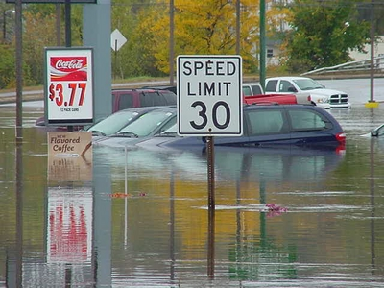

Newport during October 2005 Flood

Coastal Regulations

Coastal high hazard areas are SFHAs that are located along water levels and wave action from strong storms and hurricanes. The winds and resultant waves and tidal surges associated with these storms cause water of high velocities to sweep over near shore lands. These areas are extremely hazardous to life and property. The V zone (velocity zone) is that portion of the coastal 100-year floodplain that would be inundated by tidal surges with velocity wave action. Generally, the V zone indicates the inland extent of a 3-foot breaking wave, where the still water depths during the 100-year flood decreases to less than 4 feet. The A zone is that portion of the 100-year floodplain not subject to wave action. However, the residual forward momentum of the breaking wave may be present in this zone Coastal high hazard areas are identified on the FIRMs as Zones V1-30, VE, and V.

The minimum requirements for construction in V zones differ significantly from the requirements for construction in coastal A zones. In coastal AE or A1-30 flood zones, the FIRM identifies the appropriate 100-year flood elevation. It is important to note because of the forward momentum of breaking waves, water may be moving at high velocities in this zone, especially in the vicinity of the V zone/A zone interface.

Structures
In V zones, all new construction and substantial improvements to existing structures must be elevated on adequately anchored pilings or columns so that the bottom of the lowest horizontal structural members of the lowest floor (excluding the pilings and columns and including basements) is at or above the BFE. A registered professional engineer or architect must certify that the structure is securely fastened to adequately anchored pilings or columns to withstand velocity waters and hurricane wave wash forces. In addition, the space below the lowest floor may be used solely for parking of vehicles, building access, or storage and must be free of obstructions, or may be enclosed with non-supporting breakaway walls, open wood lattice work, or insect screening intended to collapse under wind and water loads without damaging the elevated portion of the building or the foundation.

All new structures in coastal high hazard areas (VE or V1-30 flood zones) must be located landward of the reach of mean high tide. All new construction or substantial improvements must be elevated on pilings, columns or shear walls so that the bottom of the lowest horizontal structural member of the lowest floor (excluding pilings or columns) is elevated to or above the 100-year flood level so as to not impede the flow of water. No fill material may be used for structural support.

The structure must be adequately anchored to the pile or column foundation to resist flotation, collapse, and lateral movement due to the effects of wind and water loads acting simultaneously on all building components. Wind and water loading values must each have a one percent chance of being equaled or exceeded in any given year (100-year mean recurrence interval). For wind loadings, American National Standards Institute’s Minimum Design Loads for Buildings and other Structures, ANSI AS 1170.2-1989, meets these standards. The structural design, specifications and plans for construction must be developed or reviewed by a registered professional engineer or architect who must also certify that the design and methods of construction to be used are in accordance with accepted standards for such construction.

The space below the lowest floor of all new structures or substantial improvements to existing structures in coastal high hazard areas must either be free of obstruction or constructed with non-supporting breakaway walls. Permissible construction materials are solid breakaway walls, open wood lattice-work or insect screening. It is the intention that the construction below the lowest floor is to collapse under wind and water loads without causing collapse, displacement or other structural damage to the elevated portion of the building or the supporting foundation system.

The owner of the structure should be aware that enclosures below the lowest floor in coastal areas can be treated differently for insurance purposes than for floodplain management purposes. This situation arises when the floor area of an enclosure constructed of solid breakaway walls exceeds 300 square feet. In this case, the floor of the enclosure becomes the lowest floor for NFIP rating purposes and would be charged higher actuarial insurance rates. There is no such penalty for enclosures with walls of open lattice work (at least 50 percent of the lattice construction must be open) or insect screening. For floodplain management purposes, there is no limit on the size of enclosures or breakaway walls.

A breakaway wall must have a design safe loading resistance of not less than 10 and no more than 20 pounds per square foot. Use of breakaway walls exceeding a design safe loading resistance of 20 pounds per square foot may be permitted only if a registered professional engineer or architect certifies that the design proposed meets the following conditions:

- the breakaway wall must collapse as a result of a water load less than that which would occur during the 100-year flood; and
- the elevated portion of the building and supporting foundation system must not be subject to collapse, displacement or structural damage due to the effects of wind and water loads acting simultaneously on all building components (structural and non-structural). Maximum wind and water loading values shall each have a one percent chance of being equaled or exceeded in any given year (100-year mean recurrence interval). For wind loadings, the use of the American Standards Institute’s Minimum Design Loads for Buildings and Other Structures ANSI A 58.1-1982 meets these standards.

Such enclosed space may be used solely for parking of vehicles, building access or storage.

In coastal high hazard areas (V and VE zones), the manmade alteration of sand dunes, which would increase potential flood damage, is prohibited. Coastal Erosion Hazard Area maps and regulations should be examined to determine any additional requirements before any construction in a coastal high hazard area is permitted.

One of the more effective long-term solutions for reducing loss of life and property from coastal flooding is through land use management measures. Effective land use controls prevent flood loss by reducing the number and size of new structures which can be built on the shoreline, and by requiring those that are built to be far enough from the waters edge to prevent the normal process of erosion from reaching the structure during its expected useful life.

The FEMA has available a publication entitled Coastal Construction Manual, FEMA-55, (www.fema.gov/rebuild/mat/fema55.shtm) that provides useful information for the local administrator and the engineer, architect and contractor who are involved in construction in coastal high hazard areas. Copies of the manual can be obtained from FEMA. The manual contains a sample coastal construction code.

Beach Stabilization
The most successful approach to beach stabilization currently is a process known as replenishment or nourishment. Beach replenishment simply replaces or augments an eroded beach with large volumes of new sand pumped from offshore areas or trucked into the beach. Replenishment not only improves beach quality, but also provides some storm protection. Some of these projects have been short lived; others have been relatively stable, lasting a period of years.

Building Code and Zoning Requirements
Coastal area management through the use of building code and zoning ordinance is critical to the sensitive needs of this special environment. Ordinances are needed to ensure public safety, community development and the integrity of special areas.

Unfortunately, failure to enact or adequately enforce such necessary controls has led to uncontrolled land development in many coastal zones, particularly in regions where beachfront property has attracted residents for several decades. Areas where building codes and zoning laws were not in effect prior to development exhibit a beachfront cluttered with construction that has a broad range of often substandard construction practices; buildings with only a few feet of separation, typical of urban and suburban neighborhoods; destruction of the primary dune and its inherent storm protection; and the creation of both physical and visual barriers to public access to the natural coastline.

Local authority may go beyond the normal regulations to include such items as architectural review, protection of dunes and dune rebuilding, preservation of indigenous vegetation, and limits on some architectural features. A review of current building code and zoning requirements is a first step in preparing for a new construction project, or for an addition to or renovation of an existing structure. This review should determine such requirements as:

- Required construction materials and practices;
- Minimum lot size;
- Setbacks, including the space between structures;
- Height and size restrictions;
- Protection of natural features, including the primary dunes;
- Elevation requirements;
- Access to the beach, both physical and visual;
- Utility protection; and
- Sewerage facilities.

NFIP Flood Maps and Studies

History of Maps
In the 1970's and early 1980’s when the NFIP mapping was initiated, the Federal Insurance Administration (FIA) developed FHBMs for each community, without the benefit of detailed studies or hydraulic analyses. These maps approximately identified the boundaries of the SFHA. No elevations are given on these maps. They were intended for interim use in most communities until more detailed studies could be carried out.

As money was appropriated by Congress, FEMA performed more detailed Flood Insurance Studies for many communities. These studies resulted in the publication of the FIRMs and FBFMs. The maps allow the user to identify SFHAs, determine the location of a specific property in relation to the SFHA, determine the BFE at a specific site, locate regulatory floodways, and identify undeveloped coastal barriers where flood insurance is not available.

Originally, the FIRMs were designed for use by insurance agents and lenders and showed the SFHAs (100 year floodplain). FIRMs show different floodplains with different zone designations. These are primarily for insurance rating purposes, but the zone differentiation can be very helpful for other floodplain management purposes. The FBFMs were created for use by local floodplain managers and administrators and showed the 100 to 500-year floodplain boundaries and the 100-year floodway. For all studies conducted since 1986, the FIRM is a combination of the FIRM and Flood Boundary Floodway Maps. A community with a new format FIRM has only one map. The only difference is that areas outside of the SFHA and 500-year floodplain are noted as Zone X. It is important that communities with pre-1986 FIRMs use both the FBFM and the FIRM when determining the location of the floodway.

In many smaller communities in New Hampshire, which are located away from the coast or are not located on major rivers, FEMA did not undertake a detailed flood study of the community but simply relabeled the FHBM as a FIRM. In a few cases, FEMA converted the FHBM to a FIRM by issuing a letter to the community stating the FHBM shall be considered a FIRM. FEMA would then instruct the community to line out FHBM on their map’s title block and write in FIRM. The SFHAs were also converted to “Zone A”. This action was done primarily in communities with extremely low risk of flooding, with very little or no existing development in the floodplain, and very little potential for future development. This decision not to remap was also made, in part, due to Federal fiscal restraints. These communities are identified in FEMA’s Community Status Book by an (L) designation.

Map Users
Private citizens, insurance agents/brokers, community officials, the lending industry, and Federal agencies all use the maps to assist them in understanding flood hazards. Private citizens and insurance agents/brokers use the maps to locate properties and buildings and corresponding flood insurance risk zones. Community officials use the maps to administer floodplain management regulations and mitigate flood damage. Lending institutions and Federal agencies use the maps to locate properties and buildings and determine whether flood insurance is required when making loans or providing grants for the purchase or construction of buildings. Surveyors and engineers use the information to determine the design elevation of new structures.

Flood Insurance Studies
In developed or developing communities, FEMA conducts a FIS which contains background data such as the base flood discharges and water surface elevations that are used to prepare the FIRM. The information collected from the detailed FIS is used in the production of a FIS Report, FIRM and a FBFM, upon which all determinations will be based subsequent to the date of issue. All communities should keep copies of their draft maps used in the development of the FIRM and the FBFM as a reference. The draft maps contain valuable physical data such as ground contours, flood storage areas and location of buildings that are valuable to the local administrator and the community.

The detailed FIS is conducted to:

- investigate the existence and severity of flood hazards;
- delineate the extent of flood-prone areas;
- determine the flood insurance rate zones;
- determine minimum safe elevations for structures in SFHAs; and
- recommend the floodway or channel required to discharge the 100-year flood or the coastal hazard area subject to hurricane waves.

The results of the detailed study form the basis for actuarial insurance rates and the community floodplain management regulations. The effective FIRM is based on extensive field surveys and computation of flood magnitudes and water levels.

The OEP has the initial responsibility for determining the priority of communities for detailed Flood Insurance Studies represented by FEMA. FEMA makes the final decision and selects a contractor which is a Federal Agency or a private firm represented by FEMA to conduct the study. This individual is the Federal representative who will contact the community to establish lines of communication with elected and appointed officials.

It is recommended that local officials hold a public informational meeting, which includes a presentation of the program to the citizens. At least one additional informational meeting should be held during the course of the study to discuss tentative findings and any issues that may have been raised.

When a map is created or updated, a final public meeting should be held to discuss in detail the contractor’s draft report and draft flood maps. Copies of the preliminary FIS Report, the FIRM and the FBFM must be available for the community officials and public viewing at least two weeks in advance of the final meeting. These maps will show any floodway and coastal high hazard areas.

FEMA publishes the proposed BFEs for the 1% chance annual flood and the flood insurances rates twice within ten days in a local newspaper and one in the Federal Register. After the 90-day period of appeals concludes, a six-month conversion period begins.

Besides being the technical basis of the FIRMs, the FIS report contains other useful information for floodplain managers, surveyors, and engineers including a Flood Profile and Floodway Data Table. The Flood Profile, found in the back of the FIS report, is a graphical representation of flood depths along a stream reach for various recurrence probabilities, usually the 10-, 50-, 100-, and/or 500-year floods. The profile can be thought of as a horizontal view of a section of stream taken along the middle of the channel. It is particularly useful for determining BFEs between cross-sections. The Floodway Data Tables include the computed BFE at each cross-section. They also include the water surface elevations predicted by the computer hydraulic model when it “squeezed in” the fringe to simulate the floodplain being filled with dirt or a wall being built. The model does this until it predicts the water level will increase by no more than one foot at any point along a length of waterway. When the one-foot rise occurs, that determines the boundary between the floodway and the fringe.

Flood Zones
The following are the flood zones and their descriptions that appear on FEMA’s floodplain maps.

Zone A – Areas which have been determined by approximate methods to be SFHAs. They show no elevations and are also known as “unnumbered A zones.” Regulations for development apply to these areas.

Zones A1 through A30 and Zone AE - Zones where the elevation of the base flood has been calculated and is shown on the map, sometimes as a wavy line that crosses the floodplain. On newer maps or revisions after 1985, Zone AE is used rather than numbered A Zones. Regulations apply in these zones.

Zone AO - An area of 100 year shallow flooding where depths are between one and three feet. Average depths of inundation may be shown, but no elevations are indicated. Regulations apply.

Zone AH - An area of 100 year shallow flooding with a constant water-surface elevation (usually areas of ponding) where average depths are between one and three feet. The BFEs derived from the detailed hydraulic analyses are shown at selected intervals within this zone. Regulations do apply to these areas.

Zone B and (lightly shaded) Zone X – Generally, areas within the 500 year flood zone. It may also indicate certain areas subject to 100 year flooding with average depths less than one foot or areas where the contributing drainage area is less than one square mile. Although we do not regulate in Zone B or Zone X under the NFIP, these mapped areas are reviewed by other Federal agencies when siting critical facilities.

Zone C - An area of minimal flooding. The NFIP does not require regulation of development in Zone C areas.

Zone D - Areas where the magnitude of flooding has not been determined. Regulations do not apply to construction in these zones.

Zone V - Coastal areas subject to flooding with the additional hazards associated with storm waves. Due to lack of detailed study, no flood elevations or depths are shown. Regulations and additional construction specifications apply.

Zones V1 through V30 and Zone VE - Numbered V Zones are areas along the coast subject to flooding with the additional hazards associated with storm waves. Flood elevations or depths are shown. The "V" denotes velocity due to storm surge. On newer maps or revisions, Zone VE may be used rather than numbered V Zones. Regulations and additional construction specifications apply.

Zone X - This is the same Zone as is referred to, in older maps, as Zone B or C. It denotes areas of lesser flood hazard. Regulations for construction do not apply to Zone X.

Type of Maps
There are currently three types of maps the NFIP uses, which consist of the FHBM, the Flood Boundary Floodway Map (FBFM), and the FIRM. Communities may possess all three of these maps over a period of time but it will vary from town to city as to which map a community will have. (See Appendix F for How to Find and Print Maps from FEMA’s On-Line Map Store.)

Flood Hazard Boundary Map (FHBM)
A FHBM is issued by FEMA when an area is identified as a SFHA or when an area is flooded. A community is usually issued a FHBM during the Emergency Phase of the program. The FHBMs show an approximate delineation of the 100-year floodplain or SFHA but no flood elevation. The SFHA is designated as shaded areas, labeled Zone A or Zone V in coastal zones. FHBMs are still being used where detailed Flood Insurance Studies have not been prepared or cannot be justified. They are to be used for floodplain management, in conjunction with other local studies and other available data. Typically the maps are at a large scale and a fair amount of interpretation is necessary to determine the location of SFHAs on the ground.

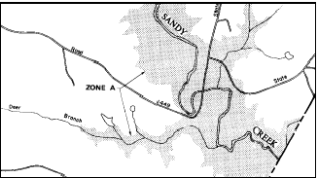

Flood Hazard Boundary Map

Flood Boundary Floodway Map (FBFM)
The Flood Boundary Floodway Map (FBFM) usually called the “floodway map,” is used for regulatory purposes within a community. The FBFMs are prepared for only selected areas based on detailed studies, and depict the 100 to 500 year floodplain boundaries and the 100-year floodway. It shows how the floodplain is divided into a floodway and the flood fringe, and also shows the location of surveyed stream cross-sections that were used to develop the hydraulic model. More precise determinations of BFEs can be made using the cross-sections in conjunction with the Floodway Data Table and flood profiles. If a map panel has only approximate floodplain areas, a floodway map will not be printed for those approximate study areas.

Regulations contained in local floodplain management regulations must be applied to development activities proposed within these areas. The FBFMs are usually provided by FEMA during the Emergency Phase of the Program.

Flood Insurance Rate Map (FIRM)
The FIRM defines the areas within the 100-year floodplain known as the SFHA. In areas studied by detailed analysis, the FIRM also indicates the BFE and the 500-year floodplain boundaries and occasionally the floodway. In less developed communities FEMA will convert the FHBM to a FIRM with only some minor changes.

FIRMs prior to June 1986 do not show the floodway, as shown on the FBFM. Since June 1986, FEMA began publishing FIRMs that indicate both the floodplain and floodway. Also the post-1986 FIRMs simplified flood insurance zone designations. The previous Zones A1-A30 and V1-V30 were replaced by the designations AE and VE; Zones B and C were replaced by Zone X. The 500-year floodplain is still shown as “shaded” portions of Zone X.

It is important that communities with pre-1986 FIRMs to use both the FHBM and the FIRM when judging the merits of permitting a structure near or at the floodway boundary.

Flood Insurance Rate Map (Coastal)
FIRMs showing coastal floodplains usually show both V Zones and A Zones. Especially in the V Zone, look carefully for the white line separating areas with different water surface elevations, see Figure below. The minimum elevation above which development must be raised is shown in parenthesis below the zone designation.

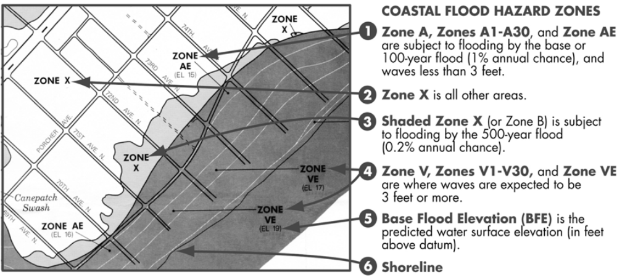
Coastal Flood Hazard Zones

Approximate Flood Insurance Rate Maps
In communities in which FEMA determined that there was a minimal flooding risk, approximate FIRMs were done. An approximate FIRM shows the area of a community that would be subject to flooding in the event of the base flood. Whereas there was no detailed study, the FIRM shows only the boundaries of the floodplain; it does not show any flood elevations. The approximate SFHA is indicated as "Zone A" on the FIRM. Zone A is the base floodplain, and any development in that area must meet the requirements of the community’s floodplain ordinance. Zone C or X is also shown on approximate FIRMs. This is an area with minimal flood hazards and regulations are not required by the NFIP. Even though a floodway is not delineated on approximate FIRMs, the model ordinance provides a method for determining the width under the definition of "regulatory floodway." In Zone A riverine areas, the regulatory floodway is determined to be the channel of the river or other water course and the adjacent land areas to a distance of one-half the width of the floodplain as measured from the normal high water mark to the upland limit of the floodplain. Communities with approximate FIRMs are identified in the New Hampshire Community Status Book by an (M) designation.

Detailed FIRMs
When a detailed study was justified (along the coast, along major rivers, and around major lakes), a detailed FIRM was produced. Within a community there may be areas for which a detailed study was conducted and areas for which only approximate flood boundaries were established. A detailed FIRM shows the boundaries of the base flood. (See portion of detailed FIRM below).

Digital Flood Insurance Rate Map (DFIRM)
In fiscal year 2003, the Department of Homeland Security's FEMA initiated a Flood Map Modernization Program (FMMP). The goal of the national FMMP is to upgrade flood hazard data and mapping to create a more accurate digital product that will improve floodplain management across the country. By 2009, it is envisioned that digital flood hazard data will be available nationwide. This will be phased in over the course of several years, with priority given to areas of greater population, need, and ability to leverage resources.

Beginning in 2005, FEMA introduced DFIRMs in the State of New Hampshire. An example of a hardcopy paper DFIRM is shown in the following figure. Eventually, DFIRMs will replace the existing FIRMs throughout the state. The new DFIRMS are being developed on a county-wide basis.

The DFIRM product involves converting the existing inventory of manually produced FIRMs to digital format. The new digital product will be able to address maintenance needs as well as restudy needs. The DFIRM product will be designed to allow for the creation of interactive, multi-hazard digital maps. Linkages will be built into a database to allow users options to access the engineering back-up material used to develop the map (e.g., hydraulic & hydrologic models, flood profiles, floodway data table, Digital Elevation Models, and structure-specific data, such as digital elevation certificates and digital photographs of bridges and culverts).

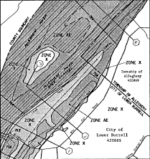

Hardcopy Digital FIRM

Determining Base Flood Elevations

A and V Zones with BFEs
The BFE can be determined for A (1-30), AE and V (1-30) zones by using either theFIRM alone or the FBFM along with the flood profiles printed in the FIS.

A and V Zones without BFEs
In unnumbered A zones, where the maps do not provide the BFE, the best available 100-year flood data should be used to establish the BFE. A licensed land surveyor or professional engineer may obtain flood information from the following sources:

US Army Corp of Engineers: Floodplain Information Studies, Flood Control Reports and general file information are often good sources of data;

Soil Conservation Service (SCS): County Soil Survey Reports describe the various soils throughout a given county and includes aerial photographs showing the location of each soil type. In addition the SCS may have flood elevation information for watersheds with projects funded through the P.L. 566 program;

U.S. Geological Survey (USGS): Flood-prone Quadrangle Maps prepared by the USGS. Standard topographic maps which show an approximate delineation of the 100-year floodplain, shown in 20’ contours;

Department of Environmental Services: Records of lake levels and stream flow data can be acquired for some lakes and streams through the Division of Water Resources;

Local Historical Flood Records: The height of past floods from newspaper articles, recorded high water marks on buildings, data submitted to the planning and zoning boards for development proposals such as subdivision and site plan reviews and residents who may remember flooding levels; and

FHBM or FIRM Maps: They can be used to estimate the BFE by locating a reference point (i.e. a road or railroad crossing etc.) through which the floodplain boundary passes. That point (s) on the ground would represent the BFE for the site in question.

If no BFE data is available, then the local floodplain enforcement official should require that the first fully enclosed floor be elevated 2 to 5 feet above the highest adjacent grade. FEMA suggests that the lowest floor be elevated to at least two to five feet above adjacent ground level. Basements or cellars below flood level should not be allowed in any A or V Zones.

Coastal Interpretation
Along the coast, areas subject to inundation by a 100-year flood are also subject to the effects of damaging waves. These are termed “V” or velocity zones. In the velocity zone, construction must meet strict standards and may only be permitted when special construction techniques, such as elevation on pilings driven to bedrock are applied. All such techniques are to be certified by a registered professional engineer or architect. (See 7.0 Coastal Regulations.)

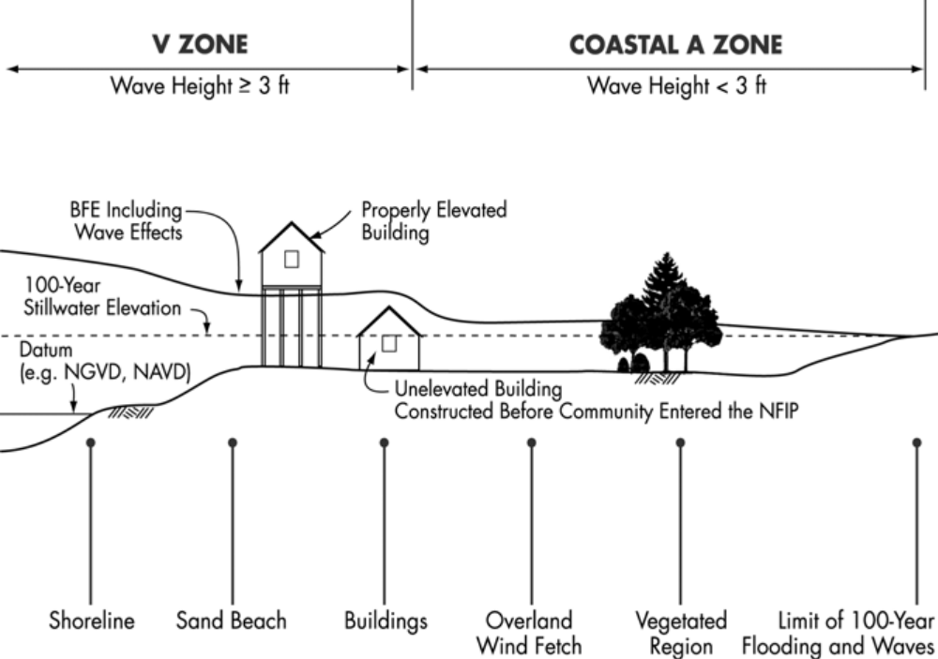

The location of the boundary between a V zone and an A zone can only be determined by scaling from the FIRM. The horizontal distances from a physical feature shown on the map must be scaled to the edge of the V zone. If the established FIRM does not include enough physical feature information, the detailed work maps used in development of the Flood Insurance Studies for communities may be helpful in making a determination.

Floodways
The floodway is that portion of the 100-year floodplain, which serves as a flood channel to pass the deeper, faster moving water. Buildings, structures and other development activities, such as fill, placed within the floodway can obstruct flood flows causing the waters to slow down and back up, resulting in higher flood levels. To protect the free movement of floodwaters and to help prevent flood problems from getting worse, FEMA has established regulations, which specifically apply to floodway areas on the NFIP maps.

In establishing a floodway, FEMA assumes that floodplain development will continue, but only to a point where present 100-year flood heights will be increased a maximum of 1 foot. To delineate specific floodway boundaries, a computer program is used to hypothetically fill both sides of the floodplain and working toward the stream, until the floodplain obstruction raises flood levels by one foot. The remaining channel is the floodway.

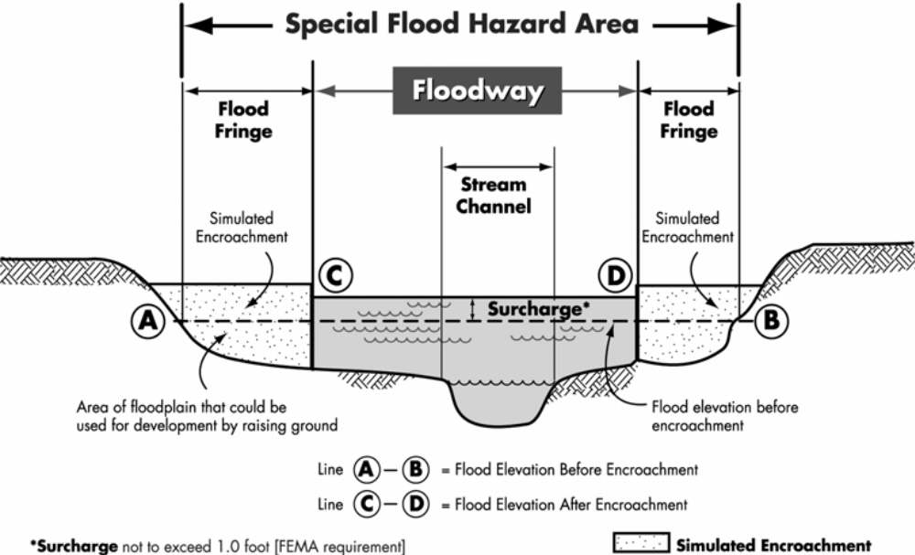

Floodway-Floodplain Cross-Section

The reason for allowing the one-foot increase is to leave ample room outside the floodway for future development regardless of whether it will occur. In a sense, the floodway concept is a trade-off. A portion of the floodplain is allowed to be developed in exchange for reserving an open area for the discharge for floodwater. This is why development which would cause any increase in the flood level is prohibited in the floodway. No new development may occur in the regulator floodway unless it can be shown by a hydraulic engineering analysis that the new development will not cause any rise in the 100-year flood elevation.

In some situations, a project sited in a floodway may be justifiable even though it would cause a rise in the BFE when built. Projects that reduce flood hazards or have a net public benefit, such as dams and bridges, fall into this category. Before these projects are approved, an application for a conditional map revision must be submitted to FEMA. The application must include scientific and technical information to support the request, evidence that a BFE increase is justified, that all engineering alternatives have been obtained, that no insurable structures are impacted and that any property owners adversely impacted have been properly notified.

Municipalities with Floodway Identified
The NFIP places special restrictions on development in the floodway. During the conduct of a flood insurances study, the floodway boundaries are computed for the major streams in the community. In most cases the floodway is shown on the Flood Boundary Floodway Map (FBFM). However, FIRMs published after June 1986 will identify the floodway. Therefore, communities with 1986 FIRMs must use both the FBFM and the FIRM when determining the location of the floodway.

The floodway data should be used by the community to prohibit development within the calculated floodway that would result in any increase in flood levels during the occurrence of the base flood discharge. Section 60.3 (d), (3) of the NFIP Regulations states that communities with floodways identified shall:

Communities should prohibit encroachments, including fill, new construction, substantial improvements, and other development within the adopted regulatory floodway unless it has been demonstrated through hydrologic and hydraulic analyses performed in accordance with standard engineering practice that the proposed encroachment would not result in any increase in flood levels within the community during the occurrence of the base flood discharge.

Municipalities without Floodway Identified
Some undeveloped communities may not have had a FIS conducted and therefore do not have floodways identified. If no floodway data is available the community is encouraged to keep the development a reasonable distance away from the stream channel and away from any high velocity flow areas.

Types of Map Changes
There may be situations where the floodplain boundary does not appear reasonable. FEMA recognizes that oftentimes, the mapping procedures are not sensitive enough to detect high spots in the floodplain or the scale is large enough not to include some adjacent higher areas in the floodplain delineation. In addition, conditions change with time and subsequent development, which warrant changes to the maps. New studies are also undertaken from time to time and which need to be included on the maps. For these reasons, FEMA has developed a process to handle these situations.

FEMA has four approaches to changing NFIP maps: restudies, limited map maintenance projects, amendments, and revisions. Requests for a restudy, amendment, or revision must be approved or made by the community, since they affect the local floodplain management program.

Restudy
A restudy is a new FIS for some or all of the community. For example, FEMA may decide to conduct a restudy where development in a small watershed has substantially changed stormwater runoff conditions over the 15 or 20 years since the original FIS was completed. Or a restudy may be needed where growth is occurring along streams without BFEs.

Limited Map Maintenance Project
A limited map maintenance project (LMMP) is a small-scale restudy that is limited in size and cost. It is frequently used for studies in unnumbered A Zones.

Map Revision
A map revision is used for other cases, including:
- scientifically based challenges to the flood elevations
-  to incorporate new data that become effective after the construction of a flood control project
- to reflect fill placed in the floodplain after the flood study currently in effect was completed
- to change the floodplain or floodway boundaries
-  to include new flood data

Map Amendment
An amendment is used to remove an area that was inadvertently included in the SFHA. Often the ground is higher than depicted on the base map used for the FIRM. This typically happens because of the problem of accurately locating the floodplain boundary on a topographic map. For example, more detailed ground elevation data can be used to amend a FIRM to show a property that is higher than the BFE to be outside the SFHA. FEMA will make map amendments based on the information submitted by the applicant. Unlike the three other types of changes, an amendment doesn’t challenge the FIS or FIRM; it simply removes certain areas or buildings from the SFHA because they are higher than the BFE.

Letter of Map Changes
FEMA uses two methods to make flood map changes. The first is to actually change the map and publish new copies. Here the effective date of a map is changed. A restudy or limited map maintenance project will generally result in a new map. Sometimes revisions and amendments result in a reprinted map. However, republishing the map can be expensive and is done only if the change affects a large area. The other method is to issue a letter that describes the map change. FEMA does this when the revision can be adequately described in writing or through use of a small, annotated map panel, such as when only one lot or building is affected.

Because such a letter officially amends or revises the effective NFIP map, it is a public record that the community must maintain. Any LOMC should be noted on the community’s master flood maps and filed by panel number in an accessible location.

If provided with a legal description of the land area above the BFE, FEMA can issue a LOMC for only a portion of the parcel. Or, a LOMC might state that only a specifically described portion (i.e. the front 70 feet with the exception of any recorded easements), is removed from the SFHA. However, the LOMC might then also state that portions of the rest of the property remain within the SFHA, subject to all floodplain management regulations.

NFIP maps are not changed based on proposed projects. However, an applicant may request a Conditional Letter of Map Revision (CLOMR) based on Fill (CLOMR-F) shown on proposed plans. A Conditional Letter of Map Amendment (CLOMA) can be requested for a vacant lot. These conditional letters inform the builder and others (such as the bank financing the project) that when the project is completed, it will qualify for a LOMR, LOMR-F, or LOMA. A LOMR, LOMR-F, or LOMA will still be required to officially change the NFIP map.

A processing fee is charged for LOMRs, CLOMRs , LOMR-Fs, and CLOMR-Fs and CLOMAs. There is no fee for requesting a LOMA.

There are two types of Letters of Map Change (LOMC): a LOMR, and a LOMA. A “LOMR-F” refers to a LOMR based on new fill in the floodplain.

Letter of Map Revision (LOMR)
Following successful adoption of the map the community enters the Regular Program of the NFIP. At this time the FIRM is published and is referred to as the effective FIRM. The effective FIRM is the latest map issued by FEMA.

At any time after a FIRM map has become effective, a community may request that the map be revised. The community begins the revision process by sending a request to FEMA for a LOMR. The LOMR is used to change flood zones, floodplain and floodway delineation, flood elevation and planimetric features. Appropriate technical data must accompany the request and it must be submitted through the community Chief Executive Officer. This assures that the community is aware of the request and will adopt the changes and revisions to the map, (See Appendix D for link to FEMA Forms and Information).

When a map revision to the Effective FIRM is warranted, FEMA will either revise and republish the affected map panels or issue a LOMR that describes the changes and officially revises the Effective FIRM. If a map is republished the floodplain ordinance must be amended at a town meeting to include the new effective date of the map.

In addition, Section 65.3 of the NFIP regulations, require that each participating community inform FEMA of any physical change that might affect the BFE in the community and submit data that show the effects of those changes within 6 months of the date the changes occurred.

Letter of Map Amendment (LOMA)
A Letter of Map Amendment (LOMA) is issued when FEMA accepts scientific or technical data that proves a property has been incorrectly included in a designated SFHA. It amends the currently effective FIRM and establishes that an individual property is not located in the SFHA. Due to the scale at which the FIRMs are prepared the accuracy of available topographic data may not show all the information necessary to permit the required interpretation of a location of a structure. Map users may find it difficult to determine whether a specific structure or parcel of land is within the SFHA. Areas of high ground may be incorporated into the SFHA because they are too small to be shown to scale. When this happens, structures or parcels of land may be inadvertently included when the map is prepared. Any owner or leasee of such property may submit scientific and/or technical data and request a LOMA from FEMA (See Appendix D for link to FEMA Forms and Information). Upon review and approval of the request by FEMA, a LOMA will be issued.

Unlike the Map Revisions, the change does not involve alterations of topography or result in significant changes to the flooding information depicted on the map. Therefore, the amendments are not subject to community review and approval nor do they have to be submitted through the community CEO. LOMA and LOMR forms can be obtained from the State NFIP Coordinator at OEP and from the FEMA Region I office in Boston. (See Appendix D for link to FEMA Forms and Information).

Appeals
Appeals are requests for changes to proposed BFE. An appeal may occur in two situations: 1) during the process of converting from the Emergency Phase to the Regular Phase; or 2) when an effective FIRM is being revised. Community officials and property owners may appeal the proposed BFE by submitting scientific and/or technical information disputing the published information. The Appeal process begins when a community submits scientific and/or technical information that challenges the technical correctness of the detailed FIS. As discussed in the Emergency Phase in the previous chapter, if the information presented on a preliminary review copy of the FIRM is thought to be incorrect, an appeal or request for change may be made to FEMA within the formal 90-day appeal period.

The Appeal period is initiated by the publication of the BFE in local newspapers and the Federal Register by FEMA. The notice must be published twice; the second notice to appear 1 week after the first. The 90-day appeal period begins after the second notice is published. If the community does not appeal during this period then the BFE published in the Federal Register becomes the effective elevation on the FIRM.

All Appeals are submitted through the Chief Executive Officer (CEO) of the community. This procedure is intended to assure that the community’s CEO is aware of all appeals and that there is equitable balancing of all the interests involved in making flood elevation determinations.

Once the detailed study is completed and all appeals are resolved, final elevations will be published in the Federal Register. The community is then given 6 months to adopt the official map and the necessary floodplain management requirements of 44CFR, Section 60.3 in the NFIP Regulations (See Appendix D for link to FEMA Regulations).

Flood Insurance

The NFIP coverage is available to all owners of insurable property (a building and/or its contents) in a community participating in the NFIP. Owners and renters may insure their personal property against flood loss. Builders of buildings in the course of construction, condominium associations, and owners of residential condominium units in participating communities all may purchase flood insurance.

Definition of a Flood
A "Flood" is defined in the Standard Flood Insurance Policy as:

A general and temporary condition of partial or complete inundation of normally dry land from overflow of inland or tidal waters, from unusual and rapid accumulation or runoff of surface waters from any source, or from mudflow; or the collapse or subsidence of land along the shore of a lake or other body of water as a result of erosion, or undermining caused by waves, or currents of water exceeding the cyclical levels which result in flood, as defined above.

Policies
The number of policies in force in the United States has increased from about 95,000 before the Flood Disaster Protection Act of 1973, to 2.2 million in 1989, to over 4.3 million currently. Any property owner of insurable property may purchase flood insurance coverage, provided that the community in which the property is located is participating in the NFIP. The amount of flood insurance coverage in force as of March 31, 2002 is over $606 billion.

FEMA works closely with the insurance industry to facilitate the sale and servicing of flood insurance policies. Flood insurance under the NFIP is sold to owners of property located in NFIP communities through two mechanisms: 1) through state-licensed property and casualty insurance agents and brokers who deal directly with FEMA; and 2) through private insurance companies with a program created in 1983 known as “Write Your Own” (WYO).

Coverage
Flood insurance coverage is provided for insurable buildings and their contents. The building coverage is for the structure and includes all permanent fixtures that stay with the building when it changes ownership such as utility equipment, wall to wall carpeting, built in appliances, and wallpaper/paneling. Property owners in NFIP communities may purchase flood insurance whether the building or its contents is located in or outside the floodplain.

Building Coverage
Under an NFIP insurance policy, the term “building” is defined as a walled and roofed structure. Manufactured homes that are above ground and affixed to a permanent site are also considered buildings under this definition as well as buildings in the course of construction, alteration, or repair.

The following items are not included under the building definition:

- gas or liquid storage tanks
- structure with more than 50 percent of its value underground (wells or septic tanks)
- tents
- tennis and swimming pool bubbles
- swimming pools
- fences
- docks
- driveways
- open pavilions
- carports
- sheds on skids
- licensed vehicles
- building declared in violation with state or local law
- landscaping
- crops

Contents Coverage
Contents coverage is available for removable items inside an insurable building. This type of coverage is available to renters even if there is no structural coverage.

Items in a structure that are not insurable:

- animals and livestock
- licensed vehicles
- personal possessions valued more than $250
- money or valuable papers

Limited coverage is offered for basements. Building coverage is not extended to wallpaper, carpeting and similar finishings. Coverage is available for the following items that are only kept in a basement:

- washers
- dryers
- freezers
- sump pumps
- well-water tanks
- oil tanks
- furnaces
- hot water heaters
- clothes washers and dryers
- air conditioners
- electric junctions
- circuit boxes

Limited coverage is also offered for enclosures below the lowest floor of an elevated post-FIRM building. Contents coverage is not available for enclosures, only structural coverage is required for utility connections and for the foundation and anchoring systems to support the building.

The amount of coverage for all buildings is based on a two-tier system: 1) basic layer of coverage and 2) an additional layer of coverage. Basic limits coverage (up to $50,000) is assigned a higher rate while additional coverage ($50,001-$250,000) can be purchased at a lower rate.

Regular Program Insurance Coverage Amounts

 | BASIC INSURANCE LIMITS | ADDITIONAL INSURANCE LIMITS | TOTAL INSURANCE LIMITS
BUILDING COVERAGE
Single-family Dwelling | $50,000 | $200,000 | $250,000
2-4 Family Dwelling | $50,000 | $200,000 | $250,000
Other Residential | $150,000 | $100,000 | $250,000
Condominium Association | $50,000 per unit | $200,000 per unit | $250,000 per unit
Nonresidential | $150,000 | $350,000 | $500,000
CONTENTS COVERAGE
Residential | $20,000 | $80,000 | $100,000
Nonresidential | $130,000 | $370,000 | $500,000

30-Day Waiting Period
When a community joins either the Emergency or Regular Program, there is normally a 30-day waiting period before any newly purchased flood insurance policy, or any additional coverage or endorsement that increases policy limits, takes effect. The waiting period ends and the policy takes effect at 12:01 a.m. on the 30th calendar day after the insurance policy application date and the payment of premium. There are ten exceptions to the 30-day waiting period. The two most common exceptions to the 30-day waiting period include:

- There is no waiting period and coverage is effective immediately when the initial purchase of flood insurance is in connection with the making, increasing, extension, or renewal of a loan.

- There is a one-day waiting period when the purchase of flood insurance is related to the revision or updating of a FHBM or FIRM. Flood insurance coverage is effective at 12:01 a.m. the day after coverage is purchased for a building where the map is revised and shows the building to be in an SFHA when it had not been in an SFHA prior to the map revision. This exception is limited to a 13-month period, which starts on the date the revised map is issued.

Increased Cost of Compliance
Increased Cost of Compliance (ICC) coverage provides for the payment of a claim to help pay for the increased costs to comply with State or community floodplain management laws or ordinances after a flood in which a building has been declared substantially damaged or repetitively damaged. When an insured building is damaged by a flood and the community declares the building to be substantially or repetitively damaged, thus triggering the requirement to comply with a community floodplain management ordinance, ICC will help pay for the cost to elevate, relocate, demolish, or floodproof (non-residential buildings only) up to a maximum of $30,000 per building or for non-condominium townhouse construction, per unit, per policy. This coverage is in addition to the building coverage for the repair of actual physical damages from flood under the Standard Flood Insurance Policy, but the total paid cannot exceed the maximum program limits of $250,000 for residential structures and $500,000 for nonresidential structures.

In addition, an ICC claim payment can be used to complement and supplement funds under other mitigation programs such as the FMA program and FEMA’s Hazard Mitigation Grant Program (HMGP) to assist communities in implementing measures to reduce or eliminate the long-term risk of flood damage to buildings insured under the NFIP.

The mandatory coverage is added to all standard flood insurance policies except for those sold in Emergency Program communities, contents-only policies, dwelling policies on individual condominium units, and group flood insurance. For these cases, ICC is not available. In a condominium building, ICC coverage is only available through the Condominium Association’s flood policy.

Repetitive loss structures would be eligible for ICC payments when two conditions are met:

- The community has adopted and is enforcing a cumulative, substantial damage provision, or repetitive loss provision in its floodplain management ordinance that requires action by the property owner; and
- The structure has a history of flood claims under the NFIP that satisfies the statutory definition of repetitive loss structure.

A repetitive loss structure is defined as a structure, covered by a contract for flood insurance issued pursuant to the National Flood Insurance Act, that has incurred flood-related damage on two occasions during a 10-year period ending on the date of the event for which a second claim is made, in which the cost of repairing the flood damage, on average, equaled or exceeded 25 percent of the market value of the structure at the time of each such flood event. In addition to the current claim, the NFIP must have paid the previous qualifying claim, and the state or community must have a cumulative, substantial damage provision or repetitive loss provision in its floodplain management law or ordinance being enforced against the structure.

This coverage will not pay for ICC to meet state or community floodplain management laws or ordinances that exceed the minimum criteria of the NFIP. This coverage will pay for the incremental cost, after demolition or relocation, of elevating or floodproofing a structure during its rebuilding at the same or another site to meet state or local floodplain management laws or ordinances even if the structure had received a variance from applicable floodplain management requirements prior to the loss.

Grandfathering
The 1968 Act separated the flood insurance ratemaking process into two distinct categories: subsidized rates and actuarial rates. Congress authorized the NFIP to offer policies at subsidized rates (at less than full actuarial risk rates) to existing buildings constructed on or before December 31, 1974 or before the effective date of the initial FIRM, whichever is later. Congress concluded that these pre-FIRM buildings were built without the occupants’ full knowledge and understanding of the flood risk, and to rate them using the actuarial rates might make the flood insurance prohibitively expensive. It also means that the buildings were constructed before the community enacted comprehensive regulations on floodplain construction.

The pre-FIRM building rates are based on the building elevation and FIRM zone. If a pre-FIRM building is substantially damaged or substantially improved, it will be re-rated as a post-FIRM building.

Flood Insurance Rates
The flood insurance rates take into account a number of different factors including the flood-risk zone shown on the FIRM, the elevation of the lowest floor above or below the BFE, the type of building, the number of floors, and the existence of a basement or an enclosure. Flood insurance rates in A-Zones are higher than in B, C, or X zones. This is because A-Zones are the higher hazard floodplain areas while B, C, or X zones are lower hazard. Within A-Zone areas, the rate is affected by a structure’s date of construction (e.g. pre-FIRM and post-FIRM). Because pre-FIRM structures were generally built before community flood regulations were adopted, they may be more prone to flooding. It is expected that post-FIRM structures were built in compliance with local floodplain regulations, and will be less susceptible to flood damage. Based on these concepts, pre-FIRM flood insurance are subsidized while post-FIRM rates are “actuarial” or based on the actual risk to flooding.

Elevation relative to the BFE is the most significant factor that influences the rate used to price Federal flood insurance. The flood zone and the total value of the building also affect the total cost for flood insurance. Because permit decisions influence elevation, it is important that floodplain administrators understand how the cost of insurance can be significantly affected by elevation.

Mandatory Purchase Requirements
The Flood Disaster Protection Act of 1973 mandates that flood insurance must be secured at the time of origination, extension, or renewal of a loan secured either by improved real estate or a mobile home in a SFHA. This applies to loans made by Federally regulated, supervised, or insured financial institutions. The National Flood Insurance Reform Act of 1994 clarifies the law to specify that flood insurance is required for the life of the loan or as long as the collateral property is determined to be in a SFHA. It also establishes a mortgagee’s or mortgage servicer’s obligation to require the purchase of flood insurance at origination or at any time thereafter during the life of the loan when the institution determines that the improved property or mobile home is located in an area having special flood hazards. The only exception to these requirements is for loans of $5,000 or less which will be repaid in a year or less. Federal agency lenders which make direct loans secured by improved real estate, e.g., Small Business Administration, must adopt similar regulations.

Relationship to Regulations
Elevation relative to the BFE is the most significant factor that influences the rate used to price Federal flood insurance. Obviously, the flood zone and the total value of the building affect the total cost. If communities allow new development and reconstruction projects to be built below the BFE, it will have consequences for future property owners and the community. Builders often complain about the additional costs to build one to two feet above the minimum BFE but owners should consider the annual savings associated with building higher.

Community Rating System
The NFIP’s CRS provides discounts on flood insurance premiums in those communities that establish floodplain management programs that go beyond NFIP minimum requirements. Under the CRS, communities receive credit for more restrictive regulations, acquisition, relocation, or floodproofing of flood-prone buildings, preservation of open space, and other measures that reduce flood damages or protect the natural resources and functions of floodplains.

CRS discounts on flood insurance premiums range from 5% up to 45%. To participate in the CRS, a community must be in the Regular Phase of the NFIP and be in full compliance with the minimum requirements of the NFIP. The community can choose to undertake some or all of the 18 public information and floodplain management activities described in the following table. The CRS assigns credit points for each activity. The table also shows the average number of credit points communities earn for each activity. These averages may be a better indication than the maximums of what each community can expect. More suggested activities and how they relate to CRS can be found in the Higher Standards section of Section 4.

To be eligible for a CRS discount, a community must do Activity 310 - Elevation Certificates. If a community has been designated as a repetitive loss community, it must also do Activity 510 - Floodplain Management Planning. All other activities are optional.

The last activity in the list is the Community Growth Multiplier. This multiplier is used to adjust the credit points for the five mapping and regulatory activities in the 400 series to reflect the community's growth rate. The faster a community grows, the more important regulating development is to preventing flood losses. The community growth adjustment multiplier is included in the final calculations of the community's score.

Activity # | Activity | Brief Description of Activity | Maximum  Points* | Average  Points*
310 | Elevation Certificates | Credit for maintaining Elevation Certificates for buildings in the floodplain that are new or substantially improved | 142 | 72
320 | Map Information | Credit for responding to map inquiries from the general public and keeping a record of it | 140 | 138
330 | Outreach Projects | Credit for disseminating written information about the flood hazard in your community | 290 | 81
340 | Hazard Disclosure | Credit for informing people that a property is in a floodplain when they first look to buy or rent a property | 81 | 24
350 | Flood Protection  Information | Credit awarded if your local library contains flood related publications | 30 | 22
360 | Flood Protection  Assistance | Credit awarded for providing technical advice to property owners and publicizing that the service is available | 71 | 57
410 | Additional Flood Data | Credit awarded for more in depth study of floodplains and/or other areas in your community | 1,230 | 148
420 | Open Space Preservation | Credit for preserving vacant land in the floodplain as open space | 900 | 206
430 | Higher Regulatory  Standards | Credit for regulations that require new development to be protected to one or more standards that are stricter that the NFIP minimum requirements | 1,750 | 159
440 | Flood Data Maintenance | Credit for keeping the community’s floodplain maps and elevation reference data current and useful | 226 | 78
450 | Stormwater Management | Credit for regulating new development in the watershed (not just the floodplain) to minimize the adverse impacts of stormwater runoff | 670 | 132
510 | Floodplain Management  Planning | Credit for preparing, adopting, implementing, evaluating, and updating a comprehensive floodplain management plan | 235 | 34
520 | Acquisition and Relocation | Credit for acquiring, relocating, or otherwise clearing buildings out of the floodplain | 3,200 | 177
530 | Flood Protection | Credit for buildings that have been floodproofed, elevated, or otherwise modified to protect them from flood damage | 2,800 | 66
540 | Drainage System | Maintenance Credit for a program that maintains open channels and storage basins in developed areas | 330 | 236
610 | Flood Warning System | Credit for a program that provides a timely identification of impending flood threats, disseminates warnings to appropriate floodplain occupants, and coordinates flood response activities | 200 | 99
620 | Levee Safety | Credit given to communities protected by levees that are properly maintained and operated | 900 | 153
630 | Dam Safety | Credit for any community in a state with a dam safety program that has submitted the necessary documentation of its program to FEMA | 120 | 66
710 | Community Growth  Adjustment | Adjustment CRS activities under the 400 series are adjusted to reflect the community‘s average growth rate

*Maximum and average points are subject to change.

A community’s discount is based on the total number of points earned by the community. The following table shows the number of credit points required for each corresponding discount.

Credit points earned, classification awarded, and premium reductions given for communities in the National Flood Insurance Program Community Rating System.
 |  | Premium Reduction
Credit Points | Class | SFHA* | Non-SFHA**
4,500+ | 1 | 45% | 10%
4,000 – 4,499 | 2 | 40% | 10%
3,500 – 3,999 | 3 | 35% | 10%
3,000 – 3,499 | 4 | 30% | 10%
2,500 – 2,999 | 5 | 25% | 10%
2,000 – 2,499 | 6 | 20% | 10%
1,500 – 1,999 | 7 | 15% | 5%
1,000 – 1,499 | 8 | 10% | 5%
500 – 999 | 9 | 5% | 5%
0 – 499 | 10 | 0 | 0
*Special Flood Hazard Area
**Preferred Risk Policies are available only in B, C, and X Zones for properties that are shown to have a minimal risk of flood damage. The Preferred Risk Policy does not receive premium rate credits under the CRS because it already has a lower premium than other policies. Although they are in SFHAs, Zones AR and A99 are limited to a 5% discount. Premium reductions are subject to change.

The CRS is only available to those NFIP communities that are in good standing with the Program and is voluntary. If a community is already doing some of these activities, it may be able to get a discounted rate on flood insurance for its citizens just by participating in the CRS. As the following table illustrates, there are currently there are 5 communities in the State of New Hampshire that participate in the CRS to receive discount in flood insurance

NEW HAMPSHIRE COMMUNITY RATING SYSTEM
ELIGIBLE COMMUNITIES
Community  Number | Community Name | CRS  Entry  Date | Current  Effective  Date | Current  Class | % Discount  For  SFHA | % Discount  For  Non-SFHA | Status
330023 | Keene, City of | 5/1/2002 | 5/1/2003 | 8 | 10 | 5 | C
330024 | Marlborough, Town of | 10/1/1994 | 10/1/1994 | 9 | 5 | 5 | C
330101 | Peterborough, Town of | 5/1/2004 | 5/1/2004 | 8 | 10 | 5 | C
330141 | Rye, Town of | 5/1/2005 | 5/1/2005 | 9 | 5 | 5 | C
330028 | Winchester, Town of | 5/1/2002 | 5/1/2002 | 9 | 5 | 5 | C

Many other communities would likely qualify with existing programs and regulations if they would participate in the CRS. The next table shows how a hypothetical “Sample Community” could receive discounts. Flood insurance discounts for citizens residing in the “Sample Community” could range from a 5% discount if it received the average number of points for its activities to 15% if it received more points.

Sample Community
CRS Credit Points
Activity # | Activity | Brief Description of Activity | Maximum  Points* | Average  Points*
310 | Elevation Certificates | Credit for maintaining Elevation Certificates for buildings in the floodplain that are new or substantially improved | 142 | 72
320 | Map Information | Credit for responding to map inquiries from the general public and keeping a record of it | 140 | 138
350 | Flood Protection  Information | Credit awarded if your local library contains flood related publications | 30 | 22
420 | Open Space Preservation | Credit for preserving vacant land in the floodplain as open space | 900 | 206
450 | Stormwater Management | Credit for regulating new development in the watershed (not just the floodplain) to minimize the adverse impacts of stormwater runoff | 670 | 132
 |  | Total | 1882 | 570

A community applies for a CRS classification by sending an application with appropriate documentation for the activities for which it wishes to receive credit. Then, the community's activities and performance are reviewed during a verification visit. FEMA sets the credit to be granted and notifies the community, the State NFIP Coordinator, insurance companies, and other appropriate parties. The classification is effective on either May 1 or October 1, (whichever comes first) after the community's application is verified.

Thereafter, the community reapplies yearly by October 1st with a simple form to remain at the same level, or with additional documentation if the community wishes to change its creditable activities. Each year the community must recertify or reverify that it is continuing to perform the activities that are being credited by the CRS. Recertification is an annual activity that includes progress reports for certain activities. The more extensive verification takes place every few years and is conducted in the form of a visit to the community similar to the initial verification visit. If a community is not properly or fully implementing the credited activities, credit points and possibly its CRS classification, will be revised. A community may expand activities each year to improve its CRS classification and gain more credit points.

It is important to note that reduction in flood insurance rates is only one of the benefits communities receive from participation in the CRS. Others include increased public safety, reduction of damages to property and public infrastructure, avoidance of economic disruption and losses, reduction of human suffering, and protection of the environment.

Disaster Operations and Mitigation

Disaster Operations
Every community needs to develop a disaster operations/recovery plan so that it will be ready to respond to a disaster immediately, as residents and businesses will be primarily concerned with getting back to normal as quickly as possible. This plan should cover disaster and emergency response activities, such as hazard recognition, emergency warning systems, evacuation, rescue, protection of critical facility, health and safety maintenance and coordination with the county, state and Federal emergency management agencies.

The community should also develop work maps of the floodplain that show buildings, addresses and elevation contour lines that can be used for a building conditions survey should a flood occur. They should be sized for on letter or legal size paper for easy use in a vehicle.
Following a flood, the community will need to do conduct a building condition survey to determine if any building is so dangerous that it should not be reentered without a careful inspection and which buildings will need a building permit before they can be repaired or reoccupied. When possible, the building condition survey is done in conjunction with the emergency manager’s initial damage assessment. On the work maps, code each building with an “A,” “B” or “C” for the three categories of building condition:
A - Apparently safe: No exterior signs of structural damage. People can be allowed back in, but they will need building permits for repairs.
B - Building obviously substantially damaged: The flood swept the building away, it has collapsed or it is missing one or more walls. The building cannot be reoccupied without major structural work.
C - Could be substantially damaged: The building may be substantially damaged, but such damage is not obvious. Any building with more than two feet of water over its first floor falls in this category.
After the field work is done, summarize the survey findings and plot them on a master mitigation map.
In addition to the building condition survey, the community will need to record high water marks. High water marks are very valuable records. They will help residents relate the last flood to the regulatory protection level. For example, if the flood was estimated to be two feet below the base flood, people can be told that if they were substantially damaged, they have to elevate their homes at least two feet above the high water marks. High water marks are also important for recording the extent of the flood and adding to the hydrologic record. Someone, usually the community’s engineer, should be responsible for obtaining readings from stream gauges and other high water marks as they are reported. Using these high water marks, the engineer should prepare a flood boundary map and estimate a flood recurrence interval.
Upon completing the building conditions survey, the community should notify each owner of its assessment of their building’s condition and whether a permit will be needed for repair/reconstruction. Repair/reconstruction projects must meet the community’s building code and flood protection ordinance. Owners of potentially substantially damaged buildings should be advised against making major repairs unless the building presents a safety hazard, because their buildings may be purchased, modified and/or demolished later. Cleanup and temporary emergency repairs are allowed to proceed without a permit. These include:

- Removing and disposing of damaged contents, carpeting, wallboard, insulation, etc.
- Hosing, scrubbing or cleaning floors, walls, ductwork, etc.
- Covering holes in roofs or walls and covering windows to prevent weather from inflicting further damage.
- Making the building safe to enter by removing sagging ceilings, shoring up broken foundations, and other actions.

The community should initiate a public information campaign informing residents about the regulatory requirements and the need to carefully clean and rebuild. This can be accomplished by issuing news releases and/or distributing materials to advise property owners about activities that need a permit; activities that do not need a permit; the substantial damage rule; the benefits of ICC flood insurance coverage; the need for licensed contractors; if required in your community; information needed for insurance and disaster assistance claims; and health and safety precautions.

If the disaster affected many properties, you likely will need more people to perform survey and inspection work. Staff assistance can come from a mutual aid agreement with neighboring communities; other communities may offer help (check with your state NFIP coordinator); or check with the building officials association, which may know of members available to help. If there was a disaster declaration, a community may be able to get temporary hires, with part of the cost reimbursed through disaster assistance. Disaster assistance may also reimburse the community for inspectors to conduct habitability inspections and to determine if buildings are substantially damaged.

Hazard Mitigation
Hazard mitigation is any sustained action taken to reduce or eliminate long-term risk to life and property resulting from natural hazards (flooding, storms, high winds, hurricanes, wildfires, earthquakes, etc.) Mitigation assists in helping to minimize damages that occur as the result of a natural disaster to structures, infrastructure, and other resources.

Hazard mitigation can take place either before a disaster occurs (pre-disaster mitigation) or after the disaster occurs (post-disaster mitigation). Pre-disaster action is focused on avoiding or minimizing the affects of a potential disaster by advance planning. Post-disaster action includes specific measures designed to break the cycle of damage, reconstruction and repeated damage. These actions might include construction i.e. dams or levees, acquisition of parcels with a history flooding, or the redesign and reconstruction of storm drains.

Hazard elimination and loss prevention are not the same thing as emergency response. Some hazard loss reduction can be achieved by components of response plans and preparedness plans, such as a flood warning system or a plan to evacuate residents in an area stricken by wildfire. However, warning and evacuation deal only with the immediate needs prior to, during, and following a disastrous event. Hazard mitigation is much more effective when it is directed toward reducing the need to respond to emergencies by lessening the impact of the hazard ahead of time.

Mitigation Assistance Programs and Grants
The Disaster Mitigation Act of 2000 (DMA) requires communities to develop natural hazard mitigation plans to be eligible for certain mitigation grant money for Presidential disasters declared after November 1, 2004. A natural hazard mitigation plan is a legally adopted document that analyzes a community’s vulnerability and prescribes actions to reduce risk. Only communities with FEMA-approved natural hazard mitigation plans are eligible to receive HMGP, Pre-Disaster Mitigation (PDM), and FMA funding.

Communities should be aware of some commonalities in all of the mitigation grant programs. There is a 75 percent Federal and 25 percent non-Federal cost-share for these grants. The grant programs do not fund large structural flood control projects such as dams, levees, floodwalls etc. Projects must meet benefit-cost, environmental, and other Federal, state, and local criteria. All applicants must be participating, and in good standing, in the NFIP if FEMA has mapped flood hazard areas in your community.

Hazard Mitigation Grant Program
The HMGP was created in 1988 to provide grants for the implementation of long-term hazard mitigation measures. HMGP is only available following a Presidential declared disaster event. A key purpose of the HMGP is to ensure that the opportunity to take critical mitigation measures to protect life and property from future disasters is not lost during recovery and reconstruction process following a disaster. The program’s objectives are:

- to implement state and local hazard mitigation plans;
- prevent future losses of lives and property due to disasters;
- provide funding for previously identified mitigation measures that benefit the disaster area; and
- to enable mitigation measures to be implemented during immediate recovery from a disaster.

Examples of projects eligible for HMGP funding include structural hazard control, such as debris basins or floodwalls; retrofitting, such as floodproofing to protect structures from future damage; acquisition and relocation of structures from hazard prone areas; and development of state or local standards to protect new and substantially improved structures from disaster damage.

Communities must have a FEMA-approved natural hazard mitigation plan to receive HMGP funding for any disaster declared after November 1, 2004. To be eligible for the HMGP funds, the anticipated benefits of a proposed mitigation project must exceed the total project cost. Funding is based on 15% of the Federal funds spent on public and individual assistance programs (minus administrative expenses) for each disaster. States whose mitigation planning process meets enhanced criteria will be able to receive 20% funding.

The State Bureau of Emergency Management, as grantee, is responsible for administering the HMGP. Communities develop HMGP project applications and apply for funds through the State. The State notifies potential applicants of the availability of funding, defines a project selection process, ranks and prioritizes projects for funding, and forwards projects to FEMA for approval. The applicant, or sub-grantee, carries out approved projects. The State or local government must provide a 25 percent match, which can be from a combination of cash and in-kind sources.

Pre-Disaster Mitigation Grant Program
The DMA of 2000 amended the Robert T. Stafford Disaster Relief and Emergency Assistance Act of 1988. The DMA provides funds to State, local and tribal governments for pre-disaster multi-hazard mitigation planning and the implementation of cost-effective mitigation projects prior to a disaster event. Examples of eligible flood related projects include the elevation, acquisition, or relocation of flood-prone structures and minor flood control projects designed to protect critical facilities.

Up to 7 percent of the HMGP funds available to a State can be used for development of State, local and tribal mitigation plans; and provides for States to receive an increased percentage of HMGP funds from 15 percent to 20 percent if, at the time of the disaster declaration, the State has in effect a FEMA approved State Mitigation Plan that meets the criteria established in regulations.

Flood Mitigation Assistance Program
The FMA program provides funding to assist States and communities to accomplish flood mitigation planning and implement measures to reduce future flood damages to structures. This program is administered by OEP. These funds can be used before disaster strikes and unlike the HMGP, this program is not dependent upon a major disaster declaration. The goal of the FMA program is to reduce or eliminate insurance claims under the NFIP. FMA provides funding to communities for measures that reduce or eliminate the long-term risk of flood damage to structures insurable under the NFIP. The FMA program also funds local natural hazard mitigation planning efforts. FEMA is focusing the FMA program on repetitive loss properties.

Examples of eligible types of projects include:

- Elevation of NFIP-insured residential structures and elevation or dry floodproofing of non-residential structures in accordance with 44 CFR §60.3.
- Acquisition of NFIP-insured structures and underlying real property.
- Relocation of NFIP-insured structures from acquired or restricted real property to sites not prone to flood hazards.
- Demolition of NFIP-insured structures on acquired or restricted real property.
- Beach nourishment activities that focus on facilitating natural dune replenishment through the planting of native dune vegetation and/or the installation of sand fencing. Placement of sand on beach is not eligible.
- Minor physical flood control projects that do not duplicate the flood-prevention activities of other Federal agencies that address localized flood problem areas such as stabilization of stream banks, modification of existing culverts, creation of small stormwater retention basins. Major structural flood control structures, such as levees, dams, and seawalls are not eligible.

Flood Mitigation and the Planning Process
Sound municipal planning is based on protecting “… the health, safety and general welfare…” of the residents within a Municipality. New Hampshire Planning Boards are charged by Statue (RSA 674:1) with the preparation of the Master Plan. Such a Plan includes one or more of the following sections: land use; housing; transportation; utility and public service; community facilities; recreation; conservation and preservation; and construction materials.

The Master Plan includes recommendations for the location of future land uses including residential, recreational, commercial and industrial development. Based on a natural resources inventory (mentioned below) and related analysis which identifies critical areas and potential development problems the Plan should, if scientifically sound, avoid placing or encouraging new development in these potentially dangerous areas. At a minimum, any well-conceived Master Plan should recognize that development should occur within the one hundred-year floodplain only in accordance with the requirements on the NFIP. The Master Plan could also provide recommendations to preserve certain areas of land for non-intensive uses of the floodplain such as parks, open space, conservation, agriculture and recreational uses.

Hazard Mitigation Plan

Hazard Identification
Determining and describing the natural hazards to which your community is exposed will help focus hazard mitigation efforts and gain community interest in mitigation activities. Creating a community hazard map is a useful way to depict the multiple hazard risk areas for your community. Much of the information is already available on other types of maps. For example, the 100-year floodplain is mapped for nearly every community in New Hampshire on FIRMs as part of the NFIP. These maps are based upon Flood Insurance Studies (FIS), and the maps and study report together include information for a community on the causes of flooding (coastal, riverine, overland, drainage, ponding, etc.); the depth of flooding; the velocity of floodwaters; the amount of warning time needed; and historical floods and losses. Most communities have additional data for rivers and streams shown on the FIRMs or on the FBFMs. The FBFM shows the high hazard areas of velocity flow for rivers and streams known as the floodway.

The FIRMs generally do not cover potential flooding in isolated or low-lying areas or from streams having drainage areas of less than one square mile. Nor do they usually take into consideration small areas of ponding, back up from sewers or drainage system blockages, dam breach hazards, or stormwater runoff problems. Other problem areas may be outside a mapped floodplain due to changes in topography or flood conditions since the date of the maps. Because this information is not included on the FIRM, it’s important to draw on the knowledge of local officials and residents familiar with local flood problems, as well as information on any community natural resource, open space, wetlands, or master planning maps, and special zoning districts. Other mapping exists for communities that can be useful for identifying hazards including topography, soils and geology, wetlands, land cover, land use, etc as well as what structures, infrastructure, or other resources may be impacted. One source of GIS information is the New Hampshire GRANIT Statewide GIS Resource (http://www.granit.sr.unh.edu).

A municipality’s Master Plan could include a number of activities, which incorporate pre-disaster mitigation. The information collected for the various sections could be used to identify, plan and mitigate future flood damage. The identification and planning process might include the following steps:

- Conduct an inventory of natural resources such as: soils; steep slopes which are highly erodible; areas susceptible to flooding (i.e. floodplains; drainage basins; surface hydrology including lakes, ponds, streams, and rivers; and wetlands). Analysis of these resources will lead to a determination of their potential uses and hopefully, the adoption of control measures, which will result in avoidance of the potential hazards.

- Review the existing “built” environment that identifies potential flood hazards. An inventory of all public facilities will help to determine the potential for flooding due to location within the floodplain, or from flash flooding due to either inadequate natural stream channels or storm drains. In addition, knowledge of storm water flows will help identify storm drainage systems which are undersized and therefore in danger of being washed out or failing cannot be moved, the buildings should be floodproofed (see 7.0 Construction Requirements). Additionally, when buildings hold valuable contents such as tax records, financial records, or historically important artifacts, the property should be relocated to a higher floor. Substantial damage to irreplaceable property can be avoided merely by making sure that the contents are above the one hundred year flood elevation.

Implementation
Finally, the planning process within a community does not stop when the Plan is written. Implementation measures to carry out the Plan are usually proposed for consideration by the local Legislative Body. Such measures include appropriate development codes and ordinances such as zoning, Subdivision Regulations, Site Plan Review Regulations and Floodplain Development Ordinances. Several tools to strengthen mitigation are as follows:

  - REGULATIONS: Floodplain regulations are the most effective way to reduce future flood losses. They can keep people from locating in the most dangerous areas and require safe building designs for other flood prone areas. Zoning, subdivision regulations, building codes and other special codes can be used to prohibit or to establish special conditions for development in high-risk areas. Conditions include setbacks, additional freeboard or other elevation requirements for building lots, roads, bridges, pipelines and buildings themselves. Regulations alone cannot deal with all high-risk area problems nor can they usually reduce flood damages to existing structures. A variety of measures is often needed, as is shown below.

  - ACQUISITION: Land can be purchased and structures relocated from high-risk areas either before a disaster or after buildings have been damages in a flood. Acquired lands can then be used for public recreation and open space.

  - FLOOD WARNING SYSTEMS AND EVACUATION PLANS: Flood warning systems and evacuation plans are critical for areas protected by levees or dams and for areas where floodwaters rise suddenly. A system can range from volunteer observers to highly automated equipment. Warning systems and evacuation plans can save lives and may reduce losses to contents of structures.

  - ENGINEERING MEASURES: Engineering measures have been applied to high-risk areas with varying degrees of success. Such measures include groins and bulkheads for coastal erosion areas, debris basins for alluvial fan and mudflow areas, pumping systems for internal drainage behind dikes and levees, the dewatering of mud flood and mudflow areas, and grouting and reinforcement for unsafe dams and levees. (More detailed information can be found in “Reducing Losses in High Risk Flood Hazard Areas: A Guidebook for Local Officials”, FEMA, 1985, www.fema.gov/hazard/flood/pubs/lib116.shtm).

  - FLOODPROOFING: The purpose of floodproofing a house is to significantly reduce or eliminate the potential of flood damage in a manner that is cost-effective and complies with all floodplain regulations. Several methods include: elevation of the structure, relocation, mini-floodwalls, sealants, and protection of utilities. For additional information refer to FEMA’s
publications “Retrofitting Flood-Prone Residential Structures” (www.fema.gov/hazard/flood/pubs/lib259.shtm) and “Flood-proofing Non-Residential Structures” (www.fema.gov/library/viewRecord.do?id=1413).

  - INNOVATIVE MEASURES: Innovative measures may also be considered depending on the types of problems. Here in New Hampshire the potential for disastrously high winds, hurricanes and winter blizzards is well documented. These storms are inevitably accompanied by the loss of power due to trees or shrubs falling on power lines. One type of ordinance that might be beneficial in this instance is the designation of a tree maintenance program including the designation of a tree warden. Preventive maintenance is a simple and relatively inexpensive means of flood hazard mitigation. At first thought such a program is aesthetically obvious. Diseased or damaged trees should be removed within the central urban area. But in truth it is even more important that such trees and any tree limb overhanging power lines be removed in rural areas before a high wind or ice storm takes down the limb and the power line. The program might involve an annual inventory of such situations and notification of the local power company. The power company usually will help in removing tree limbs that are a threat to their lines, if notified.

These suggestions are all activities, which might be incorporated in or result from any scientifically sound Master Plan. In addition, each can be designed to be effective pre-disaster mitigation measures. Municipal master planning and pre-disaster mitigation planning are both concerned with proper land use and resource development. Communities should become familiar with Hazard Mitigation because it will be a major focus of FEMA in the future. To further flood mitigation efforts on a local basis, communities should contact the local Regional Planning Commission or the State Hazard Mitigation Officer at the New Hampshire Bureau of Emergency Management. In addition, FEMA has several publications that assist communities in reducing flood damages (refer to the Appendix D for links to NFIP Publications and Documents for these publications).

Appendix A

Acronyms

ASFPM Association of State Floodplain Managers
BEM New Hampshire Bureau of Emergency Management
BFE Base Flood Elevation
BOCA Building Officials and Code Administrators
CAC Community Assistance Contact
CAV Community Assistance Visit
CEO Code Enforcement Officer
CFR Code of Federal Regulations
Cfs Cubic Feet per Second
COE U.S. Army Corps of Engineers
CRS Community Rating System
DES New Hampshire Department of Environmental Services
DFIRM Digital Flood Insurance Rate Map
DMA Disaster Mitigation Act
FBFM Flood Boundary and Floodway Map
FDIC Federal Deposit Insurance Corporation
FDPA Federal Disaster Protection Act
FEMA Federal Emergency Management Agency
FHA Federal Housing Administration
FHBM Flood Hazard Boundary Map
FIA Federal Insurance Administration
FIRM Flood Insurance Rate Map
FIS Flood Insurance Study
FMA Flood Mitigation Assistance
FMMP Flood Map Modernization Program
GIS Geographic Information System
HMGP Hazard Mitigation Grant Program
ICC Increased Cost of Compliance
LMMP Limited Map Maintenance Program
LOMA Letter of Map Amendment
LOMR Letter of Map Revision
NAI No Adverse Impact
NFIP National Flood Insurance Program
NGVD National Geodetic Vertical Datum
OEP New Hampshire Office of Energy and Planning
PDM Pre-Disaster Mitigation
RSA New Hampshire Revised Statutes Annotated
SCS Soil Conservation Service
SFHA Special Flood Hazard Area
USGS U.S. Geological Survey

Appendix B

Glossary

Accessory Structure - A small detached structure that is incidental and subordinate to the principal structure.

Actuarial Rates – Rates established by the Federal Insurance Administration pursuant to Flood Insurance Studies from individual communities. These rates are set in accordance with the National flood Insurance Program and accepted actuarial principles. Subject to various other limitations, actuarial rates are applicable only after the publication and effective date of a community’s FIRM.

Amendment – A change to an effective NFIP that results in the exclusion from the Special Flood Hazard Area (SFHA) of an individual structure or a legally described parcel of land that has been inadvertently included in the SFHA.

Anchoring - Special connections made to ensure that a building will not float off or be pushed off its foundation during a flood.

Appeal – A request to overrule a permit denial because the applicant claims that the ordinance has been incorrectly interpreted.

Backup valve – A valve inserted in a sewer or drain line that ensures that water flows in only one direction.

Backwater Effect – The rise in water surface elevation caused by some obstruction such as a narrow bridge opening, building or fill material that limits the area through which the water must flow.

Base Flood - The flood having a one percent chance of being equaled or exceeded in any given year, commonly called the 100-year flood.

Base Flood Elevation (BFE) - The elevation of the crest of the base flood or 100-year flood.

Basement - Any area of the building having its floor subgrade (below ground level) on all sides.

Berm – A mound of earth, located either away from a building, as a levee, or against the building wall.

Biennial Report - A report, formerly an annual report, submitted to FEMA. It includes questions on the number of permits and variances issued, changes in the community's flood characteristics, changes in the community's corporate limits, etc.

Breakaway Wall - A wall that is not part of the structural support of the building and is intended through its design and construction to collapse under specific lateral loading forces, without causing damage to the elevated portion of the building or supporting foundation system.

Building – A man-made structure that is principally above ground and enclosed by two walls and a roof, including mobile and manufactured homes. The NFIP only insures “buildings”. The NFIP regulations (44 CFR 59.1) use the term “structure”. (See Structure.)

Closure – A waterproof shied of metal or wood used to cover doorway and windows or fill gaps left in floodwalls and levees.

Coastal High Hazard Flooding – A condition of flooding subject to high velocity waters, including, but not limited to, hurricane wave wash or tsunamis. Coastal high hazard flooding is mapped as zone VE or V1-30 on a FIRM. Coastal flooding without the high velocity hazard is mapped as a Zone A.

Code Enforcement Officer – The official of the community who is charged with the authority to implement and administer laws, ordinances and regulations for the community. Usually this is the Chairman of the Board of Selectman, the City Council, or Mayor.

Code of Federal Regulations (CFR) – The codification of the general and permanent rules published in the Federal Register by the Executive Departments and agencies of the Federal government. NFIP regulations are printed in Parts 59 through 77 of Title 44 of the CFR.

Column – A building upright support that is set in a hole.

Community – A city, county, township or other local government with the statutory authority to enact floodplain regulations and participate in the NFIP.

Community Rating System – A program developed by the FIA to provide incentives for those communities in the Regular Program that have gone beyond the minimum floodplain management requirements to develop extra measures to provide protection from flooding.

Conditional Letter of Map Revision (CLOMR) – FEMA’s comment on a proposed project that would affect the hydrologic and/or hydraulic characteristics of a flooding source and thus result in the modification of the existing regulatory floodway of effective BFEs.

Crawl Space – The area under the first floor used for utilities. Buildings on slab or basement foundations do not have crawl spaces.

Cross Section - Survey information that records the dimensions of a valley at right angles to the flow of a flood. A cross section is used to calculate how much room is available to carry the flood discharge.

Development - means any man made change to improved or unimproved real estate, including but not limited to buildings or other structures, mining, dredging, filling, grading, paving, excavation, drilling operations or storage of equipment or materials.

Discharge – The amount of water that passes a point in a given period of time. Discharge is usually measured in cubic feet per second (cfs). For flood studies the peak flood discharge is the greatest amount of water that will pass a point at the crest of the flood.

Dry Floodproofing – Floodproofing measures designed to keep water from entering a building.

Effective Map – The latest NFIP map issued by FEMA which is in effect as of the date shown in the title box of the map as “Effective Date”, “revised”, or “Map Revised”.

Elevated Building - means a non-basement building (i) built, in the case of a building in Zones A1-30, AE, A, AO, or AH, to have the top of the elevated floor, or in the case of a building in Zones V1-30 or VE, to have the bottom of the lowest horizontal structural member of the elevated floor, elevated above the ground level by means of pilings, columns, post, piers, or "stilts;" or shear walls parallel to the flow of water and (ii) adequately anchored so as not to impair the structural integrity of the building during a flood of up to one foot above the magnitude of the base flood. In the case of Zones A1-30, AE, A, or AO, “elevated building” also includes a building elevated by means of fill or solid foundation perimeter walls with hydraulic openings sufficient to facilitate the unimpeded movement of flood waters. In the case of Zones V1-30 or VE, “elevated building” also includes a building otherwise meeting the definition of elevated building, even though the lower area is enclosed by means of breakaway walls, if the breakaway walls meet the standards.

Elevation – Raising a building and placing it on a higher foundation so the first floor is above the flood levels.

Elevation Certificate - An official form that is used to verify compliance with the floodplain management regulations of the NFIP and is required for purchasing flood insurance.

Emergency Phase or Emergency Program – Communities which enroll in the NFIP first enter the Emergency Phase, during which time property owners may obtain flood insurance for new and existing structures at subsidized rates. Communities remain in the Emergency Phase until such time as FEMA completes a detailed FIS of the community’s flood hazard areas.

Encroachment Construction – Placement of fill, or similar alteration of topography in the floodplain that hinders the passage of water or otherwise affects the flood flow.

Existing Manufactured Home Park – A manufactured home park or subdivision for which the construction of facilities for serving the lots on which the manufactured homes are to be affixed is completed before the effective date of the floodplain management regulations adopted by a community.

Expansion to an Existing Manufactured Home Park or Subdivision – The preparation of additional sites by the construction of facilities for servicing the lots on which the manufactured homes are to be affixed.

Federal Emergency Management Agency (FEMA) - Independent Federal agency that, in addition to carrying out many other responsibilities, oversees the administration of the NFIP.

Federal Insurance Administration (FIA) - The component of FEMA that has direct responsibilities for administering the NFIP.

Federal Register - A daily publication of the Federal government used to publicize Federal agencies' regulations and legal notices.

Flood or Flooding -

A. A general and temporary condition of partial or complete inundation of normally dry land areas from:

1. The overflow of inland or tidal waters;

2. The unusual and rapid accumulation or runoff of surface waters from any source; or

3. Mudslides, which are caused by flooding as defined in 2 and are akin to a river of liquid and flowing mud on the surfaces of normally dry land areas, as when earth is carried by a current of water and deposited along the path of the current.

- The collapse or subsidence of land along the shore of a lake or other body of water as a result of erosion or undermining caused by waves or currents of water exceeding anticipated cyclical levels or suddenly caused by an unusually high water level in a natural body of water, accompanied by a severe storm, or by an unanticipated force of nature, such as flash flood or an abnormal tidal surge, or by some similarly unusual and unforeseeable event which results in flooding as defined in A.

Flood Boundary and Floodway Map (FBFM) – The floodplain management map issued by FEMA that is prepared during the course of the FIS depicts the boundaries of the 100- and 500- year floodplain and the regulatory 100-year floodway.

Flood Crest – The maximum level or elevation reached by water during a flood or hazard are not still subject to flooding.

Flood Frequency – A statistical expression of the average time period between floods equaling or exceeding a given magnitude. For example, a 100-year flood has a magnitude expected to be equaled or exceeded on the average of once every hundred years; such a flood has a 1% chance of being equaled or exceed in any given year.

Flood Fringe – The part of a riverine floodplain outside the floodway.

Flood Hazard Boundary Map (FHBM) – An official map of a community, issued or approved by FEMA (or its predecessor, the Department of Housing and Urban Development), on which the boundaries of the special flood hazard areas have been designated. This map is prepared according to the best available information at the time of its preparation and is superseded by the FIRM after more detailed studies have been completed.

Flood Insurance Rate Map (FIRM) - The official map of a community which identifies the Special Flood Hazard Areas and the risk premium zones applicable to the community.

Flood Insurance Study (FIS) – A report published for a community in conjunction with its FIRM. The study contains background data such as base flood discharges and water surface elevations that were used to prepare the FIRM. In most cases, a community that is provided with a FIRM with detailed mapping will also receive a corresponding FIS.

Flood of Record – The highest flood that has been recorded for an area.

Floodplain - Any land area susceptible to being inundated by water from any source. A FIRM identifies some but not necessarily all, of a community’s floodplain as the Special Flood Hazard Area.

Floodplain Zones

A Special Flood Hazard Area where no BFE is provided

A# Numbered A Zone (e.g. A7 or A14), SFHA where the FIRM shows a BFE in relation to NGVD.

AE SFHA where BFEs are provided. AE zone delineations are now used on new FIRMs instead of A# zones

AO SFHA with sheet flow, ponding, or shallow flooding Base flood depths (feet above grade) are provided.

AH Shallow flooding SPHA BFEs in relation NGVD are
provided.

B Area of moderate flood hazard, usually depicted on FIRMs as between the limits of the base and 500-year floods. B Zones are also used to designate base floodplains of little hazard, such as those with average depths of less than one foot

C Area of minimal flood hazard, usually depicted on FIRMs as above the 500-year flood level- B and C Zones may have flooding that does not meet the criteria to be mapped as a Special Flood Hazard Area, especially local ponding and drainage problems.

D Area of undetermined but possible flood hazard. D zones are usually remote areas where the development potential does not warrant mapping study.

V The SFHA subject to coastal high hazard flooding. There are 3 types of V Zones:
V SFHA where no BFE is provided.
V# Numbered V Zone (e.g. V7 or V14), SFHA where the FIRM shows a BFE in relation to NGVD
VE SFHA where BFEs are provided. VE zone
delineations are now used on new FIRMs instead of V# zones.

X New FIRMs are now showing Zone B and C as Zone X.

Floodplain Management - The operation of an overall program of corrective and preventive measures for reducing flood damage, including but not limited to emergency preparedness plans, flood control works, and floodplain management regulations.

Floodplain Management Regulations – Refers to zoning ordinances, subdivision regulations, building codes, health regulations, and special purpose ordinances (such as a floodplain Ordinance). The term describes such state or local regulations, in any combination thereof, which provide standards for the purpose of flood damage prevention and reduction.

Floodproofing - Protection measures added to or incorporated in a building that is not elevated above the flood level to prevent or minimize flood damage.

Floodway - The channel of a river or other watercourse and the adjacent land areas that must be reserved in order to discharge the base flood without cumulatively increasing the water surface elevation more than a designated height. This is also referred to as the Regulatory Floodway.

Floodway Data Table - The table provided in the FIS which provides detailed information for each cross section on streams studied in detail.

Floodwall - A barrier of concrete, masonry lock, or other impervious material designed to keep water away from a building.

Flood Protection Level - The level or elevation of floodwater to which a building or its contents should be protected from flooding.

Functionally Dependent Use - A use which cannot perform its intended purpose unless it is located or carried out in close proximity to water. The term includes only docking facilities, and ship building and ship repair facilities, but does not include long-term storage or related manufacturing facilities.

Hazard Mitigation Assistance Grant - A planning grant program administered by FEMA.

Hazard Mitigation Grant Program - A mitigation assistance program made available by a public assistance disaster declaration, administered by FEMA.

Head - How high water is above a certain point. Head is used to explain hydrostatic loads.

Highest Adjacent Grade - Means the highest natural elevation of the ground surface prior to construction next to the proposed walls of a structure.

Historic Structure - Any structure that is:

A. Listed individually in the National Register of Historic Places or preliminarily determined by the Secretary of the Interior as meeting the requirement for individual listing on the National Register;

B. Certified or preliminarily determined by the secretary of the Interior as contributing to the historical significance of a registered historical district;

C. Individually listed on a state inventory of historic places in states with historic preservation programs which have been certified by the Secretary of the Interior; and

D. Individually listed on a local inventory of historic places in communities with historic preservation programs that have been certified either:

1. by an approved state program as determined by the Secretary of
the Interior; or

2. directly by the Secretary of the Interior in states without
approved programs.

Human Intervention - A requirement that a person take an action before a flood protection measure will work. A levee requires human intervention if gates need to be closed or pumps turned on manually.

Hydraulics - The science dealing with fluids in motion. The hydraulic analysis in a FIS calculates how high and how fast a flood discharge flows.

Hydrodynamic Forces - Forces imposed on a structure by floodwaters due to the impact of moving water on the upstream side of the structure, drag along its sides, and eddies or negative pressures on its downstream side.

Hydrostatic Forces - The pressure that is put on a building by standing water. It is measured in pounds per square foot. Hydrostatic pressure increases as water gets deeper. Standing water acts on building walls (lateral pressure) and floors (uplift).

Hydrology - The science dealing with the waters of the earth. A flood discharge is developed by a hydrologic study.

Interior Drainage - Stormwater or underseepage that collects in the area surrounded by a floodwall or levee. While such a system may keep riverine floodwater out, flooding can still affect properties if the internal drainage system cannot handle stormwater or seepage that drains in during a storm or flood.

“Jones-Upton - A program to fund relocation of buildings threatened by immediate collapse due to erosion, administered by FIA as part of the NFIP.

Letter of Map Amendment (LOMA) - The result of an administrative procedure in which the Federal Insurance Administrator reviews scientific or technical data submitted by the owner or lessee of property who believes the property has incorrectly been included is a designated Special Flood Hazard Area (SFHA). A LOMA amends the currently effective FEMA map, and established that a property is not located in a SFHA.

Letter of Map Revision (LOMR) - An official revision to the currently effective FEMA map. It is used to change flood zones, floodplain and floodway delineations, flood elevations and planimetric features. All requests for a LOMR must be made through the Chief Executive Officer of the community, since it is the community that has to adopt any changes and revision to a map.

Local Administrator - The agency or individual designated by the community to implement and enforce local floodplain management regulations and submit a biennial NFIP report to FEMA. In most cases this is the building inspector or the Chairman of the Board of Selectman.

Lowest Floor - The lowest level, including basement or cellar, of the lowest enclosed area. An unfinished or flood resistant enclosure, usable solely for parking of vehicles, building access, or storage in an area other than a basement is not considered a building’s lowest floor.

Manufactured Home - As defined in NH RSA 674:31, ”Any structure, transportable in one or more sections, which, in the traveling mode, is 8 body feet or more in width and 40 body feet or more in length, or when erected on site, is 320 square feet or more, and which is built on a permanent chassis and designed to be used as a dwelling with or without a permanent foundation when connected to required utilities, which include plumbing, heating and electrical heating systems contained therein. Manufactured housing as defined in this section shall not include pre-site built housing as defined in RSA 674:31-a.”

NOTE: The state standards are more restrictive than the Federal standards and therefore take precedence.

Mean Sea Level - The National Geodetic Vertical Datum (NGVD) of 1929 or other datum to which BFEs shown on a community’s FIRM are referenced.

National Flood Insurance Program (NFIP) - The Federal program which makes Federally subsidized flood insurance available to property owners in communities which agree to adopt an ordinance regulating new development in floodprone areas.

National Geodetic Vertical Datum (NGVD) - The National Geodetic Vertical Datum of 1929, the national datum used by the NFIP. It is based on mean sea level and was formerly known as ‘Mean Sea Level datum of 1929 (MSL). NGVD is being replaced by NAVD, North American Vertical Datum.

Natural and Technological Hazard (Division of FEMA) - Responsible for field administration of the NFIP.

New Construction - For the purposes of determining insurance rates, structures for which the “start of construction” commenced on or after the effective date of an Initial FIRM or after December 31, 1974, whichever is later, and includes any subsequent improvements to such structures. For floodplain management purposes, “new construction” means structures for which the “start of construction” commenced on or after the effective date of a floodplain management regulation adopted by a community and includes any subsequent improvement to such structures.

New Manufactured Home Park or Subdivision - A manufactured home park or subdivision for which the construction of facilities and services is completed on or after the effective date of the floodplain management regulation adopted by the community.

Nonstructural Measures - Flood protection measures that do not involve construction of large structures. Examples include acquisition, relocation, regulations, warning and preparedness, and floodproofing.

One-Hundred Year Flood - Refers to a flood level with a one percent or greater chance of being equaled or exceed in any given year.

Pier - An upright support of a building that is designed to carry building and flood loads.

Pile or Piling - A building upright support that is driven into the ground.

Ponding - A flooding condition in flat areas caused when rain runoff drains to a location that has no ready outlet. Ponding water usually stands until it evaporates, seeps into the ground, or is pumped.

Post-FIRM Building - A building that was constructed after the effective date of a community’s FIRM. A post-FIRM building is required to meet the NFIP’s minimum flood protection standards.

Pre-FIRM Building - A building constructed before the effective date of a community’s FIRM. Generally a pre-FIRM building was built without taking the flood hazard into account.

Principally Above Ground - Means that at least 51% of the actual cash value of the structure, excluding land value, is above ground.

Profile - A graph showing the side view of a flood. profile delineates the elevation of a flood at an particular location along the river.

Public Assistance - A disaster assistance program for state or local governments and non-profit organizations administered by FEMA.

Recreational Vehicle - A vehicle which is (a) built on a single chassis; (b) 400 square feet or less when measured at the largest horizontal projection; (c) designed to be self-propelled or permanently towable by a light duty truck; and (d) designed primarily not for use as a permanent dwelling but as temporary living quarters for recreational, camping, travel or seasonal use.

Relocation - Moving a building or its contents to a flood-free location.

Regular Program - Also called the Regular Phase. The second phase of community participation in the NFIP which begins when the community adopts an ordinance that meets the minimum requirements of the NFIP and adopts the technical data provided with the FIRM, Flood insurance is available at actuarial rates.

Retrofitting - Retrofitting techniques include floodproofing, elevation, construction of small levees, and other modifications made to an existing building or its yard to protect it from flood damage.

Riverine Floodplains - Of or produced by a river. Riverine floodplains have readily identifiable channels. Floodway maps can only be prepared for riverine floodplains.

Section 404 Permit - A permit required by Section 404 of the Clean Water Act to protect rivers and adjacent wetlands from being filled. This permit program is administered by the US Army Corps of Engineers.

Section 404 Grant – The HMGP, authorized by Section 404 of the Stafford Act, administered by FEMA.

Section 1316 - A section in the National Flood Insurance Act of 1968 which authorizes local officials to request that the Federal Insurance Administration (FIA) deny flood insurance coverage on a building built in violation of a local ordinance.

Section 1362 - A flooded property acquisition program authorized by Section 1362 of the National Flood Insurance Act, administered by FIA.

Sheet Flow - A condition of flooding where there is moving water but no identifiable channel. The path of flooding is unpredictable but depths are usually shallow (less than 3 feet). Sheet flow may have a high velocity on alluvial fans.

Slab - A foundation with the first floor of poured concrete which sits directly on the ground. Also called “slab on grade.”

Special Flood Hazard Area (SFHA) - The area of land that has a one percent or greater chance of being flooded in any given year, better known as the 100-year flood. The SFHA is delineated on a Flood Hazard Boundary Map or a FIRM. The SFHA is mapped as a Zone A. In coastal situations, Zone V is also a part of the SFHA. The SFHA may or may not encompass all of a community’s flood problems. See also, Base Flood and One-Hundred Year Flood.

Stage - The height, (usually in feet) above an arbitrary point set at a river gage. Stage records can only be compared for the same gage over time. Stage numbers have to be converted to elevation, typically in NGVD, in order to compare river heights between gages.

Start of Construction - The date the building permit was issued, provided the actual start of construction or other improvement was within 1180 days of the permit date. (See Section 59.1 of NFIP Regulations for complete definition).

Storm Surge - A local rise in sea level caused by winds and reduced atmospheric pressure during hurricanes and large coastal storms.

Structure - A walled and roofed building including a gas or liquid storage tank, that is principally above ground. Manufactured homes are also considered structures. (Structure for insurance coverage purposes, means a walled and roofed building, other than a gas or liquid storage tank, that is principally above ground and affixed to a permanent site as well as a manufactured home).

Structural Measures - Flood protection measures that involve construction of large structures. Examples include levees, dikes, dams, holding basins, and channel diversions.

Substantial Damage - Damage of any origin sustained by a structure whereby the cost of restoring the structure to its before damaged condition would equal or exceed 50% of the market value of the structure before the damage occurred.

Substantial Improvements - Any repair, reconstruction or improvement of a building, the cost of which equals or exceeds 50% of the market value of the structure either, (a) before the improvement or repair is started, or (b) if the building has been damaged, and is being restored, before the damage occurred.

Subsurface Drainage System - A system that has perforated drain pipes underground, usually next to the foundation footings. Ground water and underseepage enter the pipe and flow to a well or sump. The sump water is pumped out on the top of the ground or into a storm sewer system.

Stamp Pump - A pump that removes water from a stump in a subsurface drainage system.

Underseepage - Passage of water through the ground under a levee, beam, floodwall, or watertight building walls. Depending on the permeability of the soil and the duration of a flood, underseepage can negate the effects of a floodproofing measure.

Uplift - The hydrostatic pressure caused by water under a building. It can be strong enough to break through a concrete basement floor or float a frame house.

Variance - A request to be relieved of one or more ordinance requirements because the ordinance affects the property in a unique and special way.

Velocity - The rate of speed that water flows, usually expressed in feet per second (fps). While floodproofing measures can be designed to protect buildings from higher velocities, people should not be allowed in floodwaters with a velocity greater the 2 fps.

Violation - The failure of a structure or other development to be fully compliant with the community’s floodplain management regulations.

Watershed - The drainage basin or catchment area for a river, stream or surface water.

Water Surface Elevation - The height in relation to the NGVD of 1929, of floods of various magnitudes and frequencies in the floodplains of coastal or riverine areas.

Wet Floodproofing - Measures designed to minimize damage to a structure or its contents by water that is allowed into a building.

Zoning - Regulations that guide the use of land. A zoning ordinance restricts areas for specific uses and types of development, e.g., residential, commercial, industrial and agricultural. It may also identify additional requirements for developing lands.

Appendix C

Contacts

FEDERAL AGENCIES

FEMA Region I Office – (617) 223-9561
http://www.fema.gov/about/bios/regionidirector.shtm

U.S. Department of Agriculture
Natural Resources Conservation Service – 225-6401
http://www.nh.nrcs.usda.gov

U.S. Army Corp. of Engineers – 746-3950
http://www.usace.army.mil/

U.S. Geological Survey – 225-4681
http://www.usgs.gov/

REGIONAL PLANNING COMMISSIONS

Central New Hampshire Regional Planning Commission – 796-2129
http://www.cnhrpc.org/

Lakes Region Planning Commission – 279-8171
http://www.lakesrpc.org/

Nashua Regional Planning Commission – 883-0366
http://www.nashuarpc.org/

North Country Council – 444-6303
http://www.nccouncil.org/

Rockingham Planning Commission – 778-0885
http://www.rpc-nh.org/

Southern New Hampshire planning Commission – 663-4664
http://www.snhpc.org/

Southwest Regional Planning Commission – 357-0557
http://www.swrpc.org/

Strafford Regional Planning Commission – 742-2523
http://www.strafford.org/

Upper Valley- Lakes Sunapee Council – 448-1680
http://www.uvlsrpc.org/

STATE AGENCIES

NH Department of Environmental Services, Division of Water Resources – 271-3406
http://www.des.state.nh.us/water_intro.htm

NH Department of Safety
Bureau of Emergency Management – 271-2231
http://www.nh.gov/safety/divisions/bem/index.html

NH Insurance Department – 271-7973
http://www.nh.gov/insurance/consumer_services/cons_flood_2006.htm

NH Office of Energy and Planning – 271-2155
http://www.nh.gov/oep/index.htm

Appendix D

Information Web Site Links



Federal Emergency Management Agency (FEMA)

National Flood Insurance Program (NFIP)
National Flood Insurance Program (NFIP)



NFIP Information Web Sites

The following web links can also be found on the NH Office of Energy and Planning Floodplain Management Program’s web site at: http://www.nh.gov/oep/programs/floodplainmanagement/index.htm

General NFIP
Answers to Questions about the NFIP
http://www.fema.gov/business/nfip/qanda.shtm
Community Rating System (CRS)
http://www.fema.gov/business/nfip/crs.shtm
http://training.fema.gov/EMIWeb/CRS/
Laws and Regulations
http://www.fema.gov/business/nfip/laws1.shtm
Executive Order 11988
http://www.fema.gov/plan/ehp/ehplaws/eo11988.shtm
NFIP Publications
http://www.fema.gov/business/nfip/libfacts.shtm#3#3

Flood Insurance
FloodSmart (How to Find an Agent, File a Claim, etc.)
http://www.floodsmart.gov/floodsmart/pages/inscenter.jsp
The Myths and Facts about the National Flood Insurance Program
http://www.fema.gov/business/nfip/myth.shtm
FEMA’s Flood Insurance Claims Handbook http://www.fema.gov/pdf/nfip/f687_claimshdbk.pdf
FEMA’s Flood Insurance Manual
http://www.fema.gov/business/nfip/manual.shtm
Mandatory Purchase of Flood Insurance Guidelines
http://www.fema.gov/business/nfip/mpurfi.shtm

Flood Mapping
FEMA Map Service Center (Where to find, print and buy a flood map)
http://www.msc.fema.gov
NH GRANIT Flood Insurance Study (FIS) and Digital Flood Insurance Rate Maps (DFIRMs) Repository (Where to find and print FIS and DFIRMs)
http://www.granit.sr.unh.edu/dfirms/dfirm_home.htm
How to Read a Map – Tutorial
http://www.fema.gov/plan/prevent/fhm/ot_firmr.shtm
FEMA Map Modernization
http://www.fema.gov/plan/prevent/fhm/mm_main.shtm
http://nh.gov/oep/programs/floodplainmanagement/modernization.htm

FEMA Forms and Information (Elevation Certificate, Flood Proofing Certificate, Letter of Map Amendment (LOMA)/Letter of Map Revision (LOMR) Applications)
http://www.fema.gov/plan/prevent/fhm/frm_form.shtm

Status of Map Change Requests
http://www.fema.gov/plan/prevent/fhm/st_main.shtm

Documents, Guidelines, and Manuals
Managing Floodplain Development in Approximate A Zones
http://www.fema.gov/plan/prevent/fhm/dl_zonea.shtm
FEMA’s Technical Bulletins (Guidance on NFIP regulations on various topics)
http://www.fema.gov/fima/techbul
FEMA Documents (Various FEMA manuals and documents)
http://www.fema.gov/plan/prevent/fhm/frm_docs.shtm

Mitigation Funding
Flood Mitigation Assistance Program
http://nh.gov/oep/programs/floodplainmanagement/fma.htm
http://www.fema.gov/government/grant/fma/index.shtm

No Adverse Impact (NAI)
http://www.floods.org/NoAdverseImpact/NAI_Toolkit_2003.pdf

Appendix E

References

Adoption of Flood Insurance Rate Maps by Participating Communities. FEMA 495, September 2005.

Answers to Questions about the National Flood Insurance Program. FEMA. May 2004.
http://www.fema.gov/business/nfip/qanda.shtm

Answers to Questions About Substantially Damaged Building. FEMA 213 – 5/1991.
http://www.fema.gov/hazard/flood/pubs/lib213.shtm

Community Rating System Resource Center, Emergency Management Institute.
http://training.fema.gov/EMIWeb/CRS/

Floodplain Management Requirements. A Study Guide and Desk Reference to Local Officials, FEMA 480, February 2005.
http://www.floods.org/Certification/FEMA_480_TOC.asp

Joining the National Flood Insurance Program, FEMA 496, April 2005.

Manufactured Home Installation in Flood Hazard Areas. FEMA 85 - 9/1985.
http://www.fema.gov/hazard/flood/pubs/lib85.shtm

National Flood Insurance Program, Program Description. FEMA Federal Insurance and mitigation Administration. August 1, 2002.
http://www.fema.gov/doc/plan/prevent/floodplain/nfipdescrip.doc

National Flood Insurance Program’s Community Rating System. FEMA.

National Flood Insurance Program Community Enrollment and Eligibility Handbook. FEMA (553). Draft. June 2006.
National Flood Insurance Program Community Status Book for New Hampshire.
http://www.fema.gov/cis/NH.pdf

New Hampshire Floodplain Insurance Handbook. New Hampshire Office of State Planning, April 1994.

New Hampshire Floodplain Management Program – Five Year Work Plan, Community Assistance Program/State Support Services Element. October 2004.
http://www.floods.org/PDF/5_Year_Plans/5yr_NH.pdf#search=%22NH%20floodplain%20management%20five%20year%20work%20plan%22

New Hampshire Natural Hazard Mitigation Plan, Chapter III Hazard Analysis. New Hampshire Bureau of Emergency Management. 2004.
http://www.nh.gov/safety/divisions/bem/HazardMitigation/documents/Chapter_III_Hazard_Analysis.pdf

New Hampshire Executive Order 96-4
http://www.sos.state.nh.us/EXECUTIVE%20ORDERS/merrill1996-4.pdf#search=%22NH%20Executive%20Order%2096-4%22

No Adverse Impact, A Toolkit for Common Sense Floodplain Management. Association of State Floodplain Managers. 2003.
http://www.floods.org/NoAdverseImpact/NAI_Toolkit_2003.pdf

Openings in Foundation Walls for Buildings Located in Special Flood Hazard Areas. Technical Bulletin 1-93. FEMA. April, 1993.
http://www.fema.gov/pdf/fima/job2.pdf

Use Of Flood Insurance Study (FIS) Data As Available Data. Floodplain Management Bulletin 1-98. FEMA. 1998.
http://www.fema.gov/fima/fis_data.shtm

Appendix F

Find and Print Maps

- Go to the FEMA Map Store web site at http://store.msc.fema.gov.

There are several ways to find your flood map:
Option A: | Find your flood map using Product Search by Address. Use this option to find the flood map for any street address is the U.S.
Option B: | Find your flood map using the Product Catalog. This option involves selecting your state, county, community, and flood map from a list. Most communities include an Index Map that you can view to determine the panel ID of your flood map.
Option C: | Find your flood map using Map Search. Use this option to locate your flood map geographically by zooming in on a map of the U.S.
Option D: | Find your flood map using Quick Order. Use this option if you already know the panel ID of your flood map.

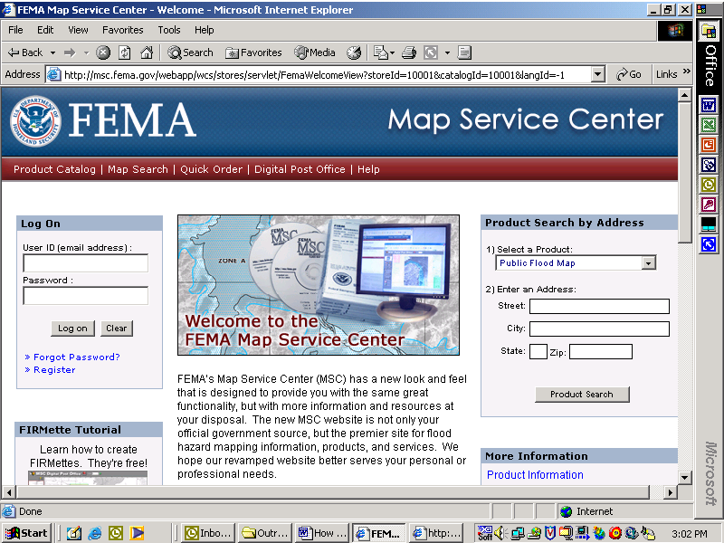
A
B
C
D

- Select first item “FEMA issued Flood Maps.”
For options A, C, and D, enter or search for the requested information and please go to Step #5 for further instructions. For option B, please go to Step #3.

- Select first item “FEMA issued Flood Maps.”

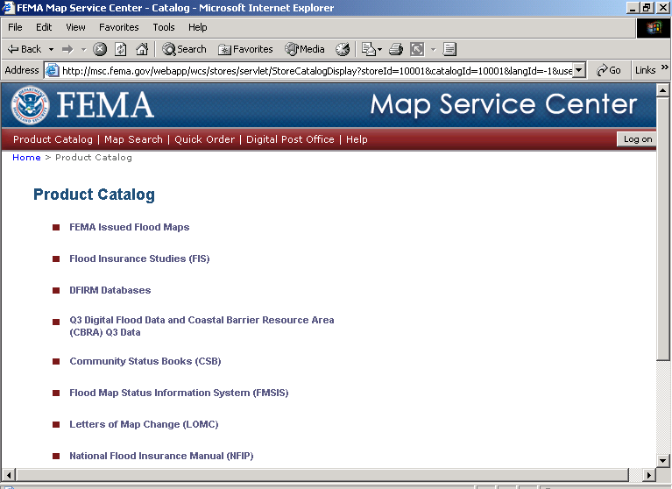

- Select state, county, and community from drop down menus. Click on item #4 “FEMA issued Flood Maps.”
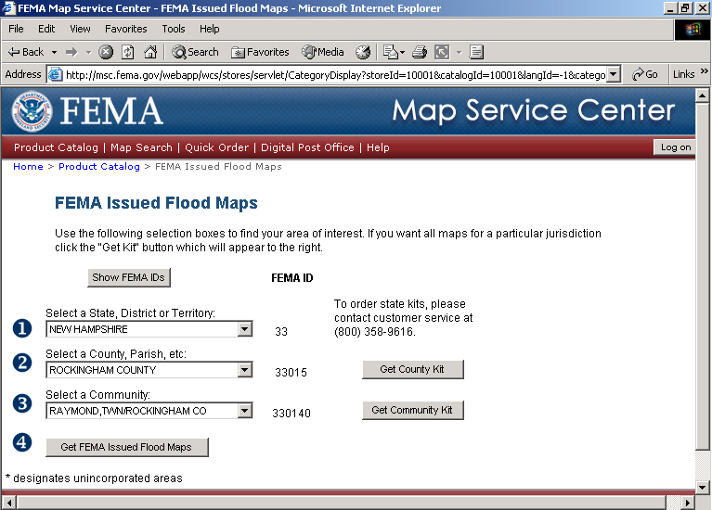
- To view a map panel, click on the green magnifying glass symbol. To purchase a map panel, click on the blue dollar sign symbol. To purchase all map panels for a community, click on Get Community Kit button.

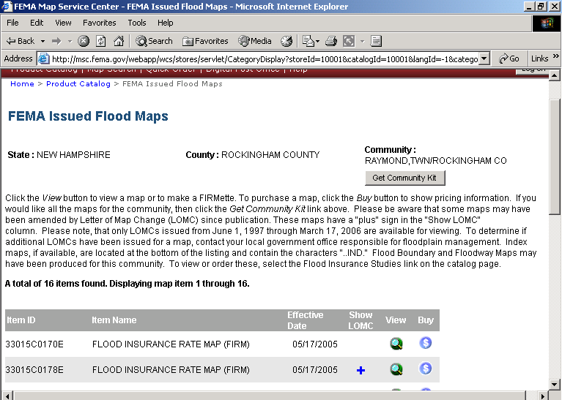

- When you click to view a map panel, another screen will open. Use the zoom and pan tools to view your area of interest.
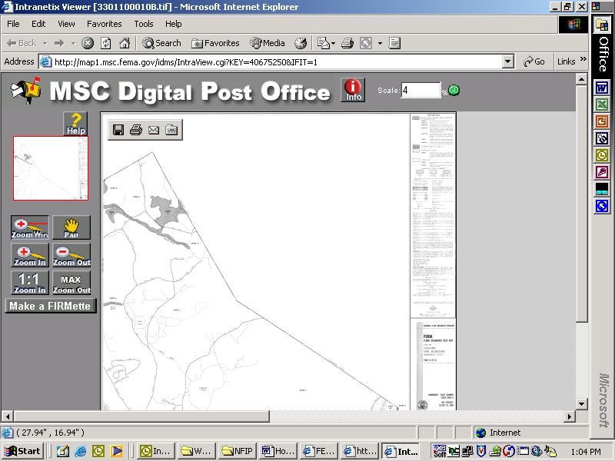

- When viewing a map panel, you have the option of printing or making a FIRMette of your area of interest. To do so, first click on “Make a FIRMette.”

- On the right side of the screen, select the paper size you wish to print by clicking on one of the three options.
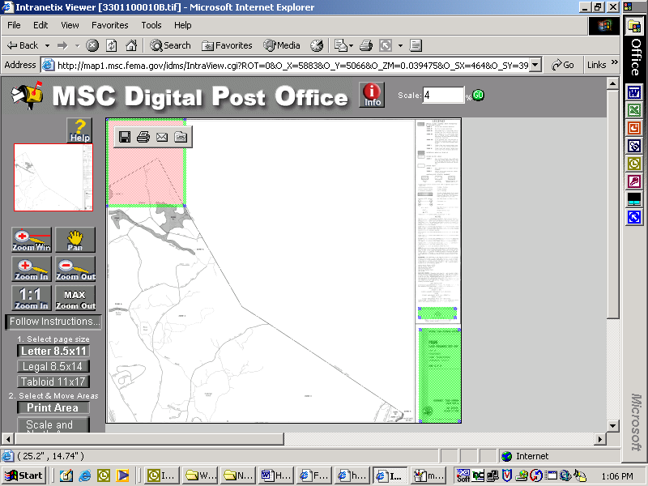

- Using your mouse, move the cursor over the pink area (this is your print area based on the size of paper chosen), left click the mouse and hold and drag the pink area to your area of interest.

- Once you have your area of interest within the pink print area, create your FIRMette by either clicking on the Adobe pdf icon (RECOMMENDED) or the Image file icon.

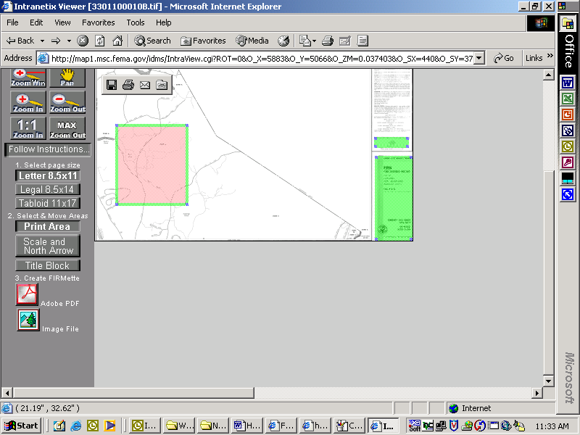

- A new screen will appear where you can click on “Save your FIRMette.” You can choose either to Open it and then print or Save it and then print.
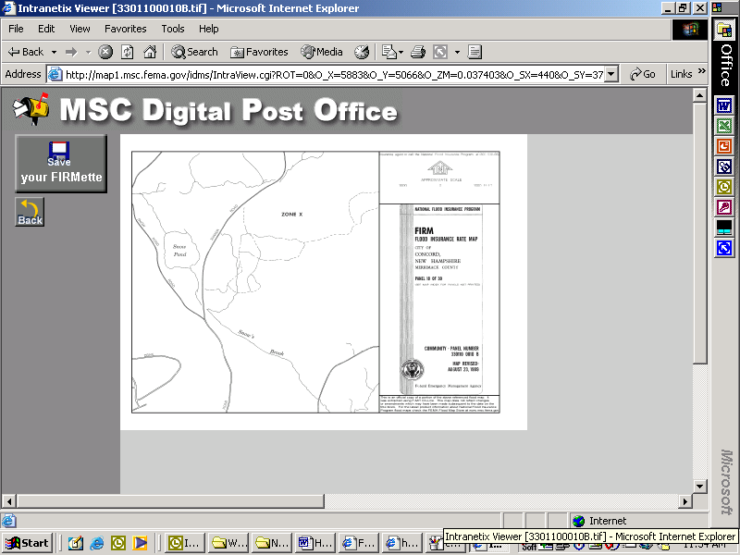

Appendix G

Sample Floodplain Development Permit and Checklist
Town of
FLOODPLAIN DEVELOPMENT APPLICATION
Applicant:
Address:
Property Location:
Tax Map & Lot #:
Property Owner (if different from applicant):
Address:

General description of proposed development:

I hereby authorize the Selectmen of the Town of and its agents to access the above parcel of land for the purpose of reviewing this application and to ensure conformance of the on-site improvements with the approved plan and ordinances and regulations of the Town of .
Signature of Property Owner

FLOODPLAIN DETERMINATION

NFIP Map Name Panel # Effective Date

Indicate in which flood zone the lot is located by referring to the Flood Insurance Rate Map (FIRM), the Floodway Boundary and Floodway Map (FBFM), or Flood Hazard Boundary Map (FHBM):
A AE or A1-30 AO AH A99 V Zone V1-30

Market value of existing structure, if applicable: $
Estimated value of improvements or repairs: $

The following should correspond with the Elevation Certificate submitted with the application:
Elevation of first fully enclosed floor: feet Base Flood Elevation: feet

Is the proposed development in a Floodway? Yes No
Note: Development in a floodway is prohibited. Require applicant to relocate.

ADDITIONAL INFORMATION REQUIRED

- Elevation Certificate (residential) and/or Floodproofing Certificate (non-residential)

- Site Plan showing the location of all existing and proposed structures and/or development, 100-year floodplain boundary and floodway boundary, if applicable. (The Town reserves the right to require these plans to be prepared and certified by a licensed civil engineer.)

- Development plans, drawn to scale, including where applicable details for anchoring structures, elevation of lowest floor (including basement), detail of floodproofing of utilities located below the first floor, and details of enclosures below the first floor.

- If the development is a subdivision with >50 lots or >5 acres, the applicant must provide the Base Flood Elevation in the subdivision plans.

- Plans showing the extent of watercourse relocation and/or landform alteration. (The Town reserves the right to require these plans to be prepared and certified by a licensed civil engineer.)

Approved: Denied:
Signed: Date:

Appendix H

Procedures for Compliance with Floodway Regulations

Please click on the following link: Floodway Procedures*

*Please note this link will take you to a large pdf file (20 MB). If you have trouble opening it and/or if you would like to request a hard copy, please contact us.

Appendix I

Biennial Report Samples

DEPARTMENT OF HOMELAND SECURITY
O.M.B. No. 1660-0003
Expires Oct. 31, 2005

See reverse side for Paperwork Burden Notice
EMERGENCY PREPAREDNESS AND RESPONSE DIRECTORATE
NATIONAL FLOOD INSURANCE PROGRAM

Biennial Report for
RETURN TO:
Federal Emergency Management Agency
Biennial Report Coordinator
3601 Eisenhower Avenue
Alexandria, VA 22304

Calendar Year 2003 and 2004

EMERGENCY AND REGULAR PROGRAM
(Without Base Flood Elevations)

INSTRUCTIONS
- This report should be completed by the locally designated Floodplain Manager (e.g., your Community Manager, Community Planner, Building Inspector, etc.).
- Please return this report within 45 days of receipt to the address above, or fax it to 1-877-NFIP-BR1. If you would like to respond via the Internet, go to www.floodmaps.fema.gov/br2005 and use the following PIN number _____________.
For more information, contact the FEMA Biennial Report Coordinator toll free at 1-877-FEMA-114 (1-877-336-2114).

SECTION I – Changes in your community that may have affected flood hazard areas:
If you answer “yes” to any question in this section, please be prepared to provide explanatory information and/or technical data including, when appropriate, your own community map or a copy of the Flood Hazard Boundary Map/Flood Insurance Rate Map showing the areas affected. Do not send this information at this time. FEMA may contact you by phone in the near future for this information.
Yes No
A. Does your community have any changes to the base data on your Flood Hazard Boundary Map/Flood Insurance Rate Map?
(e.g., adding/correcting streets, adding Letters of Map Revision, or annexations/corporate limit changes)

B. Have the characteristics of watersheds in your community changed to the extent that your floodplain needs to be restudied?
(e.g., major landuse changes due to urbanization, deforestation, wildfires, or stream relocation due to erosion/siltation)
C. Does your community have information that may be incorporated into a Flood Insurance Rate Map?
(e.g., watershed studies or Base Flood Elevations established by developers)

D. Has there been a significant man-made change affecting your designated flood hazard areas?
(e.g., levees, bridges, culverts, extensive filling, excavation, or stream channelization)

SECTION II – Community Floodplain Management Data during the last 2 years (calendar year 2003-2004 only):
Yes No
A. Has your community updated its floodplain management ordinance during the reporting period?
If so, please send a copy of the new ordinance to the return address identified above.

B. How many building permits were granted within the last 2 calendar years for new structures (including substantial
improvements to existing structures) in the designated flood hazard areas shown on your community’s Flood Hazard Boundary
Map/Flood Insurance Rate Map?
Yes No
C. Is your community in need of technical assistance in improving local floodplain management, such as regulation interpretation,
planning, enforcement procedures, floodproofing, or a community visit?

D. Please update the demographic information for your community that was provided to FEMA when your community last reported to the National
Flood Insurance Program. If any numbers are NOT correct or a “0” appears, please provide the revised numbers in the spaces below. If precise
data are not available, please give us your best estimate.
 | Permanent  Year-Round Population | 1-4 Family Structures | All other Structures
1. In your entire community (including flood hazard areas)
2a. In your flood hazard areas only.
2b. How did you determine the number GIS data best estimate
of structures in the flood hazard areas? tax map overlays other (explain)
NAME, TITLE, SIGNATURE, AND E-MAIL ADDRESS |  | PHONE NO. (include area code) | Date
 |  | PHONE NO. (include area code) | Month | Year
FEMA Form 81-28, APR 05 REPLACES ALL PREVIOUS EDITIONS Retain a copy of this report for your records
_{M}

PAPERWORK BURDEN DISCLOSURE NOTICE
FEMA Form 81-28
Public reporting burden for this form is estimated to average 1-2 hours per response. The burden estimates includes the time for reviewing instructions, searching existing data sources, gathering and maintaining the needed data, and completing, reviewing, and submitting the form. You are not required to respond to this collection of information unless a valid OMB control number appears in the upper right corner of this form. Send comments regarding the accuracy of the burden estimate and any suggestions for reducing this burden to: Information Collections Management, Federal Emergency Management Agency, 500 C Street, SW, Washington, DC 20472, Paperwork Reduction Project (3067-0018).
NOTE: Please do not send your completed form to the above address.

DEPARTMENT OF HOMELAND SECURITY
O.M.B. No. 1660-0003
Expires Oct. 31, 2005

See reverse side for Paperwork Burden Notice
EMERGENCY PREPAREDNESS AND RESPONSE DIRECTORATE
NATIONAL FLOOD INSURANCE PROGRAM

Biennial Report for
RETURN TO:
Federal Emergency Management Agency
Biennial Report Coordinator
3601 Eisenhower Avenue
Alexandria, VA 22304

Calendar Year 2003 and 2004

REGULAR PROGRAM
(No Special Flood Hazard Areas)

INSTRUCTIONS
This report should be completed by the locally designated Floodplain Manager (e.g., your Community Manager, Community Planner, Building Inspector, etc.).
Please return this report within 45 days of receipt to the address above, or fax it to 1-877-NFIP-BR1. If you would like to respond via the Internet, go to www.floodmaps.fema.gov/br2005 and use the following PIN number _____________.
For more information, contact the FEMA Biennial Report Coordinator toll free at 1-877-FEMA-114 (1-877-336-2114).

SECTION I – Changes in your community that may have affected flood hazard areas:

It has been determined by FEMA that your community contains No Special Flood Hazard Areas and does not have a Flood Hazard Boundary Map or Flood Insurance Rate Map. Completion of this form by your community will help us identify information that could be useful in evaluating your program and mapping status.

If you answer “yes” to any question in this section, please be prepared to provide explanatory information and/or technical data including, when appropriate, your own community map showing the areas affected. Do not send this information at this time. FEMA may contact you by phone in the near future for this information.

Yes No
A. Has there been a change to your community’s corporate limits or extraterritorial boundaries that has resulted in your
community annexing flood hazard areas?

B. Has there been any physical change, either natural or man-made in your community that could increase flood hazards?
(e.g., major landuse changes due to urbanization, deforestation, wildfires, or stream relocation due to erosion/siltation)

C. Does your community have new information that indicates the presence of flood hazards in your community?
(e.g., watershed studies or Base Flood Elevations established by developers)

SECTION II – Community Floodplain Management Data during the last 2 years (calendar years 2003-2004 only):
Yes No
A. If your community has a floodplain management ordinance, has it been updated during the reporting period?
If so, please send a certified copy of the new ordinance to the return address identified above.

B. Please update the demographic information for your community that was provided to FEMA when your community last reported to the National
Flood Insurance Program. If any numbers are NOT correct or a “0” appears, please provide the revised number in the spaces below. If precise
data are not available, please provide your best estimate.

 | Permanent  Year-Round Population | 1-4 Family Structures | All other Structures
1. In your entire community
NAME, TITLE, SIGNATURE, AND E-MAIL ADDRESS |  | PHONE NO. (include area code) | Date
 |  | PHONE NO. (include area code) | Month | Year
FEMA Form 81-29A, APR 05 REPLACES ALL PREVIOUS EDITIONS Retain a copy of this report for your records
_{N}

PAPERWORK BURDEN DISCLOSURE NOTICE
FEMA Form 81-29A
Public reporting burden for this form is estimated to average 12 minutes per response. The burden estimates includes the time for reviewing instructions, searching existing data sources, gathering and maintaining the needed data, and completing, reviewing, and submitting the form. You are not required to respond to this collection of information unless a valid OMB control number appears in the upper right corner of this form. Send comments regarding the accuracy of the burden estimate and any suggestions for reducing this burden to: Information Collections Management, Federal Emergency Management Agency, 500 C Street, SW, Washington, DC 20472, Paperwork Reduction Project (3067-0018).
NOTE: Please do not send your completed form to the above address.

DEPARTMENT OF HOMELAND SECURITY
O.M.B. No. 1660-0003
Expires Oct. 31, 2005

See reverse side for Paperwork Burden Notice
EMERGENCY PREPAREDNESS AND RESPONSE DIRECTORATE
NATIONAL FLOOD INSURANCE PROGRAM

Biennial Report for
RETURN TO:
Federal Emergency Management Agency
Biennial Report Coordinator
3601 Eisenhower Avenue
Alexandria, VA 22304
Calendar Year 2003 and 2004

REGULAR PROGRAM
(With Base Flood Elevations)
INSTRUCTIONS
- This report should be completed by the locally designated Floodplain Manager (e.g., your City Manager, City Planner, Building Inspector, etc.).
- Please return this report within 45 days of receipt to the address above, or fax it to 1-877-NFIP-BR1. If you would like to respond via the Internet, go to www.floodmaps.fema.gov/br2005 and use the following PIN number __________
For more information, contact the FEMA Biennial Report Coordinator toll free at 1-877-FEMA-114 (1-877-336-2114).

SECTION I – Changes in your community that may have affected flood hazard areas:
If you answer “yes” to any question in this section, please be prepared to provide explanatory information and/or technical data including, when appropriate, your own community map or a copy of the Flood Insurance Rate Map showing the areas affected. Do not send this information at this time. FEMA may contact you by phone in the near future for this information.
Yes No
A. Does your community have any changes to the base data on your Flood Insurance Rate Maps?
(e.g., adding/correcting street, adding Letters of Map Revision, or annexations/corporate limit changes)
B. Have the characteristics of watersheds in your community changed to the extent that your floodplain needs to be restudied?
(e.g., major landuse changes due to urbanization, deforestation, wildfires, or stream relocation due to erosion/siltation)
C. Does your community have information that may be incorporated into a Flood Insurance Rate Map?
(e.g., watershed studies or Base Flood Elevations established by developers)
D. Has there been a significant man-made change affecting your designated flood hazard areas?
(e.g., levees, bridges, culverts, extensive filling, excavation, or stream channelization)

SECTION II – Community Floodplain Management Data during the last 2 years (calendar years 2003-2004 only):
Yes No
A. Has your community updated its floodplain management ordinance during the reporting period?
If so, please send a copy of the new law to the return address identified above.
B. How many building permits were granted within the last 2 calendar years for new structures (including substantial improvements to existing structures) in the designated flood hazard areas shown on your community’s Flood Insurance Rate Map?
C. How many variances to your local floodplain management ordinance were granted within the last 2 calendar years for new structures or substantial improvement to existing structures in designated flood hazard areas shown on your community’s Flood Insurance Rate Map? Please provide ONLY the number of variances granted for structures with the lowest floor below the Base Flood Elevation.
Yes No
D. Is your community in need of technical assistance in improving local floodplain management, such as regulation interpretation, planning, enforcement procedures, floodproofing, or a community visit?
E. Please update the demographic information for your community that was provided to FEMA when your community last reported to the National Flood Insurance Program. If any numbers are NOT correct or a “0” appears, please provide the revised number in the space below. If precise data are not available, please give us your best estimate.

 | Permanent Year-Round Population |  | 1-4 Family Structures | All other Structures
1. In your entire community (including flood hazard areas)
2a. In your flood hazard areas only.
2b. How did you determine the number GIS data best estimate
of structures in the flood hazard areas? tax map overlays other (explain)
NAME, TITLE, SIGNATURE, AND E-MAIL ADDRESS |  | PHONE NO. (including area code) |  | Date
 |  |  |  | Month | Year
FEMA Form 81-29, APR 05 REPLACES ALL PREVIOUS EDITIONS Retain a copy of this report for your records
_{R}

PAPERWORK BURDEN DISCLOSURE NOTICE
FEMA Form 81-29
Public reporting burden for this form is estimated to average 1.5-3 hours minutes per response. The burden estimates includes the time for reviewing instructions, searching existing data sources, gathering and maintaining the needed data, and completing, reviewing, and submitting the form. You are not required to respond to this collection of information unless a valid OMB control number appears in the upper right corner of this form. Send comments regarding the accuracy of the burden estimate and any suggestions for reducing this burden to: Information Collections Management, Federal Emergency Management Agency, 500 C Street, SW, Washington, DC 20472, Paperwork Reduction Project (3067-0018).
NOTE: Please do not send your completed form to the above address.

For purpose of determining CRS discounts, all AR and A99 zones are treated as non-SFHAs
Increase in discount for Classes 1-6 effective may 1, 2001
Status: C = Current, R = Rescinded

