DRAFT/PRELIMINARY
SCOPE OF SERVICES
FOR PERAMBULATIION OF TOWN LINES
(RGM 6-2014)

I. Gathering and Researching Information on Town Lines and Monuments

Collect records of previous perambulations from each town’s files
Collect information on each town available from NH State Archives
http://sos.nh.gov/Guide.aspx (by town name)
Collect original town charter
Collect any Acts of the Legislature that have changed the lines
Collect any court cases that have changed the lines
Collect any known survey plans along the lines
Review any “blister Rust” maps, if available
Review Assessor (Tax) maps for any pertinent information
Consult with the following for any additional information
Historical Society
Conservation Commission
Town Tax Mapping consultants
Recon location of any known monuments/bounds along the lines
Have town post notice that Perambulation work will be being performed
Have Town authorization letter available for
landowners with questions
Use existing or create specific ID for each monument
Obtain preliminary GPS coordinates

II. Prepare and Coordinate Actual Perambulation

Town post general notice to citizens about date and time of Perambulation
Coordinate meeting locations and times, including placing of vehicles
During Perambulation:
Walk entire line navigating by using the preliminary GPS coordinates
Photograph bounds with specific ID cards
Photograph general area for use in future
Obtain as precise as GPS coordinates as possible
Latitude and Longitude (NAD ‘83/WGS ’84)
Renew/mark/paint bounds

III. Complete Report (Return) and File Copy with NH Secretary of State

Report to include (minimum)
Date of Perambulation
Recitation of lines and monuments found (or missing)
Names and signatures of officials representing each town
General plan/map of line with monuments and id’s shown

Specific info for each bound:
area maps (blow ups) of each bound
Use USGS, GRANIT, etc
photos taken (with ID card) (close ups and general area photos)
coordinates obtained, GPS receiver used, approximate accuracy
comments concerning the bound; its condition, etc.

IV. Appendix

Include all background information collected in preparation for the Perambulation and source(s).

V. Enter Bond positions and pictures into the GRANIT Town Monument Boundary Catalog
http://boundary.granit.unh.edu/

Number of final reports to be submitted: ___________________________

EXAMPLE OF AREA PLAN FROM GRANIT
(ORTHOPOTOGRAPHY)
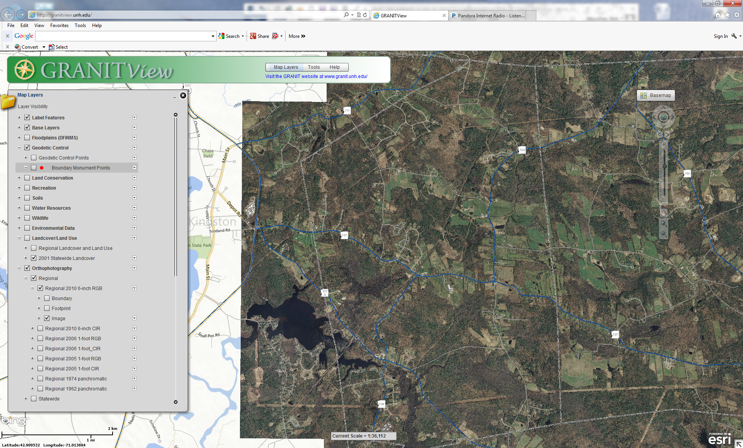

EXAMPLE OF CLOSE UP VIEW FROM GRANIT
(ORTHOPOTOGRAPHY)
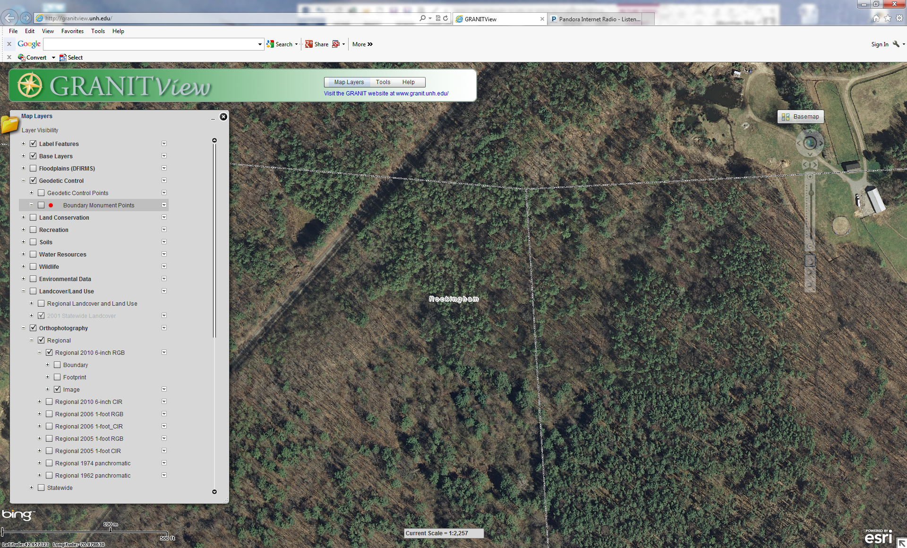

EXAMPLE OF CLOSE UP VIEW FROM GRANIT
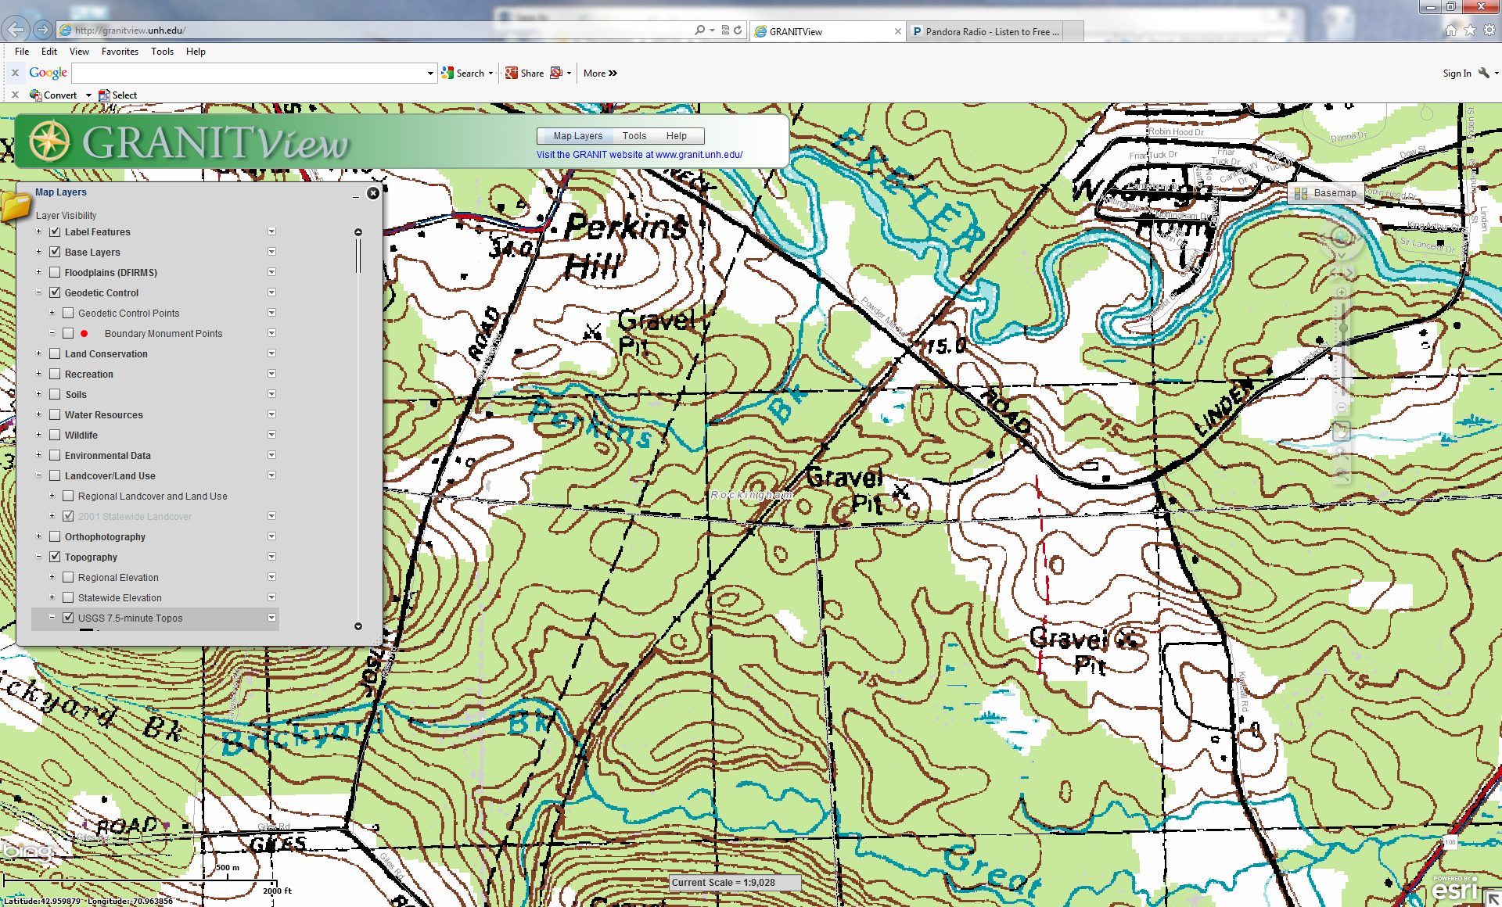
(USGS 7.5 MINUTE TOPOS)

