Variable: Median Home Purchase Price (ID # 301)

Description: Median purchase price of a home by Region in 2012. Information provided by the N.H. Department of Revenue, PA-34 Dataset.

Source_Name: Median Home Purchase Price
Source_Date: 2012
Source_URL: http://www.nhhfa.org/rl_demographic.cfm

Geography: Region, Municipality optional if data is available. (Note: samples sizes of less than 50 are considered unreliable).

Methodology:
Housing
- Go to the website: http://www.nhhfa.org/rl_demographic.cfm and select the “Housing Data” link. Select “Purchase Price Data” from the top row of tabs and then select “Purchase Price Data: Median Purchase Price” on the left hand side of the webpage. Select your geography using the drop down menus and select RPC for the region in interest. NOTE: As an optional metric, you may select by town if the information is available, however it is advised to avoid using data with sample sizes of 50 or smaller.

- In the first table, you will find Median Purchase Price (shown below). Download the table in either Excel format or PDF format by right clicking the spreadsheet. Collect data from the “All Homes” category for the year 2012.

- Create an Excel table for each region’s Median Home Price for 2012 as shown in the Example below.

Example:
 |  | All Homes
RPC Name | RPC Code | Median Purchase Price | Sample Size
NCC | 1 | $ 130,000 | 633

NOTE: This data set provides an estimate of the median sale price of existing and new primary homes in New Hampshire. A primary home is defined as a single family home occupied by an owner household as their primary place of residence. Multi-family rental housing, seasonal or vacation homes and manufactured housing are not included in the analysis of this data. (New Hampshire Housing)
Documentation Author: S. Waleryszak, SWRPC
Housing

Variable: Median Rental Cost (ID # 302)

Description: Median gross rent by Region. Information is provided by the N.H. Department of Revenue, PA-34 Dataset.
Source_Name: Median Gross Rental Cost
Source_Date: 2012
Source_URL: http://www.nhhfa.org/rl_demographic.cfm

Geography: Region, Municipality optional if data is available. (Note: samples sizes of less than 50 are considered unreliable).

Methodology:

- Go to the website: http://www.nhhfa.org/rl_demographic.cfm and select the “Housing Data” link. Select “Rental Price Data” from the top row of tabs and then select “Rental Cost Data: Median Gross Rent” on the left hand side of the webpage. Select your geography using the drop down menus and select RPC for the region in interest. NOTE: As an optional metric, you may select by town if the information is available, however it is advised to avoid using data with sample sizes of 50 or smaller.

- Download the “Median Rent” table by right clicking the spreadsheet. Collect 2012 data from the “All Units” Category for each Region.

- Create an Excel table with the information shown in the Example below:

EXAMPLE
 |  | All Units
RPC Name | RPC CODE | Median Gross Rental Cost | Sample Size
NCC | 1 | $ 716 | 784

NOTE: This data does not reflect the change in the Town of Windham’s RPC affiliation from Rockingham Planning Commission to Southern NH Planning Commission. The 2013 data will reflect this change, however.
Housing

This data set provides a median gross rental cost for rental housing in the state of New Hampshire, broken down into Regional Planning Commission (RPC) boundaries. Gross rental cost is the rent charged by the landlord plus dollar allowances for each utility paid by the tenant. Units in public housing, units with tenant income restrictions and/or rent restrictions, and units in projects that received public funding or tax credits are not included in this survey. (New Hampshire Housing)

Documentation Author: S. Waleryszak, SWRPC

Variable: Housing Affordability (ID # 303)
Housing

Description: Percentage of Renter Units and Owner Units affordable to households earning 80 percent of the Housing and Urban Development Area Median Family Income (HAMFI).
Source_Name: Percentage of Renter and Owner-Occupied Housing Units Affordable to Households Earning 80% of the HAMFI.
Source_Date: 2005-2009 American Community Survey (ACS) data
Source_URL: http://egis.hud.gov/cpdmaps/

Source_Name: Number of occupied housing units by tenure and household size
Source_Date: 2005-2009 American Community Survey (ACS) data
Source_URL: http://egis.hud.gov/cpdmaps/

Geography: Region wide by selecting each Municipality in the Regional Planning Commission boundaries.

Methodology:
- Go to http://egis.hud.gov/cpdmaps/
- Close the “Guide Me” window that pops up on the screen.
- Use the map tools to zoom to your region.
- Chose the “Map Selection Button” (you may have to expand it from the top left corner). Next, navigate to Boundaries then Grantee Boundaries and check “CoC and “UGLG” to view the boundaries of the towns and cities.
- Click on the Reports icon on the toolbar on the top of the screen.
- In the Target Jurisdiction drop-down menu, select Municipalities as your geography:
- Use the drawing controls in the window to select the municipalities in your region.
- Click the Next button in the lower-right corner of the Reports window.
- On the next screen, you will be prompted to choose an optional set of reference data to include in the report. “None (default)” should be selected; ensure that it is and then click the Next button.
- On the next screen, you will be prompted to choose the data that you want to include in the report. Click the Uncheck All button, and then click the check boxes next to Housing Supply, then click the Next Button.
- On the next screen, you can enter a customized title for the report if you wish, and then click the Finish button in the lower right-hand corner of the Reports window. Your browser will download an Excel file of the report. (Note: if the download does not begin, you may need to turn of the pop-up blocker on your website.
- Open the Excel file and locate the table showing the number of Owners and Renters that fall within the category of 80% HAMFI.
- Locate the table: Total Number of occupied housing units by tenure and household size for Owner and Renter.

Calculations

- Divide the total number of rental housing units affordable to households earning 80% of the HAMFI by the total number of rental households to calculate the percentage.
- Divide the number of owner-occupied housing units affordable to households earning 80% of the HAMFI by the total number of owner-occupied housing units to calculate the percentage.

EXAMPLE:
Housing
Southwest Region Planning Commission

- Percentage of Owner-Occupied Housing Units affordable to household earning 80% of the HAMFI: 4,552/29,495 x 100 = 15.4%

- Percentage of Renter-Occupied Housing Units affordable to households earning 80% of the HAMFI: 4,887/9,350 x 100 = 52.3%
 | SWRPC | 4
Total Owner-Occupied Housing Units | 29,495
Total Renter-Occupied Housing Units | 9,350
Owner-Occupied Units Affordable to 80% OF HAMFI | 4,552
Renter-Occupied Units Affordable to 80% of HAMFI | 4,887
Percent of Owner-Occupied Housing Units Affordable to Households Earning 80% of HAMFI | 15.4%
Percent of Renter-Occupied Housing Units Affordable to Households Earning 80% of HAMFI | 52.3%

Documentation Author: S. Waleryszak, SWRPC

Variable: Number of Assisted Housing Units (ID # 304)
Housing

Description: Number of “assisted housing” units in a particular geographic area. Data provided by the New Hampshire Housing Finance Authority.
Source_Name: Total Number of Assisted Housing Units
Source_Date: December 4, 2012
Source_URL: http://www.nhhfa.org/rent_dah.cfm

Geography: Municipality

Methodology:

- Go to http://www.nhhfa.org/rent_dah.cfm and download the “Printable Directory of Assisted Housing (with Accessible Unit Listing)” Microsoft Word document.
- Convert this Microsoft Word document into a spreadsheet using Microsoft Excel so that the fields are separated into columns. (Complete Excel file can be obtained by contacting NH Housing).
- Geocode the Housing Units based on the address data in the Excel table using GIS.
- Using GIS, calculate the total number of Assisted Housing units per town.

NOTE: This does not include “Section 8” housing vouchers, as this information is not available.

Example: Allenstown, NH

Town Name | Town FIPS | County Name | County FIPS | RPC Name | RPC Code | Total Assisted Housing Units
Allenstown | 00660 | Merrimack | 013 | CNHRPC | 5 | 105

Documentation Author: S. Waleryszak, SWRPC

Variable: Housing Unit Vacancy Rates (ID # 305)
Housing

Description: Percentage of non-seasonal vacant housing units out of the total number of housing units in a municipality.

Source_Name: Vacancy Status: U.S. Census Bureau 2010 Census Summary File 1, Table QT-H1.
Source_Date: April 1, 2010
Source_URL:
http://factfinder2.census.gov/bkmk/table/1.0/en/DEC/10_SF1/QTH1/0400000US33.06000.

Geography: Municipality

Methodology:

1. Copy and paste the link below into your browser:
http://factfinder2.census.gov/bkmk/table/1.0/en/DEC/10_SF1/QTH1/0400000US33.06000.

2. “Vacancy Status” is the third heading from the top.

3. Calculate the percent vacant by following the Example below.

EXAMPLE
Alton, NH
Total Vacant Housing Units: 2,136
Vacant Housing Units for Seasonal, Recreational, or Occasional Use: 1,928
Total Housing Units: 4,281

Total non-seasonal housing units: 4,281-1,928 = 2,353

2,136-1,928 = 208 Real Vacant housing units (not seasonal)
208 / 2,353 = 0.088
.088 x 100 = 8.8 % Real Vacancy Rate (Adjusted for vacancy status due to seasonal use)

Final table will include the following fields:
- RPC Name
- RPC Code
- County Name
- County FIPS
- Municipality Name
- Town FIPS

Documentation Author: S. Waleryszak, SWRPC

Variable: Housing Occupancy – Percent Year Round Owner-Occupied Housing Units (ID # 306)
Housing

Description: The percent of year round owner occupied housing units out of the total of occupied housing units in a given geographic area.

Source_Name: Owner Occupied Housing Units: US Census Bureau 2010 Census Summary File 1, Table QT-H3.
Source_Date: April 1, 2010
Source_URL:
http://factfinder2.census.gov/bkmk/table/1.0/en/DEC/10_SF1/QTH3/0400000US33.06000.
Geography: Municipality

Methodology:

Copy and paste the link below into your browser:
http://factfinder2.census.gov/bkmk/table/1.0/en/DEC/10_SF1/QTH3/0400000US33.06000. “Owner-occupied housing units” is the third line down where you will find the whole number and the percent of the total number of occupied housing units in that particular geographic area.

Documentation Author: S. Waleryszak, SWRPC

Variable: Housing Occupancy - Percent Renter-Occupied Housing Units (ID # 307)
Housing
Source_Name: Renter Occupied Housing Units: US Census Bureau 2010 Census Summary File 1, Table QT-H3.
Source_Date: April 1, 2010
Source_URL:
http://factfinder2.census.gov/bkmk/table/1.0/en/DEC/10_SF1/QTH3/0400000US33.06000.

Methodology
Copy and paste the link below into your browser:
http://factfinder2.census.gov/bkmk/table/1.0/en/DEC/10_SF1/QTH3/0400000US33.06000.
Renter-occupied housing units” is the sixth line down where you will find the whole number and the percent of the total number of occupied housing units in that particular geographic area. Download data for each Municipality.

Final table will include the following fields:
- RPC Name
- RPC Code
- Municipality Name
- Town FIPS
- County Name
- County FIPS
- Number of Owner Occupied Housing Units
- Percent Owner of Total Housing Units
- Number of Renter Occupied Housing Units
- Percent Rental of Total Housing Units
Documentation Author: S. Waleryszak, SWRPC

Variable: Total Number and Percent Change in Building Permits (ID # 308)
Housing

Description: The total estimated number and percent change in building permits issued for a particular municipality. Data provided by NH Office of Energy and Planning (OEP).

Source_Name: Residential Permits; Housing Units Authorized by Permit
Source_Date: 2010
Source_URL: http://www.nh.gov/oep/programs/DataCenter/Housing/documents/2009housingreport.pdf

Source_Name: Building Permits Since 2000
Source_Date: 2010
Source_URL: http://www.nhhfa.org/rl_5year.cfm

Geography: Municipality

Methodology:

- Go to the website:
- http://www.nh.gov/oep/programs/DataCenter/Housing/documents/2009housingreport.pdf and http://www.nhhfa.org/rl_5year.cfm to view Building Permit data for 2000 – 2010. You can request a customized Excel sheet from NH Housing or Office of Energy and Planning for all of the municipalities in the state of New Hampshire.
- Determine Annual Total and # of permits for first and second half of the decades (2000-2005; 2006-2010).
- Use the following mathematical formula to determine percent change between the 2000-2005 period. and the 2005 -2010 period.

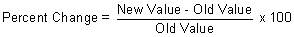

- Present data by Municipality

Example Table:

Town Name | Town FIPS | County Name | County FIPS | RPC Name | RPC Code | 2010
Acworth | 00260 | Sullivan | 019 | UVLSRPC | 3 | 6

Town Name | Town FIPS | County Name | County FIPS | RPC Name | RPC Code | 2000-2005 | 2005-2010 | PERCENT CHANGE
Acworth | 00260 | Sullivan | 019 | UVLSRPC | 3 | 46 | 34 | -26.1%

Documentation Author: S. Waleryszak, SWRPC

Variable: Percent Change in Median Home Price (ID # 309)
Housing

Description: The percent change in Median Home Prices between 2005 and 2012.
Source_Name: Median Home Purchase Price
Source_Date: April 2012
Source_URL: http://www.nhhfa.org/rl_demographic.cfm

Geography: Region, Municipality optional if data is available. (Note: samples sizes of less than 50 are considered unreliable).

Methodology:

- Go to the website: http://www.nhhfa.org/rl_demographic.cfm and select the “Housing Data” link. Select “Purchase Price Data” from the top row of tabs and then select “Purchase Price Data: Median Purchase Price” on the left hand side of the webpage. Select your geography using the drop down menus and select RPC for the region in interest. NOTE: As an optional metric, you may select by town if the information is available, however it is advised to avoid using data with sample sizes of 50 or smaller.
- In the first table, you will find Median Purchase Price (shown below). Download the table in either Excel format or PDF format by right clicking the spreadsheet. Collect data from the “All Homes” category for the year 2012.
- Calculate the percent change from 2005 – 2012. The reason for using these two periods is because 2005 was before the peak of the “housing bubble” and 2012 is the most current data.

EXAMPLE
Central Region Planning Commission
2012 = $179,900 (New Value)
2005 = $232,000 (Old Number)

Percent Change = ((179,900-232,000)/232,000) x 100 = 22.5% Decrease in Median Home Price between 2005 and 2012.

RPC Name | RPC Code | 2005* | 2012 | Percent Change
CNHRPC | 5 | $ 232,000 | $ 179,900 | -22.5%

*NOTE: This data may not reflect historical changes in town affiliations with Regional Planning Commissions. This data set provides an estimate of the median sale price of existing and new primary homes in New Hampshire. A primary home is defined as a single family home occupied by an owner household as their primary place of residence. Multi-family rental housing, seasonal or vacation homes and manufactured housing are not included in the analysis of this data. (New Hampshire Housing)

Documentation Author: S. Waleryszak, SWRPC

Variable: Number of Assisted Housing Units Near Major Employers (ID # 310)

Description: The number of assisted housing units near Major Employer Centers according to The U.S. Census Bureau’s Local Employment Dynamics (LED) On The Map program. NOTE: Additional effort on the part of the RPC will be required to determine exactly what “Near Major Employers” means to your region based on the information provided. You will find additional instructions in the “ReadMe.txt” file in the RPC folders that will be uploaded as part of the data submission.
Housing
Source_Name: Assisted Housing; Provided by the New Hampshire Housing Finance Authority
Source_Date: December 4, 2012
Source_URL: http://www.nhhfa.org/rent_dah.cfm

Geography: Municipality

Source_Name: On The Map; U.S. Census Bureau
Source_Date: 2012
Source_URL: http://onthemap.ces.census.gov/
Geography: Region, you can choose municipality as an optional method.

Methodology:

- Go to http://www.nhhfa.org/rent_dah.cfm and download the “Printable Directory of Assisted Housing (with Accessible Unit Listing)” Microsoft Word document.
- Convert this Microsoft Word document into a spreadsheet using Microsoft Excel so that the fields are separated into columns. (Excel file can be obtained by calling NH Housing).
- Using GIS, geocode the Housing Units based on the address data in the Excel table using GIS. (GIS Shapefile can be obtained by contacting SWRPC).
- Go to http://onthemap.ces.census.gov/

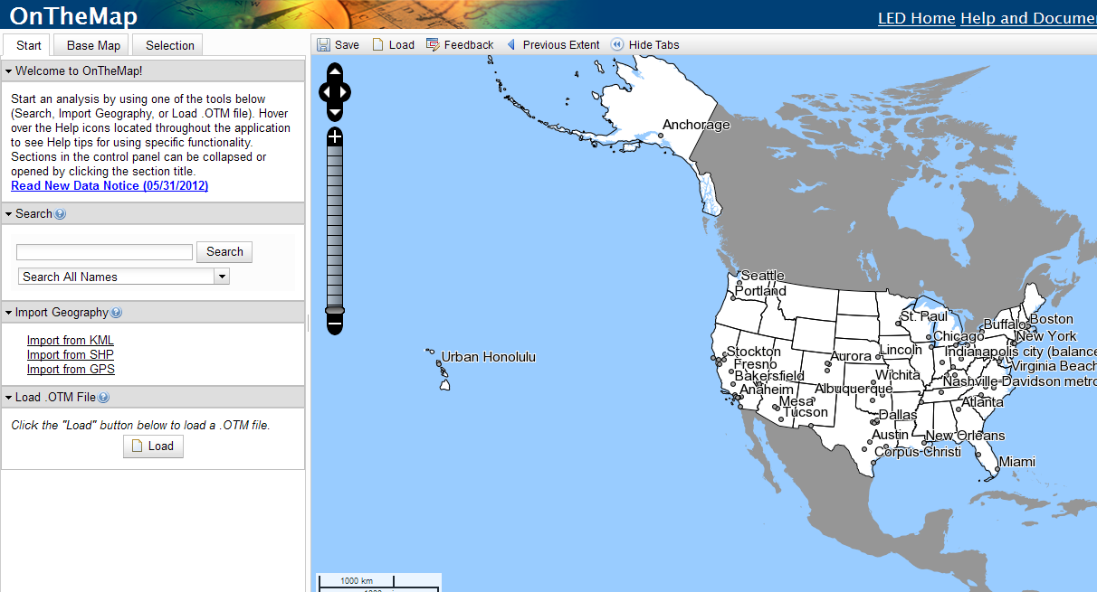

- In order to gather this information for your region, you must select an option under “Import Geography”. You will have the option to import your RPC’s towns in either a KML, SHP, or GPS format. When importing from a shapefile, you will need to choose the .shp; .shx; and .prj of the RPC shapefile. Once you have imported your proper geography click “Import”.

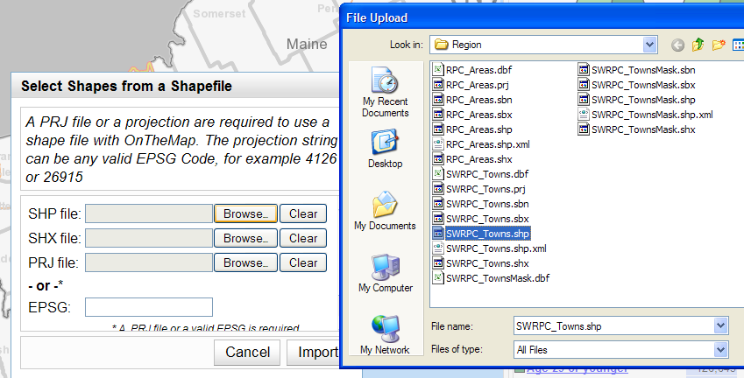
- Next, click “Select All Polygons” from the options on the left. The select “Continue with Selected Features”. In the upper left hand corner select “Confirm Selection”. A pop up will come up displaying information about your Selection Area. Click “Perform Analysis on Selection Area”.

- Select “Work”; Select Area Profile; Choose 2010; and Primary Jobs from the categories shown below and click “Go!”.

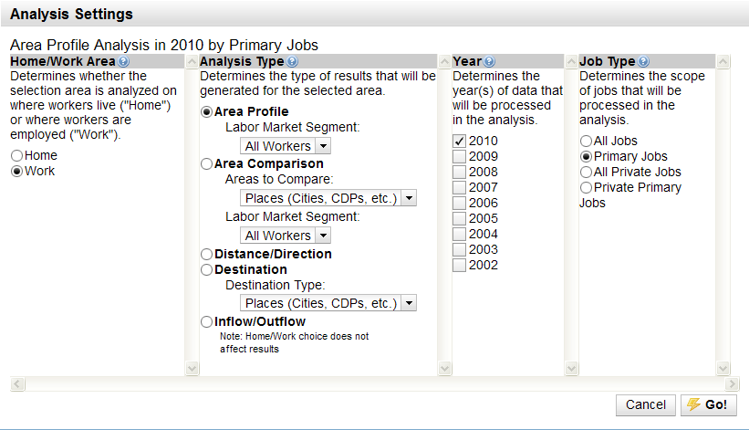
Housing

- On the left hand side of the webpage you will want to click “Zoom to Selection” if you have not already done so.

- Use the options on the left side of the screen under “Report/Map Outputs”, select “Export Geography”. You will be given the option to export to either a Shapefile or KML.

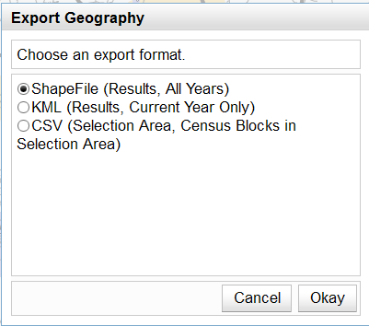

- Import the geocoded Assisted Housing data into ArcGIS and overlay the two datasets.
- Each region will be responsible for determining which areas constitute as being “major employment centers” based on the jobs per square mile figures, which can be found in the “thermals_2010_legend.csv” file, or when you drag the “thermals_2010_gif.lyr” into GIS. Calculate the number of Assisted Housing units by performing an analysis of the number of units that fall within the determined area or distance of major employers.

The result will be two geographic data sets: Assisted Housing shapefile for the State (which you can query using the RPC Code); the OnTheMap exported geography containing the thematic data layer showing jobs per square mile as well as a point shapefile showing business location data mapped by Census Block. In the “Points_2010” shapefile - Total Employees/Jobs are under the heading of c000 in the shapefile.
Housing

Documentation Author: S. Waleryszak, SWRPC

