ECONOMIC AND COMMUNITY WELL-BEING INDEX SCORES
FOR CENTRAL APPALACHIAN NETWORK (CAN) COUNTIES

Chris R. Colocousis
Carsey Institute

4.28.2008

The scores listed in the attached spreadsheet are based on indices of community and economic well-being constructed from various socioeconomic indicators, using year 2000 county-level data. Year 2000 data were used due to the wide availability of data from the 2000 Census. These index scores are one way to compare and contrast the well-being of Central Appalachian counties relative to one another for the year 2000. When 2010 data are made available, a similar approach can be used to chart change in the region. A higher index score indicates increased well-being, as measured here.

Throughout this report, differences between several types of counties are discussed. Most prominent are county economic dependence and metropolitan status.

Index scores were determined by calculating the average standardized score for the variables within each dimension (or the standardized score itself where only one indicator was used), then summing these average standardized scores together across all dimensions. The final index score was calculated by again taking the standardized score of the sum of averaged standardizes scores (across all dimensions). Scores on each dimension were reversed as appropriate so that higher scores reflected increased levels of well-being. This approach yielded the scores shown below, ranked from highest to lowest. These results are stable across a number of different methods of calculating index scores, with rankings shifting only a few places, if shifts occurred at all.

The index of economic well-being was calculated on the basis of the following eight indicators chosen to measure four dimensions of well-being:

Income
Median Household Income
Poverty Rate (individual)
% of Households between 50% and 200% of US Median Household Income (approximately $21,000 to $84,000)

Human Capital
% of Residents over Age 25 with Bachelor’s Degree or Higher

Economic Opportunity
% of Residents that Moved into County in Last 5 Years (since 1995)
Level of Industrial Diversification (Hachman Index)
% of Residents Ages 16 to 64 Employed

Wages
Average Wage per Job

Scores are shown on the table below, ranked from highest to lowest. A score of 2 can be interpreted as a county being two standard deviations above the mean (zero), or twice as high as a county with a score of 1.

County | Economic Index Score
Clermont County, Ohio | 2.56
Putnam County, West Virginia | 2.14
Knox County, Tennessee | 2.12
Anderson County, Tennessee | 1.97
Berkeley County, West Virginia | 1.84
Roane County, Tennessee | 1.79
Pleasants County, West Virginia | 1.67
Monongalia County, West Virginia | 1.67
Washington County, Tennessee | 1.66
Madison County, Kentucky | 1.66
Sullivan County, Tennessee | 1.62
Putnam County, Tennessee | 1.55
Clark County, Kentucky | 1.53
Jefferson County, Tennessee | 1.43
Jefferson County, West Virginia | 1.42
Ross County, Ohio | 1.37
Boyd County, Kentucky | 1.31
Kanawha County, West Virginia | 1.24
Washington County, Ohio | 1.23
Brooke County, West Virginia | 1.22
Hancock County, West Virginia | 1.19
Athens County, Ohio | 1.17
Washington County, Virginia | 1.17
Cabell County, West Virginia | 1.10
Wood County, West Virginia | 1.10
Brown County, Ohio | 1.09
Jackson County, West Virginia | 1.04
Greenup County, Kentucky | 1.02
Cumberland County, Tennessee | 1.00
Unicoi County, Tennessee | 0.99
Ohio County, West Virginia | 0.97
Noble County, Ohio | 0.96
Marshall County, West Virginia | 0.95
Morgan County, West Virginia | 0.93
Tyler County, West Virginia | 0.91
Smith County, Tennessee | 0.89
Muskingum County, Ohio | 0.87
Rowan County, Kentucky | 0.85
Morgan County, Ohio | 0.81
Garrard County, Kentucky | 0.80
Hamblen County, Tennessee | 0.79
Pike County, Ohio | 0.78
Hocking County, Ohio | 0.77
Tuscarawas County, Ohio | 0.77
Carroll County, Ohio | 0.73
Columbiana County, Ohio | 0.72
Harrison County, West Virginia | 0.67
Montgomery County, Kentucky | 0.66
Jefferson County, Ohio | 0.64
Highland County, Ohio | 0.61
Monroe County, Ohio | 0.57
Warren County, Tennessee | 0.54
Greene County, Tennessee | 0.54
Guernsey County, Ohio | 0.53
Perry County, Ohio | 0.53
Coshocton County, Ohio | 0.52
Hawkins County, Tennessee | 0.51
Gallia County, Ohio | 0.48
Mineral County, West Virginia | 0.47
Wayne County, West Virginia | 0.46
Laurel County, Kentucky | 0.46
Carter County, Tennessee | 0.45
Marion County, West Virginia | 0.45
Mason County, West Virginia | 0.43
Harrison County, Ohio | 0.42
Jackson County, Ohio | 0.41
Monroe County, West Virginia | 0.40
Hampshire County, West Virginia | 0.40
Cannon County, Tennessee | 0.36
Van Buren County, Tennessee | 0.29
DeKalb County, Tennessee | 0.29
Grant County, West Virginia | 0.28
Randolph County, West Virginia | 0.27
Mercer County, West Virginia | 0.27
Pulaski County, Kentucky | 0.25
Upshur County, West Virginia | 0.18
Hardy County, West Virginia | 0.16
Holmes County, Ohio | 0.15
Pendleton County, West Virginia | 0.14
Belmont County, Ohio | 0.13
Raleigh County, West Virginia | 0.12
Greenbrier County, West Virginia | 0.12
Taylor County, West Virginia | 0.10
Whitley County, Kentucky | 0.09
Adams County, Ohio | 0.05
Scioto County, Ohio | 0.05
Lincoln County, Kentucky | 0.03
Overton County, Tennessee | 0.02
Vinton County, Ohio | -0.02
Lawrence County, Ohio | -0.03
White County, Tennessee | -0.06
Meigs County, Ohio | -0.06
Fleming County, Kentucky | -0.08
Jackson County, Tennessee | -0.10
Lewis County, West Virginia | -0.11
Wise County, Virginia | -0.12
Scott County, Virginia | -0.12
Union County, Tennessee | -0.15
Bath County, Kentucky | -0.16
Wetzel County, West Virginia | -0.19
Macon County, Tennessee | -0.20
Doddridge County, West Virginia | -0.21
Preston County, West Virginia | -0.21
Wirt County, West Virginia | -0.22
Grainger County, Tennessee | -0.23
Ritchie County, West Virginia | -0.27
Morgan County, Tennessee | -0.28
Tazewell County, Virginia | -0.28
Clay County, West Virginia | -0.29
Campbell County, Tennessee | -0.30
Adair County, Kentucky | -0.30
Pickett County, Tennessee | -0.31
Fayette County, West Virginia | -0.33
Clay County, Tennessee | -0.34
Edmonson County, Kentucky | -0.35
Pocahontas County, West Virginia | -0.37
Roane County, West Virginia | -0.42
Russell County, Virginia | -0.43
Boone County, West Virginia | -0.47
Cocke County, Tennessee | -0.48
Russell County, Kentucky | -0.54
Menifee County, Kentucky | -0.54
Johnson County, Tennessee | -0.55
Barbour County, West Virginia | -0.57
Rockcastle County, Kentucky | -0.58
Gilmer County, West Virginia | -0.58
Claiborne County, Tennessee | -0.61
Green County, Kentucky | -0.61
Powell County, Kentucky | -0.61
Hart County, Kentucky | -0.62
Scott County, Tennessee | -0.65
Fentress County, Tennessee | -0.66
Braxton County, West Virginia | -0.68
Calhoun County, West Virginia | -0.68
Knox County, Kentucky | -0.70
Tucker County, West Virginia | -0.71
Estill County, Kentucky | -0.72
Carter County, Kentucky | -0.72
Nicholas County, West Virginia | -0.72
Morgan County, Kentucky | -0.74
Summers County, West Virginia | -0.79
Casey County, Kentucky | -0.83
Lee County, Kentucky | -0.90
Monroe County, Kentucky | -0.93
Lee County, Virginia | -0.94
Lawrence County, Kentucky | -0.96
Cumberland County, Kentucky | -0.98
Johnson County, Kentucky | -1.00
Jackson County, Kentucky | -1.03
Breathitt County, Kentucky | -1.05
Wolfe County, Kentucky | -1.10
Bell County, Kentucky | -1.12
Wayne County, Kentucky | -1.15
Lincoln County, West Virginia | -1.15
Clinton County, Kentucky | -1.21
McCreary County, Kentucky | -1.26
Perry County, Kentucky | -1.26
Elliott County, Kentucky | -1.28
Logan County, West Virginia | -1.32
Lewis County, Kentucky | -1.32
Clay County, Kentucky | -1.34
Floyd County, Kentucky | -1.36
Hancock County, Tennessee | -1.40
Pike County, Kentucky | -1.43
Knott County, Kentucky | -1.45
Buchanan County, Virginia | -1.58
Mingo County, West Virginia | -1.59
Leslie County, Kentucky | -1.61
Webster County, West Virginia | -1.63
Magoffin County, Kentucky | -1.80
Martin County, Kentucky | -1.94
Dickenson County, Virginia | -1.98
Owsley County, Kentucky | -2.00
Wyoming County, West Virginia | -2.00
Letcher County, Kentucky | -2.11
Harlan County, Kentucky | -2.19
McDowell County, West Virginia | -2.61

The spatial distribution of economic well-being in Central Appalachia is mapped on the following page. The periphery of the region is generally advantaged, especially at the northern and southern edges where CAN counties lie in proximity to several metropolitan areas, while the mining-dependent “core” of the region has the lowest index scores. Fourteen of the 20 lowest-scoring counties are mining-dependent, and all of the lowest 20 are noncore. No mining-dependent counties are even in the top half of the distribution. Sixteen of the top 20 are in a metropolitan area. Along with the importance of proximity to large population centers in economic well-being, proximity to transportation infrastructure (e.g., interstate highways) is generally associated with greater well-being across the region.

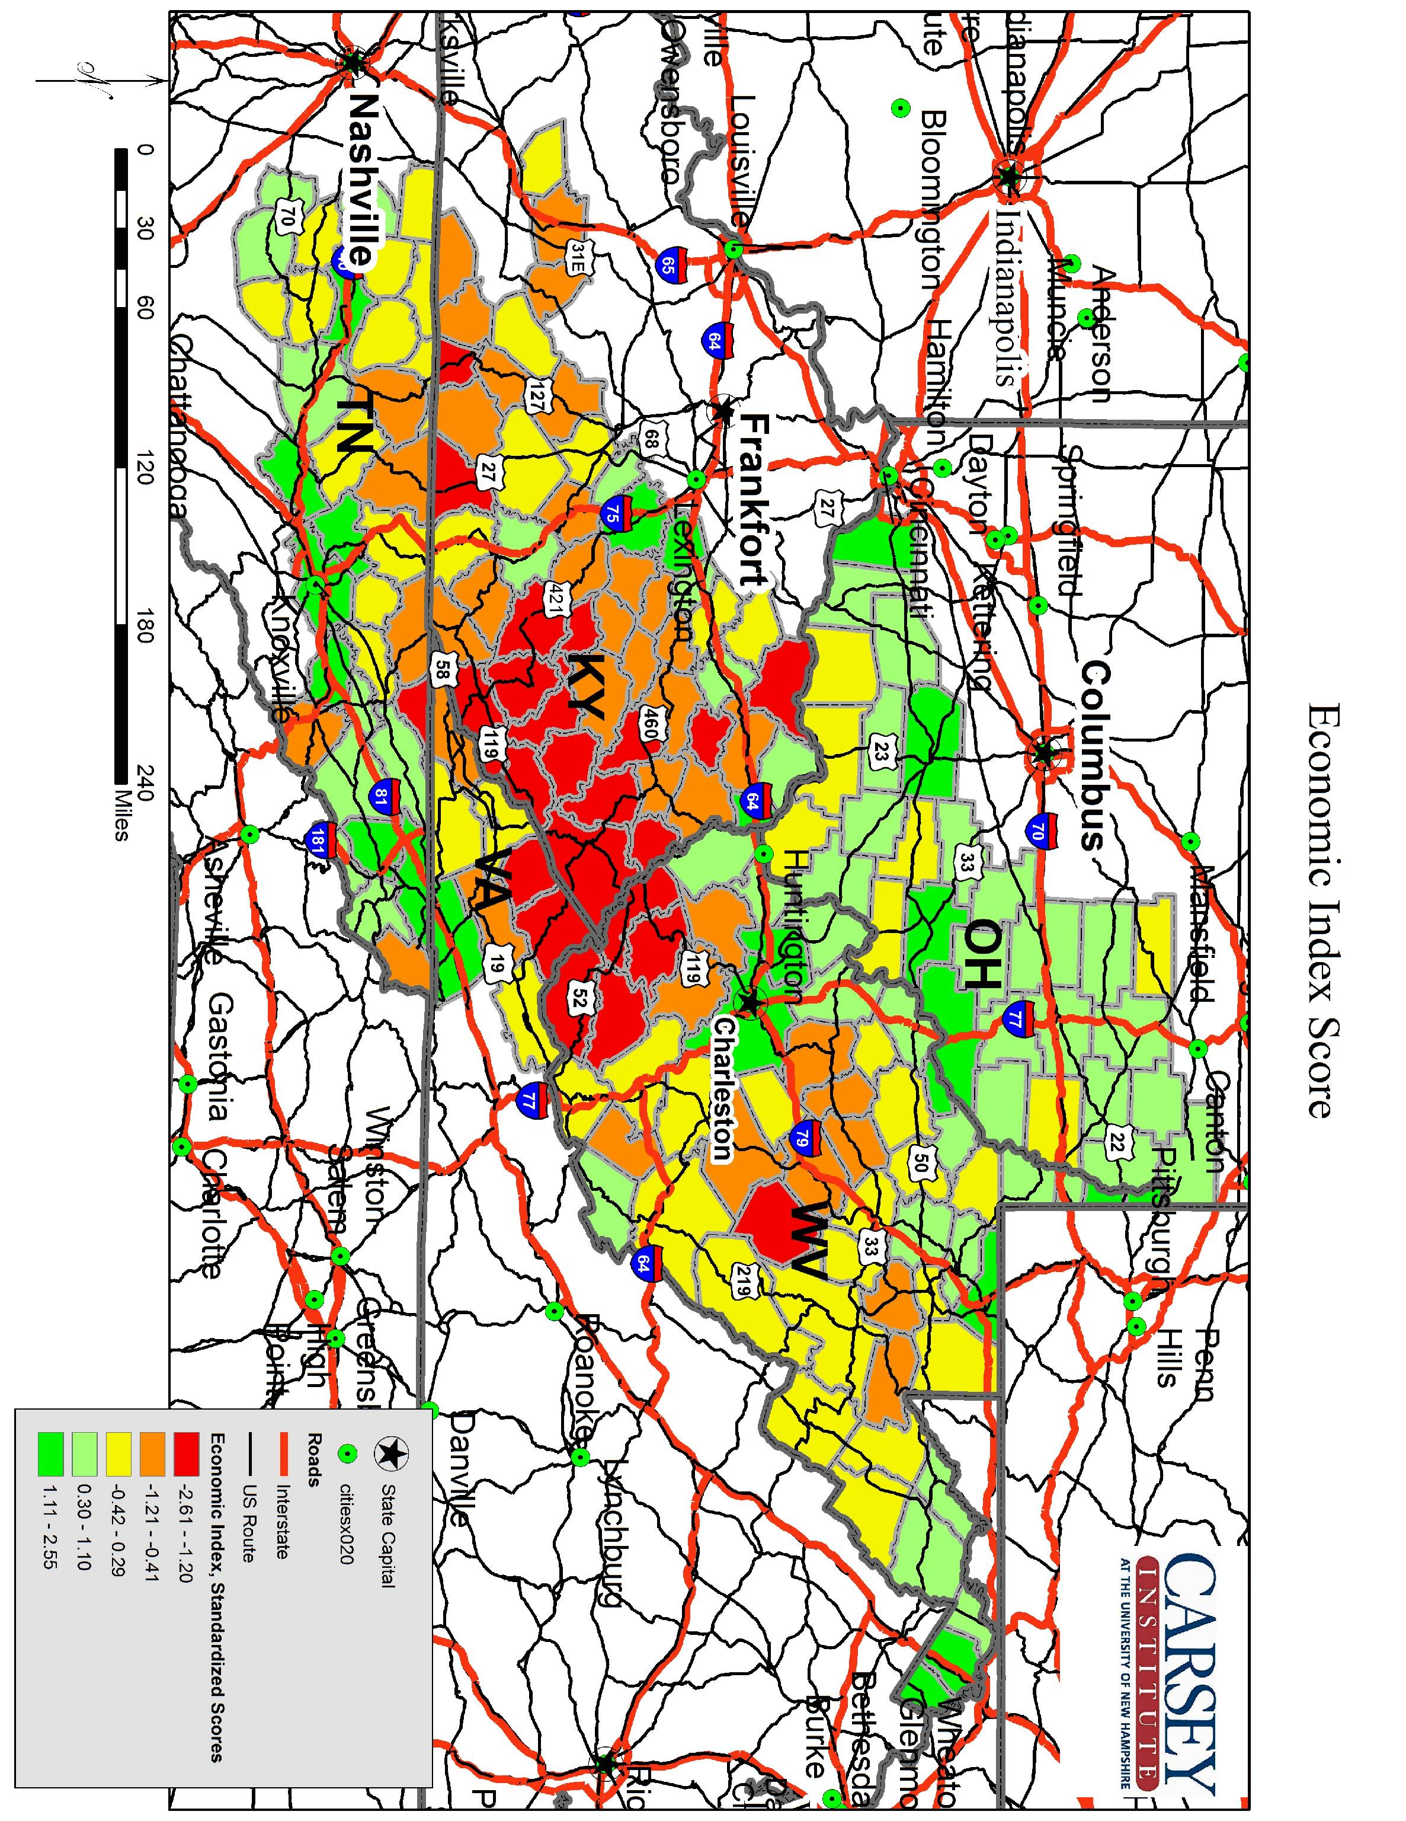

The Index of Community Well-Being was constructed from the following nine indicators selected to measure five dimensions of social well-being:

Social Capital
Associational Density Index (# selected businesses and civic/social organizations per 10K pop.)
% of Retail Firms with less than 20 Employees
Voter Participation Rate (2000 Presidential Election)

Healthcare Access
Local Physician Ratio (# practicing physicians per 1,000 pop.)

Risk Behavior
Teen Birth Rate
Idle Teen Rate (age 16-19 not working and not in school)

Crime and Safety
Serious Violent and Property Crime Rate (per. 1K pop.)
Juvenile Arrest Rate (per 1K pop. Age 10-17)

Maternal Health
% of Births with Low Birthweight (under 2,500 grams)

Again, index scores were calculated by taking the average of counties’ standardized scores across variables within dimensions of well-being, summing those averages across all five dimensions, and then calculating the standardized score on the basis of the summed averages. These scores are shown below, again ranked highest to lowest.

County | Community Index Score
Monongalia County, West Virginia | 3.14
Pleasants County, West Virginia | 3.06
Gilmer County, West Virginia | 2.57
Ohio County, West Virginia | 2.09
Monroe County, West Virginia | 1.89
Macon County, Tennessee | 1.82
Hancock County, West Virginia | 1.58
Brooke County, West Virginia | 1.52
Doddridge County, West Virginia | 1.46
Overton County, Tennessee | 1.44
Edmonson County, Kentucky | 1.42
Clay County, Tennessee | 1.41
Greenbrier County, West Virginia | 1.40
Tuscarawas County, Ohio | 1.36
Jackson County, Tennessee | 1.33
Washington County, Virginia | 1.30
Wirt County, West Virginia | 1.29
Grant County, West Virginia | 1.29
Owsley County, Kentucky | 1.25
Washington County, Tennessee | 1.20
Lewis County, West Virginia | 1.17
Harrison County, Ohio | 1.04
Belmont County, Ohio | 1.03
Dickenson County, Virginia | 1.02
Smith County, Tennessee | 0.99
Clay County, West Virginia | 0.99
Scott County, Virginia | 0.98
Mineral County, West Virginia | 0.93
Sullivan County, Tennessee | 0.92
Putnam County, West Virginia | 0.89
Jefferson County, Ohio | 0.89
Brown County, Ohio | 0.86
Columbiana County, Ohio | 0.84
Muskingum County, Ohio | 0.82
Vinton County, Ohio | 0.80
Guernsey County, Ohio | 0.79
Monroe County, Kentucky | 0.78
Jefferson County, West Virginia | 0.78
Taylor County, West Virginia | 0.77
Noble County, Ohio | 0.76
Marshall County, West Virginia | 0.75
Rowan County, Kentucky | 0.75
Pendleton County, West Virginia | 0.74
Harrison County, West Virginia | 0.73
Jackson County, Kentucky | 0.71
Lee County, Virginia | 0.71
Morgan County, Ohio | 0.71
Van Buren County, Tennessee | 0.70
Holmes County, Ohio | 0.67
Russell County, Virginia | 0.64
Unicoi County, Tennessee | 0.64
Monroe County, Ohio | 0.64
Tucker County, West Virginia | 0.63
Clinton County, Kentucky | 0.62
Preston County, West Virginia | 0.61
Wetzel County, West Virginia | 0.56
Boyd County, Kentucky | 0.55
Hancock County, Tennessee | 0.53
Gallia County, Ohio | 0.52
Wood County, West Virginia | 0.52
Upshur County, West Virginia | 0.45
Green County, Kentucky | 0.43
Cabell County, West Virginia | 0.43
Hocking County, Ohio | 0.42
Cumberland County, Kentucky | 0.38
Fleming County, Kentucky | 0.35
Knox County, Tennessee | 0.33
DeKalb County, Tennessee | 0.33
Randolph County, West Virginia | 0.30
Coshocton County, Ohio | 0.30
Elliott County, Kentucky | 0.29
Morgan County, Tennessee | 0.27
Pike County, Ohio | 0.27
Pulaski County, Kentucky | 0.27
Roane County, Tennessee | 0.24
Pickett County, Tennessee | 0.24
Webster County, West Virginia | 0.22
Washington County, Ohio | 0.18
Adair County, Kentucky | 0.16
Montgomery County, Kentucky | 0.12
Roane County, West Virginia | 0.10
Clermont County, Ohio | 0.09
Buchanan County, Virginia | 0.09
Wise County, Virginia | 0.07
Athens County, Ohio | 0.07
Kanawha County, West Virginia | 0.06
Marion County, West Virginia | 0.06
Putnam County, Tennessee | 0.04
Morgan County, Kentucky | -0.02
Ritchie County, West Virginia | -0.04
Garrard County, Kentucky | -0.05
Cannon County, Tennessee | -0.06
Greenup County, Kentucky | -0.10
Morgan County, West Virginia | -0.11
Russell County, Kentucky | -0.15
Carroll County, Ohio | -0.15
Tyler County, West Virginia | -0.16
Fayette County, West Virginia | -0.20
Menifee County, Kentucky | -0.20
Summers County, West Virginia | -0.21
Fentress County, Tennessee | -0.21
Jackson County, West Virginia | -0.23
Braxton County, West Virginia | -0.24
Adams County, Ohio | -0.27
Wayne County, West Virginia | -0.27
Tazewell County, Virginia | -0.29
Calhoun County, West Virginia | -0.32
Claiborne County, Tennessee | -0.33
Hart County, Kentucky | -0.34
Jackson County, Ohio | -0.35
Whitley County, Kentucky | -0.37
Bath County, Kentucky | -0.37
Hawkins County, Tennessee | -0.38
White County, Tennessee | -0.42
Highland County, Ohio | -0.43
Meigs County, Ohio | -0.43
McCreary County, Kentucky | -0.45
Perry County, Ohio | -0.48
Barbour County, West Virginia | -0.49
Scott County, Tennessee | -0.50
Anderson County, Tennessee | -0.50
Jefferson County, Tennessee | -0.50
Rockcastle County, Kentucky | -0.50
Johnson County, Kentucky | -0.51
Greene County, Tennessee | -0.55
Mason County, West Virginia | -0.57
Lawrence County, Ohio | -0.60
Casey County, Kentucky | -0.61
Wyoming County, West Virginia | -0.65
Letcher County, Kentucky | -0.66
Hardy County, West Virginia | -0.68
Pike County, Kentucky | -0.70
Floyd County, Kentucky | -0.71
Mingo County, West Virginia | -0.71
Breathitt County, Kentucky | -0.75
Clark County, Kentucky | -0.76
Bell County, Kentucky | -0.78
Powell County, Kentucky | -0.85
Lee County, Kentucky | -0.87
Union County, Tennessee | -0.89
Pocahontas County, West Virginia | -0.90
Leslie County, Kentucky | -0.90
Laurel County, Kentucky | -0.95
Perry County, Kentucky | -0.95
Lawrence County, Kentucky | -0.95
Johnson County, Tennessee | -0.95
McDowell County, West Virginia | -0.96
Logan County, West Virginia | -0.98
Hampshire County, West Virginia | -1.01
Madison County, Kentucky | -1.02
Magoffin County, Kentucky | -1.06
Wayne County, Kentucky | -1.08
Carter County, Kentucky | -1.09
Martin County, Kentucky | -1.09
Cumberland County, Tennessee | -1.14
Lewis County, Kentucky | -1.20
Mercer County, West Virginia | -1.22
Nicholas County, West Virginia | -1.24
Ross County, Ohio | -1.26
Warren County, Tennessee | -1.28
Hamblen County, Tennessee | -1.28
Raleigh County, West Virginia | -1.31
Campbell County, Tennessee | -1.33
Scioto County, Ohio | -1.33
Berkeley County, West Virginia | -1.34
Wolfe County, Kentucky | -1.34
Carter County, Tennessee | -1.35
Knott County, Kentucky | -1.35
Lincoln County, Kentucky | -1.48
Boone County, West Virginia | -1.56
Lincoln County, West Virginia | -1.56
Knox County, Kentucky | -1.66
Grainger County, Tennessee | -1.71
Estill County, Kentucky | -1.95
Cocke County, Tennessee | -2.02
Harlan County, Kentucky | -2.76
Clay County, Kentucky | -2.82

These community index scores are mapped in the figure below. While the spatial distribution of economic well-being is in many ways straightforward, that of social well-being is more complex. The general pattern of greater well-being at the periphery of the region is in place, but there are more exceptions visible. The mining-dependent core of the region is generally disadvantaged, but the counties with the lowest scores tend to be located just outside this core area, but inside the extreme periphery of the CAN region. Social well-being tends to increase as one moves toward the northeastern end of the region, though there is a cluster of high-scoring counties at the southeastern end, in Tennessee. The relationship between proximity to interstate highways and well-being is not as apparent as it was with the economic index, and in many cases counties with an interstate passing through them score lower than do adjacent counties without such proximity to this type transportation infrastructure. While the drawbacks of proximity to transportation infrastructure for economic well-being are probably limited, highways can facilitate criminal activity, the construction and operation of non-local retail establishments and settlement patterns not conducive to social interaction (i.e., sprawl), and other phenomena that may have a negative impact on social well-being.

While metropolitan counties are clearly the most advantaged economically, their advantage is less pronounced with respect to social well-being. The lowest-scoring 20 counties are an almost equal mixture of metropolitan, micropolitan, and noncore counties, and in contrast with the economic situation, only five of the bottom 20 are mining-dependent. Ten of the top 20 are metropolitan, while six are noncore and four are micropolitan. The third-highest county is mining dependent, and there are eight mining-dependent counties in the top half of the distribution.

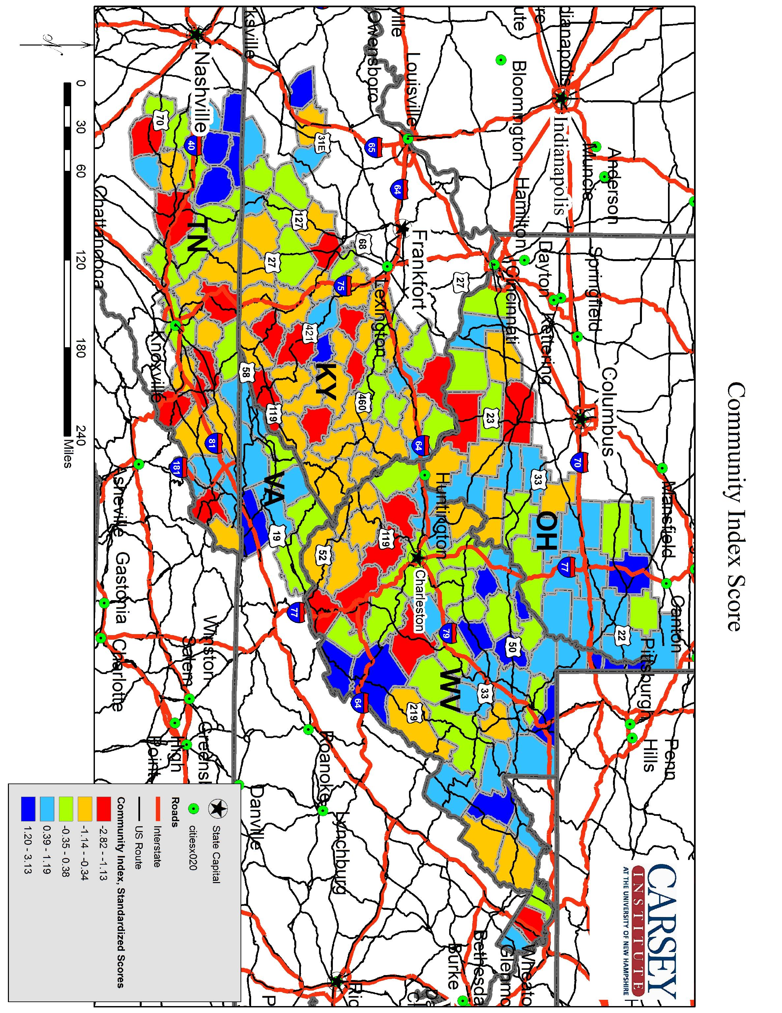

An overall index of well-being was calculated by summing the community and economic indices together. These overall index scores indicate how many standard deviations a given county is above or below both the economic and community indices (together), and are shown below.

County | Overall Index Score
Monongalia County, West Virginia | 4.81
Pleasants County, West Virginia | 4.72
Ohio County, West Virginia | 3.06
Putnam County, West Virginia | 3.03
Washington County, Tennessee | 2.86
Hancock County, West Virginia | 2.77
Brooke County, West Virginia | 2.73
Clermont County, Ohio | 2.65
Sullivan County, Tennessee | 2.54
Washington County, Virginia | 2.47
Knox County, Tennessee | 2.46
Monroe County, West Virginia | 2.30
Jefferson County, West Virginia | 2.20
Tuscarawas County, Ohio | 2.13
Roane County, Tennessee | 2.03
Gilmer County, West Virginia | 1.99
Brown County, Ohio | 1.95
Smith County, Tennessee | 1.88
Boyd County, Kentucky | 1.86
Noble County, Ohio | 1.72
Marshall County, West Virginia | 1.70
Muskingum County, Ohio | 1.70
Unicoi County, Tennessee | 1.63
Wood County, West Virginia | 1.61
Macon County, Tennessee | 1.61
Rowan County, Kentucky | 1.60
Putnam County, Tennessee | 1.59
Grant County, West Virginia | 1.57
Columbiana County, Ohio | 1.56
Cabell County, West Virginia | 1.53
Jefferson County, Ohio | 1.53
Greenbrier County, West Virginia | 1.52
Morgan County, Ohio | 1.51
Anderson County, Tennessee | 1.47
Overton County, Tennessee | 1.46
Harrison County, Ohio | 1.46
Washington County, Ohio | 1.40
Harrison County, West Virginia | 1.40
Mineral County, West Virginia | 1.39
Guernsey County, Ohio | 1.32
Kanawha County, West Virginia | 1.30
Doddridge County, West Virginia | 1.25
Athens County, Ohio | 1.24
Jackson County, Tennessee | 1.23
Monroe County, Ohio | 1.21
Hocking County, Ohio | 1.19
Belmont County, Ohio | 1.16
Wirt County, West Virginia | 1.08
Clay County, Tennessee | 1.07
Edmonson County, Kentucky | 1.06
Lewis County, West Virginia | 1.06
Pike County, Ohio | 1.05
Gallia County, Ohio | 1.00
Van Buren County, Tennessee | 1.00
Jefferson County, Tennessee | 0.92
Greenup County, Kentucky | 0.92
Pendleton County, West Virginia | 0.89
Taylor County, West Virginia | 0.87
Scott County, Virginia | 0.85
Holmes County, Ohio | 0.83
Morgan County, West Virginia | 0.83
Coshocton County, Ohio | 0.82
Jackson County, West Virginia | 0.81
Montgomery County, Kentucky | 0.78
Vinton County, Ohio | 0.78
Clark County, Kentucky | 0.78
Tyler County, West Virginia | 0.76
Garrard County, Kentucky | 0.75
Clay County, West Virginia | 0.70
Madison County, Kentucky | 0.64
Upshur County, West Virginia | 0.64
DeKalb County, Tennessee | 0.62
Carroll County, Ohio | 0.58
Randolph County, West Virginia | 0.57
Pulaski County, Kentucky | 0.52
Marion County, West Virginia | 0.51
Berkeley County, West Virginia | 0.50
Preston County, West Virginia | 0.40
Wetzel County, West Virginia | 0.37
Cannon County, Tennessee | 0.30
Fleming County, Kentucky | 0.27
Russell County, Virginia | 0.22
Wayne County, West Virginia | 0.19
Highland County, Ohio | 0.18
Hawkins County, Tennessee | 0.12
Ross County, Ohio | 0.11
Jackson County, Ohio | 0.06
Perry County, Ohio | 0.05
Morgan County, Tennessee | -0.01
Greene County, Tennessee | -0.01
Wise County, Virginia | -0.04
Pickett County, Tennessee | -0.07
Tucker County, West Virginia | -0.08
Cumberland County, Tennessee | -0.14
Adair County, Kentucky | -0.14
Mason County, West Virginia | -0.14
Monroe County, Kentucky | -0.15
Green County, Kentucky | -0.18
Adams County, Ohio | -0.22
Lee County, Virginia | -0.23
Whitley County, Kentucky | -0.28
Ritchie County, West Virginia | -0.31
Roane County, West Virginia | -0.32
Jackson County, Kentucky | -0.32
White County, Tennessee | -0.48
Laurel County, Kentucky | -0.49
Meigs County, Ohio | -0.49
Hamblen County, Tennessee | -0.49
Hardy County, West Virginia | -0.52
Fayette County, West Virginia | -0.53
Bath County, Kentucky | -0.53
Tazewell County, Virginia | -0.57
Clinton County, Kentucky | -0.58
Cumberland County, Kentucky | -0.60
Hampshire County, West Virginia | -0.61
Lawrence County, Ohio | -0.63
Russell County, Kentucky | -0.68
Menifee County, Kentucky | -0.74
Warren County, Tennessee | -0.74
Owsley County, Kentucky | -0.75
Morgan County, Kentucky | -0.77
Hancock County, Tennessee | -0.87
Fentress County, Tennessee | -0.87
Carter County, Tennessee | -0.90
Braxton County, West Virginia | -0.92
Claiborne County, Tennessee | -0.93
Mercer County, West Virginia | -0.95
Dickenson County, Virginia | -0.96
Hart County, Kentucky | -0.97
Elliott County, Kentucky | -0.99
Summers County, West Virginia | -1.00
Calhoun County, West Virginia | -1.00
Union County, Tennessee | -1.04
Barbour County, West Virginia | -1.07
Rockcastle County, Kentucky | -1.08
Scott County, Tennessee | -1.15
Raleigh County, West Virginia | -1.18
Pocahontas County, West Virginia | -1.26
Scioto County, Ohio | -1.29
Webster County, West Virginia | -1.41
Casey County, Kentucky | -1.44
Lincoln County, Kentucky | -1.45
Powell County, Kentucky | -1.46
Buchanan County, Virginia | -1.49
Johnson County, Tennessee | -1.50
Johnson County, Kentucky | -1.51
Campbell County, Tennessee | -1.62
McCreary County, Kentucky | -1.71
Lee County, Kentucky | -1.77
Breathitt County, Kentucky | -1.80
Carter County, Kentucky | -1.81
Bell County, Kentucky | -1.91
Lawrence County, Kentucky | -1.91
Grainger County, Tennessee | -1.94
Nicholas County, West Virginia | -1.96
Boone County, West Virginia | -2.03
Floyd County, Kentucky | -2.07
Pike County, Kentucky | -2.13
Perry County, Kentucky | -2.21
Wayne County, Kentucky | -2.23
Logan County, West Virginia | -2.30
Mingo County, West Virginia | -2.30
Knox County, Kentucky | -2.36
Wolfe County, Kentucky | -2.44
Cocke County, Tennessee | -2.50
Leslie County, Kentucky | -2.51
Lewis County, Kentucky | -2.52
Wyoming County, West Virginia | -2.65
Estill County, Kentucky | -2.67
Lincoln County, West Virginia | -2.71
Letcher County, Kentucky | -2.77
Knott County, Kentucky | -2.81
Magoffin County, Kentucky | -2.85
Martin County, Kentucky | -3.03
McDowell County, West Virginia | -3.57
Clay County, Kentucky | -4.16
Harlan County, Kentucky | -4.95

These scores are mapped below. The pattern of greater well-being at the edges of the region is once again prominent, again with a few exceptions, and the northeastern quadrant shows relatively high levels of well-being. The core of the region appears as an almost uniformly disadvantaged sub-region, however. Twelve of the bottom 20 are mining-dependent, while only one of the top 20 is, and only three mining-dependent counties are in the top half of the distribution. Fifteen of the top 20, and all of the top ten, are metropolitan counties. Seventeen of the bottom 20 are noncore, with only one metropolitan county in that group.

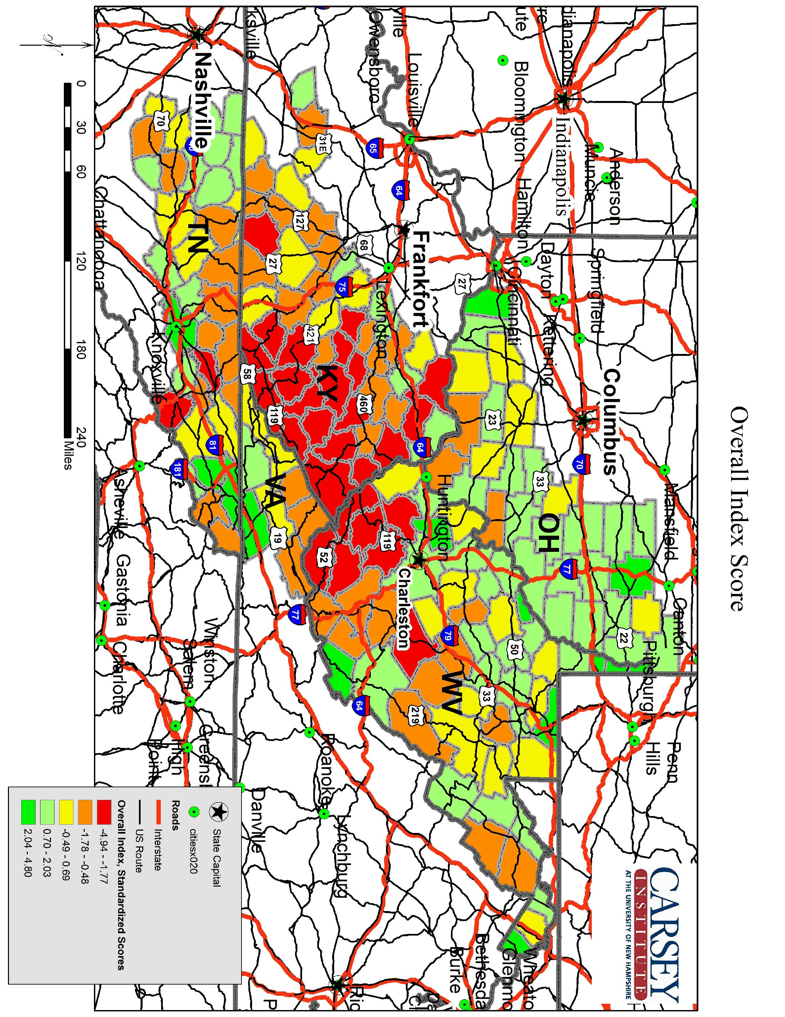

The figure below displays economic by community index scores. Counties in the upper-right quadrant are the most advantaged in the region, while counties in the lower-left quadrant are the most disadvantaged. Counties in the other two quadrants exhibit a mix of social and economic advantage and disadvantage. Counties of note include Monongalia and Pleasants in West Virginia (high economic and community scores; government- and manufacturing-dependent, respectively, and both metropolitan); Harlan and Clay in Kentucky (low economic and community scores; mining- and government-dependent, respectively, and both noncore); Owsley, KY (low economic score, high community score; nonspecialized, noncore), Dickinson, VA (low economic score, high community score; mining-dependent and noncore); Clermont, OH (high economic score, average community score; nonspecialized and metropolitan); and Gilmer (average economic score, high community score; mining-dependent and noncore) and Berkeley, WV (high economic score, low community score; government-dependent and metropolitan).

Counties in the upper-left quadrant are above average on social well-being, and below average on economic well-being. They consist primarily of noncore counties, which may embody archetypal small rural communities that possess social resources even as they are economically disadvantaged by geographical isolation. This group consists of a mixture of economic dependence types, with the exception of services-dependent counties, of which there is only one.

Counties in the lower-right quadrant are above average economically, and below average socially. This group consists primarily of metropolitan and micropolitan counties. These counties, either home to or close to sizeable population centers, to some extent enjoy the economic benefits of proximity to markets. At the same time, those features of proximity to population centers and/or urban life, such as sprawl or criminal activity, hamper the social well-being of these places. Half of these counties are manufacturing-dependent, and the remainder represent a mixture of economic-dependence types, with one exception. There are no mining-dependent counties with economic scores greater than zero, and community scores less than zero.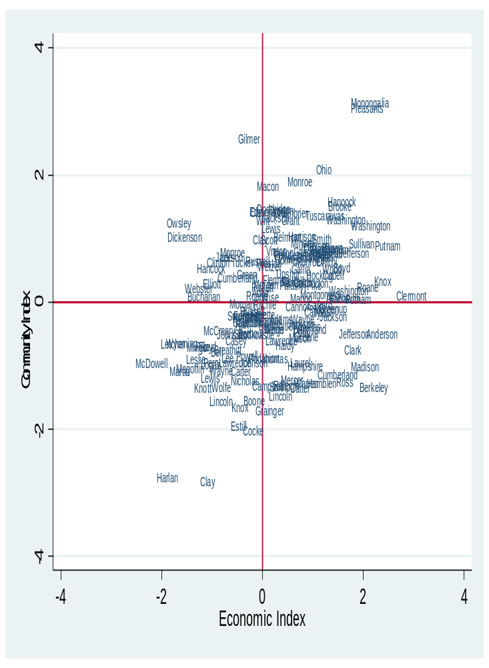

The table below displays average index scores and average scores on all dimensions of well-being by county economic dependence, as well as by metropolitan status. Mining-dependent counties tend to be the worst off economically and socially, while services-dependent counties tend, on average, to be the most economically advantaged. Federal/state government dependent counties have the highest average community index scores. Services-dependent counties have the highest overall level of well-being in the region. Though there are only a few of them in the region, it is worth noting that recreation-dependent counties are average economically, and above average socially.

In terms of metropolitan status, counties containing or linked to large population centers have the highest levels of well-being both economically and, to a lesser extent, socially. Those counties containing population centers between 10,000 and 50,000 are above average economically, though below average socially. Noncore counties, or those without a population center larger than 9,999 and not closely linked to a metropolitan area, are the worst off economically and in terms of overall well-being.

Within the region, differences emerge from state to state. Counties in Kentucky are the worst off economically and socially. Ohio counties had the highest levels of economic (and overall) well-being, Tennessee counties were above-average economically and roughly average socially. West Virginia counties were roughly average economically and above-average socially. Virginia counties had the highest levels of social well-being while they were similar to Kentucky counties in terms of economic disadvantage.

Type | # Counties | Economic | Community | Overall
Metropolitan | 48 | 0.83 | 0.37 | 1.19
Micropolitan | 38 | 0.31 | -0.22 | 0.09
Noncore | 91 | -0.56 | -0.1 | -0.67
Mining | 25 | -1.21 | -0.46 | -1.66
Manufacturing | 58 | 0.39 | 0.15 | 0.54
F/S Gov. | 16 | 0.34 | 0.38 | 0.72
Services | 14 | 0.78 | 0.25 | 1.02
Nonspecialized | 64 | -0.13 | -0.1 | -0.25
Recreation | 6 | 0.01 | 0.24 | 0.24
KY | 51 | -0.65 | -0.5 | -1.15
OH | 29 | 0.65 | 0.27 | 0.92
TN | 34 | 0.37 | -0.09 | 0.28
VA | 8 | -0.53 | 0.57 | 0.03
WV | 55 | 0.11 | 0.29 | 0.4

The USDA Economic Research Service has developed several typologies of nonmetropolitan US counties. Two that are used here are Economic Type and Policy Type. Economic Types are exclusive categories. Manufacturing dependent counties had at least 25 percent of average annual income from manufacturing in the period 1998–2000. Federal/state government dependent counties had an annual average of 15 percent or more of total county earnings derived from federal and state government during 1998−2000. Services dependent counties had at least 45 percent of total county earnings derived from services (retail trade; finance and real estate; and services) during 1998−2000. Nonspecialized counties meet none of these criteria. Policy Types are nonexclusive groupings of counties. For the purposes of this report, we have calculated and presented figures for recreation-dependent counties. Nonmetro recreation counties had a high share of: employment or earnings in recreation related industries in 1999; seasonal or occasional use housing in 2000; and per capita receipts from hotels and motels in 1997. Six counties in the CAN service region are classified as recreation-dependent in addition to their position in the USDA ERS economic dependence scheme outlined above. For more on the USDA County Typology Codes, see http://www.ers.usda.gov/Briefing/Rurality/Typology/
The US Office of Management and Budget classifies counties as follows. Metropolitan counties are those with an urbanized area of at least 50,000 people along with counties that are economically tied to the urbanized county by virtue of commuting levels of at least 25 percent. Micropolitan (“nonmetropolitan small city”) counties are those with an urbanized area of between 10,000 and 49,999, and that are not linked to metropolitan counties. Noncore (“nonmetropolitan rural”) counties are those that meet neither of these criteria.
Standardized scores (also known as “Z-scores”) are a measure of how far above or below the mean the value of a given case is. The unit of a standardized score is the standard deviation, which measures the dispersion of values for a given variable; the greater the standard deviation, the more “spread out” cases are with respect to that variable. A standardized score of 1 indicates that a case lies one standard deviation above the mean for that variable or combination of variables.
2002 data were used due to source availability issues
For five counties, values for one or more health indicators were estimated due to data suppression or availability issues. In these cases, the average of the values for all adjacent counties (for which data were available) was used.

