The Cooperative Institute for Coastal and Estuarine Environmental Technology
(CICEET)

FY 2007 Full Proposal Application
Environmental Technology Development Program

Project Title: Integrating Geospatial and Web-Based Technologies to Improve Land Use Planning in Coastal New Hampshire

Project Duration: July 1, 2007 – June 30, 2009

FY 2007 CICEET Funds Requested: Year 1: $124,127 Year 2: $112,013 Total: $236,140

Principal Investigator(s):
Name: Fay Rubin
Position and Institutional Affiliation: Project Director, Complex Systems Research Center, University of New Hampshire
Address: Morse Hall, Durham, NH 03824
Phone: 603-862-4240 Fax: 603-862-0118 e-mail: fay.rubin@unh.edu

Additional Investigator(s):
Name: Dr. William A. Salas
Position and Institutional Affiliation: President and Chief Scientist, Applied Geosolutions, LLC
Address: 87 Packers Falls Road, Durham, NH 03824
Phone: 603-292-5747 Fax: 413-714-1051 e-mail: wsalas@agsemail.com

Name: Shane Bradt
Position and Institutional Affiliation: Geospatial Extension Specialist, Cooperative Extension,
University of New Hampshire
Address: 213 Nesmith Hall, Durham, NH 03824
Phone: 603-862-4277 Fax: 603-862-0107 e-mail: sbradt@ceunh.unh.edu

NERR site(s): Great Bay National Estuarine Research Reserve, New Hampshire

Lead Principal Investigator’s Signature: ___________________________
Date:

Please Note: The Contents of this proposal are CONFIDENTIAL!

All information contained herein is considered confidential; this information shall not be duplicated, used, or disclosed in whole or in part for any purpose other than the evaluation of this application.
Abstract

Coastal and estuarine habitats in the Northeast are being significantly impacted by a rapid rate of population growth and an ever-accelerating change in land use composition. In the process of land use planning, the strength of local and regional economies is often seen to be at odds with the health of coastal and estuarine ecosystems. In order to plan for sustainable and ecologically friendly community growth, coastal towns navigate a complex formula involving the current conditions of community resources and many “what if” scenarios regarding future conditions. It is critical for coastal communities to anticipate the location and nature of such conflicts, especially when future water quality stands to be impacted by current land use decisions.

To help coastal communities make land use decisions to protect environmental character and water quality into the future, we propose the development and dissemination of a toolbox of geospatial resources for use in land use planning. The information provided by our tools can be incorporated into future master plans and conservation guidelines, serving to inform policies on water resource protection and regulations on land use. By working closely with the Exeter community in seacoast NH and the Rockingham Planning Commission, we make certain that the tools will be both of interest to and accessible by the coastal communities in New Hampshire. Our dual approach of developing software tools using both industry standard software (ArcGIS) and open source tools available in any internet browser will help to ensure that our technology can be widely disseminated and used outside of our pilot community. Our partnerships with both the Natural Resources Outreach Coalition and the National Geospatial Technology Extension Network will provide a backdrop against which the usefulness of our toolbox can be evaluated and communicated to a wide variety of coastal communities across the country.
Narrative

1) Introduction

Coastal and estuarine habitats in the Northeast are being significantly impacted by a rapid rate of population growth and an ever accelerating change in land use composition. The population of New England increased by over 7% from 1990-2005, with New Hampshire’s increase of 18% over that period clearly leading the region. This dramatic population growth in New Hampshire has been accommodated by expanding residential development, with a corresponding loss of an estimated 17,500 acres of forest land each year (Society for the Protection of New Hampshire Forests, 2005). Today, a combination of innovative technologies and effective community organization offers the opportunity for policy-makers and local/regional planners to make informed decisions about land use to support community growth, while minimizing environmental impacts. We propose to develop and disseminate a toolbox of resources to aid communities in making their land use decisions. By working closely with the town of Exeter in seacoast NH and the Rockingham Planning Commission (RPC), we will develop innovative analysis tools and evaluate the effectiveness of these tools. Our partnership with RPC and the Natural Resources Outreach Coalition (NROC) will then ensure that the effective tools will be readily accessible to other communities.

Within the realm of land use planning in coastal communities, the strength of local and regional economies are often seen to be at odds with the health of coastal and estuarine ecosystems. In order to plan for sustainable and ecologically friendly community growth, coastal towns navigate a complex formula involving the current conditions of community resources and many “what if” scenarios regarding future conditions. Among the most pressing of these competing considerations are the range of possible future growth patterns, and an understanding of current local resources and their inherent societal and natural values. The areas of coastal communities where future growth and current resources come into greatest conflict can be thought of as “hot spots”, which are often areas with both heavy development pressure and high resource value. It is critical for coastal communities to anticipate the location and nature of such potential conflicts, especially when future water quality stands to be impacted by current land use decisions.

One of the most useful techniques to protect the health of aquatic ecosystems in coastal communities through land use planning is the relationship between impervious surface coverage and water quality. Currently, such methods are not used to their full potential due to the lack of data to support the types of analyses that land use planning problems require, in addition to the complexity of the tools with which such analyses are often conducted. Water resources managers commonly understand that impervious surface (IS) coverage is a critical metric in determining both threats to and the relative health of water systems (Arnold et al., 1996) and as such, acts as a key environmental indicator. In addition, Arnold et al. (1996) indicate that both the type of IS feature (e.g. rooftops, driveways, roadways, residential, commercial/industrial) and the location of IS within a watershed can be critical factors contributing to pollution threats and water quality degradation. For example, runoff from streets contributes significantly higher amounts of polluted runoff to the system than does runoff from rooftops (Bannerman et al., 1993).

Many coastal communities are not aware of the full range of tools available for assistance with land use planning and/or are uncertain about how to effectively implement the existing tools with which they are familiar. Towns often see the use of planning tools carried out in other areas, but may never consider the possibility of using such tools in their own community due to either the perceived lack of necessary skills or the absence of a support system to help planners understand how the analyses can be applied in their own situation. In addition to these problems, some communities do not make use of available methodology simply due to a lack of access to current technologies, or the amount of time and money which such technologies apparently entail.

We propose to enhance the effectiveness of land use planning for environmental health at the community level with a set of innovative tools that we will develop in close collaboration with planners in coastal communities as well as with a variety of other end users. We will construct a set of flexible software tools that will provide communities with the information needed to effectively address the central land use issues. Our set of user-friendly tools will be designed to overcome many of the impediments outlined above, and will take advantage of current land use and impervious surface data. The use of a combination of geospatial tools and predictive models will allow coastal communities to identify current resource areas within their towns and predict the areas under the greatest pressure of future development, thereby providing an informed approach for land use planning.

We plan to deliver a range of land use planning tools in accordance with the variety of technical skills encountered in coastal towns, paving the way for wide dissemination of project outcomes to other communities. For towns with GIS capabilities, our tools will directly interface with ESRI’s ArcGIS software package. For the communities without such technical skills, we will deploy a web based mapping interface that can be used by planners and water resource managers without the need for a large investment of time and money Our tools will take advantage of the latest approaches in geospatial tools, internet-based applications and visualization technology to ensure their accessibility to coastal communities throughout the country. The variety of technological approaches will provide tools for all levels of expertise, thus allowing for the training of town planners and elected officials in addition to municipal planners.

We envision our land use planning tools being used by communities in their efforts to make thoughtful and informed decisions about land use planning in coastal areas. We believe the combination of tools and variety of delivery methods will allow towns to incorporate the best data available as part of their decision making process, enhancing their ability to make the type of smart land use planning decisions that will minimize the loss of important natural resources and protect the integrity of coastal and estuarine water quality well into the future. The information provided by our tools can be incorporated into future master plans and conservation guidelines, and thereby will influence future water resource protection and regulations on land use.

2) Objectives

To overcome the current impediments to intelligent land use planning and protection of coastal water quality, we will work closely with our local and regional partners to accomplish the project objectives. This continual opportunity for feedback will enable us to adapt our approaches and methodologies over the project cycle. This will ultimately allow us to be more responsive to community needs, as well as to any changes and opportunities in emerging technologies.

Our specific project objectives are as follows:

- Assemble existing relevant geospatial data sets for our pilot community, and develop required elements to support remaining project objectives
- Evaluate, refine and implement land use change forecast models as a decision support tool for land use planning
- Refine and implement an algorithm for the estimation of impervious surface coefficients
- Identify and adapt previously developed resource identification models to the ArcGIS ModelBuilder format to aid in identification and analysis of coastal community resources
- Design web tools for displaying maps of development pressures, threats to water quality, and land use information
- Make all data products accessible within CommunityViz and other existing geospatial products

These objectives are feasible within the scope of the project and will satisfy the goals of the funding opportunity. Specifically, the forecasting model, the impervious surface algorithm, and the use of ModelBuilder to make accessible a host of established resource identification methods are innovative technologies that will help land planners understand how land use pressures in the region are likely to change, as well as how current and future land use are likely to affect water quality and other environmental issues. This information will allow land planners to more effectively plot the future course of communities while protecting natural resources. The web system and GIS toolbox, developed through a close working relationship with Exeter and the RPC, will make useful planning information available to a broad range of communities and potential users. Our close working relationship with the pilot community and regional planners, as well as the web accessibility of the tools, will promote the broad dissemination of project outcomes to other communities.

3) Methods

We propose a series of tasks to meet each of the project objectives as described above and conceptually conveyed in Figure 1. The figure demonstrates our focus on community involvement in the execution of the project, the development of tool sets for prediction of land use change and the assessment of resource conditions, and the delivery of resources to meet the needs of a broad spectrum of users.

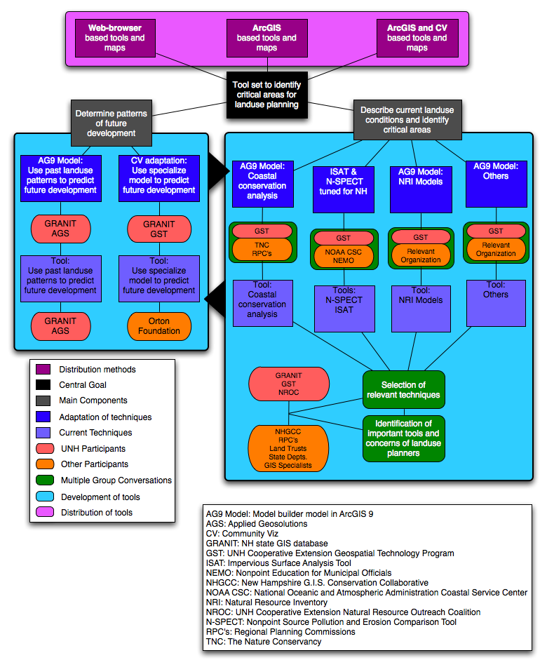

Figure 1. Flow diagram of project design.
Data Development

Objective a. Assemble existing relevant geospatial data sets, and develop required elements to support remaining project objectives.

Task a.1 Assemble existing data sets. We will identify and assemble a suite of existing geospatial data developed and maintained by three of the project partners – the town of Exeter, the Rockingham Planning Commission, and the GRANIT statewide clearinghouse. Collectively, these organizations house an array of data sets describing the physical, cultural, and biological properties of the landscape. While their data holdings are extensive, development of two additional data sets – current land use and current impervious surfaces - will be required to fully meet the project objectives and to ensure that the products generated have the greatest utility to the user community.

Task a.2 Develop land use data set. As part of the proposed project, GRANIT staff will utilize existing high resolution (1-foot) color imagery (April, 2005) to complete an updated land use data set for required areas in Rockingham County. With separate funding from the NH Department of Transportation and under the auspices of the Interstate 93 Community Technical Assistance Program (CTAP), GRANIT is coordinating an effort to involve the regional planning commissions and interested state/regional agencies in defining standards for statewide land use data development. The standards and protocols that result from that coordinated activity will be incorporated in this proposed effort, thereby ensuring broad acceptance by the end-user community. Further, Rockingham Planning Commission will be using CTAP funding to develop land use data for approximately 50% of the county, thus requiring the proposed project to support data development for only the balance of the project area.

Task a.3 Develop impervious surface data set. The current project will also require the development of a large-scale impervious surface (IS) data set. We will utilize the high resolution imagery in conjunction with object based image segmentation processing (eCognition) to create the detailed IS data. This image processing technique will provide us with the capability to identify and isolate features such as scattered, individual buildings and driveways, in addition to other larger features including parking lots, malls, commercial/industrial centers, etc. Based on a review of the literature, we expect to be able to produce a high quality IS data set using these techniques. For example, researchers in Arkansas (see http://www.eijournal.com/Automated_Feature.asp) found that by using an image segmentation classification approach, in conjunction with a set of classification rules, they were able produce an IS data set with a classification accuracy of nearly 90%. Likewise, investigators at the University of Connecticut indicate that an image segmentation approach offers tremendous potential in improved image classifications, and they continue to test its applications (http://clear.uconn.edu/publications/research/presentations/civco_asprs2002.ppt).

Tool development

Objective b. Evaluate, refine and implement land use change forecast models as a decision support tool for land use planning.

GIS and remote sensing technologies are powerful tools for mapping and monitoring land use and land cover change (LULCC), and have led to spatially explicit models of LULCC (Wood and Skole 1998, Klosterman 1999, Waddel 2002). In the last decade, a new approach for modeling the patterns and processes of land use change has emerged (Naveh and Lieberman 1998). This pattern-to-process approach focuses on how the spatial patterns of land use and land cover change result from social, economic, and ecological processes acting across the landscape (Zhou 2002).

Models of land use and land cover change have been used to examine linkages between socioeconomic processes and land development and urbanization (Turner and Meyer 1991, Brown et al. 2000). Specific modeling approaches for examining transportation, urban development, and land use change include spatial interaction models (e.g. DRAM.EMPAL by Putman 1983), spatial input-output models (e.g MEPLAN by ME&P 1989 and TRANUS by de la Barra 1989), dynamic disequilibrium models (e.g. URBANSIM by Waddell 2002) and cellular automata models (e.g. SLUETH and Urban Growth Model by Clarke et al. 1997, Silva and Clarke 2002). Some models are essentially land allocation tools that use pattern recognition algorithms, like artificial neural networks, to predict land use change without accounting for the processes that cause land use change (e.g. LTM by Pijanowski et al. 2000). Most of these models are designed to simulate changes in moderate to large metropolitan areas (e.g. MEPLAN, TRANUS, URBANSIM). We propose to evaluate the utility of the following three models for effective land use planning to protect coastal water quality for non-metropolitan communities and regions:

- CommunityViz is a widely-used decision-support tool for conducting and visualizing buildout analyses. While it enables users to evaluate alternative buildout scenarios, it does not forecast the location of future development or development pressures based on linkages between socioeconomic processes and land development and urbanization. PI Rubin has recently secured funds to establish GRANIT as the New Hampshire CommunityViz Technical Resource Center.
- What if? (Klosterman 1999) is a GIS-based land use planning tool that enables users to define land use and land use changes based on land suitability and user defined demand for developed land.
- Our SUBNET model uses principles of economic geography with macroeconomic input-output simulation model and neural networks to forecast the demand for and location of development pressures.

As our approach for this project is to adaptively collaborate with land use planning communities, we will work with and evaluate each of these models. Based on our previous discussions with local regional planning commissions (see RPC letter of support) there is a need for tools that can forecast both the demand for and likely location of future development. We describe our SUBNET model in more detail below.

SUBNET Model. With previous funding from CICEET, we refined and demonstrated our Simulating Urban growth with Bid-rent and NEural network Tools (SUBNET) model to simulate patterns of future change in land use in Strafford and Rockingham Counties, NH, based on historical and current maps of land use, soils, topography, demographics, economics, and transportation infrastructure. This model has been developed in a GIS framework and relies on land use data derived from remote sensing, GIS data on biophysical, demographic and economic conditions, and artificial intelligence algorithms for projecting the location of future land use changes. Using an artificial neural network (ANN), the model is provided historical training data and effectively “learns” how local social, economic, and biophysical characteristics relate to observed changes in land use. After training the artificial neural network, we applied the model to present day conditions to successfully predict the spatial pattern and location of future land use change pressure. To estimate future demand for land use change, we used forecasts of future demographic, economic, and employment conditions for 2020 and 2035 for Strafford and Rockingham Counties from a Policy Insight® model run. The Policy Insight® model is a state-of-the-art economic forecasting and policy analysis tool, developed by Regional Economic Models, Inc.

During the development of SUBNET, we identified the spatial attributes associated with accessibility to economic markets as a critical input for our approach. In the early 1820s, Von Thunen developed the idea of a “bid-rent” function that describes the spatial allocation of various economic activities (e.g. forestry or agriculture versus residential or urban uses). In essence, the “bid-rent” function describes the relationship between market forces and land values, which in turn drives land use (e.g. developed versus not developed). Thus, the general patterns of land use are quantitatively related to proximity, or accessibility, to urban markets and jobs. We have implemented this concept in a GIS modeling framework to examine the influence of economic, demographic, and transportation conditions on the location and spatial patterns of urban growth. Figure 2 illustrates this “bid-rent” theory where distance to market (or accessibility) is defined as the driving time to an urban center (i.e. jobs) and the rent is defined as the value (or sales price) of land. A theoretical example relates price of agricultural to built uses (Figure 2). We contend that the difference in rents between built uses and non-built uses is an indication of the pressure gradient of urban growth through the conversion of agricultural (i.e. non-built use) to residential or commercial uses. The greater this difference, the greater the pressure for development.

Task b.1 Refine model with implementation of Multi-centric Bid-rent Tool. In our previous CICEET project, we implemented the Bid-Rent function in a GIS framework using the transportation network to quantify accessibility as driving time to major central business districts (CBD) (e.g. Boston, Manchester, Portland) and land values based on real estate transactions. However, with the suburbanization of households and employment and development of neighborhood business districts (NBD), households choose location based on multiple employment centers. Thus, we propose to expand our Bid-rent modeling tool to include multi-centric (NBD and CDB) impacts on accessibility to jobs. The accessibility layer will be derived from the historic patterns of land use and driving time (determined from road network) to all business districts (NBD and CBD) in the region. Accessibility to each business district is weighted based on its size.

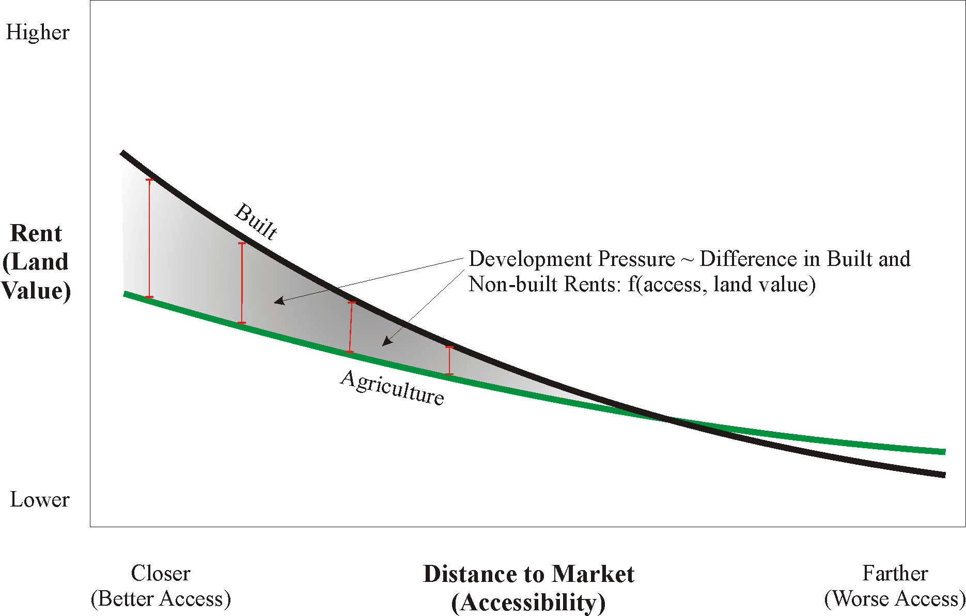 Figure 2. Theoretical representation of the mono-centric bid-rent theory. In our case, distance to market is calculated based on the nominal driving time to urban centers. Rent is determined based on real estate transactions. The larger the difference in rents, the greater the pressure for changes in land use.

Task b.2 Refine model by updating and automating the ANN Application Tool (SUBNET). The ANN model is trained using historical and current land use, biophysical conditions (e.g. soils, topography), and socio-economic conditions. The trained ANN model is then applied to current and future conditions to characterize future development pressures. Applying the trained network creates an output value that we call a “similarity index”. The similarity index is a continuous value representing a measure of similarity of the pixel in question to those pixels with a known development outcome used to train the network. For example, areas with similar characteristics to areas that were recently converted to urban will have values close to 1 and areas similar to areas that did not convert will have values close to 0. The similarity index can then be coupled with forecasts of the amount of future development to spatially allocate the predicted urban expansion pressures.

To facilitate use by land use planners, we will first test and update the previous neural network model using the updated 2005 land use data and the multi-centric accessibility layer (described above). Then, we will automate the application of the ANN model by performing all the training and testing prior to providing the tool. To do this, we will use a standard back-propagation training algorithm that iterates the weights of each node until the estimation error converges below a prescribed threshold. However, to avoid over fitting, we used a Bayesian regularization technique to limit the complexity of the model (MacKay, 1994). This is important because the success of the ANN model is often dependent on presenting a representative training data set and selecting the optimum number of nodes for the hidden layers.

Objective c. Refine and implement algorithm for the estimation of impervious surface coefficients. An important aspect of the project will be to describe future scenarios predicting IS conditions. While the methods describe above address the degree of imperviousness in 2005, the SUBNET Model forecasts will provide the means to estimate future IS coverage throughout the study area.

To meet this end, we will apply the NEMO “Population Calibrated Land-Cover-Specific Impervious Surface Coefficients” model to our study area in order to generate updated IS coefficients. Land use information from the modeling described above will be used in combination with large-scale planimetric data sets provided by the cooperating community(ies), augmented as necessary by delineations based on the 2005 aerial images, to derive coefficients tailored to the project land use classes. The coefficients will be refined to reflect population density classes (urban, suburban, and rural) based on US Census data, and as recommended by NEMO researchers based on their work in Connecticut.

Objective d. Identify and adapt previously developed resource identification models to the ArcGIS ModelBuilder format to aid in identification and analysis of coastal community resources. Some coastal communities have access to ArcGIS, and as such, will be eager for land use planning tools that can be easily incorporated into their existing technology infrastructure. While many techniques have been developed to map and analyze community resources, they have not been applied widely due to the complexity of the series of steps needed to complete the analyses. Past CICEET awards to UNH Cooperative Extension have funded the development of hands-on workshops to teach geospatial techniques to a wide range of audiences in NH communities. Our Community Mapping course focused on the use of GRANIT GIS data to map communities by types of natural resource data (conservation lands, wetlands, aquifers), helping to identify important natural and societal features of a given town. Our Watershed Analysis using Spatial Analyst workshop took a more advanced approach, and uses three dimensional GIS data paired with landcover layers to describe hydrological features of watersheds and identify areas of special interest within a given basin.

While our traditional step-by-step training has proven successful, the introduction of ModelBuilder to ESRI’s software dramatically changes the way in which analyses can be carried out. Instead of forcing users to go through an intricate series of tool activations and adjustment of analysis parameters, ModelBuilder provides a means for distributing an entire sequence of steps as a ready-made tool. In order to use any tool created in ModelBuilder, a GIS user need only know the basics of ModelBuilder and have an understanding of where the appropriate GIS data is stored on their own system. To enable coastal communities make use of this new simplified GIS approach for land use planning, we must proceed through two steps. First, we must identify the methods which have proven useful for characterizing natural resources and land use pressures. Second, we must adopt those methods to a ModelBuilder format and supply training on the application of these models to communities.

Task d.1 Identify GIS analysis useful for coastal land use planning based on a combination of research and input from stakeholder discussions. GIS analysis techniques for identifying and characterizing community resources important for planning and water quality will be evaluated by GRANIT and UNH Cooperative Extension. Some of the techniques explored will include co-occurrence mapping, unfragmented lands analysis, hydrological watershed modeling, as well as tools developed for estimating water quality changes based on land cover and land use patterns (such as N-SPECT and ISAT developed by UConn and the NOAA CSC). The techniques deemed most valuable by the investigators will be presented at stakeholder meetings held by NROC with direction from GRANIT and UNHCE-GIS for an open discussion. The meetings will have as a primary focus the land use planning needs of coastal communities and the types of data that will allow the towns to most effectively address these needs. At these meetings, we will solicit input from diverse group of stakeholders in coastal communities, including regional planning commissions, GIS applications experts, representatives of coastal communities, and members of the conservation community. Through this process, we are confident that the tools we develop will address the land use planning needs of the target constituencies as well as their counterparts throughout the coastal community.

Task d.2 Code GIS analysis techniques in ESRI ModelBuilder format and make the tools available to communities. As a result of the research on tool availability and input from end users, 3-5 GIS tools will be chosen to be incorporated into an ArcGIS ModelBuilder format. If pre-existing software tools are implemented (N-SPECT and ISAT), ModelBuilder will be used to prepare the GIS data for input to the software, and settings will be chosen for each tool to best represent the conditions specific to NH coastal communities. The GIS techniques will be investigated thoroughly by UNH Cooperative Extension, including direct contact with the originators of the methods. ModelBuilder will then be used to construct a model template for each analysis, complete with the appropriate settings and internal help dialogues. A one-day training course will be developed to instruct GIS-competent planners on the general use of ModelBuilder and the specific steps necessary to conduct each GIS analysis with the provided model. If basic GIS training is required or desired, planners will be given the opportunity to take an Introduction to ArcGIS 9 course offered by UNH Cooperative Extension. The training will be offered in person and the materials will be available online. We also plan to incorporate these models into the web-based interface being designed and constructed for Objective e, lowering even further the barrier to entry for use of these tools.

Objective e. Design web tools for display of development pressures, threats to water quality, and land use information. To effectively disseminate information useful for land use planning, we believe web-based tools offer the broadest and easiest to use access point.

Task e.1 Construct web tools to display and query data. Web tools to share, display, and explore spatial and tabular data have become the preferred mechanism for presenting and delivering information and data to the scientific community and general public. We will implement a web-based interface to our decision support tools and functions that can be easily used to compose an interactive web system capable of displaying the associated raster, vector, and point/station data in forms of maps, plots, charts and tabular statistics. A unique aspect of our web-based mapping systems will be their dynamic content and interactive user interface. Web users will easily navigate, read data values directly from the maps, and even manipulate available datasets by applying our unique macro calculator to produce their own datasets. All web codes will be developed in house with open source web map service technology combined with scripting tools (i.e. Java). This approach will allow for easy inter-operability and will make data querying and graphic drawing fast.

Task e.2 Develop three-dimensional data visualization. New 3-D geospatial applications, such as Google Earth and various open source applications such as ossimPlanet and WorldWinds, have changed the way geospatial data can be viewed. These applications expand on the traditional GIS capabilities (e.g. visualizing multiple data layers simultaneously) by allowing users to visualize and control geospatial data in three-dimensions, overlain on a “spinning globe”. In this new environment, users can “fly-over” areas of interest. We will develop customizable 3-D data visualization tools to work in conjunction with our web-based decision support systems. The 3-D data visualization tools will be designed as an extension to our mapping service discussed above. The user will be able to select layers for display on Google Earth, including multitemporal views, and these layers will be described in a KML file which can be clicked on, saved, or emailed to colleagues. (The underlying data can either remain on the server or downloaded to the user.) KML is the simple XML-based text file that Google Earth uses to specify how imagery and annotation are displayed on the globe. In this way, users of our mapping system will be able to create movie files (e.g. .mov, .mpg) for easy export and display over the internet.

Objective f. Make all data products accessible within Community Viz and other existing geospatial products. Throughout the project, the partners will ensure that all products generated can be readily incorporated into other software environments by relying on established data formats and protocols. Of particular interest will be the ability to utilize the output from the various models within the context of CommunityViz buildout analyses, thus informing the temporal analysis of the standard results.

An important leveraging source for this effort will be funds made available to GRANIT from the NH GIS Conservation Collaborative, an organization that supports land conservation planning using geospatial technologies. GRANIT has recently secured funds to establish itself as the New Hampshire CommunityViz Technical Resource Center. The external funds will allow us to generate interest and build local capacity throughout the state in using these tools, and geospatial analyses in general.

Accomplishing the tasks will allow us to meet the six objectives of our proposal and, therefore, the two goals of the funding opportunity. We plan to accomplish these tasks based on the following timeline:

Task |  | Timeline
DATA DEVELOPMENT | Assemble existing geospatial data sets | July 07 – August 07
DATA DEVELOPMENT | Develop land use data | July 07 – December 07
DATA DEVELOPMENT | Develop impervious surface data | July 07 – June 08
TOOL DEVELOPMENT | Refine and implement the SUBNET Model | July 07 – August 08
TOOL DEVELOPMENT | Refine and implement impervious surface algorithms | July 08 – December 08
TOOL DEVELOPMENT | Identify and adapt resource models to ModelBuilder | July 07 – December 08
TOOL DEVELOPMENT | Construct web tools to display and query data | September 07 – March 09
TOOL DEVELOPMENT | Make information products accessible | July 07 – June 09
REPORTING | Prepare final report | June 09

4) Community context

The project team will work closely with officials in the town of Exeter, NH, throughout the project to ensure that any tools identified, developed, and implemented are relevant, appropriate, understandable, and effective in furthering local planning objectives. We have secured the enthusiastic commitment of Sylvia von Aulock, Exeter Town Planner, as well as the town’s Planning Board (see support letter). Exeter has a long history of using innovative tools in planning, as well as a mature GIS database, and is seen as a leader in effective land use planning by other communities in the state.

We also have the commitment of the Rockingham Planning Commission (see support letter), whose professional planning staff advises local planning boards, conservation commissions, and town department officials. They will serve to ensure the project activities are pertinent to a broad constituency of communities.

Our NROC collaborators will help to coordinate and monitor our interactions with all local and regional project partners. Equally important, they are well positioned to educate other potential partners (NEMO, Sea Grant educators, other NERRs sites) as well as other communities in the coastal region about the project activities and results. Co-PI Bradt’s affiliation with the National Geospatial Technology Extension Network will also facilitate the dissemination of project results to counterparts in other coastal states.

5) Projected outcome

We are targeting two constituencies involved in the land use planning process. The first constituency is the local land use planners (e.g. town planners, conservation commissions, watershed groups) that are working within a community. This group has a wide range of technical capabilities and resources for land use planning. We expect that some will want to use the tools/ technologies themselves, and some will require that others run the tools and provide them with the resulting information. The second constituency comprises the organizations whose role is to provide assistance to communities for land use planning and natural resource management (e.g. our collaborators NROC and Rockingham Planning Commission). Our goal in working with this second group is in essence to “train the trainers”. We anticipate that our adaptive approach and plans to work directly with both groups on this demonstration project will cover a broad cross-section of the land use planning process and will lead to the following direct outcomes:

- informational needs of land use planners.
- technological needs to meet the informational needs. (A recent GRANIT survey of all municipalities in the state documented GIS resources and capabilities at the local level, and will provide valuable guidance in identifying these needs.)
- set of geospatial tools that are accessible, easy to use, and relevant to local planning officials.
- web-based technologies that will provide easy access to the tools and informational products.
- demonstration of the technologies to local land use planners (Exeter), Rockingham Planning Commission, and NROC (NH NEMO).
- feedback on the usefulness and effectiveness of the tools and information, characterized based on the range in community level land use planning.
- demonstration of training in using these tools and information products for land use planning – trainees will include community level (Exeter), regional planning commissions (RPC), and members of national NEMO network (NROC).
- plan for performance metrics to evaluate if the tools and informational products indeed lead to more effective land use planning and natural resource management (see discussion below).
- plan for dissemination and transfer of the tools, informational products and training for other regions, including additional seacoast New Hampshire areas and other regions throughout the US.

We envision a broad spectrum of potential users of this technology, including local town level land use planners, watershed groups, regional planning commissions, and national networks of educators/trainers (e.g. NEMO). Therefore, we propose evaluating several approaches for follow on activities after this 2-year project, namely (a) developing performance metrics for evaluation of the success of the technologies for improved land use planning, and (b) disseminating the tools, informational products, and training to other communities in Seacoast New Hampshire and coastal regions through out the U.S. Approaches we will evaluate include:

- Tracking web site use metrics. An important advantage of having all of the project resources (brochures, user’s guide, model, and electronic curriculum) online is the ability it provides to create useful technology transfer metrics. For example, with simple tracking of activities in the server logs, we can determine which resources are being used by whom. In addition, by requiring users to fill out registration and feedback forms we will have the capability to analyze our technology services. We will track web site use metrics to enumerate what tools are being used, who is using the tools, where the tool is used, what type of application, and interest in the electronic curriculum materials.
- We will track the number of participants at our workshops and conference presentations.
- Requests for training workshops will be used to evaluate the success of our outreach and dissemination efforts. This would include training request to RPC and NROC.
- Given that we expect significant interest from a broad community, we will evaluate tracking funding requests for implementing the tools from this project as a metric for evaluating success of technology transfer to the land use planning communities.

6) Roles and responsibilities

The Complex Systems Research Center at UNH and Applied Geosolutions, LLC have a long track record of developing innovative technical algorithms, systems, and products designed to provide solutions and answers to complex problems. These two groups will lead the technical innovation portion of our proposed land use planning project. Additionally, with the SUBNET model, this group has demonstrated the successful inclusion of socioeconomic factors as well as technical and ecological factors in the application of technology. The UNH Cooperative Extension Geospatial Outreach program is known throughout NH for developing quality training programs in geospatial technologies targeted to community needs and has extensive experience delivering these programs to a wide variety of audiences ranging from novice to advanced GIS users. NROC and RPC have an established track record of working with local officials, and have extensive experience in working with these officials to disseminate effective tools. Specific project roles and responsibilities are detailed below.

UNH CSRC/GRANIT
Fay Rubin will lead the overall management of the project, will coordinate the development of the project data sets, and will participate in regional/local coordination activities.
David Justice will be responsible for assembling/developing the geospatial data sets, will derive the development of the impervious surface coefficients, and will assist with the ModelBuilder tasks. Rob Braswell will coordinate the development of the web interface and the 3-D visualization tools, and will consult on the refinement of the SUBNET model.

Applied Geosolutions, LLC.
William Salas will participate in the overall management of the project. AGS staff will lead the development and implementation of the SUBNET model. AGS staff will assist in the development of the web interface and the 3-D visualization tools

UNH Cooperative Extension (GIS)
Shane Bradt will participate in the overall management of the project, will identify and present current resource mapping techniques to stakeholders and end users as part of NROC-facilitated discussions, will convert resource mapping techniques identified as most useful by stakeholder groups into an ArcGIS ModelBuilder format, and will produce and administer one-day training workshops on the use of ArcGIS ModelBuilder and the implementation of the models designed as part of the current project.

UNH Cooperative Extension (NROC)
NROC staff, in conjunction with the PIs, will convene stakeholder groups and/or survey individuals to discuss and determine what GIS tools would be useful for improving land-use planning and decisions. At least 3 major groups of informers have been identified: GIS professionals, NROC member organizations including regional planning commissions, and coastal community board and staff members. NROC will also coordinate community participation in the pilot testing of projects, as well as subsequent dissemination of project results and education in using those results in the context of local decision-making priorities. Finally, NROC staff will record and document community interactions through the project.

7) Budget justification

The primary requested budget element is to cover UNH salaries associated with the proposed effort, including staff affiliated with the UNH Complex Systems Research Center (CSRC) and with UNH Cooperative Extension (CE). CSRC staff will be responsible for overall project coordination (Rubin at 1 month/year), data assembly and development and participation in development of web tools (Justice at 2 months/year), and co-development of web interfaces (Braswell at 1 month/year). CE staff will be responsible for migrating the existing tools to turn-key products and participation in development of web tools (Bradt at 2 months/year), and for coordinating with our regional and municipal partners (Peterson at .5 months/year, and Stone at .5 months/year). These salaries and wages are based on rates currently in effect, with a projected annual salary increment of approximately 3%.

Other direct costs include a subcontract to Applied GeoSolutions, who will be responsible for the refinement and implementation of the SUBNET model as well as co-development of the web interfaces. A small allocation ($2500/year) has been reserved to support the participation of staff from the Rockingham Planning Commission. Additional budget items include the software acquisition cost for eCognition software ($4000) as required to produce the impervious surface data set, support for training in using the software, and miscellaneous supply, computer usage, and local travel costs.

8) Survey Question

We rate the RFP document a five out of five. We felt that we had sufficient information and support to prepare the proposal. Additionally, the CICEET staff was very helpful in responding to our inquiries.
Literature Cited
Arnold Jr., Chester L., Gibbons, C. James. 1996. Impervious surface coverage. Journal of the
American Planning Association Vol. 62, Issue 2.

Bannerman, R. T., D. W. Owens, R. B. Dodds and N. J. Hornewer. 1993. Sources of Pollutants in
Wisconsin Stormwater. Water Science and Technology 28, 3-5: 241-59.
Brown, D., B. Pijanowski and J. Duh. 2000. Modeling the Relationships between Land Use and Land Cover on Private Lands in the Upper Midwest. Journal of Environmental Management. 59:247-263.

Clarke, K. C. , Hoppen, S. and L. Gaydos (1997) "A self-modifying cellular automaton model of historical urbanization in the San Francisco Bay area" Environment and Planning B: Planning and Design, vol. 24, pp. 247-261.

De la Barra, T., 1989, Integrated Land Use and Transportation Modelling, Cambridge University Press, Cambridge.

Klosterman, R.E., 1999, The What if? Collaborative Support System, Environment and Planning, B: Planning and Design, 26: 393-408.

Mackay, D., 1994, Bayesian methods for backpropagation networks, In E. Domany, J. van Hemmen, & K. Schulten (Eds), Models of neural networks, vol III, New York: Spinger-Verlag, Chapter 6.

ME&P (Marcial Echenique & Partners Ltd.), 1989, MEPLAN Version 2.2 Urban User Guide, Marcial Echenique & Partners Ltd., Cambridge, UK

Naveh, Z and Lieberman, A.S., 1998, Landscape Ecology: Theory and Application, Springer-Verlag, New York.
Pijanowski, B.C., D. Brown, B. Shellito and G. Manik. 2002 Using neural networks and GIS to forecast land use changes: A Land Transformation Model. In press. Computers, Environment and Urban Systems.
Putnam, S.H., 1983, Integrated Urban Models, Londan, Pion.

Silva, E., and K. Clarke, 2002, Calibration of the SLEUTH urban growth model for Lisbon and Porto, Portugal, Computers, Environment and Urban Systems ,Volume 26, Issue 6, November 2002, Pages 525-552.

Society for the Protection of New Hampshire Forests, 2005, New Hampshire’s Changing Landscape 2005.

Turner, B.L. and Meyer, W.B., 1991, Land use and land cover in global environmental change: Considerations for study, International Social Sciences Journal, 130, 669-677.

Waddell, Paul, 2002, UrbanSim: Modeling Urban Development for Land Use, Transportation and Environmental Planning. Journal of the American Planning Association, Vol. 68 No. 3, Summer, pages 297-314.
Wood, C.H. and Skole, D.L., 1998, Linking satellite, census and survey data to study deforestation in the Brazilian Amazon, In “People and Pixels: linking remote sensing and social science”, National Academy Press, Washington, D.C.

Zhou, Y, 2002, Land Use/Land Cover Change Monitoring and Modeling, Ph. D. Dissertation, Department of Geography, Michigan State University.
Letters of Support
 

