APPENDIX 2: Summary of Interviews with Major GIS Stakeholders

GRANIT
Background
The NH Geographically Referenced Analysis and Information Transfer System, or GRANIT, is managed by the Complex Systems Research Center (CSRC), Institute for the Study of Earth, Oceans, and Space, at the University of New Hampshire in Durham. GRANIT was initiated in the early 1980’s by the Office of State Planning, (now part of the Office of Energy and Planning, or OEP), as an effort to develop geospatial data and software that would allow the State to effectively respond to the possibility of a high-level radioactive storage site in the state. This collaboration led to an annual contract between OEP and UNH to build GRANIT as the centralized statewide GIS clearinghouse, providing an array of services including data development, data hosting and distribution, spatial analysis, online viewing, and training and technical support in GIS and related geospatial technologies.

Current Staffing
- 6 full-time equivalent (FTE) CSRC staff (includes 2 part-time positions)
Current Funding
- OEP annual funding of approximately $70,000 supports core clearinghouse activities. Other state agencies provide an additional $20,000 - $25,000/year to sustain core services, as well as varying amounts to support project-specific activities.
- Successful in winning grant money by remaining focused and creative, and by leveraging long term relationships. Current sponsors include FEMA, USGS, NH Estuaries Project, NH DOT, NH DES, NH Fish & Game, NH GIS Conservation Collaborative.
Data
- Extensive statewide data inventory, largely based on 1:24,000-scale mapping. Focus is primarily on planning and natural resources data sets.
- Data pockets with more complete and detailed data available, resulting from regional funding opportunities.
- Also building archives of available imagery, in some cases spanning 30 to 40-year period.
- Most data sets documented using the FGDC metadata standard.
- Data delivered to users through online data query and retrieval tool (www.granit.sr.unh.edu). Users may also view most frequently used layers online through the GRANIT Data Mapper (mapper.granit.unh.edu).
Technology
- Access to a range of desktop machines, laptops, servers, printing/plotting devices, GPS units, scanners, and data archiving systems.
- Geospatial software includes the full ESRI product suite (ArcGIS, ArcSDE, ArcGIS Server, ArcIMS, etc.), Oracle, and Imagine (image processing software). Presently negotiating the purchase of ArcGIS Image Server to enhance image serving capabilities.
- System support provided by the UNH Research Computing Center.
Relationships
- Strong relationship with most state agencies. Archives and serves the data through its clearinghouse function. In most cases, data are provided on a good will basis rather than because of any formal agreements.
- Weaker relationship with the Regional Planning Commissions (RPCs), although recent project work is helping to strengthen communication. Inquiries from cities/towns generally directed to the RPCs.
- Functions as liaison with the federal government and with regional organizations.
- Coordinates with professional associations. Presently working with NH Land Surveyors Association to construct web-based tool for town monument data archiving purposes.
- Collaborates with UNH Cooperative Extension in maintaining the Geospatial Technologies Training Center, thereby providing training and consultation to GIS users throughout the state.

State GIS Programs

Department of Transportation

- Background
- In 1986 the DOT established a Steering Committee for the establishment of CAD (McDonnell Douglas software which later became GDS). This initiated the digitization of a basemap road network.
- In 1989/90 DOT had an agreement with the USGS to obtain the original digital line graph (DLG) files for the entire state network. This data was tagged with attributes and built out using GPS/dead reckoning.
- 1996/97 – GDS went out of business and the DOT switched to ESRI for GIS and Bentley MicroStation for design work.
- DOT utilizes dynamic segmentation and a linear reference system that includes a nodal reference, an X,Y location and/or a route ID with mile point designation.
- DOT uses GIS for transportation network data management, asset data management, flood damage mapping, and guardrail replacement. More recently the Bureau of Traffic is using GIS for sign management, as encouraged by the Federal government.
- DOT provides GIS services to a number of other agencies and groups including the Attorney General’s Office, Public Safety, and the FBI.
- Staffing
- At least one GIS user is in each of the eight operational districts (six Districts plus Traffic and Turnpike).
- Interns typically have a high level of GIS understanding and experience
- 1 FTE database administrator
- Technology
- Oracle/ESRI SDE for data management
- 27 licenses of ESRI ArcGIS, mostly ArcView.
- Most District offices are still using ESRI ArcView 3.x, while ArcView is currently at version 9.1
- ESRI ArcIMS for web mapping and data access
- Anticipating the arrival of ArcGIS Server version 9.2 (AGS) and continued maturing of GIS infrastructure. DOT anticipates the development of AGS tools for distributed data maintenance of DOT data sets.
- Division of Project Development, Bureau of Materials and Research utilizes GPS when taking geotechnical borings. These borings are required for any kind of design work.
- Currently 7 GPS units are available and are actively used. Plans for placing GPS units in every DOT truck have been developed and considered.
- All DOT field staff have laptops in the field.
- GIS Funding
- Federal Highway Administration - State Planning and Research Funds (SP&R) totals approximately $300K every two years.
- Project-specific funding, for example the I-93 widening project, has paid for software and data development
- Other GIS financing needs are met from State money
- Data
- The scale of GIS data varies significantly across the Dept. Detailed projects cover approximately one percent of the system, with the rest being captured at 1:24,000 scale.
- Transportation data model is similar to other states.
- The NH DOT is utilizing FGDC metadata standards (at least partially) and also maintains a GIS data dictionary. The various districts do not maintain GIS metadata.
- New Initiatives/Projects
- Asset Management Committee is looking at options for a comprehensive Asset Management system for traffic, drainage (inlets, outlets, catch basins), and pavement management, among others. There are currently a number of ‘silo’ systems in place. The objective is to geo-reference all features and to tie the various systems together. The various systems would persist but in common these systems would utilize similar data structures to support the ready integration of assets data. DOT is currently reviewing different software options to do this. Ultimately this will ensure that reporting is being done in a similar fashion across the different systems. Part of this effort is being driven by the EPA requirement for storm water management including the mapping of drainage outfalls. Some of this data is already in GIS, e.g., drainage features.
- Relationships
- Currently, there is no mandate for state GIS users to coordinate, but some level of de facto coordination occurs through the GIS Advisory Committee. Lack of coordination can result in some duplication of effort, e.g., Department of Environmental Services is also capturing outfall data along estuaries while at the same time DOT is capturing similar data.
- Geodetic control and associated FGDC standards are well controlled and adopted across the state agencies. The DOT has its own Geodetic Advisor.
- The Agency sees opportunities to coordinate and merge datasets that are being collected at the local level, e.g., Concord is currently using GPS to capture their roads and drainage infrastructure. If the State could gain access to these data it would eliminate the need for them to independently capture and maintain the same data.
- Issues
- Privacy laws are strongly preserved in the state, with the result that the DOT is unable to take advantage of video logging of traffic, even through 66% of the state comprises public roads.
- 911 is exempt from NH Right to Know law.
- There is a need for broader data access across the various state agencies in a manner that allows data to be brought directly within a GIS environment including a desktop application such as ArcView. For example, DES has data on contaminated sites; DOT would like to see these data in the context of outfalls and wetlands data. Making these data sets available as web services would allow agencies to readily share this data within both desktop and web environments.
- Need for further coordination on data collection efforts, e.g., both the DOT and E911 are performing similar road inventory activities.
- Policies and Procedures
- The DOT Bureau of Planning and Community Assistance has its own Strategic Plan which was developed in 2003/4.
- DOT has developed a number of GIS data standards. These comprise a minimum number and type of attribute fields for any GIS data development or maintenance that occurs at the District Offices.
- GIS Strategic Planning
- There is a need for statewide GIS coordination where the coordinator role has direct influence on all GIS user departments
  - There is a need to develop statewide standards
  - One point of contact for all agencies as well as between the State and federal government.
- GIO position
  - Could reside in a new small “executive branch agency” similar to the Insurance Commission. The GIS agency could potentially be managed by a Board of Directors similar to the Public Utilities Commission
  - Alternative could be a statewide Governor-appointed GIS Committee expressly tasked to established a level of cooperation and coordination similar to the Council on Resources and Development
  - State Geologist resides at UNH
- Training. There is a need to develop customized GIS training programs specialized to each agency
- Other Observations
- Building new Emergency Operations Center (EOC) which will function as the State EOC.
  - It will house multiple agencies including DOT, State Police, E911, Emergency Management, Civil Management
  - Designed to function in a standalone mode. Communication will be via microwave.
  - GIS software is ESRI. ESRI is building Event Management software for the state.
  - There will be 9 machines but no dedicated GIS technical staff. Rather E911 has fulltime GIS users who will staff the EOC.

Department of Environmental Services

- Background
- 1985 – Department was considered a part of the MacDonald Douglas/GDS (GIS/CAD) initiative but this software was never used. PC ArcInfo was purchased and deployed in 1985 by the Water Management Bureau (precursor of the NH Geological Survey) to create the statewide water well inventory and coverage of registered water uses.
- 1990 – Department acquired a license for ArcInfo on a UNIX workstation and established a GIS Coordinator position.
- Since then, the commitment to ESRI software has continued and GIS growth has occurred organically in response to specific project needs. There is currently no strategic plan that specifically addresses GIS use and development.
- Staffing
- The GIS Coordinator position supervises one GIS specialist, both positions officially administered by the Office of Information Technology.
- In addition, three full time positions within different program areas of DES are dedicated to GIS functions: one in the Wetlands Bureau, one in NHGS, and one shared by the Watershed Management Bureau and Drinking Water and Groundwater Bureau. In addition, the Waste Management Division employs one full time person devoted to field-efforts.
- Interns having some demonstrable GIS skills are in high demand for employment on a temporary and/or part-time basis.
- Technology
- 7 floating seats of ESRI ArcGIS ArcInfo
  - Wetlands Bureau has obtained a federal grant to purchase one additional ArcInfo seat
- 4 single seat ESRI ArcGIS ArcView
- 3 seats of Spatial Analyst extension
- 1 seat of TIN
- 1 seat of Network Analyst extension
- 1 seat of Geostatistical Analyst extension
- Handfull (i.e. 5-10) users of ESRI ArcExplorer (free, downloadable viewing package). Also TatukGIS Viewer.
- 3 licenses of Trimble GPS Pathfinder Office w/associated sub-meter GPS units.
- 95 ESRI ArcView 3.x
  - ArcView 3x training is provided twice a year
- ESRI ArcIMS is deployed as part of the One Stop Data Retrieval System. This system requires a user login account.
- Oracle back-end. Systems administrator is an OIT employee stationed at DES
- Funding
- Much of the funding for GIS has been project driven. Grant monies have been sought and obtained to satisfy specific data needs. This approach has resulted in rich datasets for specific geographic areas, but presents more or a challenge for developing and maintaining statewide datasets.
- The cost of software is typically written into grant proposals, e.g., various wetlands projects
- Data
- Approximately 30 core datasets are established, well organized and maintained. Most of these are available for sharing with other groups or agencies. However, there are a total of 5 restricted layers that are not distributed.
- Metadata has been developed with money from an FGDC CAP grant award. Metadata has been provided to GRANIT for incorporation in the Clearinghouse Website.
- Other standards are also in place, including standards for water quality data (used in environmental modeling), wetland permits locations, etc.
- DES has enhanced certain datasets such as NHHD, the state’s version of the National Hydrography Dataset. This 1:24,000- scale dataset consists of a directional, centerline hydrographic network that has been enhanced by linking other features such as dams, gauging stations, environmental monitoring stations, water withdrawals and returns, etc. This dataset has been developed incrementally over a period of years with assistance from a number of funding partners, including USEPA, USGS, and USDA Forest Service.
- Relationships
- Data is provided to GRANIT but the relationship is not formalized
- Data is provided to the general public through the One Stop Web Site (http://des.nh.gov/OneStop.htm). This portal requires a username and password for access. New user account requests are first vetted by DES.
- Data is provided to other agencies and government groups, e.g., Regional Planning Commissions, NH Fish and Game Department, NHDOT, NH Natural Heritage Inventory program, USGS, USEPA
- RPC’s, towns and cities also request town inventory reports including potential contamination sources, etc. These requests are typically answered using canned maps that are generated monthly
- Department also responds to the general public as well as the needs of consultants by generating custom maps as required. The general public can also access the GIS using the Public Information Center public access workstation which runs ArcView.
- Issues
- There is a potential for duplication of data development efforts. For example, locations of stream gauging sites have been recently verified by both the USGS and DES for the purpose of linking gauges to hydrographic network data. Although the scales of the final products of these efforts differ, with USGS working at the 1:100,000-scale and DES at the 1:24,000- scale, certain economies might have been realized had there been better coordination between agencies.
- Real barrier to developing and maintaining core data is the lack of funding.
- There needs to be recognition of the importance of basic GIS datasets and a program in place for their development and ongoing maintenance.
- There is a lack of appreciation by the Legislature of the potential for GIS to improve government services. The case for both savings and increased productivity needs to be made. This message is not getting to the decision makers and as a result GIS-related activities are patchy and uncoordinated.
- GIS Advisory Committee has done a good job of avoiding some duplication of effort, however, much more effective coordination needs to occur to avoid further duplication of effort, e.g., I93 Corridor project could have been better organized so that primary data layers, such as an elevation model or 5 ft contours, could be utilized by multiple departments.
- There is a need for a more complete inventory of who has what data, e.g., some Land Trusts have completed local-scale wetlands mapping but the final disposition of the resulting data is not widely known
- There is a need for a champion or leader who can make a good and effective case for a more coordinated approach for GIS activity within the state.
- Required access to data not presently available:
  - Access to E911 address data in order to map permit locations
  - Access to parcels data. In order to conduct a well inventory in the Piscataqua/Coastal watershed, NHGS needed to acquire parcel data for a total of 42 towns. Data for some towns needed to be purchased directly from a third-part vendor, other datasets were available from the appropriate regional planning commissions or directly from a knowledgeable individual at the respective town office. Not only did the process for data acquisition differ between towns, but the data varied greatly in terms of format and quality, as well as the restrictions that were imposed on its use and potential redistribution. All of these issues represent significant obstacles to the creation of a seamless, easily accessible parcels dataset.
  - Those data sets that are important to many agencies or departments should be located centrally and made available for all to access, e.g., the National Hydrography Dataset is of value to a number of agencies as well as towns and cities. This should ultimately be hosted by GRANIT as a web service that provides appropriate geoprocessing and analysis tools to users at large.
- There is a “revolving door” for GIS technical skills particularly within the RPC’s which hinders progress.
- GRANIT needs to perform more data discovery and publication. DES would like to be able to access town level data, such as high resolution wetlands mapping. For example, some communities and municipalities have purchased their own high quality data including aerial photography, DEM’s, and wetlands mapping, etc. There needs to be more data exchange so that these data can be combined with comparable datasets from other local sources throughout the state. A number of different DES programs could benefit from access to these data in the context of permitting and resource assessment activities. Data exchange and Memorandums of Understanding should be developed to facilitate this type of exchange.
- GIS Strategic Planning
- There is no strategic plan currently in place that is specifically aimed at developing GIS capabilities for DES.
- Other Observations
- GIO agenda items
  - Software licensing. What are the options for negotiating a statewide software license? Is there potential for centrally managed licensing?
  - GIS job classification. This has been proposed but has not been completed.
  - Education. Integration of GIS education into the classroom.
  - Development of custom training on GIS as applied to specific agency needs such as DES
- GRANIT should become a more established repository for data and should host a broader array of web services.
- Establish a mechanism for more easily gaining access to and sharing data
  - Enhance GRANIT Data Mapper application functionality with new tools for tracing hydrogaphic networks and other advanced geoprocessing operations.

Department of Safety, E911 & State Police
Background
The main GIS functions in the Public Safety arena are via the State’s E911 program, administered by the Bureau of Emergency Communications within the Division of Emergency Services. GIS activities emanate from the need to have comprehensive mapping of all streets and addresses within New Hampshire to support the E911 system. The E911 GIS Team acts as the de facto GIS focal point for all of the Dept. of Safety, and E911 personnel represent GIS technology at the state Emergency Operations Center (EOC) when it is activated.

The State Police Division has had a long-standing interest in employing GIS technology, however, to date financial resource limitations have prevented them from making investments and gaining first hand experience.
Staffing
The Bureau of Emergency Communications currently employs 28 personnel that are classified as “cartographers” and “data specialists” for the data collection effort. It is possible that this number will diminish as the agency transitions from statewide data collection to ongoing maintenance of the data.
Technology
- Original data are collected using GPS
- Spatial vector data are stored and managed within an ESRI ArcSDE environment
- The data are utilized and mapped using ESRI desktop ArcGIS products
Funding
100% of the E911 funding comes via a non-general fund telecommunications surcharge which is collected to manage the E911 program.
Data
The core data sets of the E911 program are street centerline and address point data sets that are collected on a town-by-town basis. Currently, these data have been collected and verified for approximately 200 of the 234 cities and towns in New Hampshire.
During the data collection process, the following additional data layers are also collected:
  - Culverts
  - Fire hydrants
  - Mile markers, signs, turnarounds on Interstate highways
Relationships
The main external GIS relationship for the E911 Team is with the Department of Transportation. The E911 Team reported that they do not have any direct contact with GRANIT and that when they “need something” they get it from DOT, even if it is available via GRANIT.

The E911 Team is the focal point of GIS activity within the broader Dept. of Safety and maintains strong and positive relationships with other divisions and bureaus such as State Police and Homelands Security and Emergency Management.

The E911 Team also maintains some limited relationships, including data sharing agreements with some of the larger municipalities in the state that maintain their own GIS programs.
Issues
While the street centerline and address point data are in high demand, there is a limited ability to distribute these data, and the data are exempt from the “public records law” RSA 91-A. The limitation is based on the highly sensitive personal information on names and addresses that is contained in these data.
GIS Strategic Planning
The Emergency Communications Bureau and State Police Division are supportive of the statewide strategic planning efforts and the notion of a statewide GIS Office. These entities anticipate that the benefits would include efficiencies in data sharing, access to shared resources for meeting ad hoc data/map requests, as well as gaining access to technical expertise for new startup GIS efforts such as within the State Police.

Regional Planning Commissions
In 1989, through a special act of the legislature, the state provided one-time funding to each of the nine RPCs for a desktop computer, plotter and digitizing tablet, PC ArcInfo GIS software, and GIS training for 2 planners. This launched the RPCs into the role of regional GIS service centers providing GIS access to every community in the state. Since that time, RPC GIS work has focused on data development for state agencies and towns, as well as regional planning projects and support of other non-profits; provision of paper maps to cities and towns to enable use of available data; and the development of methodologies for integrating GIS analysis into local and regional planning projects. Areas of planning enhanced by GIS have included land use planning, watershed management, natural resource protection, hazard mitigation, economic development, and transportation.

Staffing
Most RPCs have migrated to at least one dedicated GIS staff position who is not a professional planner. In addition, many RPC planners have some formal training in use of the ArcView GIS software.

Technology
Most RPC GIS work continues to take place on desktop computers; in most regions GIS-enabled PCs are networked with a server. The GIS software products from ESRI continue to be used. Most RPCs use ArcView 3.x for some work and are at various stages of migrating to the more modern ArcGIS 9.x.

Funding
An overall lack of funding for planning has affected the ability of RPCs to keep up with staff training and software and hardware upgrades. While only a few thousand dollars, annual software maintenance fees are a big-ticket item to the RPCs compared to their core budget funded with a small amount of State support and member dues.

Application of GIS to regional planning has been funded as isolated components of a variety of contracts with state agencies such as DOT, DES, OEP, CDFA and BEM. Lack of adequate funding for planning at the local and regional level often impedes the ability of communities and RPCs to fully receive the benefits of available GIS technology and data.

Data
Data available through GRANIT, in cooperation with state and federal agencies, provides the backbone of what RPCs have available and has enabled the integration of GIS into local and regional planning efforts. In addition, specific local, regional and sub-regional data are developed piecemeal, on an as-needed basis for specific funded projects (e.g. a River Corridor land use assessment).

Metadata development is spotty, as lack of funds and staff time limit metadata development. The resultant gaps in metadata have negative effects on data sharing, as it is difficult to discover what is available or how good a given data set is.

Relationships
The RPCs have provided the local knowledge and geographic proximity needed to assist several agencies with GIS data development, including DOT, DES, BEM, and OEP. Coordination with state agencies and initiatives through participation in the NH GIS Advisory Committee has been insufficient.

Issues
Lack of funding has affected the integration of GIS into planning. Although there have been exceptions, the capabilities of the software are underutilized in most regions, with the focus being on map production for report illustration rather than analysis.

Lack of coordination among state agencies is felt at the local and regional level. For example, towns voice frustration to the RPC about issues such as receiving road maps from both DOT and E911 and then being asked to review and approve these maps despite the presence of inconsistencies between the two.

State support for RPC GIS users is needed on an ongoing basis because of turnover and software and hardware upgrades. Such support needs to include a centralized source of information on data. Often information on available data developed by state agencies or other non-profits is obtained by chance, by "word of mouth", sometimes after efforts have been needlessly duplicated. Knowledge on the availability, background and limitations of data released by various agencies in the past is lost with turnover.

Representative Municipal GIS Programs
Background
Municipal programs throughout the state can be characterized as diverse. Many communities have taken the initiative to hire full time equivalent (FTE) GIS staff and are committed to maintaining local data resources, while others have assigned management responsibilities to existing job descriptions, and still others have purchased data without plans for long-term maintenance. In general, towns might be characterized as “advanced” (have existing programs with maintenance plans and responsibilities), “less advanced” (have dedicated staff but limited resources) or “startup” (new program focused on developing initial data layers).

Representatives of 4 NH municipalities, with varying levels of GIS activity, including John Vogl (Town of Londonderry), Sara Marchant, (Town of Milford), Doug Rathburn (Town of Derry), and Angelo Marino (City of Nashua) participated in the detailed interview.

- Current Staffing
- Staffing varies considerably among communities. For instance, Londonderry has a FTE GIS Manager, while Nashua has a PTE Manager but an FTE Data Technician. Most GIS staff is a Part Time Equivalent, sharing time between IT or Engineering tasks. In advanced communities, layer maintenance is distributed between relevant departments. Consulting firms play a large role in carrying out data development and/or maintenance tasks.
- Technology
- Geospatial software includes the full ESRI product suite (ArcGIS, ArcSDE, ArcIMS, etc.). More advanced communities are distributing data via public or internal IMS sites. Server space is on municipal servers, with connections to CAMA databases.
- Current Funding
- Funding typically comes from department budgets and has been difficult to secure and maintain. An initial source for many communities has been allowances in support of US EPA Phase II stormwater regulations. Other communities have passed warrant articles to acquire framework layers. Because of tight funding from conservative local governments, many communities seek to draw limited funding from the resale of planimetric data layers.
- Data
- An extensive data inventory is available for more advanced communities, including 1:100 scale planimetrics, parcels and CAMA data, infrastructure, utilities and 6” aerial imagery. Southern NH communities also have access to Pictometry imagery. Less advanced or startup GIS programs are dependent on statewide layers for most GIS information. Local parcels may be maintained by the RPCs or by contract technicians.
- Relationships
- All communities see room for improvement regarding relationship building/coordination and look to a state-level Geographic Information Officer to fulfill this role. Less advanced communities have working relationships with the Regional Planning Commissions (RPCs) to maintain parcels or generate annual maps, while more advanced communities have hired consulting firms to fulfill technical support or data development needs. Relationships with state or regional agencies are generally on an ad hoc basis.
- Issues
Funding for GIS at the local level has been difficult to come by. As a result, many municipalities have adopted data release policies that require fees for distribution of data. This is seen as a way of protecting the local investments made to acquire and maintain geographic data. For others, this is seen as preventing the wide release of such high-demand local information as parcels and drainage infrastructure. Municipalities have expressed a willingness to share data to an entity such as GRANIT for state agency use but seek to retain control over the wider distribution. Overall, metadata has not been adequately maintained for most local data layers. Communities have also expressed interest in having access to a consistent inventory of statewide GIS resources and activities that they might be able to partner with.
- Representative examples of municipal GIS work
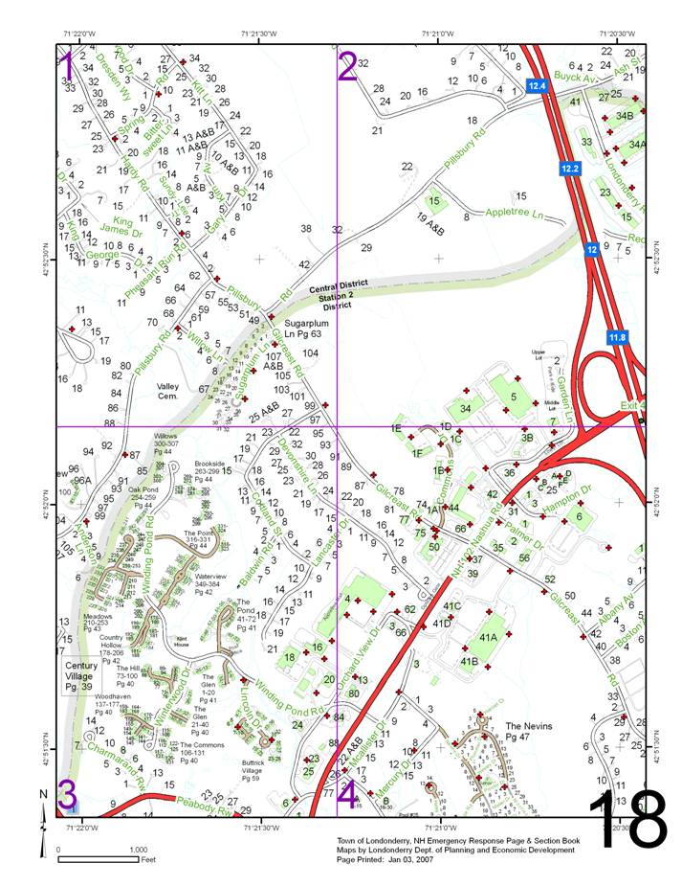

The image to the left represents a page taken from the Londonderry Fire & Rescue Page and Section Book, a local atlas containing maps for emergency response dispatching.

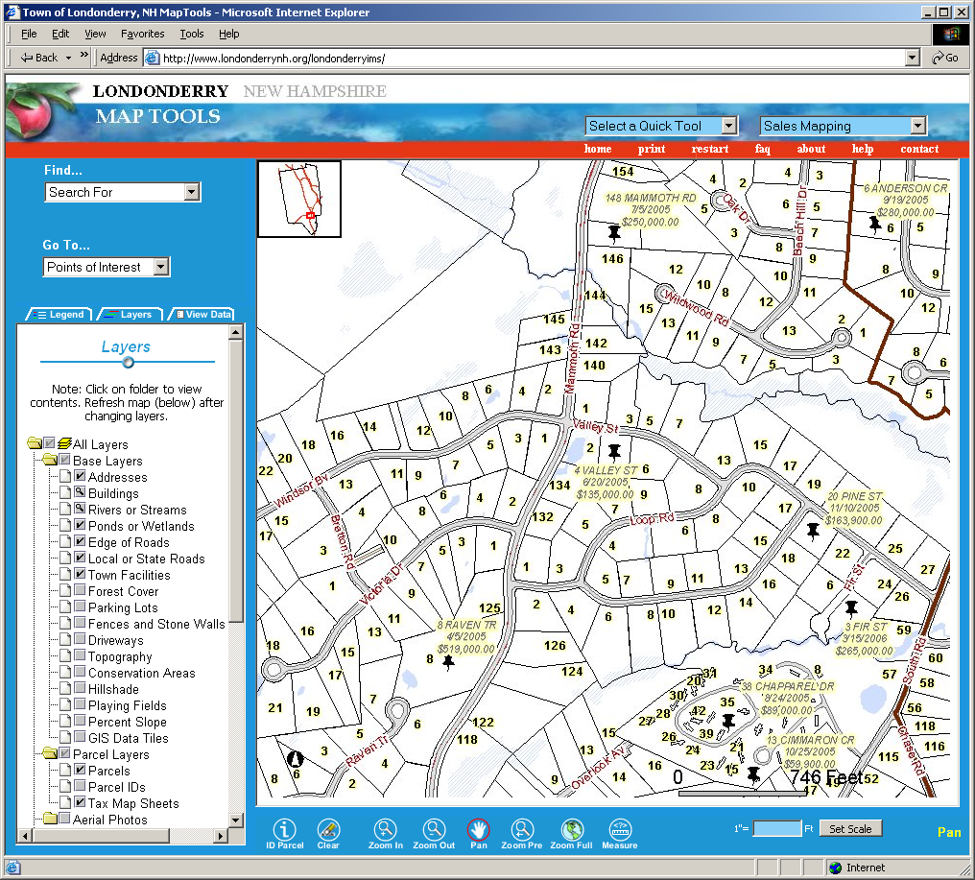

The image above shows the Londonderry MapTools interactive GIS web site. This tool provides public access to local GIS resources, in this case locations of recent sales transactions.

