NH Coastal Viewer Training Exercise 3: Tools for Assessing Land Conservation in NH
This exercise will use datasets related to land conservation in the Seacoast region. We will explore the Clipping Tool and other tools available in the Coastal Viewer and produce maps that may be distributed digitally or in print.

- [**Optional**] Sign in to ArcGIS Online – for those who have ArcGIS Online accounts only
  - When you Sign In to ArcGIS Online under the Projects tab, you can save your current map as a Project or open Projects created by other ArcGIS Online users in your community.
  - When you Sign In, the Coastal Viewer will refresh and you will lose any changes you have made to your map prior to that point.
  - If you do not have an ArcGIS Online account, you can create a free public account at https://www.arcgis.com/home/createaccount.html

- Turn on City/Town Boundaries, Conservation and Public Lands, and Conservation Focus Areas - (CFAs). Adjust colors and transparency.
  - Conservation/ Public Lands and Conservation Focus Areas – 2006 (NH) are found in the Environment and Conservation folder in the Layers list.
  - Using the Layer Actions menu, adjust the color and transparency of Conservation/Public Lands so that the Conservation Focus Areas are visible.
  - In the Visualization Options, select “Custom Layer Style ...”, “Simple” symbology, click on the Color selector box, and click the color swatch arrow.
  - Drag slider or click in color gradient to select color; drag lower slider to adjust transparency.
  - Click Apply to view changes; click Done when finished and close out of the Layer Actions menu.

- Use the Clipping Tool to determine how much of the Creek Pond Marsh CFA Core Area is already in conservation.
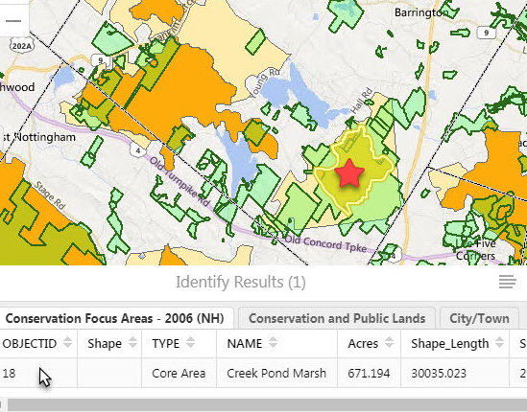
  - Zoom to Barrington. (Recall the Zoom to ... tool under the Custom Tools tab. You can use this tool to zoom to a town; a complete street address is not required.)
  - Near the intersection of Rte 125 and Rte 4, find the Creek Pond Marsh CFA Core Area (marked with red star).

  - The Clipping Tool allows you to summarize the number of point features, the length of line features, or the area of polygon features, within the boundary of a clipping polygon (e.g. a town, a watershed, etc.)
  - Use the Identify Tool (in the Home tab) to select the Creek Pond Marsh CFA Core Area as the polygon to clip to.
  - Because there are 3 data layers displayed, recall that the Identify tool will define the feature in each data layer at the location you clicked. Tab to the Conservation Focus Areas data layer to confirm that you have the Creek Pond Marsh CFA.
  - Click the Panel Actions Menu and click Run Clipping Tool.
  - Select Conservation Focus Areas – 2006 (NH) as the Source Layer. This is the layer containing the clipping polygon. (If you get an error here, try again ... this tool can be sensitive.) Click Next.
  - Choose Conservation and Public Lands as the Target Layer to clip; Click Next.
  - Choose None as the Grouping Field (we will not further group these results); Click Done.
  - Click Generate pdf.
  - When the “Save clipping results” window opens, click Download.
  - The downloading procedure may vary depending on your web browser.
  - Open the resulting pdf to view your Clipping Tool results.
  - The Report gives the area (in ft²) of Conservation/Public Land within the Creek Pond Marsh CFA.
  - Find the Shape_Area (in ft²) of the Creek Pond Marsh CFA in the Coastal Viewer Identify Results.
  - Data sets in the NH Coastal Viewer that are sourced from NH GRANIT are referenced to NH State Plane (NHSP) feet. (Those from external sources may have alternate spatial reference systems.) This can be confirmed by reviewing the Spatial_Reference_Information section in the metadata record. For data in NHSP feet, the Shape_Area will indicate area in square feet. Some data layers may have additional fields where the area has been converted to acres, hectares, or some other unit. Again, refer to the metadata.
  - Use your computer’s calculator to find that % of the Creek Pond Marsh CFA that is in some form of conservation. What is your calculation?
  - Click Close to leave the Clipping Tool.
  - A Help video for the Clipping Tool is available in the Help Tab.

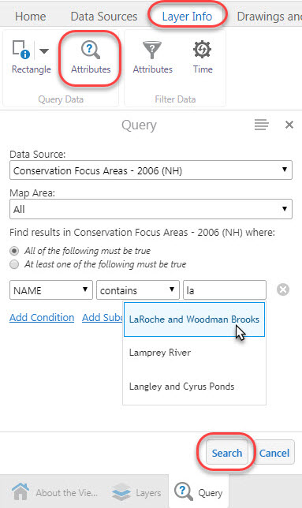
- Use the Data Query Tool to find the LaRoche and Woodman Brooks CFA in Durham, a CFA that contains parcels with a variety of Protection Levels.
  - To view Conservation lands by Protection Level (the default display), go to Turn on/off layer visualizations and select None as the visualization.
  - To use the Query Tool, click the Layer Info Tab, and click Attributes. (Be sure to select the first “attribute” icon.)
  - Choose Conservation Focus Areas – 2006 (NH) as the Data Source.
  - Use the boxes to enter the parameters “Name” contains “LaRoche and Woodman Brooks” (as you begin to type “LaRoche”, a drop-down menu will appear); Click the Search box at the bottom of the panel..
  - The Query Results window will show two results – the Core Area and Supporting Area.
  - Click the second choice, which will be the Supporting Area polygon. The map will zoom to the polygon you selected.
  - Close out of the Query dialogue boxes.

- [**Optional**] How much of the LaRoche and Woodman Brooks CFA Core and Supporting Area is protected at each Level?
  - The Clipping Tool can also be used to summarize data within multiple polygons.
  - Start by using the Identify Tool to select both the Core Area and Supporting Area of the LaRoche and Woodman Brooks CFA.
  - Click the Home Tab and click the Identify Tool.
  - Drag a box in the Map Area that covers both CFA polygons.
  - Use the Clipping Tool to determine the area of conserved land by Level in the Core and Supporting Areas of this CFA
  - Run the Clipping Tool.
  - Source Layer is Conservation Focus Areas – 2006 (NH).
  - Target Layer is again Conservation and Public Lands.
  - Group Results by Protection Level.
  - Generate pdf Report.
  - In which Level is most of the conservation land?
  - Conservation Lands Data Standards documents are available on the GRANIT website.

- Middle Little River CFA in North Hampton does not currently contain many protected parcels. Identify potential high-value parcels for conservation of wetlands and wildlife habitat in this CFA.
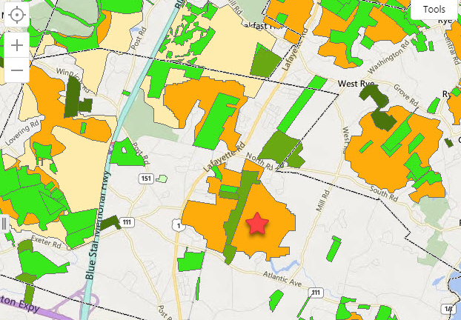
  - Zoom to the Town of North Hampton.
  - Find the Middle Little River CFA (marked with red star).
  - Turn on National Wetlands Inventory.
  - Turn on Wildlife Action Plan 2015: Highest Ranked Wildlife Habitat.
  - Adjust Visualizations for all the layers to maximize the amount of information you can show at once. You may choose to change color, transparency, fill style, drawing order, etc.
  - Draw a polygon around an area that would be of interest for conserving wetland areas and highest priority wildlife habitat.

- [**Optional**] Save your work as a Project
  - You can save your current map as a Project.
  - You must Sign In to ArcGIS online to save a Project.
  - Click the Save button in the toolbar.
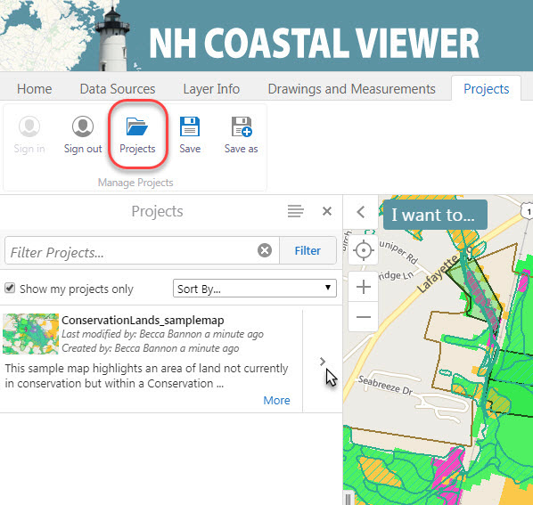
  - Type a Name and Description for your Project; click Save.
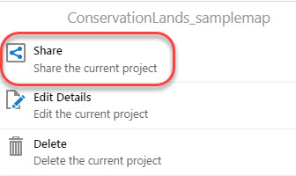
  - To share your project with others, click Projects.
  - Click the arrow next to the project name, then click Share.

  - Assign Project Privileges for ArcGIS Online users in your network.
  - Or send a Guest Link to View or Edit the project.
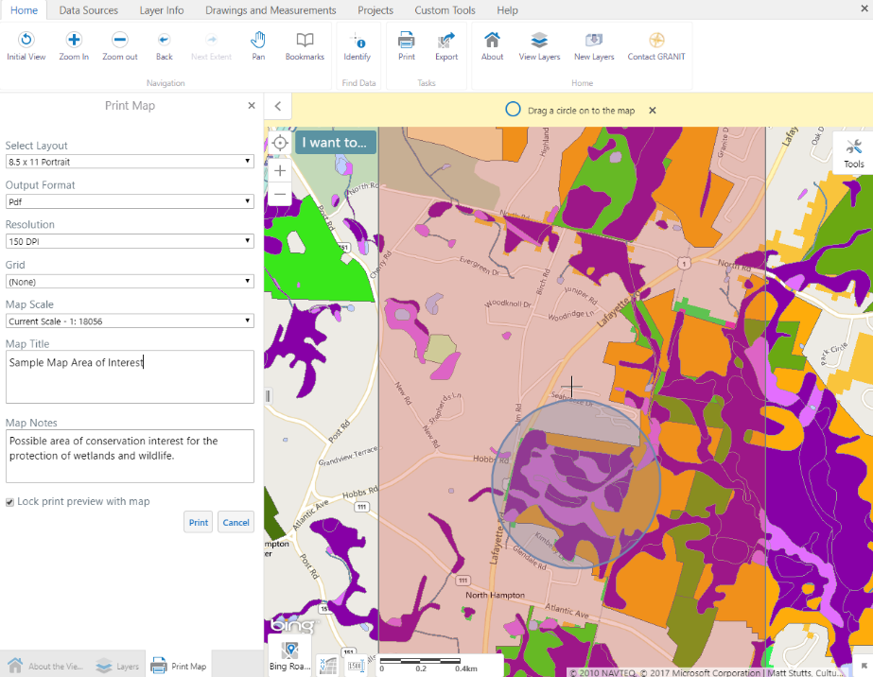
  - Your Projects List will show any projects that have been shared with you (turn off “Show my projects only”).
- Save a printable PDF map.
  - From the Home tab, click Print in the Toolbar.
  - Select desired Layout, Output Format, etc.
  - Type in a Title and any Notes.
  - The pink rectangle is the Print Preview extent.
  - Click Print.
  - Open File to open the PDF file.
Sample Output Map from NH Coastal Viewer
