NH Coastal Viewer Training Exercise 2: Drinking Water and Land Conservation
This exercise will use tools available in the NH Coastal Viewer to explore strategic land conservation for the protection of public drinking water. Our goal is to find and label parcels in the vicinity of a public water supply intake that could provide multiple water resource protection benefits.
- Turn on Data Layers
  - Start with all data layers turned off in the Table of Contents (TOC). Locate and turn on NH Parcel Mosaic/Polygons (e.g. parcel boundaries) and Conservation and Public Lands. Remember, one way to find these layers is to use the “Filter” option and enter a keyword.
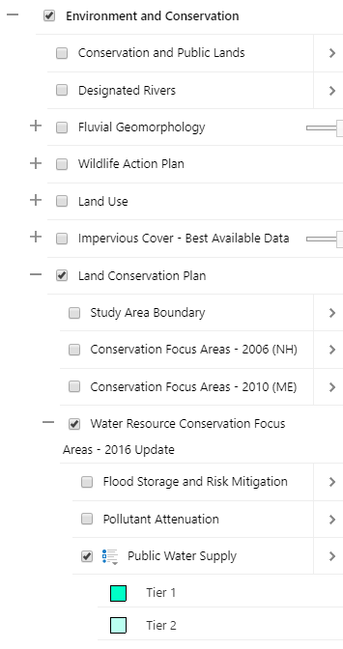
  - Keep in mind that each level of the hierarchy must be checked to display a data layer.
  - Also note that the Parcels Polygons dataset is scale-dependent as denoted by the gray font in the TOC, and will not draw until you zoom in to a larger scale.
  - Turn on Public Water Supply, found under Environment and Conservation > Land Conservation Plan > Water Resources Conservation- Focus Areas – 2016 update
  - In this case, be sure the 3 parent folders are checked and expanded, as well as the data layer itself.
  - Your map should look similar to the following, although will vary depending upon where in the coastal region you are displaying. (The base map here is set to Bing Roads.)

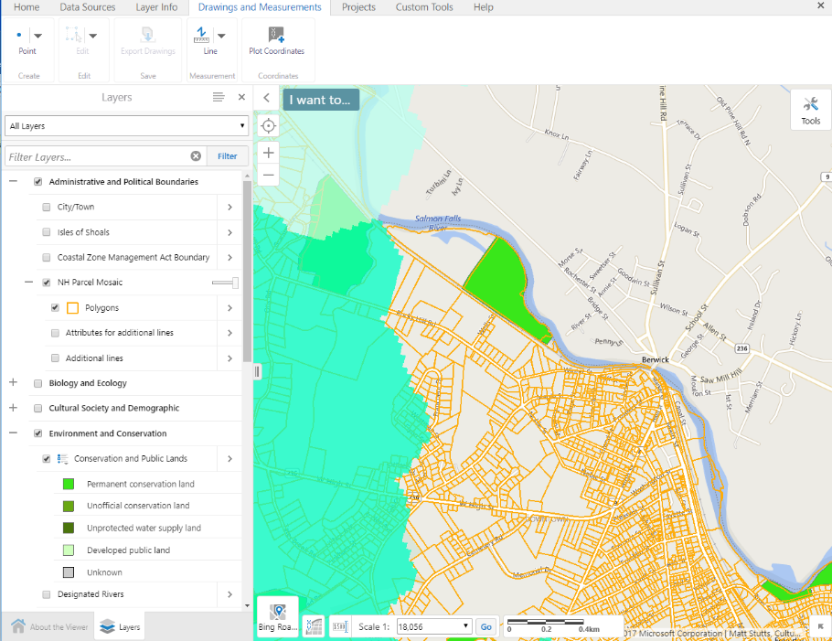

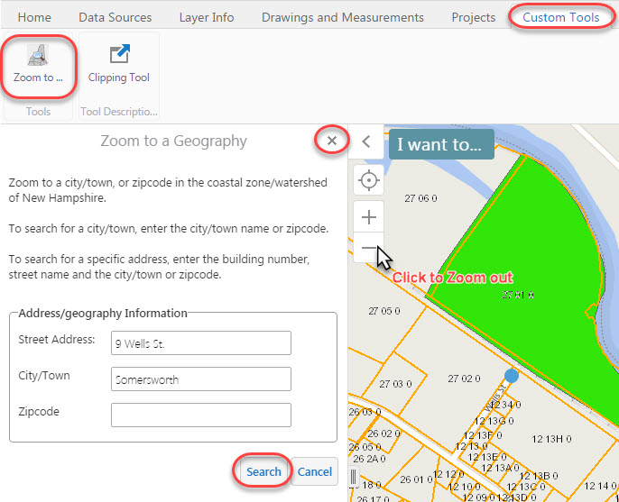
- Zoom to 9 Wells St, Somersworth, NH
  - Click on the Custom Tools tab, then click the Zoom to… tool.
  - Enter the address “9 Wells St, Somersworth” and click Search.
  - The City/Town box will autocomplete once you enter the first few characters.
  - Zoom out slightly to view parcels surrounding this address, which is near a water supply intake.
  - Click the x to close the Zoom to a Geography dialogue box.

- Consider parcels that could be of interest to expand or connect existing conservation lands within Tier 1 and Tier 2 areas.
  - Click on any Public Water Supply polygon to view a description of Tier 1 and Tier 2 designations.
  - Observe parcels already in conservation that are within Public Water Supply Tier 1 or Tier 2 areas.
  - Consider additional parcels that could be of interest for conservation.
  - When you are ready to move on, turn off the Public Water Supply Layer.

- Consider parcels within Conservation Focus Areas that are “Likely to Provide Multiple Benefits”.
  - Under Water Resources Conservation-Focus Areas-2016 update, click on and expand the Single and Multi-Benefit Areas folder.
  - Turn OFF “Areas Likely to Provide Single Benefits” and turn ON “Areas Likely to Provide Multiple Benefits”.
  - Which parcels not currently in conservation could provide multiple water resource benefits?
  - Currently, the Parcel Layer is partially covered up by other layers of data; we can change the drawing order of the map layers in order to make the parcel boundaries more visible.

- Change the Drawing Order so that parcel boundaries are not hidden by other data layers.
  - Click the Panel Actions Menu.
  - Select Change Layer Drawing Order.
  - Click Service Layers to expand.

  - Scroll down and find Parcels. (It will be approximately the 12th element in the list.)
  - Click the dots to the left of the layer name and drag the Parcels layer up the list.
  - Drop Parcels above the Multiple Benefits layer (LCP_2016Update_Multiple_Benefits).
  - Layer names in the Drawing Order list may not be identical to names in the Table of Contents of the map.
  - Click Done.

- [**Optional**] Mark parcels of interest for conservation by adding a drawing.
  - Which parcels that overlap the “Pollutant Attenuation and Public Water Supply” area would be of interest for conservation? Mark 3 parcels of interest in the map by adding drawings.
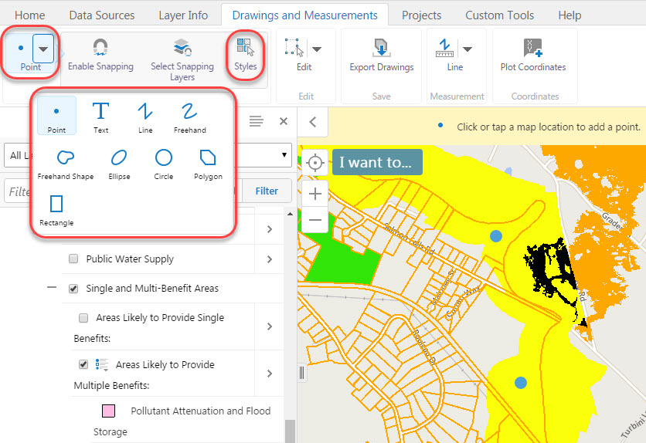
  - Click the Drawings and Measurements tab.
  - The default drawing shape is Point. Click to select.
  - Click in the map to place points.
  - Click the arrow next to Point to change the drawing type.
  - You can adjust symbols and lines using the Styles button.
  - To edit (move or reshape) or remove drawings, click the Edit button.
  - Erase allows you to delete individual drawings; If you click overlapping drawings, both will be erased.
  - Clear will permanently delete all drawings in the map.
  - Note: There is no Undo feature for the Edit tools.

- [**Optional**] Export your drawing as a shapefile for use outside the Coastal Viewer
  - Export Drawings will convert all drawings in the map to shapefiles for download to your computer using the icon in the Drawings and Measurement tab. You can then bring this data in your desktop GIS software.
  - The output is a .zip file called Export.zip.
  - Each feature type (point, polygon, line) will be saved in its own shapefile within the .zip file (i.e., Point.shp, Polygon.shp, Polyline.shp).

