Impervious Cover (SOOE Extended Edition)

Question

How much of the Piscataqua Region watershed is currently covered by impervious surfaces and how has it changed over time?

Goal

No increase in the number of watersheds and towns with greater than 10% impervious cover and no decrease in the number of watersheds and towns with less than 5% impervious cover.

Short Answer

In 2021, 5.8% of the land area of the Piscataqua Region watershed was covered by impervious surfaces. This is an increase of 1,834 acres of impervious cover or 0.2% of the land area since 2015.

Why We Track this Indicator

Impervious surfaces are human-made features, such as parking lots, roads, and buildings that do not allow precipitation to soak or infiltrate into the ground. When precipitation falls on impervious surfaces, a large proportion runs off into nearby waterways, carrying pollutants and sediments, with most of the remainder entering groundwaters. More impervious cover also leads to higher peak flows and increased stream channel erosion. In fact, studies show that when watersheds have more than 10% impervious cover¹, water quality impacts become increasingly severe, with some research showing impacts at only 5%.

Explanation

The 2021 update to this dataset is the second iteration of mapping the entire 52-town Piscataqua Region Watershed using high resolution (HR), 1-foot/60-cm orthoimagery. Impervious cover estimates using this approach represent 48,428 acres or 5.8% of the land area. This value constitutes an increase of 1,834 acres of impervious cover (0.2% of the Piscataqua Region) since 2015 (46,594 acres). Watersheds with greater than 10% impervious surface coverage of land area are concentrated in the vicinities of the Hampton-Seabrook Estuary, the Piscataqua River and the Route 16 corridor along the Cocheco River. Impervious surfaces in 2021 in each of the Piscataqua Region subwatersheds are shown as a percentage of land area in Figure IS-1.

The stated goals (above) were not met, though it was close. One watershed that had less than 5% went over the threshold and two watersheds went over 10% impervious surfaces. Communities with the highest overall impervious cover percentages included Portsmouth (27%), New Castle (21%), and Seabrook (21%), while the largest increase of impervious surfaces between 2015 and 2021 occurred in Wells (160 acres), Rochester (155 acres), Dover (109 acres), York (91 acres), Epping (72 acres), and Sanford (67 acres). Communities with the smallest increases in impervious surfaces included New Castle (2 acres), East Kingston (4 acres), and Portsmouth (4 acres). Small increases in impervious cover in urbanized areas may be a result of limited availability of buildable lots. For information on housing trends in the watershed refer to the Housing Permits indicator section of this report. Town-by-town information on impervious surfaces in 2021 is shown in Figure IS-2.

Between 2015 and 2020 population in the Piscataqua Region watershed increased 3.9% (15,039 people), and impervious cover increased 4% (1,834 acres). For every one person increase in population, impervious cover increased 0.13 acres or 5,663 square feet. However, as shown in Figures IS-1 and IS-2, the amount of impervious cover is not evenly spread across the watershed. For more discussion on municipality populations and impervious cover, see the Extended Report.

Figures

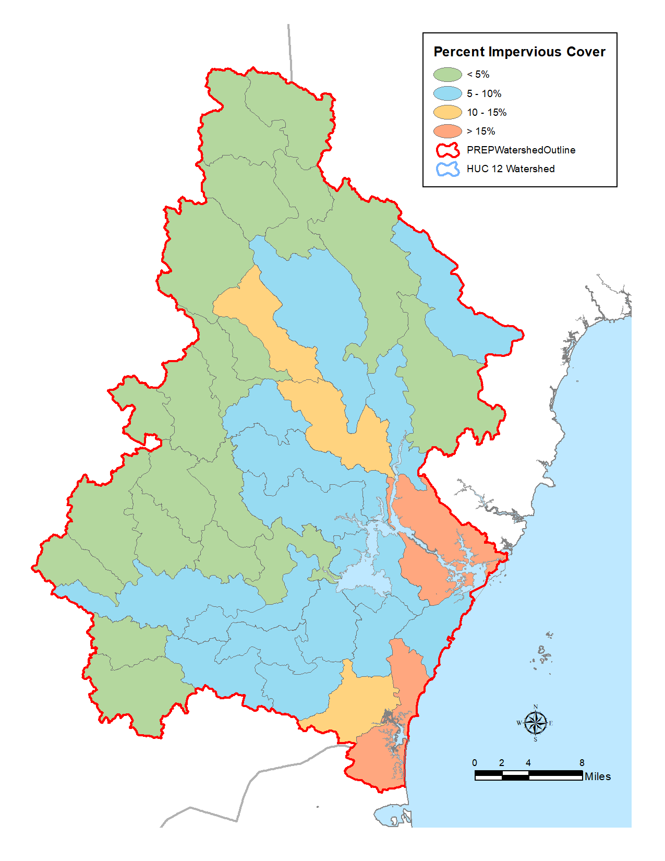
Figure IS-1. Percent impervious cover by subwatershed as of 2021. Water in each subwatershed drains to a single lowest point in the area. The bottom of the watershed or the “pour point” is the lowest point of the land area where water flows out of the watershed.

Data Source: UNH Earth Systems Research Center

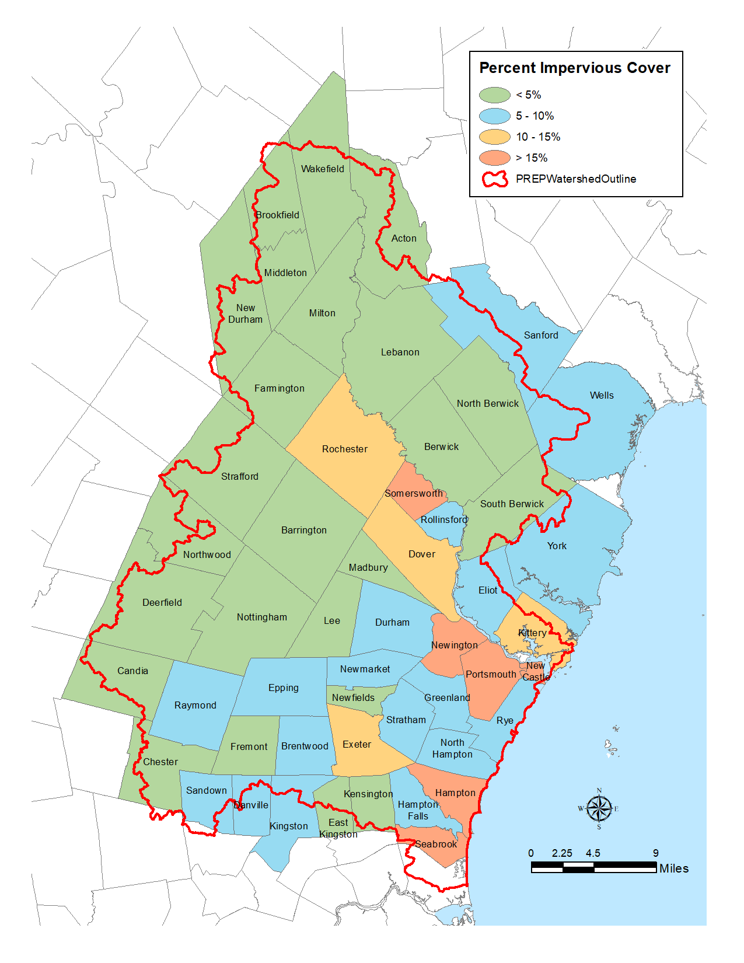
Figure IS-2. Percent impervious cover by town as of 2021.

Data Source: UNH Earth Systems Research Center.

Acknowledgements Rebecca Bannon, David Justice, and Chris Phaneuf (NH GRANIT), with contributions from Abigail Lyon (PREP) and Kalle Matso (PREP). Graphics from NH GRANIT.

Additional Discussion
In some locations, there was a visible shift of the roadways and angle of building lean (as well as other features) between the 2015 high resolution imagery and the 2021 iteration. This is not unexpected, given the 6-year gap in the image collection cycle, the different sensors that were used, the different processing techniques, etc. As a result, there are instances of 2015 IC features that do not appear to overlay precisely on the 2021 imagery. In these cases the 2015 data was left intact for the 2021 iteration. In general, for the New Hampshire data, where misalignments or questionable features occurred, the 2015 data was presumed correct because it was derived from a higher resolution data source. Conversely, this presumption was not necessarily used for the Maine features, since both the 2015 and 2021 features were derived from NAIP orthophotography.

This project represents the second iteration of mapping the entire 52-town PREP footprint using high resolution (HR), 1-foot/60-cm orthoimagery. Prior to 2015, the PREP IC mapping relied on medium resolution (MR), 30-meter satellite imagery. As noted in an earlier report (Justice and Rubin, 2015), there are marked differences between impervious cover estimates generated by the two approaches. This is in part due to the significant difference in the spatial resolution of the source data (1-foot vs. 30-meter, respectively), and in part due to the different processing methodologies used (screen interpretation vs. subpixel automated classification, respectively).

As mentioned in our previous report (Justice and Rubin, 2015), we found that HR impervious cover can be derived using orthophotography at resolutions of 1-meter and greater. It should be noted however that using leaf-on data (i.e. NAIP, 60-centimeter resolution) makes processing slower and less refined. In addition, it should be realized that only major changes in the landscape will be recognized. Despite the shortcomings of the coarser resolution NAIP orthophotography, we feel that this data source is suitably resolved to identify IC at the mapping scales from which these were derived. It is clear, however, that leaf-off photography is preferred and that the NAIP imagery should only be used as a substitute when higher resolution, leaf-off data are not available. It is anticipated that orthophoto data sources such as regularly acquired NAIP imagery can be used as base data from which to delineate significant changes in IC.

Methods

A more comprehensive description of the methods can be found in Bannon, Phaneuf, and Justice (2022).

Data for the 52 town PREP footprint (see Figure IS-1) retrieved from the NH GRANIT Clearinghouse (granit.unh.edu) were used as the basis for mapping the 2021 impervious cover. The primary data source used to update the 2015 IC consisted of 2021 60-cm resolution, 4-band National Agriculture Imagery Program (NAIP) orthophotography for both New Hampshire and Maine. Older vintage orthophotography (2015) was used for reference.

The updated IC coverage was derived by displaying the 2015 impervious cover data set for the project area, visually interpreting the 2021 source imagery, and manually digitizing changes to IC features visible in the imagery. Data were initially displayed at a minimum scale of 1:2,000 to identify features to be digitized. The scale was typically increased to 1:1,000 (or greater) when actively digitizing features. Processing was conducted on a town-by-town basis to expedite the editing process and make the overall control of the task more efficient and manageable. Changes to the digitized features included adding new IC features, identifying features that were removed since 2015, and correcting any previous errors of omission or commission (e.g. missing features and false positives). Occasional errors were identified due to differences in tree canopy or lighting in the imagery; comparison of multiple imagery collections allowed for more accurate digitizing.

After a comprehensive review of the data, the IC polygons were processed to derive the final data set for distribution. This involved merging individual town-based datasets into the final, region-wide layer that was used to derive acreage summaries by town and HUC 12 watershed units.

Data Sources

The primary source data for the project comprised 2021 60-centimeter resolution, 4-band orthophotography acquired from the National Agricultural Imagery Program (NAIP) and existing 2015 impervious cover (IC) feature data sets. Older vintage orthophotography (2015) was also used for reference.
Additional Data Tables and Graphs

The primary result of this project is a high resolution (HR) impervious cover data set capturing features for the year 2021 within the 52 town PREP footprint. Figure IS-3 displays the distribution of impervious cover mapped throughout the study area. Figure IS-4 presents a large-scale example of the mapping for a small subdivision in the study area. Figures IS-5 and IS-6 graphically shows percent impervious cover by town and subwatershed. Tables LS-1 and LS-2 summarize the impervious cover by town and subwatershed.

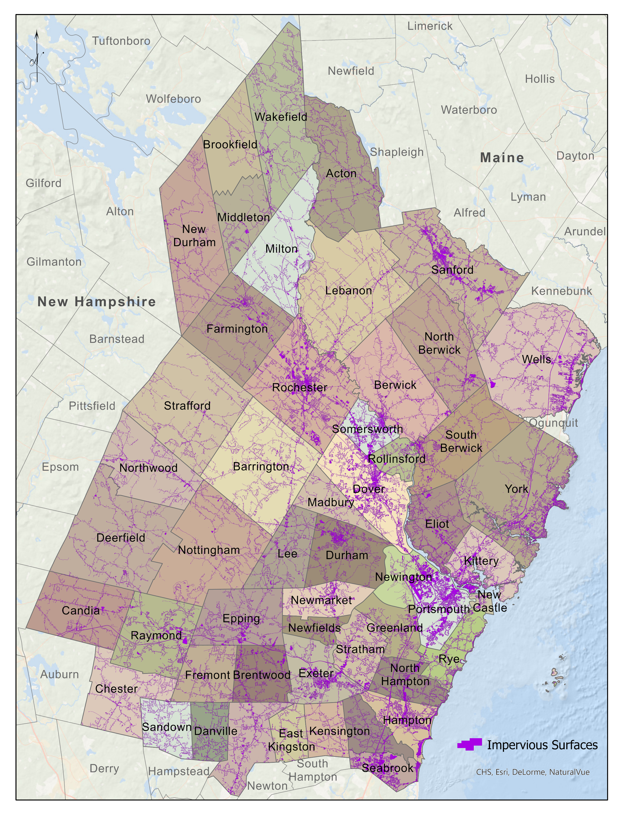

Figure IS-3. Distribution of 2021 impervious cover (purple features) in the project study area.
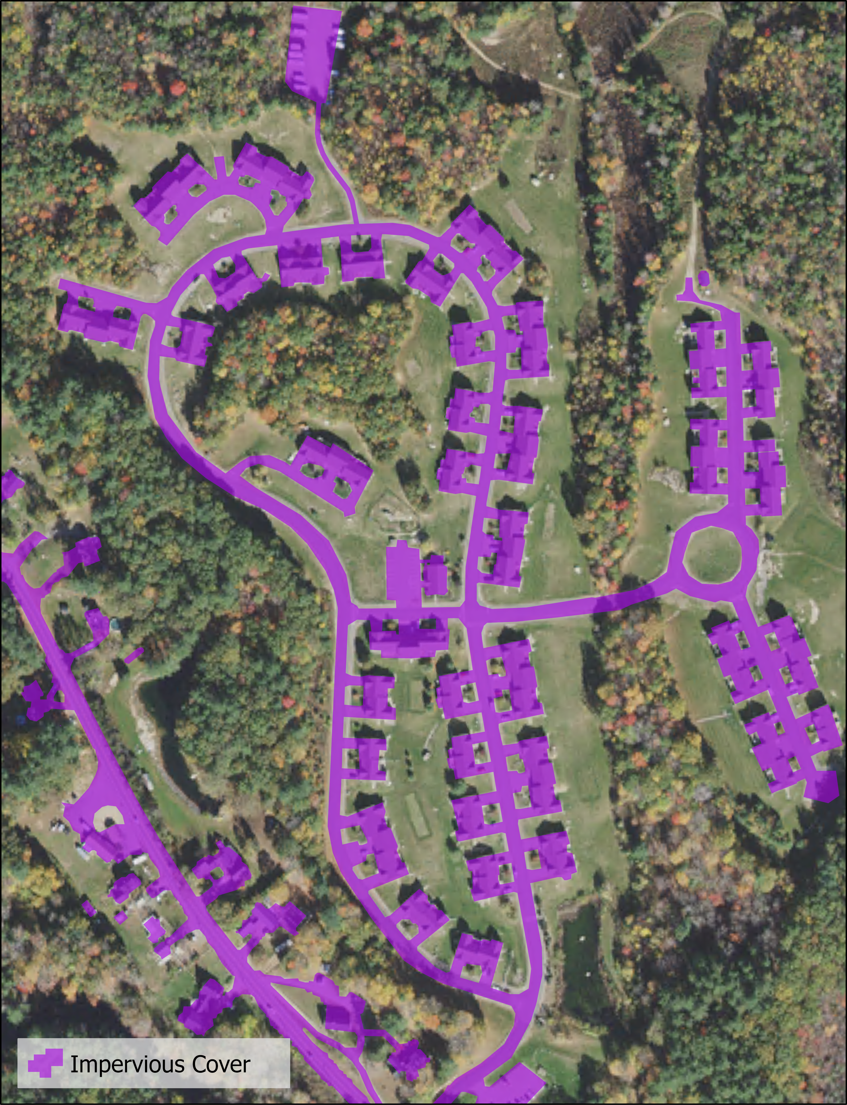

Figure IS-4. Large-scale example showing impervious cover features.
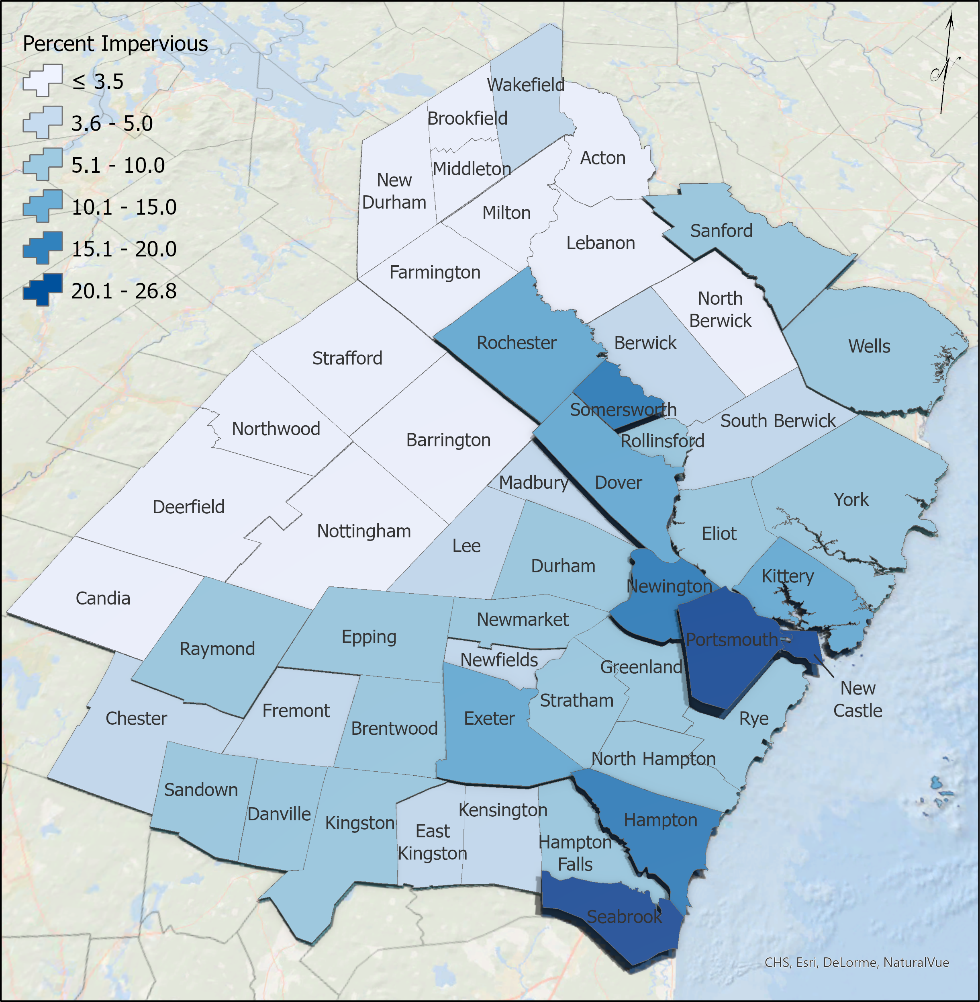

Figure IS-5. Percent impervious cover by town, 2021.

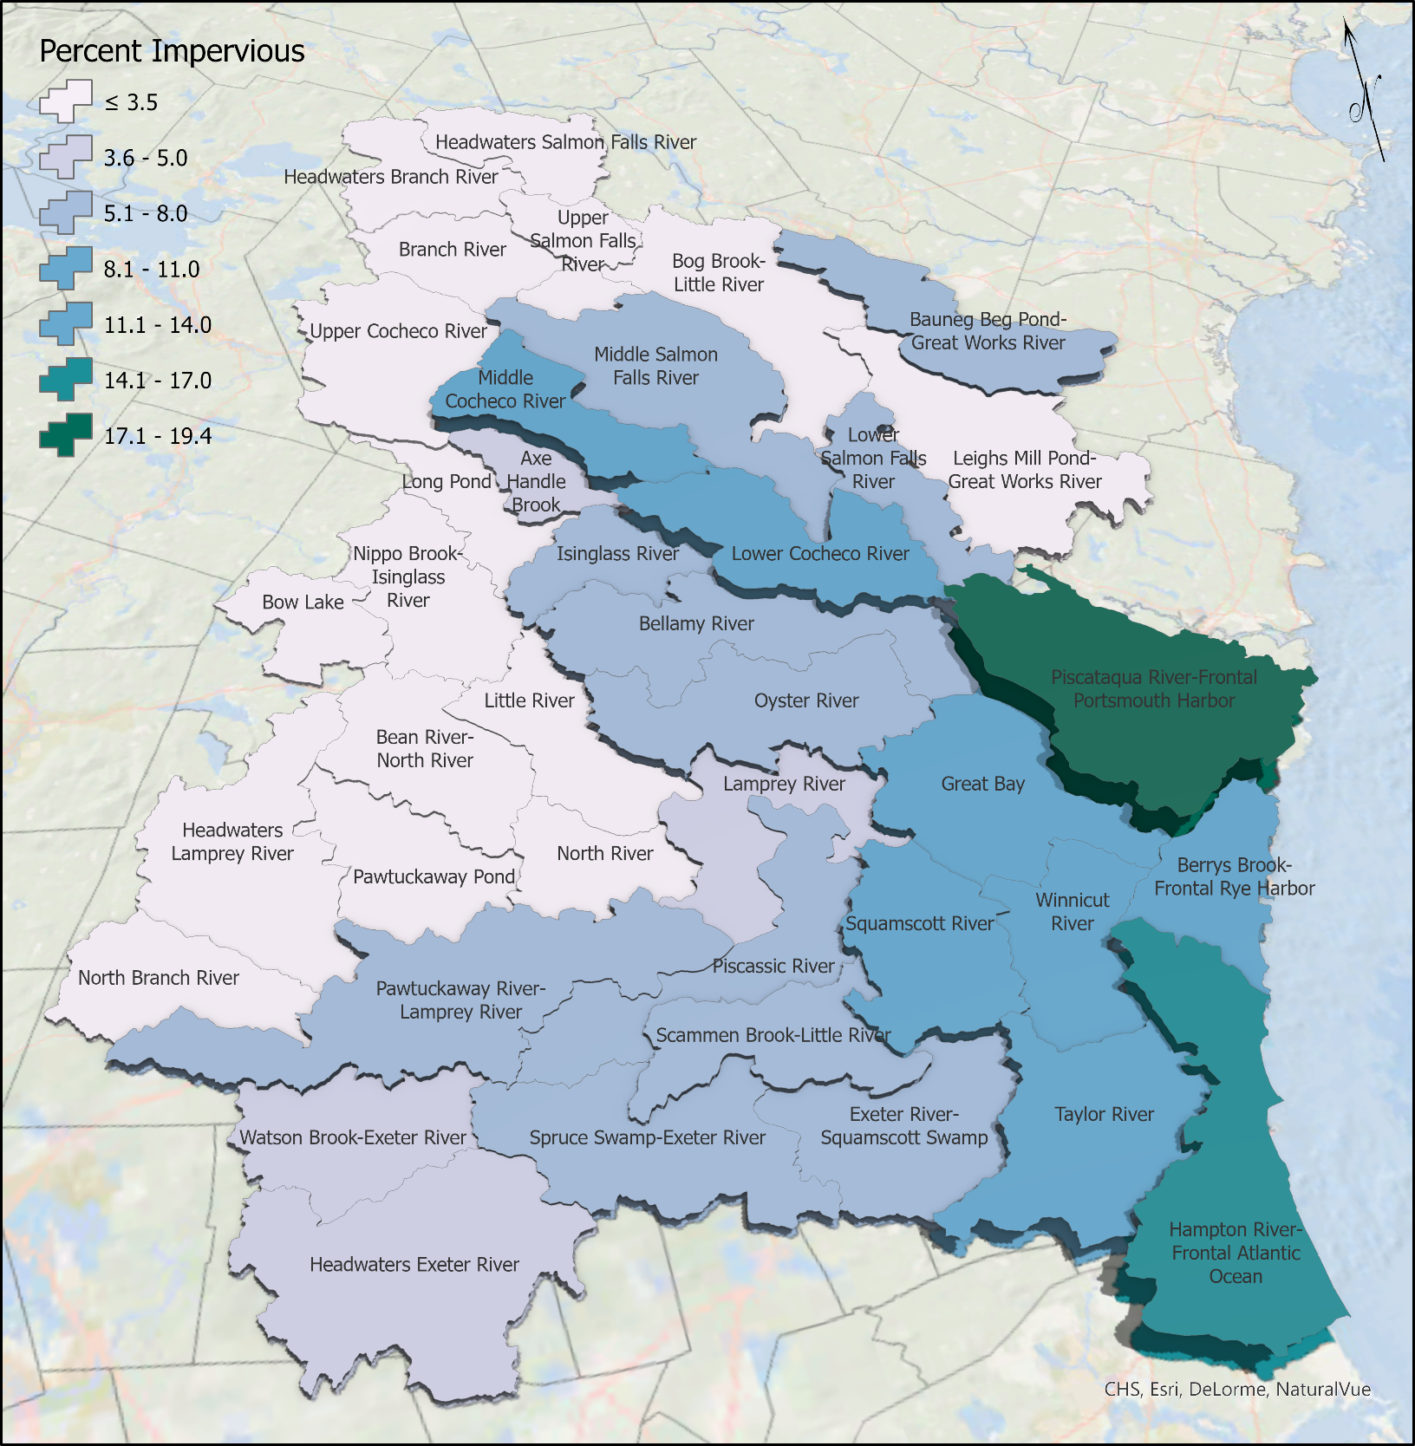

Figure IS-6. Impervious cover by HUC watershed.

State | Town | Total Area (acres) |  |  | IC (acres) |  |  | Percent IC (Land Area)
 |  | Land | Inland Water | Total | 2015 | 2021 | Change | 2015 | 2021
Maine | Acton | 24,216.3 | 2,191.7 | 26,408.0 | 747.0 | 781.4 | 34.4 | 3.1% | 3.2%
 | Berwick | 23,779.6 | 447.1 | 24,226.7 | 893.8 | 946.0 | 52.2 | 3.8% | 4.0%
 | Eliot | 12,609.4 | 150.6 | 12,759.9 | 894.0 | 957.8 | 63.8 | 7.1% | 7.6%
 | Kittery¹ | 11,548.0 | 168.2 | 11,716.1 | 1,325.8 | 1,358.8 | 33.0 | 11.5% | 11.8%
 | Lebanon | 34,957.8 | 675.8 | 35,633.6 | 1,018.0 | 1,050.5 | 32.5 | 2.9% | 3.0%
 | North Berwick | 24,265.1 | 157.6 | 24,422.7 | 759.2 | 792.6 | 33.4 | 3.1% | 3.3%
 | Sanford | 30,314.8 | 890.3 | 31,205.1 | 2,453.9 | 2,521.0 | 67.1 | 8.1% | 8.3%
 | South Berwick | 20,468.8 | 243.1 | 20,711.8 | 761.7 | 802.3 | 40.6 | 3.7% | 3.9%
 | Wells | 36,427.3 | 125.1 | 36,552.3 | 2,195.8 | 2,355.9 | 160.1 | 6.0% | 6.5%
 | York | 34,913.8 | 685.0 | 35,598.8 | 2,204.7 | 2,295.6 | 90.9 | 6.3% | 6.6%
 | Total | 253,500.6 | 5,734.4 | 259,235.0 | 13,253.9 | 13,861.9 | 608.0 | 5.2% | 5.5%
New Hampshire | Barrington | 29,719.0 | 1,398.3 | 31,117.3 | 1,003.8 | 1,037.1 | 33.3 | 3.4% | 3.5%
 | Brentwood | 10,728.1 | 134.9 | 10,863.0 | 688.1 | 722.0 | 33.9 | 6.4% | 6.7%
 | Brookfield | 14,593.0 | 287.3 | 14,880.4 | 133.7 | 138.3 | 4.6 | 0.9% | 0.9%
 | Candia | 19,328.9 | 228.2 | 19,557.2 | 645.0 | 679.8 | 34.8 | 3.3% | 3.5%
 | Chester | 16,606.2 | 111.6 | 16,717.8 | 566.1 | 604.4 | 38.3 | 3.4% | 3.6%
 | Danville | 7,438.7 | 130.7 | 7,569.4 | 400.5 | 421.5 | 21.0 | 5.4% | 5.7%
 | Deerfield | 32,575.7 | 772.1 | 33,347.8 | 697.1 | 723.4 | 26.3 | 2.1% | 2.2%
 | Dover | 17,036.9 | 1,555.2 | 18,592.1 | 2,441.7 | 2,551.0 | 109.3 | 14.3% | 15.0%
 | Durham | 14,251.1 | 1,601.2 | 15,852.3 | 922.7 | 952.6 | 29.9 | 6.5% | 6.7%
 | East Kingston | 6,318.0 | 62.8 | 6,380.8 | 274.2 | 278.2 | 4.0 | 4.3% | 4.4%
 | Epping | 16,476.6 | 299.1 | 16,775.7 | 929.7 | 996.9 | 67.2 | 5.6% | 6.1%
 | Exeter | 12,540.6 | 272.3 | 12,812.9 | 1,226.6 | 1,272.7 | 46.1 | 9.8% | 10.1%
 | Farmington | 23,213.0 | 427.0 | 23,640.0 | 781.2 | 798.2 | 17.0 | 3.4% | 3.4%
 | Fremont | 11,033.1 | 109.3 | 11,142.4 | 425.6 | 446.6 | 21.0 | 3.9% | 4.0%
 | Greenland | 6,722.5 | 1,801.4 | 8,523.9 | 586.1 | 613.0 | 26.9 | 8.7% | 9.1%
 | Hampton | 8,287.3 | 785.5 | 9,072.8 | 1,404.9 | 1,437.5 | 32.6 | 17.0% | 17.3%
 | Hampton Falls | 7,719.6 | 358.4 | 8,078.0 | 402.9 | 415.0 | 12.1 | 5.2% | 5.4%
 | Kensington | 7,616.4 | 51.4 | 7,667.8 | 287.6 | 298.0 | 10.4 | 3.8% | 3.9%
 | Kingston | 12,494.3 | 955.9 | 13,450.3 | 784.6 | 814.6 | 30.0 | 6.3% | 6.5%
 | Lee | 12,685.0 | 242.2 | 12,927.3 | 597.8 | 633.0 | 35.2 | 4.7% | 5.0%
 | Madbury | 7,383.6 | 415.5 | 7,799.1 | 266.6 | 274.4 | 7.8 | 3.6% | 3.7%
 | Middleton | 11,559.0 | 284.0 | 11,843.0 | 269.4 | 277.5 | 8.1 | 2.3% | 2.4%
 | Milton | 21,088.6 | 847.3 | 21,935.9 | 694.9 | 704.6 | 9.7 | 3.3% | 3.3%
 | New Castle | 506.2 | 841.4 | 1,347.6 | 101.5 | 103.7 | 2.2 | 20.0% | 20.5%
 | New Durham | 26,345.5 | 1,708.5 | 28,054.0 | 534.4 | 549.6 | 15.2 | 2.0% | 2.1%
 | Newfields | 4,540.8 | 105.9 | 4,646.7 | 213.6 | 219.5 | 5.9 | 4.7% | 4.8%
 | Newington | 5,214.5 | 2,702.2 | 7,916.8 | 886.5 | 903.7 | 17.2 | 17.0% | 17.3%
 | Newmarket | 8,034.5 | 1,045.8 | 9,080.3 | 579.4 | 597.4 | 18.0 | 7.2% | 7.4%
 | North Hampton | 8,861.8 | 61.0 | 8,922.8 | 732.6 | 759.2 | 26.6 | 8.3% | 8.6%
 | Northwood | 17,965.0 | 1,391.9 | 19,357.0 | 611.0 | 629.3 | 18.3 | 3.4% | 3.5%
 | Nottingham | 29,839.7 | 1,157.0 | 30,996.7 | 657.0 | 687.6 | 30.6 | 2.2% | 2.3%
 | Portsmouth | 10,003.5 | 759.9 | 10,763.4 | 2,674.8 | 2,679.1 | 4.3 | 26.7% | 26.8%
 | Raymond | 18,438.3 | 505.2 | 18,943.6 | 1,147.5 | 1,208.2 | 60.7 | 6.2% | 6.6%
 | Rochester | 28,329.2 | 751.5 | 29,080.7 | 2,858.9 | 3,013.8 | 154.9 | 10.1% | 10.6%
 | Rollinsford | 4,681.3 | 161.5 | 4,842.8 | 281.6 | 291.3 | 9.7 | 6.0% | 6.2%
 | Rye¹ | 8,464.7 | 411.3 | 8,876.0 | 666.0 | 682.2 | 16.2 | 7.9% | 8.1%
 | Sandown | 8,888.5 | 343.3 | 9,231.8 | 500.4 | 522.4 | 22.0 | 5.6% | 5.9%
 | Seabrook | 5,664.7 | 496.6 | 6,161.3 | 1,133.8 | 1,177.3 | 43.5 | 20.0% | 20.8%
 | Somersworth | 6,219.2 | 179.1 | 6,398.3 | 1,015.4 | 1,032.8 | 17.4 | 16.3% | 16.6%
 | Strafford | 31,151.8 | 1,627.1 | 32,778.9 | 562.5 | 582.6 | 20.1 | 1.8% | 1.9%
 | Stratham | 9,655.1 | 246.5 | 9,901.6 | 874.2 | 926.7 | 52.5 | 9.1% | 9.6%
 | Wakefield | 25,264.0 | 3,453.2 | 28,717.2 | 878.5 | 908.7 | 30.2 | 3.5% | 3.6%
 | Total | 585,483.6 | 31,080.9 | 616,564.5 | 33,340.4 | 34,565.4 | 1,225.0 | 5.7% | 5.9%
Study Total |  | 838,984.2 | 36,815.3 | 875,799.5 | 46,594.3 | 48,427.3 | 1,833.0 | 5.6% | 5.8%
Table LS-1. Acreage and percent impervious cover by town.
¹Acreage values for the towns of Kittery, ME and Rye, NH include the Isles of Shoals.
HUC 12  ID | HUC 12  Name | Total Area (acres) |  |  | Mapped Area (acres) |  |  |  |  | IC (acres) |  |  |  |  | Percent IC (Mapped Land Area)
 |  | Land | Inland Water | Total | Land | Inland Water |  | Total |  | 2015 |  | 2021 | Change |  | 2015 | 2021
010600030602 | Axe Handle Brook | 7,028.2 | 368.8 | 7,397.0 | 7,028.2 | 368.8 |  | 7,396.9 |  | 256.5 |  | 267.1 | 10.6 |  | 3.6% | 3.8%
010600030401 | Bauneg Beg Pond-Great Works River | 23,127.6 | 392.6 | 23,520.1 | 23,127.5 | 392.6 |  | 23,520.0 |  | 1,152.1 |  | 1,188.1 | 36.0 |  | 5.0% | 5.1%
010600030705 | Bean River-North River | 14,795.8 | 276.0 | 15,071.8 | 14,795.7 | 276.0 |  | 15,071.7 |  | 371.3 |  | 378.9 | 7.6 |  | 2.5% | 2.6%
010600030903 | Bellamy River | 20,335.0 | 1,276.8 | 21,611.8 | 20,334.9 | 1,276.8 |  | 21,611.7 |  | 1,443.8 |  | 1,514.0 | 70.2 |  | 7.1% | 7.4%
010600031002 | Berrys Brook-Frontal Rye Harbor | 10,284.6 | 333.4 | 10,618.0 | 10,281.8 | 331.6 |  | 10,613.4 |  | 948.0 |  | 963.7 | 15.7 |  | 9.2% | 9.4%
010600030505 | Bog Brook-Little River | 34,702.3 | 169.6 | 34,871.9 | 34,362.6 | 169.1 |  | 34,531.7 |  | 788.1 |  | 813.4 | 25.3 |  | 2.3% | 2.4%
010600030604 | Bow Lake | 7,885.2 | 1,239.6 | 9,124.9 | 7,881.6 | 1,239.6 |  | 9,121.2 |  | 205.4 |  | 217.2 | 11.8 |  | 2.6% | 2.8%
010600030502 | Branch River | 17,268.4 | 235.4 | 17,503.7 | 17,268.3 | 235.4 |  | 17,503.7 |  | 358.1 |  | 361.5 | 3.4 |  | 2.1% | 2.1%
010600030805 | Exeter River-Squamscott River | 12,188.8 | 174.3 | 12,363.2 | 12,188.8 | 174.3 |  | 12,363.1 |  | 618.1 |  | 634.3 | 16.2 |  | 5.1% | 5.2%
010600030904 | Great Bay | 13,102.6 | 6,121.2 | 19,223.8 | 13,102.5 | 6,121.2 |  | 19,223.7 |  | 1,111.0 |  | 1,125.0 | 14.0 |  | 8.5% | 8.6%
010600031005 | Hampton River-Frontal Atlantic Ocean | 18,059.2 | 1,341.2 | 19,400.4 | 12,930.9 | 1,229.3 |  | 14,160.2 |  | 1,935.0 |  | 1,999.2 | 64.2 |  | 15.0% | 15.5%
010600030501 | Headwaters Branch River | 17,542.9 | 839.9 | 18,382.8 | 17,101.4 | 839.9 |  | 17,941.4 |  | 397.4 |  | 411.6 | 14.2 |  | 2.3% | 2.4%
010600030801 | Headwaters Exeter River | 20,208.8 | 202.1 | 20,410.9 | 18,875.1 | 197.0 |  | 19,072.1 |  | 842.7 |  | 900.1 | 57.4 |  | 4.5% | 4.8%
010600030701 | Headwaters Lamprey River | 21,718.4 | 208.6 | 21,927.0 | 21,718.3 | 208.6 |  | 21,926.9 |  | 486.8 |  | 508.4 | 21.6 |  | 2.2% | 2.3%
010600030503 | Headwaters Salmon Falls River | 15,178.3 | 2,555.7 | 17,734.0 | 15,179.1 | 2,555.6 |  | 17,734.7 |  | 432.3 |  | 449.4 | 17.1 |  | 2.8% | 3.0%
010600030607 | Isinglass River | 10,288.6 | 438.5 | 10,727.1 | 10,288.6 | 438.5 |  | 10,727.0 |  | 498.5 |  | 527.6 | 29.1 |  | 4.8% | 5.1%
010600030709 | Lamprey River | 12,788.5 | 402.4 | 13,191.0 | 12,788.5 | 402.4 |  | 13,190.9 |  | 613.3 |  | 630.1 | 16.8 |  | 4.8% | 4.9%
010600030402 | Leighs Mill Pond-Great Works River | 31,670.4 | 269.8 | 31,940.2 | 31,670.2 | 269.8 |  | 31,940.0 |  | 1,044.5 |  | 1,116.5 | 72.0 |  | 3.3% | 3.5%
010600030707 | Little River | 12,585.2 | 358.7 | 12,943.9 | 12,585.1 | 358.7 |  | 12,943.8 |  | 375.4 |  | 397.7 | 22.3 |  | 3.0% | 3.2%
010600030606 | Long Pond | 9,801.4 | 351.3 | 10,152.6 | 9,801.3 | 351.3 |  | 10,152.6 |  | 178.6 |  | 188.1 | 9.5 |  | 1.8% | 1.9%
010600030608 | Lower Cocheco River | 19,479.4 | 583.3 | 20,062.7 | 19,479.3 | 583.3 |  | 20,062.6 |  | 2,328.4 |  | 2,418.8 | 90.4 |  | 12.0% | 12.4%
010600030507 | Lower Salmon Falls River | 13,299.2 | 567.2 | 13,866.5 | 13,299.2 | 379.6 |  | 13,678.7 |  | 968.4 |  | 1,007.9 | 39.5 |  | 7.3% | 7.6%
010600030603 | Middle Cocheco River | 16,025.2 | 275.5 | 16,300.7 | 16,025.1 | 275.5 |  | 16,300.6 |  | 1,585.5 |  | 1,657.6 | 72.1 |  | 9.9% | 10.3%
010600030506 | Middle Salmon Falls River | 37,430.2 | 789.6 | 38,219.8 | 37,430.2 | 787.2 |  | 38,217.5 |  | 2,152.4 |  | 2,213.6 | 61.2 |  | 5.8% | 5.9%
010600030605 | Nippo Brook-Isinglass River | 17,115.9 | 272.9 | 17,388.9 | 17,115.9 | 272.9 |  | 17,388.8 |  | 341.9 |  | 356.3 | 14.4 |  | 2.0% | 2.1%
010600030702 | North Branch River | 10,900.9 | 146.2 | 11,047.0 | 10,900.8 | 146.2 |  | 11,047.0 |  | 334.3 |  | 358.2 | 23.9 |  | 3.1% | 3.3%
010600030706 | North River | 8,785.7 | 65.5 | 8,851.1 | 8,785.6 | 65.5 |  | 8,851.1 |  | 250.3 |  | 273.5 | 23.2 |  | 2.8% | 3.1%
010600030902 | Oyster River | 19,317.5 | 542.4 | 19,859.8 | 19,317.4 | 542.3 |  | 19,859.7 |  | 1,357.1 |  | 1,412.2 | 55.1 |  | 7.0% | 7.3%
010600030704 | Pawtuckaway Pond | 12,107.0 | 945.4 | 13,052.4 | 12,107.0 | 945.4 |  | 13,052.3 |  | 186.8 |  | 190.0 | 3.2 |  | 1.5% | 1.6%
010600030703 | Pawtuckaway River-Lamprey River | 25,584.1 | 637.6 | 26,221.7 | 25,584.0 | 637.6 |  | 26,221.6 |  | 1,529.8 |  | 1,607.3 | 77.5 |  | 6.0% | 6.3%
010600030708 | Piscassic River | 14,407.3 | 102.9 | 14,510.1 | 14,407.2 | 102.9 |  | 14,510.1 |  | 783.7 |  | 813.6 | 29.9 |  | 5.4% | 5.6%
010600031001 | Piscataqua River-Frontal Portsmouth Harbor | 25,020.4 | 5,383.2 | 30,403.6 | 25,018.5 | 2,651.8 |  | 27,670.2 |  | 4,742.0 |  | 4,841.5 | 99.5 |  | 19.0% | 19.4%
010600030804 | Scamen Brook-Little River | 10,109.1 | 38.3 | 10,147.3 | 10,109.0 | 38.3 |  | 10,147.3 |  | 715.1 |  | 758.9 | 43.8 |  | 7.1% | 7.5%
010600030803 | Spruce Swamp-Exeter River | 14,998.9 | 182.0 | 15,180.9 | 14,998.8 | 182.0 |  | 15,180.8 |  | 815.8 |  | 858.4 | 42.6 |  | 5.4% | 5.7%
010600030806 | Squamscott River | 12,445.2 | 543.6 | 12,988.8 | 12,445.1 | 543.6 |  | 12,988.7 |  | 1,186.9 |  | 1,245.5 | 58.6 |  | 9.5% | 10.0%
010600031003 | Taylor River | 14,373.8 | 281.7 | 14,655.4 | 14,373.7 | 281.7 |  | 14,655.3 |  | 1,475.2 |  | 1,520.7 | 45.5 |  | 10.3% | 10.6%
010600030601 | Upper Cocheco River | 27,142.7 | 514.6 | 27,657.3 | 26,787.3 | 514.3 |  | 27,301.6 |  | 820.2 |  | 838.1 | 17.9 |  | 3.1% | 3.1%
010600030504 | Upper Salmon Falls River | 13,691.6 | 1,174.3 | 14,865.9 | 13,692.7 | 1,176.7 |  | 14,869.4 |  | 419.0 |  | 434.4 | 15.4 |  | 3.1% | 3.2%
010600030802 | Watson Brook-Exeter River | 10,452.0 | 122.9 | 10,574.8 | 10,451.9 | 122.9 |  | 10,574.8 |  | 404.8 |  | 434.8 | 30.0 |  | 3.9% | 4.2%
010600030901 | Winnicut River | 11,052.5 | 99.0 | 11,151.5 | 11,052.4 | 99.0 |  | 11,151.4 |  | 941.9 |  | 990.2 | 48.3 |  | 8.5% | 9.0%
Total |  | 664,298.3 | 30,823.9 | 695,122.1 | 656,691.6 | 27,785.0 |  | 684,476.6 |  | 37,396.4 |  | 38,823.4 | 1,427.0 |  | 5.7% | 5.9%
Table LS-2. Acreage and percent impervious cover by HUC 12 subwatershed.

References
Justice, D. and Rubin, F. 2015. DEVELOPING 2015 HIGH-RESOLUTION IMPERVIOUS COVER ESTIMATES FOR SELECTED TOWNS IN THE PISCATAQUA REGION ESTUARIES PARTNERSHIP 15 p.

Justice, D. and Rubin, F. 2011. DEVELOPING 2010 IMPERVIOUS SURFACE ESTIMATES
FOR THE PISCATAQUA REGION ESTUARIES PARTNERSHIP TOWNS. 27 p.

