Nodal Map Update Process (December)
Overview
In December, Nodal information is updated in GIS layers to produce Book Maps by Town as well as Wall Size PDFs, to be used for geospatially locating crash information. This information is then put on the State FTP site ( ftp://nhftp.admin.state.nh.us/)
Beginning in December 2013, the New Hampshire Department of Transportation GIS Planning section went fully electronic with this information. In past years, information was available on the State FTP site, in addition to Nodal maps getting printed for every town and disseminated via U.S. Postal mail. A cover letter goes out every year, listing any new details.
In 2013, an email distribution list was created from the Town Contact booklet/database. The memo was then emailed, stating the new process, stating that maps would be printed upon written request. A new email address (GISMAPS@dot.state.nh.us) was offered to steam-line the process.

Summary of New Process
- Verify that Jim Irwin’s process has completed the Nodal Book and Full Size PDFs.
- Quality Control Check list of towns from both Book and Full Size maps.
- Create Folder in for current year under GIS_DEV\Programs\NODAL_MAP_20xx folder, 20xx_Shapefiles.
- Create (6) sub-folders in 20xx_Shapefiles: Troop A, Troop B, Troop C, Troop D, Troop E, Troop F
- Create new MXD. Bring in New Trooper Boundary points: N46User_Boundary_Trooper. Save file as 20xx_Trooper_Nodals in newly created folder.
- Create Shapefiles for each State Troop and save in appropriate folder
- Have 2nd person verify all appropriate Troop shapefiles.
- Move files to ftp site via FileZilla
- Update Memo. Copy of 2013 letter is in NODAL_MAP_2014 folder. Get updates/OK from Glenn Davison.
- Email memo using Nodal Maps-LChamberlain@dot.state.nh.us

Getting Started

- Jim Irwin runs process to create Nodal Maps. Location is \\GIS\GIS_Dev\Programs\NODAL_MAP_20xx

- Print Book and 36x48 maps for the following towns to run Quality Control Check. (Get list from Wayne)

Create New Folders

- Create new folders on \GIS_Dev\Programs\NODAL_MAP_20xx

  - Under \NODAL_MAP_2014 Create folder 20xx_Shapefiles
  - Under 20xx_Shapefiles Create folders: Troop A, Troop B, Troop C, Troop D, Troop E, Troop F

Create New MXD
- Use Nodal_Map_Project_Setup.MXD located in \Programs\NODAL_MAP_2014\ as a template for building a new MXD.

To Create New Map (MXD)

Add the following Layers:
Boundaries
Bridges
Exits
NH_Routes
Nodes
Roads
Route Mile Markers
Towns

Add Layer N46USER.BOUNDARY_TROOP ; Change Symbology
Under Layer Properties, click Symbology tab Click Add Values (A-F)
Change Colors
A – Rose
B - Gray
C - Mango
D - Yellow
E – Med Blue
F - Green

Change outline width from 0.40 to 2.

Create Shape files by Troop location

Under Selection Menu – click on Select by Location

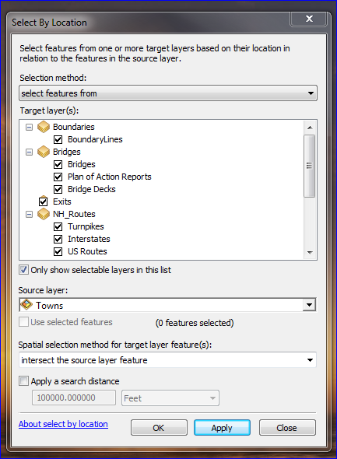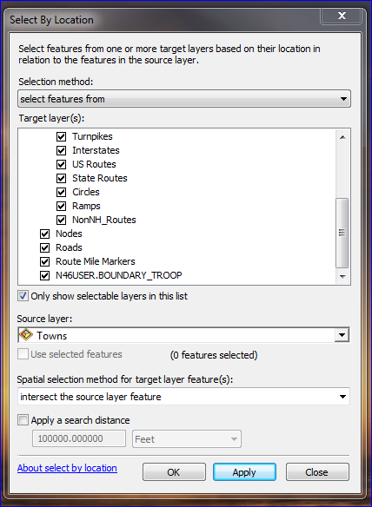

Do the following for EACH Troop section:

Click Select Tool , then click in A area. Area now lights up with blue outline
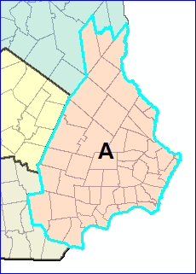

Create Shapefile for each layer by right-clicking on layer.
- Select Data-Export Data
- Rename output file to layer name. Example: for BoundaryLines layer, rename to
BoundaryLines.shp in appropriate folder
- When prompted for ‘Do you want to add the exported data to the map as a layer”” – answer ‘No

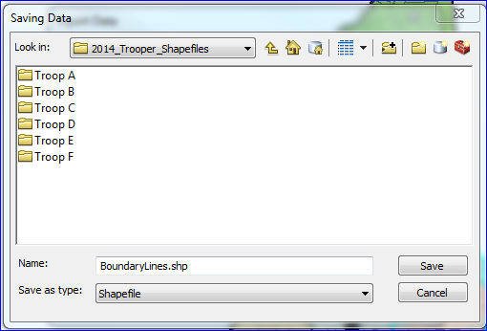

Repeat the process for each Troop, remembering to select each area before doing Layer Exports
[BoundaryLines, State, Turnpikes, Interstates, USRoutes, Circles, Nodes, Roads, Towns]

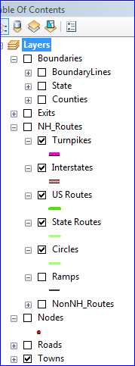

Moving Files to FTP Site

Use FileZilla to move files to State FTP site ( ftp://nhftp.admin.state.nh.us/)

Connect to DOT. Look in Quickconnect list for dot2.gis2@nhftp.admin.state.nh.us

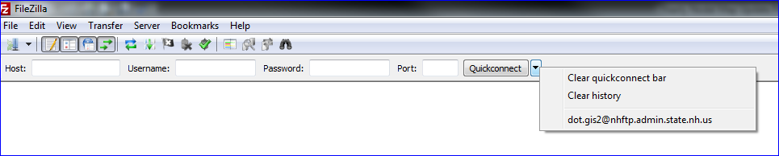

Navigate to NODAL_MAP_20xx folder to find Troop Files (Get screen shots or details from Wayne)

