Broadband Mapping
in Coos County, New Hampshire

Grantee:
Earth Systems Research Center
University of New Hampshire
8 College Road
Durham, NH 03824

NBRC Project Number NBRC-14-G-NH-00005
October 1, 2014 – June 30, 2016

Report Submitted:
July 30, 2016

Report Submitted by:
Fay Rubin
Project Director
Earth Systems Research Center
Durham, NH 03824
(603) 862-4240

Name of Project:  Broadband Mapping in Coos County, New Hampshire | NBRC Project Number:  NBRC-14-G-NH-00005
Grantee Name:  Earth Systems Research Center, University of New Hampshire | Grant Period:  October 1, 2014 – June 30, 2016
Project Director:  Fay Rubin | NBRC Grant Amount:  $102,442

Background:
Broadband “high speed internet access” has clearly become an integral part of the New Hampshire’s economy. It is critical for creating and maintaining jobs and for supporting public safety, education, healthcare, tourism, business, and our overall quality of life. The state must continually promote expanded broadband access and adoption in order to remain competitive with our neighboring states, with Canada, and globally. To do so effectively, a thorough understanding of the ever changing broadband landscape is required.
The New Hampshire Broadband Mapping & Planning Program (NHBMPP) began in 2010 as a comprehensive program that seeks to understand where broadband is currently available in NH, how it can be made more widely available in the future, and how to encourage increased levels of broadband adoption and usage. Housed at the University of New Hampshire and initially funded by the National Telecommunications and Information Administration through the American Recovery and Reinvestment Act, the NHBMPP comprises two main components: a broadband availability inventory and mapping effort, and a suite of planning and technical assistance initiatives. “Broadband Mapping in Coos County, New Hampshire” was an effort to extend the broadband availability mapping and related outreach activities of the NHBMPP, focusing on areas of northern New Hampshire where gaps in broadband availability persist.

Activities:
The Coos County project integrated data collection, data analysis, and data visualization/map generation, in order to: 1) provide an enhanced and ongoing picture of the broadband landscape in Coos County by identifying areas that are unserved/underserved; 2) work with communities, regional agencies, and providers to ensure that they are aware of the broadband gaps identified; and 3) utilize geospatial modeling tools to deliver a generalized cost estimate for additional broadband deployment in Coos County.

An important decision point faced by the NHBMPP project team early in the project was how to define broadband. In 2015, the Federal Communications Commission (FCC) released an updated broadband standard, defining broadband as a minimum download speed of 25 Mbps and a minimum upload speed of 3 Mbps (see Federal Communications Commission, “2015 Broadband Progress Report”, https://www.fcc.gov/reports-research/reports/broadband-progress-reports/2015-broadband-progress-report). The NHBMPP project team adopted this definition of broadband to guide its data collection and processing efforts.
The primary project activities completed were:

- Data Collection relied on several input mechanisms. While the initial intent was to solicit broadband availability data directly from providers, it was quickly apparent providers were either unable or unwilling to commit the resources required to provide data directly to us and we would instead need to rely on data published by the FCC. Consequently, the NHBMPP derived broadband coverage information by accessing successive versions of the FCC Form 477 data (see https://www.fcc.gov/general/broadband-deployment-data-fcc-form-477), the latest of which incorporated provider data from June 30, 2015. The data identified census blocks served by each Coos County provider, and for each block identified the broadband technology(ies) offered and the corresponding advertised speed tiers.

A component of the data collection activity involved maintaining a list of all active broadband providers in Coos County. This was also accomplished by reviewing the FCC Form 477 data to extract the provider names. Additional information on broadband providers active in Coos County was collected from local sources, although coverage footprints associated with the additional service providers was not available.

In addition to the national availability data, the NHBMPP collected local address-level data via the online broadband speed test tool hosted on the project website (http://iwantbroadbandnh.org or http://nhspeed.org). At the project outset, the speed test tool was restricted to receiving input only from wireline-based devices. During the project period, the tool was migrated to a non-flash based environment that allowed for collecting information from both wireline and wireless-based mobile devices (tablets and phones). This migration was important to support expanded speed test access and utilization.

Several marketing efforts were undertaken to promote the use of the speed test in Coos County. A promotional postcard was developed (see Figure 1), and packets containing postcards and an associated marketing flyer were mailed to all libraries in Coos County for direct distribution to library patrons. In addition, the postcards were distributed to organizations active in broadband issues in Coos County, as well as distributed at project meetings and workshops.

Figure 1. NHBMPP Promotional Speed Test Postcard

- Data Analysis involved processing the broadband availability and speed test data to generate summary maps and tables of the results, and sharing the mapping results through coordination with partners in Coos County, through a series of local workshops, and through the production of a project summary document. The results of the analyses were also used to guide the development of a geospatial modeling tool to derive generalized cost estimates for additional broadband deployment in Coos County. Each of these elements is described further below.

Broadband Availability Mapping: The data collected from the FCC, the speed test tool, and other sources was processed to generate tabular data summarizing the population of New Hampshire, and Coos County specifically, that is considered served, underserved, and unserved. Table 1 presents the results across all technologies, including fixed wireline, fixed wireless, cellular, and satellite deployments. As shown, 25,820 persons in Coos County, representing just over 78% of the 2010 population of 33,055, have broadband service available. Note that this figure is significantly lower than the state figure, with almost 94% of the statewide population having access to broadband. An additional 5,587 persons, or almost 17% of the population, are considered underserved because they have access to the internet at speeds that are not considered broadband. Finally, 1,648 persons, or 5% of the population, have no access.
Table 1. Broadband and Other Internet Availability in New Hampshire by County – All Technologies
 |  | Served  (25+ Mbps down x  3+ Mbps up) |  | Underserved -  Other Internet Access  (6-25 Mbps down x  1.5-3 Mbps up) |  | Unserved  (< 6 Mbps down x  <1.5 Mbps up)
County | Total Population (2010) | Population | % | Population | % | Population | %
Belknap | 60,088 | 57,917 | 96.4% | 2,149 | 3.6% | 22 | 0.0%
Carroll | 47,818 | 46,157 | 96.5% | 1,638 | 3.4% | 23 | 0.0%
Cheshire | 77,117 | 58,363 | 75.7% | 18,148 | 23.5% | 606 | 0.8%
Coos | 33,055 | 25,820 | 78.1% | 5,587 | 16.9% | 1,648 | 5.0%
Grafton | 89,118 | 80,724 | 90.6% | 8,203 | 9.2% | 191 | 0.2%
Hillsborough | 400,721 | 381,214 | 95.1% | 19,470 | 4.9% | 37 | 0.0%
Merrimack | 146,445 | 135,196 | 92.3% | 11,153 | 7.6% | 96 | 0.1%
Rockingham | 295,223 | 292,870 | 99.2% | 2,353 | 0.8% | 0 | 0.0%
Strafford | 123,143 | 120,217 | 97.6% | 2,926 | 2.4% | 0 | 0.0%
Sullivan | 43,742 | 35,483 | 81.1% | 8,199 | 18.7% | 60 | 0.1%
State of New Hampshire | 1,316,470 | 1,233,961 | 93.7% | 79,826 | 6.1% | 2,683 | 0.2%

Table 2 presents the corresponding data with cellular and satellite based technologies excluded. These technologies are omitted in recognition of the potential limitations associated with latency, reliability, and data caps. As shown, availability in Coos County decreases to 23,491 persons or approximately 71% of the population with access to broadband. Again, Coos County residents are at a considerable disadvantage relative to the rest of the state with respect to broadband access. An additional 4,431 persons in Coos County, or 13% of the population, have other internet access. Perhaps of most significance, over 5,000 persons, or 15.5% of the population, are without access based on wireline and fixed wireless technologies.
Table 2. Broadband and Other Internet Availability in New Hampshire by County – Excluding Cellular and Satellite Technologies
 |  | Served  (25+ Mbps down x  3+ Mbps up) |  | Underserved -  Other Internet Access  (6-25 Mbps down x  1.5-3 Mbps up) |  | Unserved  (< 6 Mbps down x  <1.5 Mbps up)
County | Total Population (2010) | Population | % | Population | % | Population | %
Belknap | 60,088 | 57,877 | 96.3% | 46 | 0.1% | 2,165 | 3.6%
Carroll | 47,818 | 45,674 | 95.5% | 521 | 1.1% | 1,623 | 3.4%
Cheshire | 77,117 | 55,050 | 71.4% | 5,199 | 6.7% | 16,868 | 21.9%
Coos | 33,055 | 23,491 | 71.1% | 4,431 | 13.4% | 5,133 | 15.5%
Grafton | 89,118 | 80,705 | 90.6% | 2,730 | 3.1% | 5,683 | 6.4%
Hillsborough | 400,721 | 380,362 | 94.9% | 1,191 | 0.3% | 19,168 | 4.8%
Merrimack | 146,445 | 135,030 | 92.2% | 305 | 0.2% | 11,110 | 7.6%
Rockingham | 295,223 | 292,849 | 99.2% | 40 | 0.0% | 2,334 | 0.8%
Strafford | 123,143 | 120,176 | 97.6% | 73 | 0.1% | 2,894 | 2.4%
Sullivan | 43,742 | 35,320 | 80.7% | 229 | 0.5% | 8,193 | 18.7%
State of New Hampshire | 1,316,470 | 1,226,534 | 93.2% | 14,765 | 1.1% | 75,171 | 5.7%

It is important to note that the availability figures in Tables 1 and 2 report on the number of persons who have access to broadband without regard to cost. Clearly not all people who have broadband available to them subscribe to services, with cost, lack of understanding of the benefits, and/or lack of interest contributing to the decision to not subscribe.
Figures 2 and 3 below presents the geographic distribution of the availability data for all technologies and with cellular and satellite technologies excluded, respectively. As shown, residents of southern Coos County have the best access to broadband, while those in the northern tier of the County have few if any options to access the Internet.

Figure 2. Broadband Availability in Coos County - All Technologies
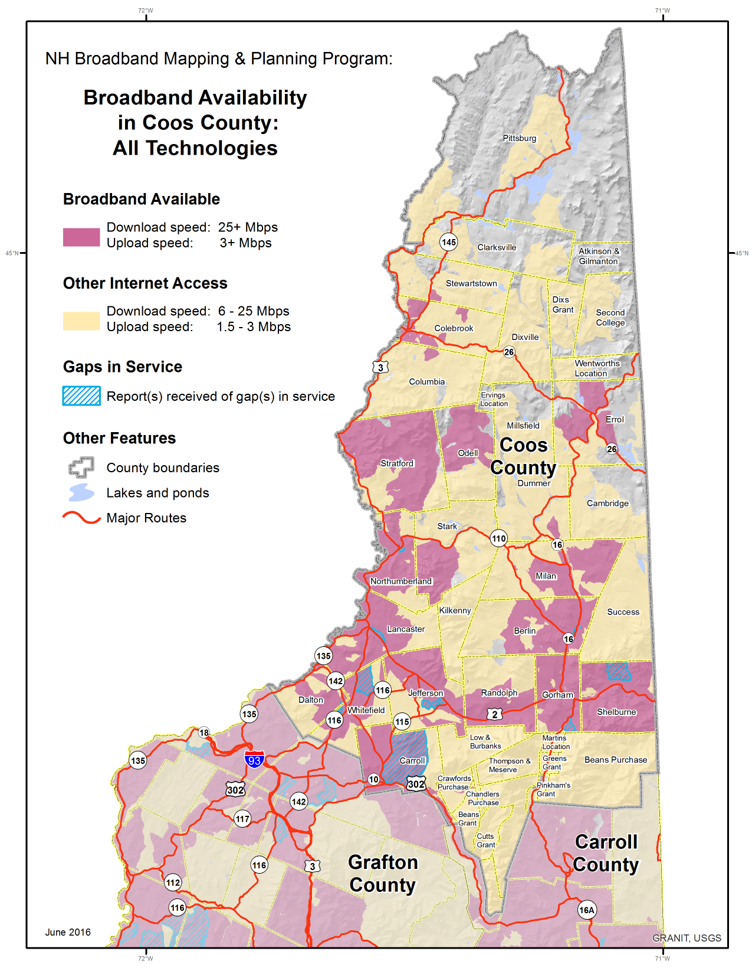
Figure 3. Broadband Availability in Coos County – Excluding Cellular and Satellite Technologies
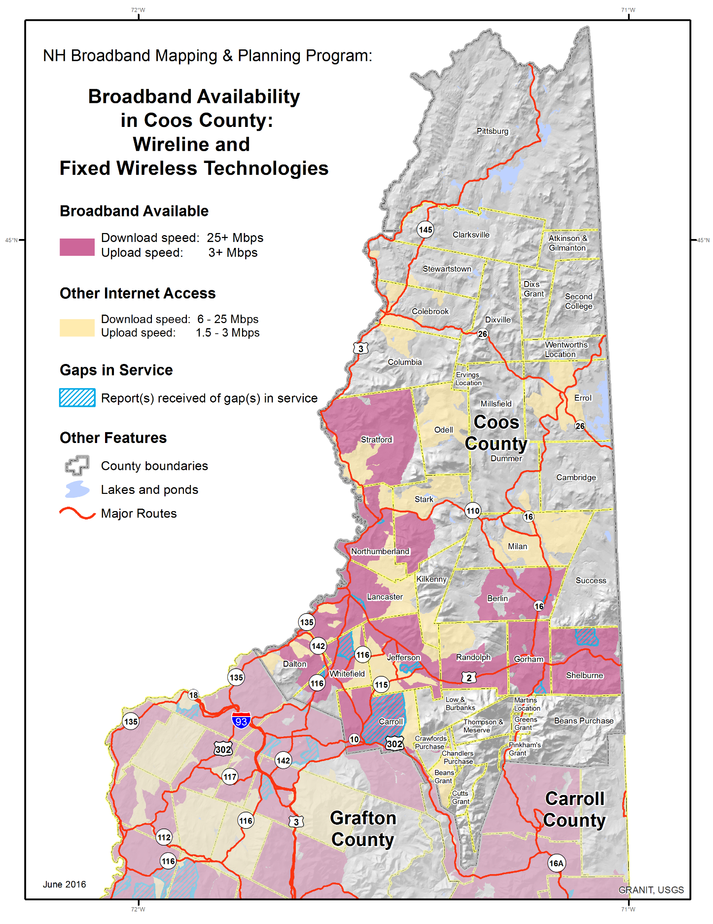
The broadband availability tables (Tables 1 and 2) and figures (Figures 2 and 3) are based on the list of broadband providers presented in Table 3 below. This provider list was generated from the June 2015 FCC Form 477 data, and does not include a number of providers who are known to offer service in Coos County but who did not submit data to the FCC.
Table 3. Coos County Internet Service Providers¹
Technology | Provider | Class of Service
Cable | Time Warner Cable Inc. | Business/Residential
Cellular | AT&T Mobility LLC | Residential
 | United States Cellular Corporation | Residential
 | USAT Corp. | Residential
 | Verizon Wireless | Business
Fiber | Bretton Woods Communications | Business
 | PAETEC Communications Inc. | Business
Fixed Wireless | King Street Wireless, L.P. | Business/Residential
 | Wireless LINC/NCIC | Business/Residential
Satellite | dishNET Satellite Broadband, L.L.C. | Residential
 | GCI Communications, Corp. | Business
 | HNS License Sub, LLC | Business/Residential
 | Skycasters, LLC | Business/Residential
Copper-Wireline (T1) | BayRing Communications | Business
 | EarthLink Business, LLC | Business
 | MCI (Verizon Business) | Business
xDSL | FairPoint Communications | Business/Residential
xDSL, Fiber | FirstLight | Business
¹Other providers offer service in Coos County (including TCC Networks/Skywire, Fibercast, etc.) and some providers listed may offer additional types of services (including FairPoint), but information on the footprints they serve was not part of the FCC data set at the time of this report.

Speed Test Data:
Table 4 below summarizes the speed test data collected via the tool hosted on the NHBMPP web site and accessible at http://nhspeed.org. Data was collected from 114 testers in 19 municipalities in Coos County. The results were aggregated to indicate the average download and upload speeds and the range of test results from each location.
The test results are important data elements that contribute to mapping and monitoring broadband access in the state. They also provide a means to verify that the actual, delivered speeds are within an acceptable range of the services advertised by broadband providers.

Table 4: Coos County Speed Test Data
 |  | Average Download Speed  (Mbps) |  | Average Upload Speed  (Mbps)
Town | # of Speed Tests | Average | Range | Average | Range
Berlin | 24 | 3.285 | .150-10.441 | 1.027 | .098-3.929
Carroll | 3 | 1.513 | .124-2.329 | 6.232 | .121-18.354
Colebrook | 10 | 3.637 | .681-8.222 | 3.506 | .131-11.945
Dalton | 5 | 1.897 | 1.276-3.127 | 0.897 | .047-1.666
Dummer | 3 | 3.639 | 2.508-4.657 | 1.047 | .737-1.507
Errol | 1 | 5.885 | 5.885-5.885 | 0.965 | .965-.965
Gorham | 7 | 2.944 | .587-10.164 | 3.980 | .369-12.370
Jefferson | 11 | 3.907 | .807-6.542 | 1.689 | .117-5.344
Lancaster | 12 | 5.679 | .673-16.269 | 2.111 | .261-11.235
Milan | 4 | 3.225 | 1.367-5.549 | 1.371 | .486-3.381
Northumberland | 3 | 3.821 | 1.936-5.230 | 1.566 | 1.069-1.933
Pittsburg | 8 | 2.195 | .661-4.083 | 0.702 | .118-1.680
Randolph | 1 | 7.081 | 7.081-7.081 | 0.665 | .665-.665
Shelburne | 4 | 3.221 | .842-8.139 | 0.716 | .101-1.054
Stark | 2 | 1.912 | 1.124-2.700 | 2.938 | 1.482-4.394
Stewartstown | 1 | 0.176 | .176-.176 | 0.065 | .065-.065
Stratford | 1 | 5.490 | 5.490-5.490 | 0.968 | .968-.968
Wentworths Location | 1 | 0.048 | .048-.048 | 0.113 | .113-.113
Whitefield | 13 | 3.095 | .105-8.110 | 0.756 | .045-2.936
Coos County | 114 | 3.416 | .048-16.269 | 1.710 | .045-18.354

Partner Coordination: Partner coordination was achieved through a series of videoconferencing meetings throughout the project. Generally, the purpose of the meetings was to update all partners on the progress of the various broadband-related activities ongoing in Coos County, to demonstrate to external partners the tools and resources developed by the NHBMPP, and to plan for the workshops and meetings held in Coos County and described below.
Workshops: Results of the data collection and analysis were shared with Coos County stakeholders through a series of three sector-targeted workshops (see Attachments 1-3 for workshop agendas). The first workshop was held in November of 2015 at Colebrook Academy, Colebrook, NH, and focused on the education and health care sectors. The program included an overview of broadband technology, a review of the broadband availability data as of the workshop date, and two sections looking at the use of video-conferencing equipment to support educational programming and health care in northern New Hampshire. The workshop included a live demonstration of using two-way high definition video technology in a teaching environment. Attendance at the workshop included town officials, emergency service providers, Chamber of Commerce staff, UNH Cooperative Extension outreach staff, and staff from the regional planning commission.
The second workshop was convened in March of 2016 at the Town & Country Inn and Resort, Gorham, NH. This session, co-sponsored by the Women’s Rural Entrepreneurial Network (WREN), focused on small business activity. The program again included a technology overview and summary of broadband availability, which was followed by a “digital audit” of the Berlin/Gorham region and a review of social media options for promoting small business activities. The successful workshop was attended by 26 participants, representing small businesses, communities, regional planning agencies, planning boards, downtown associations, and others. Press coverage was provided by NHPR as well as local/national newspapers (see Attachment 4).

The third workshop, held in June of 2016 at the Mountain View Grand Resort, Whitefield, NH, was similar in content for the first two components. The focus of the remainder of the workshop, however, was on broadband use for municipalities and public safety. Presenters discussed the Hanover Special Assessment District(s), the North Country Cell and Internet Service Project, and the NH FirstNet initiative. Participants included local officials (including planning board members, police department members, and others), staff from regional dispatch and transport centers, staff from regional planning agencies, representation from Senator Shaheen’s office, and several representatives of FairPoint.
“Broadband in 2015: Coos County”: The NHBMPP project team also shared the mapping results through the production of a separate report that describes “current conditions” with respect to broadband in Coos County (provided under separate cover). It presents an informative and easy-to-read summary of the status of broadband availability, and also discusses several of the current broadband programs and initiatives in the County. The report is being distributed via the NHBMPP web site as well as the UNH Broadband Center of Excellence web site (http://bcoe.unh.edu). Along with selected materials from the above workshops, it has also been integrated into the NH Telecommunications Advisory Board (TAB) 2016 annual report.
Geospatial Modeling to Estimate Cost of Broadband Deployment: The results of the data analysis were used in developing a generalized geospatial model that estimates the cost of additional fiber-based broadband deployment to unserved/underserved areas of Coos County (see Attachment 5). Fiber was considered for broadband expansion because it represents one technology that appears to have unlimited capacity to deliver high transmission speeds. The intent of the analysis was not to complete a make-ready estimate, but rather, to provide to communities a level of magnitude of costs associated with building out fiber to unserved areas.

Two communities – Northumberland and Berlin - were selected for the fiber expansion modeling activities. These two towns were chosen primarily due to the presence of Network NH Now (NNHN) fiber optic lines (see http://unh.edu/networknhnow). Additionally, each community has a relatively dense downtown area, with the balance of the town’s population widely dispersed throughout the remaining areas of the town.

The modeling activity utilized the processed FCC broadband availability data, the fiber line footprint provided by NNHN, road centerline data, and parcel data. Using geospatial tools to analyze these data, the model identified properties beyond the existing NNHN fiber line footprint. It then applied estimated average costs of $50,000 per road mile to extend fiber to these properties in conjunction with an average per property tie-in cost of $11,250. The generalized estimates produced for each town are provided in Table 5 below.

Table 5: Generalized Model Results for Fiber Buildout
Town | Total Number of Properties | Number of Properties Beyond NNHN Fiber Extent | Total Estimated Fiber Expansion Cost
Berlin | 5,968 | 5,156 | $65.5m
Northumberland | 1,531 | 1,218 | $16.2m

Based on these relatively high costs of expansion based on FTTH, communities may be well-served to explore hybrid solutions that combine fiber along the roadways with wireless service to the individual home.

- Data Visualization was primarily achieved through maintaining and updating the NHBMPP project web site (http://iwantbroadbandnh.org, see Figure 4), including designing a new graphic interface to make the site more intuitive and engaging. The site provides access to updated speed test data and statistics, static maps, and project reports. In addition, the site includes an interactive mapping tool that allows users to query the current broadband availability data, view the speed test data, and generate custom displays (see Figure 5). The website also hosts general information about NHBMPP activities past and present.

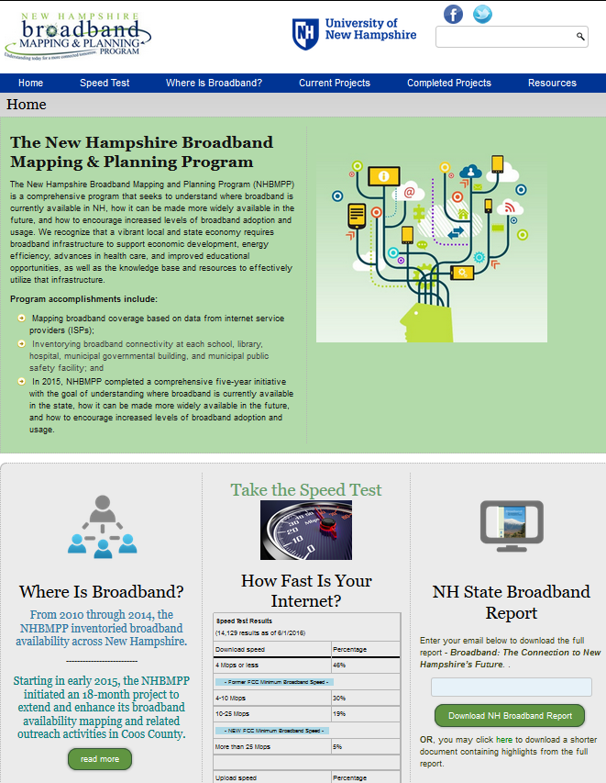
Figure 4. Home page for NHBMPP web site

Figure 5. Interactive Mapping Tool hosted on NHBMPP web site
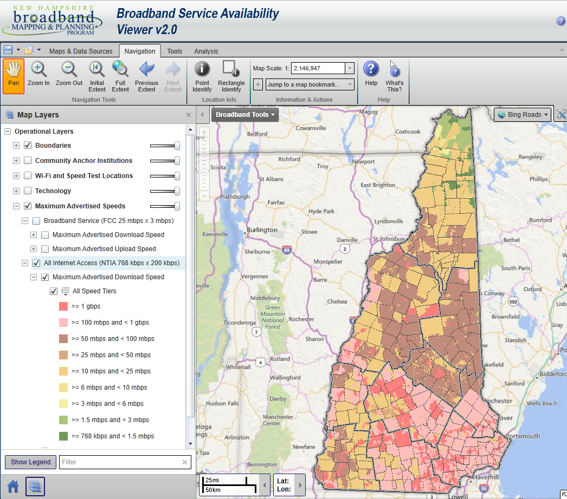

Project Outcomes:
Raising awareness, promoting change, building partnerships and coordinating public/private efforts take time and make it challenging to document short term project outcomes. However, one clear outcome is Coos County needs to expand broadband access to underserved and unserved areas in order to remain viable and competitive on many fronts. The project outputs, including maps, tables, modeling analyses, reports, and workshops, collectively served to provide to partners, stakeholders and the general public current information on areas in the County with and without access to broadband. They also identified providers offering broadband service to Coos County, as well as information on the technologies and advertised/delivered speeds associated with those technologies. The community engagement and partner collaboration components helped to achieve coordination in existing broadband initiatives, and to determine what additional efforts may be necessary to encourage expanded broadband deployment.

In the longer term, the resources developed help to provide decision-makers with the data and tools needed to expand broadband infrastructure in Coos County, which in turn will extend their use of broadband in furtherance of their programmatic goals. Expanded access to broadband will improve the economy, enhance business, support public safety and advances in health care, improve educational opportunities, and enhance the overall quality of life.

Problems Encountered:
At the outset of the effort, the project team identified a number of potential project partners who we hoped would participate with us in meetings and workshops with stakeholders as well as in preparing project documents and reports. These potential partners were largely organizations engaged in broadband-related activities in Coos County, and included entities involved in deployment initiatives, direct broadband providers, and others interested in broadband expansion in northern NH. In some instances, we were not able to fully engage these partners in our discussions around broadband expansion.

One of the problems the NHBMPP encountered in mapping broadband availability in New Hampshire is the quality of the data available. Because of limited resources, the Program relied on data published by the FCC to estimate and map broadband availability in the state. While this information was augmented with locally-collected data, for example data collected via the project speed test tool, the fundamental properties of the FCC data present important limitations. The most significant problem is that of data generalization to the Census block level. Because a single address in a Census block served by broadband results in the entire block being considered served, this level of data aggregation likely yields broadband coverage data that is overstated. A second issue with the FCC data is the lack of provider participation. In Coos County, for example, the NHBMPP was aware of broadband providers who did not submit their data to the FCC and therefore were not represented in the NHBMPP mapping results. As a result, there is likely some under-representation of broadband availability in the project maps and tables. These issues arose at the start of the NHBMPP in 2010, and continue to impact the accuracy and credibility of the data we report.

The data issues could be addressed by allocating significantly more resources to the mapping project, thereby accommodating direct collection of data from the providers to the NHBMPP and avoiding reliance on the data published by the FCC. A more modest approach to address the data quality issues would be to devote more project resources to promoting the project speed test tool and thereby maximizing access to locally collected data.

Program Continuation and Sustainability:
The NHBMPP is currently and will continue to seek opportunities to maintain its broadband mapping activities. However, at the conclusion of this project, efforts to process FCC data on broadband availability and to maintain the local speed test tool(s) will end if no new resources are identified. If that does occur, the speed test data will be archived in the GRANIT Clearinghouse. GRANIT has been hosted at UNH since the mid 1980’s, is recognized as the state’s GIS Clearinghouse, and receives annual financial support from a number of NH state agencies.

Conclusions and Recommendations:
Broadband, or high-speed Internet access, is critical infrastructure to ensure that the state’s residents and businesses are connected locally, nationally, and globally. Currently, broadband in Coos County is available to approximately 78% of the residents, and there remain significant areas with limited or no broadband access. While progress is being made to improve access, Internet Service Providers, businesses, decision makers, and concerned citizens need to work together to expand access to ensure the tools are available for creating and maintaining jobs and for supporting public safety, education, healthcare, tourism, business, and the overall quality of life.
In addition, the cost of broadband service makes it unaffordable to a number of New Hampshire businesses and residents. Much of the state has coverage from only one or two wire-line broadband providers, and this lack of competition can lead to higher prices, while not increasing available speeds. New Hampshire needs to encourage competition among providers to bring the lowest possible cost to consumers.
Not all residents of Coos County who have access to affordable broadband services take advantage of the opportunities. Many small businesses and residents are unaware of the wide range of applications, information, communication and services available on-line. New Hampshire needs to continue to coordinate, promote, and sponsor trainings for residents, businesses, and organizations on the benefits of broadband usage. Increased skills and knowledge of broadband applications encourages broadband use and will lead to a well-educated, prosperous, healthy, and a safe New Hampshire.
Finally, New Hampshire needs to monitor, inventory, and evaluate its broadband availability, affordability, adoption, and competitive position on an ongoing and regular basis. Continuing to collect statewide broadband availability and adoption data is necessary in order to measure the effectiveness of broadband efforts and to provide a clear picture of New Hampshire’s broadband competitive position in comparison to other states, to Canada, and globally.

List of Attachments:
- Workshop 1 Agenda – November, 2015
- Workshop 2 Agenda – March, 2016
- Workshop 3 Agenda – June, 2016
- Press Coverage - Workshop 2, March 2016
- Summary of FTTH Modeling Results

Attachment #1: Workshop 1 Agenda, November 2015

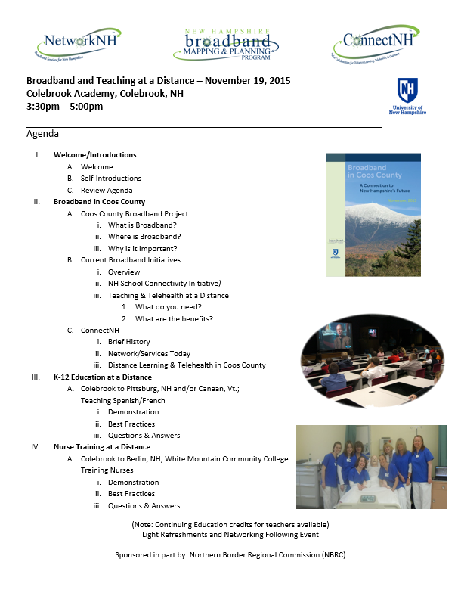

Attachment #2: Workshop 2 Agenda, March, 2016

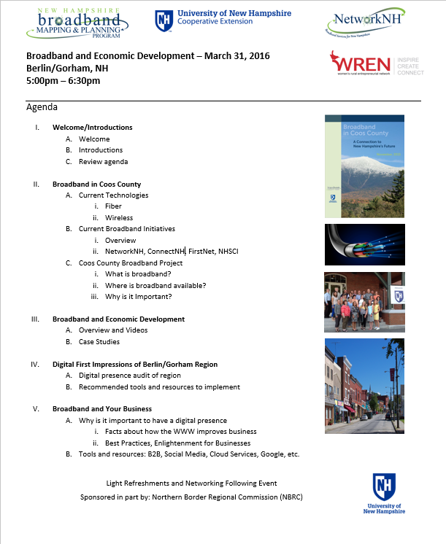\

Attachment #3: Workshop 3 Agenda, June 2016

Attachment #4: Press Coverage – Workshop 2, March 2016

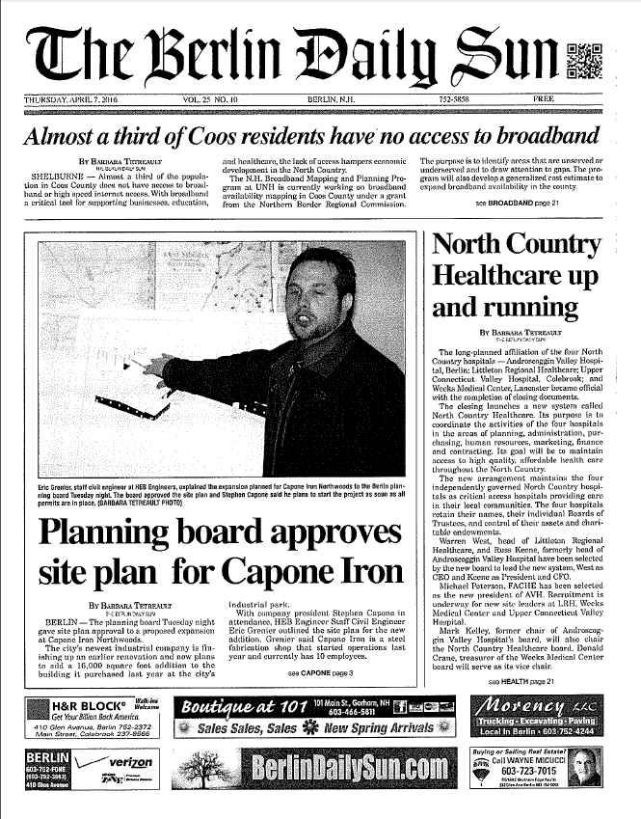

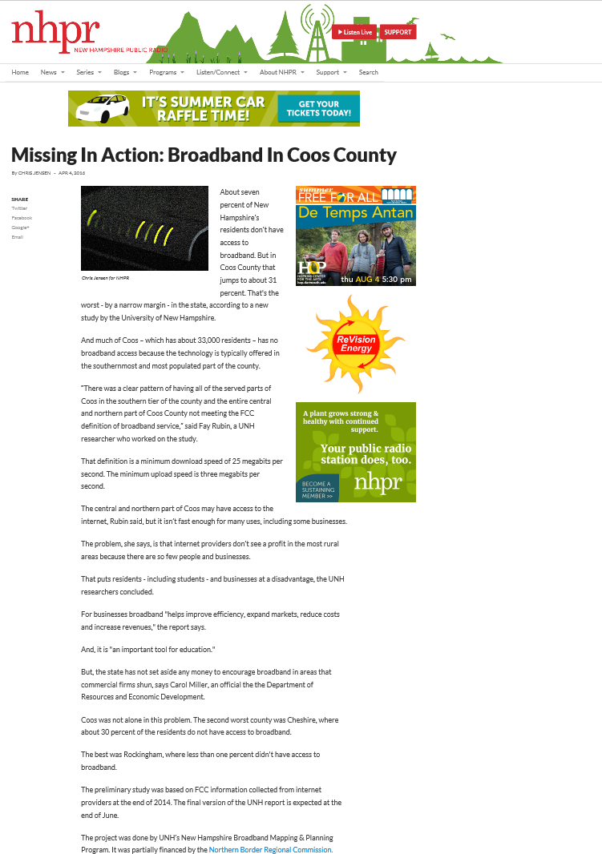

(http://nhpr.org/post/missing-action-broadband-coos-county)
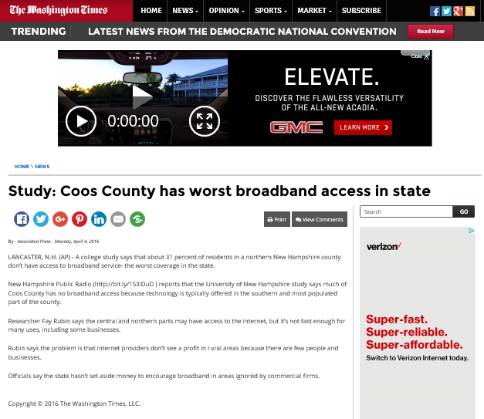
(http://www.washingtontimes.com/news/2016/apr/4/study-coos-county-has-worst-broadband-access-in-st/)

Attachment #5: Summary of Modeling Results

Fiber Build-out Cost Modeling
As part of a larger effort to map broadband availability in Coos County, New Hampshire, and to provide a suite of related technical resources to local communities, the New Hampshire Broadband Mapping & Planning Program (NHBMPP) developed a basic geospatial model to estimate the cost of building out fiber in underserved and unserved areas of northern New Hampshire. The model was not intended to produce make-ready estimates, but rather, to provide communities with a general cost estimate that could be utilized in evaluating options for broadband expansion into their unserved and underserved areas.

Why consider fiber for broadband expansion?
Fiber optic broadband offers a technology that appears to have effectively unlimited capacity to deliver high transmission speeds with very little interference over long distances. Fiber optic deployments are today reaching speeds of up to 1 gpbs and greater. In addition, Fiber to the Home (FTTH) or Fiber to the Premise (FTTP) enables providers to make available “symmetrical circuits” that deliver the same upload and download speeds. As applications like high-definition videoconferencing and those that back up large databases to the Cloud have become more prevalent, the need for symmetrical circuits has increased.
FTTH or FTTP solutions can be expensive, with costs depending on many factors. To mitigate these high costs, hybrid networks are being built, i.e. combining fiber, wired and wireless technologies. However, hybrid networks typically provide broadband access to end users at slower speeds.
To focus on the best technology available today, the NHBMPP opted to evaluate FTTH or FTTP in its modeling efforts. We utilized a suite of geospatial data and tools to develop a model that estimates the cost of fiber expansion that would bring fiber directly into homes, businesses, organizations, hospitals, government offices, etc.

The geospatial modeling approach
The NHBMPP geospatial modeling included the following steps:

- Map Network NH Now fiber network;
- Buffer the fiber network by 200’;
- Identify streets and properties that are within the buffered areas (e.g. potentially served areas), and streets and properties outside of these areas (e.g. unserved areas);
- Summarize street mileage and number of properties in the unserved areas; and
- Using industry standard cost estimates, generate an approximate cost per community to extend service into unserved areas.

The average cost per mile and connection estimates used in the analysis were developed by Network NH Now (see http://unh.edu/networknhnow) - NH’s Broadband Technology Opportunities Program which built 865 miles of fiber optic network extending into all 10 counties in New Hampshire. The figures included:

- Average cost per mile to lay fiber along the roadway: $50,000
- Average cost per property to connect to fiber: $11,250

Data sets utilized in the analysis were as follows:
- FCC Form 477 data, June 2015 version (see https://www.fcc.gov/general/broadband-deployment-data-fcc-form-477)
- Network NH Now fiber line footprint
- NH Road Centerlines, NH Department of Transportation, 2015
- NH Parcel Mosaic, NH Department of Revenue Administration, 2015

Two Coos County communities – Northumberland and Berlin - were selected for the fiber expansion modeling activities. These two towns were chosen primarily due to the presence of Network NH Now fiber. Additionally, each community has a relatively dense downtown area, with the balance of the town’s population widely dispersed throughout the remaining areas of the town.

The results

- Town of Northumberland
Results for the Northumberland analysis are presented in the table below:
Total number of properties | 1,531
Number of properties outside of NNHN 200’ buffer | 1,218
Linear miles of roadway outside of NNHN 200’ buffer | 50
Cost of fiber deployment | $16.2 m

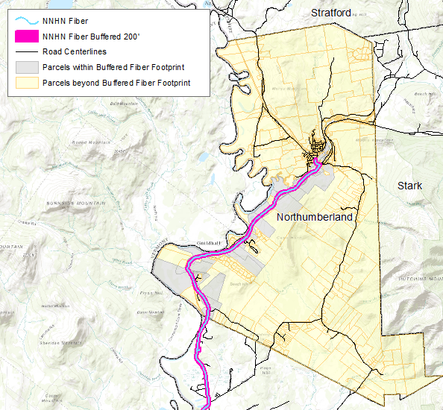
The figure to the right illustrates the geospatial data layers used in the analysis. Note the NNHN buffered footprint used to identify intersecting parcels (mapped in gray) and non-intersecting parcels (mapped in yellow).
The analysis is based on connecting each of the yellow parcels to NNHN fiber.

- Town of Berlin
Results for the Berlin analysis are presented in the table below:
Total number of properties | 5,968
Number of properties outside of NNHN 200’ buffer | 5,156
Linear miles of roadway outside of NNHN 200’ buffer | 150
Cost of fiber deployment | $65.5 m
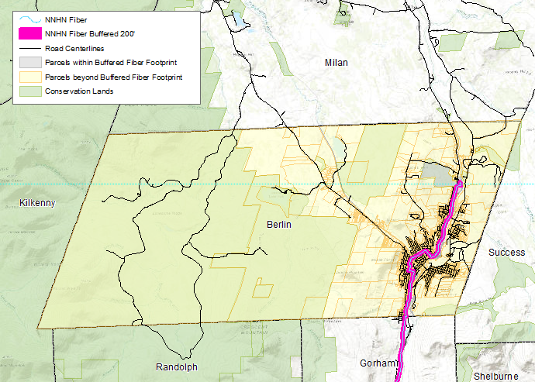
As above, the figure to the right displays the mapping data used in the analysis.

Next steps
Given the high cost of fiber deployment, it is recommended that any community considering broadband expansion conduct a feasibility study. The study should:
- Develop sustainable strategy(s) to promote comprehensive broadband access and utilization;
- Identify potential public/private partnerships in the community;
- Develop a reasonable assessment of the opportunities for the community, covering 1) the most viable and sustainable business, financial and operational models including one-time and recurring third-party funding sources (ERate, grants, etc.), and 2) the deployment plan that will enable the community to take advantage of these opportunities in conjunction with broadband‐friendly public policy development;
- Conduct a residential and business survey in order to gauge:
- Willingness and desire to change internet service providers
- Interest in and demand for higher bandwidth service and the costs associated with that service

Additional resources
The NHBMPP Broadband Solutions and Funding Toolkit available at http://iwantbroadbandnh.org/toolkit is a collection of resources to support local broadband planning in New Hampshire. Sections cover organizing a committee of local stakeholders, informing your stakeholders about broadband technologies, assessing the state of broadband in your community, creating a community plan for broadband, implementing an action plan, and understanding funding options. Armed with this information, a community can enhance broadband access to meet future economic, education, and communication needs.
Funding for broadband initiatives may require multiple sources to reach the level of investment needed by your community. Successful funding strategies could consist of combining resources from residents, businesses, municipalities, counties, and state resources. Other funding sources could include foundation funds, development corporations, and bank financing. Your strategy should be guided by how much capital you need to raise, and then finding resources to fund portions or all of the project. Broadband Communities Magazine has developed “Broadband Communities’ interactive FTTH Financial Analyzers” designed to help evaluate the financial viability of FTTH projects. Whether you are considering an FTTH network deployment or have a project under way, these tools aid in evaluating the financial implications of your project.

