DEVELOPING 2010 HIGH-RESOLUTION IMPERVIOUS COVER ESTIMATES
FOR SELECTED TOWNS IN THE PISCATAQUA REGION ESTUARIES PARTNERSHIP

A Final Report to

The Piscataqua Region Estuaries Partnership

Submitted by

David Justice and Fay Rubin
Earth Systems Research Center
Institute for the Study of Earth, Oceans and Space
Morse Hall
University of New Hampshire, Durham, NH 03824

October, 2015

This report was funded in part by a grant from the Piscataqua Region Estuaries Partnership as authorized by the U.S. Environmental Protection Agency’s National Estuary Program.

Table of Contents

List of Tables 2
List of Figures 2
Acknowledgements 2
Project Summary 3
Methods 3
Results 4
Discussion and Conclusions 4
References 15

List of Tables
Table 1. 2010 high-resolution impervious cover by town
Table 2. 2010 high-resolution impervious cover by subwatershed
Table 3. Comparison between high and medium-resolution impervious cover estimates for 2010

List of Figures
Figure 1. Project study area
Figure 2. Overview of impervious cover mapping
Figure 3. Large scale example of impervious cover features (in red) in the Wolfeboro, NH vicinity

Figure 4. Large scale example of impervious cover features (in red) in the Sanford, ME vicinity
Figure 5. New development seen in 2014 NAIP orthophotography (Wolfeboro, NH)
Figure 6. New development seen in 2014 NAIP orthophotography (Alton, NH)

Acknowledgements
Grateful thanks go to Alkier Villaluz Camonayan and Amanda Cugno for their diligence and perseverance while digitizing and updating the impervious cover for the study area.

Project Summary
Estimates of 2010 impervious cover (New Hampshire) and 2011 impervious cover (Maine) were generated to extend the coverage of previous work in Rockingham and Strafford Counties, New Hampshire, to include all of the Piscataqua Region Estuaries Partnership (PREP) footprint. The newly mapped area comprised the town of Alton in Belknap County, New Hampshire, the towns of Brookfield, Wakefield, and Wolfeboro in Carroll County, New Hampshire, and the towns of Acton, Berwick, Eliot, Kittery, Lebanon, North Berwick, Sanford, Shapleigh, South Berwick, Wells, and York in York County, Maine¹. With these new data, standardized, high resolution impervious cover estimates are now available for the entire PREP watershed.
Impervious features covered 3,026 acres (2.7%) in the New Hampshire towns and 13,612 acres (4.9%) in the Maine towns, with a total of 16,637 (4.3%) acres mapped in the entire study area. As expected, the more urbanized towns of Kittery (11.3%), Sanford (7.9%), Eliot (7.0%), and York (6.2%) contained the highest percentage of impervious cover.

Methods
The impervious surface mapping was based on 2010 1-foot resolution orthophotography in New Hampshire and 2011 1-meter orthophotography in Maine. Both data sets were derived primarily by visually interpreting and manually digitizing impervious cover features from the source imagery mapped at a minimum scale of 1:1,000.
In New Hampshire, data development began by classifying the 2010 orthophotography using eCognition image processing software in an attempt to capture the impervious cover. However, after reviewing the initial automated classification, it was determined that significant manual editing would be required to clean up the data. This was due in large part to the extensive amount of vegetation that partially obscured the underlying structures. As an alternative approach, road centerlines (NH Department of Transportation, 2010) were used as a starting point for the impervious surface mapping. First, all roads in the study area towns were reviewed relative to the 2010 imagery and realigned as necessary. Second, the roads were buffered based on the width reported by NH DOT to generate the initial impervious surface polygons. Third, selected polygons from the automated classification were added where appropriate. Lastly, the remaining impervious surface features were manually digitized for the vast majority of the area.
In Maine, impervious surface data from the Maine GIS (megis.maine.gov) provided the starting point. The initial data set was derived from the published 2004 imperviousness data set (based on 5-meter SPOT imagery collected in the summer of 2004), and updated with the published 2003-2007 imperviousness change data set (based on 1-meter orthophotography acquired from 2001 through 2007). The data set was then manually updated using 2011 1-meter orthophotography from the National Agriculture Imagery Program (NAIP) to reflect 2011 ground conditions.
For both New Hampshire and Maine, the preliminary impervious surface features were subject to a second level of review and verification prior to being finalized.

¹ The PREP footprint also includes very minor acreage within the town of Pittsfield in Merrimack County, New Hampshire. However, this area has no impervious surface features so was not mapped as part of this project.
It should be noted that these data were generated using slightly different methods from the 2010 high-resolution (HR) data generated for Rockingham and Strafford Counties in New Hampshire. While the base orthophotography is the same, the Rockingham and Strafford county data were generated using the automated classification/data clean-up approach and were reviewed and edited at a somewhat smaller scale (1:5000). Both HR approaches differ considerably from medium-resolution (MR) classifications used in past projects where 30-meter resolution Landsat Thematic Mapper (TM) and sub-pixel classification routines were used to generate estimates of impervious cover (see Justice and Rubin, 2006 and Justice and Rubin, 2003 for a complete processing description). As a result, the impervious cover percentages are significantly lower when compared to the results generated from the MR method. These differences are described in more detail below.

Results
The primary result of this project is an HR impervious cover data set for the towns of Alton, Brookfield, Wakefield, and Wolfeboro in New Hampshire, and the towns of Acton, Berwick, Eliot, Kittery, Lebanon, North Berwick, Sanford, Shapleigh, South Berwick, Wells, and York in Maine. Figure 1 shows the study area towns, while Figure 2 displays the impervious cover mapped within the study area.
Tables 1 and 2 summarize the impervious cover by town and subwatershed. As expected, the seacoast towns of Maine along with Sanford contained the greatest amount of impervious cover. The percent impervious cover is as follows for these towns: Kittery (11.3%), Sanford (7.9%), Eliot (7.0%), and York (6.2%). The least amount was found in Brookfield, New Hampshire (0.8%) which is a very rural community. For the subwatersheds, the greatest percentages were found in the Number One Pond-Mousam River (10.0%), Stevens Brook-Cape Neddick River (7.5%), and Portsmouth Harbor (7.4%) units. The Headwaters Cocheco River contained 0% impervious cover while The Big River and Branch River subwatersheds were covered by a meager 0.1% and 0.3% percent impervious cover respectively.
Final deliverables for the project include three impervious surface shapefiles (Belknap County, NH (partial), Carroll County, NH (partial), and southern ME), with associated FGDC-compliant metadata. All NH products are available for download from NH GRANIT (www.granit.unh.edu).

Discussion and Conclusions
One of the key discoveries revealed in this project was the difference between impervious cover estimates generated by the HR and MR approaches. This is in part due to the significant difference in the resolution of the source data (1-foot vs. 30-meter, respectively), and in part due to the different processing methodologies used (screen interpretation vs. subpixel automated classification, respectively). Table 3 shows a comparison of each method for the town level estimates and demonstrates that the MR mapping predicts a far greater amount of impervious cover than does the HR mapping. In terms of percent coverage, the MR method estimated as much as 4.5% greater impervious surface coverage than the HR method (town of Kittery). Thus it appears that the MR approach overestimates impervious cover to a significant degree. However, it is important to recognize that the MR approach provides useful trend information that can be generated from readily available satellite imagery and in a more cost-effective manner than that of the HR method.
That being said, with baseline impervious cover now generated at the HR scale, future updates will require only the addition of new development to the impervious layer. It is anticipated that orthophoto data sources such as regularly acquired NAIP imagery (1 meter resolution) can be used as base data from which to delineate features. While these data are acquired during the summer months, it is expected that new development will be sufficiently apparent to allow for the impervious cover to be adequately captured. The large red arrows in Figures 5 and 6 point to examples of new development (i.e. development since the 2010 date of this impervious mapping effort) exhibited in 2014 NAIP orthophotography for two areas in New Hampshire.
Finally, we note that attempts to automate impervious surface mapping using the eCognition classification approach were to a significant degree constrained by the lack of high resolution LiDAR topographic data for the study area. If LiDAR data were available, important “decision rules” could be developed within the image processing environment to assist in achieving improved results. Therefore, we recommend that future impervious surface mapping efforts re-visit the use of automated image classification techniques for areas with LiDAR coverage.
Figure 1. Project study area.
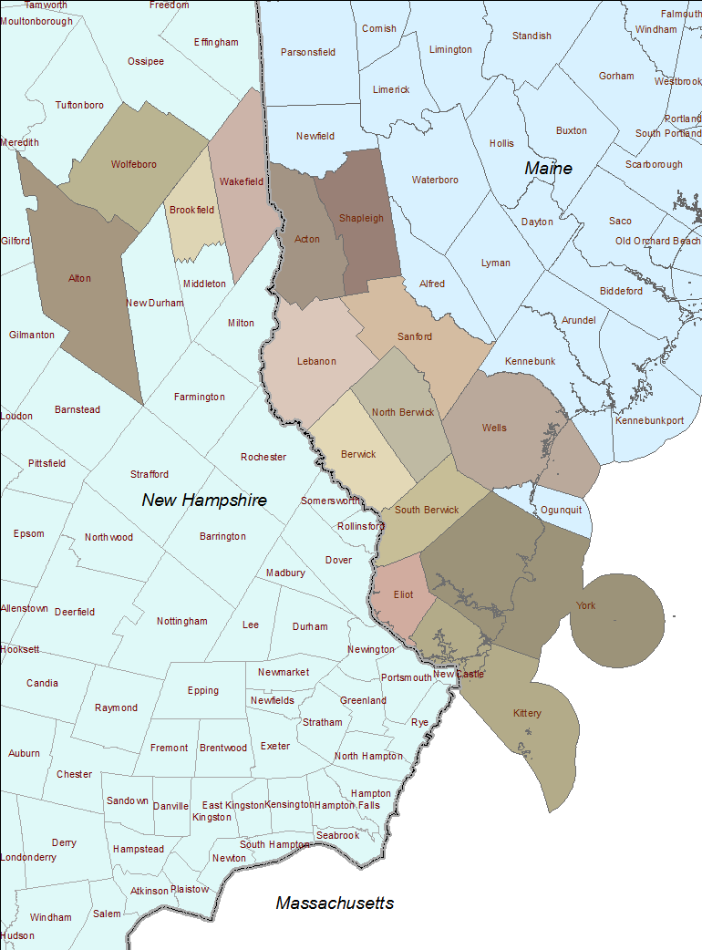

Figure 2. Overview of impervious cover mapping. Impervious features are displayed in red.
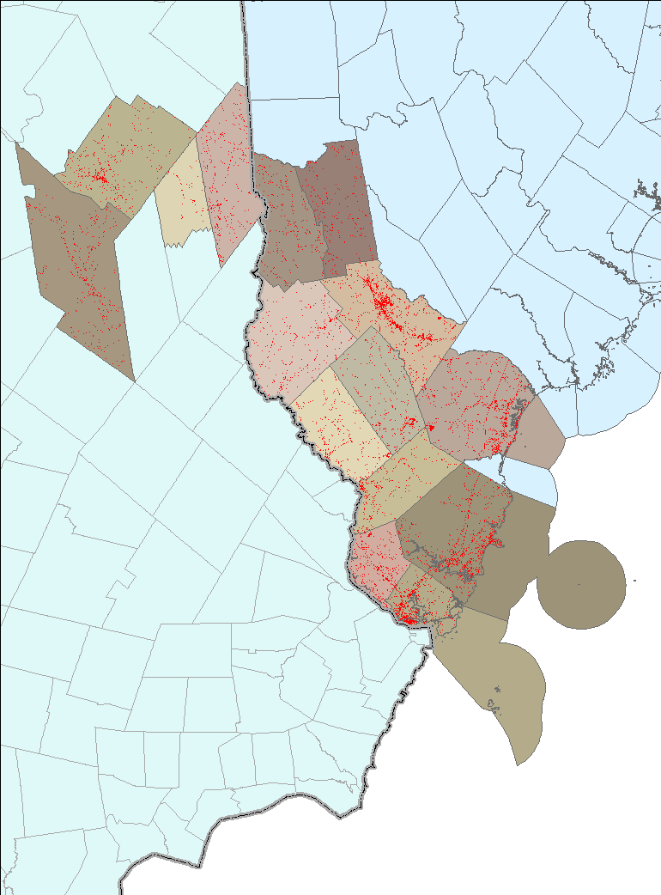

Figure 3. Large scale example of impervious cover features (in red) in the Wolfeboro, NH vicinity.
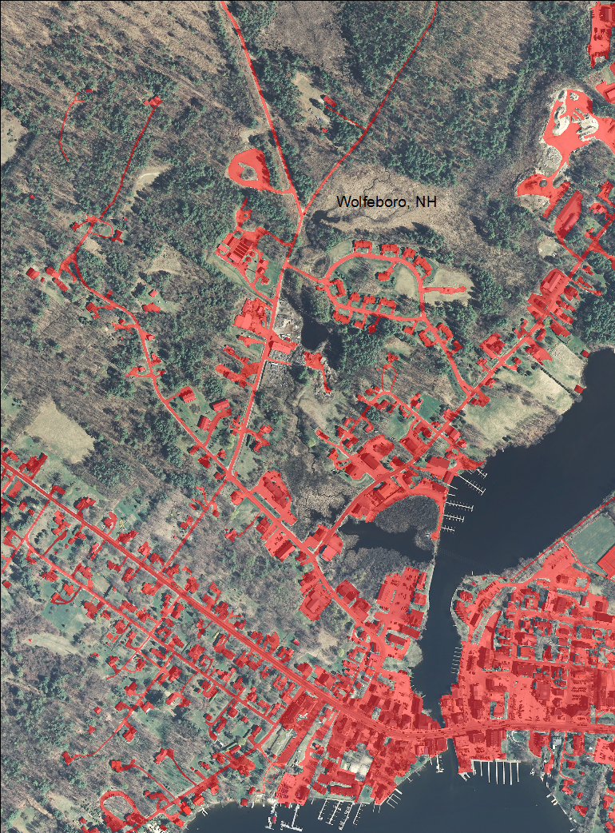

Figure 4. Large scale example of impervious cover features (in red) in the Sanford, ME vicinity.
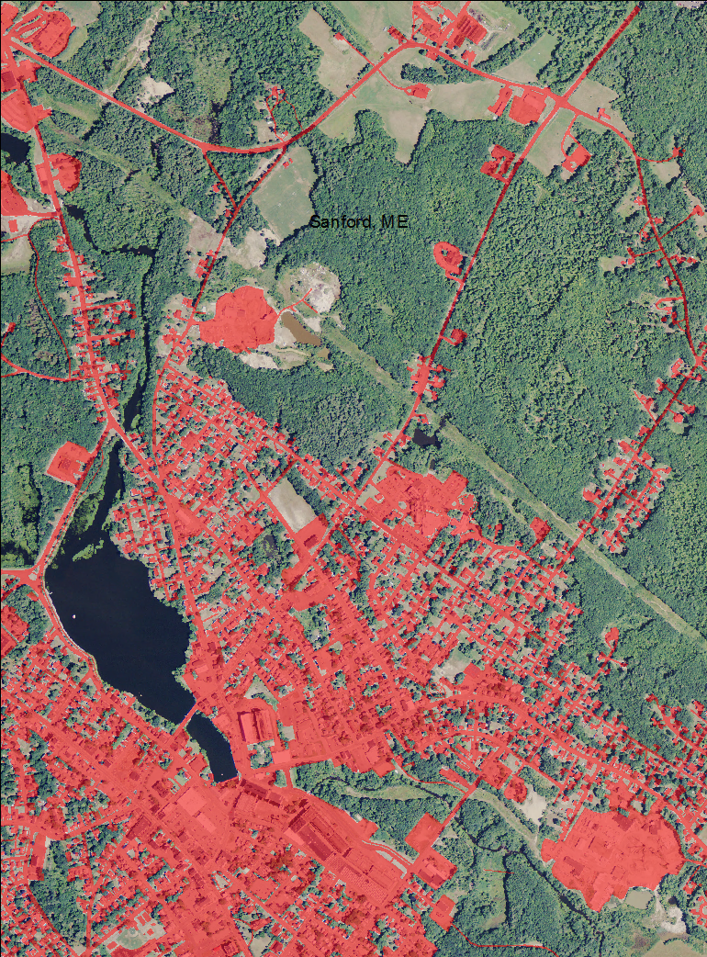

Figure 5. New development seen in 2014 NAIP orthophotography (Wolfeboro, NH).
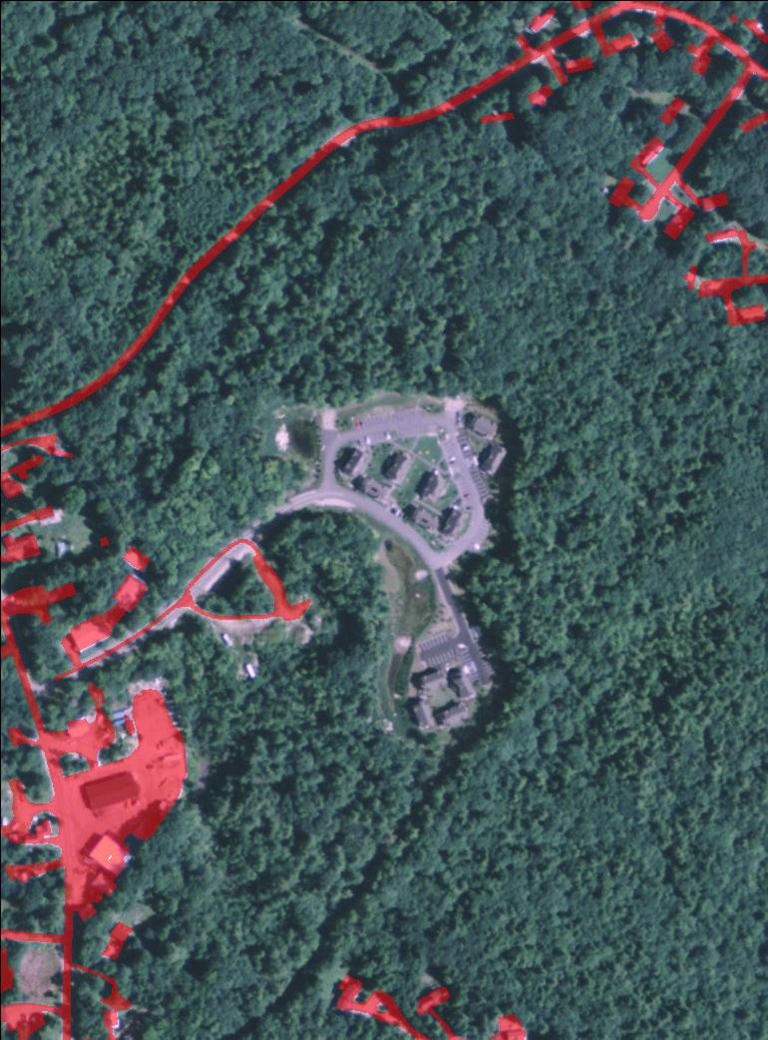

Figure 6. New development seen in 2014 NAIP orthophotography (Alton, NH).
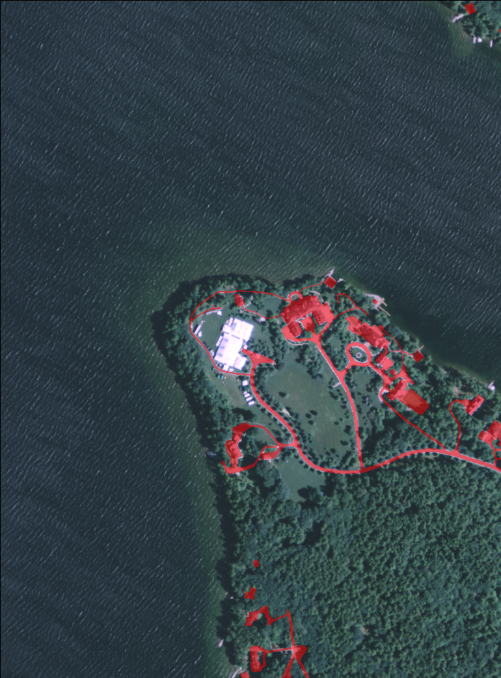

Table 1. 2010 high-resolution impervious cover by town.
State | Town | Impervious Cover |  | Total Acres
 |  | Acreage | % of Land Area | Surface Water | Land Area | Total
Maine | Acton | 743 | 3.1 | 2,146 | 24,262 | 26,408
 | Berwick | 874 | 3.6 | 225 | 24,002 | 24,227
 | Eliot | 881 | 7.0 | 1,041 | 12,609 | 13,650
 | Kittery | 1,310 | 11.5 | 36,824 | 11,375 | 48,199
 | Lebanon | 989 | 2.8 | 600 | 35,033 | 35,633
 | North Berwick | 723 | 3.0 | 129 | 24,293 | 24,422
 | Sanford | 2,417 | 7.9 | 621 | 30,584 | 31,205
 | Shapleigh | 641 | 2.6 | 1,665 | 24,696 | 26,361
 | South Berwick | 742 | 3.6 | 330 | 20,561 | 20,891
 | Wells | 2,128 | 5.8 | 10,427 | 36,430 | 46,857
 | York | 2,163 | 6.2 | 49,428 | 34,919 | 84,347
 | Total | 13,612 | 4.9 | 103,436 | 278,764 | 382,200
New Hampshire | Alton | 1,008 | 2.5 | 12,602 | 40,629 | 53,231
 | Brookfield | 123 | 0.8 | 287 | 14,593 | 14,880
 | Wakefield | 843 | 3.3 | 3,452 | 25,264 | 28,716
 | Wolfeboro | 1,052 | 3.4 | 6,713 | 30,693 | 37,406
 | Total | 3,026 | 2.7 | 23,054 | 111,179 | 134,233
Study Total |  | 16,637 | 4.3 | 126,490 | 389,943 | 516,433

Note: The coastal watershed also includes approximately 5 acres of land within the town of Pittsfield, New Hampshire. Due to this minor acreage and the lack of any impervious surface features within it, the town is not included in the mapping or tabular summary above.

Table 2. 2010 high-resolution impervious cover by subwatershed.
 | Impervious Cover |  | Total Acres
12-Digit HUC Subwatershed Name | Acreage | % of Mapped Land Area | Mapped Area | Surface Water | Land Area | Total Watershed
Alton Bay | 601 | 2.1 | 32,179 | 3,164.6 | 29,014 | 32,253
Balch Pond-Shapleigh Pond | 239 | 3.4 | 7,722 | 765.1 | 6,957 | 13,911
Bauneg Beg Pond-Great Works River | 1,115 | 4.8 | 23,472 | 392.6 | 23,079 | 23,472
Beech River | 20 | 1.6 | 1,439 | 145.1 | 1,294 | 12,827
Big River | 14 | 0.1 | 10,906 | 222.2 | 10,684 | 18,571
Branch Brook-Merriland River | 733 | 4.3 | 17,105 | 64.4 | 17,040 | 20,044
Branch River | 55 | 0.3 | 17,565 | 233.8 | 17,331 | 17,565
Brave Boat Harbor | 98 | 3.7 | 2,664 | 9.5 | 2,655 | 2,780
Day Brook-Mousam River | 98 | 5.2 | 1,909 | 34.7 | 1,874 | 12,114
Estes Lake | 196 | 4.9 | 4,218 | 182.6 | 4,035 | 19,154
Great Works River-Leighs Mill Pond | 1,016 | 3.2 | 32,094 | 269.8 | 31,824 | 32,094
Headwaters Branch River | 381 | 2.2 | 18,301 | 838.7 | 17,463 | 18,301
Headwaters Cocheco River | 3 | 0.0 | 27,475 | 515.4 | 26,959 | 27,475
Headwaters Salmon Falls River | 413 | 2.7 | 17,698 | 2,554.5 | 15,143 | 17,699
Henderson Brook | 115 | 3.0 | 4,069 | 182.2 | 3,887 | 13,057
Islands off Frontal Southern York County | 3 | 1.4 | 186 | 0.0 | 186 | 186
Little River | 779 | 2.2 | 34,874 | 165.8 | 34,708 | 34,874
Lower Salmon Falls River | 597 | 4.5 | 13,612 | 378.7 | 13,233 | 13,800
Middle Salmon Falls River | 784 | 2.1 | 38,136 | 775.0 | 37,361 | 38,143
Moultonborough Bay | 15 | 1.2 | 1,266 | 0.0 | 1,266 | 29,745
Mousam Lake | 630 | 3.7 | 19,036 | 2,052.8 | 16,983 | 19,048
Number One Pond-Mousam River | 1,181 | 10.0 | 12,190 | 384.2 | 11,806 | 12,225
Pine River | 174 | 2.0 | 9,441 | 603.4 | 8,837 | 35,664
Portsmouth Harbor | 1,870 | 7.4 | 27,922 | 2,479.3 | 25,443 | 30,548
Rock Haven Lake-Little Ossipee River | 129 | 1.6 | 8,173 | 80.8 | 8,092 | 30,175
South River | 23 | 3.3 | 1,058 | 378.5 | 680 | 20,121
Stevens Brook-Cape Neddick River | 2,767 | 7.5 | 37,000 | 258.6 | 36,741 | 40,179
Suncook Lakes-Suncook River | 127 | 1.6 | 8,569 | 478.4 | 8,091 | 45,314
The Broads | 354 | 3.4 | 21,646 | 11,192.8 | 10,453 | 39,157
Upper Salmon Falls River | 182 | 1.3 | 14,714 | 1,174.5 | 13,540 | 14,716
Wolfeboro Bay | 912 | 2.9 | 36,861 | 5,815.3 | 31,045 | 36,921
York River | 1,013 | 4.9 | 21,068 | 544.3 | 20,524 | 21,646
Study Total | 16,637 | 3.4 | 524,569 | 36,338 | 488,231 | 743,777

Table 3. Comparison between high and medium-resolution impervious cover estimates for 2010.
State | Town | 2010 High-Resolution Impervious Cover |  | 2010 Medium-Resolution Impervious Cover Estimates¹
 |  | Acreage | % of Land Area | Acreage | % of Land Area
Maine | Acton | 743 | 3.1 | 910 | 3.8
 | Berwick | 874 | 3.6 | 1,624 | 6.8
 | Eliot | 881 | 7.0 | 1,415 | 11.2
 | Kittery | 1,310 | 11.5 | 1,822 | 16.0
 | Lebanon | 989 | 2.8 | 1,645 | 4.7
 | North Berwick | 723 | 3.0 | 1,266 | 5.2
 | Sanford | 2,417 | 7.9 | 3,582 | 11.7
 | Shapleigh | 641 | 2.6 | 923 | 3.7
 | South Berwick | 742 | 3.6 | 1,207 | 5.9
 | Wells | 2,128 | 5.8 | 3,246 | 8.9
 | York | 2,163 | 6.2 | 3,461 | 9.9
 | Total | 13,612 | 4.9 | 21,101 | 7.6
New Hampshire | Alton | 1,008 | 2.5 | 1,918 | 4.7
 | Brookfield | 123 | 0.8 | 268 | 1.8
 | Wakefield | 843 | 3.3 | 1,879 | 7.4
 | Wolfeboro | 1,052 | 3.4 | 1,871 | 6.1
 | Total | 3,026 | 2.7 | 5,936 | 5.3
Study Total |  | 16,637 | 4.3 | 27,037 | 6.9

¹Impervious cover estimates for the medium-resolution study are taken from mid range (see Justice and Rubin, 2003 for a full explanation of the cell ranges)

References

Justice, D. and Rubin, F. 2006. Final Report: Impervious Surface Mapping in Coastal New Hampshire (2005). 24 p.
Justice, D. and Rubin, F. 2003. Final Report: Developing Impervious Surface Estimates for Coastal New Hampshire. 25 p.

