NH Wetlands Base Layer Field Descriptions

The following is a data dictionary describing the fields used in the attributes of the NH Wetlands Base layer. If you have any questions about the fields or the coding used, or you discover errors in the data, please contact the Water Quality Planning Section at NH Dept. of Environmental Services, Watershed Management Bureau at (603) 271-2304.

Description of Codes
NWI_ID: Unique ID for each polygon from the original National Wetland Inventory
(NWI) layer.

NWICODE: Cowardin Wetlands and Deepwater Habitats Classification Code.

NWITYPE: The “System” portion of the Cowardin Wetlands and Deepwater Habitats
Classification Code.

SSC: The “System, Sub-system and Class” portion of the Cowardin Wetlands
and Deepwater Habitats Classification Code.

Base_No: Unique ID for each polygon in the NWI layer assigned by DES from the
modified NWI layer, once uplands were removed. ID was assigned before splits were conducted.

Complex_No: Wetland Complex Number, unique ID assigned to all elements of multi-
part wetlands. Wetlands with the same Complex_No meet the requirements for the NH Method to be treated as a single complex. Wetlands within one foot of each other are assigned the same Complex_No. Complexes bisected by roads >4 lanes and rivers >4th order are split and assigned a unique Complex_No. There is a 1:1 relationship between Complex_No and AUID.

Abut_AB_L2: Describes whether or not a given polygon abuts a polygon with a
Cowardin code of Riverine Aquatic Bed, Limnetic Aquatic Bed, or Littoral.
Code Description
Y Abuts a polygon with a Cowardin code of Riverine Aquatic Bed, Limnetic Aquatic Bed, or Littoral.

N Does not abut a polygon with a Cowardin code of Riverine Aquatic Bed, Limnetic Aquatic Bed, or Littoral.

N/A Polygon is a wetland with a Cowardin code of Riverine Aquatic Bed, Limnetic Aquatic Bed, or Littoral.

Water_Type: Describes the type of water located within the wetland polygon based on
the Cowardin “System” code.
Code Description
Marine Wetland having a high salt concentration- typically
greater than 1%.

Fresh Wetland having a low salt concentration- typically
less than 1%.

PrimaryHUC: Primary HUC12 for a complex, based upon maximum area of the complex
if it spans multiple HUCs.

AUID: Assessment Unit ID unique to each wetland complex, formatted as
SSWWWhhhhhhhhh-uuu. There is a 1:1 relationship between AUID and Complex_No.

Where ‘SS’ = the state abbreviation.
Where ‘WWW’ = the Water_Type.

Code Description
MWT Marine Wetland
FWT Freshwater Wetland

Where ‘hhhhhhhhh’ = the PrimaryHUC minus the preceding ‘010’.
Where ‘uuu’ = a unique three digit identifier for a wetland complex in each HUC.

Color: Color code for convenient display. 0-9 based upon last digit of the AUID.

Shape_Length: Length of the perimeter of the polygon, displayed in feet.

Shape_Area: Area of the polygon, displayed in square feet.

The wetland complexes in this layer were constructed from the National Wetlands Inventory (NWI) base layer completed by US F&WS in the mid-1980's. This derived coverage was created by constructing wetland complexes from the individual NWI wetland polygons in accordance with the 2010 "Method for the Comparative Evaluation of Nontidal Wetlands in New Hampshire" (NH Method). Complexes bisected by large roads and rivers were split into separate wetland complexes. Once the complexes were created, an Assessment Unit ID (AUID) was assigned to each fresh water and estuarine wetland complex according to the primary hydrologic unit boundary at the subwatershed (12-digit) level that it resided in.
This base layer is intended to act as a starting point for anyone applying the NH Methods. The layer provides a unique code to each wetland complex in New Hampshire, for use in assessing water quality and other attributes of wetland complexes. Wetland complexes for New Hampshire built in accordance with the "New Hampshire Method for the Evaluation of Non-tidal Wetlands" (USDA).
Building the NH Wetland Base Layer,
which includes the 2010 Wetland Assessment Unit IDs (AUIDs)
-How they were made-

Step 1 – Preprocessing of the NWI coverage
In order to have the ArcGIS model run correctly the NWI coverage available through GRANIT had to undergo preprocessing. This was needed to remediate errors that were occurring in the model due to the polygons not snapping to common boundaries (i.e. there were very small gaps between adjoining polygons). The steps involved included:
- The selection and deletion of all the upland polygons from the NWI layer, so that only wetlands remained.
- Creation of a new file geodatabase called NH_NWI
- Creation of a new feature dataset within the file geodatabase (NH_NWI), which assigned a larger cluster tolerance than the original NWI layer (0.1 feet was utilized).
- Import of the NWI feature class to the new feature dataset.
- Creation and validation of a new topology within NH_NWI, which incorporated two rules; ‘Must Not Overlap’ and ‘Must Not Have Gaps’.
This new NWI layer was then used as the stating point for the creation of the AUIDs

Step 2 – Calculating Base Number
The first step in creating a wetland AUID was to make a working copy of the National Wetland Inventory (NWI) coverage, created in Step 1. Once copied a new filed was added called Base_No. The base number filed was then populated with a unique number for each record starting with “1”. This field will be used later to make sure the correct wetland attributes are associated with the new wetland complexes being created.

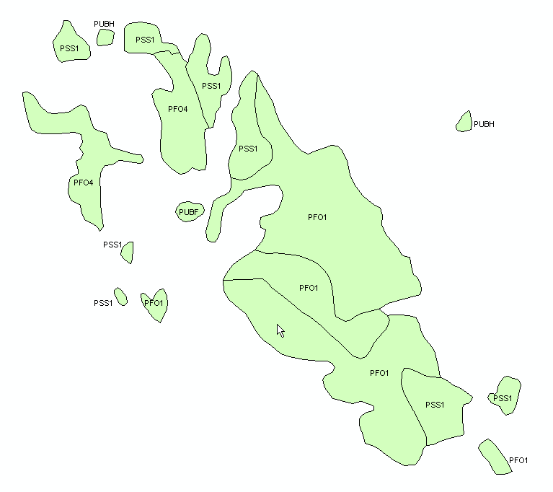
Step 3 – Creating Wetland Details
This step began by querying the NWI coverage and making three new layers. The first query was designed to identify all the marine wetlands. That query looked for wetlands with Cowardin codes beginning with M1AB, M2AB, E1AB, E2AB, E2US, E2EM and E2SS. The second query was designed to identify all palustrine wetlands and looked for wetlands with Cowardin codes beginning with P. The third query was designed to identify all the freshwater wetlands with aquatic beds. That query looked for wetlands with Cowardin codes beginning with L2, L1AB, R1AB, R2AB, R3AB, R4AB and R5AB.

The next step essentially split polygons within the marine and palustrine wetland layers that were bisected with roads having more than four lanes and fifth order or larger rivers. The marine and palustrine wetland layers were then combined together into a single ‘details’ layer.

Step 4 – Creating Wetland Complexes
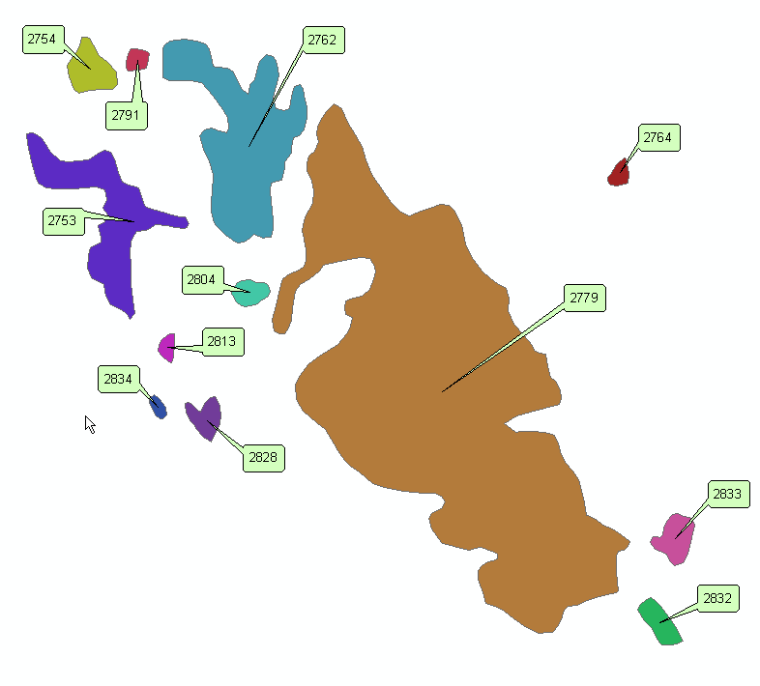
Just as in Step 3, this step began by querying the NWI coverage and making two new layers. The first query was designed to identify all the marine wetlands. That query looked for wetlands with Cowardin codes beginning with M1AB, M2AB, E1AB, E2AB, E2US, E2EM and E2SS. The second query was designed to identify all palustrine wetlands and looked for wetlands with Cowardin codes beginning with P.

The next step preformed an aggregation on the two layers, which essentially merged any polygons that were within one foot of each other. These new polygons now represent wetland complexes. The wetland complexes for the marine and palustrine wetlands were then split wherever they were bisected by roads having more than four lanes or fifth order or larger rivers. The marine and palustrine wetland layers were then combined together into a singe ‘complex’ layer. A new field was then added called Complex_No, and a unique complex number was generated for each complex starting with ‘1’.

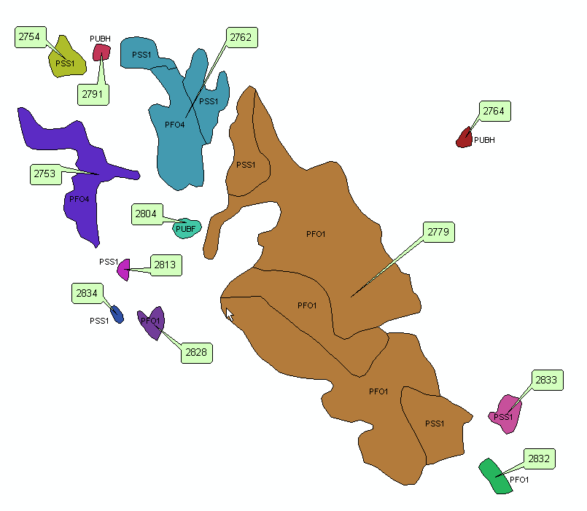
Step 5 – Combining Wetland Complexes with Details
This step spatially joined the ‘details’ layer with the ‘complex’ layer so that each individual wetland polygon was assigned the appropriate wetland complex number. This step kept all the individual wetland polygons and their associated details, adding in a complex number. Further referred to as the ‘detail-complex’ layer.

Step 6 – Determining Appropriate HUC Code
There were six processes required to determine the primary Hydrologic Unit Code (HUC) at the subwatershed (12-digit) level that would be assigned to each wetland complex. The steps involved:

- An intersect of the HUC layer with the ‘detail-complex’ layer was conducted.
- A dissolve was conducted using complex number and HUC12 as the dissolve fields.
- A table was created that calculated the maximum area for each wetland complex within an individual HUC12.
- This table was then joined back to the dissolve layer using the complex number as the join feature.
- A new filed called ‘primary’ was added to the dissolve layer. A formula was written to compare the each records area with the maximum area. Records that had identical areas and maximum areas were coded as being the primary HUC.
- The dissolve layer was then joined back to the ‘detail-complex’ layer using complex number as the join feature. The primary HUC codes for each complex were then assigned to the appropriate complexes, using the ‘primary’ field as the key.

Step 7 – Assigning HUC Code to Ocean Wetlands
After the completion of Step 6 there were several polygons that had a ‘Null’ HUC value due to the complex being outside of the HUC layer (i.e. they were in the ocean, which does not have a HUC). To correct this, polygons with null values were examined and manually assigned the HUC of the nearest HUC12.

Step 8 – Building the AUID, Part 1
To begin building the Assessment Unit IDs (AUID) the data table from the ‘detail-complex’ layer was imported to Microsoft Access. A ‘group-by’ query was built to extract the AUID and Complex_No columns, and the resulting table was then exported to Microsoft Excel. The data table could not be imported directly to excel because the number of records was greater than the maximum allowed in Excel.

Once in Excel, the data was sorted by AUID and then by Complex_No and an ‘if-then’ formula was written to generate a unique number for each complex within a given HUC12. This number was then manipulated so that if could be displayed as a three digit number with preceding zeros (i.e. 001, 002, 003, etc…). The AUID and the three digit codes were then concatenated together.

Step 9 – Building the AUID, Part 2
The final step in building the AUID was to join the ‘detail-complex’ layer with the table created in Step 8, using complex number as the join feature. Once joined the AUID fields in the layer were overwritten with the new completed AUIDs (AUID and three digit code). A final column was then added called ‘color’. This field was populated with the last digit from the full AUID (e.g. 0 to 9). This field allows for ease of viewing the layer and distinguishing between wetland complexes.

Step 10 – Removing Duplicate Records
It was identified while spot checking some of the data that there were a few duplicate polygons created. To ensure that these records were removed from the ‘detail-complex’ layer the data was exported to Microsoft Access. A ‘find duplicates make table query’ was created using Shape_Area as the duplicate value field. Once the table was created it was joined back to the ‘detail-complex’ layer, using ObjectID as the join feature. One of each pair of duplicate records was then selected and deleted from the ‘detail-complex’ layer.

Step 11 – Adding in Riverine Aquatic Bed, Limnetic Aquatic Bed, or Littoral polygons.
A new field was created in the ‘detail-complex’ layer called ‘Abut_AB_L2’. A select by location function was then conducted so that the features from the ‘detail-complex’ layer that shared a line segment with the features in the ‘aquatic beds’ layer, created in Step 3, could be identified. The selected features then had the ‘Abut_AB_L2’ field populated with a ‘Y’. The ‘aquatic beds’ layer was then appended to the ‘detail-complex’ layer. Each aquatic bed wetland was then manually examined. One of three processes were performed while examining the wetland features:
- Aquatic bed wetlands abutting a marine or palustrine wetland were clipped at the boundaries of the marine or palustrine wetland and assigned the complex number and AUID from the marine or palustrine wetland (Example 1). This occurred primarily along lakes.
- Aquatic bed wetlands that abutted multiple marine or palustrine wetlands were collapsed into a single wetland complex and AUID (Example 2).
- Aquatic bed wetlands not abutting marine or palustrine wetlands were assigned a new unique complex number and AUID.

Example 1: Aquatic bed wetlands along the edge of a lake.
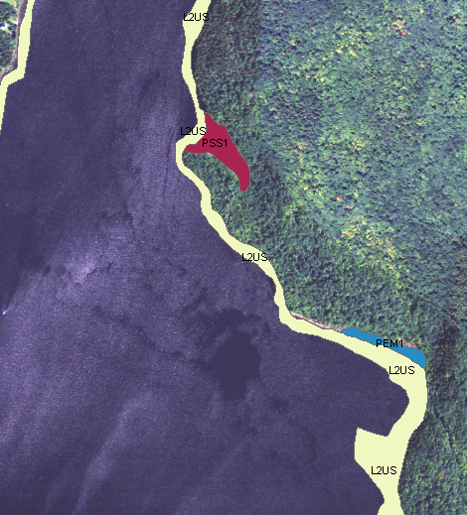
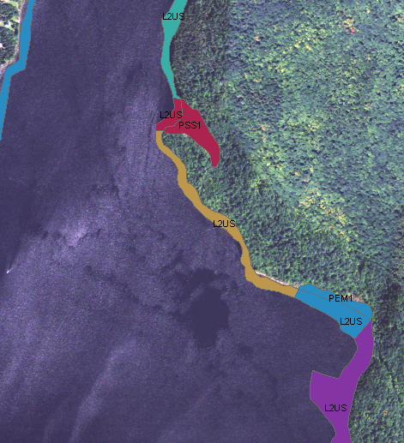

Pre-Processing Post-Processing

Example 2: Aquatic bed wetlands that spanned several marine or palustrine wetlands.
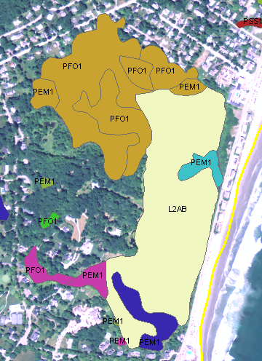
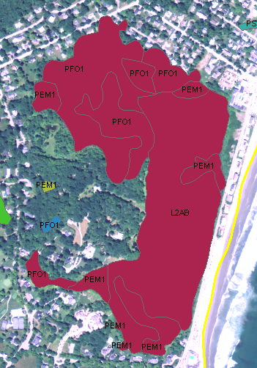

Pre-Processing Post-Processing

Step 12 – Removing slivers
The final step involved removing any small features that were created when the ‘details’ and ‘complex’ layers were split by roads having more than four lanes and fifth order or larger rivers. This step was intended to remove small features that were not truly created when a large road or stream bisected a wetland. They were more the result of the various layers not lining up appropriately resulting in the creation of “slivers”. There were several steps involved in this process, they included:
- Exporting the data to Microsoft Access.
- A ‘group-by’ query was built to extract the base number and return a count of individual base numbers.
- A ‘group-by’ query was built to extract the complex number and return a count of individual complex numbers.
- A table was built to show all the wetlands that intersected a roads having more than four lanes or fifth order or larger river.
- A query was built to extract all the wetlands that were less than 10,000 ft² and intersected a road having more than four lanes or fifth order or larger river.
- A final query was built, which used the previous queries to extract the wetland base number from wetlands that were less than 10,000 ft² and had multiple complexes associated to it.
- These wetlands were then manually examined to determine if the resulting series of wetland complexes were valid or needed to be refined.

Example 3 shows a series of four wetland complex that were created due to the bisection of a large river. Through the examination of the two original wetlands used to create this series of complexes, the aerial photography and the placement of the digitized river segment it was determined that there should only be three wetland complexes. The following decisions were made to reach this conculsion:
- The two southern complexes that had the same base number should be merged together into a single complex.
- The very small eastern complex should be merged together with the larger northern complex.
- The northern complex should be re-split along the streambed shown in the aerial photo. The piece of the complex that wraps around the western side of the center complex should be merged together with the center complex.

Example 3: Correction of Wetland Complexes Created from the Intersection of a Large River.
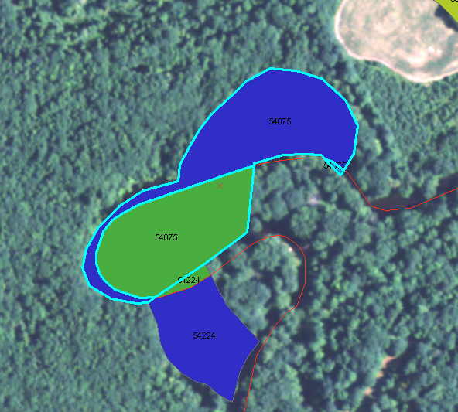
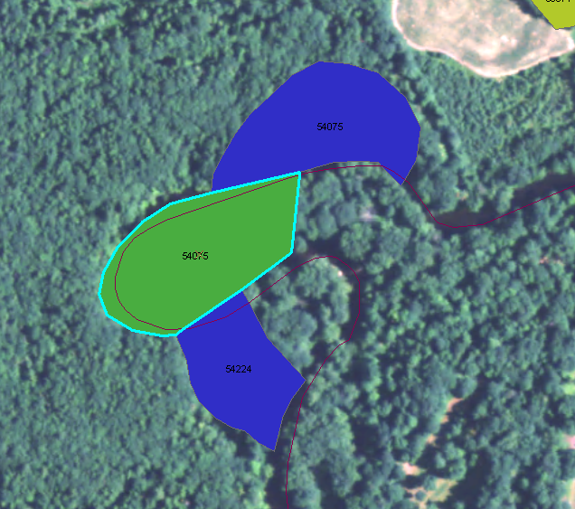

Pre-Processing Post-Processing

