Municipal Board Empowerment Series Workshop #7
NH Coastal Viewer 201

http://nhcoastalviewer.org

Exercises
Coastal Flood & Sea-level Rise Vulnerability
September 6, 2017

NH Coastal Viewer Training Exercise: Using the NH Coastal Viewer for Coastal Flood Vulnerability
This exercise will illustrate how the NH Coastal Viewer may be used to identify areas in your town susceptible to coastal flooding and sea-level rise. It presents a series of steps that will help you answer this question by 1) conducting a visual assessment and 2) by using some of the available analytical and measurement tools. The exercise assumes that you have some familiarity with the Viewer, including how to find and display data layers and how to navigate within the map display. Guidance is provided at the start to re-acquaint you with the basic tools.
Sample map generated by following exercise:
Title: Vulnerability of Mechanic Street Infrastructure to 6-ft Sea-level Rise Scenario

Begin by accessing the NH Coastal Viewer from http://www.nhcoastalviewer.org
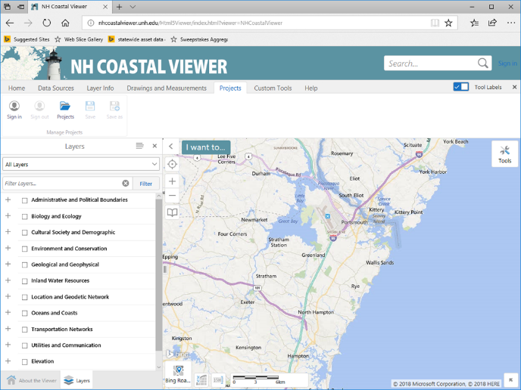
- Login to ArcGIS Online (AGO) so that you can save your project results later. Note that it is helpful to get in the habit of doing this when you first access the Coastal Viewer, as any customized views you create by zooming/panning, turning on data sets, resymbolizing data, adding text/graphics, etc., will only be saved to the project file if you are logged in from the start of the session.
  - Click the Projects tab in the top navigation bar.
  - Click on Sign in and enter your AGO credentials.

- Turn on Data Layers
  - Display the Town/City boundary layer from within the Administrative and Political Boundaries (APB) folder on your map by checking the appropriate boxes.
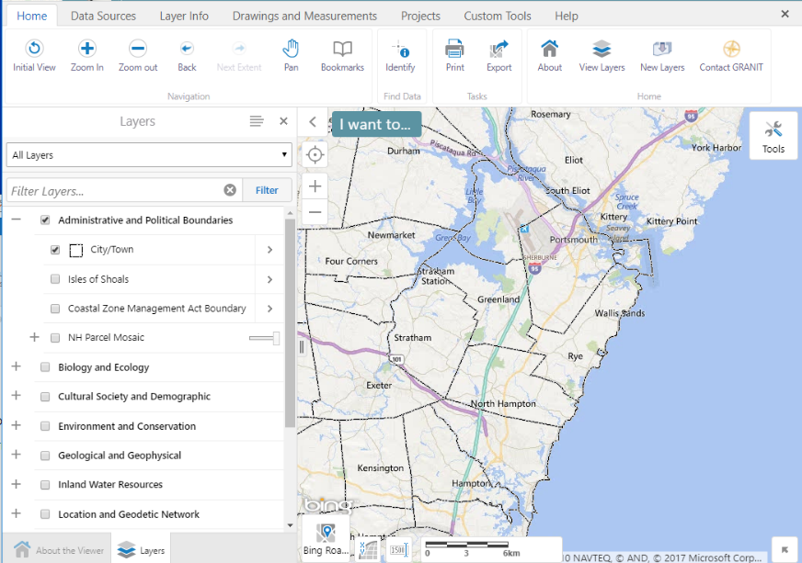
  - Expand and collapse data categories by clicking the +/- symbols. Here, start by expanding the APB folder.
  - Check both the folder name and the City/Town layer. Note that all levels of the hierarchy must be checked for data to be visible.
  - If you accidentally close the Layers panel, you can open it again by clicking the View Layers tool (found in the Home tab of the toolbar).
  - Try expanding other folders and displaying additional data sets of interest. Remember to expand and click on all levels of the layer hierarchy to fully expand folders and display a data set.
  - Note: Layers in the TOC that appear in gray font are scale-dependent and will only draw when the map is zoomed in and the font color changes to black.
- Navigate to your (coastal flood-prone) Town of Interest and Establish a Bookmark
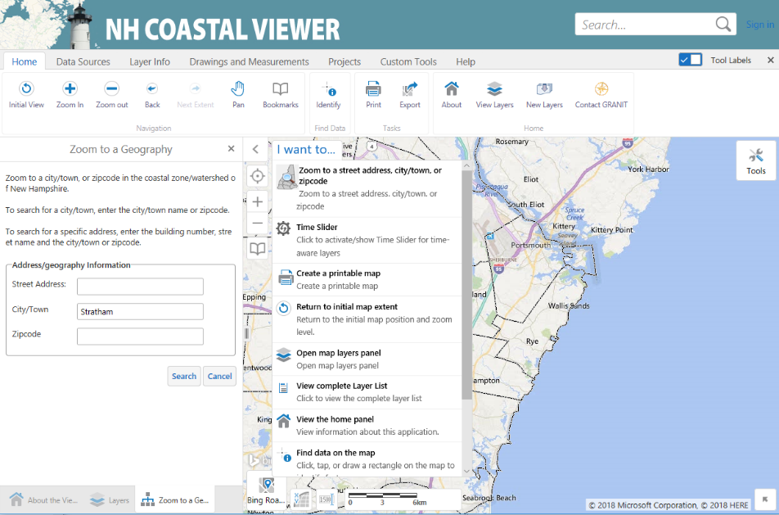
  - One way to zoom into a location of interest is to use the Zoom to a street address, city/town or zipcode option in the I want to ... menu. This will open the Zoom to a Geography panel.
  - Enter a town of interest in the City/Town text box (choose a town with tidal influence/coastal waters for this exercise). As you start to enter the text, select from one of the “autocomplete” options in the dropdown menu. This exercise uses the town of Stratham for illustration purposes.
  - Click on Search to reposition the map.
  - The map is now zoomed into an area around the town you entered. The remainder of your analysis will be based on the full map extent displayed (and not just on your town of interest). Close the Zoom to a Geography panel by clicking on the “x” in the upper right corner.
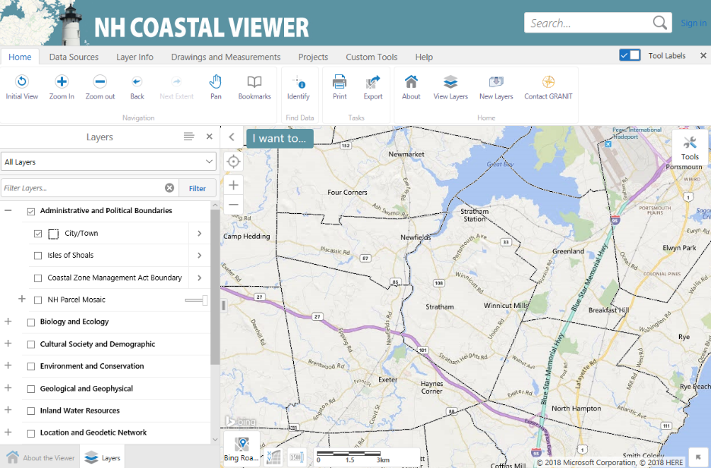
  - Create a Bookmark so that you can easily return to this map extent. Click on the + sign next to “Bookmark Current Extent”. Enter a meaningful name in the “Bookmark Name” textbox and click “OK”. Click anywhere on the map to close the Bookmarked Locations textbox. You can then return to this geographic extent at any time by clicking on the Bookmark tool again and selecting the appropriate name.

- Display the regulatory FEMA Federal Insurance Rate Map:
- Display the “Flood Hazard – Areas” layer. (It’s up to you to figure out where that layer is. Tip: Enter a word from the layer’s name in the “Filter Layers…” search box.

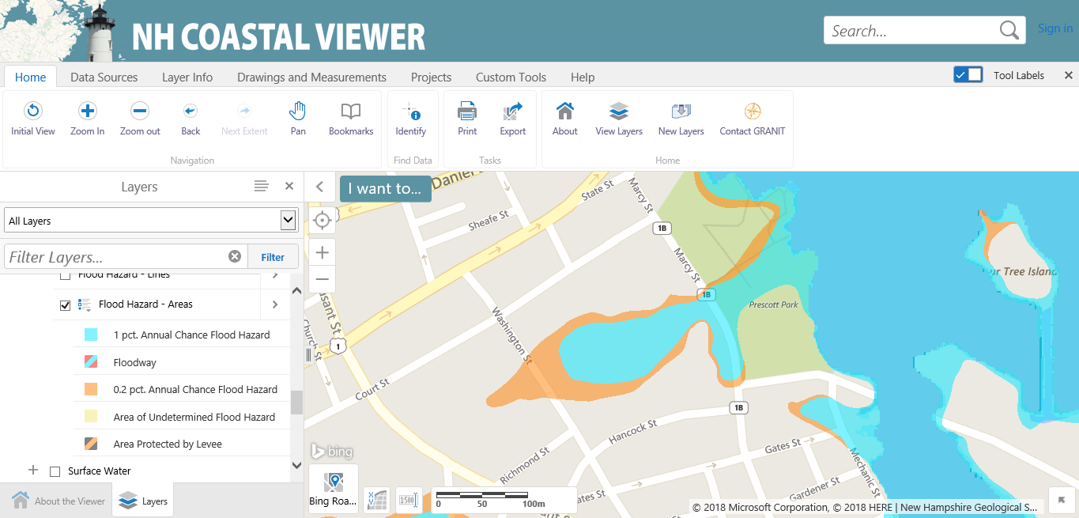

- Think of a site/location/property in your town of interest that you are familiar with and that you think might be in the 1% annual chance floodplain. Navigate to that site.
Tip: There are several ways to navigate to a site. You can zoom. If you know the address you can also “Zoom to a street address” by clicking the “I want to…” menu and selecting the first option. See 3.a. above. Your address must be correct and you must select the town name in order for this option to work.
If you have trouble thinking of a site, zoom to the Portsmouth Library in Portsmouth (if you use the tool “Zoom to a street address” enter: 175 Parrott Avenue Portsmouth 03801 –note that the zoomed to location might not be exact).

- Observe how much of the area is susceptible to flooding in a 1% annual chance storm and in a 0.2% annual chance storm. Were you surprised or not? (Answer in the space below).

- Change the base map to Bing Aerial.
  - Is a structure on the property in the 1% annual chance floodplain? ________
  - What flood zone is the property in? _______
(Tip: Use the Identify Tool for b and c.)
- Use the Clipping Tool to quantify amount of parcel in floodplain
The Clipping Tool can be used to evaluate and calculate how any vector layer (non-raster) interacts with another vector layer. We will use the Clipping Tool to determine the area of a parcel that is within the FEMA 1% annual chance floodplain and the 0.2% annual chance floodplain.
  - Turn on the “Polygons” data layer in the “NH Parcel Mosaic” (Search for “Polygons” in the Filter search to find it)
  - Select the “>” next to the “Polygons” text in the table of contents and select “Toggle Labels” to turn the parcel labels off.
  - Click on the “Identify” button found within the “Home” tab and highlight the Parcel in which your site is located by clicking anywhere within the parcel. An attribute table pops up at the bottom of the screen.
  - Click the Panel Actions Menu (button with four horizontal lines in bottom right corner of screen) and click “Run Clipping Tool.” For Source Layer select “Polygons” and for Target Layer select “Flood Hazard- Areas.” Choose “Flood Zone” as the Grouping Field and click “Done.”
  - Click Generate pdf.
  - When the “Save clipping results” window opens, click Download. The downloading procedure may vary depending on your web browser. Open the pdf to view your Clipping Tool results.
  - The Report gives the area (in ft2) of the different flood zones within your site parcel. How much of the parcel is in the 1% annual chance floodplain? ___________________ What about the 0.2% annual chance floodplain? _______________________________
Extra Exercise: The “Polygons” NH Mosaic Parcels data layer does not include area in the attribute table so it is not possible to calculate the percent of your parcel in the 1% annual chance floodplain. You could, however, run the clipping tool on the City/Town data layer and calculate the percent of a selected City or Town that is within a floodplain. Do you know how you would go about doing this? If you have time, try it out.
- Save and name your project, so that you can come back in the future.
- Turn off “Polygons”
- Now we will explore information about sea-level rise risk.
  - Turn on the “MHHW Baseline” data layer (use the Filter search box to find it). Click the “>” button in the layer table of contents to the right of the text “MHHW Baseline.” Select “Metadata.” Read the Metadata record.
What does MHHW stand for? ________________
When was this dataset published? ___________
Is the data available for download? ___________
  - Choose a sea-level rise scenario of interest to you and turn it on. (Tip: sea-level rise scenarios can be found at “Oceans and Coasts”>”Sea Level Rise Scenarios”
  - Navigate to a site of interest at risk of coastal flooding under your sea-level rise scenario (Tip: zoom, pan, zoom to address…)
  - Turn on another layer that shows infrastructure or other sites of interest in the area. (Tip: try “Shoreline Structure Inventory” in the folder “Ocean and Coasts” or try data layers in the folder “Cultural Society Demographic” or “Transportation Networks”). Adjust the layer visualizations and/or label appearance.
  - Compare sea-level rise scenarios by navigating to the “I want to…” menu (or the “Custon Tools” tab) and selecting “MHHW + SLR Slider.” Move the slider marker to explore the different inundation levels under different scenarios. Close out of the Slider.
  - Select one sea-level rise scenario. Click the tab “Drawings and Measurements” and use the tools to draw and/or write on your map to highlight a vulnerable site that may need to be adapted in the future. What is the possible depth of tidal water at this site under your selected sea-level rise scenario? (Tip: Identify tool; depth = “pixel value”) ____________
  - Click the “Projects” tab and click “save as” to save your map. Name it. Create a map sharing link.
  - On the “Home” tab select “Print” and format your map panel, title, and other features. Click “print” to create a pdf of your map.
  - Extra credit question: There is a reason why you can’t use the Clipping Tool or alter layer visualizations with the MHHW + SLR data layers. Can you figure out why?

Extra Exercise: Turn on the floodplain layer “Flood Hazard – Areas” again and compare the extent of the FEMA floodplains to the sea-level rise scenarios and the storm surge + SLR scenarios. What do you notice?

- Now let’s take a look at how salt marshes might migrate and change with sea-level rise. Turn off your sea-level rise layers.
  - Navigate to the town of Hampton.
  - Turn on the “Initial Conditions (2014)” data layer in the “Predicted Marsh Migration” subfolder. Can’t find it? Use the Filter search bar.
  - Turn on a marsh migration scenario of your choosing by selecting subfolder “Scenario 1” or “Scenario 2.” Expand the folder you selected and then click on a “Predicted Marsh Migration (Year)” layer. Toggle the scenario on and off to compare it to the initial conditions layer.
  - Turn on an infrastructure or social layer of interest (i.e., maybe public roads) and explore how it interacts with projected future salt marsh. What do you notice about future salt marsh in the Hampton area?
  - If you want to save this work, then click “Save as” on the Projects tab and name your work as a new project. Select appropriate sharing settings.

