REGIONAL BROADBAND PLANNING UNDERWAY

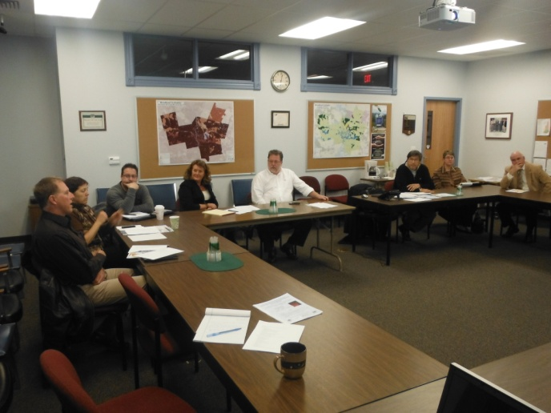
In the Southern New Hampshire Planning Region, a Broadband Stakeholders Group (BSG) has been working toward developing the first draft of a broadband plan for the region by September 2013. This group of municipal officials, planning commissioners, businesses, health, education and chamber of commerce representatives, and several broadband providers has been meeting since March 2012. The BSG has worked to identify the key issues and barriers to implementing and expanding broadband infrastructure in the region, including developing a vision statement and key strategies and recommendations. These findings have been condensed into two reports: “Broadband Issues and Barriers to Development” and a new “Broadband Sector Analysis Results Summary & Strategic Broadband Strategies for the Southern New Hampshire Region,” which is posted under “Latest News and Events,” on the SNHPC website: http://www.snhpc.org/.

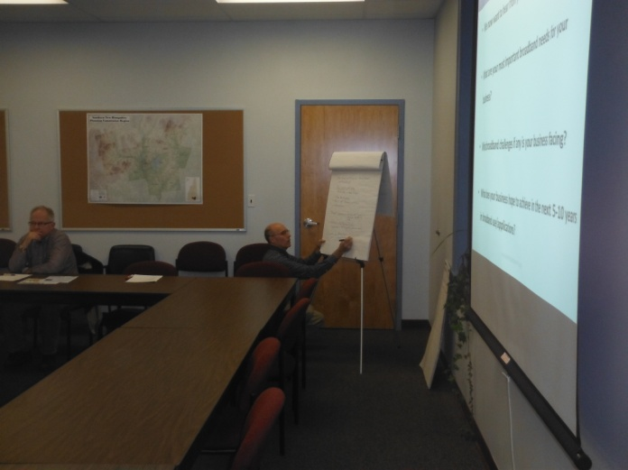
Since our first Public Broadband Forum in September 2012, SNHPC staff conducted five focus group sessions and surveyed key organizations in five sectors to draft the Broadband Sector Analysis report, including strategies to improve Broadband access and infrastructure. The sectors included Health, Public Safety, Education, Economic Development, and Government. The results and recommended strategies in this report will be a major component of our Regional Broadband Plan. At the May 16, 2013 Broadband Stakeholders Group meeting a vision statement was formally adopted. The BSG envisions the southern New Hampshire region serving as a hub of technology and innovation within the state as well as expanding connectivity, accessibility, and improving information sharing among agencies involved in public safety. Staff at SNHPC has conducted outreach to local chambers of commerce to receive feedback on how this plan can also serve economic development goals in the region. This regional vision statement will be a guiding principle for the final broadband plan. The next Broadband Stakeholders Meeting is scheduled for August 29, 2013, 3:00-5:00pm in the SNHPC Conference Room. The first draft of the plan will be presented at this meeting.

If you or anyone in your community is interested in participating in the BSG or attending meetings of the BSG, please contact Jack Munn, AICP, Chief Planner at jmunn@snhpc.org.

