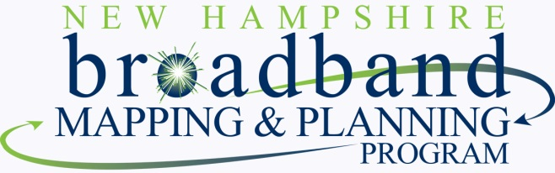

New Hampshire Broadband Mapping & Planning Program – Intellectual Property website links
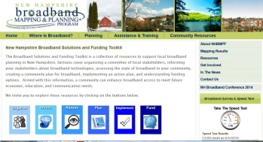
New Hampshire Broadband Solutions and Funding Toolkit

Broadband Learning Modules

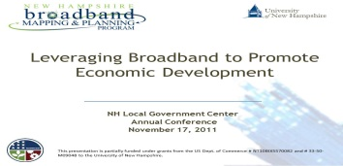
Leveraging Broadband to Grow NH’s Economy

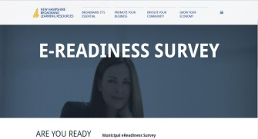
E-Readiness Survey

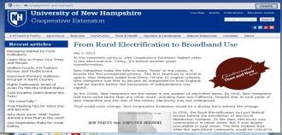
Rural Electrification & Broadband

