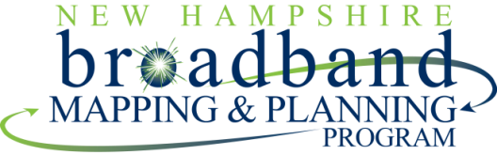

Workshop: “Train-the-Trainer: Community Broadband Planning and Development”
A New Hampshire Broadband Mapping and Planning Program (NHBMPP) Workshop

Workshop Summary: Hands-on, 9-hour workshop facilitated by Bill Shuffstall, rural broadband planning and implementation expert from Penn State Cooperative Extension. Workshop will introduce project participants to resources and materials for guiding leaders from communities and regions to identify, develop, and implement projects that increase:
- Availability of access to broadband connectivity across the community/region;
- Adoption and use of broadband tools and services
- Communities/regions ability to deliver services and functions via broadband
Workshop Objectives:
- Review research and best practices for regional broadband planning;
- Build awareness of what works and doesn’t work with respect to increasing rural communities/regions’ access to, and use of, broadband infrastructure (e.g. public-private partnerships); and
- Expose NHBMPP members to Connecting Communities Curriculum, which is designed to work communities/regions through the broadband planning process.

Audience: NHBMPP project managers and staff, RPC broadband coordinators, and other interested parties

When: May 1, 2012 (8:30am – 5:00pm)

Where: Local Government Center, 25 Triangle Park Drive, Concord, NH 03301

Cost: Free (lunch provided)

Registration: Register online (by April 13, 2012) at:
https://www.events.unh.edu/RegistrationForm.pm?event_id=9942

For more information contact: David Foote, UNH State Broadband Initiative, Nesmith Hall, Durham, NH, 03824, phone: 603-862-1565; david.foote@unh.edu

Facilitator/Trainer (brief biography): William C. (Bill) Shuffstall, Senior Extension Educator, College of Agricultural Sciences, Pennsylvania State University, University Park, Pennsylvania, USA.

Bill Shuffstall’s Extension programs use research-based information to teach community development techniques in rural communities across Pennsylvania. These programs help rural leaders better understand how global and national trends and forces are impacting their communities and how to use this knowledge to develop strategies and projects that will lead to improved community and economic development.

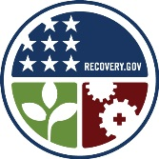
Bill is widely recognized for his expertise and understanding of how the information economy impacts rural communities and how local strategies can be used to improve access to affordable broadband service, increase residents and institutions use of digital tools and increase the quality and quantity of local web based content. Bill is a co-author of www.connectingcommunities.info, a web based curriculum that is used by community leaders to develop and implement projects that increase the availability broadband and use of digital tools in their communities. Bill holds a Master of Science from Slippery Rock University.

Funded by: The University of New Hampshire, recipient of American Recovery and Reinvestment Act Grant No. 33-50-M 09048 (CFDA No. 11.558) (Prime Agreement); New Hampshire Broadband Mapping and Planning Program (NHBMPP) grant.

